**Task -7: Identify and Remove Suspicious Browser Extensions**

**Step 1:**

Open Your Browser’s Extensions Manager

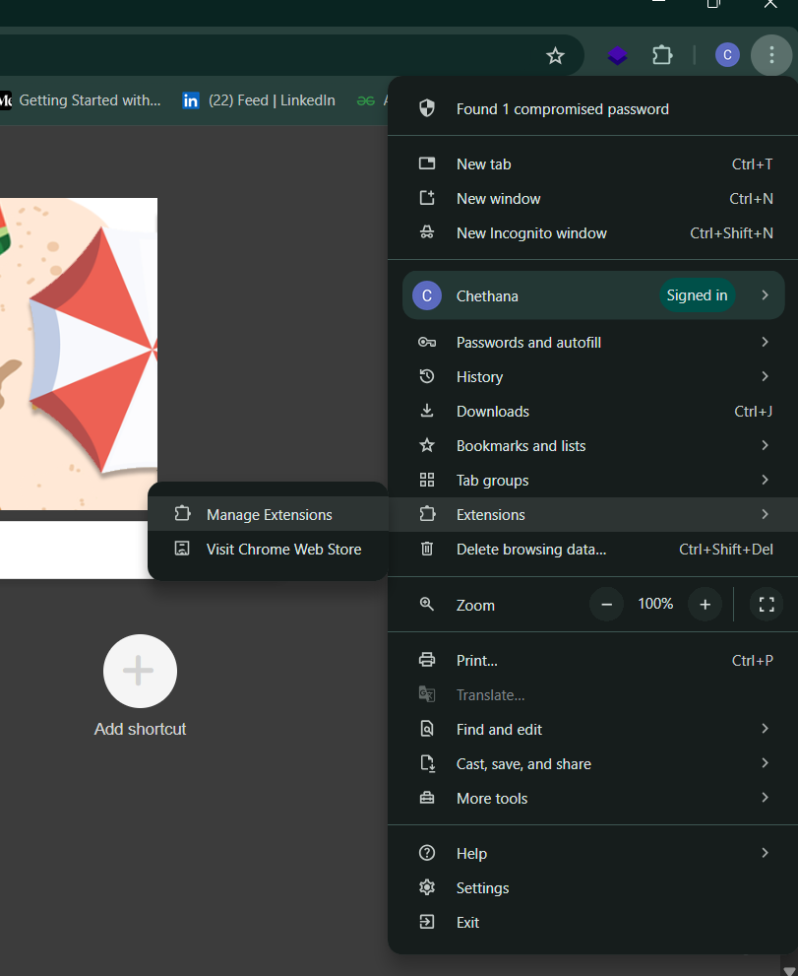

**Step 2:**

Review Installed Extensions

* Go through the list of extensions installed.

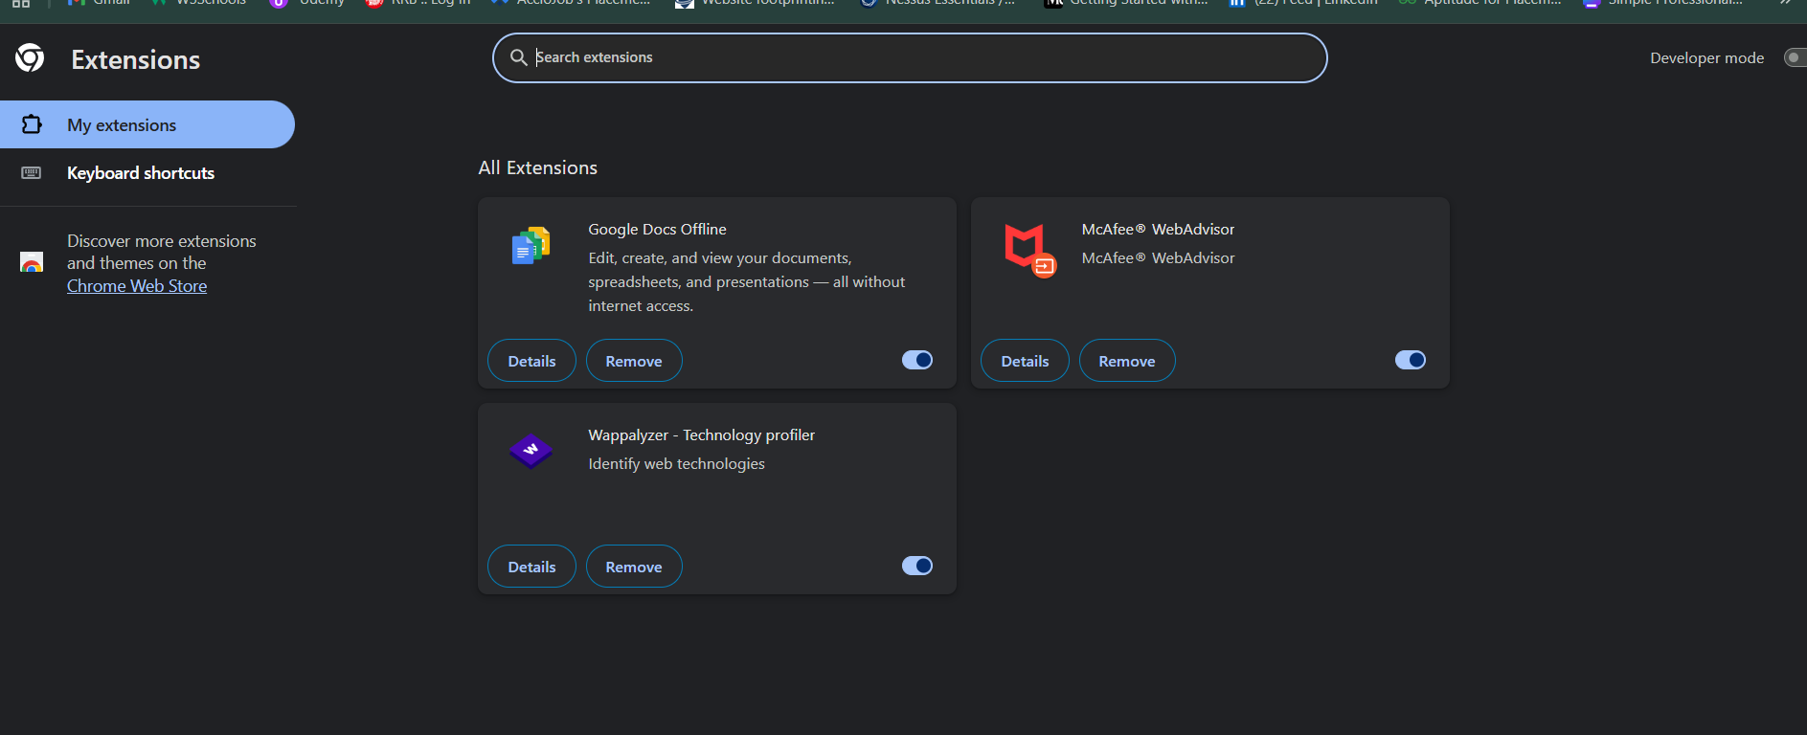

* Look for any extensions you don’t recognize or haven’t intentionally installed.
* Check for duplicates or strange names.

**Step 3:**

**Check Permissions and Reviews**

* Click on **“Details”** for each extension to see what permissions it has.
* If an extension asks for full access to all websites or your data, be cautious.

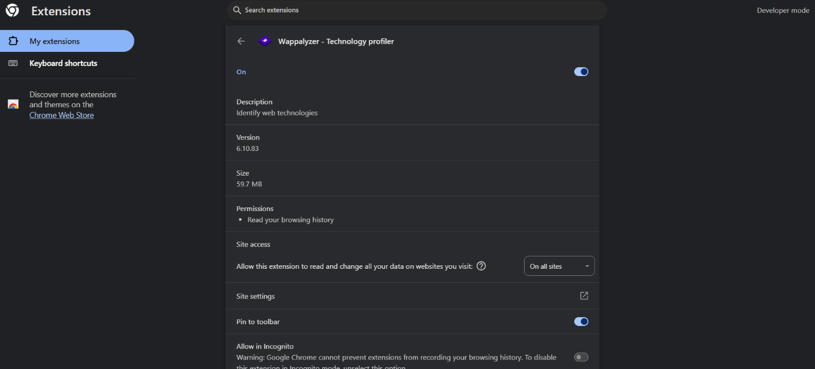

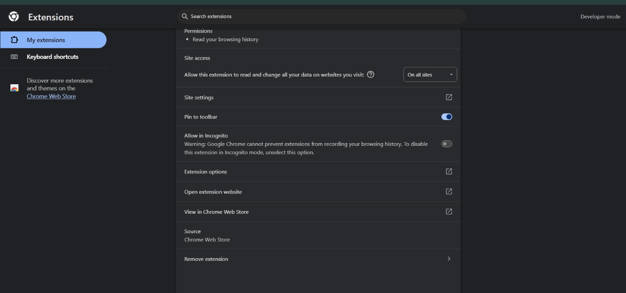

**Step 4:**

Identify and remove suspicious or unnecessary Extentions.

**Step 5:**

Restart the Browser for Performance check.