**Task 8: Identify and Remove Suspicious Browser Extensions.**

**Step 1:**

Choose and Sign up for Reputable Free VPN Service.

**Step 2:**

After completing the process of installing VPN Service checking the IP address using What is MyIPAddress.com .

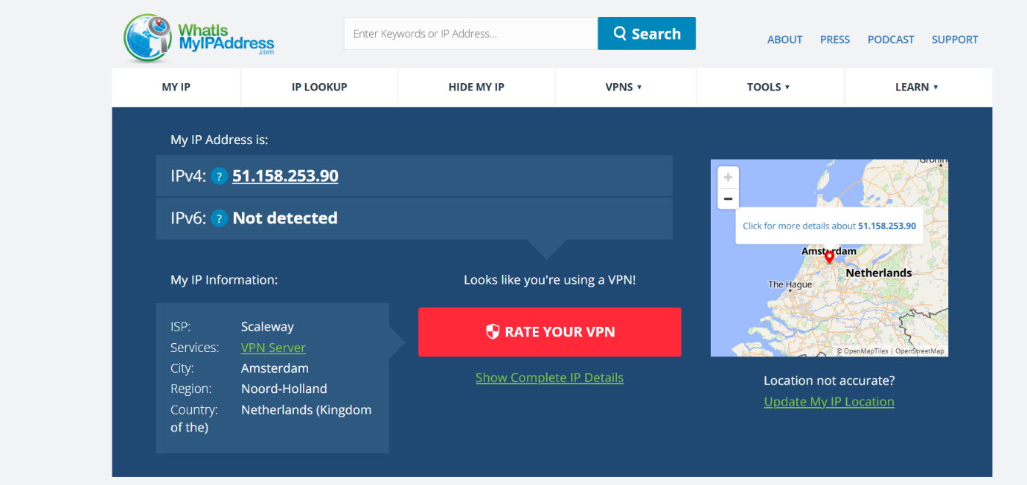

**Step 3:**

If VPN Service is ON then the IP Address cannot be detected.

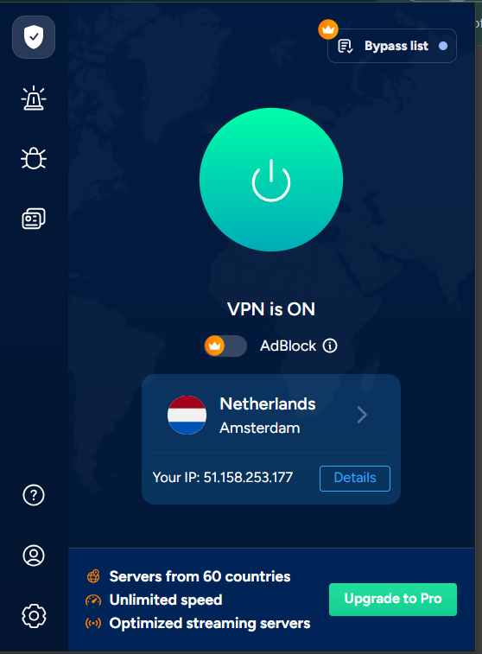

**Step 4:**

After completing the process VPN service should disconnect to get Browsing speed.

