TIME SERIES FORECASTING — PRACTICAL ASSIGNMENT
LAB EXERCISE 4: ARIMA Model Implementation and Forecasting
LAB EXERCISE 5: Seasonal ARIMA (SARIMA) Forecasting
Name: __________________________ USN: __________________________
Section: __________ Date: __________

PART A — CONCEPTS REQUIRED FOR BOTH EXPERIMENTS

1. Time Series
A time series is a sequence of observations recorded in chronological order. Examples include monthly passenger counts, daily sales, electricity demand and temperature. A time series may contain trend, seasonality, cyclical movement and random noise.

2. Stationarity
A stationary time series has statistical properties that remain reasonably stable over time. Trend, changing variance and seasonality can make a series non-stationary. ARIMA-family models generally require the series to be made stationary through differencing and suitable transformations.

3. Differencing
First-order differencing is y′t = yt − yt−1. It removes much of the trend and is represented by d in ARIMA. Seasonal differencing is y′t = yt − yt−s and removes recurring patterns at seasonal lag s; its order is D in SARIMA.

4. ACF and PACF
ACF measures correlation between a series and its lagged values. PACF measures the relationship at a lag after accounting for intermediate lags. ACF is commonly used as a guide for q and Q, while PACF is commonly used as a guide for p and P. These are diagnostic guidelines, not automatic model-selection rules.

LAB EXERCISE 4 — ARIMA MODEL IMPLEMENTATION AND FORECASTING

1. Aim
To prepare a real time-series dataset, assess stationarity, fit an ARIMA model, forecast unseen observations, evaluate forecast errors and interpret residuals.

2. Dataset and workflow
Dataset: AirPassengers, monthly international airline passenger counts, January 1949 to December 1960 (144 observations). Source: https://raw.githubusercontent.com/jbrownlee/Datasets/master/airline-passengers.csv. The chronological 80:20 split gives 115 training observations (January 1949–July 1958) and 29 test observations (August 1958–December 1960). No shuffling was performed.

3. Model and results
The provided candidate model ARIMA(2,1,2) was fitted using only the training data. The full-series Augmented Dickey-Fuller test returned p-value 0.9919, which does not provide evidence of stationarity in the original level series. First differencing was therefore examined. The model forecasted exactly 29 steps.
Model | AIC | MAE | RMSE
ARIMA(2,1,2) | 1057.5162 | 63.5453 | 82.5130
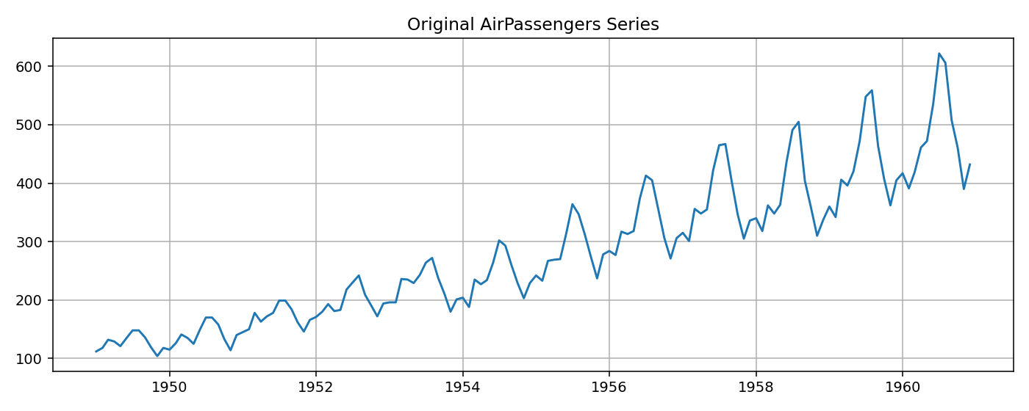
Figure 1. Original AirPassengers series: upward trend and recurring annual pattern are visible.
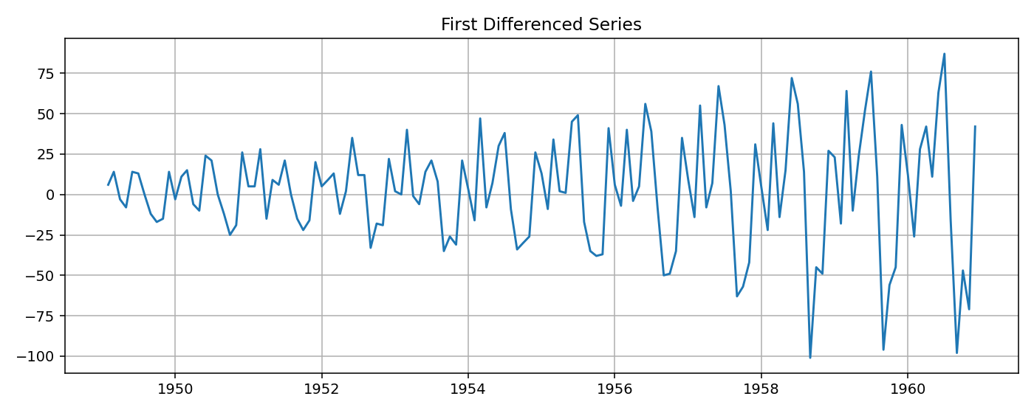
Figure 2. First-differenced series: differencing reduces the level trend, although seasonal structure can remain.
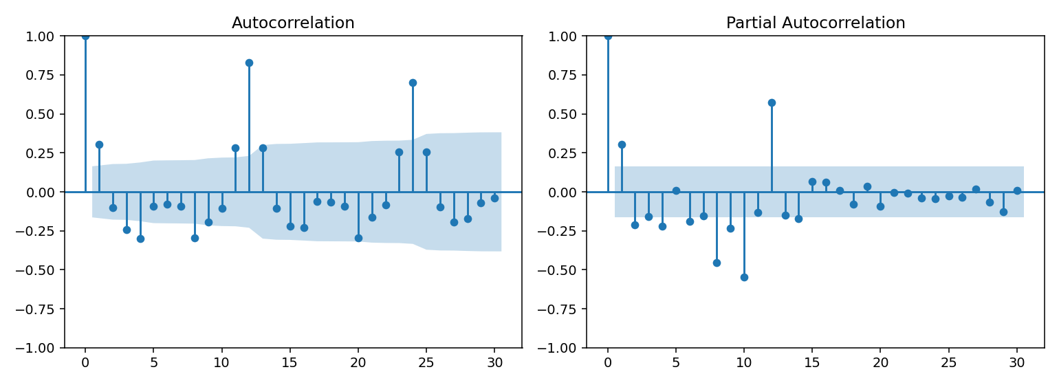
Figure 3. ACF and PACF of the first-differenced series; used as guides for candidate lag orders.
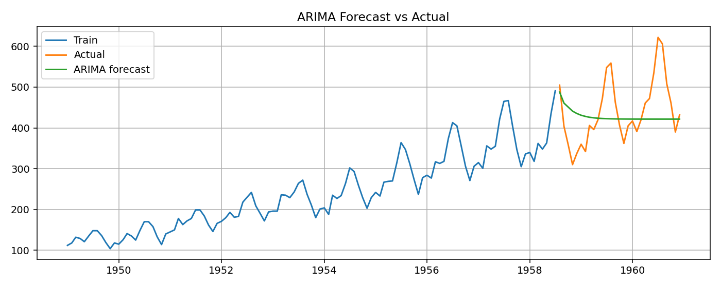
Figure 4. ARIMA forecast compared with the unseen test observations.
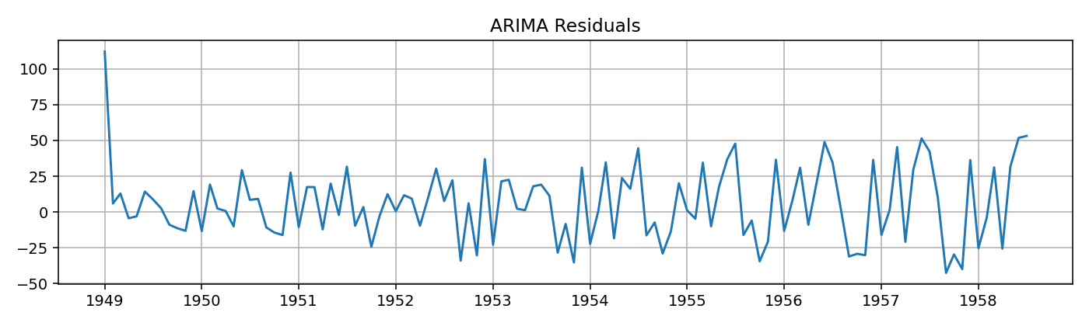
Figure 5. ARIMA residuals from the fitted training model.
Recorded parameters: p = 2, d = 1, q = 2. MAE = 63.5453. RMSE = 82.5130.

4. Observation and interpretation
The original passenger series shows a clear upward trend and repeating annual peaks, so the level series is non-stationary. The ADF p-value of 0.9919 is greater than 0.05, supporting the conclusion that the original series is non-stationary. First-order differencing reduces the trend and is consistent with d=1. The ARIMA(2,1,2) model was trained on the first 115 observations and evaluated on the final 29 observations without data leakage. Its MAE is 63.55 passengers and its RMSE is 82.51 passengers. The forecast does not fully reproduce the strong seasonal pattern, which is a limitation of using a non-seasonal ARIMA model on this seasonal dataset. Residuals should ideally resemble random noise; remaining structure suggests that further model refinement may be useful.

5. Independent tasks — Exercise 4

Task 4.1 — Change ARIMA order
ARIMA order | AIC | MAE | RMSE
(1,1,1) | 1058.2456 | 85.2542 | 97.4996
(2,1,1) | 1058.6476 | 60.5290 | 82.6211
(1,1,2) | 1057.3275 | 62.0635 | 82.6358
(2,1,2) | 1057.5162 | 63.5453 | 82.5130
Among the tested candidates, ARIMA(2,1,1) has the lowest MAE, while ARIMA(2,1,2) has the lowest RMSE by a small margin. ARIMA(1,1,2) has the lowest AIC. The preferred model therefore depends on the evaluation criterion; validation forecast errors should be considered alongside AIC.

Task 4.2 — Effect of differencing
Model | AIC | MAE | RMSE
ARIMA(2,0,2) | 1074.5413 | 92.2417 | 114.8879
ARIMA(2,1,2) | 1057.5162 | 63.5453 | 82.5130
With d=0, the model is fitted to a non-stationary level series and gives larger errors. Setting d=1 reduces the trend effect and improves both MAE and RMSE for this split.

Task 4.3 — Forecast horizon
Forecast horizon | MAE | RMSE
6 steps | 77.7872 | 85.5806
12 steps | 64.9820 | 76.7748
24 steps | 62.1027 | 79.9188
The error does not increase monotonically for these nested test horizons because the evaluation windows contain different months and seasonal peaks. Forecast uncertainty generally grows with lead time, but the measured MAE/RMSE also depend on which observations fall inside each horizon.

Task 4.4 — Residual analysis
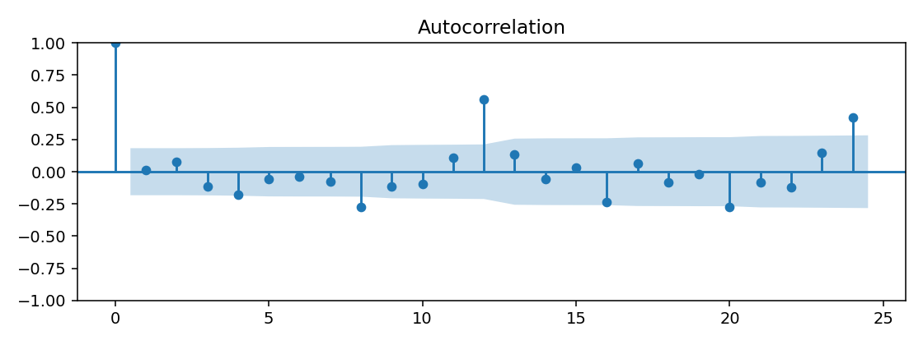
Residual ACF for ARIMA(2,1,2).
The residual ACF is inspected for significant spikes outside the confidence bands. Remaining autocorrelation indicates that the model has not captured all temporal structure; residuals are not assumed to be white noise solely because a forecast was produced.

Task 4.5 — New real dataset
Dataset: Sunspots, annual sunspot activity observations supplied by the statsmodels built-in Sunspots dataset. Frequency: yearly. Total observations: 309; chronological split: 247 training and 62 test observations. Model: ARIMA(2,1,2). MAE = 33.1613 and RMSE = 40.2278. Source: statsmodels.datasets.sunspots (bundled public dataset).
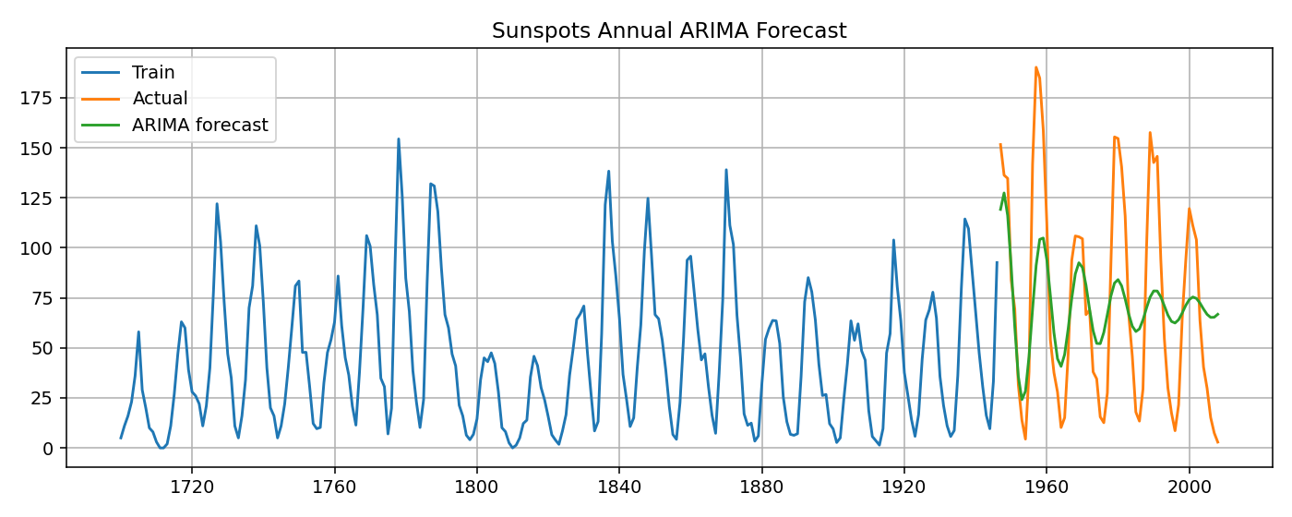
Annual Sunspots ARIMA forecast on the held-out test period.

LAB EXERCISE 5 — SEASONAL ARIMA (SARIMA) FORECASTING

1. Aim
To identify recurring seasonal patterns, fit a SARIMA model, forecast unseen observations and compare forecast errors.

2. Theory and seasonal period
SARIMA is represented as SARIMA(p,d,q)(P,D,Q,s). The first three parameters describe non-seasonal AR, differencing and MA terms. P, D and Q describe their seasonal counterparts. For monthly observations with an annual cycle, s=12 because each month is compared with the same month one year earlier.

3. Model and results
The same AirPassengers dataset and 115/29 chronological train-test split were used. The series was assigned monthly-start frequency. Seasonal differencing with lag 12 was inspected. The provided model SARIMA(1,1,1)(1,1,1,12) was fitted using the training data only.
Model | AIC | MAE | RMSE
SARIMA(1,1,1)(1,1,1,12) | 657.6013 | 25.2680 | 31.7873
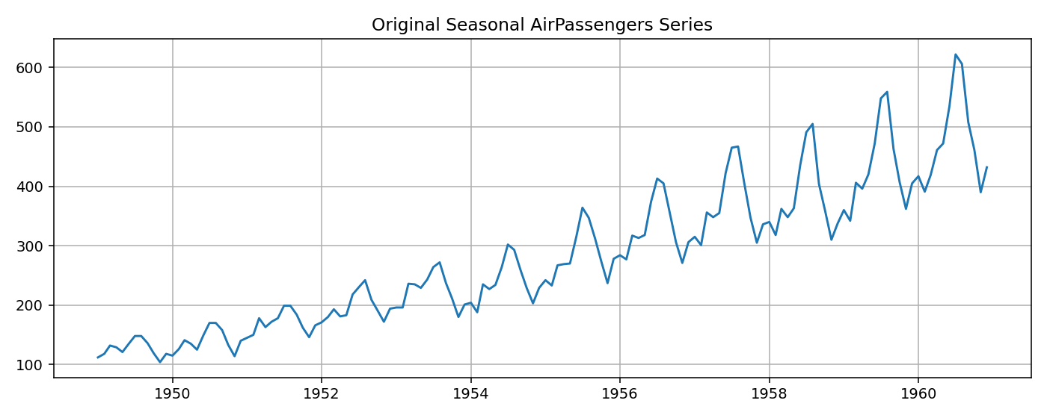
Figure 6. Original seasonal AirPassengers series.
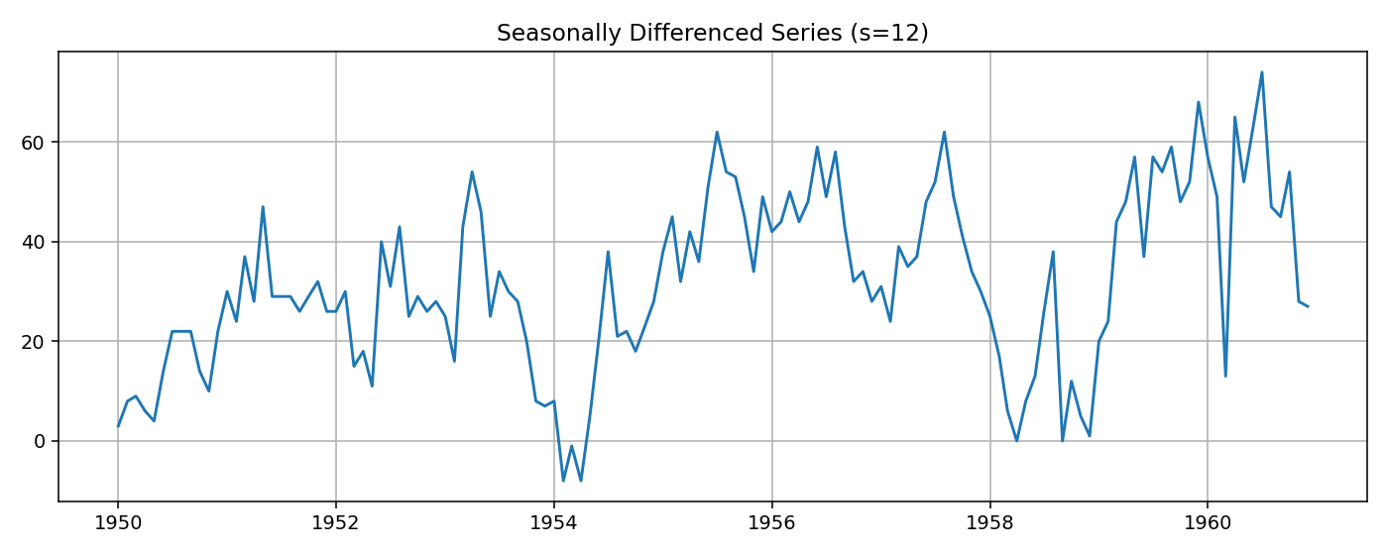
Figure 7. Seasonal differencing with s=12.
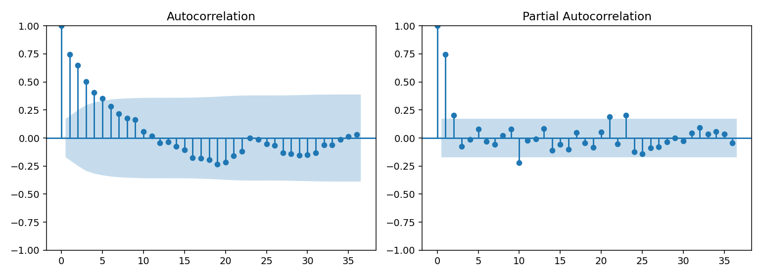
Figure 8. ACF and PACF after seasonal differencing.
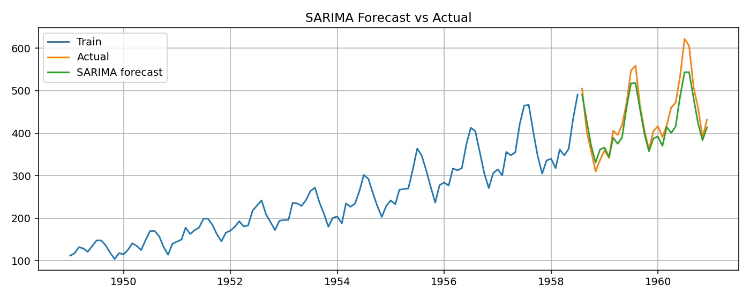
Figure 9. SARIMA forecast compared with actual test data.
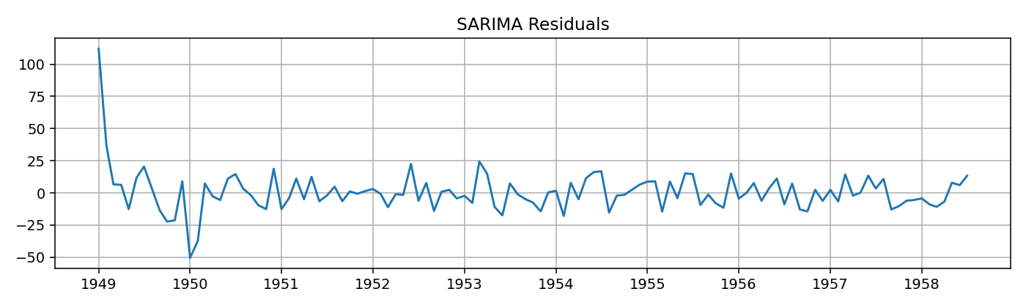
Figure 10. SARIMA residual plot.
Recorded parameters: (p,d,q) = (1,1,1); (P,D,Q,s) = (1,1,1,12). MAE = 25.2680. RMSE = 31.7873.

4. Observation and interpretation
The original monthly passenger series shows a strong repeating annual pattern along with a long-term upward trend. Seasonal differencing with s=12 compares each month with the same month in the previous year and reduces the repeating seasonal component. The SARIMA(1,1,1)(1,1,1,12) model combines non-seasonal and seasonal AR, differencing and MA terms. On the final 29 observations, it achieves MAE 25.27 and RMSE 31.79. These errors are substantially lower than those of the provided non-seasonal ARIMA(2,1,2) model on the same test set. The forecast plot allows the predicted seasonal movement to be compared with the actual passenger counts. Residual plots and residual ACF should still be examined to check for remaining structure.

5. Understanding parameters
Parameter | Value | Meaning
p | 1 | One non-seasonal AR term
d | 1 | One non-seasonal difference
q | 1 | One non-seasonal MA term
P | 1 | One seasonal AR term
D | 1 | One seasonal difference
Q | 1 | One seasonal MA term
s | 12 | 12-month annual seasonal cycle

6. Independent tasks — Exercise 5

Task 5.1 — Compare SARIMA orders
Order | Seasonal order | AIC | MAE | RMSE
(1,1,1) | (1,1,1,12) | 657.6013 | 25.2680 | 31.7873
(0,1,1) | (0,1,1,12) | 659.3416 | 24.0592 | 30.5800
(2,1,1) | (1,1,0,12) | 660.9138 | 22.1936 | 28.7345
Among the three candidates, the third configuration has the lowest MAE and RMSE, while the provided first configuration has the lowest AIC. The selected configuration should be justified using both information criteria and held-out forecast accuracy.

Task 5.2 — Seasonal period
s=12 is appropriate for monthly data when the pattern repeats annually. s=7 is appropriate for daily observations with a weekly pattern (for example, weekday/weekend demand). s=24 can be appropriate for hourly observations with a repeating daily cycle.

Task 5.3 — ARIMA vs SARIMA
Model | MAE | RMSE
Best ARIMA by MAE: ARIMA(2,1,1) | 60.5290 | 82.6211
SARIMA(1,1,1)(1,1,1,12) | 25.2680 | 31.7873
Both models use the same AirPassengers train-test split. The SARIMA model has lower MAE and RMSE, indicating that explicitly modelling the annual seasonal structure improves forecast accuracy for this dataset.

Task 5.4 — Seasonal differencing D=0 vs D=1
Seasonal differencing | AIC | MAE | RMSE
D=0 | 721.6842 | 18.6973 | 22.3992
D=1 | 657.6013 | 25.2680 | 31.7873
D=1 substantially lowers AIC, while D=0 gives lower test MAE and RMSE for this particular split. This illustrates why differencing should not be selected from one metric alone. The seasonal-differenced plot and residual diagnostics should be considered together with out-of-sample performance.

Task 5.5 — Different seasonal dataset
Dataset: atmospheric CO₂ observations from statsmodels.datasets.co2. The original observations are weekly; they were resampled to monthly means and missing monthly values were interpolated. The resulting monthly series contains 526 observations, split chronologically into 420 training and 106 test observations. Seasonal period: s=12, representing an annual cycle in monthly data. Model: SARIMA(1,1,1)(1,1,1,12). MAE = 1.8528 and RMSE = 2.1844 (in the dataset’s CO₂ concentration units). Source: statsmodels built-in CO₂ dataset.
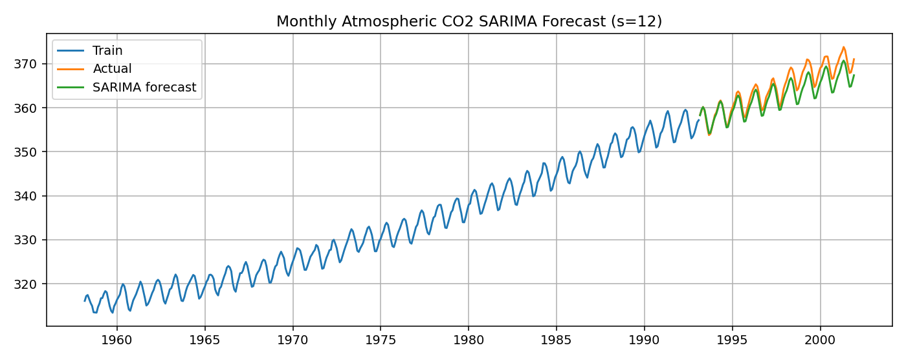
Monthly atmospheric CO₂ SARIMA forecast on the held-out test period.

FINAL CONCLUSION
This practical implemented both ARIMA and SARIMA forecasting using chronological train-test evaluation. The AirPassengers series showed trend and annual seasonality. Differencing was used to address non-stationarity, and ACF/PACF plots were examined as guides for candidate orders. The seasonal SARIMA model outperformed the provided non-seasonal ARIMA model on the same AirPassengers test set. Independent experiments compared ARIMA and SARIMA configurations, differencing choices, forecast horizons and two additional real datasets. Model choice should consider forecast accuracy, AIC/BIC and residual diagnostics rather than relying on parameter rules alone.

Implementation note
The code used for the experiments is supplied separately as complete_assignment.py and in the accompanying Jupyter Notebook. The AirPassengers source is the dataset URL stated in the assignment; the additional Sunspots and CO₂ datasets are bundled with statsmodels. All reported metrics in this document were generated by executing the Python models in this environment. Re-run the notebook in your own Jupyter environment and retain your own output/screenshots before submission.

