Name: Chetana Salunkhe
Batch: DADS 15—Sep

create database if not exists indexing; use indexing;

- Find the total revenue AND PROFIT generated?
SELECT * FROM SUPERSTORE;
SELECT SUM(SALES) AS TOTAL_REVENUE, SUM(PROFIT) AS TOTAL_PROFIT FROM SUPERSTORE;

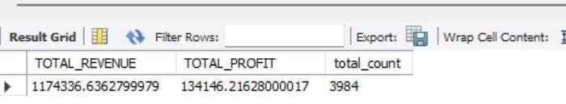

- Find the segament wise distribution of the sales?
SELECT SEGMENT, SUM(SALES) AS TOTAL_SALES FROM SUPERSTORE
GROUP BY SEGMENT;
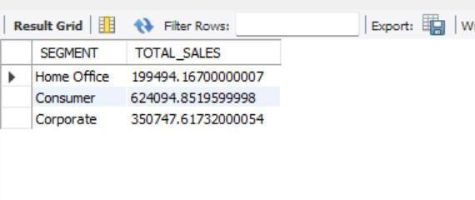

- Find the top 3 most profitable products?
SELECT `PRODUCT NAME, SUM(PROFIT) FROM SUPERSTORE
GROUP BY `PRODUCT NAME`
ORDER BY SUM(PROFIT) DES

LIMIT 3;

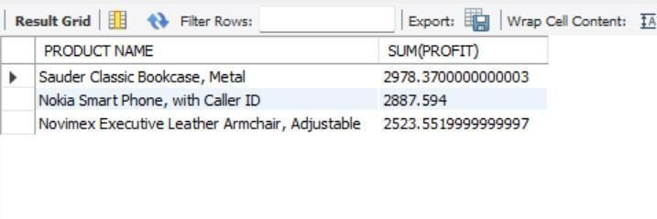

- find how many orders are placed after January 2016
SELECT
COUNT (DISTINCT `Order ID`) AS Orders_After_Jan2016
FROM superstore
WHERE `Order Date` > '2016-01-31';

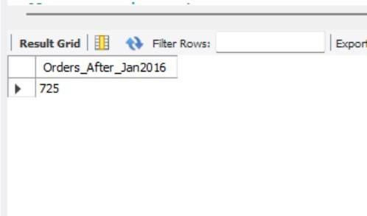

- How many states from austria are under the roof of business? select country, count(state) from superstore group by country
having country = 'austria';

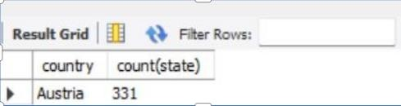

- which products and subcategories are most and least profitable ?
-- Most profitable product
SELECT `Product ID`, `Product Name`, SUM(Profit) AS Total_Profit
FROM superstore
GROUP BY `Product ID`, `Product Name`
ORDER BY Total Profit DESC
LIMIT 1;

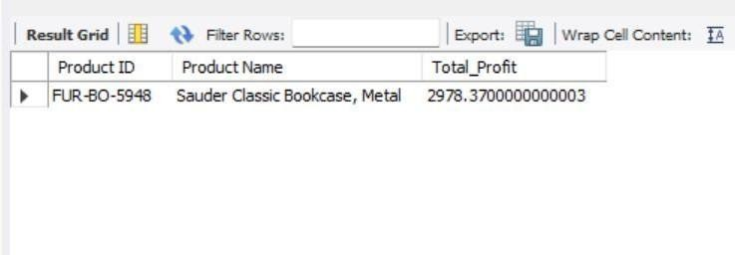

-- Least profitable product
SELECT `Product ID`, `Product Name`, SUM(Profit) AS Total_Profit
FROM superstore
GROUP BY `Product ID`, `Product name`
ORDER BY Total_Profit ASC
LIMIT 1;

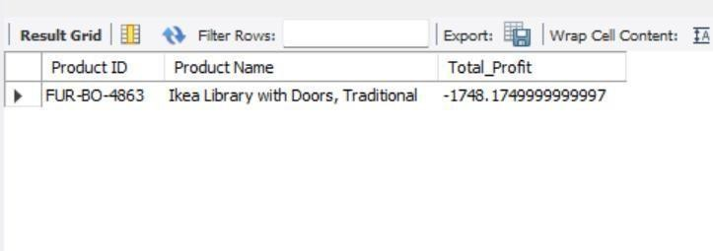

-- Most profitable sub-category

SELECT Sub_Category, SUM(Profit) AS Total_Profit
FROM superstore
GROUP BY Sub_Category
ORDER BY Total_Profit DESC
LIMIT 1;

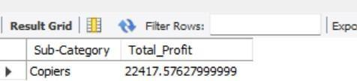

-- Least profitable sub-category

SELECT Sub_Category, SUM(Profit) AS Total_Profit
FROM superstore
GROUP BY Sub_Category
ORDER BY Total_Profit ASC
LIMIT 1;

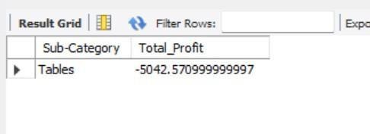

- Which customer segment contributes the most to the total revenue?
select * from superstore; select `customer id`, segment , sum(sales) as total_revenue from superstore group by segment, customer id order by sum(sales) desc
limit 1;

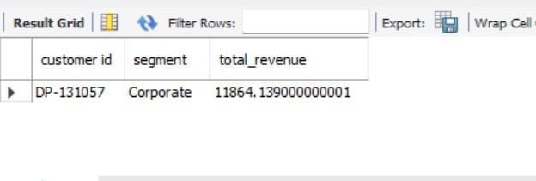
- What is the year-over-year growth in sales and Profit? select * from superstore; select year(‘order date’),sum(sales),sum(profit) from superstore
group by year (‘order date’);

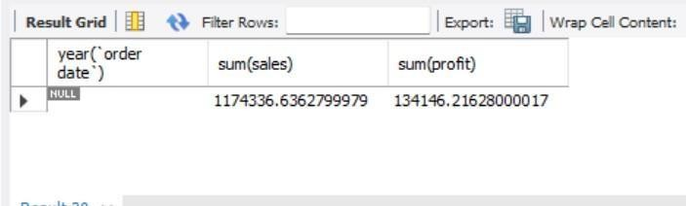

- Which countries and cities are driving the highest sales?
select country, city, sum(sales) as highest_sales from superstore group by country, city order by sum(sales)
limit 1;

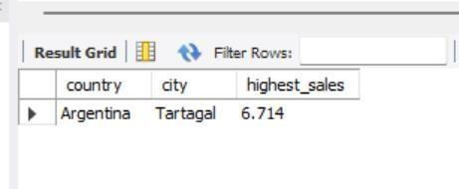
- What is the average delivery time from order to ship date across regions?
SELECT
Region,
AVG(‘Ship Date’-‘Order Date’) AS Avg_Days
FROM superstore
WHERE `Ship Date IS NOT NULL AND `Order Date` IS NOT NULL
GROUP BY Region
ORDER BY Avg_Days;

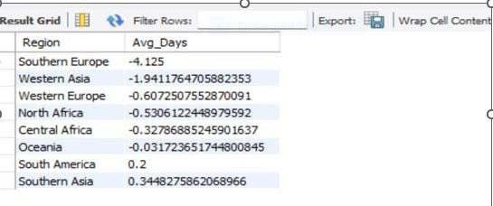

- what is the profit distribution across order priority?
Select
‘ORDER PRIORITY’, sum(profit) AS PROFIT_DISTRIBUTION from superstore GROUP BY ‘ORDER PRIORITY’;

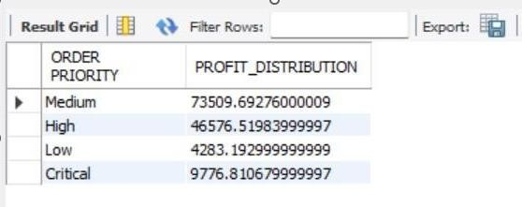
- Suggest data-driven recommendations for improving profit and reducing losses?
SELEC ‘Ship Mode’,
SUM (‘Shipping Cost’) AS Total_Shipping_Cost,
SUM(Sales) AS Total_Sales,
SUM(Profit) AS Total_Profit,
ROUND (SUM (`Shipping Cost`) * 100.0 / NULLIF(SUM(Profit),0),2) AS Ship Cost_to_Profit_Ratio
FROM superstore
GROUP BY `Ship Mode`
ORDER BY Ship Cost_to_Profit_Ratio DESC;
