***YOU ONLY LOOK ONCE (YOLO) ALGORITHMS***

*Chetan Bhaskar Badiger*

Dept of Electronics and Communication Engineering

KLS Gogte Institute Of Technology

Belagavi,Karnataka India

[chetanbadiger6511@gmail.com](mailto:chetanbadiger6511@gmail.com)

***Abstract:***

***Object detection can be a primitive task for object detection in image and video processing. It is considered one of the crowd difficult and challenging tasks in computer vision. There are many machine learning and deep learning models are proposed past like F-CNN, RNN, YOLO. In the present scenario, the requirement of the detection algorithm is to find out the end-to-end and the calculation takes as little time as possible. It is based on real-time detection and classification of objects based on images and videos to create a wide range of scientific aspects as an example of most traffic lights in a given area or as a whole objects during a given frame. There are usually errors or slow processing in the work detection and classification to solve these problems due to small and light datasets, this article only offers a view Identification and classification method based on former version 2 (YOLOv2). This model improves computation time and speed recognizes objects in images and videos equally effectively. In addition, the COCO-2017 dataset used in the implementation YOLOv2 already exists thanks to a pre-trained detection model and uses the GPU to increase speed and process 40 images per second.***

***1. INTRODUCTION***

Object detection is one of the classic problems computer vision where a person recognizes what and where - especially which objects are internally certain image and where is within the image. In real time application are self driving cars, ship detection etc. . Identifying an object does not just involve identifying it whether a certain object exists or not, but also find the right one the location of the specific area where the object is located. The object detection is more difficult than classification, which can also detect objects but does not show where you can tell from the picture and also from the classification does not work on images with only one object. Purpose The purpose of this article is to identify several objects of an image and video There are different techniques to identify the target, it will be are often divided into two categories, one of which is classification-based. Classification-based classes such as CNN, RNN and F-CNN extract regions of interest from the image and classify they use a convolutional neural network and this process is called selective search. CNN is incredibly slow because it predicts the selected interval for each run. The next class is based on regressions. An example of the COCO dataset shown in Sect form consisting of sample pieces such as a bottle, sofa, chair, motorcycle, car presents an image for identification and classification.

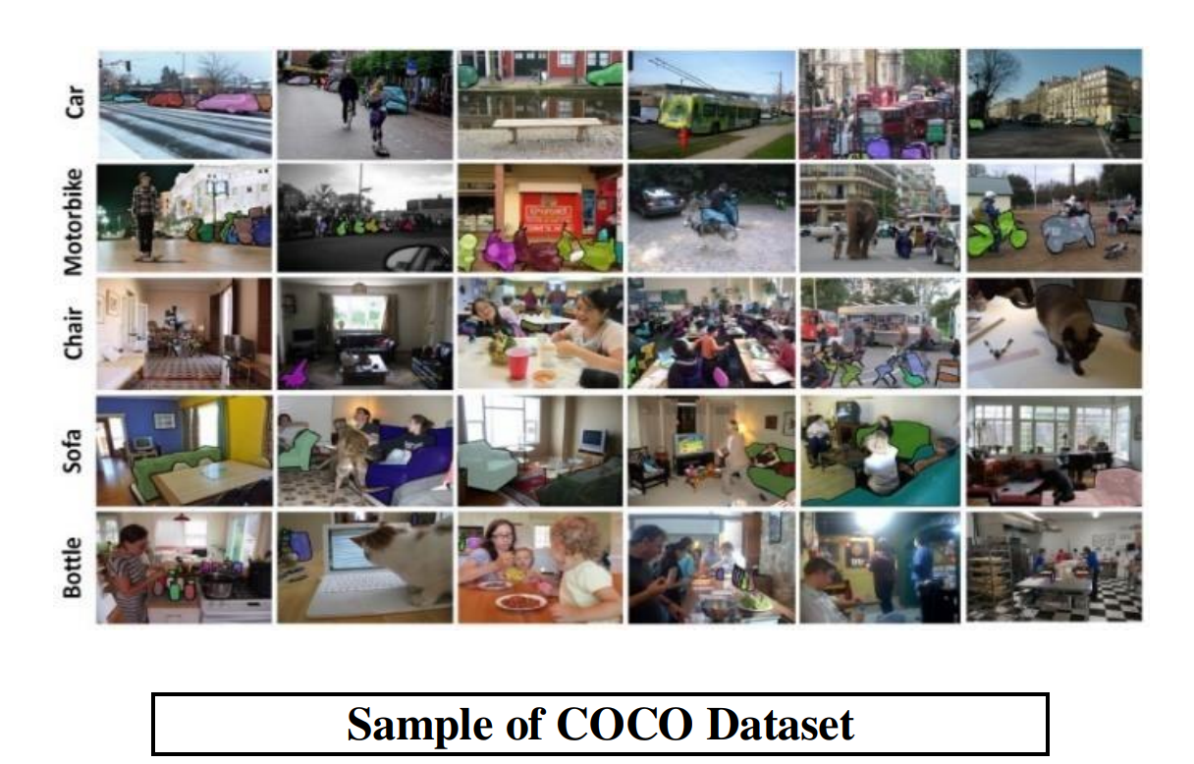

Neural networks make the job very easy. Fast R-CNN neural networks for faster R-CNN in all models shared a crucial role in the field of computer vision. This the article focuses on the field of classification and recognition of one from class objects to multiclass objects. Here comes YOLO image where you don't have to select areas of the image. Instead, YOLO predicts categories and bounding boxes multiple objects in a complete image using a single nerve to the network. YOLO can be an intelligent convolutional neural network for real-time object detection. YOLO is very fast and processes 40 frames per second. This algorithm does localization errors but predicts fewer false positives in the background. YOLOv2 is an extension of YOLO that runs on a framework called Darknet. YOLOv2 focuses anchor the boxes and use fine functions to modify them smaller objects are often better predicted. Darknet framework is used to train neural networks, inspired by the written Google Net architecture C/CUDA. YOLOv2 is much faster than traditional approaches such as R-CNN and produces as few errors as possible [4]. This model divides each image into grid boxes and each grid box makes prediction in bounding boxes associated with confidence levels. Compatible with thresholds, most boxes and the grid boxes are automatically removed when the threshold value is very less.

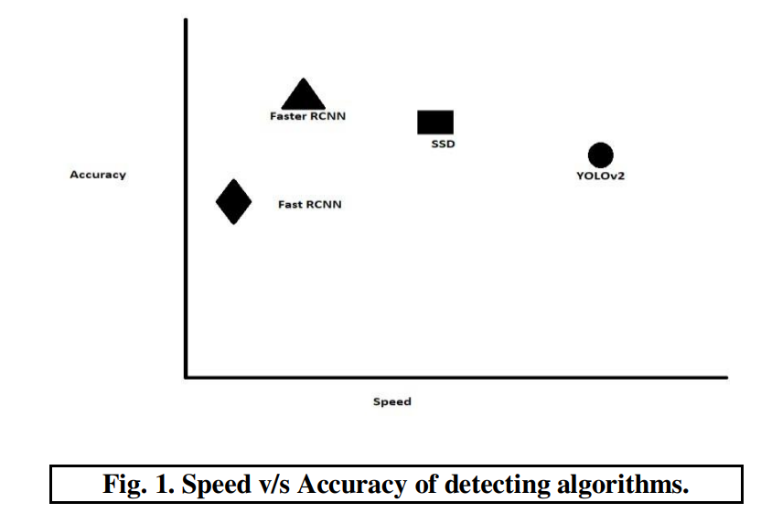

runs on a framework called Darknet. YOLOv2 focuses anchor the boxes and use fine functions to modify them smaller objects are often better predicted. Darknet framework is used to train neural networks, inspired by the written Google Net architecture C/CUDA. YOLOv2 is much faster than traditional approaches such as R-CNN and produces as few errors as possible. This model divides each image into grid boxes and each grid box makes prediction in bounding boxes associated with confidence levels. Compatible with thresholds, most boxes and the grid boxes are automatically removed when the threshold value is very less.

***A. CHARACTERISTICS OF YOLO TECHNOLOGY***

a) lightning fast and quick

Because the regression problem is treated as a framework in detection, this YOLO technique seems very fast. Because no need for that complicated plumbing at all. The only thing what needs to be done is to run the neural network over the given one during the test, a new image to predict recognition. Bass network clock rate is 45 frames per second batch processing is missing on the Titan X GPU and fast version runs at over 150 fps. This shows that it can process streaming video in real time with a latency of less than 25 milliseconds. More, YOLO seems to stretch twice or more, on average accuracy compared to other real-time systems.

b) Global image definition

Considering the predictions, YOLO has it all covered some describe when they make predictions. what YOLO works differently than techniques like sliding in the window, the technique based on the regional recommendation is YOLO sees the whole picture during practice and test. Because this information depending on the categories, their appearance everything is implicitly coded. [4] Fast R-CNN, the best detection method, makes a mistake considering background corrections available on the image objects because it cannot describe the larger situation. YOLO makes almost 50% fewer background errors compared to Fast R-CNN. [14]

c. Easy to generalize and represent

YOLO usually represents a goal during training suggested for nature pictures and works of art. Better performance detected in YOLO compared to other best detections methods such as Deformable Part Model (DPM) and R-CNN by a huge margin. Because it is considered great In theory, YOLO has less chance of falling apart using new domain names or completely unexpected inputs.

***2.LITERATURE SURVEY***

Real-time object detection using YOLO, Geethapriya. S, N. Duraimurugan, S.P. Chokkalingam. In this magazine, their the task is to identify several objects in the image using YOLO approach Shown only once: persistent, real-time Object identification by Joseph Redmon. This paper explains object detection as a regression problem and reuse I graded using the YOLO approach. Object detection and Image credit Sandeep Kumar, Aman Balyan, Manvi Chawla This paper used the Easynet model for detection images and object detection for real objects such as bicycles, fruits, animals and buildings in pictures. Object detection and classification algorithms using Deep Learning Video Surveillance Applications, Mohana and H.V. Nurturing Aradhya. This paper is previous work classifying objects in images and videos is a use The YOLOV2 approach

***3.WORKING OF YOLO V2 ALGORITHM***

Step 1 - The image is captured and distributed to a grid cell. That's it The example is taken when the image is divided into a 7x7 grid matrices. It divides the image into any number of grids, looking at the complexity of the image.

Step 2 - After the image is divided, classification and localization the image is taken in each cell of the grid. If the object is observed, it represents the probability of each grid vector. This results in bounding box and class scope.

Step 3 - Now a threshold is made, which is based on the cells with the highest probability in the grid of values ​​are selected. This step removes the bounding boxes that fail is the object or confidence points below the threshold 0.35.

Step 4 - The YOLOv2 algorithm uses anchor boxes which detects objects in one grid cell and gives their location object Finally, non-maximum damping is used at the junction For the final identification of the Union.

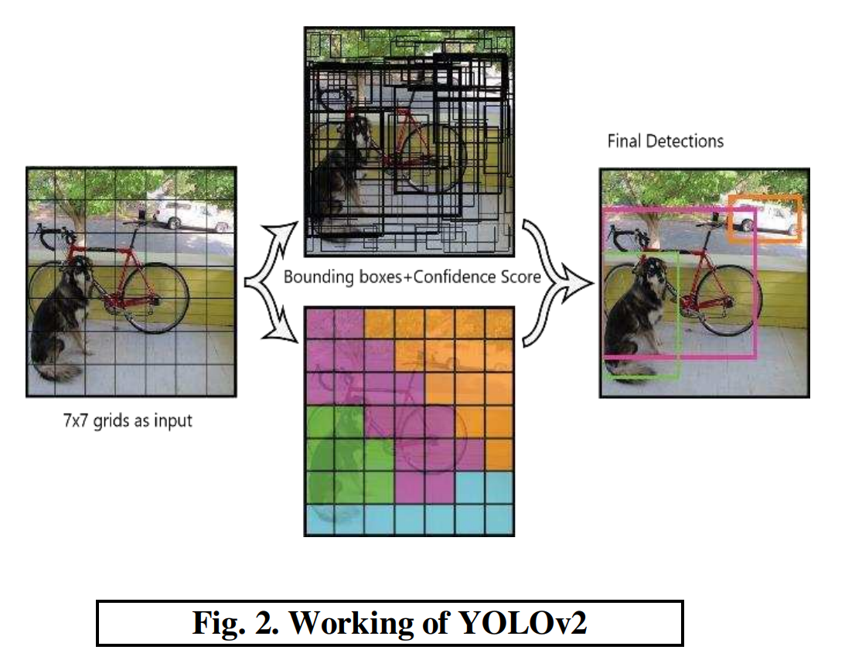

In fig 2. Shows the working of the algorithm which divides the image into SxS grid cell and every grid cell predicts bounding boxes and class probabilities which is mapped in different colors.

***3.1 BOUNDING BOXES:***

The YOLOv2 model is used to make accurate predictions boxes in the image as shown in Figure 3. Here the image contains two cars and this image is divided into a 3x3 grid for prediction bounding boxes on each grid. Then it shows a class probability of predicting this grid object. Etiquette is in the projected crop for each image grid boxes that apply to both image classification and object location Finally, when the object is detected, it is clipped the box and grid in the image that does not contain any object with a class probability of 0.

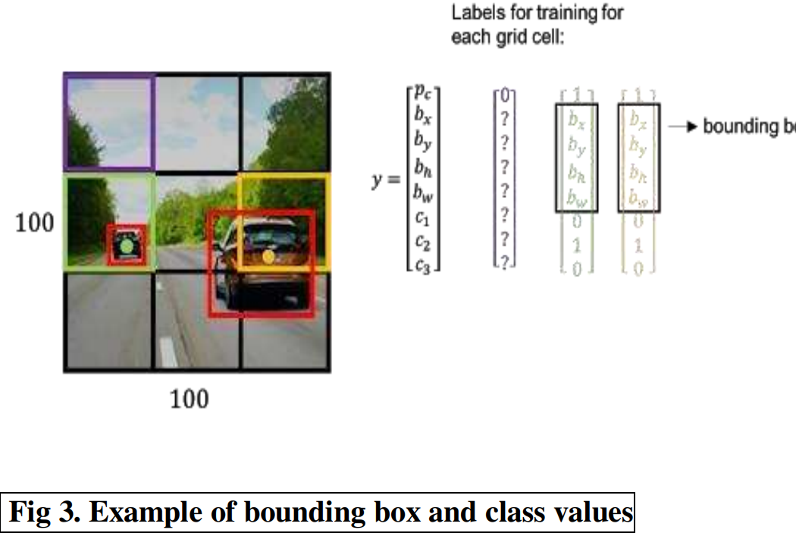

***3.2 FLOW MODEL OF YOLO V2 MODEL:***

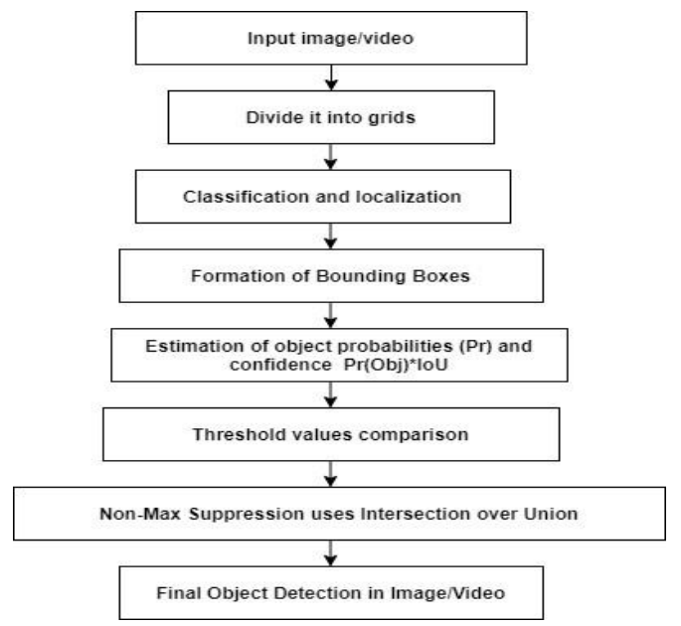

***3.3 ANCHOR BOXES:***

Anchor boxes are a set of predefined bounding boxes with a certain height and width. An anchor box is used to solve problems, ie. predict object localization. Here, the algorithm divides the input image into an arbitrary grid PxP cells. Now these cells find the center of the object and if the object is located in the middle, there is a localization task ready If this center coincides with two objects, then YOLOv2 selects one of the objects.

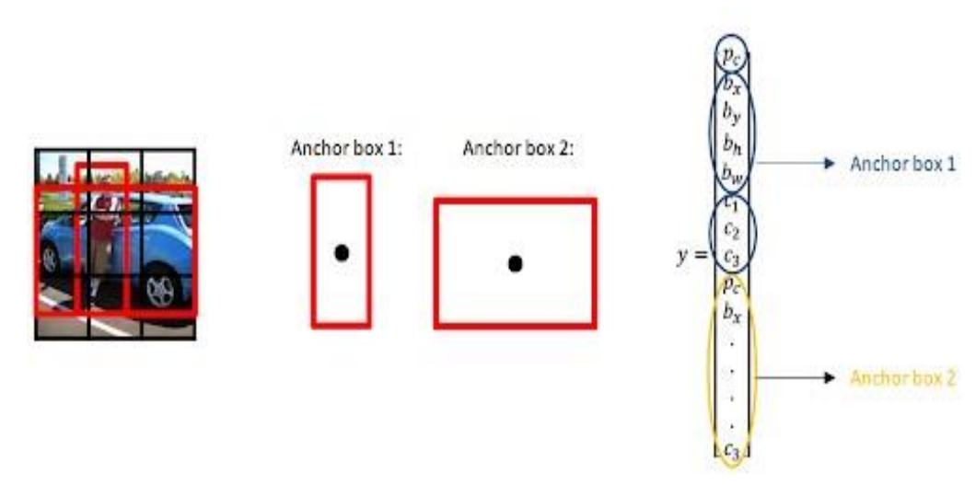



In fig 4. appears the picture is isolated into 3x3 lattices containing a car and a individual. In the event that the picture classification and question localization calculation is connected to classify three sets of categories, for illustration, mango, banana and orange, at that point the output vector “target variable” of the neural net are more often than not outlined as a lattice of eight conceivable results.

***3.4 CUDA (Compute Unified Device Architecture)***

CUDA could be a parallel handling engineering created by Nvidia to create utilize of GPU assets. It is utilized in a assortment of applications like machine learning, parallel computing, etc. This paper employments Darknet system with GPU back and to use this system having CUDA is vital. It boosts the speed of darknet in picture handling since CPU may cause hindrance to efficiency for any handling of pictures or video. CUDA as it were underpins Nvidia equipment, it can be used with a few diverse programming dialects like C , python. The have and thus the gadget work hand in hand to upgrade the workflow and computation speed. In YOLOv2, CUDA environment plays an vital part. In current scenario, normalization of object is easier utilizing CUDA as noise decrease and question excess is anticipated effectively and fastly. cuDNN could be a library of CUDA which gives GPU support to boost the speed of framework.

***4. RESULTS AND ANALYSIS:***

The paper proposes YOLOv2 to form reorganization layer. The reorganization layer uses substitute pixel and after that makes a special channel. For occurrence, with 3x3 pixels in a single channel the reorganization layer reduces the estimate and makes pixels completely different channels that's adjoining. YOLOv2 employments batch normalization in all convolutional layers which improves mAP. Here, fig 5. appears the organize engineering of YOLOv2 which speaks to the convolutional layer beginning with 3x3x32 and closes with 3x3x1024 and appears how this network process40 outlines at a time.

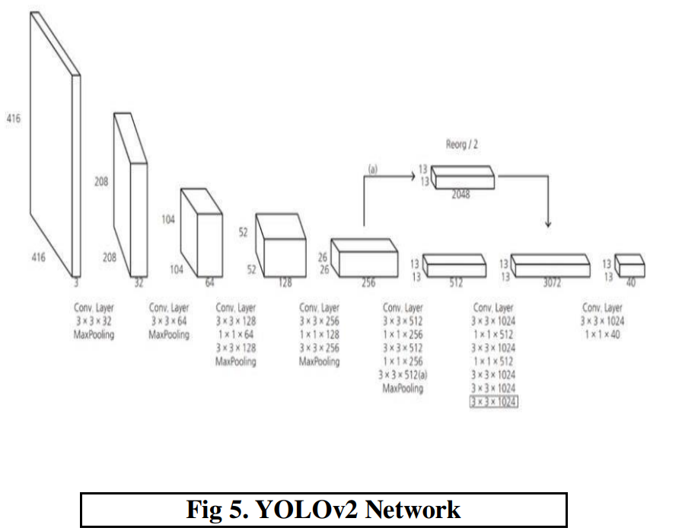

For utilizing the demonstrate it’s obligatory to introduce Microsoft Visual Studio 2015, NVIDIA GEFORCE with GPU and CUDA 9. To utilize pretrained show MS COCO dataset all these are useful to distinguish objects and classify objects. To utilize Darknet framework CUDA establishment is essential. Presently, the comes about of location of objects has appeared underneath where single protest image given as input and fig6.shows the location and labelling of the objects with localization on that single picture.

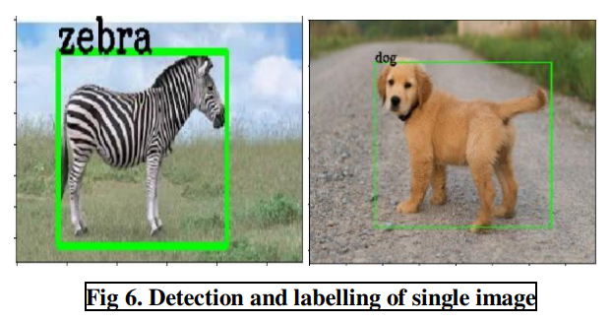

Presently, in case encourage when objects tally increments at that point GPU support doesn’t lower the execution speed.Fig. 7 appears the detection of different objects in a single picture. Both pictures show the location of diverse objects like puppy, individual and horse and in another picture bike, car, individual, etc.

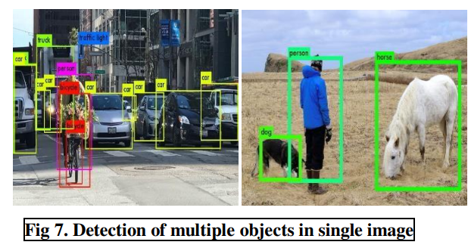

When it comes to video records, it’s completely diverse. In video records objects are moving and persistently changes in exceptionally tall speed. Here, pictures are taken from the video record that has recorded in activity flag. Fig. 8, appears how the calculation works with exactness and speed counting the object discovery. Objects in video are numerous like car, person, pack, flag, etc. but the discovery utilizing darknet framework and YOLOv2 demonstrate are exact whether the objects are expanding persistently.

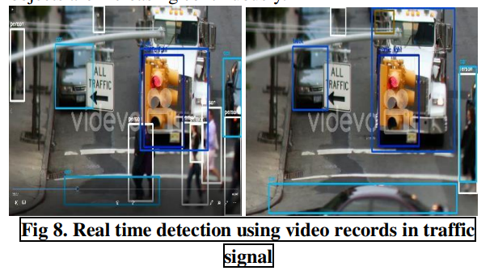

***5. CONCLUSION:***

This paper proposes YOLOv2 calculation for the discovery of objects in pictures with localization and video records. The main point of this paper is to distinguish the objects in genuine time i.e. live location utilizing webcam conjointly through video records. GPU form is amazingly quick which makes a difference the functionalities perform precise utilizing grapple boxes. The dataset utilized in this paper is COCO which comprises 80 classes. Utilizing the demonstrate YOLOv2 it is simple to identify objects with frameworks and boundaries prediction conjointly it makes a difference in anticipating with exceptionally little objects or objects which exceptionally distant within the picture. In video records location of moving objects are simpler utilizing darknet and it produces .avi record with location. In live discovery system employments webcam to distinguish live objects. Pretrained datasets helped to distinguish in effective way and classifying the objects in less time.