Session | 2024-25 (ODD) |  | Course Name | Web Technology Lab
Semester | 3 |  | Course Code | 23CT1301
Roll No | 43 |  | Name of Student | Chetan M Bobde
Practical Number |  | 5
Course Outcome |  | - Understand various internet technologies.  - Design the web pages using HTML and CSS.  - Implement the XML technology to store the data.  - Develop the interactive web pages using JavaScript.
Aim |  | Aim: [A] Introduction to XML. Program to demonstrate the use of External and Internal DTD. (Write an XML file which will display the employee information which includes the following: 1) Employee ID 2) Name of Employee 3) Department of Employee 4) Designation of Employee 5) Email of Employee 6) Salary of Employee  [B] Create XML for employee information and access second student's data using DOM.
Problem Definition |  | The problem is to demonstrate how XML can be used to store and validate structured employee information using internal and external DTDs, and to implement DOM parsing in JavaScript to access and display the second employee’s details from an XML file.
Theory  (100 words) |  | XML (Extensible Markup Language) is a markup language used to store and transport data in a structured and platform-independent way. It is both human-readable and machine-readable, making it widely used for data representation and exchange between applications. XML does not define how the data is displayed; instead, it focuses on describing the data itself using user-defined tags. To ensure that the XML document follows a valid structure, we use DTD (Document Type Definition). A DTD defines the rules and structure of the XML document, such as the elements, their hierarchy, and the type of data they contain. DTD can be declared internally within the XML file (Internal DTD) or separately in a different file (External DTD) and then linked to the XML. This helps in maintaining consistency and validation across multiple XML files.
Procedure and Execution  (100 Words) |  | - Step for Implementation:  - Create an employee XML file with all required fields: ID, Name, Department, Designation, Email, Salary.  - Add an internal DTD inside the XML for validation.  - Create an external DTD file and link it with the XML.  - Prepare another XML file containing multiple employee records.  - Write a JavaScript DOM program to parse this XML and access the second employee’s data.  - Display the extracted data on a webpage using HTML and CSS formatting.
Code:
<!DOCTYPE html>
<html lang="en">
<head>
<meta charset="UTF-8">
<meta name="viewport" content="width=device-width, initial-scale=1.0">
<title>Employee Information</title>
<style>
body {
font-family: Arial, sans-serif;
background: white;
color: black;
margin: 20px;
}

h1 {
text-align: center;
color: red;
}

button {
display: block;
margin: 15px auto;
padding: 10px 20px;
font-size: 16px;
background: blueviolet;
color: whitesmoke;
border: none;
border-radius: 6px;
cursor: pointer;
transition: 0.3s;
}

button:hover {
background: honeydew;
}

h2 {
color: navajowhite;
margin-top: 30px;
text-align: center;
}

.employee-card {
max-width: 400px;
margin: 20px auto;
background: white;
padding: 20px;
border-radius: 8px;
box-shadow: 0px 4px 6px rgba(0,0,0,0.1);
}

.employee-card p {
font-size: 16px;
margin: 8px 0;
}

.employee-card strong {
color: blanchedalmond;
}
</style>
</head>
<body>
<h1>Employee Information</h1>

<button onclick="getSecondEmployee()">Get Second Employee's Info</button>

<h2>Second Employee's Data:</h2>
<div id="second-employee-info" class="employee-card"></div>

<!-- XML data embedded inside HTML -->
<script id="xmlData" type="text/xml">
<employees>
<employee>
<empID>101</empID>
<name>Rahul Sharma</name>
<department>IT</department>
<designation>Software Engineer</designation>
<email>rahul.sharma@example.com</email>
<salary>55000</salary>
</employee>

<employee>
<empID>102</empID>
<name>kartik Tale</name>
<department>HR</department>
<designation>HR Manager</designation>
<email>kartik.taleexample.com</email>
<salary>90000</salary>
</employee>

<employee>
<empID>103</empID>
<name>Amit Patel</name>
<department>Finance</department>
<designation>Accountant</designation>
<email>amit.patel@example.com</email>
<salary>50000</salary>
</employee>
</employees>
</script>

<script>
function loadXML() {
const xmlText = document.getElementById("xmlData").textContent;
const parser = new DOMParser();
return parser.parseFromString(xmlText, "application/xml");
}

function getSecondEmployee() {
const xmlDoc = loadXML();
const employees = xmlDoc.getElementsByTagName("employee");

if (employees.length >= 2) {
const secondEmployee = employees[1];

const id = secondEmployee.getElementsByTagName("empID")[0].textContent;
const name = secondEmployee.getElementsByTagName("name")[0].textContent;
const department = secondEmployee.getElementsByTagName("department")[0].textContent;
const designation = secondEmployee.getElementsByTagName("designation")[0].textContent;
const email = secondEmployee.getElementsByTagName("email")[0].textContent;
const salary = secondEmployee.getElementsByTagName("salary")[0].textContent;

document.getElementById("second-employee-info").innerHTML = `
<p><strong>ID:</strong> ${id}</p>
<p><strong>Name:</strong> ${name}</p>
<p><strong>Department:</strong> ${department}</p>
<p><strong>Designation:</strong> ${designation}</p>
<p><strong>Email:</strong> ${email}</p>
<p><strong>Salary:</strong> ${salary}</p>
`;
} else {
alert("There are less than 2 employees in the data.");
}
}
</script>
</body>
</html>

Output:
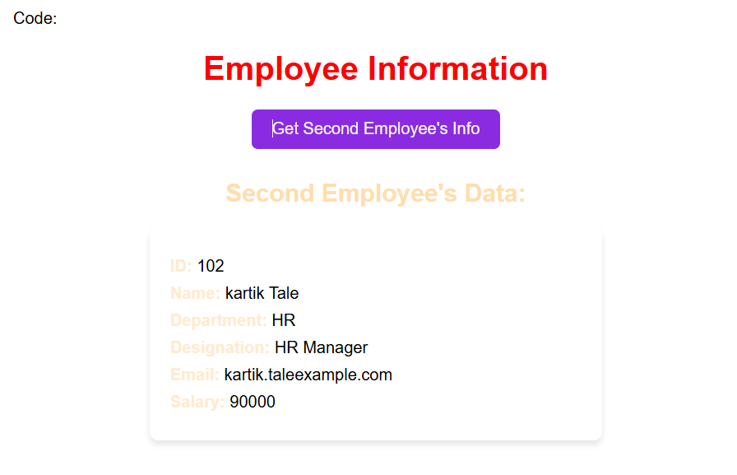
Output Analysis |  | When the XML file with employee details is executed and validated against the DTD, it confirms that the structure of the document is correct and follows the defined rules. The data for each employee is stored in a hierarchical format under the <employees> root element. On running the DOM parser program, the XML document is successfully loaded into memory as a tree structure. The parser navigates through the nodes and retrieves the details of the second employee. The output displayed on the console shows the Employee ID, Name, Department, Designation, Email, and Salary of the second employee exactly as defined in the XML file, proving that XML data can be accessed and manipulated efficiently using DOM
Link of student Github profile where lab assignment has been uploaded |  | https://github.com/chetanbob999
Conclusion |  | In this experiment, we learned the basics of XML and the use of DTD to validate the structure of XML documents. Both Internal and External DTDs were implemented to define rules for employee information. Further, by using the DOM parser, we were able to access and display the details of the second employee from the XML file. This demonstrates that XML is an effective way to store structured data, and DOM provides a simple method to navigate, read, and manipulate XML content programmatically.
Plag Report (Similarity index < 12%) |  | 9%
Date |  | 25/08/2025

