Session | 2024-25 (ODD) |  | Course Name | Web Technology Lab
Semester | 3 |  | Course Code | 23CT1301
Roll No | 43 |  | Name of Student | Chetan M Bobde
Practical Number |  | 6
Course Outcome |  | - Understand various internet technologies.  - Design the web pages using HTML and CSS.  - Implement the XML technology to store the data.  - Develop the interactive web pages using JavaScript.
Aim |  | Parsing a file cd_catalog.xml and use the response as an XML DOM  objects and extracts the info from it with JavaScript.
Problem Definition |  | Parse an external XML file (cd_catalog.xml) using JavaScript, convert it into an XML DOM, extract <CD> details, and display them in an HTML table.
Theory  (100 words) |  | Extensible Markup Language (XML) is a widely used markup language designed to store and transport data in a structured, hierarchical format that is both human-readable and machine-readable. Parsing an XML file like cd_catalog.xml and processing its content using JavaScript is a common task in web development for handling dynamic data. The Document Object Model (DOM) plays a central role in this process by representing the structure of an XML document as a tree of nodes, where each element, attribute, and piece of text becomes an object that can be accessed and manipulated programmatically. When parsing XML in JavaScript, the browser’s built-in DOMParser class or XMLHttpRequest/fetch API is typically used to load the XML data and convert it into a DOM object. For example, by fetching cd_catalog.xml using fetch(), the response text can be passed to DOMParser().parseFromString(xmlText, "text/xml"), which transforms the XML string into a navigable DOM structure. Once parsed, the XML can be traversed using DOM methods such as getElementsByTagName(), getAttribute(), or childNodes to extract specific elements like <CD>, <TITLE>, <ARTIST>, or <YEAR> from the catalog.
Procedure and Execution  (100 Words) |  | Step for Implementation:  - Create cd_catalog.xml with CD details.  - Save HTML file (index.html) with JavaScript code to load and parse XML.  - Use XMLHttpRequest to fetch and process XML into DOM.  - Extract data using getElementsByTagName and build an HTML table.  - Run project on a local server (e.g., Python http.server or VS Code Live Server).  - Open in browser → Click Load Catalog → View table with CD info.
Code:
Index.html :
<!DOCTYPE html>
<html lang="en">
<head>
<meta charset="UTF-8">
<title>CD Catalog</title>
<style>
body {
font-family: Arial, sans-serif;
text-align: center;
margin: 20px;
}
table {
border-collapse: collapse;
width: 80%;
margin: 20px auto;
}
table, th, td {
border: 1px solid black;
}
th, td {
padding: 10px;
text-align: center;
}
th {
background-color: #f2f2f2;
}
button {
padding: 10px 20px;
background: #4CAF50;
border: none;
color: white;
cursor: pointer;
border-radius: 5px;
}
button:hover {
background: #45a049;
}
</style>
</head>
<body>
<h2>CD Catalog from XML</h2>
<button onclick="loadXMLDoc()">Load Catalog</button>
<br><br>
<div id="tableContainer"></div>

<script>
function loadXMLDoc() {
let xhttp = new XMLHttpRequest();
xhttp.onreadystatechange = function() {
if (this.readyState === 4 && this.status === 200) {
cdDetails(this);
}
};
xhttp.open("GET", "cd_catalog.xml", true);
xhttp.send();
}

function cdDetails(xml) {
let xmlDoc = xml.responseXML;
let cds = xmlDoc.getElementsByTagName("CD");

let table = "<table><tr><th>Title</th><th>Artist</th><th>Country</th><th>Company</th><th>Price</th><th>Year</th></tr>";

for (let i = 0; i < cds.length; i++) {
table += "<tr>" +
"<td>" + cds[i].getElementsByTagName("TITLE")[0].childNodes[0].nodeValue + "</td>" +
"<td>" + cds[i].getElementsByTagName("ARTIST")[0].childNodes[0].nodeValue + "</td>" +
"<td>" + cds[i].getElementsByTagName("COUNTRY")[0].childNodes[0].nodeValue + "</td>" +
"<td>" + cds[i].getElementsByTagName("COMPANY")[0].childNodes[0].nodeValue + "</td>" +
"<td>" + cds[i].getElementsByTagName("PRICE")[0].childNodes[0].nodeValue + "</td>" +
"<td>" + cds[i].getElementsByTagName("YEAR")[0].childNodes[0].nodeValue + "</td>" +
"</tr>";
}

table += "</table>";
document.getElementById("tableContainer").innerHTML = table;
}
</script>
</body>
</html>
cd_catalog.xml :
<?xml version="1.0" encoding="UTF-8"?>
<CATALOG>
<CD>
<TITLE>Empire Burlesque</TITLE>
<ARTIST>Kartik Tale</ARTIST>
<COUNTRY>India</COUNTRY>
<COMPANY>America</COMPANY>
<PRICE>10.80</PRICE>
<YEAR>2004</YEAR>
</CD>
<CD>
<TITLE>Hide your heart</TITLE>
<ARTIST>Prem N</ARTIST>
<COUNTRY>USA</COUNTRY>
<COMPANY>CBS </COMPANY>
<PRICE>9.90</PRICE>
<YEAR>1999</YEAR>
</CD>
<CD>
<TITLE>Greatest Hits</TITLE>
<ARTIST>Omkar D</ARTIST>
<COUNTRY>Colombia</COUNTRY>
<COMPANY>MMC</COMPANY>
<PRICE>9.80</PRICE>
<YEAR>2005</YEAR>
</CD>
</CATALOG>
Output:
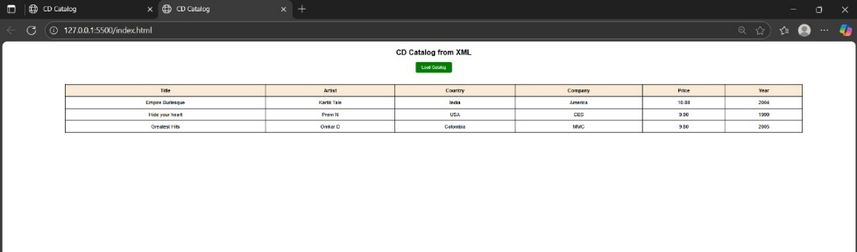
Output Analysis |  | When the Load Catalog button is clicked, the XML file is read by JavaScript. The program extracts CD details like title, artist, country, company, price, and year. These details are displayed in an HTML table. The output shows that XML data can be parsed and shown clearly on a webpage.
Link of student Github profile where lab assignment has been uploaded |  | https://github.com/chetanbob999
Conclusion |  | The output confirms that the XML file is successfully parsed into a DOM object, and the extracted information is accurately displayed as a user-friendly table or list on the webpage. Proper error handling ensures that issues like malformed XML or loading errors are clearly communicated.
Plag Report (Similarity index < 12%) |  | 10%
Date |  | 8/09/2025

