Session | 2024-25 (ODD) |  | Course Name | Web Technology Lab
Semester | 3 |  | Course Code | 23CT1301
Roll No | 43 |  | Name of Student | Chetan M Bobde
Practical Number |  | 2
Course Outcome |  | - Understand various internet technologies.  - Design the web pages using HTML and CSS.  - Implement the XML technology to store the data.  - Develop the interactive web pages using JavaScript.
Aim |  | Create a web form by using form tags in HTML5.
Problem Definition |  | To create a User Registration Form using HTML5 form tags where the user can enter details.
Theory  (100 words) |  | I
Procedure and Execution  (100 Words) |  | Step for Implementation :  - Start HTML Document – Begin with <!DOCTYPE html> and basic <html>, <head>, <body> structure.  - Create Heading – Add a title or heading for the registration form.  - Form Tag – Use <form> with attributes like action, method, and enctype.  - Input Fields – Add text, email, and password inputs for user details.  - Gender Selection – Use radio buttons for male/female options.  - Date Input – Use <input type="date"> for date of birth.  - Dropdown List – Provide a <select> element for course selection.  - File Upload – Use <input type="file"> for uploading profile photo.  - Checkbox – Add terms and conditions checkbox.  - Buttons – Include Submit and Reset buttons to complete the form.  - Save & Run – Save the file with .html extension and open it in a browser to test.
Code:

<!DOCTYPE html>
<html lang="en">
<head>
<meta charset="UTF-8">
<meta name="viewport" content="width=device-width, initial-scale=1.0">
<title>CHETAN</title>
</head>
<body>
<form action="/server">
<fieldset>
<legend>Registration Form</legend>
<div>
<label for ="username">Username</label>
<input type = "text"id="Username" placeholder="Enter Username"/>
</div>
<br>
<div>
<label for="Password">Password</label>
<input type ="password"id="Password" placeholder ="Enter Password"/>
</div>
<br>
<div>
<label for="Birth">Date of Birth: </label>
<input type ="date"id ="Birth" placeholder="Enter Birth"/>
</div>
<br>
<div>
Choose your subject:
<input type="checkbox"id="physics"name="sub"value="physics"/>
<label for ="physics">physics</label>
<input type ="checkbox"id="chemistry"name="sub"value="chemistry"/>
<label for="chemistry">chemistry</label>
<input type ="checkbox"id="Biology"name="sub"value="Biology"/>
<label for="Biology">Biology</label>
</div>
<br>
<div>
Choose your Profession
<select name ="Profession"id="Profession">
<option>Select your option</option>
<option value="Stu"selected>Student</option>
<option value="dev">Developer</option>
</select>
</div>
<br>
<div>
<label for="feedback"> feedback: </label>
<textarea id="feedback"name="feedback"rows="1"cols="50"></textarea>
</div>

<br>
<button type="button"onclick="alert('Hello World!')">Click Me!</button>
</fieldset>
</form>
</body>
</html>

Output:
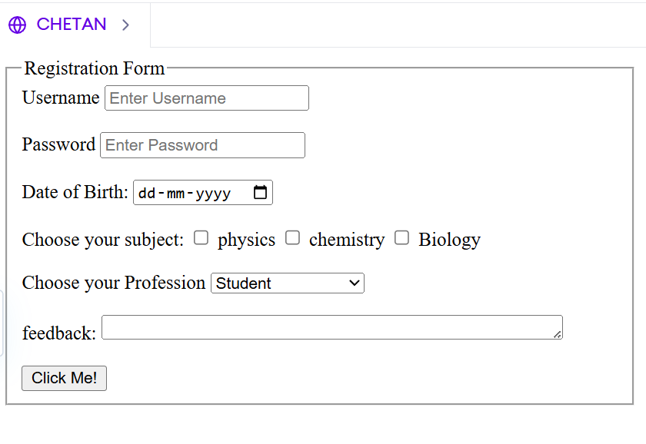
Output Analysis |  | The program generates a registration form with fields for username, password, date of birth, subject selection, profession, feedback, and age confirmation. A button displays a “Hello World!” alert.
Link of student Github profile where lab assignment has been uploaded. |  | https://github.com/chetanbob999
Conclusion |  | The User Registration Form was successfully created using HTML5 form tags. It collects user details through various input fields, validates required information, and provides options to submit or reset the data.
Plag Report (Similarity index < 12%) |  | 10%
Date |  | 13/08/2025

