Session | 2024-25 (ODD) |  | Course Name | Web Technology Lab
Semester | 3 |  | Course Code | 23CT1301
Roll No | 43 |  | Name of Student | Chetan M Bobde
Practical Number |  | 3
Course Outcome |  | - Understand various internet technologies.  - Design the web pages using HTML and CSS.  - Implement the XML technology to store the data.  - Develop the interactive web pages using JavaScript.
Aim |  | Design a web page using CSS which includes the following:  1) Use different font styles.  2) Control the repetition of image with background-repeat and no-repeat property.  3) Define style for links as a: link, a: active, a: hover, a: visited  4) Add customized cursors for links.
Problem Definition |  | Develop and demonstrate the usage of inline, internal and external style sheet using CSS.
Theory  (100 words) |  | CSS (Cascading Style Sheets) is a language used to describe the presentation of HTML documents. It helps to separate content from design, giving developers control over colors, layouts, backgrounds, typography, spacing, and user interaction styles. A CSS rule consists of a selector, which targets HTML elements, and a declaration block that contains property–value pairs. Properties define what aspect of the element is styled, while values specify how it should appear. For example, using h1 { color: blue; } sets all level-one headings to display in blue. CSS follows a principle called cascading, where rules are applied in order of specificity and importance. If two rules conflict, the one defined later or with higher specificity overrides the other. Inline styles usually have the highest specificity, followed by embedded styles in the <style> tag, and then external stylesheets, which are commonly used for consistency and maintainability. Some CSS properties also inherit their values from parent elements, such as font-related properties, while others like margins and borders do not inherit.
Procedure and Execution  (100 Words) |  | Step for Implementation:  - Create Project Folder  - Make a folder (e.g., css-demo) to store your HTML and CSS files.  - Create an External CSS File (style.css)  - Define body background using background-image with repeat or no-repeat.  - Add styles for links using a:link, a:visited, a:hover, and a:active.  - Set customized cursors for links.  - Create HTML File (index.html)  - Add <link rel="stylesheet" href="style.css"> to connect external CSS.  - Use <style> inside <head> for internal CSS (e.g., headings, paragraphs).  - Apply inline CSS with style="" inside tags (e.g., <p style="color:red;">).  - Use Different Font Styles  - Apply fonts like Arial, Georgia, or Courier New in different elements.  - Background Repeat Demonstration  - Use one section with background-repeat: repeat;  - Use another with background-repeat: no-repeat;.  - Add Link Section  - Insert a few <a> tags to show link color changes in various states.  - Add Cursor Demonstration  - Use <span> or <p> with different cursor styles like text, pointer, wait, etc.  - Run in Browser  - Open index.html in Chrome/Edge/Firefox to test.
Code:
<!DOCTYPE html>
<html lang="en">
<head>
<meta charset="UTF-8">
<title>CSS Demonstration</title>
<!-- External Style Sheet -->
<link rel="stylesheet" href="style.css">
<!-- Internal Style Sheet -->
<style>
h2 {
color: #8b0000;
text-align: center;
margin-top: 30px;
}
.internal-box {
background-color: #ffe4e1;
border: 2px solid #8b0000;
border-radius: 10px;
padding: 15px;
margin: 20px auto;
width: 60%;
box-shadow: 0px 4px 6px rgba(0,0,0,0.1);
font-size: 17px;
text-align: center;

}
</style>
</head>
<body>

<!-- External CSS Example -->
<h1>Demonstration of CSS Types</h1>
<p>This paragraph is styled using an <b>external
stylesheet</b>. Notice the font, color, and spacing.</p>

<!-- Internal CSS Example -->
<h2>Internal CSS Example</h2>
<div class="internal-box">
This section is styled using <b>internal CSS</b> inside the
&lt;style&gt; tag.
</div>

<!-- Inline CSS Example -->
<h2>Inline CSS Example</h2>
<p style="color: white; background-color: #6a5acd; font-size:
20px; padding: 12px; border-radius: 8px; width: 60%; margin: 0
auto; text-align: center;">
This paragraph is styled using <b>inline CSS</b>, applied
directly to the element.
</p>

</body>
</html>

Output:
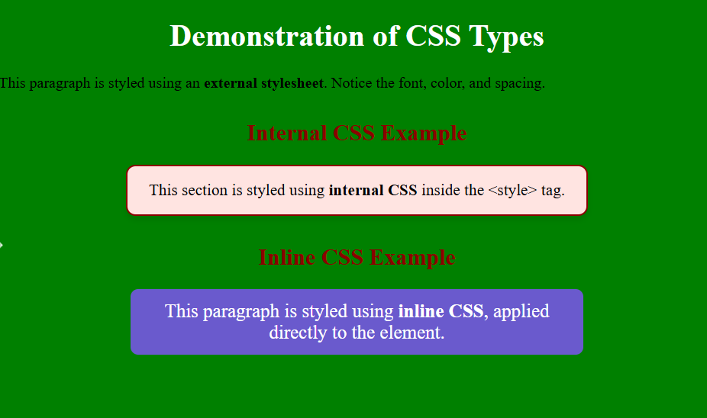
Output Analysis |  | The webpage displays headings and text in different fonts, with a background image set to no-repeat. Links change color in different states (link, visited, hover, active), and the cursor becomes a pointer on links. The output meets all the given requirements.
Link of student Github profile where lab assignment has been uploaded |  | https://github.com/chetanbob999
Conclusion |  | Using CSS, we can make a simple HTML page more attractive and user-friendly. Different fonts improve readability, background-repeat controls design, link pseudo-classes add interactivity, and custom cursors enhance user experience.
Plag Report (Similarity index < 12%) |  | 10%
Date |  | 20/08/2025

