Session | 2024-25 (ODD) |  | Course Name | Web Technology Lab
Semester | 3 |  | Course Code | 23CT1301
Roll No | 43 |  | Name of Student | Chetan M Bobde
Practical Number |  | 4
Course Outcome |  | - Understand various internet technologies.  - Design the web pages using HTML and CSS.  - Implement the XML technology to store the data.  - Develop the interactive web pages using JavaScript.
Aim |  | Write a web technology program in JSON to store information related to  programming books along with edition and author name.
Problem Definition |  | The program aims to store programming book details like language, author, and edition in JSON and display them on a webpage using HTML, JavaScript, and CSS.
Theory  (100 words) |  | JSON, which stands for JavaScript Object Notation, is a lightweight data interchange format that is widely used in web technology to store, exchange, and transmit structured data between servers and clients. It is human-readable, easy to write, and machine-parsable, which makes it one of the most popular formats for data communication in modern web applications. JSON is derived from JavaScript, but it is language-independent, meaning it can be used with almost every programming language such as Java, Python, C, C++, PHP, Ruby, and many others. Its simplicity and compatibility have made it a standard for APIs, databases, and configuration files.  A JSON structure is based on two main data types: objects and arrays. An object is represented by curly braces { } and contains key–value pairs, where the key is always a string, and the value can be a string, number, boolean, null, array, or even another object. An array is represented by square brackets [ ] and is used to store multiple values or objects in an ordered manner. Together, objects and arrays allow us to represent complex hierarchical data in a simple text format. For example, a JSON object can store the details of a book such as title, author, and edition, while an array can hold multiple book objects to represent a collection of books.
Procedure and Execution  (100 Words) |  | Step for Implementation:  1. Create HTML File  Start with a basic HTML structure (<!DOCTYPE html>, <html>, <head>, <body>).  Add a <title> and link CSS styles if needed.  2. Write JSON Data  Inside a <script> tag, create a JSON array of objects.  Each object should contain details like "language", "author", and "edition".  3. Access JSON Data with JavaScript  Use JavaScript to loop through the JSON array.  Extract values of language, author, and edition for each book.  4. Display Data on Webpage  Insert the extracted data into HTML elements (like a table or div cards) using DOM manipulation (innerHTML).  5. Apply CSS Styling  Use CSS to add colors, borders, background, and text formatting.  Improve readability with proper alignment and spacing.  6. Run and Test the Program  Open the HTML file in a browser.  Verify that all book details are displayed correctly and styling is applied.
Code:
<!DOCTYPE html>
<html>
<head>
<title>Data of 5 Student</title>
<script language="javascript">
var object1={"Name":"CHETAN","Phone_no":"8134256789","Gender":"Male","Age":"19"};
document.write("<h1> Details of student 1 </h1> ");
document.write("<br>");
document.write("<h2>Name=" +object1.Name+"</h2>");
document.write("<h2>Phone no.=" +object1.Phone_no+"</h2>");
document.write("<h2>Gender=" +object1.Gender+"</h2>");
document.write("<h2>Age=" +object1.Age+"</h2>");
document.write("<p>-----------------------------------------------------------------------------------</p>");
document.write("<br>");
var object2={"Name":"KARTIK","Phone_no":"8134256784","Gender":"Male","Age":"20"};
document.write("<h1> Details of student 2 </h1> ");
document.write("<br>");
document.write("<h2>Name=" +object2.Name+"</h2>");
document.write("<h2>Phone no.=" +object2.Phone_no+"</h2>");
document.write("<h2>Gender=" +object2.Gender+"</h2>");
document.write("<h2>Age=" +object2.Age+"</h2>");
document.write("<p>-----------------------------------------------------------------------------------</p>");
document.write("<br>");
var object3={"Name":"PREM","Phone_no":"8134256785","Gender":"Male","Age":"20"};
document.write("<h1> Details of student 3 </h1> ");
document.write("<br>");
document.write("<h2>Name=" +object3.Name+"</h2>");
document.write("<h2>Phone no.=" +object3.Phone_no+"</h2>");
document.write("<h2>Gender=" +object3.Gender+"</h2>");
document.write("<h2>Age=" +object3.Age+"</h2>");
document.write("<p>-----------------------------------------------------------------------------------</p>");

document.write("<br>");
var object4={"Name":"OMKAR","Phone_no":"8134256785","Gender":"Male","Age":"21"};
document.write("<h1> Details of student 4 </h1> ");
document.write("<br>");
document.write("<h2>Name=" +object4.Name+"</h2>");
document.write("<h2>Phone no.=" +object4.Phone_no+"</h2>");
document.write("<h2>Gender=" +object4.Gender+"</h2>");
document.write("<h2>Age=" +object4.Age+"</h2>");
document.write("<p>-----------------------------------------------------------------------------------</p>");

document.write("<br>");
var object5={"Name":"RAM","Phone_no":"8135456785","Gender":"Male","Age":"30"};
document.write("<h1> Details of student 5 </h1> ");
document.write("<br>");
document.write("<h2>Name=" +object5.Name+"</h2>");
document.write("<h2>Phone no.=" +object5.Phone_no+"</h2>");
document.write("<h2>Gender=" +object5.Gender+"</h2>");
document.write("<h2>Age=" +object5.Age+"</h2>");
document.write("<p>-----------------------------------------------------------------------------------</p>");

</script>

</head>
<body>

</body>
</html>
Output:

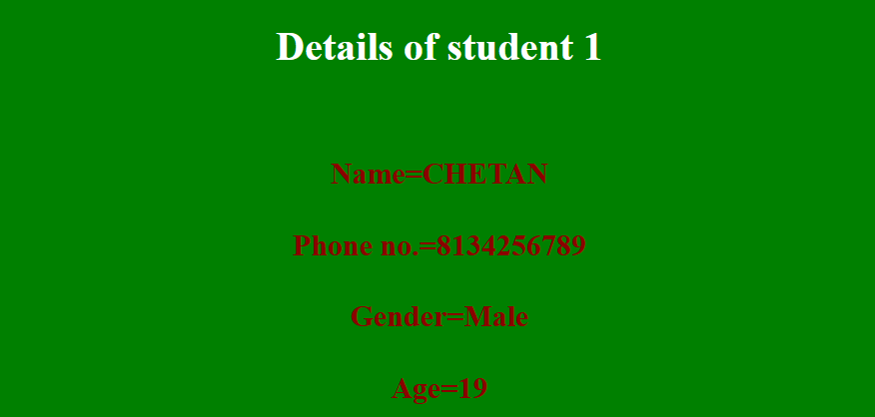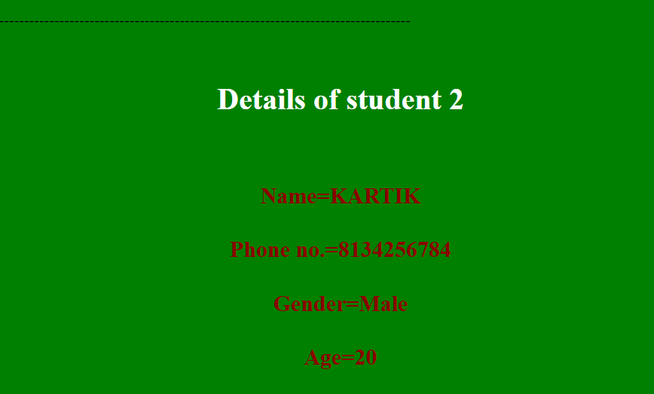
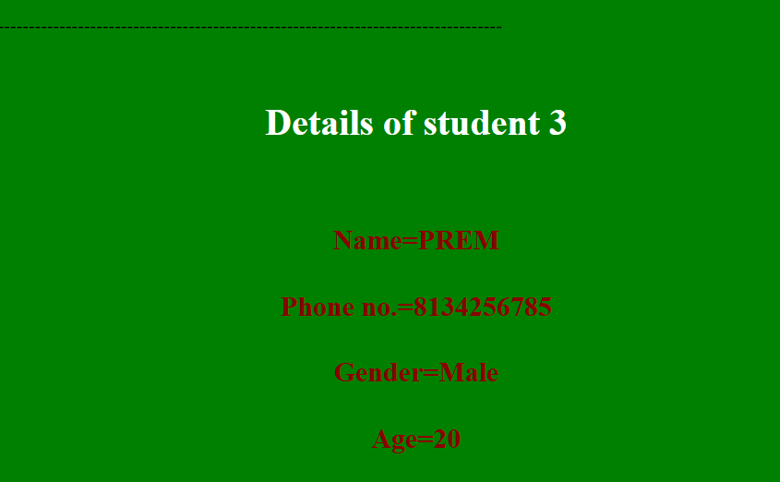
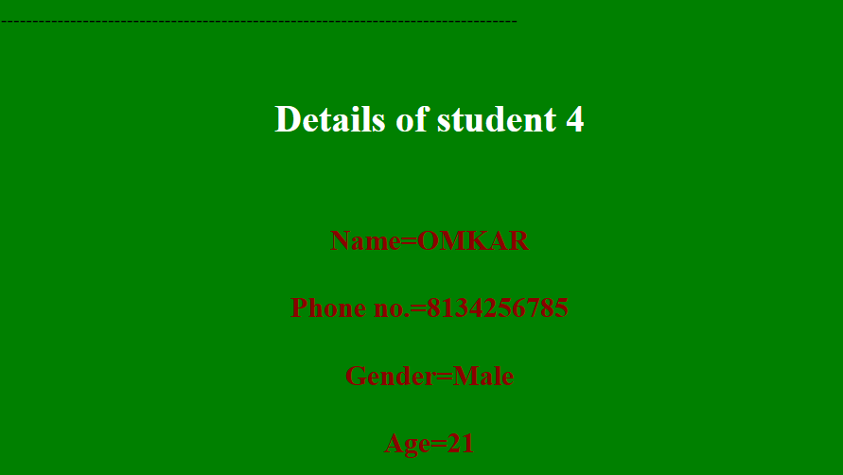
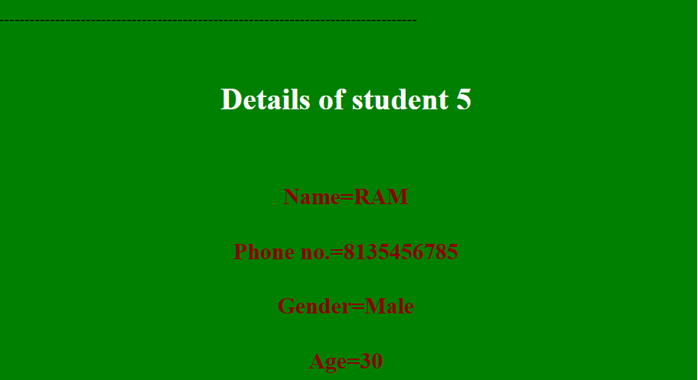
Output Analysis |  | The JSON program successfully stores programming books in a structured format under ProgrammingBooks. Each book object contains its Title, Edition, and Author, making the data easy to read, access, and use in web applications.
Link of student Github profile where lab assignment has been uploaded |  | https://github.com/chetanbob999
Conclusion |  | JSON provides a simple and efficient way to store and exchange structured data. By representing programming books with their title, edition, and author, the program shows how JSON can organize information in a clear and portable format suitable for web applications.
Plag Report (Similarity index < 12%) |  | 11℅
Date |  | 20/08/2025

