e-Yantra Robotics Competition (eYRC-2016)

Task 3 - Bothoven

In this task you have to test the serial communication between PC and the Firebird V.

You will find following folders in **Bothoven.zip** with this **Read_me** file:

1. Python_serial:

It contains Serial.py file. This code will serially send data.

1. Embedded_serial:

It contains an AVR Studio Project on serial communication for Firebird V. This will serially receive the data and display it on the LCD.

**Steps:**

1. The hex file for serial communication in Firebird V is given at following location “Embedded_serial/default/embedded_serial.hex”
2. Burn the hex file in the robot using AVR bootloader or STK programmer.
3. Connect the robot to the PC using USB to Serial cable.
4. Check the COM port number in Device Manager.
5. Open Serial.py file given in the Python_serial folder and write the COM PORT number in the line given.

ser **=** serial**.**Serial('COM n')

1. Run the Serial.py file. The output will be displayed on the LCD screen of the robot as shown in Figure 1.

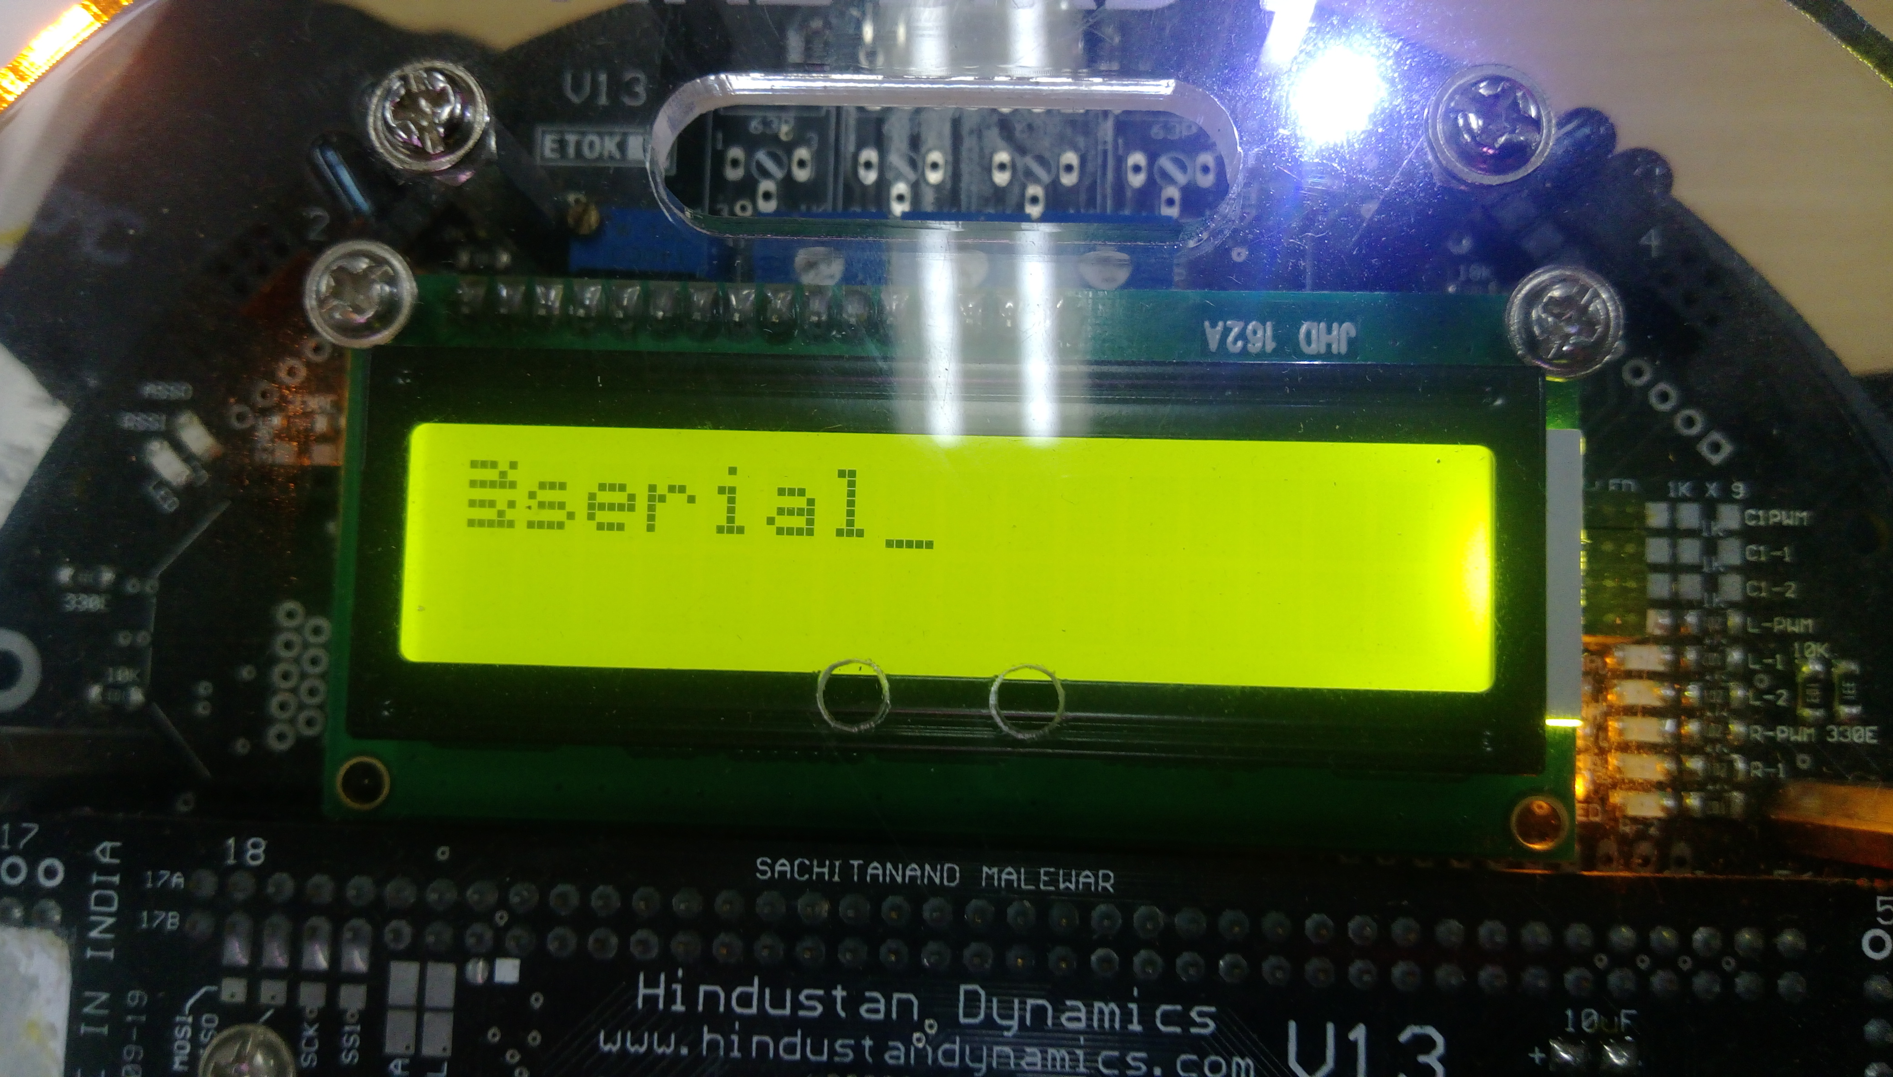

Figure 1

**Instructions for Submissions:**

1. **Follow the above mentioned steps.**
2. **Click a picture of LCD screen of Firebird V using a camera. This picture must clearly depict the LCD screen.**
3. **Upload the picture using instructions provided on Task 3 tab of the Portal.**