NATIONAL INSTITUTE OF TECHNOLOGY
TIRUCHIRAPALLI – 620 015

( HOSPITAL MANAGEMENT SYSTEM )

DBMS LAB PROJECT
Based on mysql/php
( CA712 )

Submitted to Dr. U. Vignesh

Department of Computer Applications
MCA
Semester-II

Submitted by 205119027

ABSTRACT
The purpose of the project entitled as “HOSPITAL MANAGEMENT SYSTEM” is to computerize the Front Office Management of Hospital to develop software which is user friendly simple, fast, and cost – effective. It deals with the collection of patient’s information, diagnosis details, etc. Traditionally, it was done manually. The main function of the system is register and store patient details and doctor details and retrieve these details as and when required, and also to manipulate these details meaningfully System input contains patient details, diagnosis details, while system output is to get these details on to the screen. The Hospital Management System can be entered using a username and password. It is accessible either by an administrator or receptionist. Only they can add data into the database. The data can be retrieved easily. The data are well protected for personal use and makes the data processing very fast.

INDEX

1. INTRODUCTION
1.1 Introduction
1.2 Problem introduction
1.3 Modules in the project
2. REQUIREMENTS SPECIFICATION
2.1 Introduction
2.2 Software requirements
3. SYSTEM IMPLEMENTATION
3.1 Introduction
3.2 Sample code
4. CONCLUSION

INTRODUCTION
1.1 Introduction:
The project Hospital Management system includes registration of patients, storing their details into the system, and also computerized billing in the pharmacy, and labs. The software has the facility to give a unique id for every patient and stores the details of every patient and the staff automatically. It includes a search facility to know the current status of each room. User can search availability of a doctor and the details of a patient using the id.
The Hospital Management System can be entered using a username and password. It is accessible either by an administrator or receptionist. Only they can add data into the database. The data can be retrieved easily. The interface is very user-friendly. The data are well protected for personal use and makes the data processing very fast.
Hospital Management System is powerful, flexible, and easy to use and is designed and developed to deliver real conceivable benefits to hospitals.
Hospital Management System is designed for multispeciality hospitals, to cover a wide range of hospital administration and management processes. It is an integrated end-to-end Hospital Management System that provides relevant information across the hospital to support effective decision making for patient care, hospital administration and critical financial accounting, in a seamless flow.
Hospital Management System is a software product suite designed to improve the quality and management of hospital management in the areas of clinical process analysis and activity-based costing. Hospital Management System enables you to develop your organization and improve its effectiveness and quality of work. Managing the key processes efficiently is critical to the success of the hospital helps you manage your processes

1.2 Problem Introduction:

Lack of immediate retrievals: -
The information is very difficult to retrieve and to find particular information like- E.g. - To find out about the patient’s history, the user has to go through various registers. This results in in convenienceand wastage of time.
Lack of immediate information storage: -
The information generated by various transactions takes time and efforts to be stored at right place.
Lack of prompt updating: -
Various changes to information like patient details or immunization details of child are difficult to make as paper work is involved.
Error prone manual calculation: -
Manual calculations are error prone and take a lot of time this may result in incorrect information. For example calculation of patient’s bill based on various treatments.
Preparation of accurate and prompt reports: -
This becomes a difficult task as information is difficult to collect from various register.

Objective:-
- Define hospital
- Recording information about the Patients that come.
- Generating bills.
- Recording information related to diagnosis given to Patients.
- Keeping record of the Immunization provided to children/patients.
- Keeping information about various diseases and medicines available to cure them.
These are the various jobs that need to be done in a Hospital by the operational staff andDoctors. All these works are done on papers.
Scope of the Project:-
- Information about Patients is done by just writing the Patients name, age and gender. Whenever the Patient comes up his information is stored freshly.
- Bills are generated by recording price for each facility provided to Patient on a separate sheet and at last they all are summed up.
- Diagnosis information to patients is generally recorded on the document, which contains Patient information. It is destroyed after some time period to decrease the paper load in the office.
- Immunization records of children are maintained in pre-formatted sheets, which are kept in a file.
- Information about various diseases is not kept as any document. Doctors themselves do this job by remembering various medicines.
All this work is done manually by the receptionist and other operational staff and lot of papers are needed to be handled and taken care of. Doctors have to remember various medicines available for diagnosis and sometimes miss better alternatives as they can’t remember them at that time.

1.3 MODULES:
The entire project mainly consists of 7 modules, which are
- Admin module
- User module (patient)
- Doctor module
- Nurse module
- Pharmacist module
- Laboratorist module
- Accountant module

1.3.1 Admin module:
- manage department of hospitals, user, doctor, nurse, pharmacist, laboratorist accounts.
- watch appointment of doctors
- watch transaction reports of patient payment
- Bed ,ward, cabin status
- watch blood bank report
- watch medicine status of hospital stock
- watch operation report
- watch birth report
- watch diagnosis report
- watch death report

1.3.2 user module(patient):

- View appointment list and status with doctors
- View prescription details
- View medication from doctor
- View doctor list
- View blood bank status
- View operation history
- View admit history. like bed, ward icu etc
- Manage own profile

1.3.3 Doctor module:
- Manage patient. account opening and updating
- Create, manage appointment with patient
- Create prescription for patient
- Provide medication for patients
- Issue for operation of patients and creates operation report
- Manage own profile

1.3.4 Nurse module:

- Manage patient. account opening and updating
- Allot bed, ward, cabin for patients
- Provide medication according to patient prescription
- Manage blood bank and update status
- Keep record of patient operation, baby born and death of patient
- Manage own profile

1.3.5 Pharmacist module:
- Maintain medicine
- Keep records of hospitals stock medicines and status
- Manage medicine categories
- Watch prescription of patient
- Provide medication to prescriptions

1.3.6 Laboratorist module:
- Watch prescription list
- Upload diagnostic report
- Preview of report files. like xray images, ct scan, mri reports
- Manage own profile

1.3.7 Accountant module:

- Create invoice for payment
- Order invoice to patient
- Take cash payment
- Watch payment history of patients
- Manage own profile

REQUIREMENT SPECIFICATION

2.1 INTRODUCTION:
To be used efficiently, all computer software needs certain hardware components or the other software resources to be present on a computer. These pre-requisites are known as(computer) system requirements and are often used as a guideline as opposed to an absolute rule. Most software defines two sets of system requirements: minimum and recommended. With increasing demand for higher processing power and resources in newer versions of software, system requirements tend to increase over time. Industry analysts suggest that this trend plays a biggerpart in driving upgrades to existing computer systems than technological advancements.

2.2 SOFTWARE REQUIREMENTS:

Software Requirements deal with defining software resource requirements and pre-requisites that need to be installed on a computer to provide optimal functioning of an application. These requirements or pre-requisites are generally not included in the software installation package and need to be installed separately before the software is installed.

SOFTWARE REQUIREMENTS FOR PRESENT PROJECT:
OPERATING SYSTEM : Windows 7/ XP/8
FRONT END : PHP,CSS
DATABASE : MYSQL

SYSTEM IMPLEMENTATION
3. IMPLEMENTATION
3.1 Inroduction:
Implementation is the stage of the project when the theoretical design is turned out into a working system. Thus it can be considered to be the most critical stage in achieving a successful new system and in giving the user, confidence that the new system will work and be effective.

The implementation stage involves careful planning, investigation of the existing system and it’s constraints on implementation, designing of methods to achieve changeover and evaluation of changeover methods.

3.2 Sample code: SQL
1. Creating Table employee –

2. Creating Table patient –
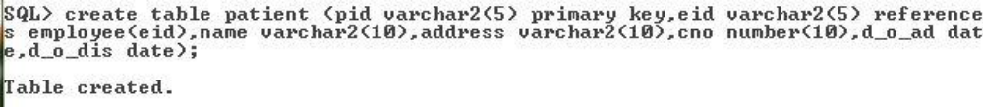

3. Creating Table doctor –

4. Creating Table nurse –

5. Creating Table rooms –

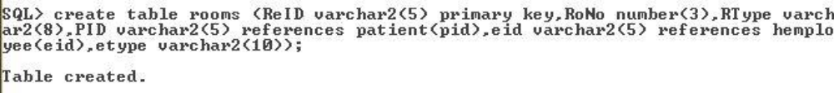
6. Creating Table receptionist –

7. Creating Table records –
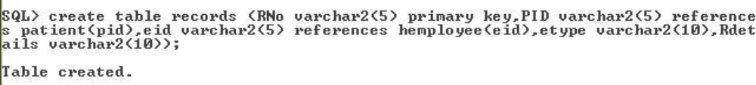
8. Creating Table medicines –

  - Inserting data and viewing table employee –
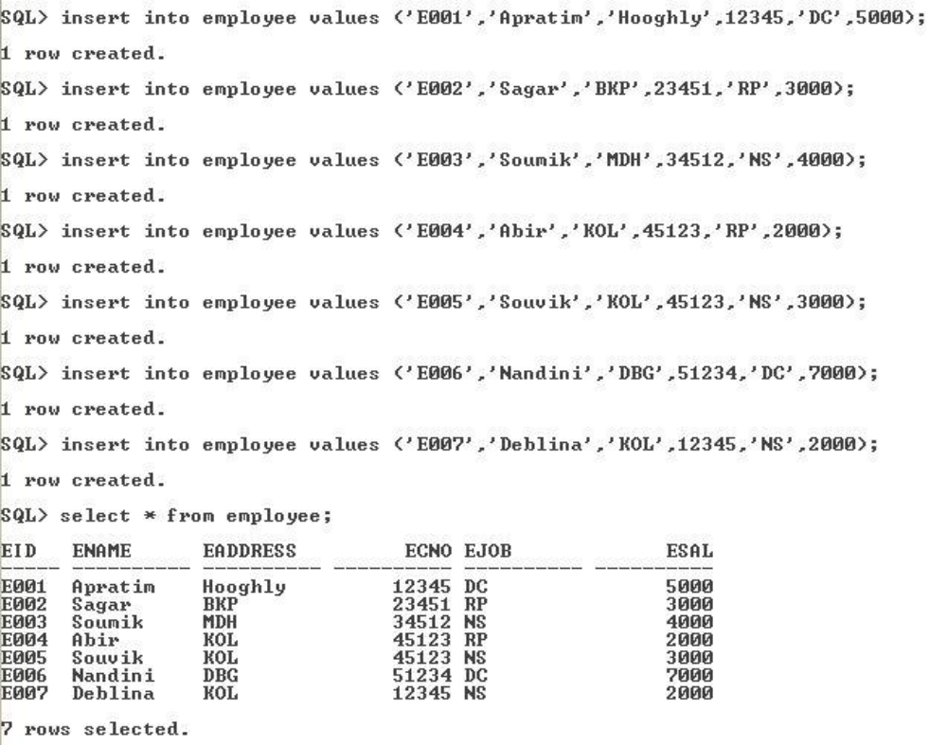

  - Inserting data and viewing table doctor –
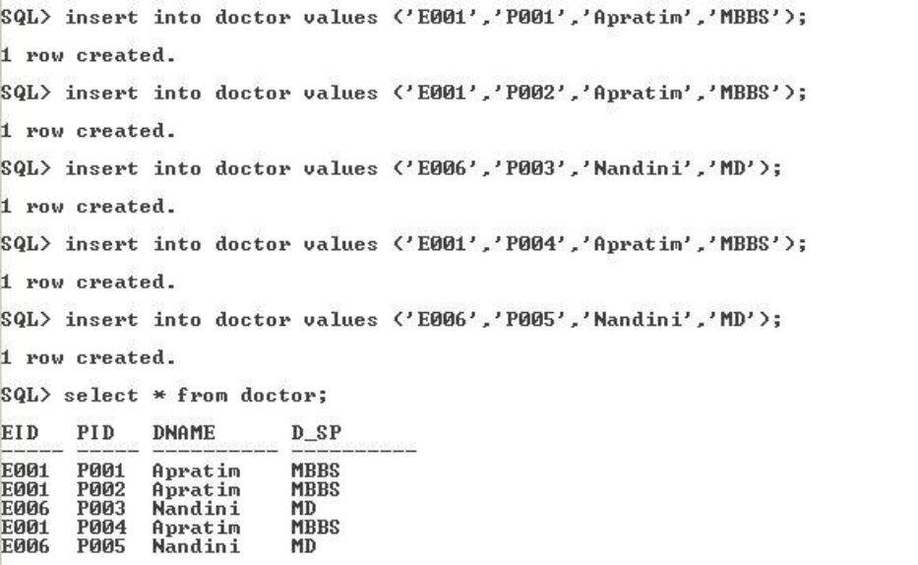

  - Inserting data and viewing table nurse –
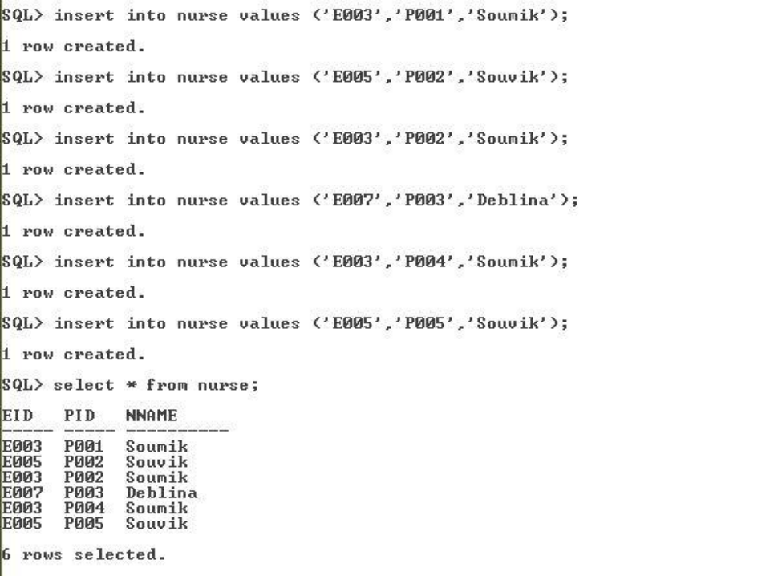

  - Inserting data and viewing table rooms –
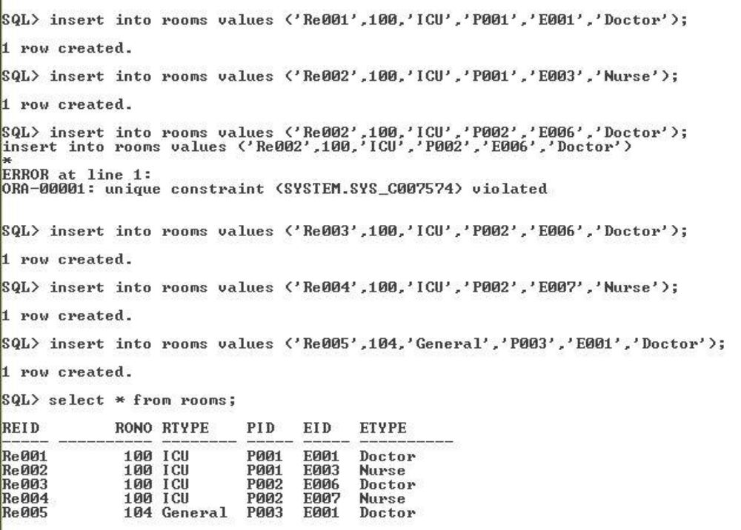

  - Inserting data and viewing table receptionist –
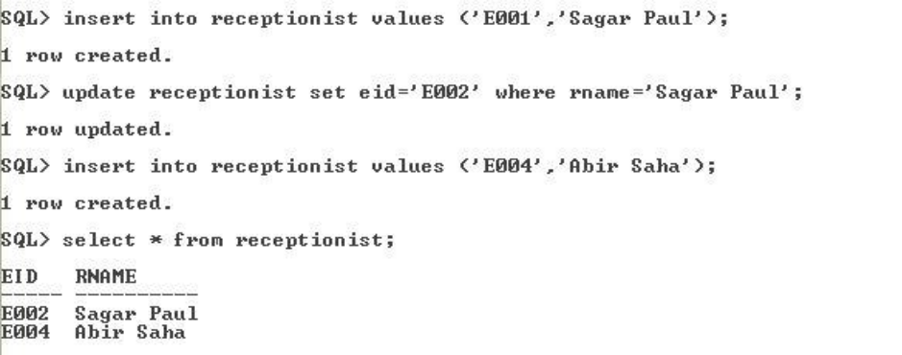

  - Inserting data and viewing table medicines –
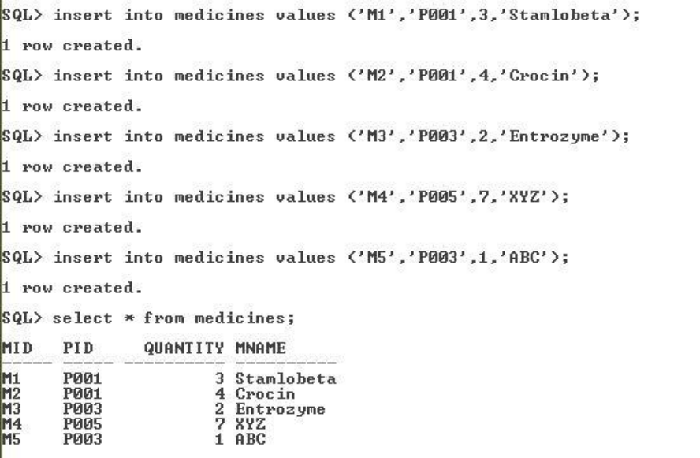

  - Inserting data and viewing table records –
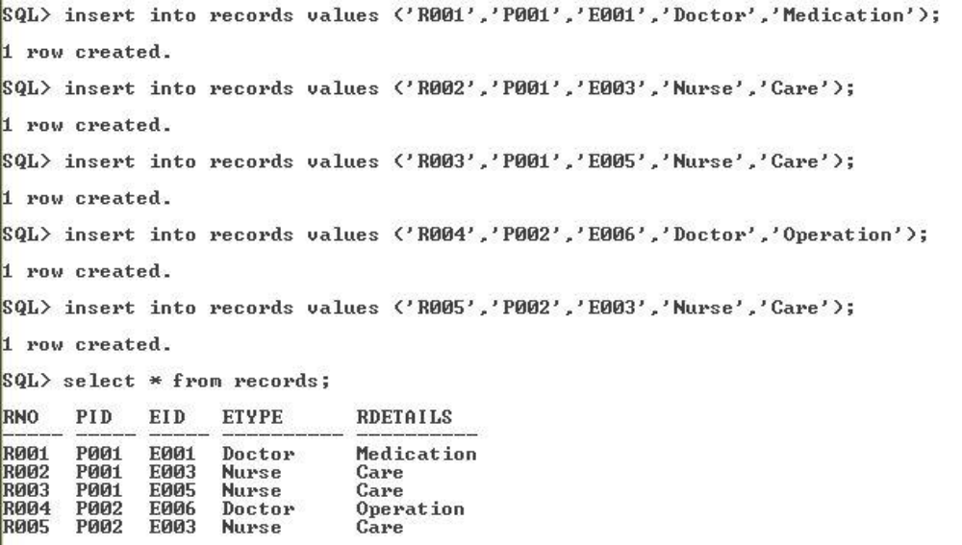
Home.html:
<!DOCTYPE html>
<html>
<body>
<table width="1350" height="640" border="1" >
<tr>
<td colspan="2" style="background-color:#FFF5EE;">
<h1>HOSPITAL MANAGEMENT SYSTEM</h1>
<h3 align="center">ADMIN PANEL</h3>
</td>
</tr>
<tr>
<td style="background-color:#00FFFF;width:50px;height:400px;">
<table align="center">
<tr><td><form action="doctor.php" align="center">
<input type="submit" align="center" value=" doctor ">
</form></td>
</tr>

<tr>
<td><form action="nurse.php" align="center">
<input type="submit" align="center" value=" nurse ">
</form></td>
</tr>

<tr>
<td><form action="patient.php" align="center">
<input type="submit" align="center" value=" patient ">
</form></td>
</tr>

<tr>
<td><form action="pharmacist.php" align="center">
<input type="submit" align="center" value=" pharamacist ">
</form></td>
</tr>

<tr>
<td><form action="laboratorist.php" align="center">
<input type="submit" align="center" value=" laboratorist ">
</form></td><tr>
<td><form action="accountant.php" align="center">
<input type="submit" align="center" value=" accountant ">
</form></td>
</tr>
</table>
</td>
<td style="background-color:#eeeeee;height:200px;width:400px;height:400px;"><h3 align="center">Advanced, powerfull, flexible complete management software for hospital, clinic and medical institutes. Integrates and facilitates all user area of a hospital: </h3><h4>align="center">Administrator</h4>
<h4 align="center">Doctor</h4>
<h4 align="center">Patient</h4>
<h4 align="center">Nurse</h4>
<h4 align="center">Pharmacist</h4>
<h4 align="center">Laboratorist</h4>
<h4 align="center">Accountant</h4>
</td>
</tr>
<tr>
<td colspan="2" style="background-color:#9ACD32;text-align:center;">
<table align="right">
<th>
<tr>
<form action="appointment.php" align="center">
<input type="submit" align="center" value=" appointment ">
</form>
</tr>
<tr>
<form action="payment.php" align="center">
<input type="submit" align="center" value=" payment ">
</form>
</tr>
<tr>
<form action="bloodbank.php" align="center">
<input type="submit" align="center" value=" bloodbank ">
</form>
</tr>
<tr>
<form action="medicine.php" align="center">
<input type="submit" align="center" value=" medicine ">
</form>
</tr>
<tr>
<form action="operations.php" align="center">
<input type="submit" align="center" value=" operations ">
</form>
</tr>
<tr>
<form action="birthreport.php" align="center">
<input type="submit" align="center" value=" birthreport ">
</form>
</tr>
<tr>
<form action="deathreport.php" align="center">
<input type="submit" align="center" value=" deathreport ">
</form>
</tr>
<tr>
<form action="bedallotment.php" align="center">
<input type="submit" align="center" value=" bedallotment ">
</form>
</tr>
</th>
</table>
</td>
</tr></table></body></html>

Doctor.PHP
<!DOCTYPE html>
<html>
<body>
<table width="1350" height="640" border="1" >
<tr>
<td colspan="2" style="background-color:#FFF5EE;">
<h1>HOSPITAL MANAGEMENT SYSTEM</h1>
<h3 align="center">ADMIN PANEL</h3>
</td>
</tr>
<tr>
<td style="background-color:#00FFFF;width:50px;height:400px;">
<table align="center">
<tr>
<td><form action="nurse.php" align="center">
<input type="submit" align="center" value=" nurse ">
</form></td>
</tr>
<tr>
<td><form action="patient.php" align="center">
<input type="submit" align="center" value=" patient ">
</form></td>
</tr>
<tr>
<td><form action="pharmacist.php" align="center">
<input type="submit" align="center" value=" pharamacist ">
</form></td>
</tr>
<tr>
<td><form action="laboratorist.php" align="center">
<input type="submit" align="center" value=" laboratorist ">
</form></td>
<tr>
<td><form action="accountant.php" align="center">
<input type="submit" align="center" value=" accountant ">
</form></td>
</tr>
</table>
</td>
<td style="background-color:#eeeeee;height:200px;width:400px;height:400px;">
<?php
$host='localhost';
$username='root';
$password='';
$dbname='hospital';
$con=mysql_connect($host,$username,$password);
mysql_select_db($dbname);
$result = mysql_query("SELECT * FROM doctor");
echo "<h4 align='center'> doctors list </h4>";
echo "<table border=1 align=center><tr><th>s.no</th><th>name</th><th>d_id</th><th>qualification</th><th>speciality</th><th>age</th></tr>";
while($row = mysql_fetch_array($result))
{
echo "<tr>";
echo "<td>" . $row['s_no'] . "</td>";
echo "<td>" . $row['name'] . "</td>";
echo "<td>" . $row['d_id'] . "</td>";
echo "<td>" . $row['qualification'] . "</td>";
echo "<td>" . $row['speciality'] . "</td>";
echo "<td>" . $row['age'] . "</td>";
echo "</tr>";

}

echo "</table>";
mysql_close($con);
?>
<br><br>
<table align="right">
<th>
<tr>
<form action="adddoctor.php" align="center">
<input type="submit" align="center" value=" add new doctor ">
</form>
</tr>
<tr>
<form action="deletedoctor.php" align="center">
<input type="submit" align="center" value=" delete doctor ">
</form></tr>
<tr>
<form action="viewcompletedoctor.php" align="center">
<input type="submit" align="center" value=" viewcomplete ">
</form>
</tr>
<tr>
<form action="admin.html" align="center">
<input type="submit" align="center" value=" home ">
</form>
</tr></table>
</td>
</tr><tr>
<td colspan="2" style="background-color:#9ACD32;text-align:center;">
<table align="right">
<th>
<tr><form action="appointment.php" align="center">
<input type="submit" align="center" value=" appointment ">
</form>
</tr><tr><form action="payment.php" align="center">
<input type="submit" align="center" value=" payment ">
</form>
</tr><tr><form action="bloodbank.php" align="center">
<input type="submit" align="center" value=" bloodbank ">
</form>
</tr><tr>
<form action="medicine.php" align="center">
<input type="submit" align="center" value=" medicine ">
</form>
</tr><tr><form action="operations.php" align="center">
<input type="submit" align="center" value=" operations ">
</form>
</tr><tr>
<form action="birthreport.php" align="center">
<input type="submit" align="center" value=" birthreport ">
</form>
</tr><tr><form action="deathreport.php" align="center">
<input type="submit" align="center" value=" deathreport ">
</form>
</tr><tr><form action="bedallotment.php" align="center">
<input type="submit" align="center" value=" bedallotment ">
</form>
</tr></th> </table>
</td></tr></table>
</body>
</html>

Appointment.php
<!DOCTYPE html>
<html>
<body>

<table width="1350" height="640" border="1" ><tr>
<td colspan="2" style="background-color:#FFF5EE;">
<h1>HOSPITAL MANAGEMENT SYSTEM</h1>
<h3 align="center">DOCTOR PANEL</h3>
</td>
</tr>
<tr>
<td style="background-color:#00FFFF;width:50px;height:400px;">
<table align="center">
<tr> <td><form action="docappointment.php" align="center">
<input type="submit" align="center" value=" Appointment ">
</form> </td></tr>
<tr> <td><form action="docperscription.php" align="center">
<input type="submit" align="center" value=" perscription ">
</form> </td> </tr>
<tr> <td> <form action="docoperation.php" align="center">
<input type="submit" align="center" value=" Operation ">
</form> </td></tr>
<tr> <td><form action="docmedicines.php.php" align="center">
<input type="submit" align="center" value=" Add Medicines ">
</form></td></tr>
<tr> <td> <form action="doctests.php" align="center">
<input type="submit" align="center" value=" Add Tests ">
</form></td>
</table>
</td>
<td style="background-color:#eeeeee;height:200px;width:400px;height:400px;">
<h2 align="center"> Appointments </h2>
<?php
$host='localhost';
$username='root';
$password='';
$dbname='hospital';
$con=mysql_connect($host,$username,$password);
mysql_select_db($dbname);
$result = mysql_query("SELECT * FROM appointment WHERE d_id='$a'");
echo "<table border=1 align=center> <tr> <th>s.no</th> <th>pid</th> <th>name</th> <th>problem</th> <th>date</th> <th>time</th> <th>status</th> <th> update</th> </tr>";

while($row = mysql_fetch_array($result))
{
echo "<tr>";
echo "<td>" . $row['s_no'] . "</td>";
echo "<td>" . $row['p_id'] . "</td>";
echo "<td>" . $row['name'] . "</td>";
echo "<td>" . $row['problem'] . "</td>";
echo "<td>" . $row['date_of_app'] . "</td>";
echo "<td>" . $row['time_of_app'] . "</td>";
echo "<td>" . $row['status'] . "</td>";
echo "<td>" ;?> <form action="updateappointment.php" align="center" method="POST">
<input type="hidden" name="sno" value=" <?php echo $row['s_no']; ?> ">
<input type="hidden" name="pid" value=' <?php echo $row['p_id']; ?> '>
<input type="submit" align="center" value=" update ">
</form> <?php echo "<td>";
echo "</tr>";
}
echo "</table>";
mysql_close($con);
?>
<br><br>
<table align="center">
<tr>
<td><form action="allappointment.php" align="center">
<input type="submit" align="center" value=" all Appointment ">
</form> </td>
<td><form action="pendingappointment.php" align="center">
<input type="submit" align="center" value=" pending Appointment ">
</form> </td>
<td> <form action="upcomingappointment.php" align="center">
<input type="submit" align="center" value=" upcoming appointment ">
</form> </td>
<td><form action="completedappointment.php" align="center">
<input type="submit" align="center" value=" completed Appointment ">
</form></td></table>
</td></tr>
<tr>
<td colspan="2" style="background-color:#9ACD32;text-align:center;">
<table align="center"> <tr> <td> Doctor name </td> <td> </td> <td> Doctor id </td> <td> </td> </tr> </table>
</td></tr>
</table></body></html>

4.CONCLUSION:

Since we are entering details of the patients electronically in the” Hospital Management System”, data will be secured. Using this application/Project we can retrieve patient’s history with a single click. Thus processing information will be faster. It guarantees accurate maintenance of Patient details. It easily reduces the book keeping task and thus reduces the human effort and increases accuracy speed.

