Abstract
Passive markers applied to Motion Capture system usually haven’t any traits used to discriminate each other. Intricate human motion must lead to lose of markers in one binocular vision system. When the missing points reappear, identifying the marker belonged to which joints becomes a pivotal problem. Most available systems require manual steps to correct the tracking procedure. This work presents a novel approach based nearest neighbor method for identification such lost and reappearing marker. It combines an extended 3D Kalman filter and multi-trace data fusing technology, significant improving the accurately tracking rate. Experiments show that the proposed method can obtain the all markers’ 3D motion parameters.
Introduction
Motion Capture provides a convenient way of detecting and acquiring realistic human motion data. Markers are usually used in systems to track the joints on a body, especially passive markers for not hindering the participant’s natural motion. They are often little reflector spheres which are unlabeled, assigned to the joints on a participant’s body. Because of the intricacies of the human motion, occluded markers might occur leading to not seen points and therefore lost tracking in subsequent frames. However, multi-binocular vision system will ameliorate this, when one marker lost in a binocular vision subsystem, it maybe appears in another binocular vision subsystem. But the identification for the reappearance marker makes tracking become very difficult. The data fusion technology is one of the pivotal technologies to solve this problem, which determines which local tracks obtained in all the binocular visions to the same marker and then calculate a fused global track with these local tracks.
A data fusion procedure involves the track association and the track fusion. The track association determines whether the local tracks obtained in different cameras belong to the same target. The nearest neighbour algorithm (NN) [2] is a straightforward approach for track associating. However, the NN method could cause incorrect association when the targets are dense. In order to solve this problem, many approaches are proposed such as joint probabilistic data association (JPDA) [3], fuzzy data association (FDA) [4], multiple hypothesis tracking (MHT) [5], etc. This paper gives also a data association method based on NN for its simpleness and effectiveness, and this method improves the associated correct rate because the threshold can be changed adaptively by considering the track error.
Related work
The track fusion integrates the associated local tracks of one target into a global track. Many algorithms have been proposed, such as hybrid fusion (HF) [6], covariance intersection (CI) [7], an approximated correlated tracks fusion method [8], etc. In these algorithms, the correlativity of the track errors of the local tracks of one target should be considered because of the common process noise. In this paper, the track errors could be considered as uncorrelated because the common process noise can be ignored in the predigesting indoor environment, and a filter is designed to predict and track each marker in the track fusion procedure.
A novel fusing algorithm is proposed in this paper. In the association procedure, a data association method based on NN is implemented to associate the local tracks with the marker which they belong to, in which the adaptive association threshold and space-time constraint is used to reduce the associated incorrect rate. In the track fusion stage, an extended 3D Kalman Filter [9] is used to track each marker.
The fusion architecture
There are three kinds of fusion architectures [10]: the centralized fusion, the distributed fusion and the hybrid fusion. The distributed fusion is preferred because it reduces the load of the fusion centre greatly through separate the fusion centre from the local tracking. The fusion architecture of this paper is showed in Fig. 1.

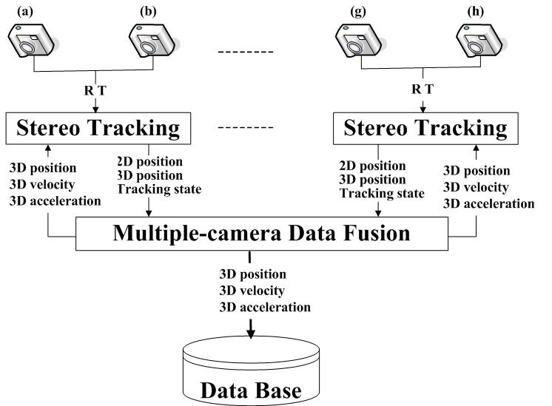
Fig. 1. The fusion architecture

The scene is covered with eight cameras (a)-(h) in Fig.1, and the neighbouring two cameras are composed one binocular vision subsystem because of their larger overlapped region than others. Each subsystem can detect and track markers independently. The fusion module receives the local tracks of each marker produced by all the subsystems and its goal is to compute a global track. The global tracks obtained in the fusion module are feed back every subsystem to improve its tracking performance and stored in a database to drive a human model.
In the proposed fusion procedure, each local track which is received from the subsystem includes each marker’s 2D position, 3D position and tracking state, and the global track is one maker’s 3D position, 3D velocity and 3D acceleration. The 3D positions of one marker in each local track are fused primarily to reduce the quantity of the fusing data, and the 2D positions of one marker in each local track are used to supply more information when an occlusion happens.
Data fusion algorithm
- Extended Kalman Filter
An extended 3D Kalman Filter is used to track each marker, which is consisted by 10 parameters:
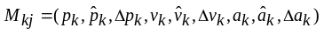 (1)
Where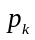, 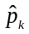, 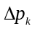is 3D calculated position, 3D predictive position and the predictive error of the marker 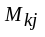 respectively at time k; , , 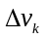is 3D calculated velocity, 3D predictive velocity and the predictive error respectively; 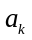, 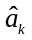, 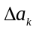is 3D calculated acceleration, 3D predictive acceleration and the predictive error respectively.
The equations (2, 3) are used to predict the maker’s position. The equations (4, 5) are used to update the maker’s velocity. The equations (6, 7) are used to update the maker’s acceleration.
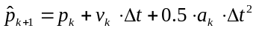 (2)
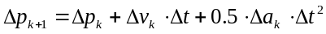 (3)
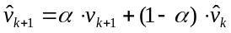 (4)
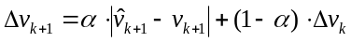 (5)
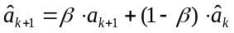 (6)
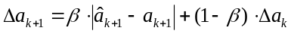 (7)
where 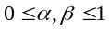.
- Principle of the Fusion Algorithm
- Space-Time Constraint: The space-time constraint is used to measure the 3D matches of two tracks. One marker’s 3D positions and velocities from the two-camera subsystems should be identical at the same time, because they are view-independent entities. In reality, they are not identical because of image noise, calibration error and 2D matching error. If one marker is visible in h subsystems, it will have h 3D local tracks.
- Classification of Markers: In the fusion process, the markers are classified into five classes according to the occlusive degree and the visible degree in the view of one camera. Different fusion strategies are applied to fuse the corresponding markers. We take four cameras for example showed in Fig. 2.
The first class: Be visible in one subsystem at least, and on right tracking state currently. Because these markers have been tracked correctly in the subsystems, only the track fusion process is needed to be done by using their 3D positions.
The second class: Be invisible in any subsystem, but visible in two cameras at least and on right tracking state currently. To this kind of maker, their 2D positions are used in track fusion process.
The third class: Neither visible in any subsystem nor visible in any two cameras. Because they are out of 3D view, the current tracks are replaced by the predictive tracks temporarily.
The fourth class: Be visible in any subsystem, and on new tracking state. Track association is needed to identify their IDs before the track fusion process.
The fifth class: Be visible in the subsystem, and on occlusive tracking state. To this kind of maker, we only feed back the fused track to the subsystem to modify the occlusive tracking.

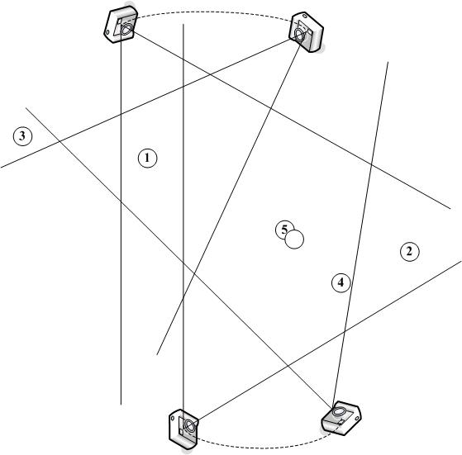
Fig. 2. Five classes of the tracked markers

- Identifying New Markers’ ID: There is no new marker in the motion capture system because the total number of markers has been settled ahead. But for the subsystem the new markers probably exist. At time k, n markers’ tracks 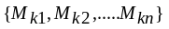are needed to obtain, where n is the total number of markers in the system and is the global ID of the marker. Assume s global tracks 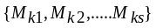are obtained currently, and n-s tracks 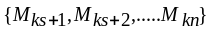 are unresolved. Temporality m local new tracks 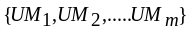 are given. The problem is to compute an optimal ID 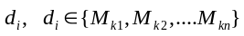for each marker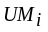, the formulation is:
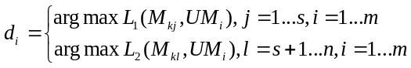 (8)
is used to measure the likelihood ofassociating with, and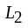is used to measure the likelihood of associating with. If is identified, the markerwill be added to the track which it belongs to.
The improved NN method is used. The shorter distance between and (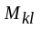), the more interrelated they are. will be associated with () when their distance is the shortest and in the threshold (), where is constant andis variable.
- Procedure of Fusion Algorithm
Step1. Use Eq.(2) to predict all the markers’ positions at next time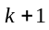.
Step2. Fuse the first marker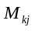, 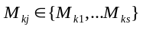.
Assume the marker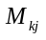is visible in h subsystems. Its track can be expressed as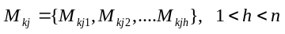, where 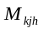is a local track obtained in a subsystem. Finally s markers’ tracks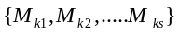can be obtained. If is true, turn to Step5.
Step3. Fuse the second marker, 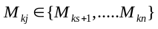.
Two cameras, in which the marker is tracked on right tracking state, are randomly combined to a binocular subsystem, and its 3D position is calculated by public cross line algorithm. Addto the tracks. If is true, turn to Step5.
Step4. Fuse the third marker, .
The 3D track of the marker will be replaced by the predictive track because it is out of 3D view. The predictions of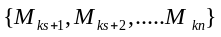are expressed as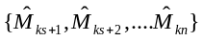.
Step5. Associate the new marker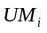with the marker, .
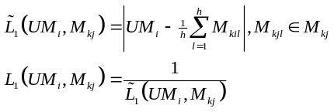 (9)
Assume 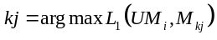 according to Eq.(9), only 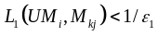is true, canbe associated with. The parameteris 30mm, equals the marker’s radius. Ifis associated, turn to Step7.
Step6. Associate the new markerwith the marker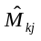, 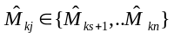.
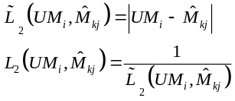 (10)
Assume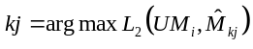 according to Eq.(10), only 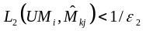is true, canbe matched with. The parameteris variational along with the predictive error. It is determined by the marker’s radius and the predictive error. Ifis not associated, it is an invalid marker, whereas add it to the suited track.
Step7. Calculate the mean of each, 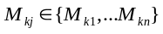.
Assume every local track’s weight of the markeris uniform.
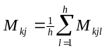 (11)
Step8. Use Eq.(3)-Eq.(7) to update all the markers’ position predictive errors, velocities and accelerations.
Step9. Feed back the 3D tracks of the fourth and fifth markers to the subsystems which they belong to.
- Experiments
Our experiment is done in 5m*5m indoor scene surrounded by the black cloth. The 8 cameras are located in front of an actor, and the resolution of the images is 752×480 and the frame rate is 30F/s. The angle between two neighbouring cameras isn’t zero. The 25 white markers with 25mm diameter are attached on the actor. The performance of the proposed fusion algorithm is presented by tracking the marker in the rectangle.
The images from eight cameras at the 1st frame are shown in Fig. 3, which shows that the marker is visible in all the cameras. The fusing results of the fist frame are shown in Table1. The "subi" means the no.ith stereo tracing subsystem, where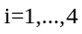. Their tracking state is expressed as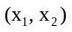, whereis the 2D tracking state in the left camera and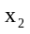is the 2D tracking state in the right camera. "Fusion" means the data fusion result, and its tracking state is expressed as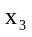. 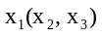 equals one of the numbers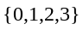, where means the invisible tracking state, means the right tracking state, means the occlusive tracking state, means the new tracking state.

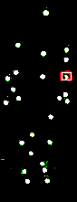 |  | 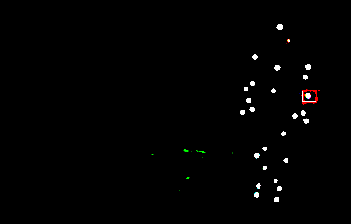 | 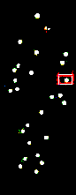 | 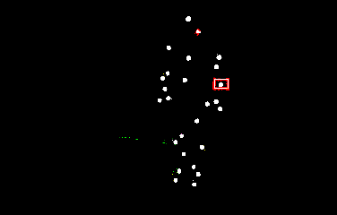 | 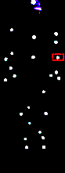 | 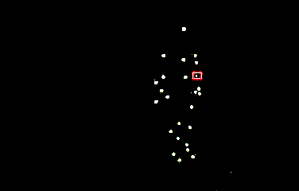 | 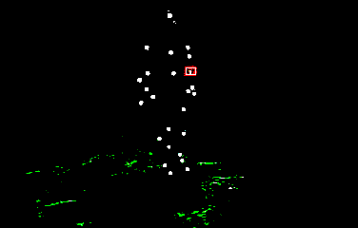
(a) | (b) | (c) | (d) | (e) | (f) | (g) | (h)
Fig. 3. Eight images at 1st frame: the marker is visible in all the cameras
TABLE I
result in the 1st frame
Sub No. | Tracking state | 3D tracking position (mm)
Sub1 | (1,1) | (528.385,-232.728,358.509)
Sub2 | (1,1) | (522.454,-222.163,349.096)
Sub3 | (1,1) | (536.571,-231.568,342.852)
Sub4 | (1,1) | (535.798,-226.015,342.539)
Fusion | 1 | (530.802,-228.119,348.249)

The images from eight cameras at the 15th frame are shown in Fig. 4, which shows that the marker is lost in camera (a), (c), (h). The results are shown in Table2. "Prediction" means the predictive position by the extended 3D Kalman Filter, "Error" means the position predictive error and "unused" means that the local 3D positions are not used in fusion procedure.
The four "unused" show that all the subsystems are invalid at the 15th frame because the marker is not tracked correctly in any subsystem. We combine the right camera of sub1 and the left camera of sub3 to a temporary binocular subsystem. The predictive error in Table2 implies that the proposed algorithm could track the marker accurately when it is not tracked correctly or lost in any subsystem.

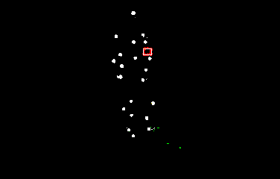 | 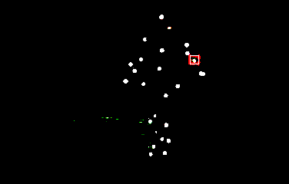 | 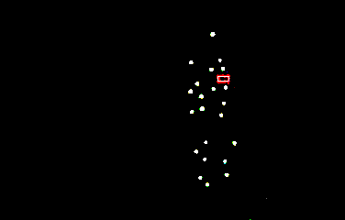 | 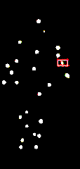 | 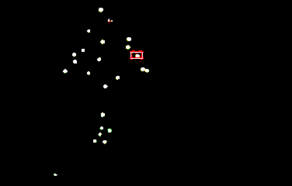 | 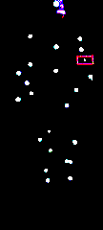 |  | 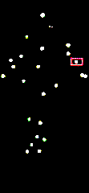 |  | 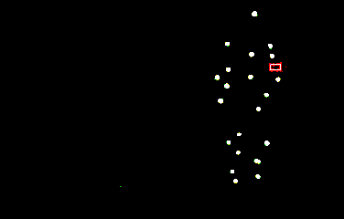
(a) | (b) | (c) | (d) | (e) |  | (f) | (g) | (h)
Fig. 4. Eight images at 15th frame: the marker is lost in camera (a), (c), (h)
TABLE III
result in the 15th frame
Sub No. | Tracking state | Tracking position (mm)
Sub1 | (0,1) | unused
Sub2 | (0,1) | unused
Sub3 | (1,2) | unused
Sub4 | (2,0) | unused
Fusion | 1 | (552.661,-354.104, 400.122)
Prediction(mm) |  | (553.342,-357.69,412.559)
Error(mm) |  | (0.68121,3.5864,12.4366)

The images from eight cameras at the 33rd frame are shown in Fig. 5, which shows that the marker appears again at camera (a), (c), (h). The results are shown in Table3. "ID" means the id of the marker, and it equals d₁₂. The stress IDs in Table3 imply that the marker is identified correctly at sub1, sub2 and sub3 using the proposed algorithm.

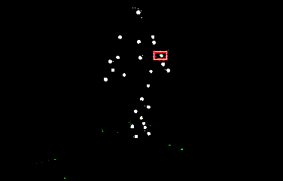 | 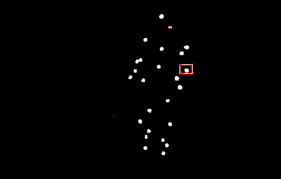 | 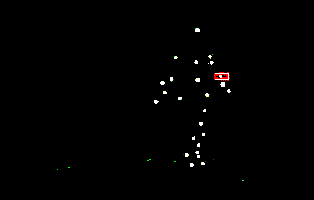 | 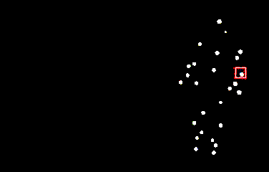 | 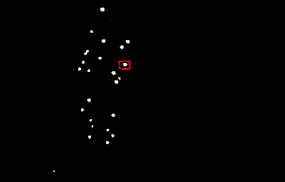 | 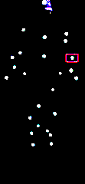 | 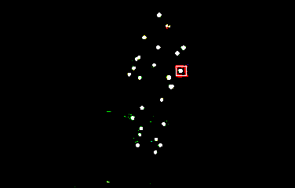 | 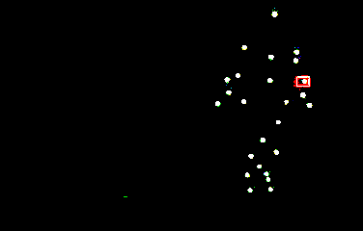
(a) | (b) | (c) | (d) | (e) | (f) | (g) | (h)
Fig. 5. Eight images at 33rd frame: the marker appears again at camera (a), (c), (h)
TABLE IIIII
result in the 33rd frame
Sub No. | Tracking state | Tracking position (mm) | ID
Sub1 | (3,1) | unused | d₁₂
Sub2 | (3,1) | unused | d₁₂
Sub3 | (1,2) | unused | d₁₂
Sub4 | (1,3) | unused | d₁₂
Fusion | 1 | (585.175,-160.672,191.02) | d₁₂
- Conclusions
In this paper, a novel fusion algorithm is proposed to obtain the marker’s accurate 3D track.
In future, the detection and elimination of the wrong position for a certain marker will be studied when the 3D positions in some subsystems are different from each other obviously, and the factor of the cameras’ viewpoint is considered to improve the accuracy of 3D positions in a binocular subsystem.
Acknowledgment
The paper is supported by Hi-Tech Research and Development Program of China (Program No. 2006AA01Z324), and National Natural Science Grants of China.
References
- Barca, J.C.; Rumantir, G.; Koon Li, R.; “A New Illuminated Contour-Based Marker System for Optical Motion Capture”, Innovations in Information Technology, 2006. Nov. 2006 Page(s):1 - 5 Digital Object Identifier 10.1109/INNOVATIONS.2006.301980.
- Bar-Shalom Y. “Multitarget-Multisensor tracking: applications and advances”, Norwood, MA:Artech House, 1990. 65-68.
- Puranik, S.P.; Tugnait, J.K. “Multisensor tracking of multiple maneuvering targets using multiscan JPDA and IMM filtering”, American Control Conference, 2005. Proceedings of the 2005 8-10 June 2005 Page(s): 2058-2063 vol.3. Digital Object Identifier 10.1109/ACC.2005.1470273.
- Ashraf M. Aziz,Tummala M,Cristi R. Fuzzy logic data correlation approach in multisensor-multitarget tracking systems. Signal Processing,1999,76(2):195-209.
- Blackman, S.S. “Multiple hypothesis tracking for multiple target tracking”, Aerospace and Electronic Systems Magazine, IEEE Volume 19, Issue 1, Part 2, Jan 2004 Page(s): 5-18 Digital Object Identifier 10.1109/MAES.2004.1263228.
- Liang Jimin; Wang Changming; Yin Tingrui; “A hybrid measurement fusion algorithm for multisensor target tracking”, Intelligent Control and Automation, 2004. WCICA 2004. Fifth World Congress on Volume 6, 15-19 June 2004 Page(s): 5422-5425 Vol.6. Digital Object Identifier 10.1109/WCICA.2004.1343765.
- Ren C. Luo, Ying Chih Chou, Ogst Chen. “Multisensor Fusion and Integration Algorithms Applications, and Future Research Directions”, Proceedings of the 2007 IEEE International Conference on Mechatronics and Automation August 5 - 8, 2007, Harbin, China.
- Kaplan, L.M.; Blair, W.D.; Bar-Shalom, Y. “Simulations Studies of Multisensor Track Association and Fusion Methods”, Aerospace Conference, 2006 IEEE 4-11 March 2006 Page(s): 16pp. Digital Object Identifier 10.1109/AERO.2006.1655913.
- Jiangbin Zheng, David Dagan Feng, Wanchi siu, Yanning Zhang, XiuYing Wang, Rongchun Zhao. “The accurate extraction and tracking of moving objects or video surveillance”, Proceedings of International Conference on Machine Learning and Cybemetics, pp.1909-1913, 2002.
- C.-Y. Chong, S. Moni, W. H. Barker, and K.-C. Chang, "Architectures and algorithms for track association and fusion," IEEE Aerospace and Electronic Systems Magazine, vol. 15, no. 1, pp. 5-13, Jan. 2000.

