# TDDE01 Machine Learning lab 1

Group B18: Chetan Kandya (cheka108), Oscar Melin (oscme169), Rasmus Rynell (rasry945)

## Assignment 1: Handwritten digit recognition with K-means

We started the assignment by importing, casting, and splitting the data, see code on lines * in appendix 1. Using the KKNN-package we then created and trained a weighted k-Nearest neighbor classifier with 30 neighbors and the kernel “rectangular”, see code on lines * in appendix 1. By evaluating the model using both training and test data produces the following results:

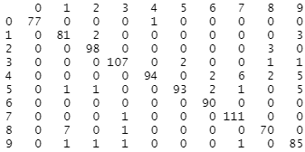Test-data: Train-data:

Misclassification error: 5.329154% Misclassification error: 4.500262%

As one can see the hardest numbers for the model to recognize seems to be “1”,”7” and “9” as indicated be having the most incorrect predictions. Despite this the overall model seems pretty good only having about a 5% misclassification error across all values tested (957 for the testing data and 1911 for training data).

## Assignment 2: Linear regression and ridge regression

## Assignment 3: Logistic regression and basis function expansion

## Statement of contribution:

## Appendix: