Q.1 <!DOCTYPE html> is it a tag of html? If not, what is it and why do we use it?

Ans:- All HTML documents must start with a <!DOCTYPE> declaration. The declaration is not an HTML tag. It is an "information" to the browser about what document type to expect.

Q.2 Explain Semantic tags in html? And why do we need it?

Ans:- The semantic HTML tags help the search engines and other user devices to determine the importance and context of web pages. The pages made with semantic elements are much easier to read. It has greater accessibility. It offers a better user experience

Q.3 Differentiate between HTML Tags and Elements?

Ans:- Tags are the starting and ending parts of an HTML element. They begin with < symbol and end with > symbol. Whatever written inside < and > are called tags.

Elements enclose the contents in between the tags. They consist of some kind of structure or expression. It generally consists of a start tag, content and an end tag.

Q.5 Write HTML code so that it looks like the below image:-



Ans:-

<https://github.com/chetankhanna1995/Web-Development_PPT_Assignments/tree/main/Assignment-1/Q5>

Q.6 What are some of the advantages of HTML5 over its previous versions?

Ans:- HTML5 supports audio and video controls with the use of <audio> and <video> tags. It uses SQL databases and application cache to store offline data. Allows JavaScript to run in background. This is possible due to JS Web worker API in HTML5. HTML5 allows to draw shapes like circle, rectangle, triangle etc. HTML5 language is more mobile-friendly.

Q.8 What is the difference between <figure> tag and <img> tag?

Ans:- The image tag is used to embed the image in an HTML document whereas the figure tag is used to semantically organize the content of an image in the HTML document.

Q.9 What’s the difference between html tag and attribute and give example of some global attributes?

Ans:- Tags are used to mark up the start of an HTML element and they are usually enclosed in angle brackets. An example of a tag is: <h1>.Most tags must be opened <h1> and closed </h1> in order to function.

Attributes contain additional pieces of information. Attributes take the form of an opening tag and additional info is placed inside.

Global Attribute Example:- id,class,style,title

Q.10 Write Html code so that it looks like the below image

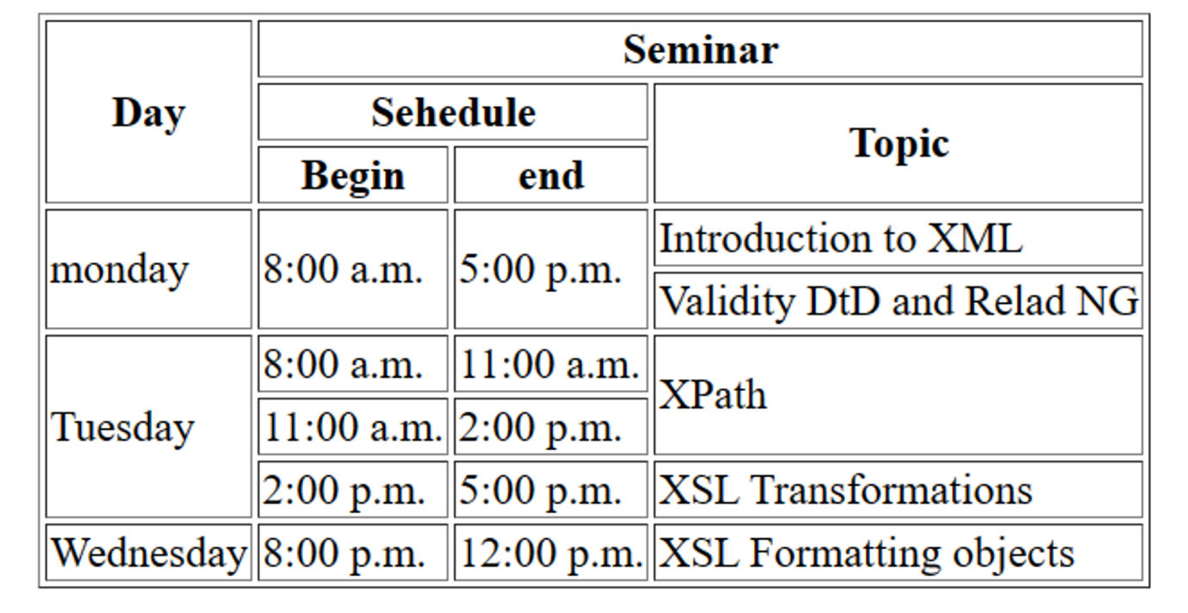

Ans:-

<https://github.com/chetankhanna1995/Web-Development_PPT_Assignments/tree/main/Assignment-1/Q10>