Q.1 What’s Box Model in CSS ?

Ans-  A box that wraps around every HTML element. It consists of: margins, borders, padding, and the actual content

Q.2 What are the Different Types of Selectors in CSS & what are the advantages of them?

Ans- CSS Selector Divide into 5 Types: -

1)Simple Selectors-Select Based on on name, id, class.

2) Combinator selectors

3) Pseudo-class selectors

4) Pseudo-elements selectors

5) Attribute selectors

Advantage using CSS Selector: - CSS selectors are used to "find" (or select) the HTML elements you want to style

Q.3 What is VW/VH ?

Ans:- VH stands for “viewport height”, which is the viewable screen's height.

VW stands for “viewport width”, which is the viewable screen's width.

Q.4 Whats difference between Inline, Inline Block and block ?

Ans:- Inline :- The element doesn’t start on a new line and only occupy just the width it requires. You can’t set the width or height.

Inline Block :-  It’s formatted just like the inline element, where it doesn’t start on a new line. BUT, you can set width and height values.

Block :- The element will start on a new line and occupy the full width available. And you can set width and height values.

Q.5 How is Border-box different from Content Box?

Ans:- Border-box:- an element, padding and border are included in the width and height.

**content-box:**This is the default value of box-sizing. The dimension of element only includes ‘height’ and ‘width’ and does not include ‘border’ and ‘padding’ given to element.

Q.6 What’s z-index and How does it Function ?

Ans:- z-index is a CSS property that defines the order of overlapping HTML elements. Elements with a higher index will be placed on top of elements with a lower index.

Q.7 What’s Grid & Flex and difference between them?

Ans :- Grid and flexbox. The basic difference between CSS grid layout and CSS flexbox layout is that flexbox was designed for layout in one dimension - either a row or a column. Grid was designed for two-dimensional layout - rows, and columns at the same time.

Q.8 Difference between absolute and relative and sticky and fixed position explain with example.

Ans :- Relative Position: Setting the top, right, bottom, and left properties of an element with position: relative; property will cause it to adjust from its normal position. The other objects or elements will not fill the gap.

position: relative;

Absolute Position: An element with position: absolute; will cause it to adjust its position with respect to its parent. If no parent is present, then it uses the document body as parent.

position: absolute;

sticky Position:- A sticky element toggles between relative and fixed , depending on the scroll position. It is positioned relative until a given offset position is met in the viewport - then it "sticks" in place.

position: sticky;

Fixed Position: Position: fixed; property applied to an element will cause it to always stay in the same place even if the page is scrolled. To position the element we use top, right, bottom, left properties.

position: fixed;

Q.9 Build Periodic Table as shown in the below image.

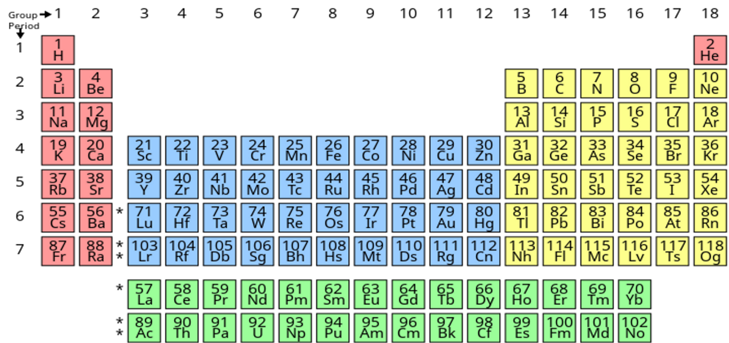

Ans:- <https://github.com/chetankhanna1995/Web-Development_PPT_Assignments/tree/main/Assignment-2/Q9>

**Q.10** Build Responsive Layout both desktop and mobile and Tablet, see below image for reference ?

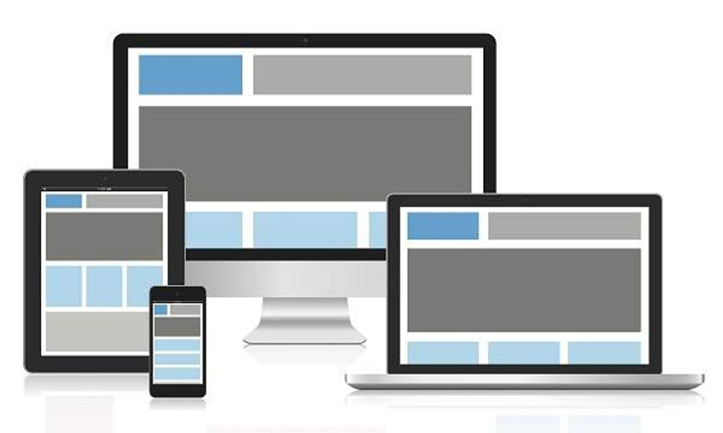

Ans:- <https://github.com/chetankhanna1995/Web-Development_PPT_Assignments/tree/main/Assignment-2/Q10>