1. **Create a Node API to post the data for products in to the database. (Create appropriate database for testing)**

**const express = require("express")**

**const mongoose = require("mongoose")**

**const routes = require("./route")**

**mongoose**

**.connect("mongodb://localhost:27017/students", { useNewUrlParser: true,useUnifiedTopology: true })**

**.then(() => {**

**const app = express()**

**app.use("/api", routes)**

**app.listen(process.env.PORT||3000, () => {**

**console.log("Server has started!")**

**})**

**})**

**const { builtinModules } = require('module');**

**const mongoose = require('mongoose');**

**const schema = mongoose.Schema({**

**name:String,**

**branch:String**

**});**

**module.exports = mongoose.model("Post",schema);**

**const express = require('express');**

**const Post = require('./Model/Post');**

**const router = express.Router();**

**router.get('/post',async(req,res)=>{**

**const post = await Post.find()**

**res.send(post)**

**})**

**module.exports = router;**

1. **Create appropriate navbar with proper links. Fetch the data from below mentioned API and display the same in the front-end component. (Images should be displayed properly)**

**<nav class="navbar navbar-expand-md bg-dark navbar-dark">**

**<a class="navbar-brand" href="#">Navbar</a>**

**<button class="navbar-toggler" type="button" data-toggle="collapse" data-target="#collapsibleNavbar">**

**<span class="navbar-toggler-icon"></span>**

**</button>**

**<div class="collapse navbar-collapse" id="collapsibleNavbar">**

**<ul class="navbar-nav">**

**<li class="nav-item">**

**<a class="nav-link" routerLink="/post" href="#">Post</a>**

**</li>**

**</ul>**

**</div>**

**</nav>**

**import { NgModule } from '@angular/core';**

**import { RouterModule, Routes } from '@angular/router';**

**import {PostsComponent} from './posts/posts.component'**

**const routes: Routes = [**

**{ path: 'post', component: PostsComponent }**

**];**

**@NgModule({**

**exports: [RouterModule]**

**})**

**export class AppRoutingModule {**

**}**

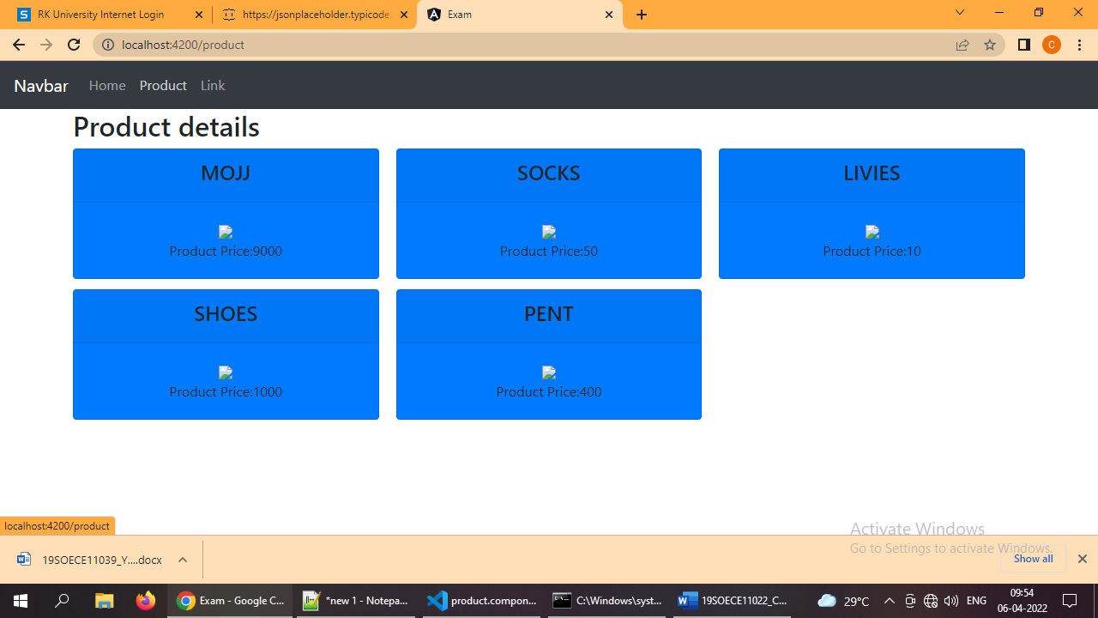

1. **Create a Form(template drive or reactive) with 4-5 appropriate fields of your choice and provide basic validations**

**<form #login="ngForm" (ngsubmit)="onSubmit(login)">**

**<div class="form-group">**

**<label for="email">Email address:</label>**

**<input type="email" class="form-control" name="email" required minlength="5" #email="ngModel" ngModel placeholder="Enter email" id="email">**

**<div *ngIf="email.touched && email.invalid" class="alert alert-danger">**

**<span *ngIf="email.errors?.['required']">Please Enter Email.</span>**

**<span *ngIf="email.errors?.['minlength']">Please Enter At-Least 5 Character.</span>**

**</div>**

**</div>**

**<div class="form-group">**

**<label for="mobileno">Mobile No:</label>**

**<input type="mobileno" class="form-control" name="mobileno" required minlength="10" #mobileno="ngModel" ngModel placeholder="Enter Mobile Number" id="mobileno">**

**<div *ngIf="mobileno.touched && mobileno.invalid" class="alert alert-danger">**

**<span *ngIf="mobileno.errors?.['required']">Please Enter Mobile No.</span>**

**<span *ngIf="mobileno.errors?.['minlength']">Please Enter At-Least 10 Character.</span>**

**</div>**

**</div>**

**<div class="form-group">**

**<label for="pincode">Pincode:</label>**

**<input type="pincode" class="form-control" name="pincode" required minlength="6" #pincode="ngModel" ngModel placeholder="Enter Pincode" id="pincode">**

**<div *ngIf="pincode.touched && pincode.invalid" class="alert alert-danger">**

**<span *ngIf="pincode.errors?.['required']">Please Enter Mobile No.</span>**

**<span *ngIf="pincode.errors?.['minlength']">Please Enter At-Least 6 Character.</span>**

**</div>**

**</div>**

**<div class="form-group">**

**<div class="dropdown" type="dropdown" class="form-control" name="dropdown" required #dropdown="ngModel" ngModel placeholder="Enter Pincode" id="dropdown">**

**<button type="button" class="btn btn-primary dropdown-toggle" data-toggle="dropdown-menu">**

**Dropdown button**

**</button>**

**<div class="dropdown-menu">**

**<a class="dropdown-item" href="#">India</a>**

**<a class="dropdown-item" href="#">USA</a>**

**<a class="dropdown-item" href="#">UK</a>**

**</div>**

**</div>**

**<div *ngIf="dropdown.touched && dropdown.invalid" class="alert alert-danger">**

**<span *ngIf="dropdown.errors?.['required']">Please Select Country.</span>**

**</div>**

**</div>**

**<button type="submit" class="btn btn-primary">Submit</button>**

**</form>**

