ShopNest Store Power BI Capstone Report
1. Introduction
In this project, a Power BI dashboard was created using the ShopNest retail dataset. The goal of the dashboard is to analyze important business metrics such as revenue, order trends, payment methods, delivery performance, and customer reviews. The dashboard helps in understanding how the business is performing and identifies key insights that can support better decision-making.
Dashboard Overview
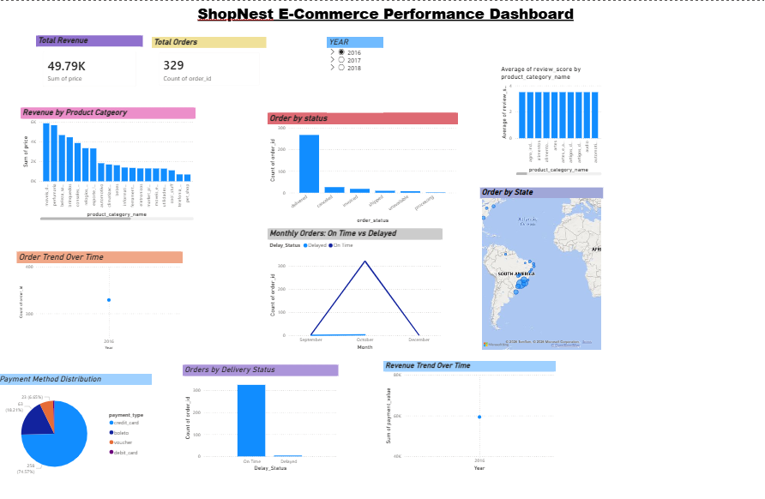
The dashboard contains different visuals such as bar charts, line charts, pie charts, and a map visualization. These visuals provide an overview of sales performance, customer behavior, and operational efficiency.

1. Top Categories by Total Price

Question Statement
Identify and visualize the top 10 product categories by total sales.
Visualization
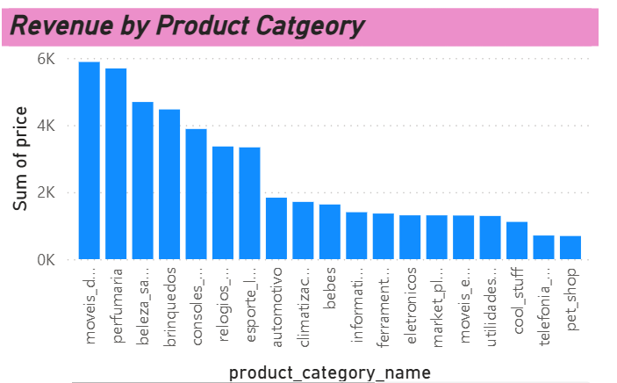
Explanation
This bar chart shows the total revenue generated by different product categories. It helps identify which categories are contributing the most to overall sales. By analyzing this visual, businesses can focus more on high-performing categories and improve strategies for low-performing ones.

2. Delayed Orders Analysis

Question Statement
Determine the number of delayed orders and analyze delivery performance.
Visualization
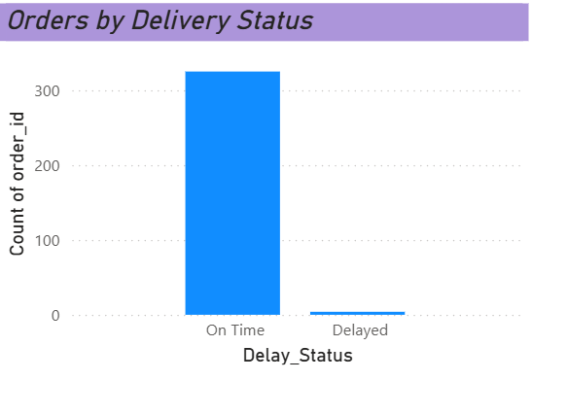
Explanation
This chart displays the number of orders that were delivered on time and those that were delayed. It helps understand the efficiency of the delivery process and highlights areas where improvements might be needed.

3. Monthly Comparison of Delayed and On-Time Orders

Question Statement
Compare the number of on-time deliveries and delayed deliveries for each month.
Visualization

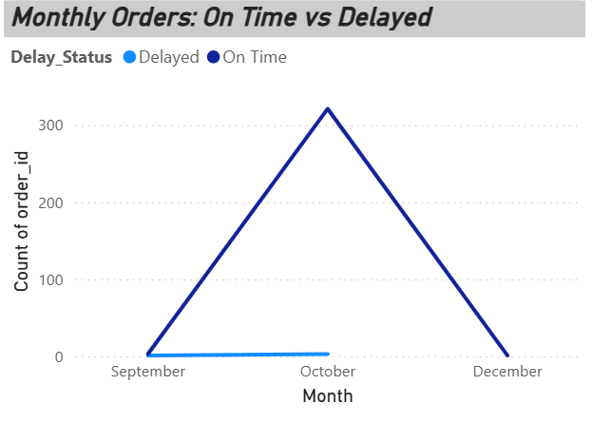

Explanation
This line chart compares delayed and on-time orders for each month. It allows us to observe patterns in delivery performance and identify months where delays were higher.
4. Payment Method Analysis

Question Statement
Analyze the most commonly used payment methods by customers.
Visualization
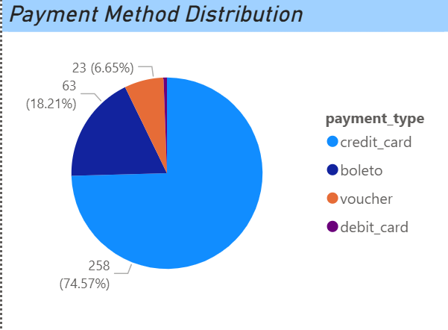
Explanation
This pie chart shows the distribution of payment methods used by customers. It highlights which payment option is preferred the most. Understanding customer payment preferences can help businesses improve the checkout experience.

5. Product Rating Analysis

Question Statement
Analyze product performance based on customer review ratings.
Visualization
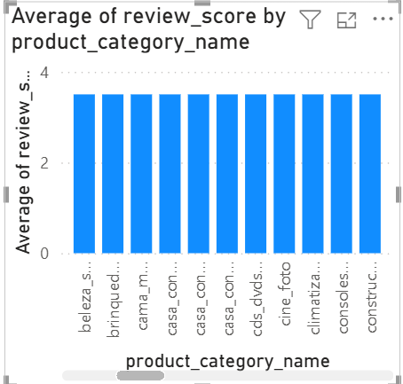
Explanation
This chart shows the average review score for different product categories. It helps identify categories with high customer satisfaction and categories that may need improvement.

6. State-wise Sales Analysis

Question Statement
Identify states with higher and lower sales activity.
Visualization
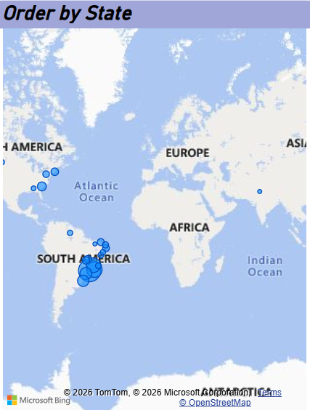
Explanation
This map visual shows the geographical distribution of orders across different states. It helps in understanding which regions have higher demand and which areas have fewer orders.

7. Seasonal Sales Patterns

Question Statement
Analyze sales trends over time.
Visualization
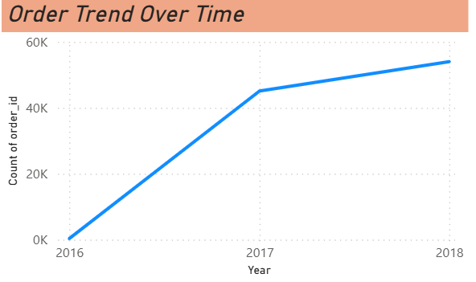Explanation
This chart shows how the number of orders changes over time. It helps identify trends and patterns in customer purchasing behavior throughout the year.

8. Revenue Analysis

Question Statement
Analyze the total revenue generated and how it changes over time.
Visualization
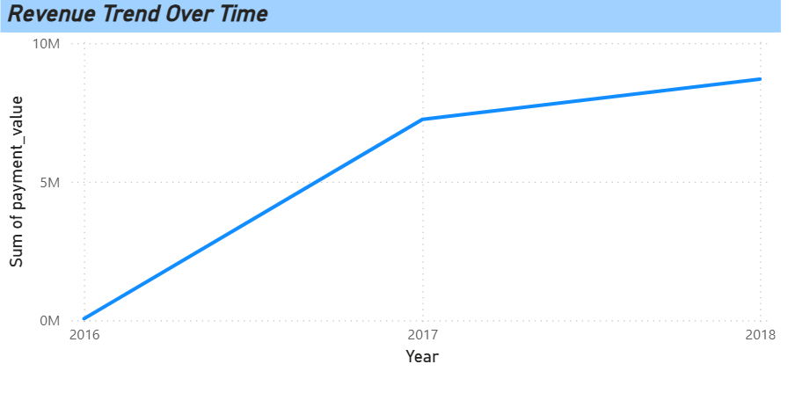
Explanation

This chart shows how revenue has changed over time. It helps identify whether the business is growing and highlights any noticeable trends in sales performance.

Conclusion

The Power BI dashboard provides a clear overview of ShopNest’s sales performance and operational efficiency. The visualizations help identify top-selling product categories, customer payment preferences, delivery performance, and revenue trends. These insights can help businesses make better decisions to improve their performance and customer satisfaction.

