- Design the Library system: Identify the use cases of the system. (Suggestive use cases: borrow book, return books, read newspapers, reference, and digital library). Develop the use case diagram, Packages and documentation for the same. Preferable use of uses & Extends relationships expected.

Use Case Diagram
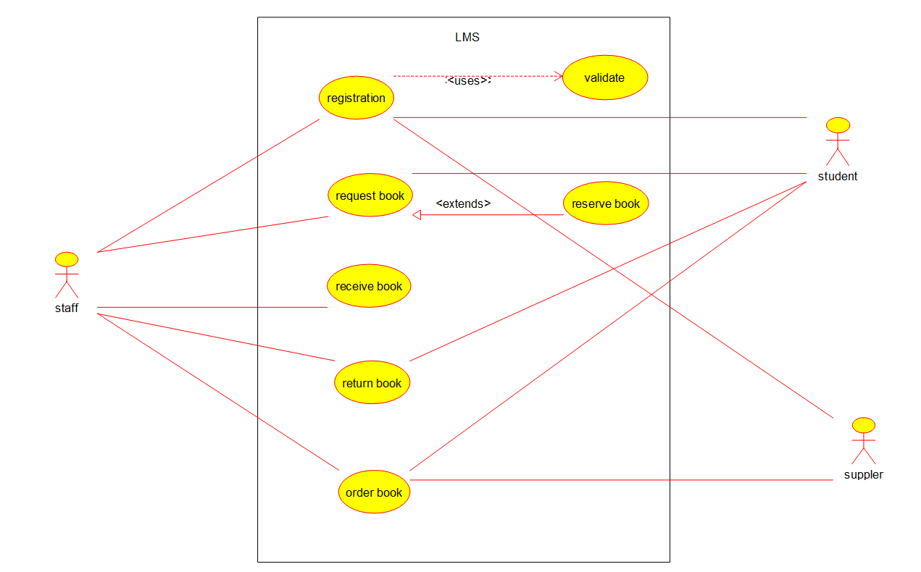

Package Diagram

- Design the Examination system: Identify the use cases. (Suggestive use cases:– Form filling, Get Hall Ticket, Write exam, get result ,Verify Hall Ticket) Develop the use case diagram, Packages and documentation for the same. Preferable use of uses & Extends relationships expected.

Use Case Diagram
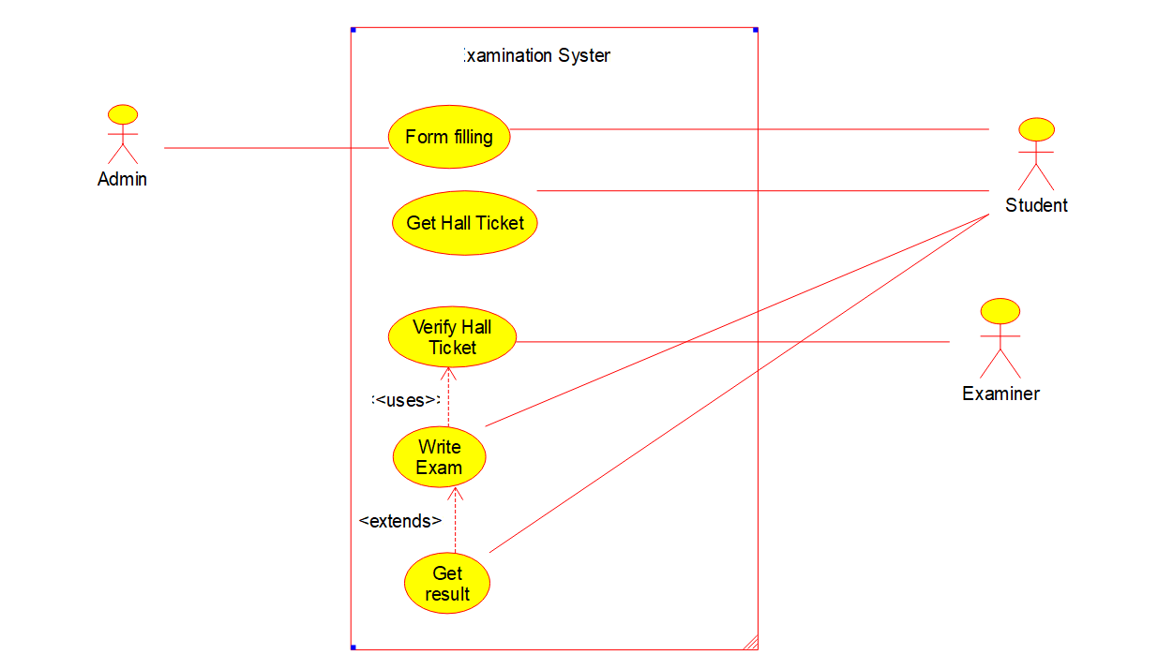

Package Diagram

- Analyze and design the system for ATM Transaction: Identify the use cases. (Suggestive use cases : Transaction, Approval process, Invalid PIN, Deposit Amount, Deposit savings, Deposit checking, withdraw Amount, withdraw checking, saving, withdraw saving denied, checking Transaction History, saving Transaction History). Develop the use case diagram, Packages and documentation for the same. Draw the essential class diagrams.

Use Case Diagram
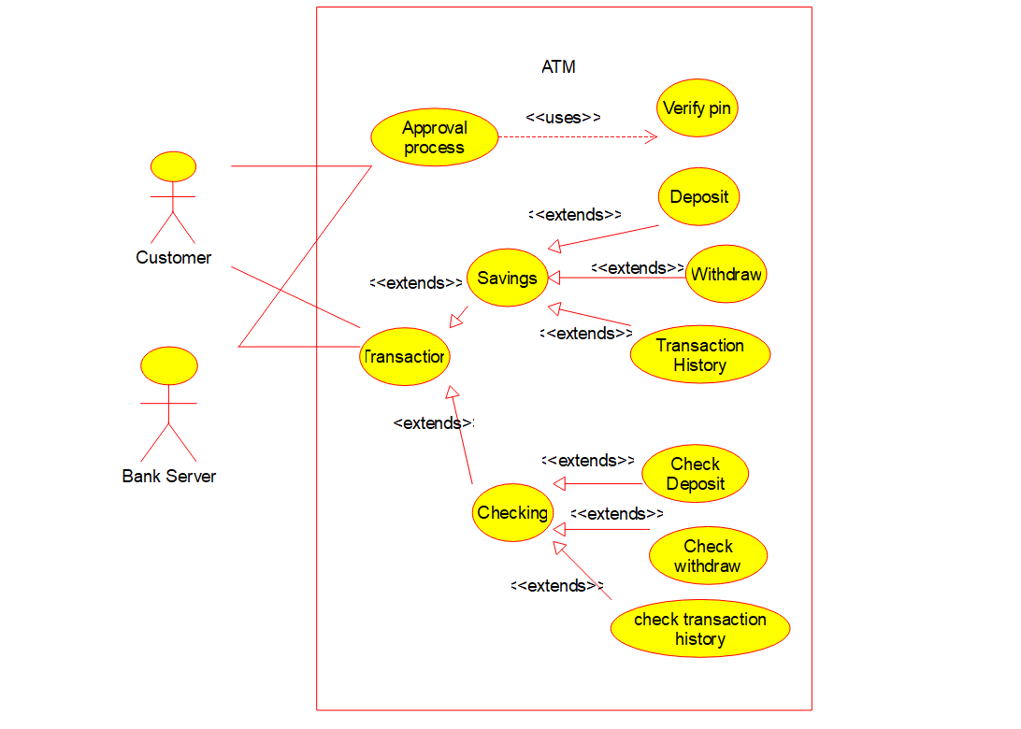

Class Diagram
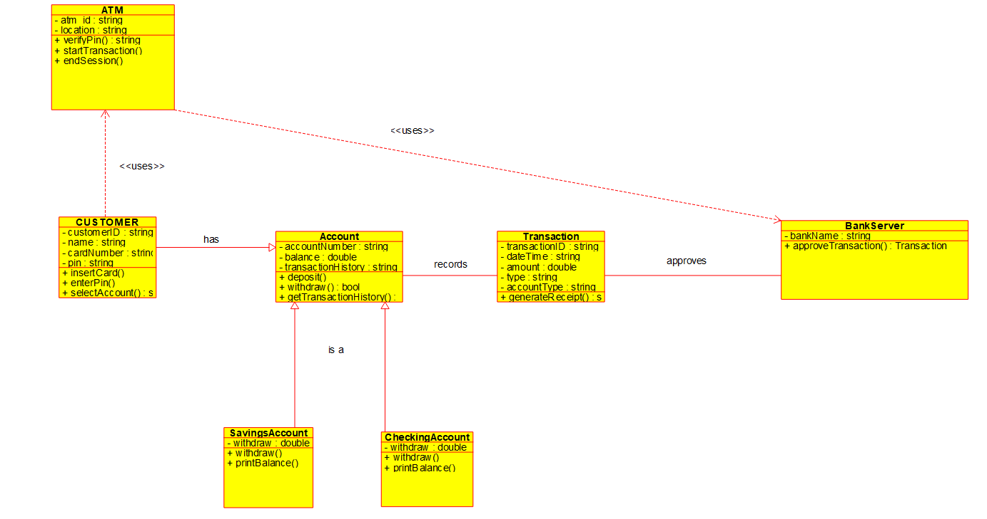

Package Diagram

- Analyze and design the system for voting system (The actors are presiding officer, 1st polling officer, 2nd polling officer,Election officer, voter, candidate; Processes : Voting, counting, and announcement of results). Develop the use case diagram, Packages and documentation for the same. Draw the essential sequence diagrams and state chart diagrams.

Use Case Diagram
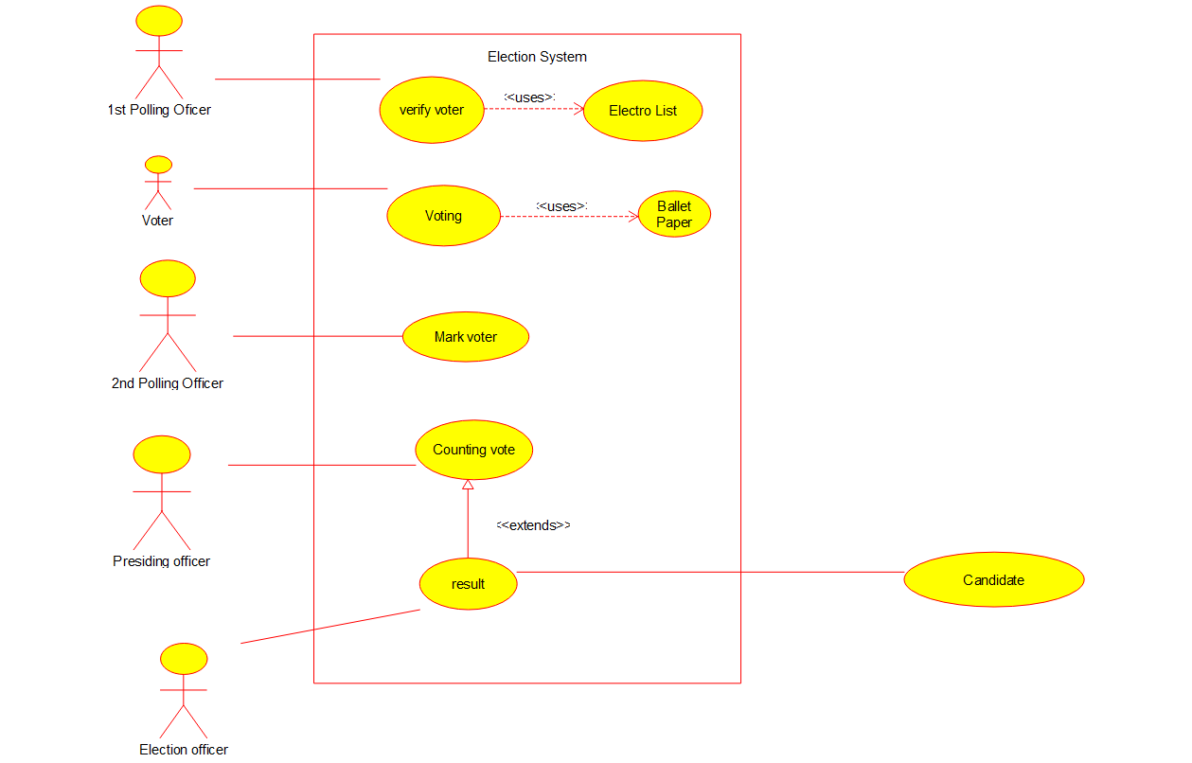

Class Diagram
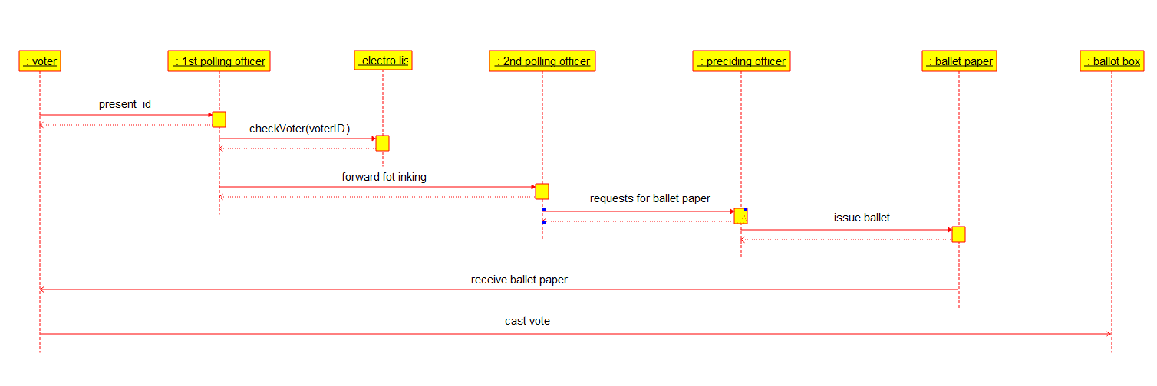

State Diagram
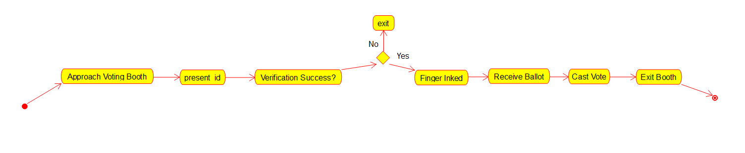

- Analyze and design the system for Results section of autonomy, mainly responsible for CGPA, SGPA Calculation, Grade card generation. Develop the class diagrams and packages.

Class Diagram
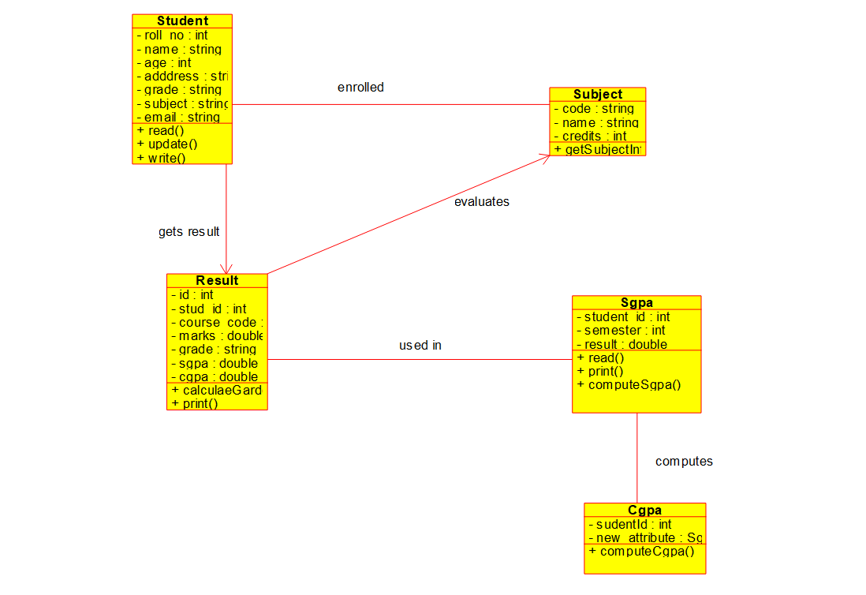

Package Diagram

- Analyze and design the system for Employee reference. (The Process HR Manager contacts Employees of his company and HR manager of other company to publicise about the vacancy. The person who has referred the right candidate, will be given bonus. Interview, Short listing, selection list announcement, Bonus for referred employees are all parts of the process.). Develop the use case diagram , sequence diagrams and state chart diagrams.

Use Case Diagram

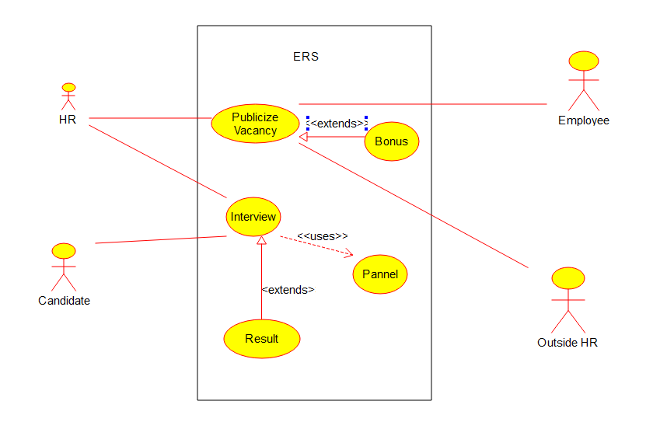
Sequence Diagram

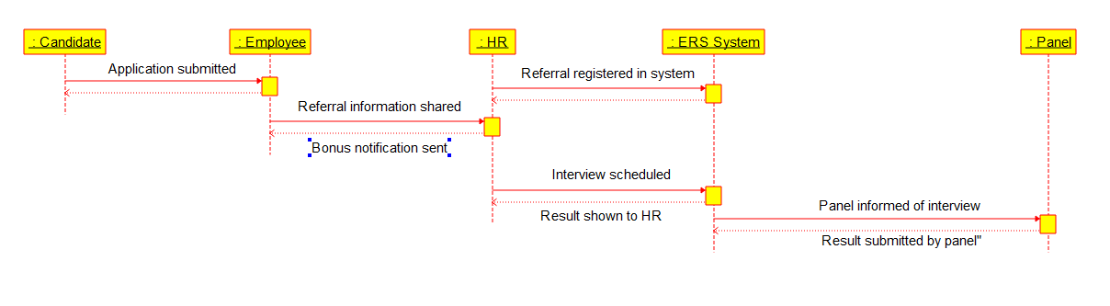

- Analyze and design the system for autonomous education system. (Classes: students Teacher, courses, subjects, core, Electives, Labs). Develop the class diagrams, sequence diagrams and packages.

Use Case Diagram

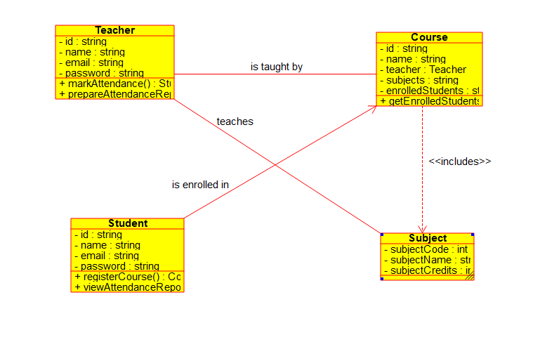

Sequence Diagram

- Analyze and design the system for Railway reservation, which includes the details of Boarding station, classes of reservation, fare, Time table, concessions, No. of Seats, Seat No, State of reservation ( confirmed, waiting, RAC). Develop the class diagrams, packages, component diagrams and deployment diagrams.

C:ass Digram

- Analyze and design the system for Income Tax assessment. Develop the class diagrams, collaboration diagrams, state chart diagrams.

- Analyze and design the system for Online shopping system. Develop the class diagrams, collaboration diagrams, state chart diagrams and packages.
a. Check for the product. b. Place order.
c.Track the order. d.Cancel the order. e.Feedback.

