- Design the Library system: Identify the use cases of the system. (Suggestive use cases: borrow book, return books, read newspapers, reference, and digital library). Develop the use case diagram, Packages and documentation for the same. Preferable use of uses & Extends relationships expected.

Use Case Diagram
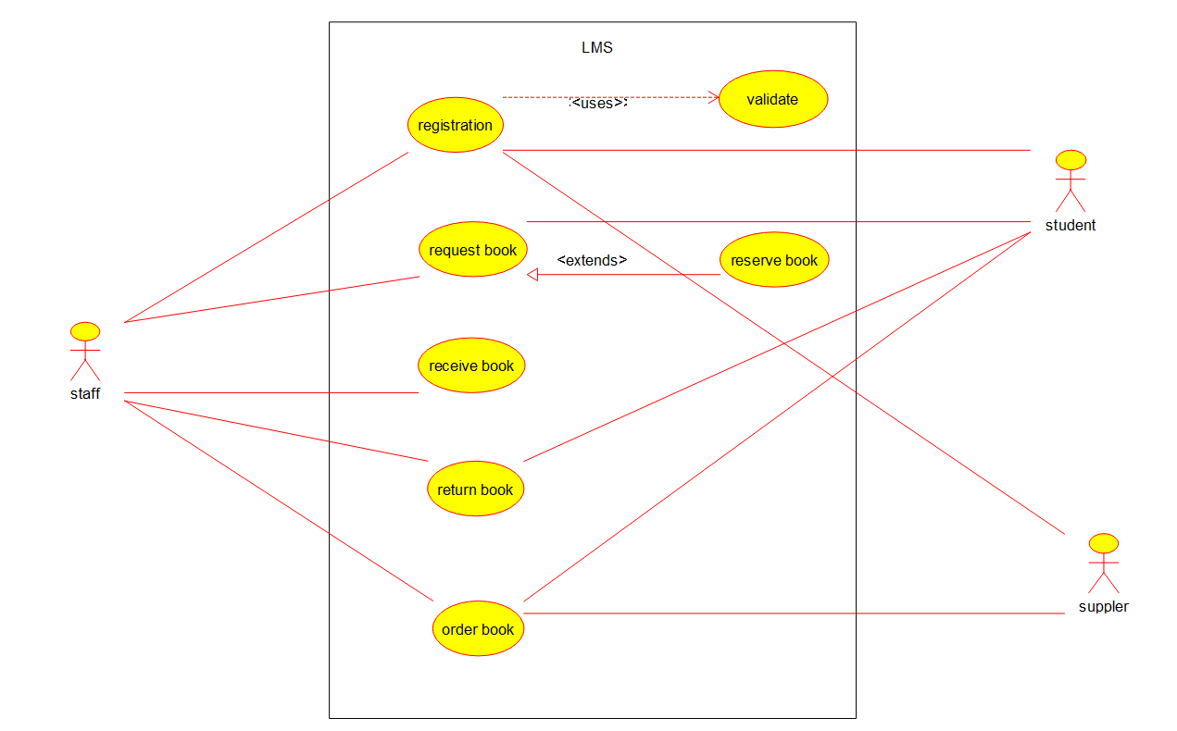

Package Diagram

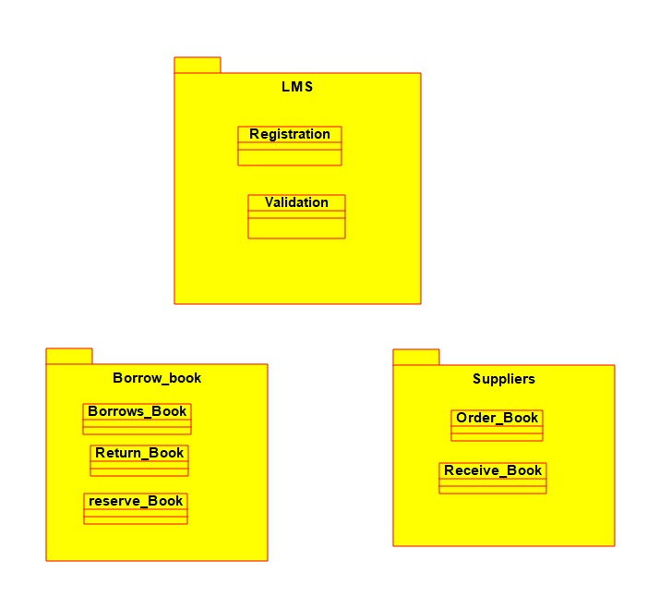

Documentation

Library Management System (LMS) - Use Case Documentation

1. Introduction

The Library Management System (LMS) use case diagram represents the interactions between different actors and the system's functionalities. The system enables users such as Students, Staff, and Suppliers to manage book-related activities efficiently.

2. Actors

1. Student

Registers in the system.

Requests and reserves books.

Validates book requests.

2. Staff

Manages book-related activities, including receiving, returning, and ordering books.

Handles student requests for books.

Manages book reservations.

3. Supplier

Supplies books to the library upon order from staff.

3. Use Cases and Descriptions

1. Registration

Actor: Student

Description: A student registers in the system to access library services.

Pre-condition: The student must provide valid details.

Post-condition: The student is added to the system and can request books.

2. Request Book

Actors: Student, Staff

Description: A student requests a book, and the staff processes the request.

Pre-condition: The student must be registered in the system.

Post-condition: The request is either approved or rejected.

3. Reserve Book

Actors: Student, Staff

Description: A student can reserve a book if it is not available.

Pre-condition: The book must be currently checked out or unavailable.

Post-condition: The book is reserved, and the student will be notified once available.

4. Validate

Actor: Student

Description: The system validates whether a book request meets the library rules.

Pre-condition: A student must have an active account.

Post-condition: The book request is validated or rejected.

5. Receive Book

Actor: Staff

Description: Staff receives books that have been returned by students.

Pre-condition: The book must be borrowed.

Post-condition: The book is marked as available.

6. Return Book

Actor: Staff

Description: Staff processes book returns from students.

Pre-condition: The student must have an active borrowing record.

Post-condition: The book is returned, and its status is updated.

7. Order Book

Actors: Staff, Supplier

Description: The staff places an order for new books from the supplier.

Pre-condition: The book must not be available in the library.

Post-condition: The book is ordered, and the supplier processes it.

4. Relationships in the Use Case Diagram

<<extends>> Relationship:

"Request Book" extends to "Reserve Book" since if a requested book is unavailable, the student may need to reserve it.

<<uses>> Relationship:

"Registration" uses "Validate" since validation is required before a student is registered.

- Design the Examination system: Identify the use cases. (Suggestive use cases:– Form filling, Get Hall Ticket, Write exam, get result ,Verify Hall Ticket) Develop the use case diagram, Packages and documentation for the same. Preferable use of uses & Extends relationships expected.

Use Case Diagram
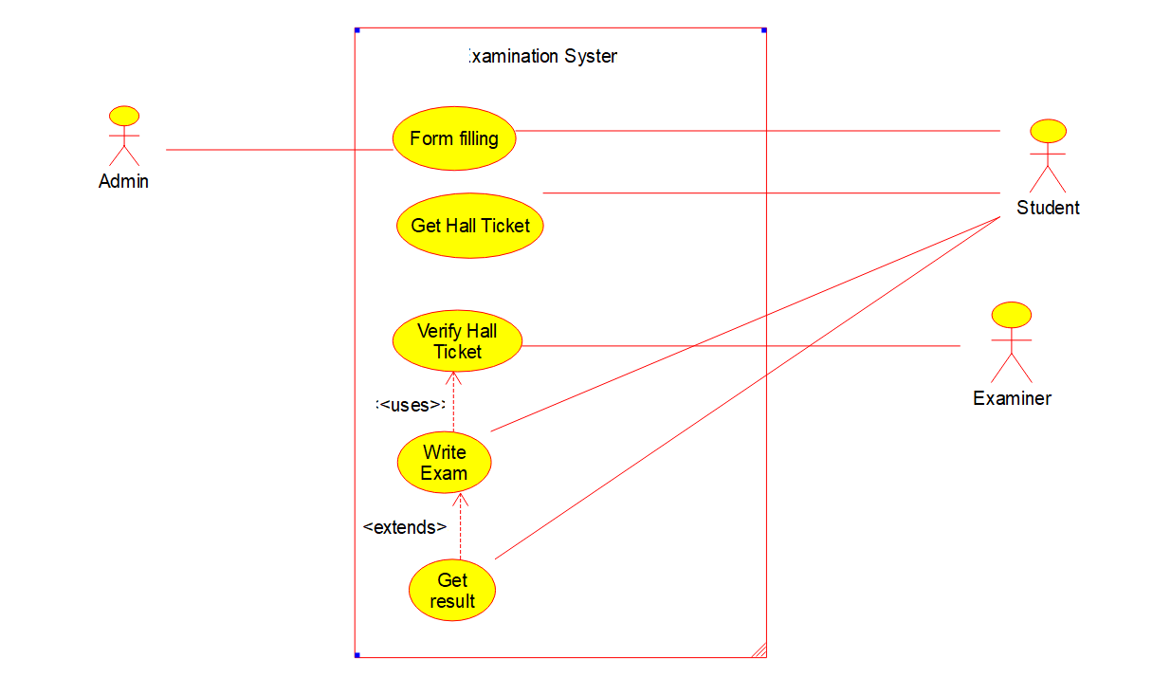

Package Diagram
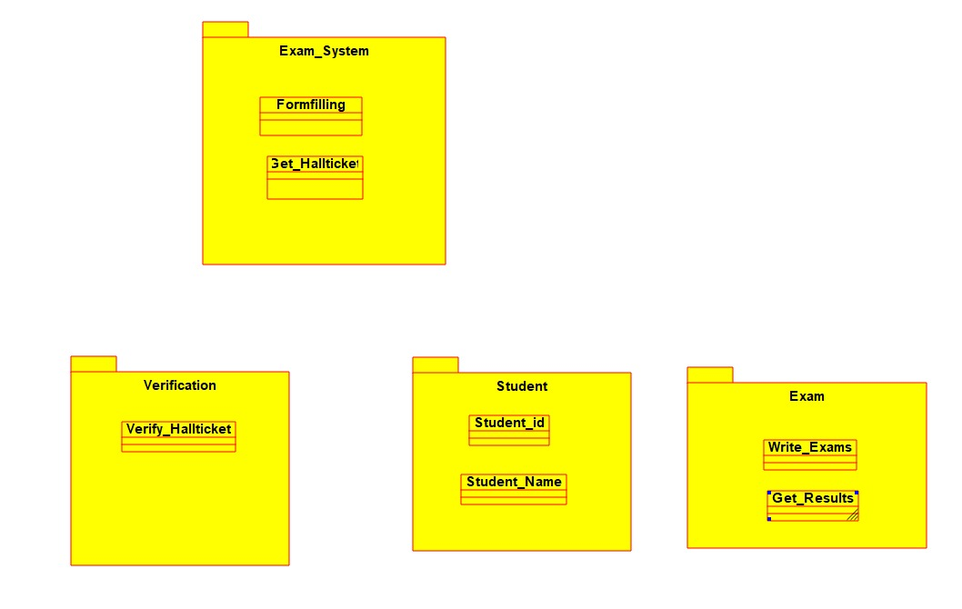

Documentation

1. Form Filling
Actor: Student
Description:
A student must fill out an examination form to register for upcoming exams. The form includes details like student name, roll number, course, subjects, and payment details (if applicable).

The system verifies the entered information and ensures the student is eligible to appear for the exams.

Once the form is successfully submitted, a confirmation message is sent to the student.

2. Get Hall Ticket
Actors: Student, Admin
Description:

Once the student completes the registration, the admin generates hall tickets for eligible students.

The hall ticket contains details like student name, roll number, exam date, time, venue, and subjects.

The student downloads the hall ticket from the system or receives it via email.

The hall ticket is mandatory to enter the examination hall.

3. Verify Hall Ticket
Actors: Examiner
Description:

Before the exam begins, the examiner checks the student's hall ticket to confirm their identity.

The examiner verifies the details on the hall ticket against the student’s ID card.

If there is any mismatch or missing document, the student is not allowed to write the exam.

Once verified, the student is permitted to enter the examination hall.

4. Write Exam
Actors: Student, Examiner
Description:

The student writes the exam as per the scheduled date and time.

The exam can be in offline mode (pen-paper-based) or online mode (computer-based).

The examiner monitors the students to prevent malpractice.

In an online exam, answers are auto-submitted once the time is up.

In an offline exam, the examiner collects answer sheets at the end.

5. Get Results
Actors: Student, Admin
Description:

After evaluation, the examiner submits the marks to the system.

The admin verifies and publishes the results.

The student logs into the system to check their results.

The system may provide options for re-evaluation requests if the student is not satisfied.

6. Admin Management
Actor: Admin
Description:

The admin manages the entire examination process.

Responsibilities include student registration approval, hall ticket generation, scheduling exams, assigning examiners, and publishing results.

The admin has full control over system functionalities and can resolve student queries.

7. Student
Role:

Registers for the exam by filling out the form.

Downloads the hall ticket.

Appears for the exam.

Checks the results after evaluation.

8. Examiner
Role:

Verifies hall tickets before the exam.

Ensures students follow exam rules and prevents cheating.

Collects answer sheets (offline) or oversees online submissions.

Evaluates the exams and submits marks.

- Analyze and design the system for ATM Transaction: Identify the use cases. (Suggestive use cases : Transaction, Approval process, Invalid PIN, Deposit Amount, Deposit savings, Deposit checking, withdraw Amount, withdraw checking, saving, withdraw saving denied, checking Transaction History, saving Transaction History). Develop the use case diagram, Packages and documentation for the same. Draw the essential class diagrams.

Use Case Diagram
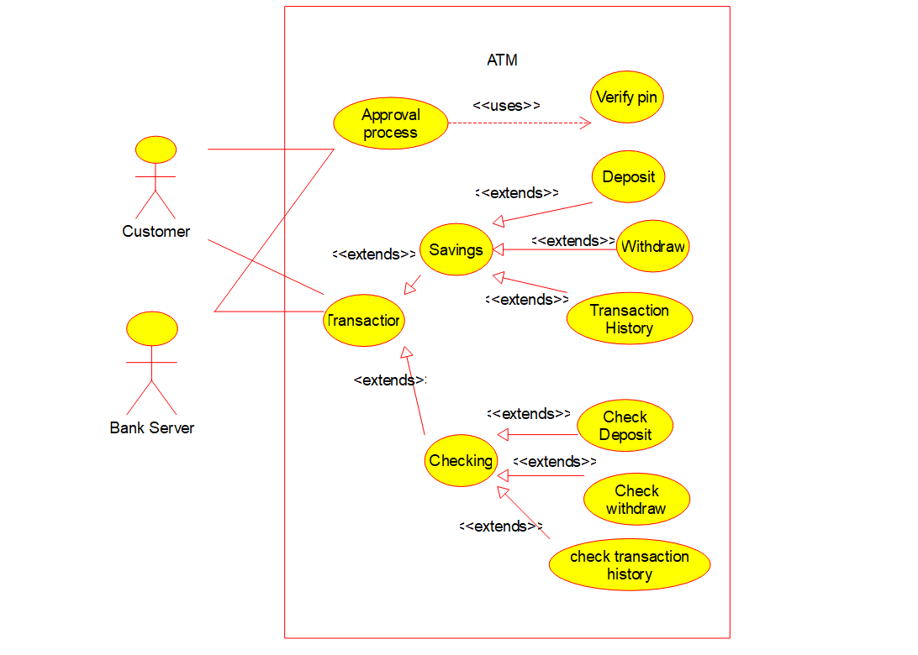

Class Diagram
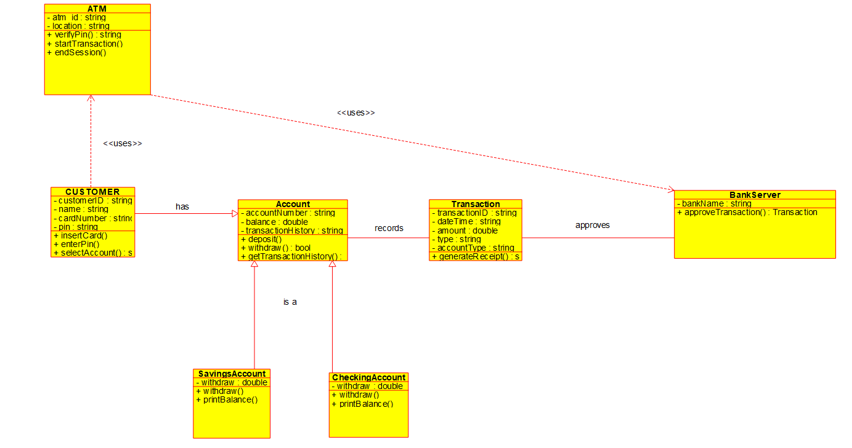

Package Diagram
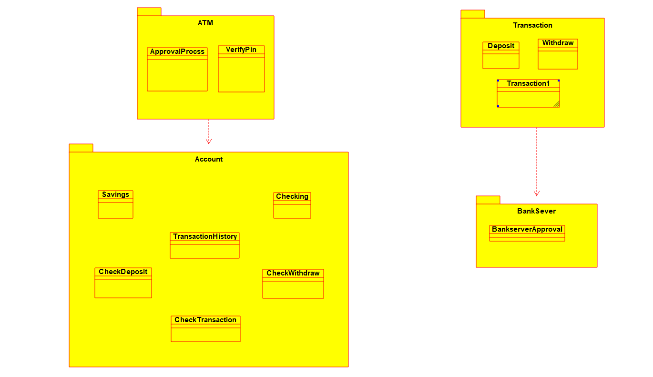

Documentation

1. Approval Process
Actors: ATM Machine, Bank Server
Description:

When a customer initiates a transaction (withdrawal, deposit, etc.), the ATM sends a request to the bank server for approval.

The bank server verifies the customer's credentials, account balance, and transaction type.

If the transaction is valid, the server approves it and sends confirmation.

If the transaction fails (due to insufficient funds, incorrect details, or technical issues), an error message is displayed.

2. Verify PIN
Actors: Customer, ATM Machine, Bank Server
Description:

The customer enters their Personal Identification Number (PIN) to access their account.

The ATM sends the PIN to the bank server for verification.

If the PIN matches the registered credentials, the customer is granted access.

If the PIN is incorrect, the system prompts the customer to retry. After multiple incorrect attempts, the ATM may block the card for security reasons.

3. Savings
Actors: Customer, ATM Machine, Bank Server
Description:

Customers can access their savings account for transactions.

After selecting the savings account, they can check the balance, deposit money, or withdraw cash.

The ATM interacts with the bank server to retrieve and update savings account details.

4. Transactions
Actors: Customer, ATM Machine, Bank Server
Description:

The customer initiates a transaction (withdrawal, deposit, transfer, or balance inquiry).

The ATM processes the request and communicates with the bank server.

The server validates and updates the account accordingly.

A transaction receipt may be printed or displayed on the screen.

5. Deposit
Actors: Customer, ATM Machine, Bank Server
Description:

The customer inserts cash or checks into the ATM.

The ATM machine scans and verifies the deposit amount.

The bank server updates the account balance after verification.

A deposit confirmation message is displayed, and a receipt is printed.

6. Checking
Actors: Customer, ATM Machine, Bank Server
Description:

The customer accesses their checking account to perform transactions.

The ATM retrieves and displays the current account balance.

Customers can withdraw, transfer, or deposit funds from their checking account.

7. Check Withdrawal
Actors: Customer, ATM Machine, Bank Server
Description:

The customer inserts a check into the ATM for withdrawal.

The ATM verifies the check details (account number, signature, amount).

The bank server authenticates the check and processes the withdrawal.

The approved amount is dispensed to the customer. If the check is invalid, an error message is displayed.

8. Check Transaction History
Actors: Customer, ATM Machine, Bank Server
Description:

The customer selects the option to view their recent transactions.

The ATM sends a request to the bank server.

The bank server retrieves and displays the last few transactions (deposits, withdrawals, transfers).

A printed receipt may be provided if requested.

9. Withdraw
Actors: Customer, ATM Machine, Bank Server
Description:

The customer selects the withdrawal option and enters the desired amount.

The ATM checks if the requested amount is within the daily withdrawal limit and available balance.

If valid, the ATM dispenses cash and updates the bank server.

A withdrawal confirmation receipt is provided.

10. Check Deposit
Actors: Customer, ATM Machine, Bank Server
Description:

The customer deposits a check into the ATM.

The ATM scans and verifies the check’s authenticity.

The bank server processes the check and updates the balance after clearance.

A confirmation receipt is printed or displayed.

11. Customer
Role:

A customer interacts with the ATM to perform transactions.

They authenticate using a debit card and PIN before accessing their account.

They can check balances, deposit money, withdraw cash, and view transaction history.

12. Bank Server
Role:

The bank server validates and approves all ATM transactions.

It checks customer credentials, account balance, and transaction eligibility.

It updates the account balance and records each transaction in the database.

- Analyze and design the system for voting system (The actors are presiding officer, 1st polling officer, 2nd polling officer,Election officer, voter, candidate; Processes : Voting, counting, and announcement of results). Develop the use case diagram, Packages and documentation for the same. Draw the essential sequence diagrams and state chart diagrams.

Use Case Diagram
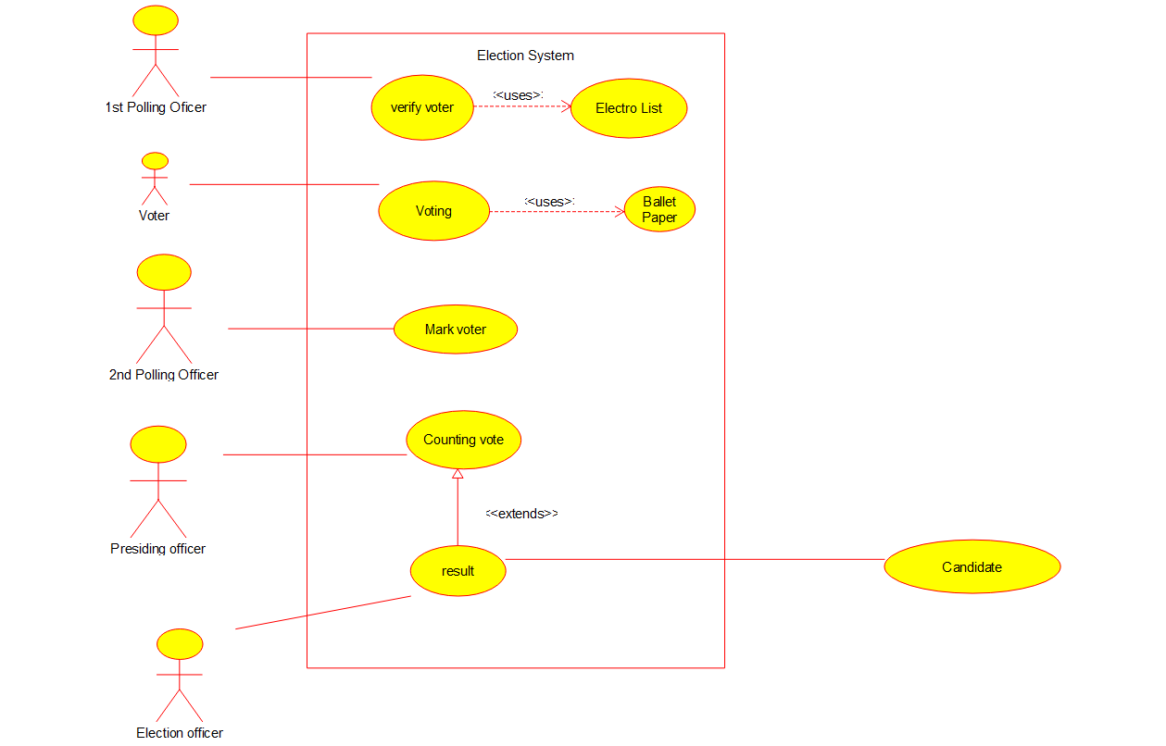

Sequence Diagram
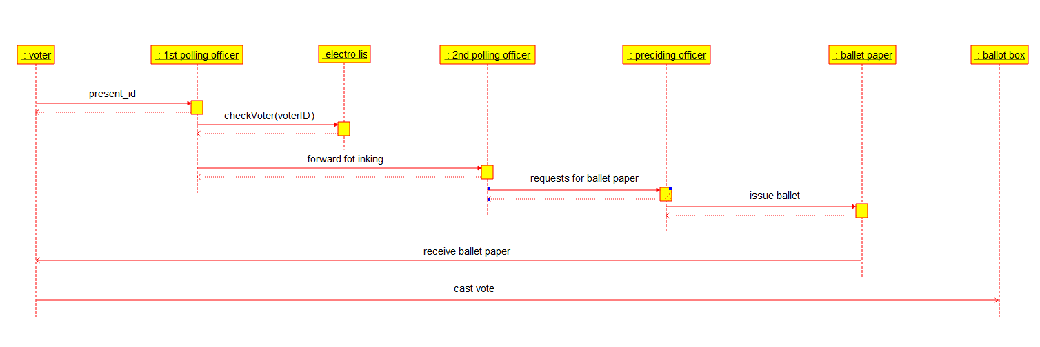

State Diagram
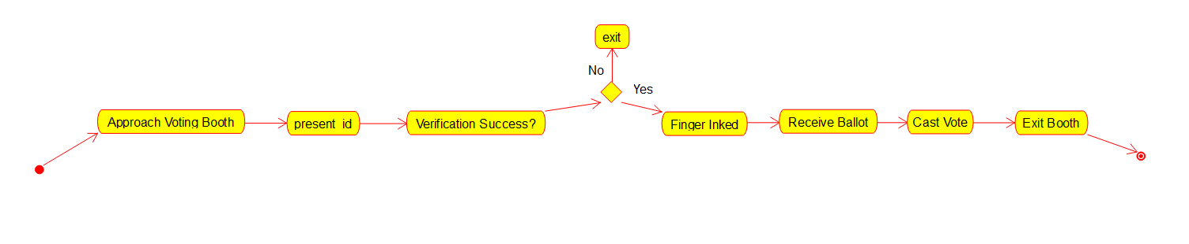

Package Diagram
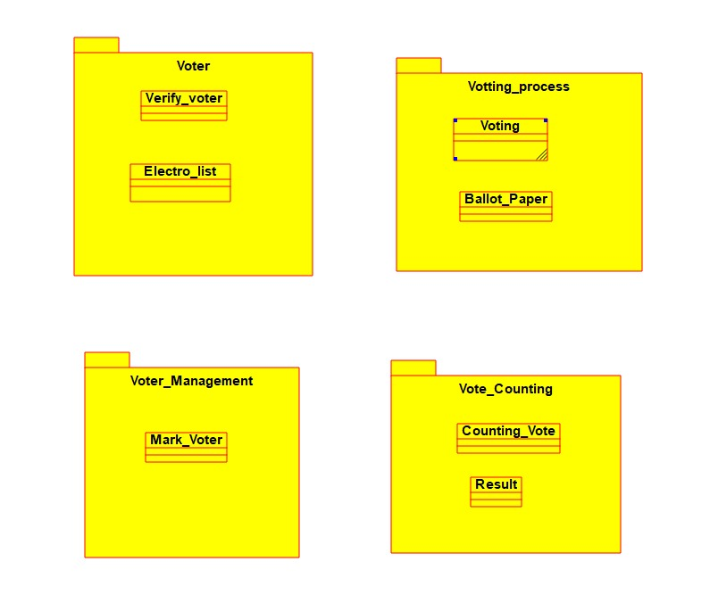

Documentaion
1. Verify Voter
Actors: Voter, Poll Officer 1, Election Officer
Description:

The voter arrives at the polling station and provides their identification (e.g., voter ID, fingerprint, or biometric verification).

Poll Officer 1 verifies the voter’s credentials against the electoral list.

If verified, the voter is allowed to proceed to the voting area.

If the voter’s details do not match or they have already voted, they are denied access.

2. Voting
Actors: Voter, Ballot Paper, Electronic Voting Machine (EVM)
Description:

The voter receives a ballot paper (for paper-based voting) or accesses an electronic voting machine (EVM) for digital voting.

The voter selects their preferred candidate and marks the ballot or presses the button on the EVM.

The completed ballot paper is placed in a ballot box, or the EVM records the vote digitally.

3. Mark Voter
Actors: Poll Officer 2
Description:

After voting, Poll Officer 2 marks the voter’s finger with indelible ink to prevent multiple voting.

The voter’s details are updated in the electoral system as “Voted”.

This ensures fair voting and avoids duplicate entries.

4. Counting Votes
Actors: Election Officer, Counting Team
Description:

After polling ends, the ballot boxes are sealed and transported to the counting center.

If using paper ballots, votes are manually counted.

If using Electronic Voting Machines (EVMs), votes are automatically tallied.

The Election Officer supervises the counting process to ensure transparency.

5. Announce Results
Actors: Election Officer, Media, Public
Description:

Once all votes are counted, the Election Officer compiles the final results.

The results are verified before official announcement.

The Election Commission or government body publicly declares the winning candidates.

Results are shared through media, official websites, and press conferences.

6. Electoral List
Actors: Election Commission, Poll Officers
Description:

The electoral list contains the names of all registered voters.

Poll Officers use this list to verify voter identities before allowing them to vote.

The list is updated before elections to include new voters and remove ineligible ones.

7. Ballot Paper
Actors: Voter, Poll Officers
Description:

If using paper-based voting, voters receive a ballot paper listing all candidates.

The voter marks their choice and places the paper in a sealed ballot box.

Ballot papers are counted manually after the voting period ends.

8. Poll Officer 1
Role:

Verifies the voter’s identity against the electoral list.

Ensures that the voter is eligible to vote.

Directs the voter to the voting booth.

9. Voter
Role:

The primary actor in the voting process.

Provides identification for verification.

Casts their vote either using a ballot paper or EVM.

Follows voting rules and procedures.

10. Poll Officer 2
Role:

Marks the voter with indelible ink after they have voted.

Updates records to prevent duplicate voting.

Assists in managing voters at the polling station.

11. Election Officer
Role:

Supervises the entire election process.

Ensures fair voting and prevents fraud.

Oversees vote counting and result announcement.

Reports any election irregularities to authorities.

- Analyze and design the system for Results section of autonomy, mainly responsible for CGPA, SGPA Calculation, Grade card generation. Develop the class diagrams and packages.

Class Diagram
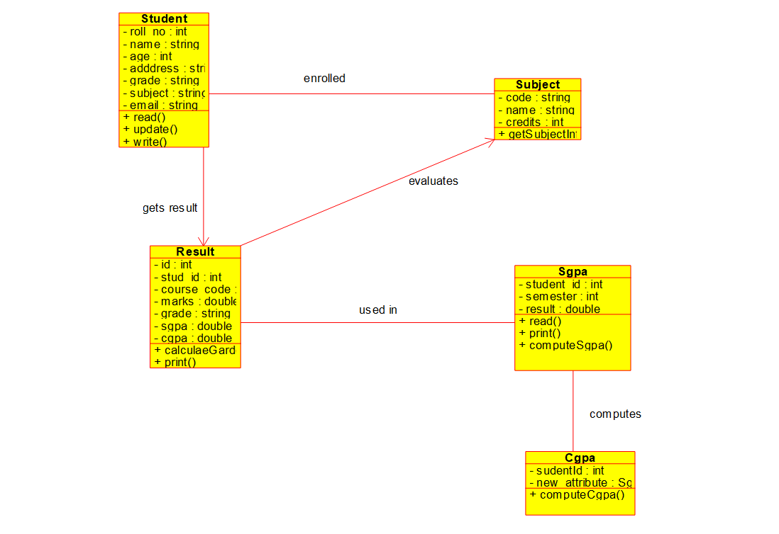

Package Diagram

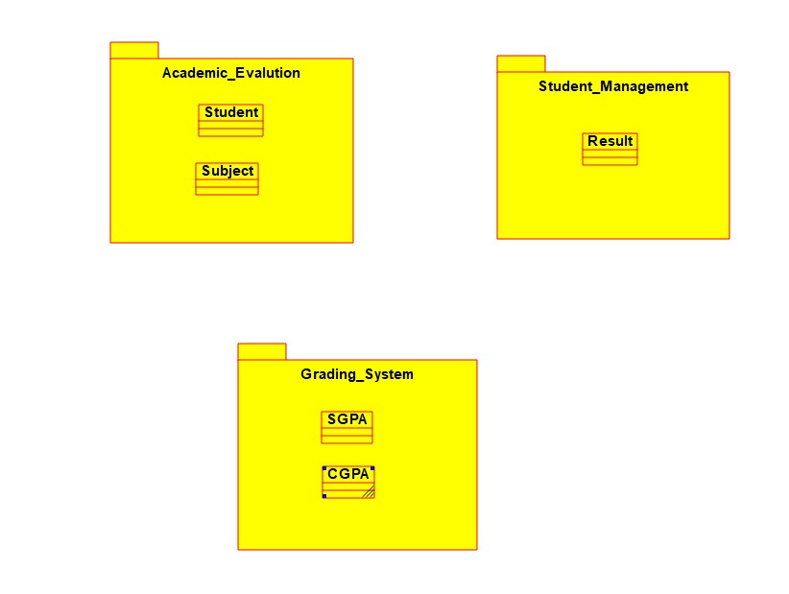

Description

Result Section – Description (for CGPA, SGPA, Grade Card Generation)

The Result Section of an Autonomous Education System plays a crucial role in evaluating and presenting students' academic performance. It encompasses three main functionalities:

1. ✅ SGPA Calculation (Semester Grade Point Average)

Description:

SGPA is calculated at the end of each semester.

It reflects a student's performance in all subjects (core, electives, labs) taken during a single semester.

Each subject is assigned a credit value and a letter grade (e.g., A, B, C), which is mapped to a grade point (e.g., A = 10, B = 8).

SGPA is computed using the formula:

\text{SGPA} = \frac{\sum (C_i \times G_i)}{\sum C_i}

Where:
= credits of the -th subject
= grade point of the -th subject

Features:

Automatically considers only the subjects registered in the current semester.

Includes both theory and lab subjects.

Calculates separate SGPA for regular and supplementary students (if applicable).

2. 📘 CGPA Calculation (Cumulative Grade Point Average)

Description:

CGPA reflects the cumulative academic performance over multiple semesters.

It is calculated by aggregating all SGPAs earned across completed semesters.

This provides a long-term academic overview and is used for final classifications like "Distinction", "First Class", etc.

Formula:

\text{CGPA} = \frac{\sum (SGPA_i \times T_i)}{\sum T_i}

Where:
= SGPA of semester
= Total credits in semester

Features:

Automatically updates each semester.

Reflects backlog clearing and improvements.

Used to generate final results and transcripts.

3. 🧾 Grade Card Generation

Description:

A grade card (or marksheet) is an official document displaying a student's performance in a given semester or program.

It includes details such as:

Student name and roll number

Semester and academic year

Subject-wise grades and credits

SGPA and CGPA

Result status (PASS/FAIL)

Features:

Generated automatically once SGPA and CGPA are calculated.

Available in digital (PDF) and printable formats.

Includes space for digital signatures of academic authorities.

May include remarks like “Passed with Distinction”, “With Backlogs”, etc.

- Analyze and design the system for Employee reference. (The Process HR Manager contacts Employees of his company and HR manager of other company to publicise about the vacancy. The person who has referred the right candidate, will be given bonus. Interview, Short listing, selection list announcement, Bonus for referred employees are all parts of the process.). Develop the use case diagram , sequence diagrams and state chart diagrams.

Use Case Diagram

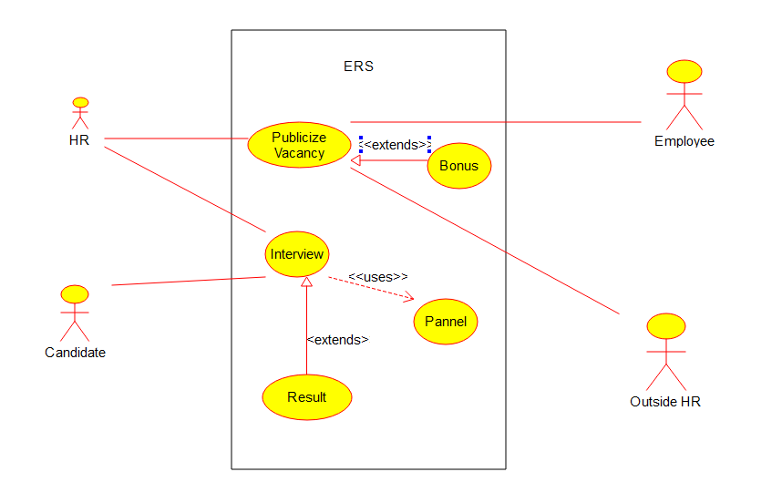
Sequence Diagram
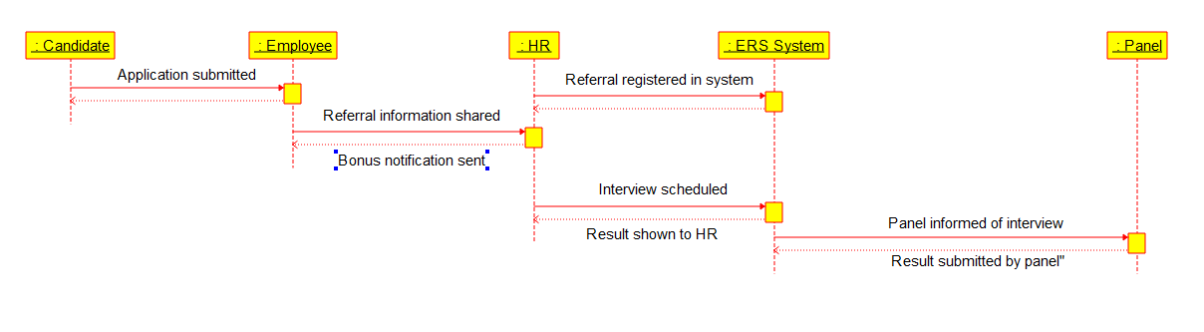

State Diagram
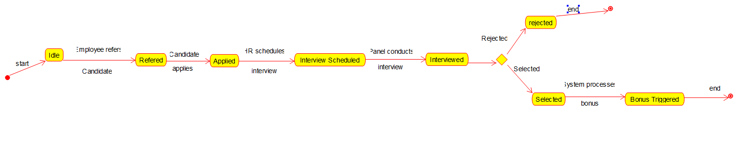

Documentation
Here is a detailed and comprehensive description of the Employee Referral Process as described in your scenario:

📘 System Description: Employee Referral Process

🔍 Overview

The Employee Referral Process is a structured recruitment method where a company leverages its internal and external human resources network to find suitable candidates for job vacancies. In this process, the HR Manager plays a key role by initiating communication about the vacancy with internal employees and HR managers from other companies to increase reach and improve the chances of finding the right candidate.

The system also ensures that those who successfully refer candidates who are selected are rewarded with a referral bonus. The overall process includes candidate referral, interviews, shortlisting, selection, and bonus disbursement.

👥 Key Participants

1. HR Manager (Company A)

Initiates and manages the recruitment and referral process.

Contacts internal employees and HRs from other companies to inform them of job openings.

2. Employees (Company A)

Receive vacancy details from their HR Manager.

Refer potential candidates from their network.

Are eligible for a referral bonus if their candidate is selected.

3. HR Manager (Company B or External HR)

May be contacted by HR Manager of Company A.

Shares vacancy details within their network or suggests candidates.

4. Referred Candidates

Individuals referred by employees or external HRs.

Undergo the interview and selection process.
🔁 Step-by-Step Process Description

1. Vacancy Announcement

The HR Manager creates a job listing with details like position, department, skills required, and qualifications.

The vacancy is circulated internally (to current employees) and externally (to HR managers in other companies) through emails, portals, or internal messaging systems.

2. Candidate Referral

Employees of the company or external HRs refer candidates by submitting resumes and details to the HR.

Each referral is logged into the system, associating the referred candidate with the person who made the referral.

3. Interview Scheduling

Referred candid

- Analyze and design the system for autonomous education system. (Classes: students Teacher, courses, subjects, core, Electives, Labs). Develop the class diagrams, sequence diagrams and packages.

Use Case Diagram

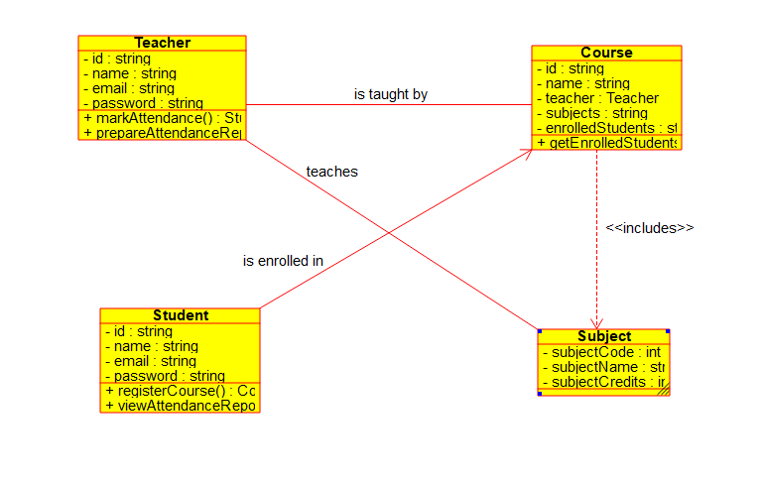

Sequence Diagram

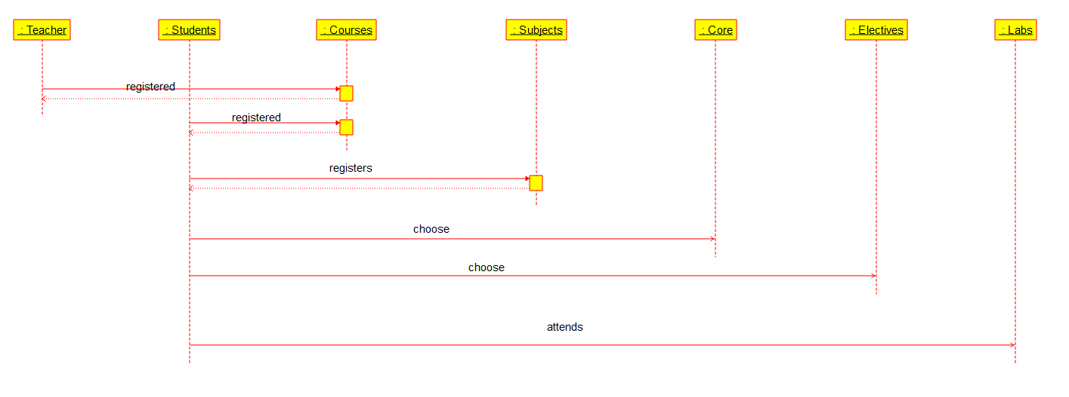

Package Diagram
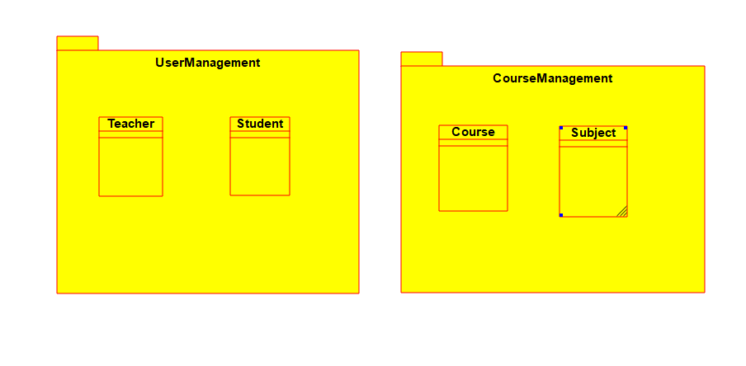

Documentation

🎓 Autonomous Education System – Full Description

An Autonomous Education System allows an academic institution to independently design its curriculum, assess student performance, and manage academic operations. It is flexible, dynamic, and student-centric, and is typically deployed in universities or colleges with academic autonomy granted by regulatory bodies.

This system is organized around several key classes/entities that work together to manage education delivery. Below is a complete description of each.

1. Student

Description:

The central user of the education system.

A student is an individual enrolled in a program and registered for courses each semester.

Students interact with the system to view course options, register for electives and labs, submit assignments, appear for assessments, and track their academic progress.

Attributes:

Student ID

Name

Email

Program

Year/Semester

Registered Courses

Grades/CGPA

Responsibilities:

Register for core, elective, and lab courses.

Attend classes, submit coursework, take exams.

View academic progress and feedback.

2. Teacher

Description:

Faculty member responsible for delivering one or more subjects or labs.

Teachers create course materials, deliver lectures, evaluate student performance, and guide academic projects.

They also participate in curriculum design under the autonomous model.

Attributes:

Teacher ID

Name

Department

Subjects Taught

Office Hours

Responsibilities:

Teach subjects (core/elective/labs).

Prepare assessments and assign grades.

Mentor students academically.

Contribute to syllabus design.

3. Course

Description:

A course is a unit of study comprising a subject, its objectives, content, assessments, and learning outcomes.

Courses may be Core, Elective, or Lab-based.

Each course has credit points, a schedule, and is delivered by one or more faculty.

Attributes:

Course Code

Course Title

Type (Core/Elective/Lab)

Credits

Prerequisites

Faculty Assigned

Responsibilities:

Maintain course syllabus and objectives.

Deliver lectures/labs as per schedule.

Conduct internal assessments and final exams

4. Subject

Description:

A subject is the actual topic of study under a course (e.g., Data Structures, Anatomy, Thermodynamics).

Subjects are the academic content around which courses are built.

Subjects are categorized into core, elective, or lab.

Attributes:

Subject Code

Subject Name

Department

Semester Offered

Category (Core/Elective/Lab)

Responsibilities:

Define specific academic content.

Help structure the course curriculum.

5. Core

Description:

Core subjects are compulsory courses that form the foundation of the academic program.

These are pre-defined and automatically assigned based on the program structure.

Students must complete all core subjects to fulfill graduation requirements.

Attributes:

Core Code

Title

Credits

Semester

Responsibilities:

Ensure foundational knowledge and skills.

Provide necessary pre-requisites for electives and advanced study.

6. Elective

Description:

Elective subjects offer students flexibility to choose topics based on interest or career goals.

Electives can be intra-departmental (offered within the program) or interdisciplinary (open electives from other departments).

Students must choose a specific number of electives to complete their degree.

Attributes:

Elective Code

Title

Department

Credits

Pre-requisites

Responsibilities:

Promote interdisciplinary learning.

Allow academic exploration and specialization.

7. Lab

Description:

Labs are practical, hands-on courses associated with certain core or elective theory subjects.

They help students apply theoretical knowledge through experiments, simulations, or project work.

Attributes:

Lab Code

Associated Subject

Lab Manual

Faculty/Instructor

Equipment Used

Responsibilities:

Facilitate skill development through practical work.

Evaluate students on experiment reports, lab viva, or project deliverables.

🔁 Relationships Between Classes

📊 Example Real-World Scenario

A 3rd-year Computer Science student logs into the system to register for the upcoming semester. The system shows a list of mandatory core subjects, a set of electives to choose from, and a lab course linked to the core subject "Operating Systems." The student registers for all, views schedules, attends lectures, submits assignments, and checks grades, all through the autonomous education system.

- Analyze and design the system for Railway reservation, which includes the details of Boarding station, classes of reservation, fare, Time table, concessions, No. of Seats, Seat No, State of reservation ( confirmed, waiting, RAC). Develop the class diagrams, packages, component diagrams and deployment diagrams.

Class Digram
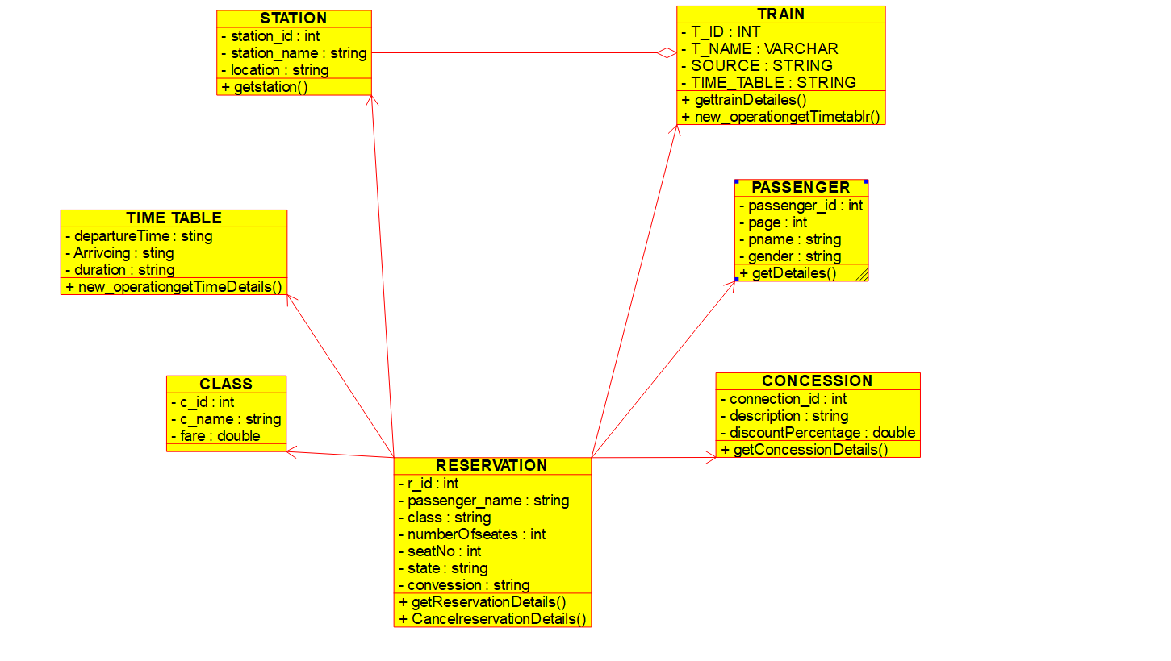

Package Diagram
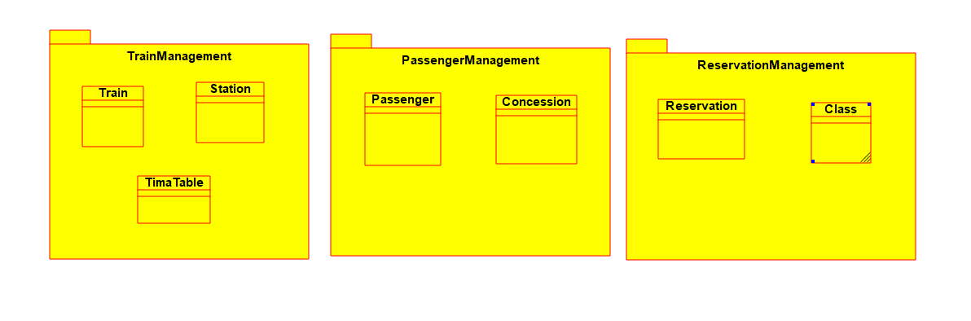

Documentation

🚆 Railway Reservation System – Analysis & Design

🔍 System Overview

The Railway Reservation System is an application that enables passengers to reserve seats on trains, view schedules, check fare details, and receive a reservation status. It handles various types of reservations (confirmed, RAC, waiting), calculates fares including applicable concessions, manages seat allocation by class, and ensures an updated train timetable.

📊 System Requirements

🎯 Functional Requirements

1. View train timetable based on source and destination.

2. Select boarding and destination stations.

3. Choose class of travel (e.g., Sleeper, AC, First Class).

4. Display available seats and reservation status.

5. Calculate fare (including concessions like senior citizen, student, etc.).

6. Reserve seat and assign seat number.

7. Display reservation status: Confirmed, RAC, or Waiting List.

8. Print reservation ticket with all details.

⚙ Non-Functional Requirements

Should be responsive and fast.

Must handle concurrent bookings.

Data must be accurate and updated in real-time.

Secure payment and personal information storage.

🧱 System Design – Main Components

1. Train

Train Number

Train Name

Route (Stations List)

Timetable (Arrival/Departure Times)

Classes Available

2. Station

Station Code

Station Name

Zone/Region

Distance from Origin

3. Timetable

Train Number

Station Code

Arrival Time

Departure Time

Day Number (relative to departure)

4. Class of Reservation

Class ID (e.g., SL, 3A, 2A, 1A)

Class Name (Sleeper, AC 3 Tier, etc.)

Fare per KM

Total Seats in Each Coach

5. Fare

Base Fare (distance × rate per km)

Class Multiplier (AC has higher rate than Sleeper)

Additional Charges (reservation charge, GST)

Discount (Concessions if applicable)

6. Concessions

Type (Senior Citizen, Defense, Student, Handicap, etc.)

Eligibility Criteria

Concession Percentage

7. Reservation

PNR Number

Passenger Details

Train Number

Boarding Station

Destination Station

Travel Date

Class

Seat Number

Reservation Status (Confirmed, RAC, Waiting)

Fare Paid

8. Seat

Coach ID

Seat Number

Reservation Status

Assigned to PNR (if booked)

🔄 Reservation Status Logic

1. Confirmed (CNF):

Seat is available; booking is completed with seat assigned.

2. RAC (Reservation Against Cancellation):

Partial confirmation; passenger can board but may not have a berth until someone cancels.

3. Waiting List (WL):

All seats and RACs are booked. Passenger is on waitlist. Confirmation depends on cancellations.

🖥 Use Case Diagram Description

Actors:

Passenger (User)

Reservation System (Automated System Admin)

Use Cases:

Search Train Timetable

Select Route (Boarding and Destination)

Choose Class

Check Seat Availability

Apply for Concession (if eligible)

View Fare

Book Ticket

Generate PNR and Ticket

Check Booking Status (CNF, RAC, WL)

🔁 Sequence Diagram: Booking a Ticket

1. Passenger → Search trains between two stations

2. System → Display available trains and classes

3. Passenger → Select train, class, and date

4. System → Show seat availability and fare

5. Passenger → Apply concessions (if any)

6. System → Calculate final fare

7. Passenger → Confirm and pay

8. System → Assign seat and generate PNR

9. System → Display ticket and reservation status

- Analyze and design the system for Income Tax assessment. Develop the class diagrams, collaboration diagrams, state chart diagrams.

Class Digram
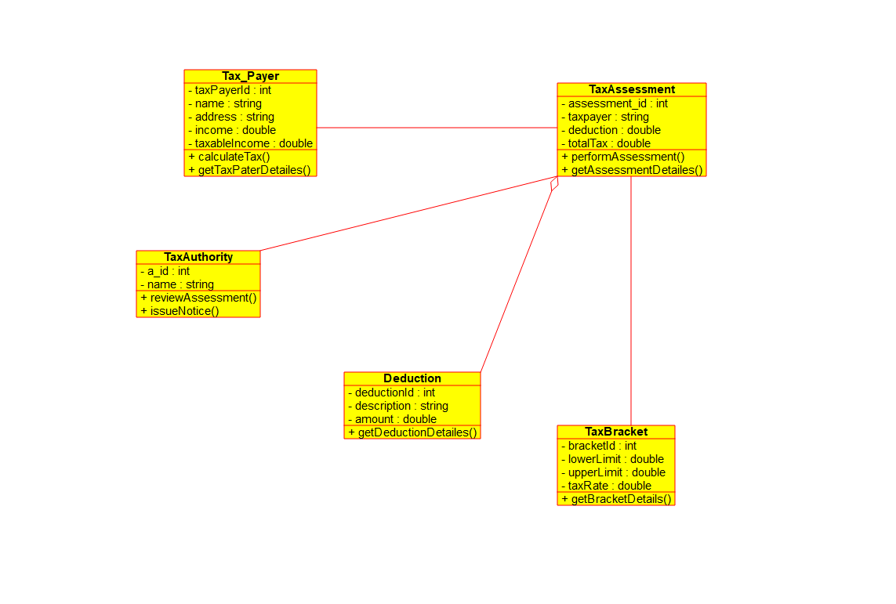

Collaboration Diagram

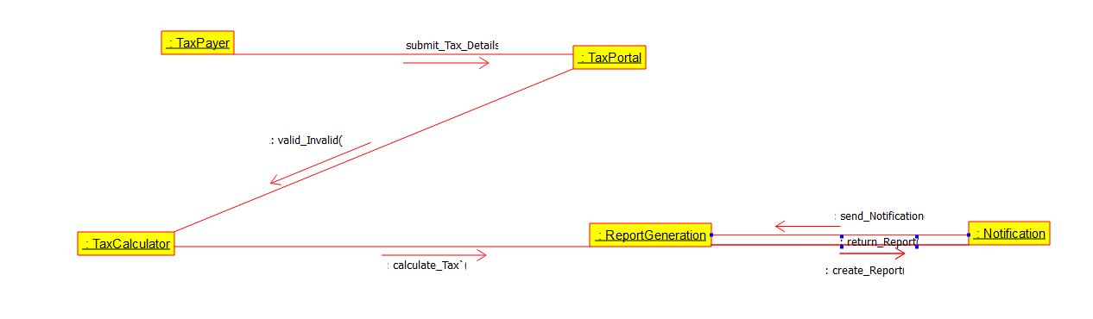

State Diagram

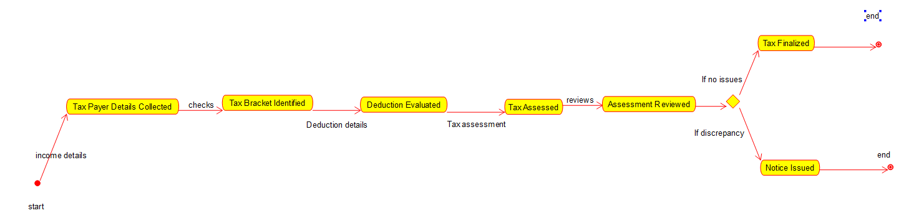

Documentation
Here is a complete analysis and design of an Income Tax Assessment System, including:

Descriptions of use cases and actors

Class Diagram

Collaboration Diagram

State Chart Diagram

💼 System Overview: Income Tax Assessment System

The Income Tax Assessment System is a government-authorized software used to collect, process, evaluate, and assess the income tax returns filed by individuals, businesses, and entities. The system allows users to file returns, claim deductions, view tax liabilities, make payments, and receive assessments or refunds.

👥 Actors in the System

1. Taxpayer

Individual, business, or entity filing their income tax return.

Uses the system to submit income, claim deductions, and check status.

2. Income Tax Officer (ITO)

Government officer who verifies the return, assesses the correctness, initiates scrutiny if needed, and processes assessments or refunds.

3. System Administrator

Manages users, updates tax rules, and ensures system uptime and accuracy

- Analyze and design the system for Online shopping system. Develop the class diagrams, collaboration diagrams, state chart diagrams and packages.
a. Check for the product. b. Place order.
c.Track the order. d.Cancel the order. e.Feedback.

Use Case Diagram

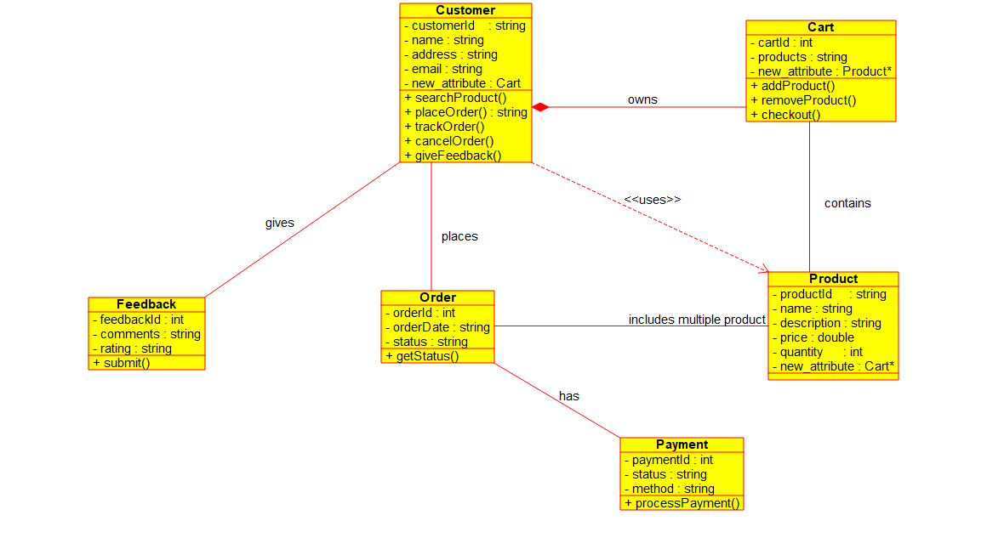

Collaboration Diagram

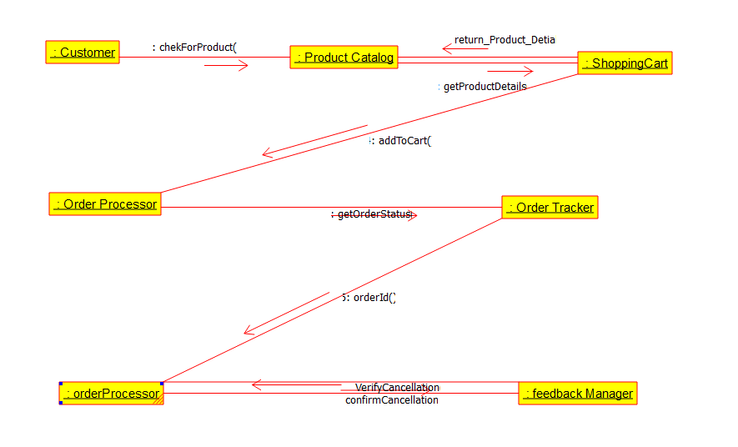

State Diagram

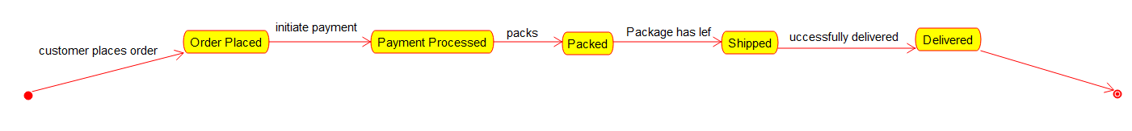

Documentation

1. System Overview
The Online Shopping System allows customers to:
Browse and check products
Place orders
Track the status of their orders
Cancel orders
Provide feedback after delivery
The system supports multiple users and handles operations from product selection to feedback post-delivery.

2. System Requirements

🔹 Functional Requirements
Product catalog browsing
Add to cart and place an order
Order tracking (dispatched, shipped, delivered)
Cancel order before shipping
Post-purchase feedback submission

🔹 Non-Functional Requirements
Scalability to support many users
Secure payment and data privacy
Responsive UI/UX for various devices

3. Class Diagram

Main Classes and Attributes/Methods:
Class | Attributes / Methods
User | userId, name, email, password  login(), register()
Product | productId, name, category, price, stock  getDetails()
Order | orderId, userId, list of products, status, date  placeOrder(), cancelOrder()
Cart | cartId, userId, productList  addProduct(), removeProduct(), checkout()
Payment | paymentId, amount, method, status  processPayment()
Feedback | feedbackId, userId, productId, rating, comment  submitFeedback()
Shipment | shipmentId, orderId, status  trackOrder()

📌 Relationships:
A User has one Cart
A User places many Orders
An Order is linked to one or more Products
Each Order has one Shipment
A User provides Feedback on Products

4. Collaboration Diagram (For "Place Order")

Objects:

:User
:Cart
:Order
:Payment
:Shipment

Interaction Flow:
User selects items → Cart
User triggers checkout() on Cart
Cart creates a new Order
Order invokes processPayment() on Payment
On success, Shipment is initiate
Order is confirmed

