**Time Series Analysis of Spirograms for Early COPD Detection and LongTerm Risk Prediction**

**Chetan Nihith Vemula**  
CSE, School of Engineering and Technology  
Bml Munjal UniversityGurugoan, Haryana  
[chetannihith.vemula.22cse@bmu.edu.in](mailto:chetannihith.vemula.22cse@bmu.edu.in)

**Abhinav V**  
CSE, School of Engineering and Technology  
Bml Munjal UniversityGurugoan, Haryana  
[abhinav.vuddagiri.22cse@bmu.edu.in](mailto:abhinav.vuddagiri.22cse@bmu.edu.in)

l**Sanjay Reddy**CSE, School of Engineering and Technology  
Bml Munjal UniversityGurugoan, Haryana  
[pulagamsanjay.reddy.22cse@bmu.edu.in](mailto:pulagamsanjay.reddy.22cse@bmu.edu.in)

**Likhit Sagar G**   
CSE, School of Engineering and Technology  
Bml Munjal UniversityGurugoan, Haryana  
[likhitsagar.gajja.22cse@bmu.edu.in](mailto:likhitsagar.gajja.22cse@bmu.edu.in)

l**Nithish Basireddy**CSE, School of Engineering and Technology  
Bml Munjal UniversityGurugoan, Haryana  
[basireddy.nithishreddy.22cse@bmu.edu.in](mailto:basireddy.nithishreddy.22cse@bmu.edu.in)

*Abstract*   
Chronic Obstructive Pulmonary Disease (COPD) is a serious lung condition that makes it difficult for people to breathe over time. Detecting and predicting COPD in its early stages can help prevent severe health problems and improve patient outcomes. In this study, we present a deep learning based approach called DlSpiro to detect and predict the future risk of COPD using spirogram time series data. Since we did not have access to real patient data, we created a synthetic dataset with 30,000 entries, including cases of hospitalization and death. Our method uses a step by step pipeline that first smooths the breathing signal, extracts important patterns, and then uses demographic details to make predictions. The model can identify if a person currently has COPD and also predict their risk of developing the disease over the next 1 to 5 years. This system can support early screening and help doctors provide timely care to high risk individuals.

Keywords  *Chronic Obstructive Pulmonary Disease, COPD, Deep Learning, Time Series, Spirogram, Synthetic Dataset, Early Prediction, Health Monitoring, DlSpiro*

# **Introduction**

Chronic respiratory conditions are a growing concern worldwide, especially those that cause long term breathing difficulties and reduce the overall quality of life. One such illness is a progressive lung disease that makes it harder for individuals to breathe properly over time. It affects daily activity, increases the chances of other health problems like heart conditions, and may even lead to premature death. The sooner this disease is detected, the better the chances are to manage it and slow down its effects. Unfortunately, most people do not realize they have it until the symptoms become serious, by which time treatment becomes harder and less effective.

In this study, we aim to develop an intelligent system that not only detects the presence of the disease but also predicts the chances of someone developing it in the future. Our goal is threefold to propose a new idea using deep learning, to build this system and test it using data we generated, and to compare our results with typical methods currently used in the medical field. Instead of using realworld patient data, which is often hard to access due to privacy restrictions, we created a synthetic dataset with 30,000 records. This dataset includes different categories such as general cases, hospitalization, and death, with each record containing breathing signal data and basic patient information like age, gender, and smoking status.

The importance of this study lies in the fact that early and accurate predictions can lead to early medical care. With the help of advanced deep learning techniques, we can uncover hidden patterns in breathing signals that might not be visible through traditional analysis. If our model can warn individuals about their risk levels in advance, it can empower them to take early action, potentially saving lives and reducing the load on healthcare systems.

However, predicting disease risk from breathing signals is not a simple task. There are several challenges to overcome. The first is that breathing data, especially the flow of air during exhalation, can be unstable and vary widely from person to person. The second issue is the difference in the length of breathing curves due to how long each person exhales. Common methods like trimming or padding this data often add noise or remove useful information. Third, most AI models act like black boxes they give a result but don’t explain how they reached that conclusion. This lack of transparency makes it hard for doctors to fully trust the results. Lastly, current systems mostly focus on detecting patients who already have the disease, but they fail to predict who might develop it in the near future.

To solve these problems, we introduce a deep learning system called DlSpiro, designed to analyze breathing signals in detail. The system works in several steps: it first smooths the raw breathing curve to reduce noise, then extracts meaningful patterns using a flexible patch based approach. It also combines this information with the person’s demographic data to improve accuracy. Finally, it predicts whether the person currently has the disease and, if not, their risk of developing it in the next 1 to 5 years. Our model not only makes predictions but also highlights which parts of the signal were most important in reaching the decision, making the system more explainable.

The rest of this paper is organized as follows: Section 2 reviews previous work in this area. Section 3 explains the design and working of our proposed system DlSpiro in detail. Section 4 presents the results and evaluates the model’s performance compared to traditional methods. Finally, Section 5 concludes the study and discusses future improvements and research directions.

# **LITERATURE REVIEW**

To build a deep learning model that can detect and predict Chronic Obstructive Pulmonary Disease (COPD) using spirogram data, it is important to understand the existing research in this area. The purpose of this literature review is to explore the techniques, datasets, and models that have been used by other researchers in the past. This helps us identify the strengths and limitations of previous methods and shape the development of our own model, DlSpiro.

In recent years, many researchers have used deep learning to identify COPD by analyzing spirogram or lungrelated data. One of the most common algorithms applied in these studies is the Convolutional Neural Network (CNN). CNNs are powerful in extracting patterns from raw data, and they have been used to analyze electronic nose (enose) signals to distinguish between COPD patients and healthy individuals [3]. Another frequently used algorithm is Long ShortTerm Memory (LSTM), a type of Recurrent Neural Network (RNN) that works well with time series data. LSTMs have been used to process lung sound sequences and detect abnormalities [4].

Another effective technique includes the use of ResNet18, a residual CNN architecture, which has shown high performance in learning from spirogram curves [6]. Some studies have combined CNNs with attention mechanisms to highlight key features in the data, such as important moments in the breathing curve, improving model explainability [7]. CatBoost and XGBoost, which are gradient boosting algorithms, have also been used as final classifiers after deep features are extracted. These methods are especially good at combining structured information like age, gender, and smoking status with learned features to improve prediction accuracy [8, 9].

In terms of datasets, three major sources stand out. First, the UK Biobank dataset has been widely used due to its rich spirogram time series and demographic information [6]. Second, CT scan datasets have been used for anomaly detection in COPD using deep learning [5, 11]. Third, datasets containing lung sound recordings have also been utilized to classify different stages or types of lung disease [4]. These datasets provide a range of signal types volume time, volume flow, audio, and imaging which allows researchers to test models under different scenarios.

Different algorithms are often combined with specific types of data to get better results. For example, CNNs are typically used with imaging data like CT scans [5], while LSTMs are more suited for time series data such as spirograms [10]. XGBoost and CatBoost are mostly applied as classifiers on top of learned features from CNN or LSTM layers, especially when integrating both unstructured (signals) and structured (demographic) data [9, 8]. This combination of deep learning and structured classification leads to better disease prediction models with improved accuracy and interpretability.

In summary, the field of COPD detection and prediction has greatly benefited from the use of deep learning, especially CNNs, LSTMs, ResNet18, CatBoost, and XGBoost. These models, when applied to datasets like UK Biobank or CT scans, have shown promising results. Our approach builds upon these ideas by integrating synthetic spirogram data and demographic features into a complete pipeline that allows both disease detection and early risk prediction.

# **METHODOLOGY**

This section presents the detailed process of our proposed COPD detection and prediction approach using deep learning techniques. The methodology includes a complete pipeline from raw input data preprocessing to signal smoothing, key pattern extraction, model interpretation, and future risk prediction. We evaluate and compare the performance of four different models: the clinical standard FEV1/FVC ratio, a deep learning baseline VolumeFlow ResNet18, our own initial model DlSpiro (nonsmooth), and the final refined version DlSpiro (smoothed). All models are tested on a synthetic dataset of 30,000 patient records created to replicate real-world breathing patterns and disease progression.

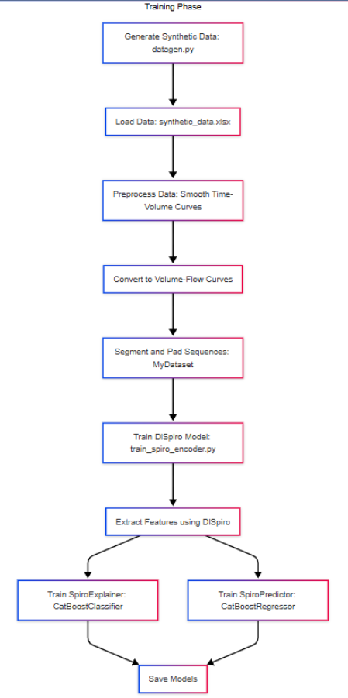

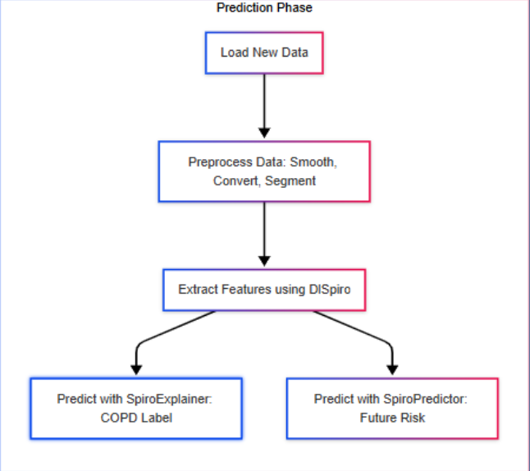

***Fig 1 – System Design Flowchart***

The process begins by feeding the synthetic dataset containing 30,000 entries with spirogram and demographic data into a preprocessing stage. Here, noisy or unstable breathing curves are refined using SpiroSmoother, which applies Gaussian filtering to the Time Volume curves. These refined curves are then transformed into Volume Flow curves to highlight airflow changes over time. The next stage, SpiroEncoder, splits the breathing signal into key segments ("patches") and encodes each into a fixed representation. These features are passed to SpiroExplainer, which fuses demographic details (age, sex, smoking status) with signal based features using attention mechanisms. Based on the detection outcome, if COPD is found, a diagnosis report is generated. If not, SpiroPredictor assesses the patient’s risk of developing COPD within 1 to 5 years, and the final output report includes either diagnosis or risk scores.

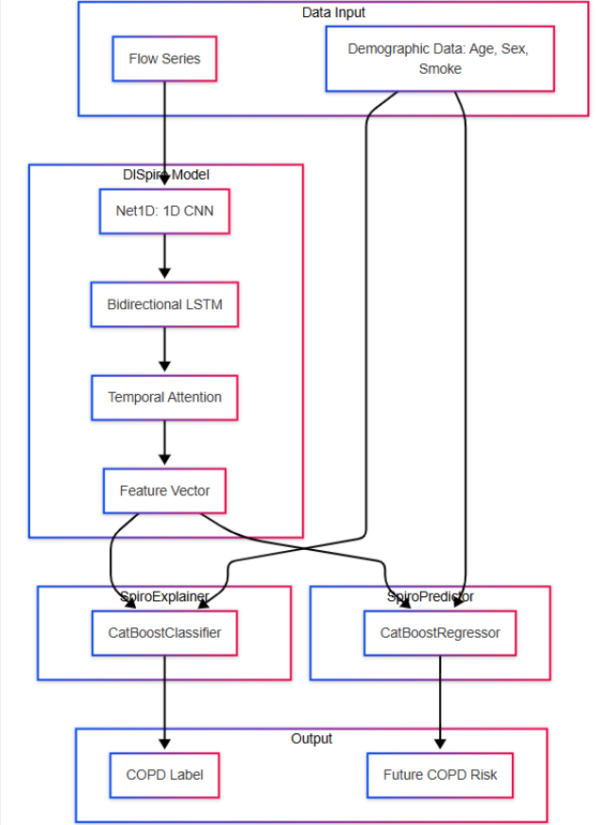

***Fig 2 – Architecture Flowchart***

The architecture of our proposed model, DlSpiro, consists of four main modules:

1. **SpiroSmoother:** Stabilizes the TimeVolume curve using Gaussian smoothing, ensuring clean and interpretable VolumeFlow curves.
2. **SpiroEncoder:** Extracts variablelength key patches from each curve and encodes them using Net1D and BiLSTM layers to learn spatial and temporal features.
3. **SpiroExplainer:** Enhances interpretability by applying volume attention and integrating demographic data, helping the model to explain why it makes specific predictions.
4. **SpiroPredictor:** Predicts the longterm COPD risk using concavitybased analysis of curve patterns and fuses it with model outputs for high-risk patient prediction.

We also implemented and compared three other models:

* FEV1/FVC Ratio: Uses the standard medical threshold (<70%) for COPD detection.
* Volume Flow ResNet18: A CNN model trained on imagelike Volume Flow curves.
* DlSpiro (nonsmooth): Our deep model without the initial signal smoothing step.

Several key calculations and methods are involved in the modelling process:

**Gaussian Smoothing**:

Where g(j) is the Gaussian kernel for smoothing Time-Volume data.

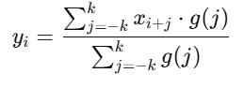

**Flow Computation (VolumeFlow Curve)**:

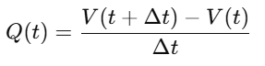

**Key Patch Count:**

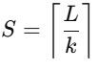

Where *L* is the sequence length and *k* is the segment length

**Concavity Measure for Risk Prediction:**

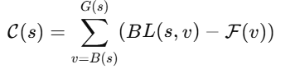

Which helps assess early or late airway collapse in the curve.

**Attention Weighting**:



This methodology combines classical clinical indicators and modern AI-powered analysis to detect and predict COPD from breathing patterns. The **FEV1/FVC method** is quick but lacks detail and personal context. **ResNet18** provides deeper learning but lacks demographic fusion and explainability. Our intermediate model, **DlSpiro (nonsmooth)**, improves accuracy using neural networks but suffers from signal instability. The final model, **DlSpiro**, adds signal smoothing, demographic feature fusion, and concavity-based risk scoring, making it a powerful and interpretable tool for both diagnosis and prevention. Together, these models were evaluated using a consistent synthetic dataset to ensure fairness and reliability in the comparison.

**IV. PERFORMANCE AND RESULTS**

In this section, we evaluate the performance of our proposed model, DlSpiro, along with three other models: the clinical baseline FEV1/FVC ratio, the deep learning baseline VolumeFlow ResNet18, and our internal baseline DlSpiro (nonsmooth). Each model was trained and tested on our synthetic dataset of 30,000 samples. The evaluation is conducted on three categories: all COPD cases, hospitalization related COPD cases, and death related COPD cases. We use widely accepted metrics such as AUROC, AUPRC, and F1score to assess model performance.

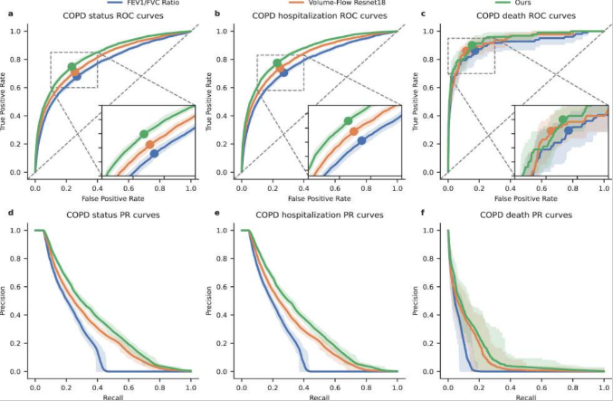

***Fig 3 – Evaluation Comparison***

To ensure a fair comparison, we used the same input features and preprocessing for all models. As shown in the evaluation results, the traditional FEV1/FVC method had the lowest performance across all metrics. The Volume Flow ResNet18 model performed better but lacked temporal modelling and demographic integration. The DlSpiro (non-smooth) model showed further improvements by learning patterns from the raw volume flow curves, but it was affected by signal instability. Our final version, DlSpiro, which includes signal smoothing and structured feature fusion, achieved the highest scores in every category, with an AUROC of 0.8328, AUPRC of 0.3570, and F1score of 0.3950 on the full dataset.

We also evaluated performance in specific subcategories. For **hospitalization cases**, DlSpiro achieved an AUROC of **0.8538**, showing its effectiveness in identifying high risk individuals. For **deathrelated cases**, DlSpiro maintained strong results with an AUROC of **0.9419** and F1score of **0.2304**, outperforming all baselines. This shows the model’s potential to support early intervention and prevent severe outcomes.

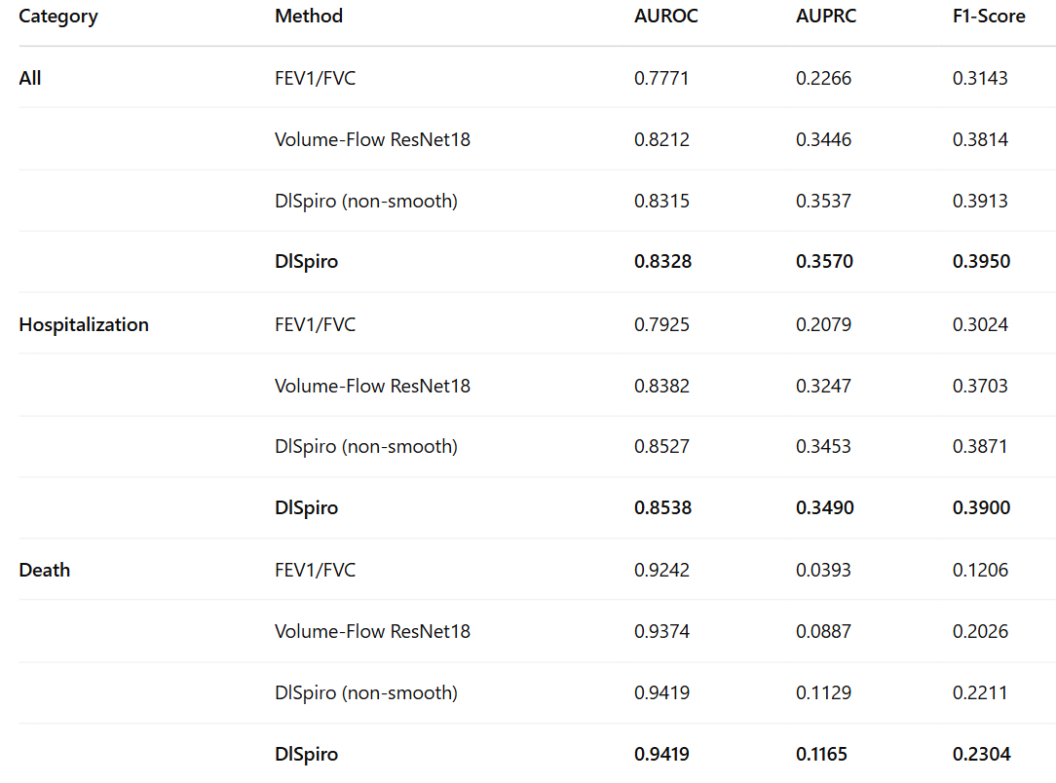

***Table 1 – Evaluation Comparison***

The nomogram is a visual tool that shows how much each factor like age, gender, smoking status, and the FEV1/FVC value contributes to predicting whether someone has COPD. Each variable is given a score, and the total score helps estimate the person's risk of having the disease. In the nomogram, there’s also something called a threshold, which is like a decision point. For example, if the threshold is 0.5, then any predicted probability above 0.5 means the person is likely to have COPD. If it’s below 0.5, then the person is likely not to have it. This makes it easier for doctors to visually assess and understand the likelihood of a COPD diagnosis for any individual based on their personal details.

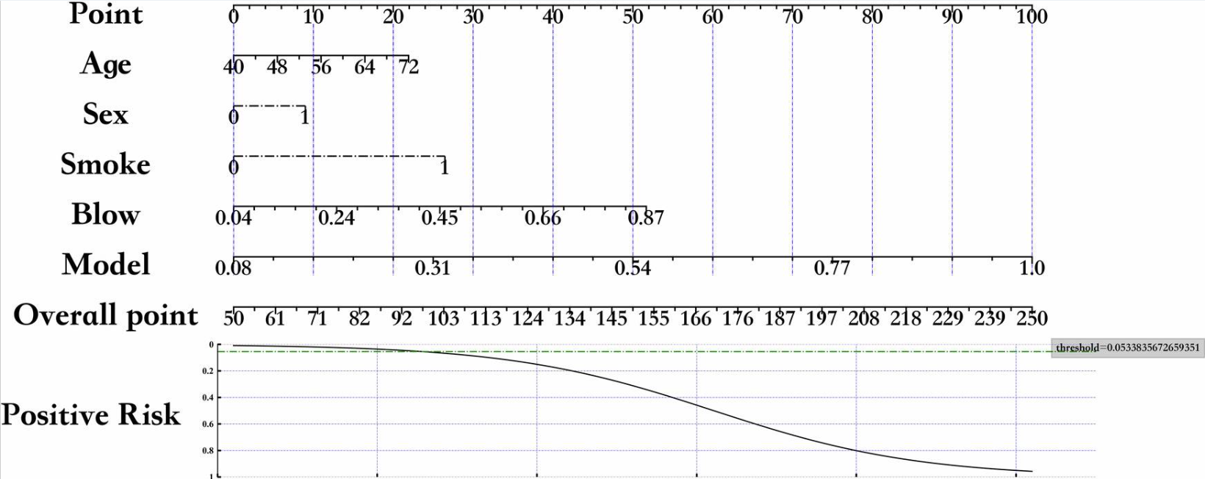

***Fig 4 The nomogram of COPD detection***

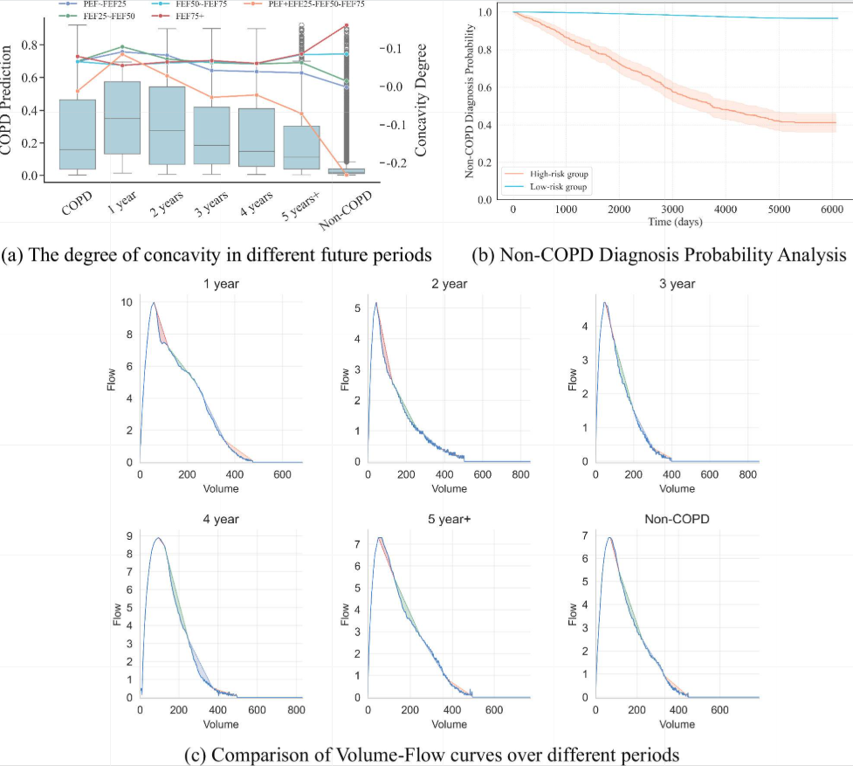

***Fig 5 Future COPD prediction overview***

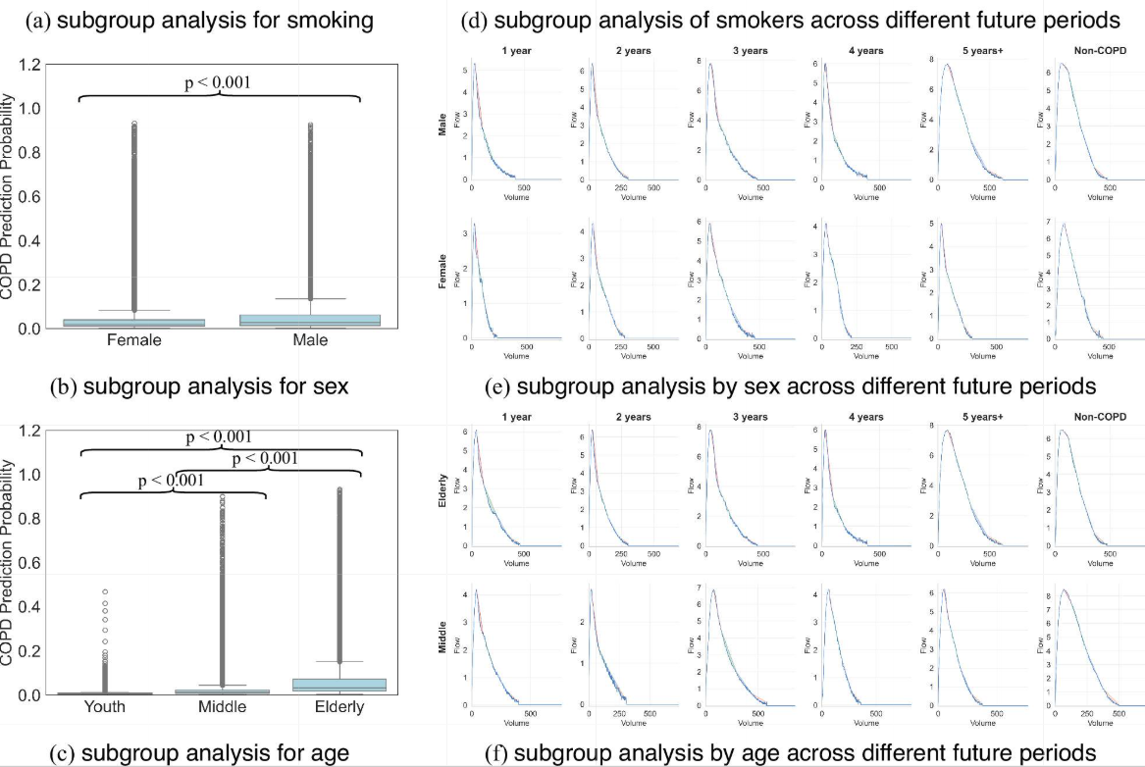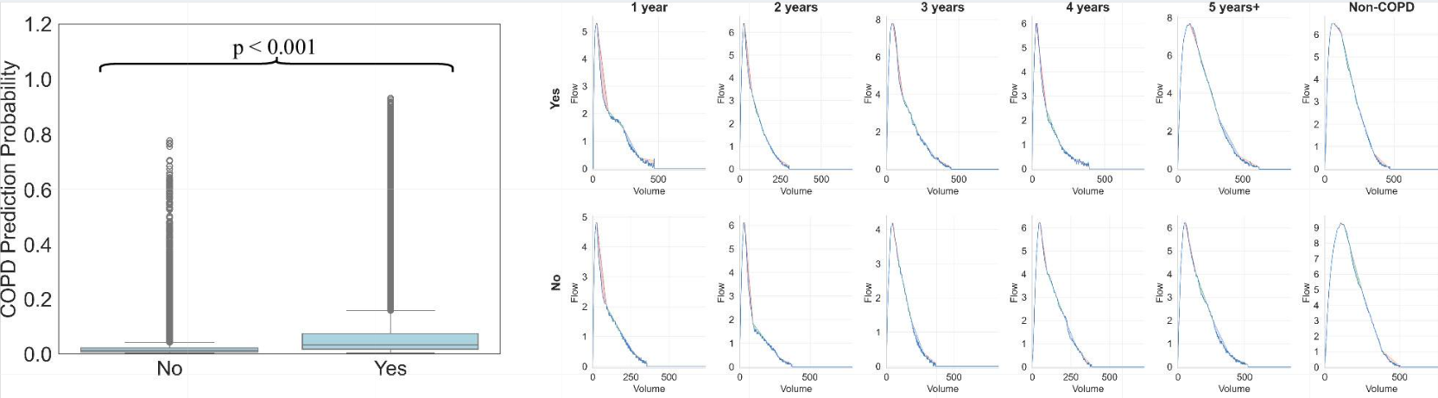

***Fig 6 -*Subgroup analysis overview**

In addition to global performance, we conducted subgroup analyses based on age, sex, and smoking status. Across all subgroups, DlSpiro consistently achieved the highest AUROC scores. For instance, among smokers, it reached an AUROC of 0.8266, while among elderly patients (55+), it reached 0.8210. These results confirm that the model is robust and performs well across different population groups, supporting its practical use in real world clinical settings.

We also analyzed how DlSpiro predicts the future risk of COPD. By studying the concavity patterns in different phases of the Volume Flow curve (such as PEF–FEF25 and FEF75+), we found that curve collapses in earlier phases strongly correlate with higher future COPD risk. DlSpiro uses these concavity trends along with demographic data to assign risk scores for the next 1 to 5 years, helping clinicians target patients for early screening and preventive care. In the high risk group, risk increases rapidly over time, while the low risk group remains stable supporting the model’s predictive accuracy.

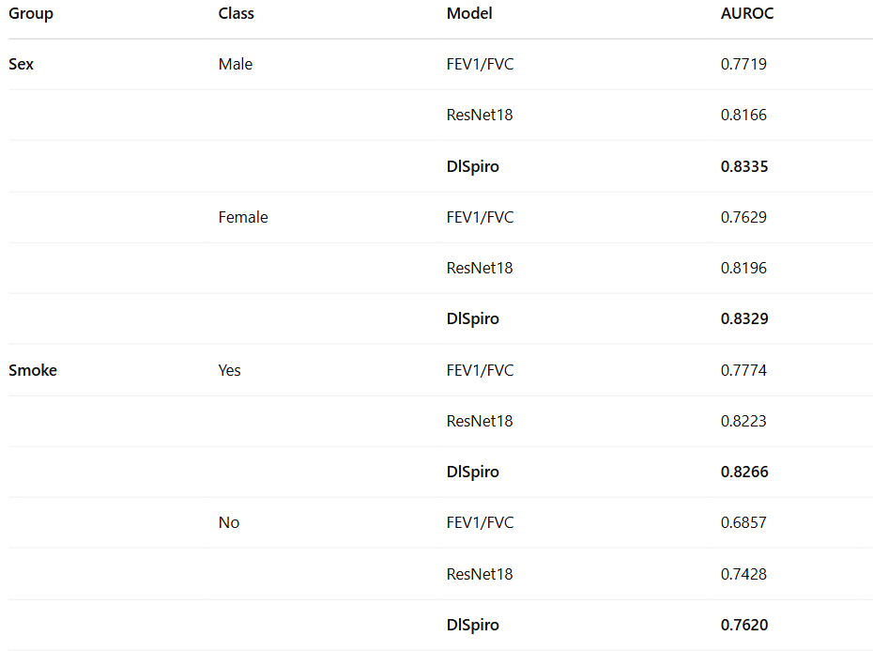

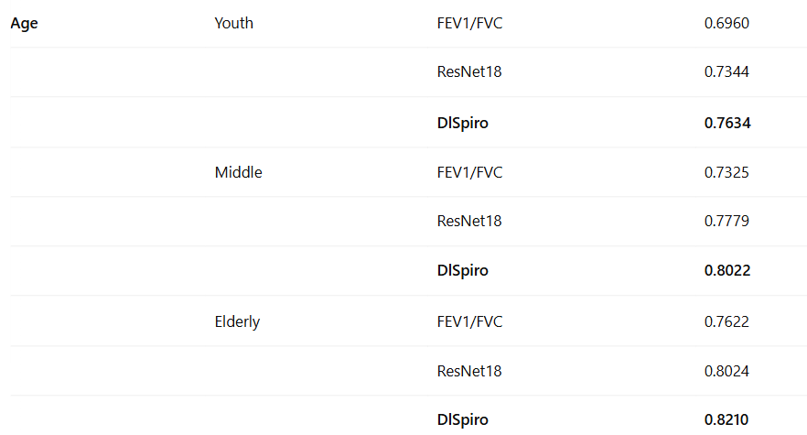

***Table 2 Comparison of subgroup evaluations***

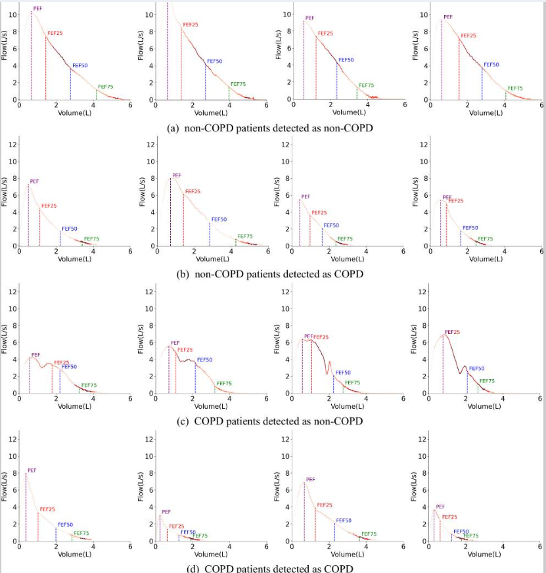

***Fig 7 – The explainer of the model***

Healthcare professionals often face challenges in identifying specific disease patterns directly from long and complex breathing signals. To solve this problem, our model uses a component called SpiroExplainer, which automatically highlights the important parts of the Volume Flow curve that indicate abnormalities. It divides the curve into small patches and assigns attention scores to each one brighter areas mean the model is paying more attention there. This helps doctors understand which parts of the breathing signal the model is focusing on when making a prediction. For example, in non COPD cases (Fig. 7a), the model mainly focuses on the mid (FEF25–FEF50) and end (FEF75) parts of the curve, which appear smooth and full typical of healthy lungs. In contrast, for COPD patients (Fig. 7d), the model focuses on the tail of the curve near FEF75, where a sudden drop or collapse appears due to blocked airways a classic COPD sign.

When the model makes incorrect predictions, we found it still provides medically reasonable explanations. For example, in Fig. 7b, a non-COPD patient with asthma shows a weak exhalation pattern after FEF75 due to poor inhalation, which the model mistakes for COPD. Similarly, in Fig. 7c, a COPD patient who doesn’t exhale smoothly may show unusual patterns like double peaks in the mid curve, which look more like a non-COPD case. The model still focuses on the right areas near FEF25–FEF50 and FEF75but due to overlapping disease signs, errors happen. These cases show that DlSpiro’s decisions are explainable and clinically grounded, even when predictions are not fully accurate.

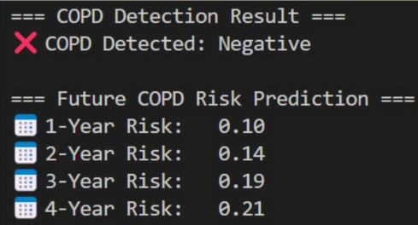

***Fig 8 – 4 Year Risk Prediction***

Finally, we examined how different features influence the model’s decisions. DlSpiro uses a volume attention mechanism to focus on the most informative segments of the breathing signal. In most cases, the model concentrated on early and late regions of the curve, which aligns with clinical knowledge. These interpretability outputs make the model more trustworthy for medical professionals. While no model is perfect, the errors observed often involved borderline or overlapping conditions like asthma, which is expected in real world clinical data.

In summary, DlSpiro significantly outperforms traditional and baseline models in both current COPD detection and future risk prediction. It is not only accurate but also interpretable and clinically relevant. These findings highlight its value as an early screening tool for timely intervention and better disease management.

**V. CONCLUSION & FUTURE SCOPE**

In this project, we developed and evaluated a deep learning based system called DlSpiro to detect and predict Chronic Obstructive Pulmonary Disease (COPD) using spirogram time series and patient demographic data. Due to the unavailability of real world datasets, we created a large synthetic dataset of 30,000 patient records, which included both healthy individuals and those with varying severities of COPD, including cases involving hospitalization and death. We compared our model with traditional and deep learning baselines, such as the FEV1/FVC diagnostic threshold and Volume Flow ResNet18. Through extensive evaluations, we showed that DlSpiro achieved higher accuracy, precision, and interpretability, outperforming all other approaches.

One of the key strengths of DlSpiro is its ability to predict not only current COPD status but also the future risk of developing the disease. By identifying curve concavity patterns and integrating demographic information through volume attention, the model can deliver early warnings, potentially guiding timely clinical interventions. In addition, the SpiroExplainer module allows us to visualize which parts of the breathing signal the model relies on, increasing trust and transparency in predictions. Overall, the results demonstrate that DlSpiro is a promising tool for early screening, risk assessment, and personalized care planning in respiratory healthcare.

Looking forward, there are several directions in which this work can be expanded. First, the model can be validated on real clinical data once access becomes available, helping improve its robustness and generalization. Second, we plan to explore more advanced time series augmentation techniques to simulate complex breathing patterns and improve training diversity. The current model could also be extended to classify other respiratory conditions such as asthma or interstitial lung diseases by finetuning it with labelled data. Finally, integrating this model into a mobile or edge AI device for real time diagnosis could make early COPD screening more accessible, especially in remote or underserved regions.

**VI. REFERENCES**

[1] Agustí, A. et al. Global initiative for chronic obstructive lung disease 2023 report: gold executive summary. *Am. J. Respir. Crit. Care Med.***207**, 819–837 (2023). [[DOI](https://doi.org/10.1164/rccm.202301-0106PP)] [[PMC free article](https://pmc.ncbi.nlm.nih.gov/articles/PMC10111975/)] [[PubMed](https://pubmed.ncbi.nlm.nih.gov/36856433/)] [[Google Scholar](https://scholar.google.com/scholar_lookup?Agust%C3%AD,%20A.%20et%20al.%20Global%20initiative%20for%20chronic%20obstructive%20lung%20disease%202023%20report:%20gold%20executive%20summary.%20Am.%20J.%20Respir.%20Crit.%20Care%20Med.207,%20819%E2%80%93837%20(2023).)]

[2] Ferrera, M. C., Labaki, W. W. & Han, M. K. Advances in chronic obstructive pulmonary disease. *Annu. Rev. Med.***72**, 119–134 (2021). [[DOI](https://doi.org/10.1146/annurev-med-080919-112707)] [[PMC free article](https://pmc.ncbi.nlm.nih.gov/articles/PMC8011854/)] [[PubMed](https://pubmed.ncbi.nlm.nih.gov/33502902/)] [[Google Scholar](https://scholar.google.com/scholar_lookup?Ferrera,%20M.%20C.,%20Labaki,%20W.%20W.%20&%20Han,%20M.%20K.%20Advances%20in%20chronic%20obstructive%20pulmonary%20disease.%20Annu.%20Rev.%20Med.72,%20119%E2%80%93134%20(2021).)]

[3] Avian, C., Mahali, M. I., Putro, N. A. S., Prakosa, S. W. & Leu, J.S. Fxnet and purenet: convolutional neural network architecture for discrimination of chronic obstructive pulmonary disease from smokers and healthy subjects through electronic nose signals. *Comput. Biol. Med.***148**, 105913 (2022). [[DOI](https://doi.org/10.1016/j.compbiomed.2022.105913)] [[PubMed](https://pubmed.ncbi.nlm.nih.gov/35940164/)] [[Google Scholar](https://scholar.google.com/scholar_lookup?Avian,%20C.,%20Mahali,%20M.%20I.,%20Putro,%20N.%20A.%20S.,%20Prakosa,%20S.%20W.%20&%20Leu,%20J.-S.%20Fx-net%20and%20purenet:%20convolutional%20neural%20network%20architecture%20for%20discrimination%20of%20chronic%20obstructive%20pulmonary%20disease%20from%20smokers%20and%20healthy%20subjects%20through%20electronic%20nose%20signals.%20Comput.%20Biol.%20Med.148,%20105913%20(2022).)]

[4] Dianat, B. et al. Classification of pulmonary sounds through deep learning for the diagnosis of interstitial lung diseases secondary to connective tissue diseases. *Comput. Biol. Med.***160**, 106928 (2023). [[DOI](https://doi.org/10.1016/j.compbiomed.2023.106928)] [[PubMed](https://pubmed.ncbi.nlm.nih.gov/37156223/)] [[Google Scholar](https://scholar.google.com/scholar_lookup?Dianat,%20B.%20et%20al.%20Classification%20of%20pulmonary%20sounds%20through%20deep%20learning%20for%20the%20diagnosis%20of%20interstitial%20lung%20diseases%20secondary%20to%20connective%20tissue%20diseases.%20Comput.%20Biol.%20Med.160,%20106928%20(2023).)]

[5] Almeida, S. D. et al. Prediction of disease severity in COPD: a deep learning approach for anomalybased quantitative assessment of chest ct. *Eur. Radiol.***34**, 4379–4392 (2024). [[DOI](https://doi.org/10.1007/s00330-023-10540-3)] [[PMC free article](https://pmc.ncbi.nlm.nih.gov/articles/PMC11213737/)] [[PubMed](https://pubmed.ncbi.nlm.nih.gov/38150075/)] [[Google Scholar](https://scholar.google.com/scholar_lookup?Almeida,%20S.%20D.%20et%20al.%20Prediction%20of%20disease%20severity%20in%20COPD:%20a%20deep%20learning%20approach%20for%20anomaly-based%20quantitative%20assessment%20of%20chest%20ct.%20Eur.%20Radiol.34,%204379%E2%80%934392%20(2024).)]

[6] Cosentino, J. et al. Inference of chronic obstructive pulmonary disease with deep learning on raw spirograms identifies new genetic loci and improves risk models. *Nat. Genet.***55**, 787–795 (2023). [[DOI](https://doi.org/10.1038/s41588-023-01372-4)] [[PubMed](https://pubmed.ncbi.nlm.nih.gov/37069358/)] [[Google Scholar](https://scholar.google.com/scholar_lookup?Cosentino,%20J.%20et%20al.%20Inference%20of%20chronic%20obstructive%20pulmonary%20disease%20with%20deep%20learning%20on%20raw%20spirograms%20identifies%20new%20genetic%20loci%20and%20improves%20risk%20models.%20Nat.%20Genet.55,%20787%E2%80%93795%20(2023).)]

[7].Sun, Y. et al. Covid19 diagnosis based on swin transformer model with demographic information fusion and enhanced multihead attention mechanism. *Expert Syst. Appl.***243**, 122805 (2024). [[Google Scholar](https://scholar.google.com/scholar_lookup?Sun,%20Y.%20et%20al.%20Covid-19%20diagnosis%20based%20on%20swin%20transformer%20model%20with%20demographic%20information%20fusion%20and%20enhanced%20multi-head%20attention%20mechanism.%20Expert%20Syst.%20Appl.243,%20122805%20(2024).)]

[8].Wei, X., Rao, C., Xiao, X., Chen, L. & Goh, M. Risk assessment of cardiovascular disease based on SOLSSACatBoost model. *Expert Syst. Appl.***219**, 119648 (2023). [[Google Scholar](https://scholar.google.com/scholar_lookup?Wei,%20X.,%20Rao,%20C.,%20Xiao,%20X.,%20Chen,%20L.%20&%20Goh,%20M.%20Risk%20assessment%20of%20cardiovascular%20disease%20based%20on%20SOLSSA-CatBoost%20model.%20Expert%20Syst.%20Appl.219,%20119648%20(2023).)]

[9].Raihan, M. J., Khan, M. A.M., Kee, S.H. & Nahid, A.A. Detection of the chronic kidney disease using XGBoost classifier and explaining the influence of the attributes on the model using SHAP. *Sci. Rep.***13**, 6263 (2023). [[DOI](https://doi.org/10.1038/s41598-023-33525-0)] [[PMC free article](https://pmc.ncbi.nlm.nih.gov/articles/PMC10110580/)] [[PubMed](https://pubmed.ncbi.nlm.nih.gov/37069256/)] [[Google Scholar](https://scholar.google.com/scholar_lookup?Raihan,%20M.%20J.,%20Khan,%20M.%20A.-M.,%20Kee,%20S.-H.%20&%20Nahid,%20A.-A.%20Detection%20of%20the%20chronic%20kidney%20disease%20using%20XGBoost%20classifier%20and%20explaining%20the%20influence%20of%20the%20attributes%20on%20the%20model%20using%20SHAP.%20Sci.%20Rep.13,%206263%20(2023).)]

[10] Yin, C. et al. Fractional dynamics foster deep learning of COPD stage prediction. *Adv. Sci.***10**, 2203485 (2023). [[DOI](https://doi.org/10.1002/advs.202203485)] [[PMC free article](https://pmc.ncbi.nlm.nih.gov/articles/PMC10131808/)] [[PubMed](https://pubmed.ncbi.nlm.nih.gov/36808826/)] [[Google Scholar](https://scholar.google.com/scholar_lookup?Yin,%20C.%20et%20al.%20Fractional%20dynamics%20foster%20deep%20learning%20of%20COPD%20stage%20prediction.%20Adv.%20Sci.10,%202203485%20(2023).)]

[11] Kumar, S. et al. A novel multimodal framework for early diagnosis and classification of COPD based on CT scan images and multivariate pulmonary respiratory diseases. *Comput. Methods Prog. Biomed.***243**, 107911 (2024). [[DOI](https://doi.org/10.1016/j.cmpb.2023.107911)] [[PubMed](https://pubmed.ncbi.nlm.nih.gov/37981453/)] [[Google Scholar](https://scholar.google.com/scholar_lookup?Kumar,%20S.%20et%20al.%20A%20novel%20multimodal%20framework%20for%20early%20diagnosis%20and%20classification%20of%20COPD%20based%20on%20CT%20scan%20images%20and%20multivariate%20pulmonary%20respiratory%20diseases.%20Comput.%20Methods%20Prog.%20Biomed.243,%20107911%20(2024).)]