**Prerequisites :**

1. MySQL(version 8.0.17) database has been used for development. The same needs to be there on the machine where the application would be run.
2. Development has been done using the Eclipse IDE version Version: 2019-09 R (4.13.0).
3. Java, Spring Boot, Spring MVC, Hibernate and MySQL technologies have been used for development.

**Assumptions :**

1. As of now, the port for the server has been set as 8082. If you wish to change, please change the setting named “server.port” in the application.properties file of the application to the port you wish to use.
2. Likewise the data source properties for the database like username, password etc. are also maintained in the application.properties and would require to be changed as per your maintained MySQL database.
3. The topic description has a limit of 120 words as mentioned in the requirement document. The number of words are calculated based on the assumption that the sentences would be formed in such a way that after every sentence ending with a period(.) sign, there would be a space following the period sign before the next sentence starts. E.g. “My name is Chetan. I am working on this assignment.” As you can notice, there’s a space after “Chetan.” Before the next sentence starts with an “I”.
4. The date of the lightning talk session would be the first Tuesday of the upcoming month if it's an even month or the month next to that one. **e.g. If I add a record today i.e. 16th October 2019, then the date of the lighting talk should be saved as 3rd December 2019.**
5. When you try to view topics, it’ll display the topics of the upcoming Lightning Talk session only. E.g. If you have records in the database table for 3rd December 2019 as well as 4th February 2020, when you view the topics from the application, it’ll display the topics for the upcoming one(i.e. 3rd December 2019) only.
6. Please note that the development of this project has been done on Eclipse, so the steps mentioned below are from Eclipse’s perspective and might vary in case you wish to use a different IDE.

**Steps to run the application :**

To run the application, run the LightningTalksApplication class in the package com.assignment.LightningTalks by opening the file in the IDE and then right clicking on the file, choosing the option “Run As” and then “Java application”.

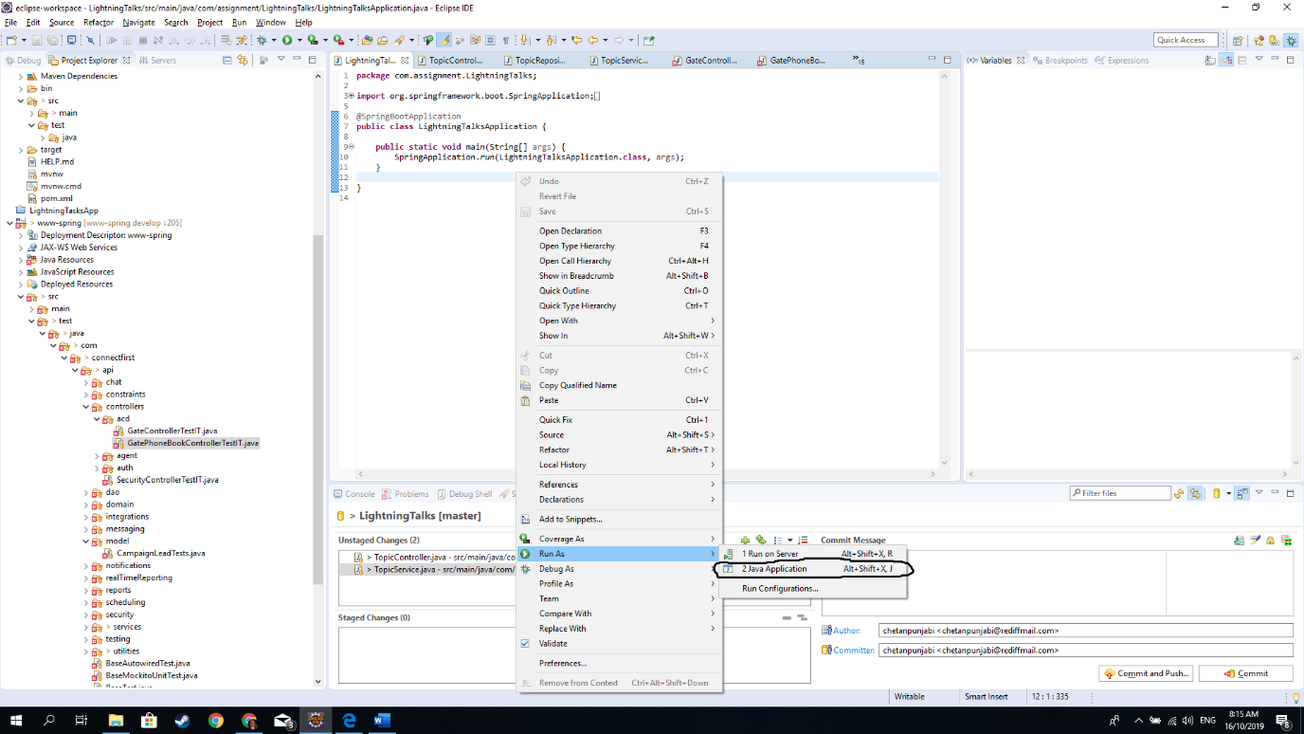

Alternately, you may also right click the project on the Project Explorer window on the left, choose “Run As” and then select “Java Application”. Upon selecting that option, it’ll ask you the class to run, where you can select the class named LightningTalksApplication.

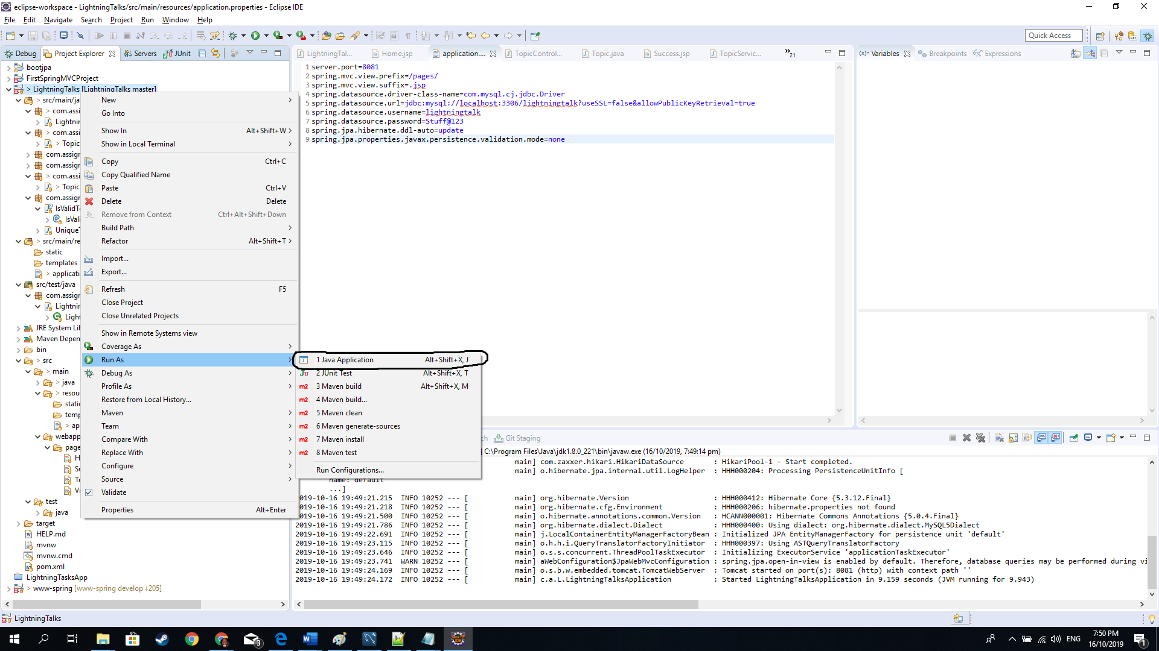

**Run Tests:**

For running the tests, run the LightningTalksApplicationTests class in the package com.assignment.LightningTalks by opening the file in the IDE and then right clicking on the file, choosing the option “Run As” and then “Junit Test”.

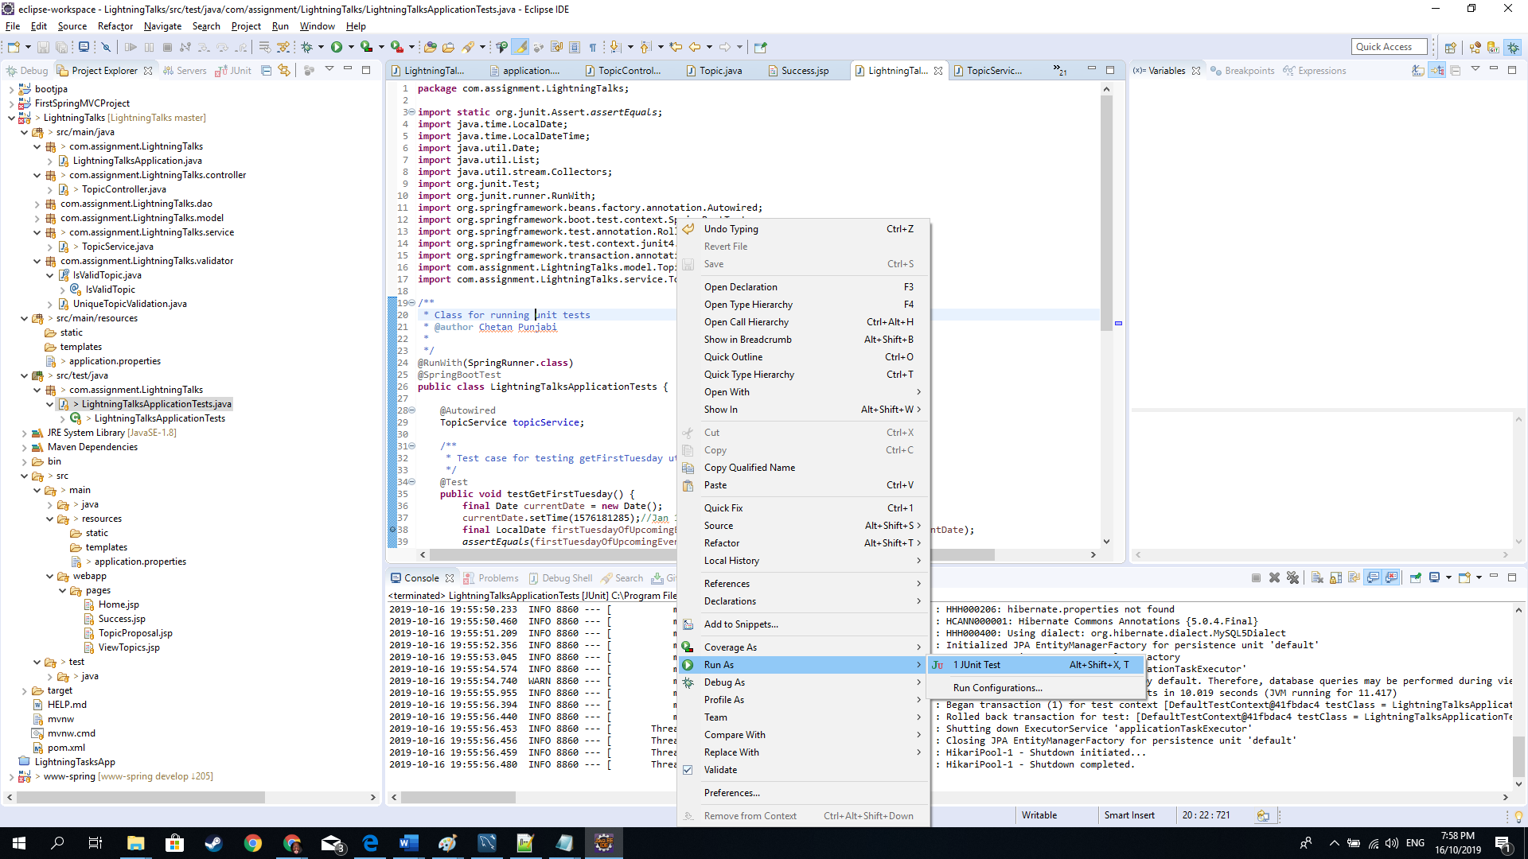

Alternately, you may also right click the project on the Project Explorer window on the left, choose “Run As” and then select “JUnit Test”.

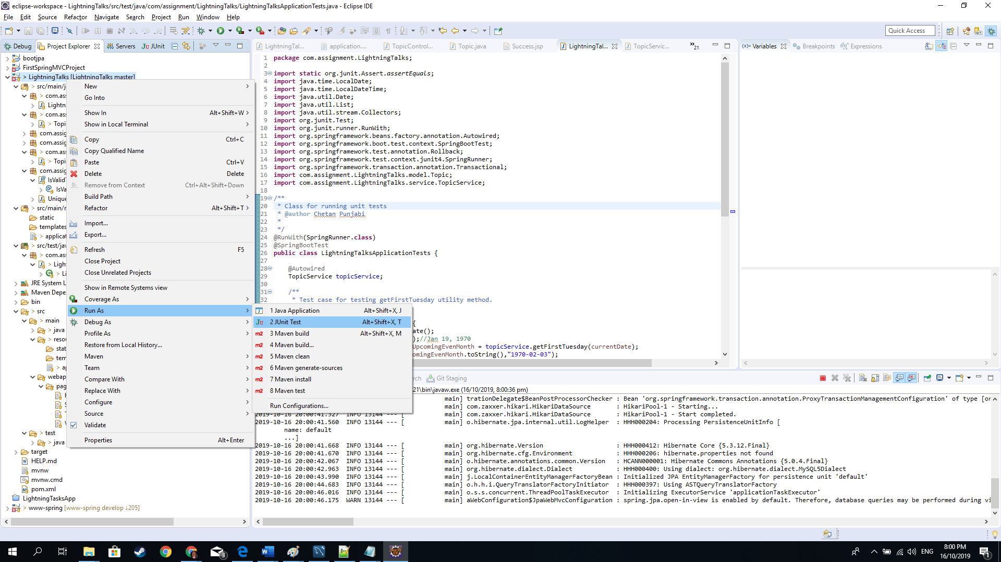

**User Guide:**

1. After running the application, type the url : <http://localhost:8082> in a browser window and hit Enter. It’ll open the Home Page of the application.
2. You can choose the option to add/submit a topic using the option “Submit Topic” or view topics for the upcoming Lightning talk using the “View Topics” option.