KUBERNETES INTERVIEW QUESTIONS

1. What is Kubernetes? / What do you understand by Kubernetes?
Kubernetes is an open-source container-orchestration tool or system used to automate tasks such as the management, monitoring, scaling, and deploying containerized applications.
Kubernetes is a container management system developed in the Google platform. The purpose of Kubernetes is to manage a containerized application in various types of physical, virtual, and cloud environments. Google Kubernetes is a highly flexible container tool to deliver even complex applications, consistently. Applications run on clusters of hundreds to thousands of individual servers.
Kubernetes is an open-source system for automating deployment, scaling, and management of containerized applications.
To understand what Kubernetes is good for, let's look at some examples:
- You would like to run a certain application in a container on multiple different locations. Sure, if it's 2-3 servers/locations, you can do it by yourself but it can be challenging to scale it up to additional multiple location.
- Performing updates and changes across hundreds of containers
- Handle cases where the current load requires to scale up (or down)

The purpose of Kubernetes is to make it easier to organize and schedule your application across a fleet of machines. At a high level it is an operating system for your cluster.
Basically, it allows you to not worry about what specific machine in your datacenter each application runs on. Additionally it provides generic primitives for health checking and replicating your application across these machines, as well as services for wiring your application into micro-services so that each layer in your application is decoupled from other layers so that you can scale/update/maintain them independently.
Kubernetes is used for the automation of the manual operations that are involved in the deployment, management, and scaling of containerized applications. It keeps track of the ones that are deployed into the cloud, restarts orphaned ones, shuts down the unused, and automatically provides resources such as storage, memory, and CPU when required.

The best way to carry out the management of the life cycle of containerized applications over a large scale is through a container orchestration system like Kubernetes. It automates the deployment and scaling of several containers simultaneously. Containers that are running the same application are arranged together and act as replicas. They serve to load balance incoming requests. Kubernetes, then, supervises these groups of containers and ensures that they are functioning correctly.

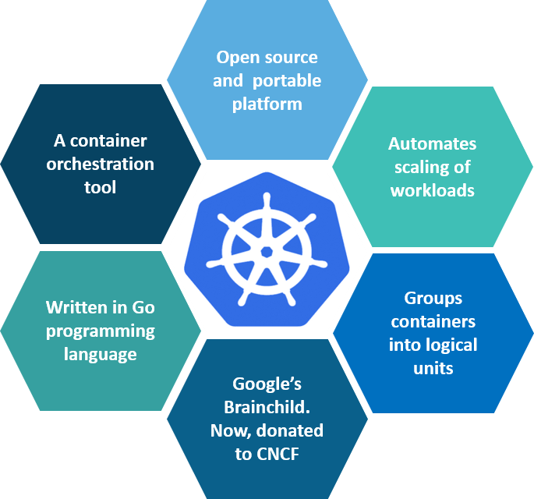
Fig 1: What is Kubernetes

Kubernetes is an open-source container management tool that holds the responsibilities of container deployment, scaling & descaling of containers & load balancing. Being Google’s brainchild, it offers excellent community and works brilliantly with all the cloud providers. So, we can say that Kubernetes is not a containerization platform, but it is a multi-container management solution.
Kubernetes is a distributed open-source technology that helps us in scheduling and executing application containers within and across clusters. A Kubernetes cluster consists of two types of resources:
The Master => Coordinates all activities in the cluster, for example, => scheduling applications, maintaining applications' state, scaling applications, and rolling out new updates
Nodes => A node is an instance of an OS that serves as a worker machine in a Kubernetes cluster.
Also, Node will have two components
- Kubelet => Agent for managing and communicating with the master
- Tool (Docker/containers) => Tools for running container operations
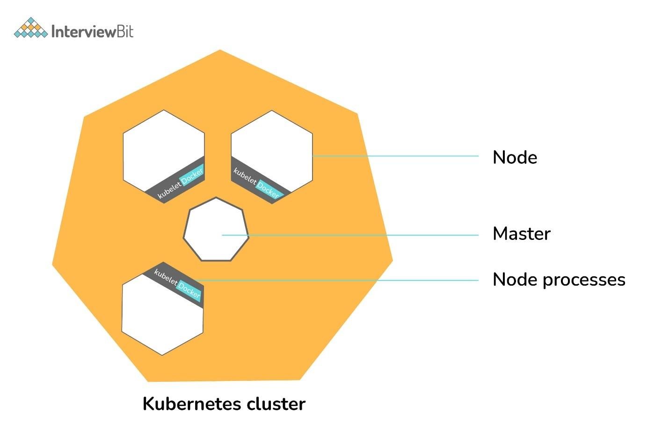Kubernetes Cluster
It is designed based on ground-up as a loosely coupled collection of containers centered around deploying, maintaining, and scaling workloads. Works as an engine for resolving state by converging actual and the desired state of the system (self-healing). Hidden from the underlying hardware of the nodes and provides a uniform interface for workloads to be both deployed and consume the shared pool of resources(hardware) in order to simplify deployment.
Pods are the smallest unit of objects that can be deployed on Kubernetes, Kubernetes packages one or more containers into a higher-level structure called a pod. Pod runs one level higher to the container.
A POD always runs on a Node but they share a few resources which can be Shared Volumes, Cluster Unique IP, Info about how to run each container. All containers in the pod are going to be scheduled on an equivalent node.
Services are the unified way of accessing the workloads on the pods, Control plane which is the core of Kubernetes is an API server that lets you query, manipulate the state of an object in Kubernetes.
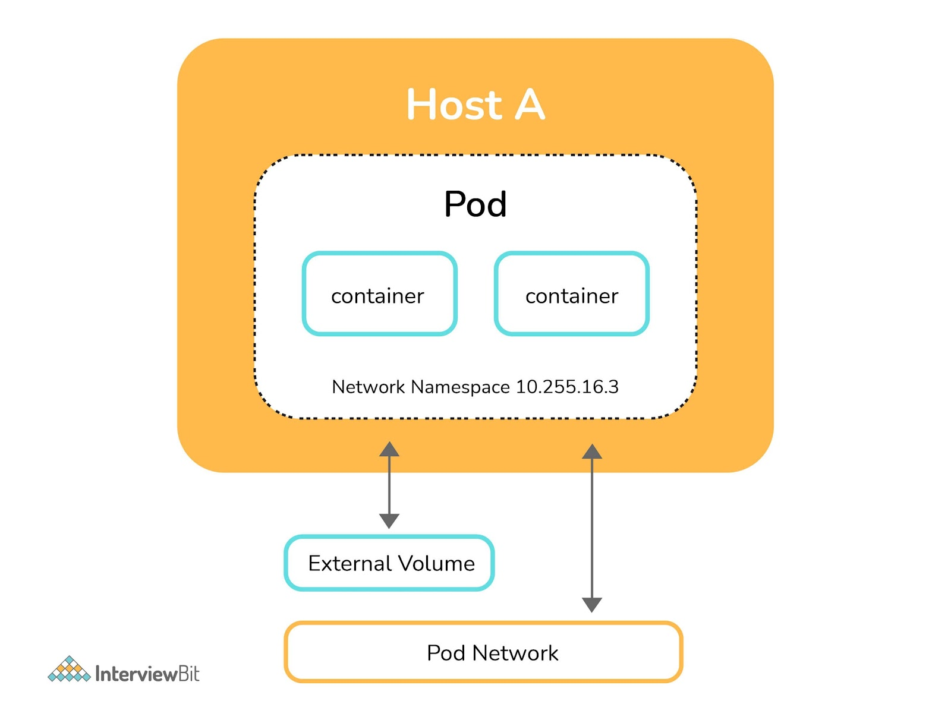POD
The following image describes the work-flow of the Kubernetes from a high level, wherein the application description is a YAML file also known as configuration or spec file with the help of which we can deploy applications bundled in the form of pods in cluster or node
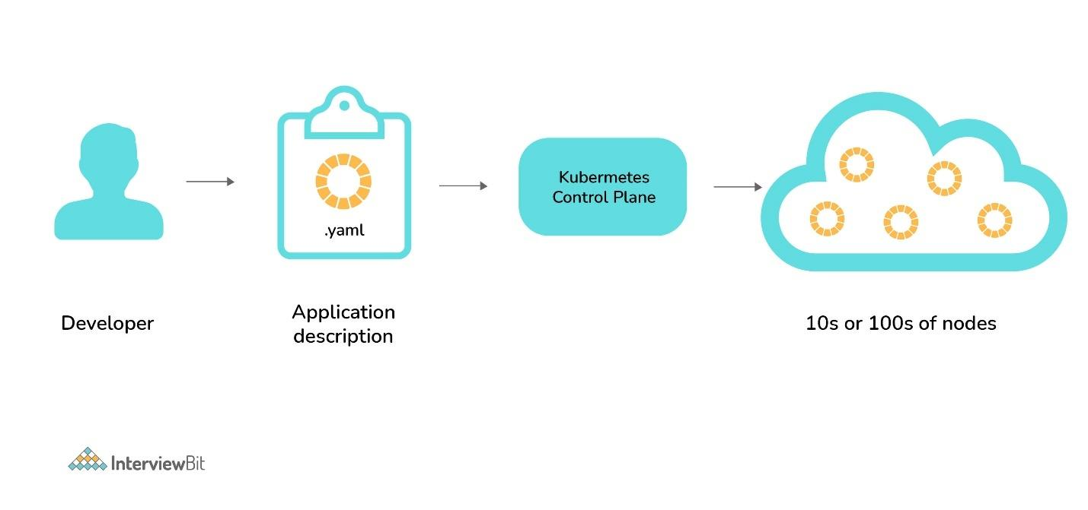Kubernetes Flow
This is one of the most basic Kubernetes interview questions yet one of the most important ones! Kubernetes is an open-source container orchestration tool or system that is used to automate tasks such as the management, monitoring, scaling, and deployment of containerized applications. It is used to easily manage several containers (since it can handle grouping of containers), which provides for logical units that can be discovered and managed.
First, let us compare Kubernetes with Docker Swarm:
Comparison | Kubernetes | Docker Swarm
Controller | Master | Manager
Slave | Nodes | Workers
Deployment unit | Pod | Task
Load balancing | Service | Ingress
Kubernetes is a container orchestration tool that is used for automating the tasks of managing, monitoring, scaling, and deploying containerized applications. It creates groups of containers that can be logically discovered and managed for easy operations on containers.

This is one of the most basic Kubernetes interview questions yet one of the most important ones! Kubernetes is an open-source container orchestration tool or system that is used to automate tasks such as the management, monitoring, scaling, and deployment of containerized applications. It is used to easily manage several containers (since it can handle grouping of containers), which provides for logical units that can be discovered and managed.

2. What is the use of Kubernetes?
Kubernetes is mainly used to easily manage several containers (since it can handle the grouping of containers), which provides logical units that can be discovered and managed.
Kubernetes is used because:
- Kubernetes can run on-premises bare metal, OpenStack, public clouds Google, Azure, AWS, etc.
- It helps you to avoid vendor lock issues as it can use any vendor-specific APIs or services except where Kubernetes provides an abstraction, e.g., load balancer and storage.
- It will enable applications that need to be released and updated without any downtime.
- Kubernetes allows you to assure those containerized apps run where and when you want and help you to find resources and tools which you want to work.

3. What are the disadvantages of Kubernetes?
- Kubernetes dashboard is not as helpful as it should be
- Security is not very effective.
- It is very complex and can reduce productivity
- Kubernetes is more costly than its alternatives.
The biggest disadvantages of Kubernetes are listed below:
- Security is the biggest issue with Kubernetes. It is not very secure.
- Kubernetes dashboard is not very user-friendly.
- Kubernetes is very complex to use. That's why it can reduce productivity.
- Kubernetes is costlier than its alternatives.

4. What is Kube-proxy?
Kube-proxy is an implementation of both a network proxy and a load balancer. It is used to support service abstraction used with other networking operations. It is responsible for directing traffic to the container depend on IP and the port number.
In Kubernetes, Kube-proxy is an implementation of both a network proxy and a load balancer. It is used to support service abstraction with other networking operations and responsible for directing traffic to the container depending on IP and the port number.
The kube-proxy runs on each of the nodes. It can do simple tasks such as TCP, UDP, forwarding, and so on. It shows the services in the Kubernetes API on each node.

Kube-proxy is an implementation of a load balancer and network proxy used to support service abstraction with other networking operations. Kube-proxy is responsible for directing traffic to the right container based on IP and the port number of incoming requests.
Kube-proxy can run on each and every node and can do simple TCP/UDP packet forwarding across backend network service. So basically, it is a network proxy that reflects the services as configured in Kubernetes API on each node. So, the Docker-linkable compatible environment variables provide the cluster IPs and ports which are opened by proxy.
kube-proxy does 2 things
- for every Service, open a random port on the node and proxy that port to the Service.
- install and maintain iptables rules which capture accesses to a virtual ip:port and redirect those to the port in (1)
The kube-proxy is a component that manages host sub-netting and makes services available to other components.Kubeproxy handles network communication and shutting down master does not stop a node from serving the traffic and kubeproxy works, in the same way, using a service. The iptables will route the connection to kubeproxy, which will then proxy to one of the pods in the service.kube-proxy translate the destination address to whatever is in the endpoints.

5. What are the features of Kubernetes?
The features of Kubernetes are:
- Automated Scheduling
- Self-Healing Capabilities
- Automated rollouts & rollback
- Horizontal Scaling & Load Balancing
- Offers environment consistency for development, testing, and production
- Infrastructure is loosely coupled to each component can act as a separate unit
- Provides a higher density of resource utilization
- Offers enterprise-ready features
- Application-centric management
- Auto-scalable infrastructure
- You can create predictable infrastructure

- Kubernetes places control for the user where the server will host the container. It will control how to launch. So, Kubernetes automates various manual processes.
- Kubernetes manages various clusters at the same time.
- It provides various additional services like management of containers, security, networking, and storage.
- Kubernetes self-monitors the health of nodes and containers.
- With Kubernetes, users can scale resources not only vertically but also horizontally that too easily and quickly.
- The features of Kubernetes, are as follows:
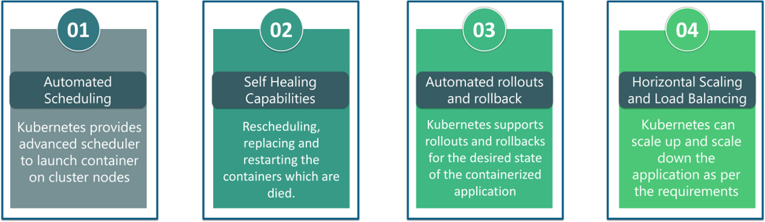
- Fig 4: Features Of Kubernetes

6. What are K8s?
K8s is nothing but just another term for Kubernetes.
K8s (K-eight characters-S) is a term for Kubernetes. It is an open-source orchestration framework for the containerized applications.

7.How to do maintenance activity on the K8 node?
Whenever there are security patches available the Kubernetes administrator has to perform the maintenance task to apply the security patch to the running container in order to prevent it from vulnerability, which is often an unavoidable part of the administration. The following two commands are useful to safely drain the K8s node.
- kubectl cordon
- kubectl drain –ignore-daemon set
The first command moves the node to maintenance mode or makes the node unavailable, followed by kubectl drain which will finally discard the pod from the node. After the drain command is a success you can perform maintenance.
Note: If you wish to perform maintenance on a single pod following two commands can be issued in order:
- kubectl get nodes: to list all the nodes
- kubectl drain <node name>: drain a particular node

8. What was the main motive behind the development of Kubernetes?
The main motive behind the development of Kubernetes is to provide a "platform for automating deployment, scaling, and operations of application containers across clusters of hosts."

9. What do you understand by the term orchestration when it comes to software and DevOps?
The term orchestration specifies integrating multiple services that allow them to automate processes or synchronize information in a specific time sequence.
For example, suppose we have six or seven microservices for an application to run, then if you place them in separate containers, this would inevitably create obstacles for communication. Using orchestration, we can do it quickly to enable all services in individual containers to work seamlessly to accomplish a single goal.

10. Define orchestration in Kubernetes
Orchestration in Kubernetes defines as an automatic method of scheduling the work of every container. It is used for applications that are based on microservices within clusters.

11. List tools for container orchestration
The tools for container orchestration are 1) Docker swarm, 2) Apache Mesos, and 3) Kubernetes.

Which problems does a container orchestration solve?

Containers run in an isolated process (usually in it's own namespace). This means that by default the container will not be aware of other containers. Additionally, it will not be aware of the systems files, network interfaces, and processes. While this can greatly help with portability of the software it does not solve several production issues such as microservices, container discovery, scalability, disaster recovery, or upgrades.
Adding a container orchestrator can greatly reduce the complexity in production as these tools are designed to resolve the issues outlined above. For example, Kubernetes is built to allow containers to be linked together, deploy containers across an entire network, scale and load balance the network based on container resource consumption, and allow upgrades of individual containers with no downtime.
If you are only running a single container or two containers together you are correct in that an orchestrator may be unnecessary and add unneeded complexity.

12. What is orchestration in software?
Application orchestration in the software process means that we can integrate two or more applications. We will be able to automate arrangement, coordination, and management of computer software. The goal of any orchestration process is to streamline and optimize frequent repeatable processes.

13. What is orchestration when it comes to software and DevOps?

Orchestration refers to the integration of multiple services that allows them to automate processes or synchronize information in a timely fashion. Say, for example, you have six or seven microservices for an application to run. If you place them in separate containers, this would inevitably create obstacles for communication. Orchestration would help in such a situation by enabling all services in individual containers to work seamlessly to accomplish a single goal.

14. What is Container Orchestration?
Consider a scenario where you have 5-6 microservices for an application. Now, these microservices are put in individual containers, but won’t be able to communicate without container orchestration. So, as orchestration means the amalgamation of all instruments playing together in harmony in music, similarly container orchestration means all the services in individual containers working together to fulfill the needs of a single server.

15. What is the need for Container Orchestration?
Consider you have 5-6 microservices for a single application performing various tasks, and all these microservices are put inside containers. Now, to make sure that these containers communicate with each other we need container orchestration.
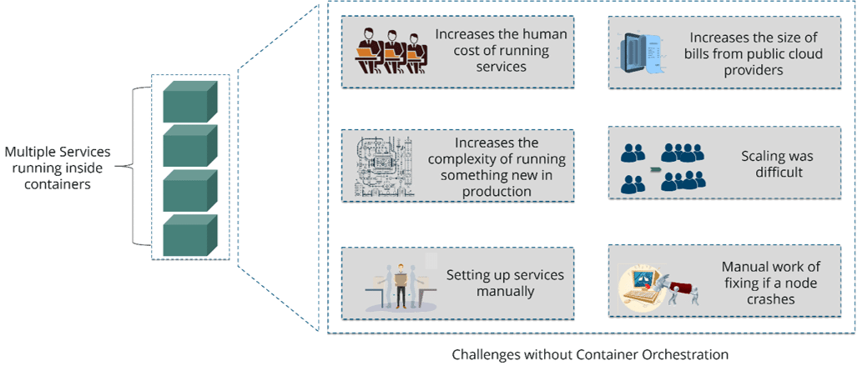
Fig 3: Challenges Without Container Orchestration

As you can see in the above diagram, there were also many challenges that came into place without the use of container orchestration. So, to overcome these challenges the container orchestration came into place.

16. What is the relation between Docker and Kubernetes?
Docker is an open-source platform used to handle software development. It is mainly used to package the settings and dependencies that the software/application needs to run into a container, which allows for portability and several other advantages. On the other hand, Kubernetes is used to allow the manual linking and orchestration of several containers, running on multiple hosts that have been created using Docker.

17. What is the difference between Kubernetes and Docker?

Problem
And what are they used for?
Answer
Docker and Kubernetes are complementary.
- Docker provides an open standard for packaging and distributing containerized applications, while
- Kubernetes provides for the orchestration and management of distributed, containerized applications created with Docker.
In other words, Kubernetes provides the infrastructure needed to deploy and run applications built with Docker.

How is Kubernetes different from Docker Swarm?

Features | Kubernetes | Docker Swarm
Installation & Cluster Config | Setup is very complicated, but once installed cluster is robust. | Installation is very simple, but the cluster is not robust.
GUI | GUI is the Kubernetes Dashboard. | There is no GUI.
Scalability | Highly scalable and scales fast. | Highly scalable and scales 5x faster than Kubernetes.
Auto-scaling | Kubernetes can do auto-scaling. | Docker swarm cannot do auto-scaling.
Load Balancing | Manual intervention needed for load balancing traffic between different containers and pods. | Docker swarm does auto load balancing of traffic between containers in the cluster.
Rolling Updates & Rollbacks | Can deploy rolling updates and does automatic rollbacks. | Can deploy rolling updates, but not automatic rollback.
DATA Volumes | Can share storage volumes only with the other containers in the same pod. | Can share storage volumes with any other container.
Logging & Monitoring | In-built tools for logging and monitoring. | 3rd party tools like ELK stack should be used for logging and monitoring.

Kubernetes | Docker Swarm
Kubernetes Provides an auto-scaling feature. | Docker Swarm does not provide an auto-scaling feature.
Manually configure your load balancing settings. | Does auto load balancing
Installation is complicated & time-consuming. | Installation is easy & fast.
GUI is available. | GUI not available.
It provides a built-in load balancing technique. | Process scheduling is done to maintain services while updating.

18. What are the key differences between the Docker Swarm and Kubernetes?
Docker Swarm is an open-source container orchestration platform used to cluster and schedule Docker containers. It is a native of Docker. Following is the list of key differences between the Docker Swarm and Kubernetes:
Docker Swarm | Kubernetes
Docker Swarm is easy and convenient to set up, but it doesn't have a robust cluster. | Kubernetes is more complicated than Docker Swarm to set up, but it assures a robust cluster.
Docker Swarm can't do auto-scaling as the Kubernetes can do, but Docker's scaling is five times faster than Kubernetes. | Kubernetes can do auto-scaling, but scaling is slower than Docker Swarm.
Docker Swarm doesn't provide a GUI. | Kubernetes provides a GUI in the form of a dashboard.
Docker Swarm provides an automatic load balancing feature of traffic between containers in a cluster. | It requires manual intervention in Kubernetes for load balancing such traffic.
Docker requires third-party tools such as the ELK stack for logging and monitoring. | Kubernetes provides such integrated tools for logging and monitoring purposes.
In Docker Swarm, we can easily share storage volumes with any container. | In Kubernetes, we can only share storage volumes with containers in the same pod.
We can deploy rolling updates in Docker Swarm but can't deploy automatic rollbacks. | In Kubernetes, we can deploy rolling updates as well as automatic rollbacks.

19. What are the main differences between the Docker Swarm and Kubernetes?
Docker Swarm is Docker’s native, open-source container orchestration platform that is used to cluster and schedule Docker containers. Swarm differs from Kubernetes in the following ways:
- Docker Swarm is more convenient to set up but doesn’t have a robust cluster, while Kubernetes is more complicated to set up but the benefit of having the assurance of a robust cluster
- Docker Swarm can’t do auto-scaling (as can Kubernetes); however, Docker scaling is five times faster than Kubernetes
- Docker Swarm doesn’t have a GUI; Kubernetes has a GUI in the form of a dashboard
- Docker Swarm does automatic load balancing of traffic between containers in a cluster, while Kubernetes requires manual intervention for load balancing such traffic
- Docker requires third-party tools like ELK stack for logging and monitoring, while Kubernetes has integrated tools for the same
- Docker Swarm can share storage volumes with any container easily, while Kubernetes can only share storage volumes with containers in the same pod
- Docker can deploy rolling updates but can’t deploy automatic rollbacks; Kubernetes can deploy rolling updates as well as automatic rollbacks

20. What is the difference between Docker Swarm and Kubernetes?
Below are the main difference between Kubernetes and Docker:
- The installation procedure of the K8s is very complicated but if it is once installed then the cluster is robust. On the other hand, the Docker swarm installation process is very simple but the cluster is not at all robust.
- Kubernetes can process the auto-scaling but the Docker swarm cannot process the auto-scaling of the pods based on incoming load.
Kubernetes is a full-fledged Framework. Since it maintains the cluster states more consistently so autoscaling is not as fast as Docker Swarm

21. What do you understand by a node in Kubernetes?
In Kubernetes, a node is the smallest unit of hardware. It is used to define a single machine in a cluster that can act as a virtual machine from a cloud provider or physical machine in the data center. Every machine of the Kubernetes cluster can act as a substitute for other machines.
A node the smallest unit of hardware. It defines a single machine in a cluster that can be a virtual machine from a cloud provider or physical machine in the data center. Every machine available in the Kubernetes cluster can substitute other machines.
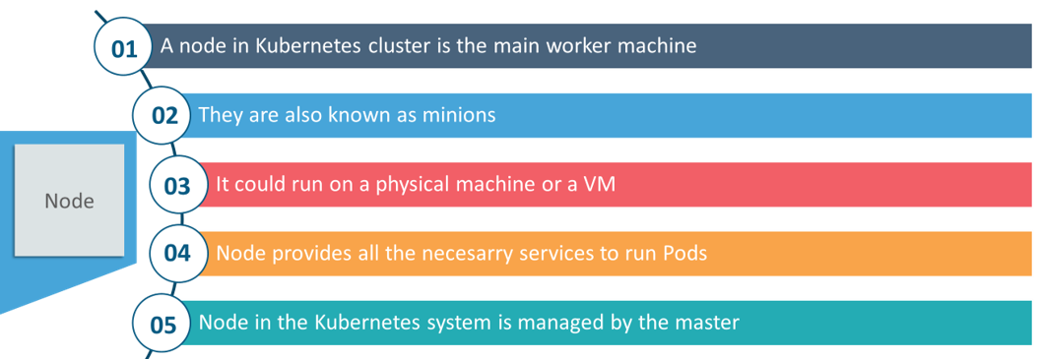

22. What is a node in Kubernetes?
A node in Kubernetes is a worker machine which is also known as a minion. This node could be a physical machine or a virtual machine. For each node, there is a service to run pods, and it is managed by master components. The node services could include kubelet, kube-proxy, and so on.

A node is the smallest fundamental unit of computing hardware. It represents a single machine in a cluster, which could be a physical machine in a data center or a virtual machine from a cloud provider. Each machine can substitute any other machine in a Kubernetes cluster. The master in Kubernetes controls the nodes that have containers.

23. Explain the working of the master node in Kubernetes?
The master node dignifies the node that controls and manages the set of worker nodes. This kind resembles a cluster in Kubernetes. The nodes are responsible for the cluster management and the API used to configure and manage the resources within the collection. The master nodes of Kubernetes can run with Kubernetes itself, the asset of dedicated pods.

24. What is a node in Kubernetes?
A node is the smallest fundamental unit of computing hardware. It represents a single machine in a cluster, which could be a physical machine in a data center or a virtual machine from a cloud provider. Each machine can substitute any other machine in a Kubernetes cluster. The master in Kubernetes controls the nodes that have containers.

25. Can you brief on the working of the master node in Kubernetes?
Kubernetes master controls the nodes and inside the nodes the containers are present. Now, these individual containers are contained inside pods and inside each pod, you can have a various number of containers based upon the configuration and requirements. So, if the pods have to be deployed, then they can either be deployed using user interface or command-line interface. Then, these pods are scheduled on the nodes, and based on the resource requirements, the pods are allocated to these nodes. The kube-apiserver makes sure that there is communication established between the Kubernetes node and the master components.
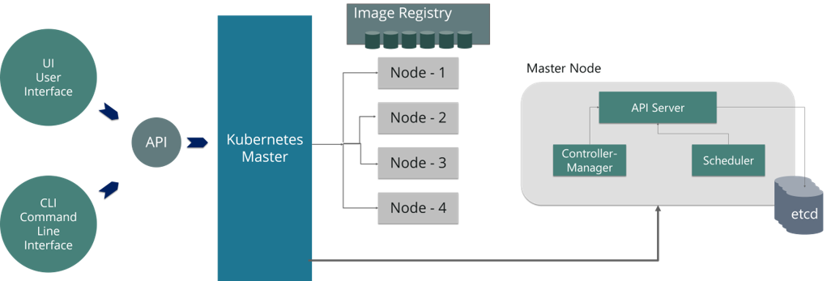
Fig 8: Representation Of Kubernetes Master Node

26. What are the important components of node status?
The important component of node status are:
- Condition
- Capacity
- Info
- Address

27. What is the use of a Kubernetes Kube-scheduler?
A Kube-scheduler is the default scheduler for Kubernetes. It is used to assign nodes to newly created pods.
Kube-scheduler is the default scheduler for Kubernetes. It assigns nodes to newly created pods.

28. What is the role of the Kube-scheduler in Kubernetes?
In Kubernetes, the Kube-scheduler are used to assign nodes to newly created pods.

29. What is the role of kube-apiserver and kube-scheduler?
The kube - apiserver is the master node control panel's front-end and follows the scale-out architecture. This is used to expose all the APIs of the Kubernetes Master node components. It is responsible for establishing communication between Kubernetes Node and the Kubernetes master components.
The kube-scheduler is used to distribute and manage the workload on the worker nodes. It chooses the most suitable node to run the unscheduled pod based on resource requirement and keeps track of resource utilization. It makes sure that the workload is not scheduled on nodes that are already full.

30. How to write a Kubernetes scheduler?
The kube-scheduler is the default scheduler for Kubernetes. It is designed such that if you prefer, you can write your own one and use that instead.
Following is the syntax:
kube-scheduler [flags]
The scheduling life cycle:
- A pod is created and the preferred state is mentioned, and without filling the node name, it is saved to etcd
- The scheduler notices the new pod with no node bound
- It finds a suitable node for that pod
- It then informs the API server to bind the pod to the node, and next, the new desired state is saved to etcd
- Kubelets watch the pods that are bound and start the containers on the particular node

31. What does a kube-scheduler do?
The kube-scheduler has the job of assigning the nodes to the newly created pods.

32. What is the job of the kube-scheduler?
The kube-scheduler assigns nodes to newly created pods.

33. What is the role of kube-apiserver and kube-scheduler?
The kube – apiserver follows the scale-out architecture and, is the front-end of the master node control panel. This exposes all the APIs of the Kubernetes Master node components and is responsible for establishing communication between Kubernetes Node and the Kubernetes master components.
The kube-scheduler is responsible for the distribution and management of workload on the worker nodes. So, it selects the most suitable node to run the unscheduled pod based on resource requirement and keeps a track of resource utilization. It makes sure that the workload is not scheduled on nodes that are already full.

34. What do you understand by daemon sets in Kubernetes?
Daemon sets are sets of pods that run on a host and are used for host layers attributes like monitoring network or simple network.
Daemon sets are a set of pods that runs on a host. They are used for host layers attributes like monitoring network or simple network.

35. Why use Daemon sets?
Daemon sets are used because:
- It enables to runs storage platforms like ceph and glusterd on each node.
- Daemon sets run the logs collection on every node such as filebeat or fluentd.
- It performs node monitoring on each and every node.

36. What is a DaemonSet?

DaemonSets are used in Kubernetes when you need to run one or more pods on all (or a subset of) the nodes in a cluster. The typical use case for a DaemonSet is logging and monitoring for the hosts. For example, a node needs a service (daemon) that collects health or log data and pushes them to a central system or database.
As the name suggests you can use daemon sets for running daemons (and other tools) that need to run on all nodes of a cluster. These can be things like cluster storage daemons (e.g. Quobyte, glusterd, ceph, etc.), log collectors (e.g. fluentd or logstash), or monitoring daemons (e.g. Prometheus Node Exporter, collectd, New Relic agent, etc.)

37. What are Daemon sets?
A Daemon set is a set of pods that runs only once on a host. They are used for host layer attributes like a network or for monitoring a network, which you may not need to run on a host more than once.

38. What is Heapster in Kubernetes?
A Heapster is a metrics collection and performance monitoring system for data collected by the Kublet.
- Heapster: It is used to gather data and events from the containers and pods within the cluster. A Heapster is a metrics collection and performance monitoring system for data that are collected by the Kublet.
- InfluxDB: It is used along with heapster for visualizing data within the Kubernetes environment.
- Grafana: It is a time-series database used to store the data captured by all heapster pods.

39. What is a Heapster?
The Heapster lets us do the container cluster monitoring. It lets us do cluster-wide monitoring and event data aggregation. It has native support for Kubernetes.

40. What is ‘Heapster’ in Kubernetes?
In this Kubernetes interview question, the interviewer would expect a thorough explanation. You can explain what it is and also it has been useful to you (if you have used it in your work so far!). A Heapster is a performance monitoring and metrics collection system for data collected by the Kublet. This aggregator is natively supported and runs like any other pod within a Kubernetes cluster, which allows it to discover and query usage data from all nodes within the cluster.

41. What is Heapster?
Heapster is a cluster-wide aggregator of data provided by Kubelet running on each node. This container management tool is supported natively on Kubernetes cluster and runs as a pod, just like any other pod in the cluster. So, it basically discovers all nodes in the cluster and queries usage information from the Kubernetes nodes in the cluster, via on-machine Kubernetes agent.

42. What are the main reasons behind using Kubernetes?
Kubernetes is mainly used because of the following reasons:
- We can use Kubernetes easily on on-premises bare metal, OpenStack, public clouds Google, Azure, AWS, etc.
- Using Kubernetes, we can avoid vendor lock issues as it can use any vendor-specific APIs or services except where Kubernetes provides an abstraction, e.g., load balancer and storage.
- It enables applications that need to be released and updated without any downtime.

43. What does the node status contain in Kubernetes?
In Kubernetes, the main components of a node status are Address, Condition, Capacity, and Info.

44. Explain node port
The node port service is a fundamental way to get external traffic to your service. It opens a particular port on all nodes and forwards network traffic sent to this port.

45. What is the Kubernetes Network Policy?
In Kubernetes, the Network Policy specifies how the same namespace's pods would communicate with each other and the network endpoint.

46. What process is used to run on the Kubernetes Master Node?
The Kube-api server process runs on the Kubernetes Master Node. It is used to scale the deployment of more instances.

47. Which types of systems use Kubernetes?
Kubernetes is the Linux kernel that is used for distributed systems. It provides a consistent interface for applications that use the shared pool of resources.

48. What do you understand by Kubernetes controller manager?
The Kubernetes controller manager is a daemon used for garbage collection, core control loops, and namespace creation. It also enables the running of more than one process on the master node.
The controller manager is a daemon used for garbage collection, core control loops, and namespace creation. It enables the running of more than one process on the master node.

49. Mention the types of controller managers

Types of controller managers are: 1) endpoints controller, 2) service accounts controller, 3) node controller, 4) namespace controller, 5) replication controller, 6) token controller.

50. What is the use of a namespace in Kubernetes?
In Kubernetes, Namespaces are used for dividing cluster resources between users. It is also helpful for more than one user to spread projects or teams and provide a scope of resources.
Namespaces in Kubernetes are used for dividing cluster resources between users. It helps the environment where more than one user spread projects or teams and provides a scope of resources.

51. What is a pod in Kubernetes?
In Kubernetes, containers are not run directly so, pods are high-level structures used to wrap one or more containers to make them able to run. Containers in the same pod share a local network and the same resources. That's why they can easily communicate with other containers in the same pod. In this way, they were on the same machine while maintaining a degree of isolation.

52. What do you understand by a cluster of containers in Kubernetes?
A cluster of containers is nothing but a set of machine elements or nodes. Clusters specify specific routes so that the containers running on the nodes can communicate with each other. In Kubernetes, the container engine also provides hosting for the API server.

53. What are the different types of controller managers?
Following is the list of different types of controller managers:
- Endpoints controller
- Service accounts controller
- Namespace controller
- Node controller
- Replication controller
- Token controller

54. What is the Google Container Engine? What is its use?
The Google Container Engine is an open-source management platform tailor-made for Docker containers and clusters. It is used to provide support for the clusters that run in Google public cloud services.

55. What is kubelet in Kubernetes?
In Kubernetes, the kubelet is a service agent used to control and maintain a group of pods by checking pod specifications. The kubelet runs on each node and makes them able to communicate between a master node and a slave node.
The kubelet is a service agent which controls and maintains group pf pods by checking pod specification using Kubernetes. The kubelet runs on each node and allows to communicate between a master node and a slave node.

56. What do you understand by the node port service?
The node port service is a way to attain external traffic to your service. It is used to open a particular port on all nodes and forward the network traffic to this port.

57. What is Cluster IP in Kubernetes?
In Kubernetes, the cluster IP is a service inside the cluster that enables other apps to be accessed within the cluster.

58. What are the various services available in Kubernetes?
Following is the list of various services available in Kubernetes:
- Cluster IP service
- Load Balancer service
- Node Port service
- External Name Creation service etc.

59. What do you understand by Ingress Network?
Ingress network is a set of rules which allow permission for connections into the Kubernetes cluster.

60. Explain the architecture of Kubernetes with a diagram?
Architectural Diagram:
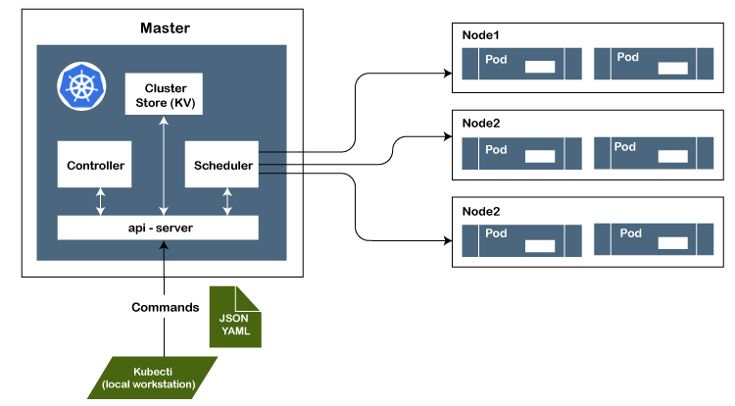
61. Explanation of the critical components used in the diagram:
Master Node: The master node is the first and most crucial component of the Kubernetes' architecture. It is used to manage the Kubernetes cluster. It is the entry point for all kinds of administrative tasks.
There may be more than one master node in the cluster to check for fault tolerance.
API Server: The API server is an entry point for all the REST commands. It is used to control the cluster.
Scheduler: The scheduler is used to schedule the tasks to the slave node and distribute the workload. It also stores the resource usage information for every slave node.
Etcd: The etcd component is used to store configuration detail and good values. It communicates with the most component and receives commands and work. It is also responsible for managing network rules and port forwarding activity.
Worker/Slave nodes: Worker nodes or Slave nodes are another essential components that contain all the required services to manage the networking between the containers, communicate with the master node, which allows you to assign resources to the scheduled boxes.
Kubelet: It gets the Pod's configuration from the API server and ensures that the described containers are up and running.
Docker Container: The Docker container runs on each of the worker nodes, which runs the configured pods.
Pods: A pod is specified as a combination of single or multiple containers that logically run together on nodes.

62. What do you understand by Kubectl in Kubernetes? What is it used for?
In Kubernetes, Kubectl is software that is used to control Kubernetes clusters. The ctl in "Kubectl" stands for control, a command-line interface to pass the command to the cluster and manage the Kubernetes component.

63. What is the full form of GKE, and what is its use?
The full form of GKE is Google Container Engine. It is a management platform that supports clusters and Docker containers that run within the public cloud services of Google.

64. What is the difference between a daemon set, a deployment, and a replication controller?
Following is the difference between a daemon set, a deployment, and a replication controller:
Daemon set: A daemon set is used to ensure that all nodes you have selected are running precisely one copy of a pod.
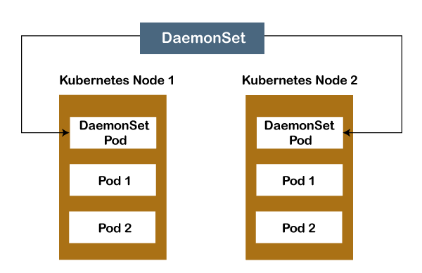
Deployment: A deployment is a resource object in Kubernetes. It is used to provide declarative updates to applications. It also manages the scheduling and lifecycle of pods. It offers many key features for managing pods, such as pod health checks, rolling updates of pods, the ability to roll back and quickly scale pods horizontally.
Replication Controller: The replication controller is used to specify how many exact copies of a pod should be running in a cluster. It differs from a deployment in that it does not offer pod health checks, and the rolling update process is not as robust.

65. What is the use of load balancer in Kubernetes?
A load balancer is used in Kubernetes to provide a standard way to distribute network traffic among different services, which runs in the backend.

66. How can we run Kubernetes locally?
We can use the Minikube tool to run Kubernetes locally. It runs a single-node cluster in a VM (virtual machine) on the computer. So, it is best for users who have just started learning Kubernetes.

67. What is a sidecar container, and what is its use?
A sidecar container is a utility container used to support the main container in a Pod. We can pair a sidecar container with one or more main containers and enhance those primary containers' functionality. It is mainly used for monitoring or when the system logs.

68. What do you understand by a headless service?
A headless service is a specific type of service which uses an IP address, but instead of load balancing, it returns associated pods.

69. What are the main objects used in Kubernetes?
Following is the list of objects used in Kubernetes:
- Pods
- Replication sets and controllers
- Jobs and cron jobs
- Daemon sets
- Distinctive identities
- Deployments
- Stateful sets.

70. What are the different types of pods in Kubernetes?
There are mainly two types of pods in Kubernetes:
- Single Container Pods: We can create Single Container Pods by using the run command in Kubernetes.
- multi-container pods: We can create multi-container pods by using the "create" command in Kubernetes.

71. What do you understand by Prometheus in Kubernetes?
Prometheus is an application that is used for the monitoring and alerting process. We can call out Prometheus to your systems, grab real-time metrics, compress it, and stores them properly in a database.

72. What is the difference between a replica set and a replication controller?
A Replica set and a Replication Controller both are used to do almost the same thing. Both of them ensure that a specified number of pod replicas are running at any given time.
The usage of selectors can distinguish the difference between them to replicate pods. The Replica Set uses Set-Based selectors while replication controllers use Equity-Based selectors.

73. What is the difference between the Equity-Based Selectors and the Selector-Based Selectors?
See the differences between the Equity-Based Selectors and the Selector-Based Selectors:
Equity-Based Selectors: Equity-Based Selectors are the type of selector that allows filtering by label key and values. This selector will only look for the pods, which will have the same phrase as that of the label. For example, if your label key says app=nginx, then, with this selector, you can only look for those pods with label app equal to Nginx.
Selector-Based Selectors: The Selector-Based Selectors are used to allow filtering keys according to a set of values. You can say that these selectors look for pods whose label has been mentioned in the set. For example, if your label key says app in (Nginx, NPS, Apache). With this selector, if your app is equal to any of Nginx, NPS, or Apache, then the selector will take it as a true result.

74. What are some examples of recommended security measures for Kubernetes?
Following are some examples of recommended security measures for Kubernetes:
- Defining resource quota
- Support for auditing
- Restriction of etcd access
- Regular security updates to the environment
- Network segmentation
- Definition of strict resource policies
- Continuous scanning for security vulnerabilities
- Using images from authorized repositories etc.

75. How can we get a static IP for a Kubernetes load balancer?
We can achieve a static IP for the Kubernetes load balancer by changing DNS records because the Kubernetes Master can assign a new static IP address.

76. What do you understand by minikube in Kubernetes?
Minikube is software that facilitates users to run Kubernetes. It runs on the single nodes within the VM on your computer. This tool is also used by programmers who are developing an application using Kubernetes.

77. Which are the most important Kubectl commands?
Following is the list of some important Kubectl commands:
- kubectl annotate
- kubectl cluster-info
- kubectl attach
- kubectl apply
- kubectl config
- kubectl autoscale
- kubectl config current-context
- kubectl config set etc.

78. What do you understand by the labels in Kubernetes?
Labels are a set of keys that contain some values. The key values are connected to pods, replication controllers, and associated services. Generally, labels are added to some object during its creation time. We can easily modify them at the run time.

79. What are the main objectives of the replication controller?
Following are the main objectives of the replication controller:
- A replication controller is mainly responsible for controlling and administering the pod lifecycle.
- It is used to monitor and verify whether the allowed numbers of replicas are running or not.
- It also helps the users to check the pod status.
- It enables to alter a pod. The user can drag its position the way interested in it.

80. What do you understand by Sematext Docker Agent?
The Sematext Docker agent is a log collection agent with events and metrics, which runs as a small container in each Docker host. These agents are responsible for gathering metrics, events, and logs for all cluster nodes and containers.

81. What do you understand by persistent volume in Kubernetes?
In Kubernetes, a persistent volume is a storage unit that the administrator controls. It is used to manage an individual pod in a cluster.

82. Do all of the nodes occupy the same size in the cluster?
No, all the nodes don't occupy the same size in the cluster. The Kubernetes components, such as kubelet, take up resources on your nodes, and you still need more capacity for the node to do any task. In the larger cluster, it is always preferred to create a mix of different instance sizes. So, the Kubernetes can easily schedule the pods that require a lot of memory with intensive compute workloads on large nodes, and smaller nodes can handle smaller pods.

83. What is the ContainerCreating pod in Kubernetes?
A ContainerCreating pod is a specific type of pod scheduled on a node but can't start up properly.

84. What are the different types of Kubernetes Volume?
Following are the different types of Kubernetes Volume:
- EmptyDir
- GCE persistent disk
- Flocker
- HostPath
- NFS
- ISCSI
- rbd
- PersistentVolumeClaim
- downwardAPI

85. What are the Secrets in Kubernetes?
Secrets are the objects in Kubernetes that stores sensitive information like username and password after performing encryption.

86. What do you understand by OpenShift in Kubernetes?
OpenShift is a public cloud application development and hosting platform developed by Red Hat. It is used to provide automation for management so that developers can easily write codes.

87. What do you understand by federated clusters?
Federated clusters are a set of multiple clusters that are managed as a single cluster.

88. What is the difference between Kubernetes Volumes and Docker volumes?
The main differences between Kubernetes Volumes and Docker volumes are:
Kubernetes Volumes | Docker Volumes
The Kubernetes volumes are not limited to any container. | The Docker volumes are limited to a pod in the container.
Kubernetes volumes support all containers deployed in a pod of Kubernetes. | Docker volumes do not support all containers deployed in Docker.

89. What are the ways to provide API-Security on Kubernetes?
There are the following ways to provide API-Security on Kubernetes:
- Using correct auth mode with API server authentication mode.
- Making kubeless that protects its API via authorization-mode.
- Ensuring the kube-dashboard uses a restrictive RBAC (Role-Based Access Control) policy.

90. What do you understand by PVC? What is its full form?
The full form of PVC is Persistent Volume Claim. It is storage requested by Kubernetes for pods. In PVC, it doesn't require knowing the underlying provisioning. You can create the claim in the same namespace where the pod is created.

91. What do you understand by container resource monitoring?
The users need to understand the application's performance and resource utilization at all the different abstraction layers. Kubernetes create abstraction at different levels like containers, pods, services, and whole cluster to monitor them well. This process is called container resource monitoring.
Following is a list of some container resource monitoring tools:
- Heapster: It is used to gather data and events from the containers and pods within the cluster. A Heapster is a metrics collection and performance monitoring system for data that are collected by the Kublet.
- InfluxDB: It is used along with heapster for visualizing data within the Kubernetes environment.
- Grafana: It is a time-series database used to store the data captured by all heapster pods.
- CAdvisor: It is a built-in tool in a kubelet that automatically discovers all the active containers and monitors them.
- Prometheus: It specifies a project of CNCF, which provides powerful querying, alerting, and visualization capabilities.

Tools that are used for container monitoring are:
- Heapster
- cAdvisor
- Prometheus
- InfluxDB
- Grafana

92. What tasks are performed by Kubernetes?

Kubernetes is the Linux kernel which is used for distributed systems. It helps you to be abstract the underlying hardware of the nodes(servers) and offers a consistent interface for applications that consume the shared pool of resources.

Explain Kubernetes Architecture
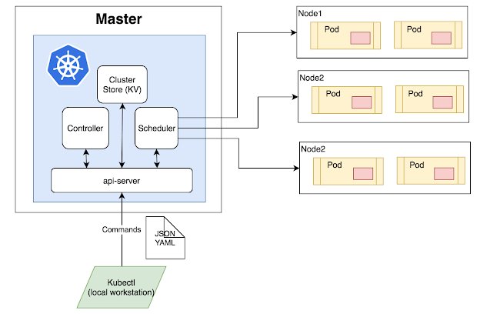Kubernetes Architecture Diagram
- Master Node: The master node is the first and most vital component which is responsible for the management of Kubernetes cluster. It is the entry point for all kinds of administrative tasks. There may be more than one master node in the cluster to check for fault tolerance.
- API Server: The API server acts as an entry point for all the REST commands used for controlling the cluster.
- Scheduler: The scheduler schedules the tasks to the slave node. It stores the resource usage information for every slave node. It is responsible for distributing the workload.
- Etcd: etcd components, store configuration detail, and wright values. It communicates with the most component to receive commands and work. It also manages network rules and port forwarding activity.
- Worker/Slave nodes: Worker nodes are another essential component that contains all the required services to manage the networking between the containers, communicate with the master node, which allows you to assign resources to the scheduled containers.
- Kubelet: It gets the configuration of a Pod from the API server and ensures that the described containers are up and running.
- Docker Container: Docker container runs on each of the worker nodes, which runs the configured pods.
- Pods: A pod is a combination of single or multiple containers that logically run together on nodes.

93. List various services available in Kubernetes
Various services available in Kubernetes are 1) Cluster IP service, 2) Load Balancer service, 3) Node Port service, 4) External Name Creation service.

94. Define Cluster IP

The Cluster IP is a Kubernetes service that offers a service inside the cluster that other apps inside cluster can access.

95. Define Ingress Network
Ingress network is defined as a collection of rules which allow permission for connections into the Kubernetes cluster.

96. What is Kubectl used for?
Kubectl is a software for controlling Kubernetes clusters. Ctl stands for control, which is a command-line interface to pass the command to the cluster and manage the Kubernetes component.

97. What is GKE?
GKE or Google Container Engine is a management platform that supports clusters and Docker containers that run within public cloud services of Google.

98. Why load balancer is needed?
A load balancer is needed because it gives a standard way to distribute network traffic among different services, which runs in the backend.

99. How to run Kubernetes locally?
Kubernetes can be run locally using the Minikube tool. It runs a single-node cluster in a VM (virtual machine) on the computer. Therefore, it offers the ideal way for users who have just started learning Kubernetes.

100. List components of Kubernetes
There are three components of Kubernetes, they are:
- Addons
- Node components
- Master Components

101. Define headless service
Headless service is defined as a service that uses IP address, but instead of load balancing, it returns of associated pods.

102. What is minikube?
Minikube is a software that helps the user to run Kubernetes. It runs on the single nodes that are inside VM on your computer. This tool is also used by programmers who are developing an application using Kubernetes.

103. Mention the uses of GKE
The uses of the GKE (Google Kubernetes Engine) are:
- It can be used to create docker container clusters
- Resize application controllers
- Update and then upgrade the clusters of container
- Debug cluster of the container.
- GKE can be used to creates a replication controller, jobs, services, container pods, or load balancer.

104. Define orchestration in Kubernetes
Orchestration in Kubernetes defines as an automatic method of scheduling the work of every container. It is used for applications that are based on microservices within clusters.

105. Explain Prometheus in Kubernetes
Prometheus is an application that is used for monitoring and alerting. It can be called out to your systems, grab real-time metrics, compress it, and stores properly in a database.

106. Mention the list of objects of Kubernetes?
Objects that are used in Kubernetes are: 1) Pods, 2) Replication sets and controllers, 3) Jobs and cron jobs, 4) Daemon sets, 5) Distinctive identities, 6) Deployments, 7) and Stateful sets.

107. Define Stateful sets in Kubernetes
The stateful set is a workload API object that is used to manage the stateful application. It can also be used to manage the deployments and scaling the sets of pods. The state information and other data of stateful pods are store in the disk storage, which connects with stateful set.

108. Explain Replica set
A Replica set is used to keep replica pods stable. It enables us to specify the available number of identical pods. This can be considered a replacement for the replication .controller.

109. List out some important Kubectl commands:
The important Kubectl commands are:
- kubectl annotate
- kubectl cluster-info
- kubectl attach
- kubectl apply
- kubectl config
- kubectl autoscale
- kubectl config current-context
- kubectl config set.

110. Why uses Kube-apiserver?
Kube-apiserver is an API server of Kubernetes that is used to configure and validate API objects, which include services, controllers, etc. It provides the frontend to the cluster’s shared region using which components interact with each other.

111. Explain the types of Kubernetes pods
There are two types of pods in Kubernetes:
- Single Container Pod: It can be created with the run command.
- Multicontainer pods: It can be created using the “create” command in Kubernetes.

112. What are the labels in Kubernetes?
Labels are a collection of keys that contain some values. The key values are connected to pods, replication controllers, and associated services. Generally, labels are added to some object during its creation time. They can be modified by the users at run time.

113. What are the objectives of the replication controller?
The objectives of the replication controller are:
- It is responsible for controlling and administering the pod lifecycle.
- It monitors and verifies whether the allowed number of replicas are running or not.
- The replication controller helps the user to check the pod status.
- It enables to alter a pod. The user can drag its position the way interested in it.

114. What do you mean by persistent volume?
A persistent volume is a storage unit that is controlled by the administrator. It is used to manage an individual pod in a cluster.

115. What are Secrets in Kubernetes?
Secrets are sensitive information like login credentials of the user. They are objects in Kubernetes that stores sensitive information like username and password after performing encryption.

116. What is Sematext Docker Agent?
Sematext Docker agent is a log collection agent with events and metrics. It runs as a small container in each Docker host. These agents gather metrics, events, and logs for all cluster nodes and containers.

117. Define OpenShift
OpenShift is a public cloud application development and hosting platform developed by Red Hat. It offers automation for management so that developers can focus on writing the code.

118. What are federated clusters?
Federated clusters multiple clusters that are managed as a single cluster.

119. Mention the difference between Docker volumes and Kubernetes Volumes
Kubernetes Volumes | Docker Volumes
Volumes are not limited to any container. | Volumes are limited to a pod in the container.
Kubernetes volumes support all containers deployed in a pod of Kubernetes. | Docker volumes do not support all containers deployed in Docker.

120. What are the ways to provide API-Security on Kubernetes?
The ways to provide API-Security on Kubernetes are:
- Using correct auth mode with API server authentication mode= Node.
- Make kubeless that protects its API via authorization-mode=Webhook.
- Ensure the kube-dashboard uses a restrictive RBAC (Role-Based Access Control) policy

121. What is ContainerCreating pod?
A ContainerCreating pod is one that can be scheduled on a node but can’t start up properly.

122. What are the types of Kubernetes Volume?
The types of Kubernetes Volume are:
- EmptyDir
- GCE persistent disk
- Flocker
- HostPath
- NFS
- ISCSI
- rbd
- PersistentVolumeClaim
- downwardAPI

123. Explain PVC
The full form of PVC stands for Persistent Volume Claim. It is storage requested by Kubernetes for pods. The user does not require to know the underlying provisioning. This claim should be created in the same namespace where the pod is created.

124. What is the Kubernetes Network Policy?
Network Policy defines how the pods in the same namespace would communicate with each other and the network endpoint.

125. What is Kubernetes proxy service?
Kubernetes proxy service is a service which runs on the node and helps in making it available to an external host.

126. How can containers within a pod communicate with each other?

Containers within a pod share networking space and can reach other on localhost. For instance, if you have two containers within a pod, a MySQL container running on port 3306, and a PHP container running on port 80, the PHP container could access the MySQL one through localhost:3306.

127. What does a Pod do?

Pods represent the processes running on a cluster. By limiting pods to a single process, Kubernetes can report on the health of each process running in the cluster. Pods have:
- a unique IP address (which allows them to communicate with each other)
- persistent storage volumes (as required)
- configuration information that determine how a container should run.
Although most pods contain a single container, many will have a few containers that work closely together to execute a desired function.

128. Explain what are some Pods usage patterns?

Pods can be used in two main ways:
- Pods that run a single container. The simplest and most common Pod pattern is a single container per pod, where the single container represents an entire application. In this case, you can think of a Pod as a wrapper.
- Pods that run multiple containers that need to work together. Pods with multiple containers are primarily used to support colocated, co-managed programs that need to share resources. These colocated containers might form a single cohesive unit of service—one container serving files from a shared volume while another container refreshes or updates those files. The Pod wraps these containers and storage resources together as a single manageable entity.
Each Pod is meant to run a single instance of a given application. If you want to run multiple instances, you should use one Pod for each instance of the application. This is generally referred to as replication. Replicated Pods are created and managed as a group by a controller, such as a Deployment.

129. Explain what is a Master Node and what component does it consist of?
- The master node is the most vital component responsible for Kubernetes architecture
- It is the central controlling unit of Kubernetes and manages workload and communications across the clusters
The master node has various components, each having its process. They are:
- ETCD
- Controller Manager
- Scheduler
- API Server
ETCD (Cluster store)
- This component stores the configuration details and essential values
- It communicates with all other components to receive the commands and work in order to perform an action
- It also manages network rules and posts forwarding activity
Controller Manager
- It is responsible for most of the controllers and performs a task
- It is a daemon which runs in a continuous loop and is responsible for collecting and sending information to API server
- The key controllers handle nodes, endpoints, etc.
Scheduler
- It is one of the key components of the master node associated with the distribution of workload
- The scheduler is responsible for workload utilization and allocating pod to a new node
- The scheduler should have an idea of the total resources available as well as resources allocated to existing workloads on each node
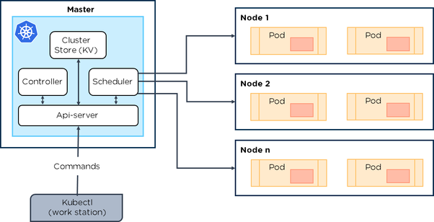

130. Explain when to use Docker vs Docker Compose vs Docker Swarm vs Kubernetes
- Docker is a container engine, it makes you build and run usually no more than one container at most, locally on your PC for development purposes.
- Docker Compose is a Docker utility to run multiple containers and let them share volumes and networking via the docker engine features, runs locally to emulate service composition and remotely on clusters. Docker Compose is mostly used as a helper when you want to start multiple Docker containers and don't want to start each one separately using docker run ....
- Docker Swarm is for running and connecting containers on multiple hosts. It does things like scaling, starting a new container when one crashes, networking containers.
- Kubernetes is a container orchestration platform, it takes care of running containers and enhancing the engine features so that containers can be composed and scaled to serve complex applications (sort of PaaS, managed by you or cloud provider). Kubernetes' goal is very similar to that for Docker Swarm but it's developer by Google.

131. What are namespaces? What is the problem with using one default namespace?

Namespaces allow you split your cluster into virtual clusters where you can group your applications in a way that makes sense and is completely separated from the other groups (so you can for example create an app with the same name in two different namespaces).
- When using the default namespace alone, it becomes hard over time to get an overview of all the applications you manage in your cluster. Namespaces make it easier to organize the applications into groups that makes sense, like a namespace of all the monitoring applications and a namespace for all the security applications, etc.
- Namespaces can also be useful for managing Blue/Green environments where each namespace can include a different version of an app and also share resources that are in other namespaces (namespaces like logging, monitoring, etc.).
- Another use case for namespaces is one cluster, multiple teams. When multiple teams use the same cluster, they might end up stepping on each others toes. For example if they end up creating an app with the same name it means one of the teams overriden the app of the other team because there can't be too apps in Kubernetes with the same name (in the same namespace).

132. What does it mean that "pods are ephemeral"?

Pods are ephemeral. They are not designed to run forever, and when a Pod is terminated it cannot be brought back. In general, Pods do not disappear until they are deleted by a user or by a controller.
Pods do not "heal" or repair themselves. For example, if a Pod is scheduled on a node which later fails, the Pod is deleted. Similarly, if a Pod is evicted from a node for any reason, the Pod does not replace itself.

133. What happens when a master fails? What happens when a worker fails?

Kubernetes is designed to be resilient to any individual node failure, master or worker. When a master fails the nodes of the cluster will keep operating, but there can be no changes including pod creation or service member changes until the master is available. When a worker fails, the master stops receiving messages from the worker. If the master does not receive status updates from the worker the node will be marked as NotReady. If a node is NotReady for 5 minutes, the master reschedules all pods that were running on the dead node to other available nodes.

134. What is a StatefulSet in Kubernetes?

When using Kubernetes, most of the time you don’t care how your pods are scheduled, but sometimes you care that pods are deployed in order, that they have a persistent storage volume, or that they have a unique, stable network identifier across restarts and reschedules. In those cases, StatefulSets can help you accomplish your objective. It manages the deployment and scaling of a set of Pods, and provides guarantees about the ordering and uniqueness of these Pods.
StatefulSets are valuable for applications that require one or more of the following.
- Stable, unique network identifiers.
- Stable, persistent storage.
- Ordered, graceful deployment and scaling.
- Ordered, automated rolling updates.

135. When to use StatefulSet?

Some examples of reasons you’d use a StatefulSet include:
- A Redis pod that has access to a volume, but you want it to maintain access to the same volume even if it is redeployed or restarted
- A Cassandra cluster and have each node maintain access to its data
- A webapp that needs to communicate with its replicas using known predefined network identifiers

136. How does Kubernetes use etcd?

137. Why do we need Kubernetes (and other orchestrators) above containers?

138. Can you explain a relationship between container runtime and container orchestration?

139. Explain what are Taints in Kubernetes?

140. How do I build a High Availability (HA) cluster?

141. How does StatefulSets use differ from the use of "stateless" Pods with Persistent Volumes?

142. What are the benefits of Kubernetes?
With the container orchestration tool Kubernetes, it becomes extremely easy to handle containers. We can respond to customer demands by deploying the applications faster and in a more predictable manner.
Here, we will list some of the benefits of Kubernetes:
- Automatic scheduling
- Automated rollback
- Horizontal scaling
- Auto-healing capabilities

143. What is a Kubernetes cluster?
A Kubernetes cluster is a group of nodes that run containerized applications across various environments and machines—cloud-based, physical, virtual, and on-premises. It enables the easy development of applications as well as their management and movement.

144. What is the difference between Kubernetes and Docker Swarm?
Docker Swarm is a default container orchestration tool that comes with Docker. Docker Swarm can only orchestrate simple Docker containers. Kubernetes, on the other hand, helps manage much more complex software application containers. Kubernetes offers support for larger demand production environment.

145. What is a Kubernetes namespace?
The Kubernetes namespace is used in the environment wherein we have multiple users spread in the geographically vast areas and working on multiple projects. What the namespace does is dividing the cluster resources between multiple users.

146. What are federated clusters?
Multiple clusters that are managed as a single cluster is referred to as federated clusters.

147. What is a pod in Kubernetes?
We can think of a Kubernetes pod as a group of containers that are run on the same host. So, if we regularly deploy single containers, then our container and the pod will be one and the same.

148. What is a container cluster?
A container cluster lets us place and manage containers in a dynamic setup. It can be considered as a set of nodes or Compute Engine instances. The API server of Kubernetes does not run on cluster nodes, instead the Container Engine hosts the API server.

149. What is a kubelet?
We can think of a kubelet as the lowest level component in a Kubernetes. The kubelet is responsible for making the individual machines run. The sole purpose of a kubelet is that in a given set of containers, it has to ensure that they are all running.

Following is the syntax:
kube-scheduler [flags]
The scheduling life cycle:
- A pod is created and the preferred state is mentioned, and without filling the node name, it is saved to etcd
- The scheduler notices the new pod with no node bound
- It finds a suitable node for that pod
- It then informs the API server to bind the pod to the node, and next, the new desired state is saved to etcd
- Kubelets watch the pods that are bound and start the containers on the particular node

148. What are the ways to provide API Security on Kubernetes?
Following are some of the ways that provide API Security:
- Using the correct auth mode with the API server authentication mode= Node, RBAC
- Ensuring that the traffic is protected by TLS
- Using API authentication
- Ensuring that kubeless protects its API via authorization-mode=Webhook
- Monitoring RBAC failures
- Removing default Service Account permissions
- Ensuring that the kube-dashboard applies a restrictive RBAC policy
- Implementing a pod security policy for container restrictions and the protection of the node
- Using the latest version of kube

149. If an organization is looking for ways to improve its deployment methods and desires a more scalable and responsive platform, what should be done?
The company should move to a cloud environment and implement a microservice architecture for implementing Docker containers. Once the base framework is set up, Kubernetes can be used for the autonomous development of applications and the quick delivery of the same by the team.

150. If an organization has a large distributed system with several data centers, virtual machines, and a huge number of employees working on various tasks, how can the tasks be managed with consistency with the help of Kubernetes?
The company can do well with something that offers scale-out capability, agility, and the DevOps practice to the cloud-based applications. Kubernetes, in this situation, can enable the customization of the scheduling architecture and support multiple container formats. This results in greater efficiency as well as provides support for various container networking solutions and container storage.

151. What is the difference between a replica set and a replication controller?
The difference is mainly in the selectors used for pod replication. A replica set uses set-based selectors, and replication controllers use equity-based selectors.

152. How does Kubernetes scale?
The kubectl scale command enables the ability to instantly change the number of replicas needed for running an application. While using this command, the new number of replicas need to be specified by setting the –replicas flag.

153. What is a Kubernetes context?
A context is a group of access parameters that has a cluster, a user, and a namespace. The current context is the cluster that is currently the default for kubectl, and all kubectl commands run against that cluster.

154. Give examples of some recommended security measures for Kubernetes.
- Defining resource quotas
- Auditing support
- Providing restricted access to etcd
- Regular security updates
- Network segmentation
- Strict resource policies
- Regular scans for security vulnerabilities
- Using images from repositories that are authorized

155. What is a Headless Service?
The headless service is like normal services but without the Cluster IP. It enables direct access to pods without the need for a proxy.

156. What is Minikube?
The Minikube makes it easy for the local running of Kubernetes. Within a virtual machine, the Minikube runs a single-node Kubernetes cluster.

157. What is Kubectl?
Kubectl is a Kubernetes command-line tool that is used for deploying and managing applications on Kubernetes. Kubectl is especially useful for inspecting the cluster resources, and for creating, updating, and deleting the components.

158. What is GKE?
GKE is Google Kubernetes Engine which is used for managing and orchestrating systems for Docker containers. GKE also lets us orchestrate container clusters within the Google Public Cloud.

159. What are the components of a Kubernetes Master?
The components of the Kubernetes Master include the API server, the controller manager, the Scheduler, and the etcd components. The Kubernetes Master components are responsible for running and managing the Kubernetes cluster.

160. What is the use of kube-controller-manager?
It is the Kubernetes Controller Manager. The kube-controller-manager is a daemon that embeds the core control loops which regulate the system state, and it is a non-terminating loop.

161. What is load balancing on Kubernetes?
The process of load balancing will let us expose services. There are two types of load balancing when it comes to Kubernetes:
- Internal load balancing: This is used for balancing the loads automatically and allocating the pods with the required configuration.
- External load balancing: This directs the traffic from the external loads to the backend pods.

162. Where is the Kubernetes cluster data stored?
The primary data store of Kubernetes is etcd, which is responsible for storing all Kubernetes cluster data.

163. How to set a static IP for Kubernetes load balancer?
Kubernetes Master assigns a new IP address.
We can set a static IP for Kubernetes load balancer by changing the DNS records whenever Kubernetes Master assigns a new IP address.

164. Explain the Kubernetes architecture.
Pods
Pods are the smallest units that Kubernetes administers. It constitutes a set of containers. It shares a single IP address and all the resources, such as storage and memory, among every container within it. A pod can have a single container when the service or application is a single process.
Deployments
Kubernetes deployments determine the scale at which one wants to run an application, such as how the pods need to be replicated on the Kubernetes nodes, the desired number of pod replicas to be run, and the desired update strategy for the deployment.
Services
If a pod dies, Kubernetes replaces it to prevent any downtime. A service is the only interface that the application consumers deal with. When pods are changed, their internal names and IPs might change as well. A service exposes a single IP address or machine name linked to pods whose numbers and names are unreliable. It ensures that nothing appears changed to the outside network.
Nodes
A Kubernetes node collects, runs, and manages pods that function together.
The Kubernetes Control Plane
The Kubernetes control plane is the main entry point for users and administrators to handle the management of various nodes. HTTP calls or command-line scripts are used to assign operations to it. How Kubernetes interacts with applications is controlled by the control plane.

Cluster
The above components put together in a single unit is referred to as a cluster.
Kubernetes Components:
The control plane and the individual nodes consist of three main components each.
Control plane
- API Server
The Kubernetes API server validates and configures data for API objects, including pods, replication controllers, services, etc. It serves REST operations and provides the frontend to the cluster’s shared state through which all other components communicate.
- Scheduler
The scheduler assigns work to the nodes, keeps track of the capacity of resources, and ensures that a worker node’s operation is within the right threshold.
- Controller Manager
The controller manager ensures that a cluster’s shared state is operating in the desired manner. It monitors various controllers, which respond to events.
Worker Node Components:
- Kubelet
A kubelet keeps track of the state of a pod and ensures that every container is operating well.
- Kube proxy
The kube proxy is a network proxy that maintains network rules on nodes. It sends requests for work to the appropriate containers.
- etcd
This etcd component manages and holds the critical data that distributed systems require to operate. It is an open-source distributed key-value store that is used to share the state of a cluster. It helps with the setup of the overlay network for containers.
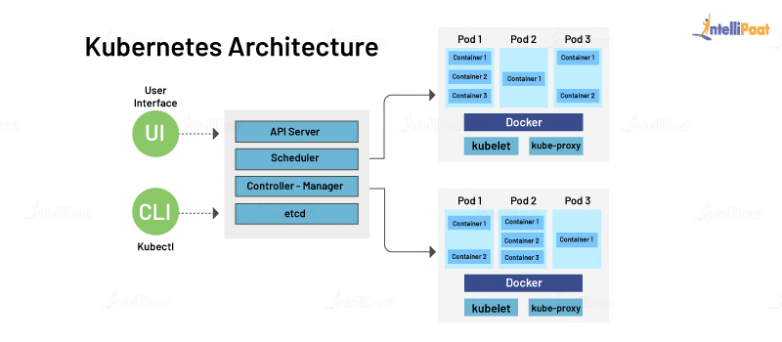

165. What do I need on-premises to run the Kubernetes architecture?
Many on-premises environments are remodeled to enable Kubernetes integration. Integrating storage, servers, and networking into a smoothly running environment requires top skills. For Kubernetes, deciding the right storage and networking equipment is crucial as it facilitates interaction with resources for storage, load balancers, etc. A critical part of Kubernetes’ value proposition is the ability to automate storage and the networking components.

166. How are Kubernetes and Docker related?
This is one of the most frequently asked Kubernetes interview questions, where the interviewer might as well ask you to share your experience working with any of them. Docker is an open-source platform used to handle software development. Its main benefit is that it packages the settings and dependencies that the software/application needs to run into a container, which allows for portability and several other advantages. Kubernetes allows for the manual linking and orchestration of several containers, running on multiple hosts that have been created using Docker.

167. What is the difference between deploying applications on hosts and containers?

Deploying Applications consist of an architecture that has an operating system. The operating system will have a kernel that holds various libraries installed on the operating system needed for an application.
Whereas container host refers to the system that runs the containerized processes. This kind is isolated from the other applications; therefore, the applications must have the necessary libraries. The binaries are separated from the rest of the system and cannot infringe any other application.

168. What are the main components of Kubernetes architecture?
There are two primary components of Kubernetes Architecture: the master node and the worker node. Each of these components has individual components in them.

169. What is the role of Kube-apiserver?
This kind validates and provides configuration data for the API objects. It includes pods, services, replication controllers. Also, it provides REST operations and also the frontend of the cluster. This frontend cluster state is shared through which all other component interacts.

170. What does the node status contain?
The main components of a node status are Address, Condition, Capacity, and Info.

171. What process runs on Kubernetes Master Node?
The Kube-api server process runs on the master node and serves to scale the deployment of more instances.

172. What is a pod in Kubernetes?
In this Kubernetes interview question, try giving a thorough answer instead of a one-liner. Pods are high-level structures that wrap one or more containers. This is because containers are not run directly in Kubernetes. Containers in the same pod share a local network and the same resources, allowing them to easily communicate with other containers in the same pod as if they were on the same machine while at the same time maintaining a degree of isolation.

173. How are Kubernetes and Docker related?
This is one of the most frequently asked Kubernetes interview questions, where the interviewer might as well ask you to share your experience working with any of them. Docker is an open-source platform used to handle software development. Its main benefit is that it packages the settings and dependencies that the software/application needs to run into a container, which allows for portability and several other advantages. Kubernetes allows for the manual linking and orchestration of several containers, running on multiple hosts that have been created using Docker.

174. What is the difference between deploying applications on hosts and containers?
Deploying Applications consist of an architecture that has an operating system. The operating system will have a kernel that holds various libraries installed on the operating system needed for an application.
Whereas container host refers to the system that runs the containerized processes. This kind is isolated from the other applications; therefore, the applications must have the necessary libraries. The binaries are separated from the rest of the system and cannot infringe any other application.

175. What are the main components of Kubernetes architecture?
There are two primary components of Kubernetes Architecture: the master node and the worker node. Each of these components has individual components in them.

176. What is the role of Kube-apiserver?
This kind validates and provides configuration data for the API objects. It includes pods, services, replication controllers. Also, it provides REST operations and also the frontend of the cluster. This frontend cluster state is shared through which all other component interacts.

177. What does the node status contain?
The main components of a node status are Address, Condition, Capacity, and Info.

178. What process runs on Kubernetes Master Node?
The Kube-api server process runs on the master node and serves to scale the deployment of more instances.

179. What is a pod in Kubernetes?
In this Kubernetes interview question, try giving a thorough answer instead of a one-liner. Pods are high-level structures that wrap one or more containers. This is because containers are not run directly in Kubernetes. Containers in the same pod share a local network and the same resources, allowing them to easily communicate with other containers in the same pod as if they were on the same machine while at the same time maintaining a degree of isolation.

180. What is a cluster of containers in Kubernetes?
A cluster of containers is a set of machine elements that are nodes. Clusters initiate specific routes so that the containers running on the nodes can communicate with each other. In Kubernetes, the container engine (not the server of the Kubernetes API) provides hosting for the API server.

181. What is the Google Container Engine?
The Google Container Engine is an open-source management platform tailor-made for Docker containers and clusters to provide support for the clusters that run in Google public cloud services.

182. What is Minikube?
With the help of Minikube, users can Kubernetes locally. This process lets the user run a single-node Kubernetes cluster on your personal computer, including Windows, macOS, and Linus PCs. With this, users can try out Kubernetes also for daily development work.

183. What is a Namespace in Kubernetes?
Namespaces are used for dividing cluster resources between multiple users. They are meant for environments where there are many users spread across projects or teams and provide a scope of resources.

184. Name the initial namespaces from which Kubernetes starts?
- Default
- Kube – system
- Kube – public

185. What is the Kubernetes controller manager?
The controller manager is a daemon that is used for embedding core control loops, garbage collection, and Namespace creation. It enables the running of multiple processes on the master node even though they are compiled to run as a single process.

186. What are the types of controller managers?
The primary controller managers that can run on the master node are the endpoints controller, service accounts controller, namespace controller, node controller, token controller, and replication controller.

187. What is etcd?
Kubernetes uses etcd as a distributed key-value store for all of its data, including metadata and configuration data, and allows nodes in Kubernetes clusters to read and write data. Although etcd was purposely built for CoreOS, it also works on a variety of operating systems (e.g., Linux, BSB, and OS X) because it is open-source. Etcd represents the state of a cluster at a specific moment in time and is a canonical hub for state management and cluster coordination of a Kubernetes cluster.

188. What are the different services within Kubernetes?
Different types of Kubernetes services include:
- Cluster IP service
- Node Port service
- External Name Creation service and
- Load Balancer service

189. What is ClusterIP?
The ClusterIP is the default Kubernetes service that provides a service inside a cluster (with no external access) that other apps inside your cluster can access.

190. What is NodePort?
The NodePort service is the most fundamental way to get external traffic directly to your service. It opens a specific port on all Nodes and forwards any traffic sent to this port to the service.

191. What is the LoadBalancer in Kubernetes?
The LoadBalancer service is used to expose services to the internet. A Network load balancer, for example, creates a single IP address that forwards all traffic to your service.

192. What is the Ingress network, and how does it work?
An ingress is an object that allows users to access your Kubernetes services from outside the Kubernetes cluster. Users can configure the access by creating rules that define which inbound connections reach which services.
How does it work- This is an API object that provides the routing rules to manage the external users' access to the services in the Kubernetes cluster through HTTPS/ HTTP. With this, users can easily set up the rules for routing traffic without creating a bunch of load balancers or exposing each service to the nodes.

193. What do you understand by Cloud controller manager?
You must have heard about Public, Private and hybrid clouds. With the help of cloud infrastructure technologies, you can run Kubernetes on them. In the context of Cloud Controller Manager, it is the control panel component that embeds the cloud-specific control logic. This process lets you link the cluster into the cloud provider's API and separates the elements that interact with the cloud platform from components that only interact with your cluster.
This also enables the cloud providers to release the features at a different pace compared to the main Kubernetes project. It is structured using a plugin mechanism and allows various cloud providers to integrate their platforms with Kubernetes.

194. What is Container resource monitoring?
This refers to the activity that collects the metrics and tracks the health of containerized applications and microservices environments. It helps to improve health and performance and also makes sure that they operate smoothly.

195. What is the difference between a replica set and a replication controller?
A replication controller is referred to as RC in short. It is a wrapper on a pod. This provides additional functionality to the pods, which offers replicas.
It monitors the pods and automatically restarts them if they fail. If the node fails, this controller will respawn all the pods of that node on another node. If the pods die, they won't be spawned again unless wrapped around a replica set.
Replica Set, on the other hand, is referred to as rs in short. It is told as the next-generation replication controller. This kind of support has some selector types and supports the equality-based and the set-based selectors.
It allows filtering by label values and keys. To match the object, they have to satisfy all the specified label constraints.

196. What is a headless service?
A headless service is used to interface with service discovery mechanisms without being tied to a ClusterIP, therefore allowing you to directly reach pods without having to access them through a proxy. It is useful when neither load balancing nor a single Service IP is required.

197. What are federated clusters?
The aggregation of multiple clusters that treat them as a single logical cluster refers to cluster federation. In this, multiple clusters may be managed as a single cluster. They stay with the assistance of federated groups. Also, users can create various clusters within the data center or cloud and use the federation to control or manage them in one place.
You can perform cluster federation by doing the following:
Cross cluster that provides the ability to have DNS and Load Balancer with backend from the participating clusters.
Users can sync resources across different clusters in order to deploy the same deployment set across the various clusters.

198. What is Kubelet?
The kubelet is a service agent that controls and maintains a set of pods by watching for pod specs through the Kubernetes API server. It preserves the pod lifecycle by ensuring that a given set of containers are all running as they should. The kubelet runs on each node and enables the communication between the master and slave nodes.

199. What is Kubectl?
Kubectl is a CLI (command-line interface) that is used to run commands against Kubernetes clusters. As such, it controls the Kubernetes cluster manager through different create and manage commands on the Kubernetes component

200. Give examples of recommended security measures for Kubernetes.
Examples of standard Kubernetes security measures include defining resource quotas, support for auditing, restriction of etcd access, regular security updates to the environment, network segmentation, definition of strict resource policies, continuous scanning for security vulnerabilities, and using images from authorized repositories.

201. How can you get a static IP for a Kubernetes load balancer?
A static IP for the Kubernetes load balancer can be achieved by changing DNS records since the Kubernetes Master can assign a new static IP address.

202. How do we control the resource usage of POD?
With the use of limit and request resource usage of a POD can be controlled.
Request: The number of resources being requested for a container. If a container exceeds its request for resources, it can be throttled back down to its request.
Limit: An upper cap on the resources a single container can use. If it tries to exceed this predefined limit it can be terminated if K8's decides that another container needs these resources. If you are sensitive towards pod restarts, it makes sense to have the sum of all container resource limits equal to or less than the total resource capacity for your cluster.
Example:
apiVersion: v1
kind: Pod
metadata:
name: demo
spec:
containers:
- name: example1
image:example/example1
resources:
requests:
memory: "_Mi"
cpu: "_m"
limits:
memory: "_Mi"
cpu: "_m"

203. What are the various K8's services running on nodes and describe the role of each service?
Mainly K8 cluster consists of two types of nodes, executor and master.
Executor node: (This runs on master node)
- Kube-proxy: This service is responsible for the communication of pods within the cluster and to the outside network, which runs on every node. This service is responsible to maintain network protocols when your pod establishes a network communication.
- kubelet: Each node has a running kubelet service that updates the running node accordingly with the configuration(YAML or JSON) file. NOTE: kubelet service is only for containers created by Kubernetes.
Master services:
- Kube-apiserver: Master API service which acts as an entry point to K8 cluster.
- Kube-scheduler: Schedule PODs according to available resources on executor nodes.
- Kube-controller-manager: is a control loop that watches the shared state of the cluster through the apiserver and makes changes attempting to move the current state towards the desired stable state

204. What is PDB (Pod Disruption Budget)?
A Kubernetes administrator can create a deployment of a kind: PodDisruptionBudget for high availability of the application, it makes sure that the minimum number is running pods are respected as mentioned by the attribute minAvailable spec file. This is useful while performing a drain where the drain will halt until the PDB is respected to ensure the High Availability(HA) of the application. The following spec file also shows minAvailable as 2 which implies the minimum number of an available pod (even after the election).
Example: YAML Config using minAvailable =>
apiVersion: policy/v1beta1
kind: PodDisruptionBudget
metadata:
name: zk-pdb
spec:
minAvailable: 2
selector:
matchLabels:
app: zookeeper

205. What’s the init container and when it can be used?
init containers will set a stage for you before running the actual POD.
Wait for some time before starting the app Container with a command like sleep 60.
Clone a git repository into a volume.

206. What is the role of Load Balance in Kubernetes?
Load balancing is a way to distribute the incoming traffic into multiple backend servers, which is useful to ensure the application available to the users.
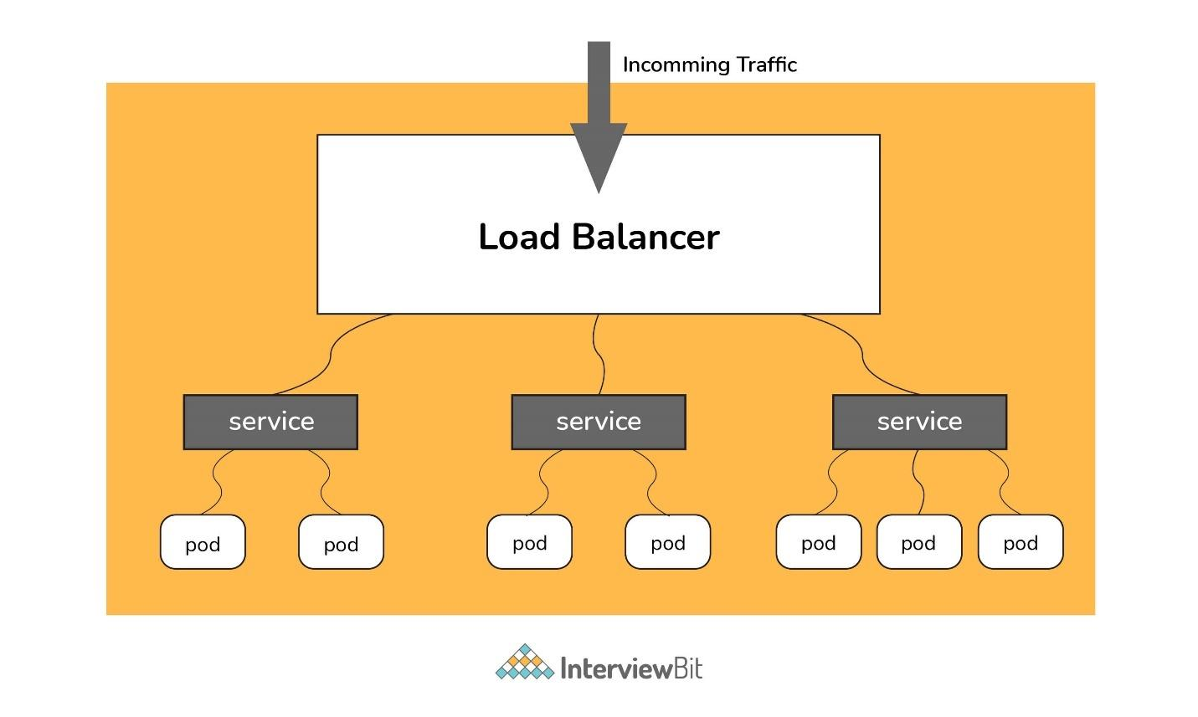Load Balancer
In Kubernetes, as shown in the above figure all the incoming traffic lands to a single IP address on the load balancer which is a way to expose your service to outside the internet which routes the incoming traffic to a particular pod (via service) using an algorithm known as round-robin. Even if any pod goes down load balances are notified so that the traffic is not routed to that particular unavailable node. Thus load balancers in Kubernetes are responsible for distributing a set of tasks (incoming traffic) to the pods

207. What are the various things that can be done to increase Kubernetes security?
By default, POD can communicate with any other POD, we can set up network policies to limit this communication between the PODs.
- RBAC (Role-based access control) to narrow down the permissions.
- Use namespaces to establish security boundaries.
- Set the admission control policies to avoid running the privileged containers.
- Turn on audit logging.

208. How to monitor the Kubernetes cluster?
Prometheus is used for Kubernetes monitoring. The Prometheus ecosystem consists of multiple components.
- Mainly Prometheus server which scrapes and stores time-series data.
- Client libraries for instrumenting application code.
- Push gateway for supporting short-lived jobs.
- Special-purpose exporters for services like StatsD, HAProxy, Graphite, etc.
- An alert manager to handle alerts on various support tools.

209. How to get the central logs from POD?
This architecture depends upon the application and many other factors. Following are the common logging patterns
- Node level logging agent.
- Streaming sidecar container.
- Sidecar container with the logging agent.
- Export logs directly from the application.
In the setup, journalbeat and filebeat are running as daemonset. Logs collected by these are dumped to the kafka topic which is eventually dumped to the ELK stack.

210. How is Kubernetes related to Docker?
It’s a known fact that Docker provides the lifecycle management of containers and a Docker image builds the runtime containers. But, since these individual containers have to communicate, Kubernetes is used. So, Docker builds the containers and these containers communicate with each other via Kubernetes. So, containers running on multiple hosts can be manually linked and orchestrated using Kubernetes.

211. What is the difference between deploying applications on hosts and containers?
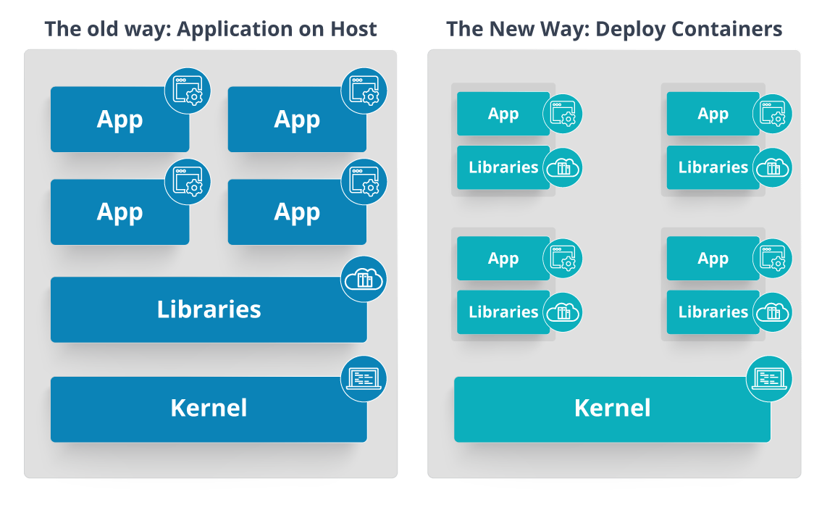
Fig 2: Deploying Applications On Host vs Containers

Refer to the above diagram. The left side architecture represents deploying applications on hosts. So, this kind of architecture will have an operating system and then the operating system will have a kernel that will have various libraries installed on the operating system needed for the application. So, in this kind of framework you can have n number of applications and all the applications will share the libraries present in that operating system whereas while deploying applications in containers the architecture is a little different.
This kind of architecture will have a kernel and that is the only thing that’s going to be the only thing common between all the applications. So, if there’s a particular application that needs Java then that particular application we’ll get access to Java and if there’s another application that needs Python then only that particular application will have access to Python.
The individual blocks that you can see on the right side of the diagram are basically containerized and these are isolated from other applications. So, the applications have the necessary libraries and binaries isolated from the rest of the system, and cannot be encroached by any other application.

212. What is Container Orchestration?
Consider a scenario where you have 5-6 microservices for an application. Now, these microservices are put in individual containers, but won’t be able to communicate without container orchestration. So, as orchestration means the amalgamation of all instruments playing together in harmony in music, similarly container orchestration means all the services in individual containers working together to fulfill the needs of a single server.

213. How does Kubernetes simplify containerized Deployment?
As a typical application would have a cluster of containers running across multiple hosts, all these containers would need to talk to each other. So, to do this you need something big that would load balance, scale & monitor the containers. Since Kubernetes is cloud-agnostic and can run on any public/private providers it must be your choice simplify containerized deployment.

214. What do you know about clusters in Kubernetes?
The fundamental behind Kubernetes is that we can enforce the desired state management, by which I mean that we can feed the cluster services of a specific configuration, and it will be up to the cluster services to go out and run that configuration in the infrastructure.
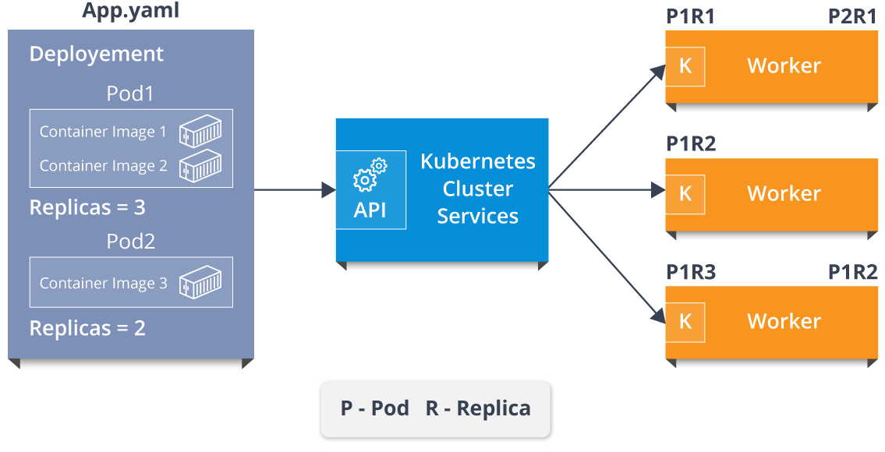
Fig 5: Representation Of Kubernetes Cluster
So, as you can see in the above diagram, the deployment file will have all the configurations required to be fed into the cluster services. Now, the deployment file will be fed to the API and then it will be up to the cluster services to figure out how to schedule these pods in the environment and make sure that the right number of pods are running.
So, the API which sits in front of services, the worker nodes & the Kubelet process that the nodes run, all together make up the Kubernetes Cluster.

215. What is Google Container Engine?
Google Container Engine (GKE) is an open-source management platform for Docker containers and clusters. This Kubernetes based engine supports only those clusters which run within Google’s public cloud services.

216. What is Minikube?
Minikube is a tool that makes it easy to run Kubernetes locally. This runs a single-node Kubernetes cluster inside a virtual machine.

217. What is Kubectl?
Kubectl is the platform using which you can pass commands to the cluster. So, it basically provides the CLI to run commands against the Kubernetes cluster with various ways to create and manage the Kubernetes component.

218. What is Kubelet?
This is an agent service which runs on each node and enables the slave to communicate with the master. So, Kubelet works on the description of containers provided to it in the PodSpec and makes sure that the containers described in the PodSpec are healthy and running.

219. What are the different components of Kubernetes Architecture?
The Kubernetes Architecture has mainly 2 components – the master node and the worker node. As you can see in the below diagram, the master and the worker nodes have many inbuilt components within them. The master node has the kube-controller-manager, kube-apiserver, kube-scheduler, etcd. Whereas the worker node has kubelet and kube-proxy running on each node.
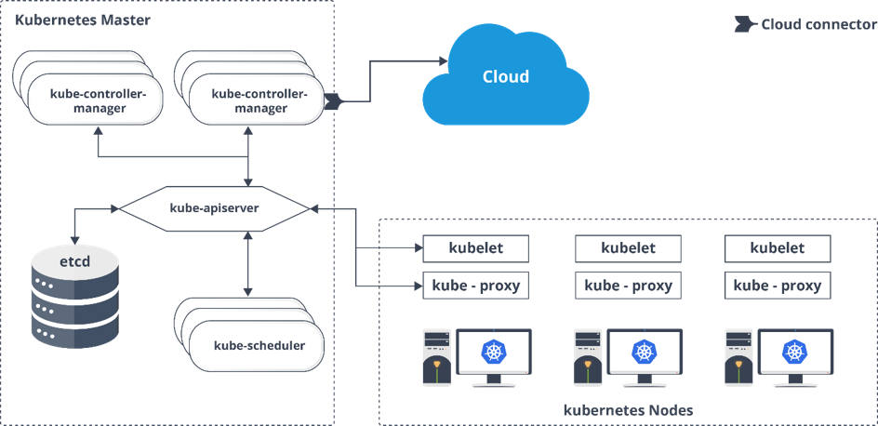
Fig 7: Architecture Of Kubernetes

220. What do you understand by Kube-proxy?
Kube-proxy can run on each and every node and can do simple TCP/UDP packet forwarding across backend network service. So basically, it is a network proxy that reflects the services as configured in Kubernetes API on each node. So, the Docker-linkable compatible environment variables provide the cluster IPs and ports which are opened by proxy.

221. Can you brief about the Kubernetes controller manager?
Multiple controller processes run on the master node but are compiled together to run as a single process which is the Kubernetes Controller Manager. So, Controller Manager is a daemon that embeds controllers and does namespace creation and garbage collection. It owns the responsibility and communicates with the API server to manage the end-points.
So, the different types of controller manager running on the master node are :
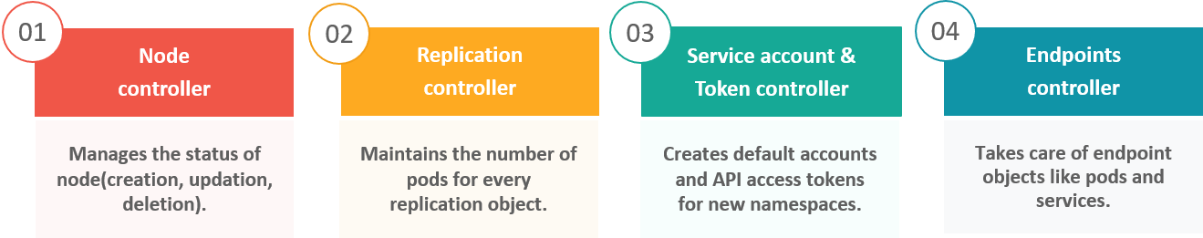
Fig 9: Types Of Controllers

222. What is ETCD?
Etcd is written in Go programming language and is a distributed key-value store used for coordinating distributed work. So, Etcd stores the configuration data of the Kubernetes cluster, representing the state of the cluster at any given point in time.

223. What are the different types of services in Kubernetes?
The following are the different types of services used:
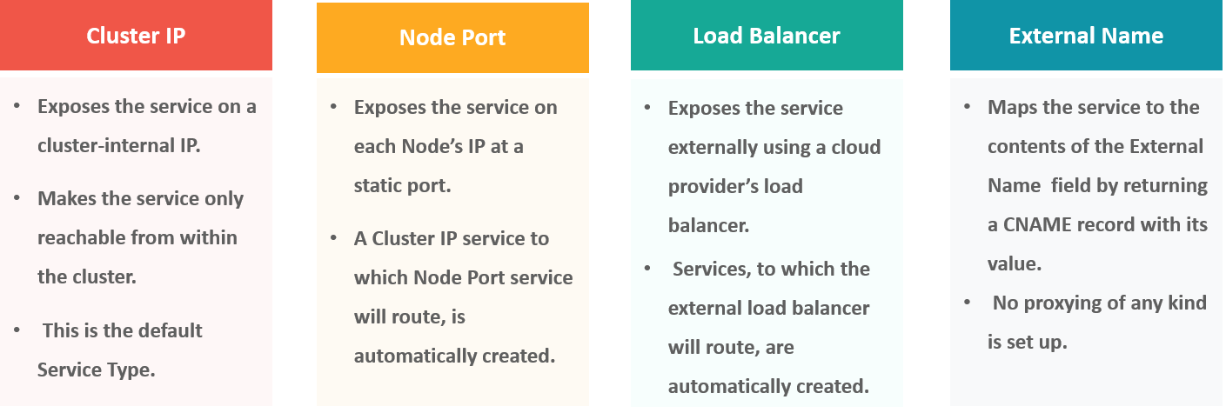
Fig 10: Types Of Services

224. What do you understand by load balancer in Kubernetes?
A load balancer is one of the most common and standard ways of exposing service. There are two types of load balancer used based on the working environment i.e. either the Internal Load Balancer or the External Load Balancer. The Internal Load Balancer automatically balances load and allocates the pods with the required configuration whereas the External Load Balancer directs the traffic from the external load to the backend pods.

225. What is Ingress network, and how does it work?
Ingress network is a collection of rules that acts as an entry point to the Kubernetes cluster. This allows inbound connections, which can be configured to give services externally through reachable URLs, load balance traffic, or by offering name-based virtual hosting. So, Ingress is an API object that manages external access to the services in a cluster, usually by HTTP and is the most powerful way of exposing service.
Now, let me explain to you the working of Ingress network with an example.
There are 2 nodes having the pod and root network namespaces with a Linux bridge. In addition to this, there is also a new virtual ethernet device called flannel0(network plugin) added to the root network.
Now, suppose we want the packet to flow from pod1 to pod 4. Refer to the below diagram.
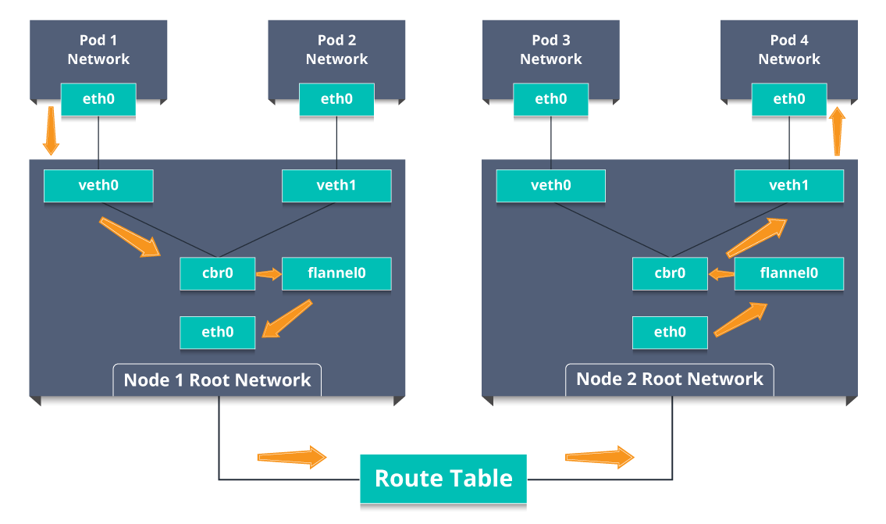
Fig 11: Working Of Ingress Network
- So, the packet leaves pod1’s network at eth0 and enters the root network at veth0.
- Then it is passed on to cbr0, which makes the ARP request to find the destination and it is found out that nobody on this node has the destination IP address.
- So, the bridge sends the packet to flannel0 as the node’s route table is configured with flannel0.
- Now, the flannel daemon talks to the API server of Kubernetes to know all the pod IPs and their respective nodes to create mappings for pods IPs to node IPs.
- The network plugin wraps this packet in a UDP packet with extra headers changing the source and destination IP’s to their respective nodes and sends this packet out via eth0.
- Now, since the route table already knows how to route traffic between nodes, it sends the packet to the destination node2.
- The packet arrives at eth0 of node2 and goes back to flannel0 to de-capsulate and emits it back in the root network namespace.
- Again, the packet is forwarded to the Linux bridge to make an ARP request to find out the IP that belongs to veth1.
- The packet finally crosses the root network and reaches the destination Pod4.

226. What do you understand by Cloud controller manager?
The Cloud Controller Manager is responsible for persistent storage, network routing, abstracting the cloud-specific code from the core Kubernetes specific code, and managing the communication with the underlying cloud services. It might be split out into several different containers depending on which cloud platform you are running on and then it enables the cloud vendors and Kubernetes code to be developed without any inter-dependency. So, the cloud vendor develops their code and connects with the Kubernetes cloud-controller-manager while running the Kubernetes.
The various types of cloud controller manager are as follows:
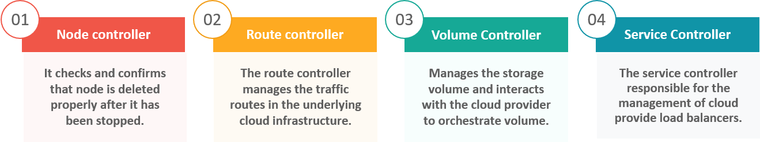
Fig 12: Types Of Cloud Controller Manager

227. What is Container resource monitoring?
As for users, it is really important to understand the performance of the application and resource utilization at all the different abstraction layer, Kubernetes factored the management of the cluster by creating abstraction at different levels like container, pods, services and whole cluster. Now, each level can be monitored and this is nothing but Container resource monitoring.
The various container resource monitoring tools are as follows:
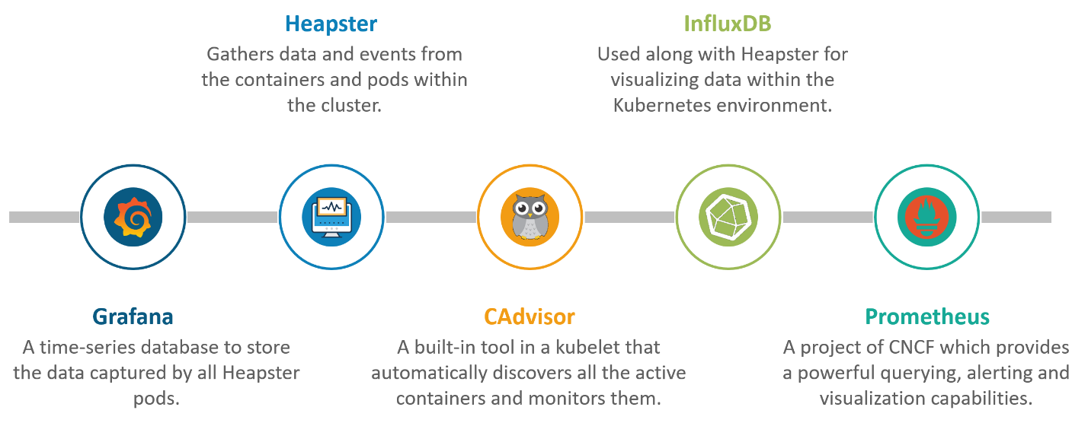
Fig 13: Container Resource Monitoring Tools

228. What is the difference between a replica set and replication controller?
Replica Set and Replication Controller do almost the same thing. Both of them ensure that a specified number of pod replicas are running at any given time. The difference comes with the usage of selectors to replicate pods. Replica Set use Set-Based selectors while replication controllers use Equity-Based selectors.
- Equity-Based Selectors: This type of selector allows filtering by label key and values. So, in layman terms, the equity-based selector will only look for the pods which will have the exact same phrase as that of the label.
Example: Suppose your label key says app=nginx, then, with this selector, you can only look for those pods with label app equal to nginx.
- Selector-Based Selectors: This type of selector allows filtering keys according to a set of values. So, in other words, the selector based selector will look for pods whose label has been mentioned in the set.
Example: Say your label key says app in (nginx, NPS, Apache). Then, with this selector, if your app is equal to any of nginx, NPS, or Apache, then the selector will take it as a true result.

229. What is a Headless Service?
Headless Service is similar to that of a ‘Normal’ services but does not have a Cluster IP. This service enables you to directly reach the pods without the need of accessing it through a proxy.

230. What are the best security measures that you can take while using Kubernetes?
The following are the best security measures that you can follow while using Kubernetes:
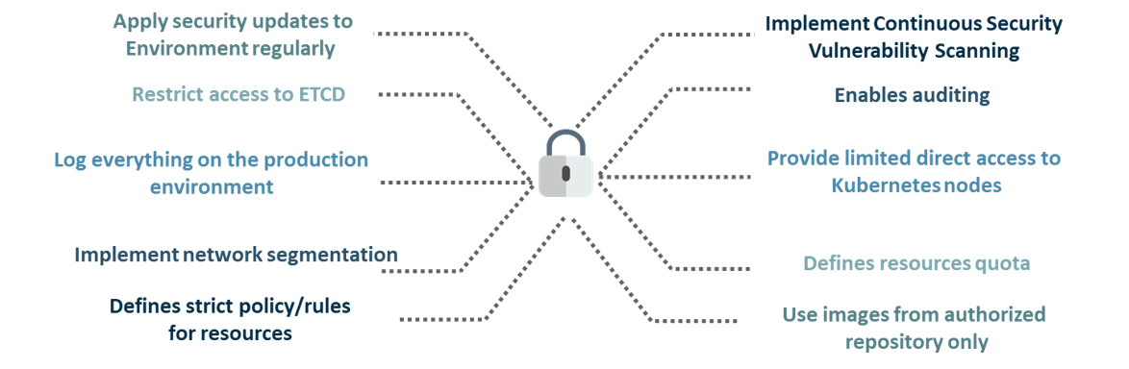
Fig 14: Best Security Measures

231. What are federated clusters?
Multiple Kubernetes clusters can be managed as a single cluster with the help of federated clusters. So, you can create multiple Kubernetes clusters within a data center/cloud and use federation to control/manage them all at one place.
The federated clusters can achieve this by doing the following two things. Refer to the below diagram.
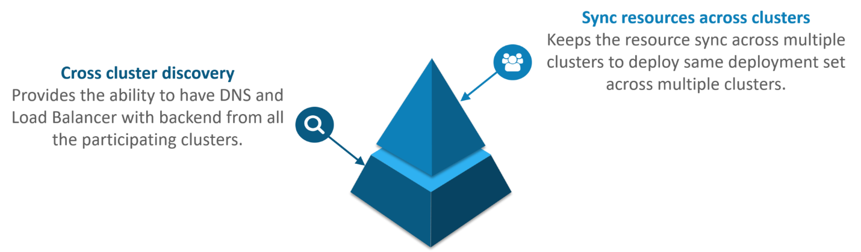
Fig 15: Federated Clusters

232. Scenario-Based Interview Questions
This section of questions will consist of various scenario-based questions that you may face in your interviews.
Scenario 1: Suppose a company built on monolithic architecture handles numerous products. Now, as the company expands in today’s scaling industry, their monolithic architecture started causing problems.
How do you think the company shifted from monolithic to microservices and deploy their services containers?
Solution:
As the company’s goal is to shift from their monolithic application to microservices, they can end up building piece by piece, in parallel and just switch configurations in the background. Then they can put each of these built-in microservices on the Kubernetes platform. So, they can start by migrating their services once or twice and monitor them to make sure everything is running stable. Once they feel everything is going good, then they can migrate the rest of the application into their Kubernetes cluster.
Scenario 2: Consider a multinational company with a very much distributed system, with a large number of data centers, virtual machines, and many employees working on various tasks.
How do you think can such a company manage all the tasks in a consistent way with Kubernetes?
Solution:
As all of us know that I.T. departments launch thousands of containers, with tasks running across a numerous number of nodes across the world in a distributed system.
In such a situation the company can use something that offers them agility, scale-out capability, and DevOps practice to the cloud-based applications.
So, the company can, therefore, use Kubernetes to customize their scheduling architecture and support multiple container formats. This makes it possible for the affinity between container tasks that gives greater efficiency with an extensive support for various container networking solutions and container storage.
Scenario 3: Consider a situation, where a company wants to increase its efficiency and the speed of its technical operations by maintaining minimal costs.
How do you think the company will try to achieve this?
Solution:
The company can implement the DevOps methodology, by building a CI/CD pipeline, but one problem that may occur here is the configurations may take time to go up and running. So, after implementing the CI/CD pipeline the company’s next step should be to work in the cloud environment. Once they start working on the cloud environment, they can schedule containers on a cluster and can orchestrate with the help of Kubernetes. This kind of approach will help the company reduce their deployment time, and also get faster across various environments.
Scenario 4: Suppose a company wants to revise it’s deployment methods and wants to build a platform which is much more scalable and responsive.
How do you think this company can achieve this to satisfy their customers?
Solution:
In order to give millions of clients the digital experience they would expect, the company needs a platform that is scalable, and responsive, so that they could quickly get data to the client website. Now, to do this the company should move from their private data centers (if they are using any) to any cloud environment such as AWS. Not only this, but they should also implement the microservice architecture so that they can start using Docker containers. Once they have the base framework ready, then they can start using the best orchestration platform available i.e. Kubernetes. This would enable the teams to be autonomous in building applications and delivering them very quickly.
Scenario 5: Consider a multinational company with a very much distributed system, looking forward to solving the monolithic code base problem.
How do you think the company can solve their problem?
Solution
Well, to solve the problem, they can shift their monolithic code base to a microservice design and then each and every microservices can be considered as a container. So, all these containers can be deployed and orchestrated with the help of Kubernetes.
Scenario 6: All of us know that the shift from monolithic to microservices solves the problem from the development side, but increases the problem at the deployment side.
How can the company solve the problem on the deployment side?
Solution
The team can experiment with container orchestration platforms, such as Kubernetes and run it in data centers. So, with this, the company can generate a templated application, deploy it within five minutes, and have actual instances containerized in the staging environment at that point. This kind of Kubernetes project will have dozens of microservices running in parallel to improve the production rate as even if a node goes down, then it can be rescheduled immediately without performance impact.
Scenario 7: Suppose a company wants to optimize the distribution of its workloads, by adopting new technologies.
How can the company achieve this distribution of resources efficiently?
Solution
The solution to this problem is none other than Kubernetes. Kubernetes makes sure that the resources are optimized efficiently, and only those resources are used which are needed by that particular application. So, with the usage of the best container orchestration tool, the company can achieve the distribution of resources efficiently.
Scenario 8: Consider a carpooling company wants to increase their number of servers by simultaneously scaling their platform.
How do you think will the company deal with the servers and their installation?
Solution
The company can adopt the concept of containerization. Once they deploy all their application into containers, they can use Kubernetes for orchestration and use container monitoring tools like Prometheus to monitor the actions in containers. So, with such usage of containers, giving them better capacity planning in the data center because they will now have fewer constraints due to this abstraction between the services and the hardware they run on.
Scenario 9: Consider a scenario where a company wants to provide all the required hand-outs to its customers having various environments.
How do you think they can achieve this critical target in a dynamic manner?
Solution
The company can use Docker environments, to put together a cross-sectional team to build a web application using Kubernetes. This kind of framework will help the company achieve the goal of getting the required things into production within the shortest time frame. So, with such a machine running, the company can give the hands-outs to all the customers having various environments.
Scenario 10: Suppose a company wants to run various workloads on different cloud infrastructure from bare metal to a public cloud.
How will the company achieve this in the presence of different interfaces?
Solution
The company can decompose its infrastructure into microservices and then adopt Kubernetes. This will let the company run various workloads on different cloud infrastructures.

233. How to turn the service defined below in the spec into an external one?

spec:
selector:
app: some-app
ports:
- protocol: UDP
port: 8080
targetPort: 8080
Explanation -
Adding type: LoadBalancer and nodePort as follows:
spec:
selector:
app: some-app
type: LoadBalancer
ports:
- protocol: UDP
port: 8080
targetPort: 8080
nodePort: 32412

234. Complete the following configuration spec file to make it Ingress

metadata:
name: someapp-ingress
spec:
Explanation -
One of the several ways to answer this question.
apiVersion: networking.k8s.io/v1
kind: Ingress
metadata:
name: someapp-ingress
spec:
rules:
- host: my.host
http:
paths:
- backend:
serviceName: someapp-internal-service
servicePort: 8080

235. How to configure TLS with Ingress?
Add tls and secretName entries.
spec:
tls:
- hosts:
- some_app.com
secretName: someapp-secret-tls

236. Why use namespaces? What is the problem with using the default namespace?
While using the default namespace alone, it becomes hard over time to get an overview of all the applications you can manage in your cluster. Namespaces make it easier to organize the applications into groups that make sense, like a namespace of all the monitoring applications and a namespace for all the security applications, etc.
Namespaces can also be useful for managing Blue/Green environments where each namespace can include a different version of an app and also share resources that are in other namespaces (namespaces like logging, monitoring, etc.).
Another use case for namespaces is one cluster with multiple teams. When multiple teams use the same cluster, they might end up stepping on each other's toes. For example, if they end up creating an app with the same name it means one of the teams overrides the app of the other team because there can't be two apps in Kubernetes with the same name (in the same namespace).

237. In the following file which service and in which namespace is referred?

apiVersion: v1
kind: ConfigMap
metadata:
name: some-configmap
data:
some_url: silicon.chip
Answer - It's referencing the service "silicon" in the namespace called "chip".

238. What is an Operator?
"Operators are software extensions to K8s which make use of custom resources to manage applications and their components. Operators follow Kubernetes principles, notably the control loop."

239. Why do we need Operators?
The process of managing applications in Kubernetes isn't as straightforward as managing stateless applications, where reaching the desired status and upgrades are both handled the same way for every replica. In stateful applications, upgrading each replica might require different handling due to the stateful nature of the app, each replica might be in a different status. As a result, we often need a human operator to manage stateful applications. Kubernetes Operator is supposed to assist with this.
This will also help with automating a standard process on multiple Kubernetes clusters

240. What is GKE?
GKE is Google Kubernetes Engine that is used for managing and orchestrating systems for Docker containers. With the help of Google Public Cloud, we can also orchestrate the container cluster.

241. What is Ingress Default Backend?
It specifies what to do with an incoming request to the Kubernetes cluster that isn't mapped to any backend i.e what to do when no rules being defined for the incoming HTTP request If the default backend service is not defined, it's recommended to define it so that users still see some kind of message instead of an unclear error.

242. How to run Kubernetes locally?
Kubernetes can be set up locally using the Minikube tool. It runs a single-node bunch in a VM on the computer. Therefore, it offers the perfect way for users who have just ongoing learning Kubernetes.

243. What is Kubernetes Load Balancing?
Load Balancing is one of the most common and standard ways of exposing the services. There are two types of load balancing in K8s and they are:
Internal load balancer – This type of balancer automatically balances loads and allocates the pods with the required incoming load.
External Load Balancer – This type of balancer directs the traffic from the external loads to backend pods.

244. What the following in the Deployment configuration file mean?

spec:
containers:
- name: USER_PASSWORD
valueFrom:
secretKeyRef:
name: some-secret
key: password
Explanation -
USER_PASSWORD environment variable will store the value from the password key in the secret called "some-secret" In other words, you reference a value from a Kubernetes Secret.

245. How to troubleshoot if the POD is not getting scheduled?
In K8’s scheduler is responsible to spawn pods into nodes. There are many factors that can lead to unstartable POD. The most common one is running out of resources, use the commands like kubectl describe <POD> -n <Namespace> to see the reason why POD is not started. Also, keep an eye on kubectl to get events to see all events coming from the cluster.

246. How to run a POD on a particular node?
Various methods are available to achieve it.
- nodeName: specify the name of a node in POD spec configuration, it will try to run the POD on a specific node.
- nodeSelector: Assign a specific label to the node which has special resources and use the same label in POD spec so that POD will run only on that node.
- nodeaffinities: required DuringSchedulingIgnoredDuringExecution, preferredDuringSchedulingIgnoredDuringExecution are hard and soft requirements for running the POD on specific nodes. This will be replacing nodeSelector in the future. It depends on the node labels.

247. What are the different ways to provide external network connectivity to K8?
By default, POD should be able to reach the external network but vice-versa we need to make some changes. Following options are available to connect with POD from the outer world.
- Nodeport (it will expose one port on each node to communicate with it)
- Load balancers (L4 layer of TCP/IP protocol)
- Ingress (L7 layer of TCP/IP Protocol)
Another method is to use Kube-proxy which can expose a service with only cluster IP on the local system port.
$ kubectl proxy --port=8080 $ http://localhost:8080/api/v1/proxy/namespaces//services/:/

248. How can we forward the port '8080 (container) -> 8080 (service) -> 8080 (ingress) -> 80 (browser)and how it can be done?
The ingress is exposing port 80 externally for the browser to access, and connecting to a service that listens on 8080. The ingress will listen on port 80 by default. An "ingress controller" is a pod that receives external traffic and handles the ingress and is configured by an ingress resource For this you need to configure the ingress selector and if no 'ingress controller selector' is mentioned then no ingress controller will manage the ingress.
Simple ingress Config will look like
host: abc.org
http:
paths:
backend:
serviceName: abc-service
servicePort: 8080
Then the service will look like
kind: Service
apiVersion: v1
metadata:
name: abc-service
spec:
ports:
protocol: TCP
port: 8080 # port to which the service listens to
targetPort: 8080

249. What is the difference between config map and secret? (Differentiate the answers as with examples)

Config maps ideally stores application configuration in a plain text format whereas Secrets store sensitive data like password in an encrypted format. Both config maps and secrets can be used as volume and mounted inside a pod through a pod definition file.
Config map:
kubectl create configmap myconfigmap
--from-literal=env=dev
Secret:
echo -n ‘admin’ > ./username.txt
echo -n ‘abcd1234’ ./password.txt
kubectl create secret generic mysecret --from-file=./username.txt --from-file=./password.txt

250. If a node is tainted, is there a way to still schedule the pods to that node?

When a node is tainted, the pods don't get scheduled by default, however, if we have to still schedule a pod to a tainted node we can start applying tolerations to the pod spec.
Apply a taint to a node:
kubectl taint nodes node1 key=value:NoSchedule
Apply toleration to a pod:
spec:
tolerations:
- key: "key"
operator: "Equal"
value: "value"
effect: "NoSchedule"

251. Can we use many claims out of a persistent volume? Explain?

The mapping between persistentVolume and persistentVolumeClaim is always one to one. Even When you delete the claim, PersistentVolume still remains as we set persistentVolumeReclaimPolicy is set to Retain and It will not be reused by any other claims. Below is the spec to create the Persistent Volume.
apiVersion: v1
kind: PersistentVolume
metadata:
name: mypv
spec:
capacity:
storage: 5Gi
volumeMode: Filesystem
accessModes:
- ReadWriteOnce
persistentVolumeReclaimPolicy: Retain

252. What kind of object do you create, when your dashboard like application, queries the Kubernetes API to get some data?

You should be creating serviceAccount. A service account creates a token and tokens are stored inside a secret object. By default Kubernetes automatically mounts the default service account. However, we can disable this property by setting automountServiceAccountToken: false in our spec. Also, note each namespace will have a service account
apiVersion: v1
kind: ServiceAccount
metadata:
name: my-sa
automountServiceAccountToken: false

253. What is the difference between a Pod and a Job? Differentiate the answers as with examples)

A Pod always ensure that a container is running whereas the Job ensures that the pods run to its completion. Job is to do a finite task.
Examples:
kubectl run mypod1 --image=nginx --restart=Never
kubectl run mypod2 --image=nginx --restart=onFailure
○ → kubectl get pods
NAME READY STATUS RESTARTS AGE
mypod1 1/1 Running 0 59s
○ → kubectl get job
NAME DESIRED SUCCESSFUL AGE

254. How do you deploy a feature with zero downtime in Kubernetes?

By default Deployment in Kubernetes using RollingUpdate as a strategy. Let's say we have an example that creates a deployment in Kubernetes
kubectl run nginx --image=nginx # creates a deployment
○ → kubectl get deploy
NAME DESIRED CURRENT UP-TO-DATE AVAILABLE AGE
nginx 1 1 1 0 7s
Now let’s assume we are going to update the nginx image
kubectl set image deployment nginx nginx=nginx:1.15 # updates the image
Now when we check the replica sets
kubectl get replicasets # get replica sets
NAME DESIRED CURRENT READY AGE
nginx-65899c769f 0 0 0 7m
nginx-6c9655f5bb 1 1 1 13s
From the above, we can notice that one more replica set was added and then the other replica set was brought down
kubectl rollout status deployment nginx
# check the status of a deployment rollout
kubectl rollout history deployment nginx
# check the revisions in a deployment
○ → kubectl rollout history deployment nginx
deployment.extensions/nginx
REVISION CHANGE-CAUSE
1 <none>
2 <none>

255. How to monitor that a Pod is always running?

We can introduce probes. A liveness probe with a Pod is ideal in this scenario.
A liveness probe always checks if an application in a pod is running, if this check fails the container gets restarted. This is ideal in many scenarios where the container is running but somehow the application inside a container crashes.
spec:
containers:
- name: liveness
image: k8s.gcr.io/liveness
args:
- /server
livenessProbe:
httpGet:
path: /healthz

256. What are the types of multi-container pod patterns? (Explain each type with examples)

- sidecar:
A pod spec which runs the main container and a helper container that does some utility work, but that is not necessarily needed for the main container to work.
- adapter:
The adapter container will inspect the contents of the app's file, does some kind of restructuring and reformat it, and write the correctly formatted output to the location.
- ambassador:
It connects containers with the outside world. It is a proxy that allows other containers to connect to a port on localhost.
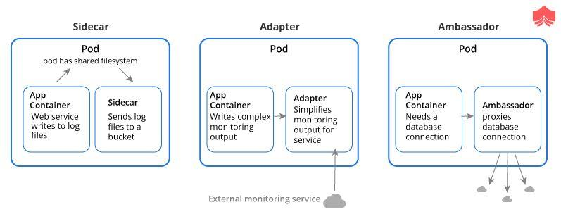
reference:https://matthewpalmer.net/Kubernetes-app-developer/articles/multi-container-pod-design-patterns.html

257. What is the difference between replication controllers and replica sets?

The only difference between replication controllers and replica sets is the selectors. Replication controllers don't have selectors in their spec and also note that replication controllers are obsolete now in the latest version of Kubernetes.
apiVersion: apps/v1
kind: ReplicaSet
metadata:
name: frontend
labels:
app: guestbook
tier: frontend
spec:
# modify replicas according to your case
replicas: 3
selector:
matchLabels:
tier: frontend
template:
metadata:
labels:
tier: frontend
spec:
containers:
- name: php-redis
image: gcr.io/google_samples/gb-frontend:v3
Reference: https://Kubernetes.io/docs/concepts/workloads/controllers/replicaset/

258. How do you tie service to a pod or to a set of pods?

By declaring pods with the label(s) and by having a selector in the service which acts as a glue to stick the service to the pods.
kind: Service
apiVersion: v1
metadata:
name: my-service
spec:
selector:
app: MyApp
ports:
- protocol: TCP
port: 80
Let's say if we have a set of Pods that carry a label "app=MyApp" the service will start routing to those pods.

259. Having a Pod with two containers, can I ping each other? like using the container name?

Containers on same pod act as if they are on the same machine. You can ping them using localhost:port itself. Every container in a pod shares the same IP. You can `ping localhost` inside a pod. Two containers in the same pod share an IP and a network namespace and They are both localhost to each other. Discovery works like this: Component A's pods -> Service Of Component B -> Component B's pods and Services have domain names servicename.namespace.svc.cluster.local, the dns search path of pods by default includes that stuff, so a pod in namespace Foo can find a Service bar in same namespace Foo by connecting to `bar`

260. Does the rolling update with state full set replicas =1 makes sense?

No, because there is only 1 replica, any changes to state full set would result in an outage. So rolling update of a StatefulSet would need to tear down one (or more) old pods before replacing them. In case 2 replicas, a rolling update will create the second pod, which it will not be succeeded, the PD is locked by first (old) running pod, the rolling update is not deleting the first pod in time to release the lock on the PDisk in time for the second pod to use it. If there's only one that rolling update goes 1 -> 0 -> 1.f the app can run with multiple identical instances concurrently, use a Deployment and roll 1 -> 2 -> 1 instead.

261. Different Ways to provide API-Security on Kubernetes?

Use the correct auth mode with API server authorization-mode=Node,RBAC Ensure all traffic is protected by TLS Use API authentication (smaller cluster may use certificates but larger multi-tenants may want an AD or some OIDC authentication).
Make kubeless protect its API via authorization-mode=Webhook. Make sure the kube-dashboard uses a restrictive RBAC role policy Monitor RBAC failures Remove default ServiceAccount permissions Filter egress to Cloud API metadata APIs Filter out all traffic coming into kube-system namespace except DNS.
A default deny policy on all inbound on all namespaces is good practice. You explicitly allow per deployment.Use a podsecurity policy to have container restrictions and protect the Node Keep kube at the latest version.

262. what does kube-proxy do?

kube-proxy does 2 things
- for every Service, open a random port on the node and proxy that port to the Service.
- install and maintain iptables rules which capture accesses to a virtual ip:port and redirect those to the port in (1)
The kube-proxy is a component that manages host sub-netting and makes services available to other components.Kubeproxy handles network communication and shutting down master does not stop a node from serving the traffic and kubeproxy works, in the same way, using a service. The iptables will route the connection to kubeproxy, which will then proxy to one of the pods in the service.kube-proxy translate the destination address to whatever is in the endpoints.

263. What runs inside the kubernetes worker nodes?

Container Runtime
- Kubelet
- kube-proxy
Kubernetes Worker node is a machine where workloads get deployed. The workloads are in the form of containerised applications and because of that, every node in the cluster must run the container run time such as docker in order to run those workloads. You can have multiple masters mapped to multiple worker nodes or a single master having a single worker node. Also, the worker nodes are not gossiping or doing leader election or anything that would lead to odd-quantities. The role of the container run time is to start and managed containers. The kubelet is responsible for running the state of each node and it receives commands and works to do from the master. It also does the health check of the nodes and make sure they are healthy. Kubelet is also responsible for metric collectins of pods as well. The kube-proxy is a component that manages host subnetting and makes services available to other components.

264. Is there a way to make a pod to automatically come up when the host restarts?

Yes using replication controller but it may reschedule to another host if you have multiple nodes in the cluster
A replication controller is a supervisor for long-running pods. An RC will launch a specified number of pods called replicas and makes sure that they keep running. Replication Controller only supports the simple map-style `label: value` selectors. Also, Replication Controller and ReplicaSet aren't very different. You could think of ReplicaSet as Replication Controller. The only thing that is different today is the selector format. If pods are managed by a replication controller or replication set you can kill the pods and they'll be restarted automatically. The yaml definition is as given below:
- apiVersion: v1
- kind: ReplicationController
- metadata:
- name: test
- spec:
- replicas: 3
- selector:
- app: test
- template:
- metadata:
- name: test
- labels:
- app: test
- spec:
- containers:
- name: test
- image: image/test
- ports:
- containerPort: 80

265. Is there any other way to update configmap for deployment without pod restarts?

well you need to have some way of triggering the reload. ether do a check every minute or have a reload endpoint for an api or project the configmap as a volume, could use inotify to be aware of the change. Depends on how the configmap is consumed by the container. If env vars, then no. If a volumeMount, then the file is updated in the container ready to be consumed by the service but it needs to reload the file
The container does not restart. if the configmap is mounted as a volume it is updated dynamically. if it is an environment variable it stays as the old value until the container is restarted.volume mount the configmap into the pod, the projected file is updated periodically. NOT realtime. then have the app recognise if the config on disk has changed and reload

266. Do rolling updates declared with a deployment take effect if I manually delete pods of the replica set with kubectl delete pods or with the dashboard? Will the minimum required a number of pods be maintained?

Yes, the scheduler will make sure (as long as you have the correct resources) that the number of desired pods are met. If you delete a pod, it will recreate it. Also deleting a service won't delete the Replica set. if you remove Service or deployment you want to remove all resources which Service created. Also having a single replica for a deployment is usually not recommended because you cannot scale out and are treating in a specific way
Any app should be `Ingress` -> `Service` -> `Deployment` -> (volume mount or 3rd-party cloud storage)
You can skip ingress and just have `LoadBalancer (service)` -> `Deployment` (or Pod but they don't auto restart, deployments do)

267. what is the difference between externalIP and loadBalancerIP ?

loadBalancerIP is not a core Kubernetes concept, you need to have a cloud provider or controller like metallb set up the loadbalancer IP. When MetalLB sees a Service of type=LoadBalancer with a ClusterIP created, MetalLB allocates an IP from its pool and assigns it as that Service's External LoadBalanced IP.the externalIP, on the other hand, is set up by kubelet so that any traffic that is sent to any node with that externalIP as the final destination will get routed.`ExternalIP` assumes you already have control over said IP and that you have correctly arranged for traffic to that IP to eventually land at one or more of your cluster nodes and its is a tool for implementing your own load-balancing. Also you shouldn't use it on cloud platforms like GKE, you want to set `spec.loadBalancerIP` to the IP you preallocated. When you try to create the service using .`loadBalancerIP` instead of `externalIP`, it doesn't create the ephemeral port and the external IP address goes to `<pending>` and never updates.

268. In Kubernetes - A Pod is running 2 containers, when One container stops - another Container is still running, on this event, I want to terminate this Pod?

You need to add a liveness and readiness probe to query each container, if the probe fails, the entire pod will be restarted .add liveness object that calls any api that returns 200 to you from another container and both liveness and readiness probes run in infinite loops for example, If X depended to Y So add liveness in X that check the health of Y.Both readiness/liveness probes always have to run after the container has been started .kubelet component performs the liveness/readiness checks and set initialDelaySeconds and it can be anything from a few seconds to a few minutes depending on app start time. Below is the configuration spec
- livenessProbe spec:
- livenessProbe:
- httpGet:
- path: /path/test/
- port: 10000
- initialDelaySeconds: 30
- timeoutSeconds: 5
- readinessProbe spec:
- readinessProbe:
- httpGet:
- path: /path/test/
- port: 10000
- initialDelaySeconds: 30
- timeoutSeconds: 5

269. what is the ingress, is it something that runs as a pod or on a pod?

An ingress is an object that holds a set of rules for an ingress controller, which is essentially a reverse proxy and is used to (in the case of nginx-ingress for example) render a configuration file. It allows access to your Kubernetes services from outside the Kubernetes cluster. It holds a set of rules. An Ingress Controller is a controller. Typically deployed as a Kubernetes Deployment. That deployment runs a reverse proxy, the ingress part, and a reconciler, the controller part. the reconciler configures the reverse proxy according to the rules in the ingress object. Ingress controllers watch the k8s api and update their config on changes. The rules help to pass to a controller that is listening for them. You can deploy a bunch of ingress rules, but nothing will happen unless you have a controller that can process them.
LoadBalancer service -> Ingress controller pods -> App service (via ingress) -> App pods

270. What happens if daemonset can be set to listen on a specific interface since the Anycast IP will be assigned to a network interface alias

Yes, hostnetwork for the daemonset gets you to the host, so an interface with an Anycast IP should work. You'll have to proxy the data through the daemonset.Daemonset allows you to run the pod on the host network, so anycast is possible.Daemonset allows us to run the pod on the host network At the risk of being pedantic, any pod can be specified to run on the host network. The only thing special about DaemonSet is you get one pod per host. Most of the issues with respect to IP space is solved by daemonsets. As kube-proxy is run as daemonset, the node has to be Ready for the kube-proxy daemonset to be up.

271. How to forward port `8080 (container) -> 8080 (service) -> 8080 (ingress) -> 80 (browser)` how is it done?

The ingress is exposing port 80 externally for the browser to access, and connecting to a service that listens on 8080. The ingress will listen on port 80 by default. An "ingress controller" is a pod that receives external traffic and handles the ingress and is configured by an ingress resource For this you need to configure ingress selector and if no 'ingress controller selector' is specified then no ingress controller will control the ingress.
simple ingress Config will look like
- host: abc.org
- http:
- paths:
- backend:
- serviceName: abc-service
- servicePort: 8080
- Then the service will look like
- kind: Service
- apiVersion: v1
- metadata:
- name: abc-service
- spec:
- ports:
- protocol: TCP
- port: 8080 # this is the port the service listens on
- targetPort: 8080

272. Are deployments with more than one replica automatically doing rolling updates when a new deployment config is applied?

The Deployment updates Pods in a rolling update fashion when .spec.strategy.type==RollingUpdate .You can specify maxUnavailable and maxSurge to control the rolling update process. Rolling update is the default deployment strategy.kubectl rolling-update updates Pods and ReplicationControllers in a similar fashion. But, Deployments are recommended, since they are declarative, and have additional features, such as rolling back to any previous revision even after the rolling update is done.So for rolling updates to work as one may expect, a readiness probe is essential. Redeploying deployments is easy but rolling updates will do it nicely for me without any downtime. The way to make a rolling update of a Deployment and kubctl apply on it is as below
- spec:
- minReadySeconds: 180
- replicas: 9
- revisionHistoryLimit: 20
- selector:
- matchLabels:
- deployment: standard
- name: standard-pod
- strategy:
- rollingUpdate:
- maxSurge: 1
- maxUnavailable: 1
- type: RollingUpdate

273. If you have multiple containers in a Deployment file, does use the HorizontalPodAutoscaler scale all of the containers?

Yes, it would scale all of them, internally the deployment creates a replica set (which does the scaling), and then a set number of pods are made by that replica set. the pod is what actually holds both of those containers. and if you want to scale them independently they should be separate pods (and therefore replica sets, deployments, etc).so for hpa to work You need to specify min and max replicas and the threshold what percentage of cpu and memory you want your pods to autoscale..without having the manually run kubectl autoscale deployment ,you can use the below yaml file to do the same
- apiVersion: autoscaling/v1
- kind: HorizontalPodAutoscaler
- metadata:
- annotations:
- name: app
- spec:
- maxReplicas: 15
- minReplicas: 10
- scaleTargetRef:
- apiVersion: autoscaling/v1
- kind: Deployment
- name: app targetCPUUtilizationPercentage: 70

274. Suppose you have to use database with your application but well, if you make a database container-based deployment. how would the data persist?

Deployments are for stateless services, you want to use a StatefulSet or just define 3+ pods without a replication controller at all. If you care about stable pod names and volumes, you should go for StatefulSet.Using statefulsets you can maintain which pod is attached to which disk.StatefulSets make vanilla k8s capable of keeping Pod state (things like IPs, etc) which makes it easy to run clustered databases. A stateful set is a controller that orchestrates pods for the desired state. StatefulSets formerly known as PetSets will help for the database if hosting your own. Essentially StatefulSet is for dealing with applications that inherently don't care about what node they run on, but need unique storage/state.

275. If a pod exceeds its memory "limit" what signal is sent to the process?

SIGKILL as immediately terminates the container and spawns a new one with OOM error. The OS, if using a cgroup based containerisation (docker, rkt, etc), will do the OOM killing. Kubernetes simply sets the cgroup limits but is not ultimately responsible for killing the processes.`SIGTERM` is sent to PID 1 and k8s waits for (default of 30 seconds) `terminationGracePeriodSeconds` before sending the `SIGKILL` or you can change that time with terminationGracePeriodSeconds in the pod. As long as your container will eventually exit, it should be fine to have a long grace period. If you want a graceful restart it would have to do it inside the pod. If you don't want it killed, then you shouldn't set a memory `limit` on the pod and there's not a way to disable it for the whole node. Also, when the liveness probe fails, the container will SIGTERM and SIGKILL after some grace period.

276. Let’s say a Kubernetes job should finish in 40 seconds, however on a rare occasion it takes 5 minutes, How can I make sure to stop the application if it exceeds more than 40 seconds?

When we create a job spec, we can give --activeDeadlineSeconds flag to the command, this flag relates to the duration of the job, once the job reaches the threshold specified by the flag, the job will be terminated.
kind: CronJob
apiVersion: batch/v1beta1
metadata:
name: mycronjob
spec:
schedule: "*/1 * * * *"
activeDeadlineSeconds: 200
jobTemplate:
metadata:
name: google-check-job
spec:
template:
metadata:
name: mypod
spec:
restartPolicy: OnFailure
containers:
- name: mycontainer
image: alpine
command: ["/bin/sh"]
args: ["-c", "ping -w 1 google.com"]

277. How do you test a manifest without actually executing it?

use --dry-run flag to test the manifest. This is really useful not only to ensure if the yaml syntax is right for a particular Kubernetes object but also to ensure that a spec has required key-value pairs.
kubectl create -f <test.yaml> --dry-run
Let us now look at an example Pod spec that will launch an nginx pod
○ → cat example_pod.yaml
---
apiVersion: v1
kind: Pod
metadata:
name: my-nginx
namespace: mynamespace
spec:
containers:
- name: my-nginx
image: nginx
○ → kubectl create -f example_pod.yaml --dry-run
pod/my-nginx created (dry run)

278. How do you initiate a rollback for an application?

Rollback and rolling updates are a feature of Deployment object in the Kubernetes. We do the Rollback to an earlier Deployment revision if the current state of the Deployment is not stable due to the application code or the configuration. Each rollback updates the revision of the Deployment
○ → kubectl get deploy
NAME DESIRED CURRENT UP-TO-DATE AVAILABLE AGE
nginx 1 1 1 1 15h
○ → kubectl rollout history deploy nginx
deployment.extensions/nginx
REVISION CHANGE-CAUSE
1 <none>
2 <none>
kubectl undo deploy <deploymentname>
○ → kubectl rollout undo deploy nginx
deployment.extensions/nginx
○ → kubectl rollout history deploy nginx
deployment.extensions/nginx
REVISION CHANGE-CAUSE
2 <none>
3 <none>
We can also check the history of the changes by the below command
kubectl rollout history deploy <deploymentname>

279. How do you package Kubernetes applications?

Helm is a package manager which allows users to package, configure, and deploy applications and services to the Kubernetes cluster.
helm init # when you execute this command client is going to create a deployment in the cluster and that deployment will install the tiller, the server side of Helm
The packages we install through client are called charts. They are bundles of templatized manifests. All the templating work is done by the Tiller
helm search redis # searches for a specific application
helm install stable/redis # installs the application
helm ls # list the applications

280. What are init containers?

Generally, in Kubenetes, a pod can have many containers. Init container gets executed before any other containers run in the pod.
apiVersion: v1
kind: Pod
metadata:
name: myapp-pod
labels:
app: myapp
annotations:
pod.beta.Kubernetes.io/init-containers: '[
{
"name": "init-myservice",
"image": "busybox",
"command": ["sh", "-c", "until nslookup myservice; do echo waiting for myservice; sleep 2; done;"]
}
]'
spec:
containers:
- name: myapp-container
image: busybox
command: ['sh', '-c', 'echo The app is running! && sleep 3600']

281. What is node affinity and pod affinity?

- Node Affinity ensures that pods are hosted on particular nodes.
Pod Affinity ensures two pods to be co-located in a single node.
Node Affinity
apiVersion: v1
kind: Pod
metadata:
name: with-node-affinity
spec:
affinity:
nodeAffinity:
requiredDuringSchedulingIgnoredDuringExecution:
nodeSelectorTerms:
- matchExpressions:
- key: Kubernetes.io/e2e-az-name
operator: In
values:
- e2e-az1
Pod Affinity
apiVersion: v1
kind: Pod
metadata:
name: with-pod-affinity
spec:
affinity:
podAffinity:
requiredDuringSchedulingIgnoredDuringExecution:
- labelSelector:
matchExpressions:
- key: security
operator: In
values:
- S1
The pod affinity rule says that the pod can be scheduled to a node only if that node is in the same zone as at least one already-running pod that has a label with key “security” and value “S1”
Reference: https://Kubernetes.io/docs/concepts/configuration/assign-pod-node/

282. How do you drain the traffic from a Pod during maintenance?

When we take the node for maintenance, pods inside the nodes also take a hit. However, we can avoid it by using the below command
kubectl drain <nodename>
When we run the above command it marks the node unschedulable for newer pods then the existing pods are evicted if the API Server supports eviction else it deletes the pods
Once the node is up and running and you want to add it in rotation we can run the below command
kubectl uncordon <nodename>
Note: If you prefer not to use kubectl drain (such as to avoid calling to an external command, or to get finer control over the pod eviction process), you can also programmatically cause evictions using the eviction API.
More info: https://Kubernetes.io/docs/tasks/administer-cluster/safely-drain-node/

283. I have one POD and inside 2 containers are running one is Nginx and another one is wordpress So, how can access these 2 containers from the Browser with IP address?

Just do port forward kubectl port-forward [nginx-pod-name] 80:80 kubectl port-forward [wordpress-pod-name] drupal-port:wordpress-port.
To make it permanent, you need to expose those through nodeports whenever you do kubectl port forward it adds a rule to the firewall to allow that traffic across nodes but by default that isn’t allowed since flannel or firewall probably blocks it.proxy tries to connect over the network of the apiserver host as you correctly found, port-forward on the other hand is a mechanism that the node kubelet exposes over its own API

284. If I have multiple containers running inside a pod, and I want to wait for a specific container to start before starting another one.

One way is Init Containers are for one-shot tasks that start, run, end; all before the next init container or the main container start, but if a client in one container wants to consume some resources exposed by some server provided by another container or If the server ever crashes or is restarted, the client will need to retry connections. So the client can retry always, even if the server isn't up yet. The best way is sidecar pattern_ are where one container is the Main one, and other containers expose metrics or logs or encrypted tunnel or somesuch. In these cases, the other containers can be killed when the Main one is done/crashed/evicted.

285. What is the impact of upgrading kubelet if we leave the pods on the worker node - will it break running pods? why?

Restarting kubelet, which has to happen for an upgrade will cause all the Pods on the node to stop and be started again. It’s generally better to drain a node because that way Pods can be gracefully migrated, and things like Disruption Budgets can be honored. The problem is that `kubectl` keeps up with the state of all running pods, so when it goes away the containers don’t necessarily die, but as soon as it comes back up, they are all killed so `kubectl` can create a clean slate. As kubelet communicates with the apiserver, so if something happens in between of upgrade process, rescheduling of pods may take place and health checks may fail in between the process. During the restart, the kubelet will stop querying the API, so it won’t start/stop containers, and Heapster won’t be able to fetch system metrics from cAdvisor. Just make sure it’s not down for too long or the node will be removed from the cluster!

286. How service that selects apps based on the label and has an externalIP?

The service selects apps based on labels, so if no pods have appropriate labels, the service has nothing to route and labels can be anything you like. Since all pod names should be unique, you can just set the labels as the pod name. Since statesets create the same pods multiple times, they won't be configured with distinct labels you could use to point disparate services to the correct pod. If you gave the pods their own labels manually it will work. Also, service selects pods based on selector as well their location label as well Below .yaml file of Grafana dashboard service shows the same
- apiVersion: v1
- kind: Service
metadata:
- name: grafanaportforward
- namespace: kubeflow
labels:
- run: grafana-test
spec:
ports:
- - port: 3000
- protocol: TCP
- name: grafana
- externalIPs:- x.y.x.q
- selector:app: grafana-test

287. Does the container restart When applying/updating the secret object (kubectl apply -f mysecret.yml)? If not, how is the new password applied to the database?

If you are mounting the secret as a volume into your pod, when the secret is updated the content will be updated in your pod, without the pod restarting. It's up to your application to detect that change and reload, or to write your own logic that rolls the pods if the secret changes .volumeMount controls what part of the secret volume is mounted into a particular container (defaults to the root, containing all those files, but can point to a specific file using `subPath`), and where in the container it should be mounted with `mountPath`.Example spec is below
- volumeMounts:
- - readOnly: true
- mountPath: /certs/server
- name: my-new-server-cert
- volumes:
- - name: server-cert
- secret:
- secretName: mysecret
Also, it depends on how the secret is consumed by a container. If env vars, then no. If a volumeMount, then the file is updated in the container ready to be consumed by the service but it needs to reload the file. The container does not restart. if the secret is mounted as a volume it is updated dynamically. if it is an environment variable it stays as the old value until the container is restarted

288. How should you connect an app pod with a database pod?

By using a service object. reason being, if the database pod goes away, it's going to come up with a different name and IP address. Which means the connection string would need to be updated every time, managing that is difficult. The service proxies traffic to pods and it also helps in load balancing of traffic if you have multiple pods to talk to. It has its own IP and as long as service exists pod referencing this service in upstream will work and if the pods behind the service are not running, a pod will not see that and will try to forward the traffic but it will return a 502 bad gateway.So just defined the Service and then bring up your Pods with the proper label so the Service will pick them up.

289. How to configure a default ImagePullSecret for any deployment?

You can attach an image pull secret to a service account. Any pod using that service account (including default) can take advantage of the secret.you can bind the pullSecret to your pod, but you’re still left with having to create the secret every time you make a namespace.
- imagePullSecrets:
- name: test
Also, you can Create the rc/deployment manually and either specify the imagepullsecret or a service account that has the secret or add the imagepullsecret to the default service account, in which case you'd be able to use `kubectl run` and not have to make any manual changes to the manifest. Depending on your environment and how secret this imagepullsecret is, will change how you approach it.

290. When deploying you will get an error of mounting as read-only, which is effecting to fluent to read some of the mentioned sources in the configmap.how can we avoid this read-only error?

configmaps are always mounted read-only. if you need to modify a configmap in a pod, you should copy it from the configmap mount to a regular file in the pod and then modify it. To solve this issue we should use an init container to mount the configmap, copy the configmap into an `emptyDir` volume and share the volume with the main container.
configmaps are mounted read-only so that you can't touch the files. when the master configmap changes the mounted file also changes. so if you were to modify the local mounted file, it would be overwritten anyways.

291. If you have a pod that is using a ConfigMap which you updated, and you want the container to be updated with those changes, what should you do?

if the config map is mounted into the pod as a volume, it will automatically update not instantly and the files will change inside the container. If it is an environment variable it stays as the old value until the container is restarted
For example: create a new config.yaml with your custom values
- apiVersion: v1
- kind: ConfigMap
- metadata:
- name: testconfig
- namespace: default
- data:
- config.yaml: |
- namespaces:
- default
- labels:
- "app"
- "owner"
Then create a pod definition, referencing the ConfigMap
- apiVersion: v1
- kind: Pod
- metadata:
- name: testobject
- spec:
- serviceAccountName: testobject
- containers:
- name: testobject
- image: test/appv1
- volumeMounts:
- name: config-volume
- mountPath: /app/config.yaml
- subPath: config.yaml
- volumes:
- name: config-volume
- configMap:
- name: testconfig
- restartPolicy: Never

292. I have a configmap for 3 files that are going to be mounted in supposing "fluentd/etc/" and the respective files would be fluent.conf, kubernetes.conf, systemd.conf, config map in deployment.yaml is like this

volumeMounts:
name: fluentd
mountPath: /fluentd/etc
name: varlog
mountPath: /var/log
name: container1
mountPath: /var/lib/docker/containers
readOnly: true
securityContext:
privileged: true
terminationGracePeriodSeconds: 30
volumes:
name: varlog
hostPath:
path: /var/log
name: container1
hostPath:
path: /var/lib/docker/containers
name: fluentd
configMap:
name: fluentd-config

293. Multiple Choice Interview Questions
This section of questions will consist of multiple-choice interview questions, that are frequently asked in interviews.
Q1. What are minions in the Kubernetes cluster?
- They are components of the master node.
- They are the work-horse / worker node of the cluster.[Ans]
- They are monitoring engine used widely in kubernetes.
- They are docker container service.
Q2. Kubernetes cluster data is stored in which of the following?
- Kube-apiserver
- Kubelet
- Etcd[Ans]
- None of the above
Q3. Which of them is a Kubernetes Controller?
- ReplicaSet
- Deployment
- Rolling Updates
- Both ReplicaSet and Deployment[Ans]
Q4. Which of the following are core Kubernetes objects?
- Pods
- Services
- Volumes
- All of the above[Ans]
Q5. The Kubernetes Network proxy runs on which node?
- Master Node
- Worker Node
- All the nodes[Ans]
- None of the above
Q6. What are the responsibilities of a node controller?
- To assign a CIDR block to the nodes
- To maintain the list of nodes
- To monitor the health of the nodes
- All of the above[Ans]
Q7. What are the responsibilities of Replication Controller?
- Update or delete multiple pods with a single command
- Helps to achieve the desired state
- Creates a new pod, if the existing pod crashes
- All of the above[Ans]
Q8. How to define a service without a selector?
- Specify the external name[Ans]
- Specify an endpoint with IP Address and port
- Just by specifying the IP address
- Specifying the label and api-version
Q9. What did the 1.8 version of Kubernetes introduce?
- Taints and Tolerations[Ans]
- Cluster level Logging
- Secrets
- Federated Clusters
Q10. The handler invoked by Kubelet to check if a container’s IP address is open or not is?
- HTTPGetAction
- ExecAction
- TCPSocketAction[Ans]
- None of the above

