1. What are the popular DevOps tools for Continuous Integration and Continuous Deployment?
Azure Pipelines support macOS, Windows, and Linux. Following are a few popular tools for Continuous Integration:
- Jenkins
- TeamCity
- Codeship
- GitLab CI
- CircleCI
- Travis CI
- Bamboo
Following are some of the popular Continuous Deployment tools:
- Jenkins
- Azure Pipelines for Deployment
- DeployBot
- TeamCity
- Bamboo
- ElectricFlow
- AWS CodeDeploy
- Octopus Deploy
- Shippable

2. What are Azure Boards?
Azure Boards is an Azure DevOps service. It helps manage the work in software projects and provides a wide range of functionalities like native support for Kanban and Scrum, customizable dashboards, and integrated reporting. Azure Boards include features like boards, sprints, work items, dashboards, backlogs, queries, etc.

3. What is Azure Repos?
This is a basic Azure DevOps interview question but it can be difficult to answer. Azure Repos is a version control system that can manage the different versions of a code and the code itself throughout the lifecycle of development. It is easy to track any changes in the code made by different teams. It also keeps a detailed record of these changes and the history for better coordination within the team. The changes are then merged at a later stage.
Azure Repos offers a centralized version control system (Team Foundation Version Control) as well as a distributed version control system (Git).

4. What are containers?
Containers provide the means to package software code, its configurations, dependencies, and packages into a single unit or object. Multiple containers can run on the same machine and share OS with other containers for running fast, reliable, and consistent deployments anywhere.

5. What containers does Azure DevOps support?
Azure DevOps provides the following container support:
- Docker
- Azure Kubernetes services
- Asp.Net with containers
- Azure Service Fabric application with Docker support

6. What are Azure Pipelines?
Azure DevOps Pipeline automatically develops and tests code projects. It is a service on the Azure cloud that works well with most project types and languages. This service helps in improving the availability of code projects to other users.

7. What is the use of Selenium in DevOps?
Selenium is used for continuous testing in DevOps. It specializes in forms of regression and functional testing.

8. What are Azure Test Plans?
This is another one of the popular interview questions on Azure DevOps.
Azure Test Plans is a service provided by Azure DevOps. It provides a browser-based test management solution along with crucial capabilities in user acceptance testing, exploratory testing, and planned manual testing. It also includes a browser extension for the provision of exploratory testing as well as feedback from stakeholders.
Exploratory and manual testing are critical methods that consist of the evaluation of product or service quality.
Azure Test Plans, additionally, focus on DevOps on automated testing. It combines the contributions from developers, managers, testers, product owners, and user experience advocates and enhances the quality of a project.

9. What are some important features of Memcached?
Memcached offers a wide variety of features like:
- CAS Tokens
- Callbacks
- GetDelayed
- Binary protocol
- Igbinary

10. What is the Dogpile effect and how can you prevent it?
Dogpile effect or cache stampede indicates the expiry of cache, followed by the website being simultaneously hit by numerous requests. Semaphore lock helps prevent this effect by generating a new value as the cache expires.

11. What is Continuous Testing? What is the use of Test Automation in DevOps?
DevOps is all about people, culture, and automation. Continuous testing plays a crucial role in DevOps. Scripts are written for software testing and made auto executable so that testing can be automated and frequent releases are possible using the delivery pipelines.

12. What is Forking Workflow?
Forking Workflow gives Developers the service-side repositories. It supports open-source projects and is often used together with a Git hosting service like Bitbucket.
Want to become a DevOps expert? Take up Intellipaat’s DevOps Course in Bangalore!

13. What are some of the useful plugins in Jenkins.
Following are a few useful Jenkins plugins:
- Amazon EC2
- Maven 2 project
- HTML publisher
- Join
- Copy artifact
- Green Balls
Want to learn more about cloud architecture? Check out our Azure Training Course in Bangalore!

14. Can we move or copy Jenkins from one server to another?
Yes, it is possible. Jenkins can be moved or copied from one server to another. When copying Jenkins, it is possible to move the jobs directory from the older server to the new or the current one. This enables moving an installation by copying in the corresponding job directory.

15. What are Azure DevOps Projects?
Azure DevOps Project is a simplified way to effectively bring existing code and Git repository for the creation of CI and CD pipeline to Azure.

16. What is the difference between Azure DevOps Services and Azure DevOps Server?
This is one of the trickier Azure DevOps interview questions. Azure DevOps Services is the cloud service of Microsoft Azure and it offers a highly scalable and reliable hosted service that is globally available. DevOps Server, on the other hand, is an on-premise offering that is on a SQL Server back end.
Enterprises go for the on-premise offering when they want their day within their network or when there is a requirement for accessing SQL Server reporting services that are integrated with Azure DevOps data and tools.

17. What are the different DevOps solution architectures?
Multiple tools and technologies can be leveraged with Azure to design solution architectures for the below DevOps scenarios:
- CI/CD for Azure VMs
- CI/CD for Azure Web Apps
- CI/CD for containers
- DevTest image factory
- Using Azure Web Apps and Jenkins for Java CI/CD
- Using Jenkins and Terraform on Azure Virtual Architecture for immutable infrastructure CI/CD
- Using Jenkins and Kubernetes on Azure Kubernetes Service for Container CI/CD

18. What are the reasons to use CI and CD and Azure pipelines?
Make sure to go through this question as it is one of the important interview questions. Implementing CI and CD pipelines ensure quality and reliable code.
Azure pipelines are there to ensure a secure, easy, and quick way to automate project development processes and availability. They are entirely free for use in public projects and cost-effective for private ones (free 30 hours per month).
Below are a few reasons for using CI/CD and Azure pipelines:
- Supports any platform or language
- Enables work with open-source project>
- Building on Windows, Mac, and Linux machines
- Enables simultaneous deployment to various types of a target
- Integration with GitHub and Azure deployments

19. What should you do to make a NuGet package available to anonymous users outside your organization alongside minimizing the number of publication points?
The answer is the introduction of a new feed for the package. Packages that are hosted in Azure Artifacts, find storage in a feed. Sharing packages with higher scalability and according to requirements can be ensured by setting up permissions on the feed. These multiple feeds enable control of access to packages across four levels. These four levels of access are:
- Owners
- Readers
- Contributors
- Collaborators

20. How can you enable communication between members of the development team working in different locations around the world using Azure DevOps?
For such an application, the isolation of members of different project teams into different communication channels is the first criterion. Additionally, maintaining communication history in the concerned channels is necessary. Effective integration with Azure DevOps is also important for the application and allows one to add external suppliers and contractors to projects. The Microsoft teams have addressed these requirements through their offering of the right capabilities.
Classifying teams allows the creation of different channels by users for the organization of communications according to the topic. Every channel can include a few to thousands of users.
Microsoft Teams provides a guest access feature that allows the invitation of external people to join internal channels for the purpose of meetings, file sharing, and messaging. It helps in B2B project management and can also directly integrate with Azure DevOps.

21. Which feature can be used for the development of a multi-tier application using Azure App Service web apps as the front end and Azure SQL database as the back end?
The appropriate option, in this case, is Application Map in Azure Application Insights. This is because it helps in identifying the performance bottlenecks as well as the failure hotspots in different components of the multi-tier applications.
Application components and the related dependencies are represented by the nodes on the map. Furthermore, it is also capable of providing the status for health KPI and alerts.
Become a master of Azure by going through this online Microsoft Azure Training

22. What can you do to improve the quality of code if there are many unused variables and empty catch blocks?
Selecting “Run PMD” in a Maven build task will do the trick. PMD is a source code analyzer that is capable of identifying common programming errors like unnecessary object creation, unused variables, and empty code blocks.
An Apache Maven PMD Plugin will automatically run the tool on a project’s source code and the detailed code error results are provided on the site report.
23. What are the necessary components for the integration of Azure DevOps and Bitbucket?
The integration of Azure DevOps and Bitbuckets requires a self-hosted agent and an external Git service connection. Since GitLab CI/CD is compatible with GitHub and Bitbucket. Instead of moving an entire project to GitLab, it is possible to connect the external repository. One can make use of GitLab CI/CD in this manner.

24. Explain Pair Programming with reference to DevOps.
Pair programming is an engineering practice of Extreme Programming Rules. It involves two programmers working on the same system and on the same design/code/algorithm.
One programmer can be the driver and the other as the observer and constantly monitor the progress of a project and identify problems. The roles can be removed at any moment without prior intimation.
25. What do you mean by Azure boards?
This Azure DevOps service is used for managing the project of software. The various abilities offered by it include reporting, dashboards, kanban, and scrums. Backlogs, queries, dashboards, sprints, and work items are the essential features of Azure boards.

26. What do you mean by Azure pipelines?
It is considered one of the most important cloud services. With the help of Azure pipelines, the project codes can be built as well as tested automatically. With the aid of major languages and the kind of projects, it does its work productively. The project code is shared with other customers as well by this feature.
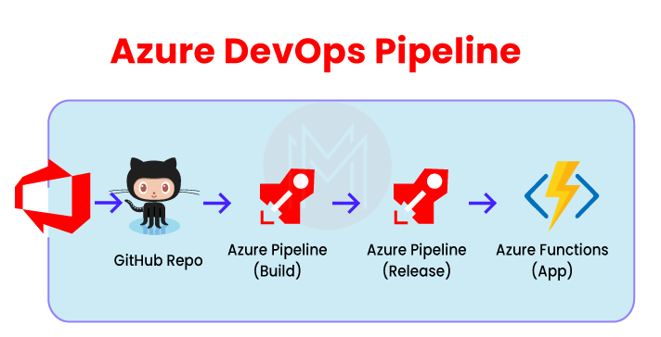

27. What do you mean by Azure Repos?
This system version control is used for managing code and various versions by the use of the lifecycle of the development. It can also track the multiple changes in the code via different teams. The list of changes then can be used for coordination and collaboration between the teams in the future. Centralized version control, as well as distributed version control, is its essential features. An example of distributed version control can be Git. And an example of centralized version control is TFVC.

28. What do you mean by Azure artifacts?
Azure artifact is an extension making it easy to install, discover, and publish the packages such as npm, NuGet, and Maven in Azure DevOps. The package management becomes a smooth process in the existing workflows because of its deep integration with other hubs such as Build.
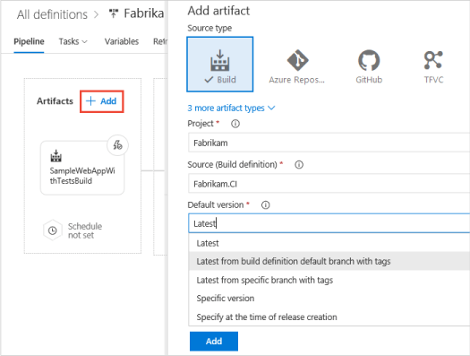

29. What do you mean by Azure test plans?
This Azure DevOps service is used for managing all the test solutions. Exploratory testing, manual planned testing, and customer testing are all provided under this one service. Testing exploration, as well as the stakeholders' feedback storage, is maintained by its extensive browser. Testing explorations and manuals are essential techniques for product development because they are considered the reason for testing automation.

30. What do you mean by Multi-stage pipeline?
CI, CD, or both are allowed by a multi-stage pipeline in a single YAML pipeline code. Being easy to maintain and easy to check the current stage of our deployment is among the many benefits provided by it.

31. List some benefits of Azure pipelines.
Some of the benefits provided by Azure pipelines are-
- Integration with GitHub
- Integration with Azure deployments
- The ability to work with any platform or language
- The ability to deploy and work on multiple targets at the same time
- Configuration of open-source projects
- Build on Windows, Linux, and Mac machines

32. What is meant by the pull requests in Azure DevOps Repos?
Pull requests are used for reviewing as well as merging codes to a Git project. Pull requests enable the team to review the code and also provide feedback on it. Either feature or topic branch, along with a fork, can be the source of pull requests.
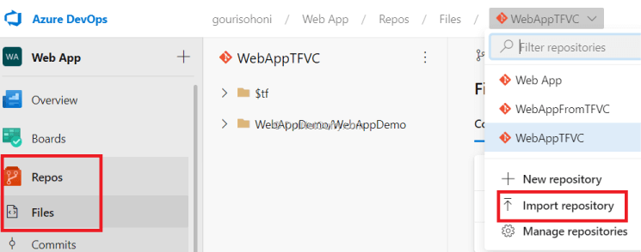

33. Explain Forks in Azure DevOps.
We can separate the risky, confidential, and experimental changes from our original codebase with the help of forks. A fork is a whole new copy of code collections that include commits, branches, and files. A fork seems like a repository that has been cloned and pushed to a new and empty repository. The fork files and branches can't be shared with the original codebase once a fork is created. But a pull request can carry them along.
34. List some of the features of Memcached.
A wide range of features are offered by Memcached, such as-
- Callbacks
- CAS tokens
- Igninary
- GetDelayed
- Binary protocol

35. Mention why Azure boards should be used?
Azure boards should be used because of the following reasons-
- Interactive visual tools are provided
- Scaling makes it easy to begin as levels rise
- In-built tools enable social communication
- Extensibility is provided
- Easy to customize
- Flexibility and easy storage of collected data
- Can be begun at no cost
- Identifying the needs and notifying the changes is easy
- The progress and status are observed in the dashboard.

36. Differentiate between Jira and Azure DevOps.
Atlassian Jira is also a well-known application life cycle management (ALM) tool. It is especially liked by the agile teams. Originally it was a bug tracking tool. But now, it has grown into a more comprehensive tool that now contains many software development and management tools. The main intention of this tool is to keep things on track. Azure DevOps, on the other hand, not only tracks but extends to building and development as well.

37. Why is Selenium used in DevOps?
The use of Selenium in DevOps is for continuous testing. Its specializations include functional and regression testing.
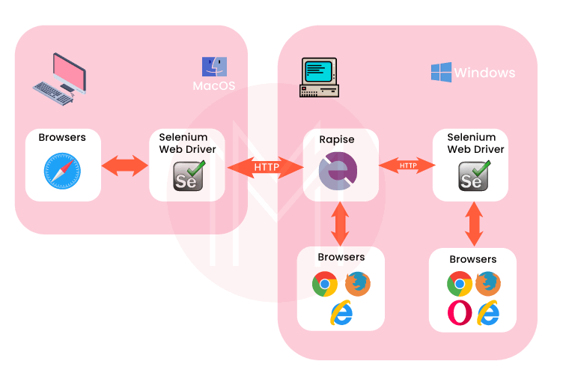

38. What is meant by roles?
Roles are the type of servers that help us towards common aim achievement. These are managed as well as loaded as virtual machines.
The three types of roles Azure provides are:
- Worker Role
- Web role
- VM role

39. What different types of backlogs and board options are available in Azure boards?
Three classes of backlogs are available to manage the work:
- Product
- Portfolio
- Sprint
And two types of boards are available-
- Kanban
- Taskboards
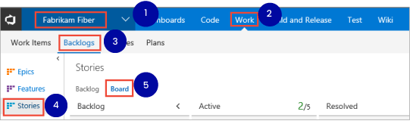

40. Tell us something about fault domains.
They are the logical hardware groups that can share the same power source as well as network. They are used for racking the data centers on-premise. These fault domains get automatically distributed by the Azure platform when VMs are designed using available sets. This approach limits network outages, physical hardware failures, etc.

41. Tell us something about the Update domains feature.
They are the logical hardware groups that can be rebooted as well as maintained at the same time. These updated domains get automatically distributed when the VMs are designed using available sets. This ensures our application instance, as well as the running of the Azure platform, is under periodic maintenance. Only a single order of updates can be rebooted at a time.
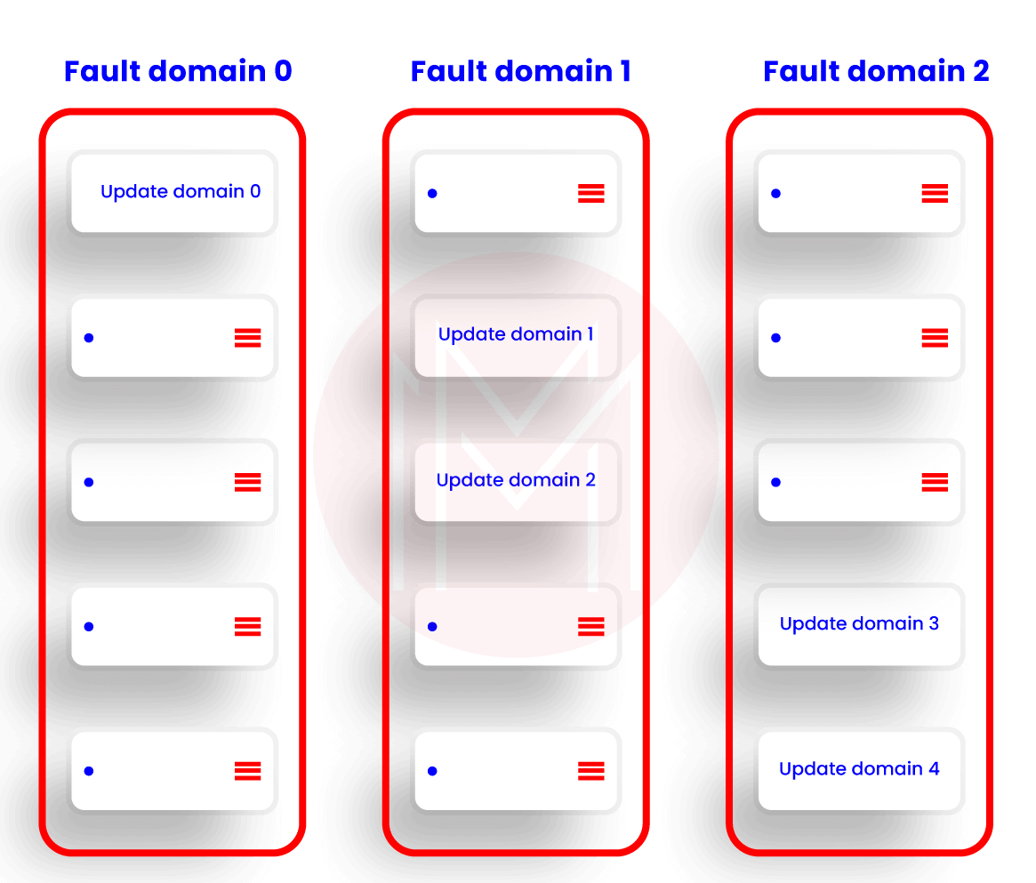

42. How can Azure Ad applications be used?
A secured and simple way is provided to select and connect with web applications by this feature. The same as the SaaS apps access can also be accessed in the Azure. It doesn't require a VPN to change the infrastructure of the network.

43. What is VNet?
The rendering of our cloud network refers to the VNet. Our launched cloud instances get isolated from the remaining resources with the help of VNet.

44. What is meant by system capabilities and user capabilities in the Azure pipeline?
The self-hosted agent contains a set of capabilities that defines the scope of various capabilities. The name-value pairs are referred to as capabilities. They are called system capabilities when they get discovered automatically by the agent software. On the other hand, they are called user capabilities when they are defined by us. System capabilities such as operating system name, machine name, and other installed software are detected by the agent software.
45. What is the azure cli command used to run the pipeline?
Az pipelines run [-branch]
[-commit-id]
[-folder-path]
[-id]
[-name]
[-open]
[-org]
[-project]
[-variables]

46. Elaborate self-hosted agent in Azure pipeline.
Self-hosted agents allow us to set up as well as management jobs on our own. We opt for self-hosted agents when we want more access to installing dependent software as per our needs and deployments. Also, the speed can be boosted by the persistence of machine-level caches and configuration from run to run.

47. Elaborate Microsoft-hosted agents in the Azure pipeline.
It is the by default Microsoft agents that get the jobs executed. From assigning the resources to installing and maintaining, everything gets done when we opt for this Microsoft-hosted agent.

48. What is a Dogpile effect? How can it be prevented?
- The period after the cache expires and several requests have been made on the website from the client refer to the Dogpile effect.
- The simplest technique to avoid this effect is a semaphore lock. The semaphore lock generates a new value after the cache expires.

49. Explain the use of an active directory in Azure.
It is used for access management. It helps in enabling access to the employees to particular products and services of our networks. Some major examples include Salesforce.com and Twitter. Application-built support in galleries is provided by this active directory.
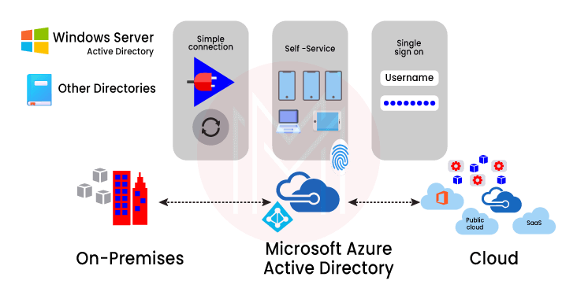

50. Elaborate Azure service fabric.
This distributed systems platform makes it simple for the package, scalable management, deployment, and microservices reliability. Development and management of the applications of the cloud can also be done by this. Hence the developers can pay more attention to the critical implementation jobs.

51. Tell us about the Azure Redis cache.
It is an open-source data structure. It works as a database and cache. Azure Redis cache is made based on the famous Redis cache of open source. Secured access from azure applications is provided with the help of this feature. The structure of data which are like strings, sets, and hashes along with queries, is maintained by this.

52. What is meant by containers? Which containers are supported by azure DevOps?
To package the software code, its dependencies, and its configurations into a single object or unit, containers are used. Multiple containers can be there working and sharing the operating system on the same machine. This enables fast, consistent, and reliable deployments. The following containers are supported by azure DevOps:
- Asp.Net with containers
- Docker
- Azure service fabric app along with docker support
- Azure Kubernetes services

53. Explain the function of Scrum master in azure boards.
Scrum master is always on the lookout to remove all the hindrances, resolve impediments, and other blocking issues arising during a sprint. They are continually ensuring the improvement of the team. They can be called part team members, part cheerleaders, and part coaches.
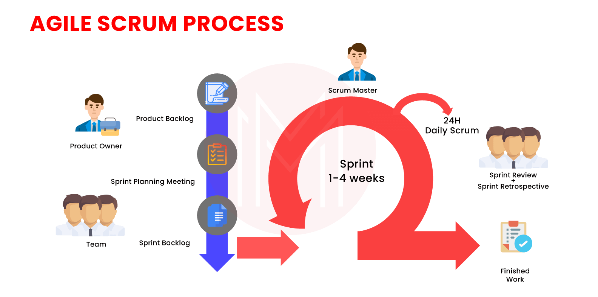

54. How can a Git repository be created in Azure DevOps?
A Git repository can be created by following the given steps:
- Open DevOps
- Choose the respective project
- Click on Repos
- Click on Files from Repos
- Click on repositories
- Click on the "New repository" option from the dropdown menu
- Choose repository type as Git in the panel appeared.
- Give the repository a name
- The "Add a README" checkbox can be unchecked. Otherwise, a readme.txt file will be added.
- Now, click on create button
(The repository will get selected by default once it is created)
Now, given below are the Top 10 FAQs about Azure DevOps.
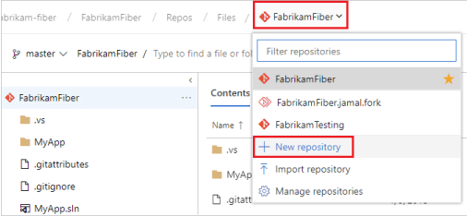
55.Mention some of the alternatives to azure DevOps?
Some of the main alternatives to azure DevOps are GitHub, Jenkins, GitLab, Jira, TeamCity, Bitbucket, Jira, Octopus Deploy, and Amazon Web Services.

56. Mention the advantages of using Azure DevOps.
The main advantages of using azure DevOps are:
- Higher efficiency
- Customer satisfaction
- Speedier code deployment in the market via ceaseless integration and delivery
- More collaboration between the operation and development teams.
- Incessant improvements as well as reduced failures
- Transparency between different teams
- Speedier operational support
- Better adaptation
- Robust infrastructure as well as IT performance

57. Which service is used for managing Azure resources?
Various services, such as deployment, management, etc., are handled by the Azure Resource Manager.

58. Differentiate between Azure DevOps server and azure DevOps services.
Azure DevOps Server is an on-premise platform based on a SQL server. Generally, enterprises opt for an on-premise platform whenever there is a need to access SQL server reporting services integrated with azure DevOps tools and data.
Azure DevOps services, on the other hand, are the cloud services of Microsoft Azure. It offers highly reliable as well as scalable globally available services.

59. What are the main components of Azure DevOps?
The main components of azure DevOps are given below:
- Azure Boards- work item tracking, agile planning, reporting, and visualization tool
- Azure Repos- cloud-hosted private git Repos are provided
- Azure pipelines- a language and cloud-agnostic CD/CI platform supporting containers or Kubernetes
- Azure test plans- a planned and integrated testing solution is provided
- Azure artifacts- integrated package management supporting npm, Maven, NuGet, and Python package feeds from private or public sources.
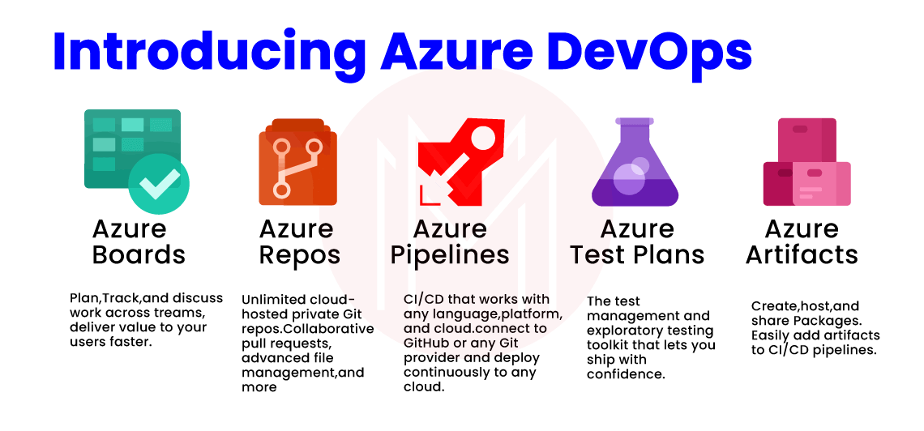

60. Elaborate on the job role of Azure DevOps engineer.
An Azure DevOps engineer is responsible for designing and implementing a scalable, strong, realistic, and practical cloud solution that would work for the clients.

61. Which web applications can be deployed with Azure?
The web applications given below can be deployed with Azure:
- PHP
- ASP.NET
- WCF

62. Mention different ways for connecting with a project in Azure DevOps.
Following different ways can be followed to connect to a project:
- Integrating with Team Explorer or Visual studio.
- Visual studio code
- Through web portal
- Eclipse/Team explorer
- Intellij with the Azure DevOps services
- Android studio with the Azure DevOps services

63. Elaborate on the projects of Azure DevOps.
To gain experience, the projects of azure DevOps are very important. This helps in the Git repository and code existence for designing the ceaseless delivery as well as integration pipelines of Azure DevOps.
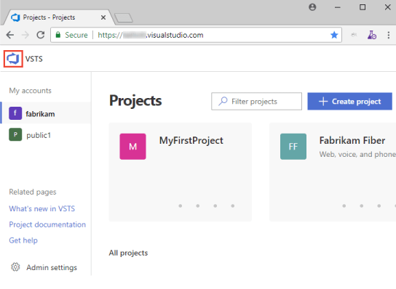

64. Briefly explain continuous monitoring.
DevOps and agile are used simultaneously to develop the process through expectations and adoption. We can constantly monitor the progress, infatuation, and process visualization. And we will be provided with quick alerts in real-time. We can select the process as per our requirement through data analysis. Hence continuous monitoring is of great help.

65. Which tools are useful for Continuous Integration?
Azure Pipelines has support for all the platform like Linux, macOS, and Windows also we can consider following tools for the Continuous Integration.
- Jenkins
- TeamCity
- Travis CI
- Bamboo
- GitLab CI
- CircleCI
- Codeship

66. Which tools are useful for Continuous Deployment?
Following are few useful Continuous Deployment tools
  - Azure Pipelines for Deployment.
  - Jenkins.
  - TeamCity.
  - Bamboo.
  - ElectricFlow.
  - Octopus Deploy.
  - AWS CodeDeploy.
  - DeployBot.
  - Shippable.

67. What is InfrastructureConfiguration Which tools are useful for InfrastructureConfiguration?
In today’s fast and competitive market, many companies demand a faster deployment process and Infrastructure Configuration, so treating Infrastructure as software and manage the processes such as version control, continuous integration, deployment and automated testing will make infrastructure changes more rapidly and reliably.
Following are the most popular tools for Infrastructure Configuration.
  - Chef
  - Puppet
  - Ansible

68. What is Continuous Testing? What is the use of Test Automation in DevOps?
DevOps is not about jobs or tools, it’s about people, culture and automation. and to implement DevOps, continuous testing plays a very important role where writing scripts for software testing and make it auto executable so that we can automate the testing and do the frequent releases using the delivery pipelines.
We have to write unit testing to achieve Continuous Testing.

69. Which tools are useful for Continuous Testing?
For test Automation there are many open source tools are available, following are few names
  - Selenium
  - JMeter
  - JUnit
  - AntUnit
  - Cucumber
  - SoapUI
  - Tricentis Tosca

70. What is Continuous Monitoring?
DevOps and Agile are all about inspection and adaption to make continuous improvement in our process, and for that, we must have to monitor continuously the process, application performance and infrastructures.
By doing continuous infatuates monitoring, we can visualize the process and get the early alerts in real time. By analyzing that data, we can take decision wisely and adapt the things and process that best suits for the business.

71. Which tools are useful for Continuous Monitoring?
For continuous monitoring Nagios, SysDig and Zabbix are the famous open source tools available in the market. Infrastructure as code(laC) vendors like Amazon and Google have tools like AWS CloudWatch and StackDriver. Also, New Relic is a good option for continuous monitoring.

72. What is the container and What containers Azure DevOps support?
The container will provide a way to package your software code, its configurations, Packages and its dependencies into a single unit or object.
We can have multiple containers that can run on the same machine and share the operating system with other containers so that we can run anywhere fast and reliable and consistent deployments.
Azure DevOps has the following container support.
  - Docker
  - Asp.Net with containers.
  - Azure Kubernetes services.
  - Azure Service Fabric application with Docker support.

73. What is Azure DevOps? What is the difference between Azure DevOps and VSTS Online?
Microsoft Visual Studio Team Services, now known as Azure DevOps having excellent application lifecycle management tool.
We can plan a project with Agile tools and templates, manage and run test plans, Version control source code and manage the branches, deploy the solution across all platform using Azure Pipelines, by implementing Continuous Instigation and Continuous Deployment.

74. What services Azure DevOps Provides?
Azure DevOps provides full application lifecycle management from planning to coding, and from testing to build and deploy.

75. What is Azure Boards?
Azure board provides service to manage your works, using the Agile Scrum and Kanban templates, Dashboard that we can customize and reporting.

76. What are Azure Repos?
Azure Repos is a code version control system that can manage your code and its version.
Using that we can track the changes, whenever team edits code it has all the version history so later, we can coordinate with the team and merge the changes.
The azure repo has both a centralized version control system as well as a distributed version control system.
Git: Distributed Version Control System
Team FoundationVersion Control (TFVC): Centralized Version Control System.

77. What are Azure Pipelines?
Azure Pipelines has all the features that are required for supporting Continuous Integration (CI) and Continuous Deployment (CD).
Using that we can constantly test and build the code and release it to any target.

78. What are Azure Test Plans?
Azure test plan provides browser-based test management using that we can manage all the testing like Exploratory & manual testing, Continuous testing, Unit & functional testing also we can ask or Request stakeholder to provide feedback.

79. What is the significance of having configuration management in DevOps?
Configuration management (CM) assists the team to streamline various tasks and accomplish them in less time. In this way, it enhances the organization’s agility and performance. Also, it assists in providing consistency and enhancing the product development process by implementing means of design streamlining, control, extensive documentation, and change implementation during different phases of the project. You can be aware of configuration management when you go through the devops tutorial.

80. Describe the flow of the DevOps pipeline?
Generally, a pipeline is a set of automated processes that are defined and being followed by the software engineering team. Essentially, DevOps pipeline permits the DevOps software developers and DevOps engineers to competently and consistently compile, create and deploy the software code into production environments.
The corresponding flow is as below:
  - Developer focus on accomplishing functionality.
  - The developer sets up his code for the test environment.
  - Testers work on authenticating the feature. The business team can arbitrate and give feedback.
  - Developers focus on the test as well as business feedback in a constant collaboration manner.
  - The code is finally handed over the production and authenticated again

81. What are the key differences between DevOps and Agile?
When preparing for DevOps interviw Questions answer, this is one of the most typical questions a candidate needs to be aware of. There are several similarities between DevOps and Agile methodology. But when it comes to software development, both are fundamentally unique approaches. Here are the differences between the two:
  - Agile prioritizes timeliness but DevOps provides identical priority to quality and timeliness.
  - DevOps presents smaller release cycles with instant feedback whereas Agile presents only smaller release cycles without instant feedback.
  - Agile depends on feedback from customers whereas DevOps depends on feedback from its monitoring tools.
  - The scope of work is agility only for Agile whereas it is agility and need for automation for DevOps.

82. How does AWS help DevOps?
AWS (Amazon Web Services) is a popular cloud provider. It assists DevOps by offering the following benefits:.
  - Scaling: Plenty of machines can be set up on AWS by using computation power and unlimited storage.
  - AWS presents ready-to-use flexible resources.
  - With various services presented by AWS, a myriad of tasks can be automated.
  - AWS is safe to implement and through its diverse security options offered under the Identity and Access Management (IAM), certainly, the application deployments and builds can be safeguarded.

83. Briefly explain various phases in DevOps:
AWS (Amazon Web Services) is a popular cloud provider. It assists DevOps by offering the following benefits:.
When you undergo devops training, you can get familiar with different phases in DevOps. The different phases available in the DevOps lifecycle are as below:
Plan: Firstly, there must be a plan for the type of application required to be developed. It is always a decent idea to get a rough picture of the development process.
Code: The application is coded according to the end-user requirements.
Build: It involves building the application by assimilating different codes created in the previous steps.
Test: Recognized as the most vital step of the application development, it involves testing the application and rebuilding, if necessary.
Integrate: Several codes from different programmers are combined into one.
Deploy: The code is deployed in a cloud environment for future usage. Any new modifications do not influence the overall functioning of a high-traffic website.
Operate: Operations are carried out on the code if needed.
Monitor: The performance of the application is monitored. Modifications are done to fulfill the end-user requirements.

84 What are the antipatterns of DevOps?
A pattern is the one that is most frequently followed by huge masses of entities. When a pattern is accepted by an organization by considering that it is being used by others without determining the requirements of the organization then it turns out to be an anti-pattern. Likewise, various myths around DevOps can lead to antipatterns, they are as below:
  - DevOps is not a culture but a process.
  - DevOps is nothing but an Agile approach.
  - There must be a distinct DevOps group.
  - DevOps resolves every problem.
  - DevOps associates to developers operating a production environment.
  - DevOps follows Development-driven management
  - DevOps does not excessively focus on development.
  - DevOps culture cannot be implemented because of the absence of the right set of people.

85. What are a few of the finest practices that must be followed for DevOps success?
Though you Learn DevOps Step by Step, it is important that you know which practices to follow for success in DevOps implementation.
Listed below are the important best practices necessary to be followed for DevOps implementation:
  - The speed of delivery implies the time taken for a task to continue into the production environment.
  - It is crucial to calculate the definite or the average time that it needs to recover in case any failure occurs in the production environment.
  - The number of bugs being mentioned by the customer also influences the overall quality of the application.

86. What is the DevOps toolchain?
DevOps toolchain is formed by a stack of tools. It automates some tasks like the development and deployment of your application. Tasks in DevOps can be carried out manually with easy steps, but the requirement for automation rapidly increases due to the rise in its complexity. Therefore, toolchain automation is important for continuous delivery. Basically, GitHub a Version Control Repository is recognized as the core component of a DevOps toolchain. In this toolchain, some other tools can be delivery pipelines, backlog tracking, etc. When you enroll in the Devops course in Hyderabad, you gradually become aware of various tools and toolchains in DevOps.

87. What does it mean by a branching strategy in DevOps?
Branching is a method implemented for code isolation. It creates a copy of the source code to make two versions that are separately developed. Various kinds of branching are available. Thus, the DevOps team should make a choice based on application requirements. Correspondingly, the choice is referred to as a branching strategy.

88. What is a Puppet?
Puppet is famously known as an open-source configuration management tool being utilized for the deployment, configuration, and management of servers. Essentially, its working is based on client-server architecture. In this architecture, the client is an agent whereas the server is recognized as the master. It is found that a puppet agent and master converse via a safely encrypted channel with the assistance of SSL.

89. What are the advantages of Azure DevOps ?
The given below are some important advantages of the Azure DevOps
- It delivers the software continuously.
- It simply solves the problems which are complex.
- It identifies the problems quickly and solves them with high speed.
- It is also used for quick features transport.
- It maintains the secured operating environment.
- It is used to develop the collaboration of the various teams.
90. Describe about azure DevOps ?
It is a new version of Microsoft VSTS, it is used for the project planning by using the templates and the tools of Azure. Its functionality helps to manage and run the plans of the test, it is also used for the solution deployment through various platforms to leverage the pipelines. It provides CI and CD quick deployment.
91. Define Azure boards ?
It is a DevOps service which is used to manage the projects of software, It offers various sets of abilities like dashboards, reporting, scrum and kanban. Its essential feature contains queries, backlogs, sprints, dashboards and work items.
92. Describe about Azure repos ?
It is a system version control which is used for code management and various versions by using the lifecycle of the development. It is also used to track the changes for the code through various teams, the clear list of changes may be used for coordination between teams and collaborate the changes for future use.

One of the essential features of it is centralized version control and distributed version control. Git is an example for distributed version control, TFVC is an example for centralized version control.
93. Explain Azure pipelines ?
It is One of the essential azure cloud services, with which we can build and test the projects code automatically. It works productively with the help of major languages and types of the project, it shares that project code with other customers also.
94. Explain the test plans of Azure ?
They are Azure DevOps services which offer solutions for test management, it offers the essential abilities, exploratory testing, customer testing, planned testing manually. It maintains an extensive browser, which offers testing exploration along with stakeholders feedback storage. The essential techniques like testing exploration and manuals are required for the product development, they are the reason for testing automation.
95. Mention some important components of azure devops integration and the bit bucket ?
Answer for this question represents the relation between hosted agent and the service of external Git, its continuous integration and continuous deployment is congruent through Github and the server of Git such as bit bucket. Instead of transforming the complete Gitlab project, it is used for external respiratory connection to get the advantages of its continuous integration and the continuous development.
96. Describe the projects of Azure DevOps ?
Project of the azure devops is an essential choice for gaining experience, which is helped for code existence and Git repository to design the continuous delivery and integration pipelines of Azure DevOps.
97. Mention the services provided by Azure DevOps ?
It offers the complete lifecycle management of applications, that is from plan to code, and also from test to build and deployment.
98. Describe continuous monitoring ?
For simultaneous development of our process, agile and devops are used by adopting and spectations. We need to monitor the constant progress and the infrastructure, with the monitoring of simultaneous infatuation, we can do process visualization to gain quick alerts in real time. With the help of data analysis we can select and the process which suits our organization.
99. List Out some useful tools of continuous monitoring ?
- Lansweeper
- Spiceworks
- Snort
- Solarwinds
- Nagios
- Tenable
- Ipswitch WhatsUp Gold
- Paessler PRTG
- Rapid7 Insight
- Cisco Identity Services Engine
100. Name the web application which can be deployed with Azure ?
The given below are the web applications, that can be deployed with Azure
- ASP.NET
- PHP
- WCF
101. Mention the service is used to manage the Azure resources.
Azure resource manager is the one for resource management, that contains various services like deployment, management etc.
102. Make a comparison between DevOps and agile methodology ?
DevOps: It is a kind of culture which helps to collaborate operation teams and the development, and makes them work simultaneously. The output of this process is continuous integration, testing, deployment, development and it scans the entire lifecycle of the software.

Agile: It is a type of procedure of software which concentrates small, iterative, the quick delivery of the software and the feedback from users. This process displays the problems and the gaps between developers and the users.

103. Make a comparison between Azure DevOps server and services ?
Azure DevOps services: It is a microsoft service of cloud, which is reliable, scalable and hosted services which are available globally.
Azure DevOps server: It is a kind of on premise, which is used to build the back end server of SQL. People select this option for their requirement of their day with the network, the main reason for selecting it contains the requirement of SQL servers access by using azure data and tools.
They Both provide the same services along with particular advantages, the given below are some benefits of services
- It easily manages the server.
- Its remote sites are used for best connectivity.
- The latest features get quick access.

104. Mention the reasons for why should we use azure boards ?
Its characteristics and applications are the reason for selecting them, the given below are some of the reasons.
- Easy to begin by using scaling as levels increase.
- It provides the visual tools which are interactive.
- Simple to customize.
- It is used for social communication by using in-built tools.
- The collected data is flexible and has the capacity of storage.
- Simple to identify the needs and notify the changes taking place.
- It provides a chance to begin with no cost.
- It provide the advantage of extensibility
- It observes the progress and status in the dashboards.
105. Made a comparison between VSTS and Azure DevOps ?
The services of the microsoft visual studio namely Azure DevOps, which have better management tools for the application lifecycle. Our projects may plan with the templates and the tools of the Agile, it helps to run and manage the test plans, source code, version control and to manage the branches. By using CI and CD the solution deployment beyond all platforms with the help of azure pipeline.
106. Explain the roles and their use ?
They are kind of servers, which are managed and loaded as virtual machines that help to work for common aim achievement.
Azure have 3 kinds of roles
- Web Role
- Worker Role
- VM Role
107. Briefly explain the virtual machine scale sets ?
a compute resource which is used for the deployment and the management of a pair of twin VMs, they are designed with the similar configuration for true autoscale. There is no special need for VMs pre-provisioning and simple for services of large scale, they concentrate on workload of containerised, big data.
108. Make a note about availability sets ?
This set is VMs logical group, which helps us to find how our application is built in Azure that offers availability, to get highly availability for application it is suggested that two or multiple VMs are designed in the sets of availability which leads to the Azure SLA at 99.95. If we use single VMs along with the storage of Azure premium, then for the maintenance of unplanned events Azure SLA is used.
109. Introduce fault domains.
They are nothing but the logical groups belonging to hardware, which can share the same network and power source. They are used to rack the data centers on premise, when we designed our VMs with help of availability sets then these fault domains are automatically distributed by the platform of Azure. The failures of physical hardware, outgages of network, etc are limited by this approach.
110. Introduce Update domains.
a hardware logical group which can be maintained or rebooted at the similar time, these updated domains automatically distribute our VMs when we design VM in the set of availability. This process is used to ensure our application instance and it keeps running as a platform of azure that goes under the maintenance of periodic. We can robot only a single order of updated domain at a time, it may not continuously proceed while the maintenance.
111. Briefly explain about Network security groups ?
NSG includes the access control list which may permit or neglect the traffic of a network for subnets, they may be associated with an NIC of individuals that connect with a subnet or with the subnets. If a subnet is associated with an NSG then a subnet ACL is applied for VM, it also limits the traffic for an individual NIC with the help of NSG.
112. Are Scale sets works with availability sets of Azure ?
Yes, it is an inferred set of availability, which contains 5 update domains and 5 fault domains. Its VMs span is more than 100, that is equal to various sets of availability. VMs set of availability is present in the same network, VMs control node is created by the common configuration in sets of availability.
113. Explain about break fix issues.
Break fix issues are nothing but the technical issues, that term belongs to industrial which includes work with technical support when it fails in normal functioning. This failure needs supportive organizations interruption for working order restoration.
114. Explain the Containers and Azure DevOps supports which containers ?
Containers offer a simple software code approach which associates the dependencies, package and the configuration in a solitary project. We may increase the reply through the beginning, by which various containers run on identical mechain and share with other containers also. Containers used for the quick and well founded deployment, Azure DevOps gave support for Asp.Net, docker and the containers.
115. Why should we use Azure pipelines, continuous integration and continuous development ?
The execution of the azure pipelines, continuous integration and continuous development is the better way to secure the code quality. They provide a simple, secured and quick way for process automation, which helps to project build and also warrant the obtainability.
It offers free services for public projects and also 30 hours free service per month for private projects. The given points are some reasons for why we should use Azure DevOps pipelines, continuous integration and continuous delivery.
- It holds up any platform.
- The continuous deployment for different kinds of the targets.
- Azure development integration.
- It helps for windows, linux machines and the mac building.
- Github integration.
- Working abilities through the project of open source.

116. What is the use of an active directory in Azure ?
It is the system of access management, which helped to access the grant for our employees to particular services and products of our networks. Twitter and salesforce.com are best examples for it, it provides application built support in galleries that may be directly added.
117. If we do maximum failed attempts of authentication via Azure AD, then what happens ?
We have more advanced strategies for accounts lock, that is based on requests of IP addresses and passwords which are entered. By using those advanced strategies we can increase the time of lockout, which seems like an attack.
118. How to find applications list which are pre integrated with AD and their capabilities ?
It has nearly 2,600 applications, which are pre integrated. Those applications keep up SSO, single sign on allow us to utilize the credentials of our organization for our apps access. They also gave automated support for de provisioning and provisioning.
119. How to use Azure Ad applications ?
It provides us a simple and secure way for selecting and connecting with web applications, we also have the chance to access the same as our saas apps access in Azure. VPN is not required to change the infrastructure of our network.
120. Write a note on Azure service fabric.
It is a platform of distributed systems, which made it simple for package, deployment, scalable management and microservices reliability. It is also used to develop and manage the applications of cloud, developers may neglect the tough problems of infrastructure and pay attention to mission critical implementation, workloads demand which are reliable and scalable. They constitute for future use and platform of mildware for management of enterprise class and the applications of cloudscale.
121. Explain about VNet ?
It is nothing but the rendering of our cloud network, that isolates our launched cloud instances from our remaining resources.
122. Bring Out the main variations between Subscription Administrator and Directory Administrator ?
We need to assign a subscription administrator for Azure signup, it may use a Microsoft account or the work account of the directory. It is used by Azure portal management service, we can add co-admins when others are required to access with the same subscription.
It has various admin sets used to manage the features of the directory, they have different azure portal access. They can design and assign roles of administration for others, to reset the passwords and the domain management.
123. What are the restrictions for customers using managed disks ?
They abolish the restrictions that are associated with accounts storage, its number per subscription is restricted to 2000.
124. Make a note about Azure Redis cache ?
Azure redis cache is an open source data structure, which works as cache and database. It is based on the famous redis cache of open source that provides secured access from azure applications. It maintains structure for data they are like hashes, sets, strings along with queries.

125. What are the DevOps tools?
To Implement DevOps, Automation plays a major role and we defiantly need some tools for Implementation. Following are the major areas:
- Planning
- Code management
- Build and Testing
- Release management
- Deploy and Monitor
Here’s a list of tools that can help you meet your DevOps requirement perfectly.

126. What are the advantages of Azure DevOps ?
The given below are some important advantages of the Azure DevOps
- It delivers the software continuously.
- It simply solves the problems which are complex.
- It identifies the problems quickly and solves them with high speed.
- It is also used for quick features transport.
- It maintains the secured operating environment.
- It is used to develop the collaboration of the various teams.

127. Describe about azure DevOps ?
It is a new version of Microsoft VSTS, it is used for the project planning by using the templates and the tools of Azure. Its functionality helps to manage and run the plans of the test, it is also used for the solution deployment through various platforms to leverage the pipelines. It provides CI and CD quick deployment.

128. Define Azure boards ?
It is a DevOps service which is used to manage the projects of software, It offers various sets of abilities like dashboards, reporting, scrum and kanban. Its essential feature contains queries, backlogs, sprints, dashboards and work items.

129. Describe about Azure repos ?
It is a system version control which is used for code management and various versions by using the lifecycle of the development. It is also used to track the changes for the code through various teams, the clear list of changes may be used for coordination between teams and collaborate the changes for future use.
One of the essential features of it is centralized version control and distributed version control. Git is an example for distributed version control, TFVC is an example for centralized version control.

130. Explain Azure pipelines ?
It is One of the essential azure cloud services, with which we can build and test the projects code automatically. It works productively with the help of major languages and types of the project, it shares that project code with other customers also.

131. Explain the test plans of Azure ?
They are Azure DevOps services which offer solutions for test management, it offers the essential abilities, exploratory testing, customer testing, planned testing manually. It maintains an extensive browser, which offers testing exploration along with stakeholders feedback storage. The essential techniques like testing exploration and manuals are required for the product development, they are the reason for testing automation.

132. Mention some important components of azure devops integration and the bit bucket ?
Answer for this question represents the relation between hosted agent and the service of external Git, its continuous integration and continuous deployment is congruent through Github and the server of Git such as bit bucket. Instead of transforming the complete Gitlab project, it is used for external respiratory connection to get the advantages of its continuous integration and the continuous development.

133. Describe the projects of Azure DevOps ?
Project of the azure devops is an essential choice for gaining experience, which is helped for code existence and Git repository to design the continuous delivery and integration pipelines of Azure DevOps.

134. Mention the services provided by Azure DevOps ?
It offers the complete lifecycle management of applications, that is from plan to code, and also from test to build and deployment.

135. Describe continuous monitoring ?
For simultaneous development of our process, agile and devops are used by adopting and spectations. We need to monitor the constant progress and the infrastructure, with the monitoring of simultaneous infatuation, we can do process visualization to gain quick alerts in real time. With the help of data analysis we can select and the process which suits our organization.

136. List Out some useful tools of continuous monitoring ?
- Lansweeper
- Spiceworks
- Snort
- Solarwinds
- Nagios
- Tenable
- Ipswitch WhatsUp Gold
- Paessler PRTG
- Rapid7 Insight
- Cisco Identity Services Engine

137. Name the web application which can be deployed with Azure ?
The given below are the web applications, that can be deployed with Azure
- ASP.NET
- PHP
- WCF

138. Mention the service is used to manage the Azure resources.
Azure resource manager is the one for resource management, that contains various services like deployment, management etc.

139. What features does Azure DevOps provide?
Azure DevOps provides many integrated features that you can use based on your project requirement. You can access these features directly in the browser or IDE.
- Azure Boards to manage the PBIs and Tasks.
- Azure Pipelines for the automation of build pipelines and releases.
- Azure Repos allows you to manage your code versions.
- Azure Test Plans to manage the Test artifacts.
- Azure Artifacts manages the public and private package feeds.
- Azure OnePlan provides the capability for enhanced visibility and alignment of the team working on the project.

140. What is Azure DevOps Services?
Azure DevOps provides different services:
- Azure Boards
- Azure Pipelines
- Azure Repos
- Azure Test Plans
- Azure Artifacts
- Extensions Marketplace

141. What are Azure DevOps Boards?
Azure Boards is a service to manage software projects. You can easily track features, stories, tasks and bugs associated with your projects. It provides capabilities including reporting, dashboards, support for Scrum and Kanban. You can plan, discuss and track work across the teams. For more visit Azure Boards

142. What is the Azure DevOps Pipeline?
Azure DevOps Pipeline performs the build and testing of any type of projects with any programming language to make them available to other targets. Azure Pipeline is an automated combination of Continuous Integration and Continuous Delivery to build, test the code project and ship it to deployment target.

143. What different ways does Azure DevOps offer to define pipelines?
You should have a basic understanding of key concepts such as triggers, stages, tasks, task group, variables, variable groups, build artifacts to create a release pipeline. Azure DevOps offers two ways to define pipelines:
Using YAML Syntax – Here you can use a YAML file to create your pipeline that you can version with your rest of code. The YAML file ‘azure-pipeline.yml’ contains all the code changes to build and deploy your infrastructure and application. You can also use YAML Editor in Azure DevOps portal to create your pipeline.
Using Classic Interface – Azure DevOps offers the capability to create releases using highly configurable and manageable pipelines by Classic User Interface. You can create releases to multiple stages with required approvals and checks using these pipelines. For more visit Define Classic Pipeline.

144. What is a Multi-stage Pipeline?
Multi-stage Pipeline allows you to define CI, CD or both in your single YAML pipeline code. It offers some benefits such as easy to maintain, you can easily check that in which stage your deployment is currently in, and many more. For more about Multi-stage pipeline visit Multi-stage Pipeline Azure DevOps.

145. Why should you use Azure DevOps Pipelines?
Azure pipelines comes with many benefits:
Provides ability to work with any language or platform
Provides integration with GitHub
Can configure Open-Source Projects
Has ability to deploy on different type of targets at same time
Has integration with Azure Deployments
Provide build on Linux, Windows and Mac Machines

146. What is Release in Azure DevOps?
Releases or Release Pipelines allow you to continuously deliver your software to customers at a faster rate with lower risk. Release pipelines provide capability to fully automate the testing and delivery of your software in multiple stages prior to production. You can control these automated ways by approvals or on-demand deployments.
Azure DevOps allows you to create release pipelines by navigating to Releases in Pipeline Menu. Once you click on ‘New’ then ‘New Release Pipeline’, It will navigate you to the new release pipeline page where you can specify Build Artifacts, Stages, Pre-deployment conditions, Variables and other Deployment options.

147. Explain variable and variable groups in Azure DevOps.
Variables allow you to store some data that can be used across pipelines. All variables are mutable and stored as strings.
Variable Groups provide the ability to use variables across multiple pipelines. You can store secrets in variable or variable groups.

148. What are Azure DevOps artifacts?
Azure Artifacts allows you to create and share npm, NuGet and Maven package feeds from private and public sources with a team. Azure artifacts has capability to manage all types of packages like npm, NuGet, Maven etc.
You can easily add fully integrated Package management to your Continuous Integration/Continuous Delivery CI/CD pipelines with a single click or via ARM functionality. For more about Azure Artifacts visit Azure Artifacts.

149. What are Azure DevOps Test Plans?
Azure Test Plans is a planned and exploratory testing solution to improve code quality and provides three types of test management artifacts -test plans, test suites and test cases in Azure DevOps server. For more about Azure Test Plans you can refer Azure Test Plans.

150. What are Azure DevOps Repos?
Azure Repos is a set of version control tools by Azure DevOps. Azure repos are used to manage the code. It provides an unlimited number of private repositories, pull requests and code search for your projects. You can create a branch as per your requirement and can push the code from any IDE, GIT client or editor. Azure repos support two types of version control as below.
Git – is a distributed version control system and most widely used.
TFVC – Team Foundation Version Control – a centralized version control

151. What is Pull Request in Azure DevOps Repos?
Pull requests are used to review and merge code to a Git project. Pull requests allow your team to review your code and provide feedback on your code. Pull requests can come from either feature or topic branches in the same repository or from a fork.

152. What is Forks?
Forks provide a way to isolate confidential, risky and experimental changes from an original codebase. A fork is a complete new copy of code repository including branches, commits and files. A fork looks like someone cloned a repository and pushed to a new, empty repository. Once a Fork is created, you can not share fork files, branches with the original codebase unless pull request carries them along.

153. What are the major areas of DevOps tools?
Candidates could face this simple question, among other common Azure DevOps interview questions. The answer implies that automation plays a major role in the implementation of DevOps. Therefore, DevOps tools are highly dominant in the areas of planning, code management, building and testing, and release management. In addition, DevOps tools also have functionalities in deployment and monitoring tasks in the DevOps ecosystem.

154. What are the popular DevOps tools for continuous integration and continuous deployment?
The notable DevOps tools for continuous integration include Jenkins, GitLab CI, TeamCity, Bamboo, Codeship, CircleCI, and Travis CI. The popular DevOps tools for continuous deployment include Azure Pipelines for Deployment, Jenkins, Bamboo, DeployBot, Shippable, ElectricFlow, and TeamCity.

155. What is continuous testing and the ideal DevOps tools for the same?
Candidates could expect to face this entry in frequently-asked Azure DevOps interview questions. First of all, you need to understand that DevOps is not about tools or process improvements. DevOps focuses on people, automation, and culture changes. Therefore, automated testing through writing scripts to execute the testing process automatically enables frequent releases. Many opensource tools for test automation can help in achieving the DevOps objective of continuous testing. Some of the notable DevOps tools for continuous testing are Selenium, JMeter, AntUnit, JUnit, SoapUI, and Cucumber.

156. What is the difference between Azure DevOps Services and Azure DevOps Server?
Candidates would generally face this entry as one of the tricky Azure DevOps interview questions. Azure DevOps Services is the cloud service of Microsoft Azure with a highly scalable, reliable, and globally available hosted service. On the other hand, DevOps Server is an on-premises offering, built on a SQL Server back end.
Enterprises choose the on-premises option when they need their day within their network. Another scenario for choosing on-premises involves the need for accessing SQL Server reporting services integrating effectively with Azure DevOps data and tools. Both Azure DevOps Services and Azure DevOps Server offer similar basic services, albeit with certain added benefits of the former. Here are the additional advantages of Azure DevOps Services.
- Simpler server management.
- Better connectivity with remote sites.
- Faster access to new and productive features.
- Transition in focus from capital expenditures on servers and infrastructure towards operational expenditures on subscriptions.

157. Which factors should I consider for choosing one from Azure DevOps Services and Azure DevOps Server?
Candidates could find this entry as one of the advanced Azure DevOps interview questions. Most important of all, you can get follow-up questions regarding each factor in response to this question. The important factors to consider before making the choice of a platform between Azure DevOps Services and Azure DevOps Server are:
- Scope and scale data
- Authentication requirements
- Users and groups
- Management of user access
- Security and data protection precedents
- Process customization
- Reporting

158. What are the different DevOps solution architectures?
You can leverage multiple tools and technologies with Azure for the following DevOps scenarios to design solution architectures.
- CI/CD for Containers
- Java CI/CD using Jenkins and Azure Web Apps
- Container CI/CD using Jenkins and Kubernetes on Azure Kubernetes Service
- Immutable Infrastructure CI/CD using Jenkins and Terraform on Azure Virtual Architecture
- DevTest image factory
- CI/CD for Azure VMs
- CI/CD for Azure Web Apps

159. What are Azure boards?
Azure Boards is an Azure DevOps service that helps in the management of work in software projects. Azure Boards provide a diverse set of capabilities such as customizable dashboards, integrated reporting, and native support for Kanban and Scrum. The core features of Azure Boards include work items, boards, backlogs, sprints, dashboards, and queries.

160. What is Jenkins, and how can it be integrated with Azure Pipelines?
Jenkins is a popular Java-based open-source continuous integration (CI) server that enables DevOps teams to build applications across several platforms in real-time. Azure Pipelines can help developers build applications on any platform, including Windows, Linux, and Mac. It also connects effectively with Jenkins for DevOps teams who already use or prefer Jenkins for CI.
Developers can integrate Jenkins with Azure Pipelines in two ways. The first approach is to run CI tasks separately in Jenkins. This requires configuring a Jenkins CI pipeline and an Azure DevOps webhook to trigger the continuous integration process when a developer pushes the source code to a repository or branch.
Another option is to wrap a Jenkins CI operation inside an Azure pipeline. In this technique, an Azure Pipelines build definition will be set to leverage Jenkins tasks to invoke a CI job in Jenkins, and download and publish the artifacts produced by Jenkins.

161. What are fault domains and update domains?
Fault domains and update domains are the two IT infrastructure redundancy options available to Azure DevOps users. The former is a logical set of the underlying hardware that shares a common power source and network switch. It is similar to a rack in an on-premise data center in terms of its operations. The Azure platform distributes virtual machines (VMs) among various fault domains, which reduces the impact of physical hardware failures, network outages, and power outages.
The latter (update domains) is also a logical collection of the underlying hardware – the difference is that it may be serviced or rebooted simultaneously. The Azure platform distributes the VMs among various update domains. As the Azure platform goes through pre-scheduled maintenance at regular intervals, this strategy assures that at least one application instance is always available.

162. Can you briefly explain the concept of virtual machine scale sets, and do scale sets work with Azure availability sets?
Users can construct and manage a group of load-balanced VMs using Azure virtual machine scale sets. The number of virtual machine instances can be increased or decreased automatically in response to demand or a set schedule. Scale sets give the applications high availability while allowing users to manage, configure, and upgrade many VMs from a single site. Using virtual machine scale sets, one may create large-scale services for areas like computation, big data analysis, and container workloads.
Yes, scale sets do work with Azure availability sets. A scale set of VMs and an availability set of VMs can coexist in the same virtual network. Control node VMs (which often require special configuration) can be placed in the availability set, whereas data nodes are placed in the scale set.

163. What is continuous testing?
As the name implies, continuous testing is the execution of automated tests at regular intervals whenever code changes are performed. These tests are executed as a component of the software deployment process to offer quicker feedback on source repository-published changes. Initially, the goal of continuous testing was to reduce the amount of time required to deliver feedback to developers. The fundamental purpose is to test more frequently, particularly at the individual level early in development.
Eventually, one must test the unified codebase as a whole. Continuous testing promotes the automation of tests wherever possible during the development cycle. This guarantees that teams analyze the code validity and overall quality at each level. These insights can assist organizations in determining whether the application is ready to enter the delivery pipeline.

164. What are the benefits to be gained from continuous testing?
Some of the primary benefits or advantages of adopting continuous testing are as follows:
- Early detection of critical flaws
- Collaboration among developers, QA, and the operations team
- Accurate assessment of code quality at each milestone
- Easy integration into the rest of the DevOps process
- Better code quality through faster test results
- Lower failure rates for new releases
- Rapid deployment of products to market

165. What are the key advantages of using Azure Pipelines and CI/CD?
This is one of the most important interview questions that candidates will be asked. CI and CD pipelines are designed to provide high-quality, reliable code. Azure Pipelines is intended to offer a safe, straightforward, and speedy method of automating project development operations while also guaranteeing the availability of those processes. One may use it for free in public projects, and their pricing for private projects is quite competitive, with a free tier of up to 30 hours per month.
Some of the key advantages of using CI/CD on Azure Pipelines include:
- Any language or platform is supported.
- It allows you to work with open-source projects.
- Building on PCs running Windows, macOS X, and Linux is possible.
- It supports simultaneous deployment to different kinds of targets
- GitHub and Azure deployments are both supported.

166. How can one use Azure DevOps to enable communication in a development team located across the world?
To enable communication in distributed teams, one must first organize team members as per their function and collaboration requirements. It is possible to achieve this via designated channels on Microsoft Teams.
It is also vital to keep track of communication history in the relevant channels. Integrating Microsoft Teams with Azure DevOps is essential because it enables users to add external experts and consultants to projects while retaining full visibility.
Microsoft Teams aids in DevOps communication in several ways. Users can create distinct channels for structuring communications based on the topic by classifying teams. These channels can have several users — ranging from hundreds to thousands. The guest access function lets you invite anyone from outside your organization to join internal streams for discussions, document sharing, and conversations. It aids in administering software development projects and may be seamlessly integrated with Azure DevOps.

167. What is NuGet? How can one allow anonymous external users to access a NuGet package while also reducing the number of publishing points?
NuGet is the Microsoft-supported system for exchanging code for .NET (including.NET Core) frameworks. It defines how packages for .NET are created, hosted, and consumed, providing the tools for each of those functions. A NuGet package is a single ZIP file with the .nupkg extension that contains compiled code, any related files, and a detailed manifest that provides information like the package’s version number.
It may be feasible to make a NuGet package accessible to anonymous users from the outside world by adding a new feed that is associated with the package. This would be one such approach — i.e., to save packages that are hosted in Azure Artifacts in a feed so that they are more easily accessible. By assigning rights to the feed, you can make sure that data packets are exchanged with a focus on maintaining security and per the needs of certain roles. These feeds provide four layers of package access control. These are the four tiers of access – owner, readers, contributors, and collaborators.

168. What distinguishes Azure DevOps Services from Azure DevOps Server?
This is a challenging Azure DevOps interview question. Azure DevOps Services offers a scalable and trustworthy hosted developer solution. In contrast, DevOps Server works on-premise with a SQL Server backend. When organizations prefer to retain their data inside their network or want access to SQL Server’s reporting services, they may choose the on-premise solution.

169. Which feature can help create a multi-tier app – for example, with Azure SQL at the backend and Azure App Service web apps in front?
The Application Map is the suitable option in Azure Application Insights in this scenario. This is because it aids in detecting performance bottlenecks and failure hotspots in various components of multi-tier applications. The nodes on the map indicate application components and their dependencies. Additionally, it can provide the status of health key performance indicators (KPIs) and warning signals.

170. How can a script be set up such that it will execute whenever a repository gets new commits from the push stream?
There are three different approaches to modifying a script so that it would run automatically whenever a repository obtains new commits through push: define a pre-receive hook or an update hook based on when one should trigger the script.
- When commits are pushed to the target repository, the pre-receive hook is activated and begins processing the data. Any script that is associated with this hook will be executed before the updating of any references. This is a helpful hook for running scripts that aid in enforcing development policies.
- The update hook functions like the pre-receive hook and is triggered before any changes are made. But the update hook is called just once for each commit published to the destination repository.
At this point, the post-receive hook of the target repository is activated, which occurs after updates are successfully merged into the repository. This is a fantastic method for configuring simple deployment scripts, invoking continuous integration systems, sending notification emails to repository maintainers, and other similar tasks.
Hooks are not versioned and are instead kept locally in each Git repository’s directory. One may generate scripts in the hooks directory included inside the “.git” directory, or they can be generated in another location and associated within the directory.
171. List out the core operations of DevOps with application development and with infrastructure?
The core operations of DevOps with application development and with infrastructure are:
Application development
- Code building
- Code coverage
- Unit testing
- Packaging
- Deployment
Infrastructure
- Provisioning
- Configuration
- Orchestration
- Deployment

172. What are the popular DevOps tools for continuous integration and continuous deployment?
Jenkins, GitLab CI, TeamCity, Bamboo, Codeship, CircleCI, and Travis CI are all well-known DevOps technologies for continuous integration. Azure Pipelines for Deployment, Jenkins, Bamboo, DeployBot, Shippable, ElectricFlow, and TeamCity are some of the most popular DevOps technologies for continuous deployment.

173. Name the tools that are used for Continuous Testing?
For test Automation there are many open source tools are available, following are few names
- Selenium
- JMeter
- JUnit
- AntUnit
- Cucumber
- SoapUI
- Tricentis Tosca

174. Which tools are useful for Infrastructure Configuration?
The most popular tools for Infrastructure Configuration are as follows-
- Chef
- Puppet
- Ansible

175. Describe Azure Boards
Azure board provides service to manage your works, using the Agile Scrum and Kanban templates, Dashboard that we can customize and reporting.

176. Mention some important features of Memcached
Memcached offers a wide variety when it comes to feature. To name a few,
- Firstly, CAS Tokens
- Secondly, Callbacks
- Then, GetDelayed
- Also, Binary protocol
- Moreover, Igbinary

177. Explain if there is any possibility to share a single instance of a Memcache between multiple projects?
Yes, it is possible to share a single Memcache instance across many projects. Memcache is a memory-based storage system that can be run on one or more servers. You can also set your client to communicate with a certain set of instances. This allows you to operate two separate Memcache processes on the same host while maintaining complete independence.

178. Explain what Dogpile effect is? How can you prevent this effect
The dogpile effect is a period of time when the cache expires, followed by numerous requests from the client on the website. A semaphore lock is the simplest technique to avoid this impact. As the cache expires, the semaphore lock generates a new value.

179. Explain Pair Programming with reference to DevOps
- Pair programming is basically an engineering practice of Extreme Programming Rules. Under this method, two programmers work on the same system, on the same design/algorithm/code.
- While one programmer act as a “driver’’, the other acts as an “observer” who continuously monitor the progress of a project to identify problems. Not to mention, the roles can be undone at any point of time without any prior intimation.

180. What is the use of Selenium in DevOps?
Selenium in DevOps is basically used for continuous testing. The tool specializes in functional and regression forms of testing.

181. What do you understand by containers?
Containers refer to a form of lightweight virtualization, providing isolation among processes. They are generally heavier than a chroot but lighter than a hypervisor. Further, Git has the following advantages:
- Firstly, it helps with data redundancy and replication.
- Secondly, it is highly available.
- After that, it supports collaboration.
- Moreover, it can be used for a variety of projects.
- Subsequently, it uses only one Git directory per repository.
- Further, it supports disk utilization.

182. Can we move or copy Jenkins from one server to another?
Yes, Jenkins can be moved as well as copied from one server to another. When you copy Jenkins, for example, the jobs directory from the previous server to the new or current server might be relocated. By copying in the correct task directory, you can migrate an installation from one location to another.

183. Can we install Ansible on the controlling machines?
Yes, we can install Ansible on the controlling machine by using the machine nodes that are managed with the help of SSH.

184. What is Forking Workflow?
Forking Workflow gives every developer with their service side repositories. As a result, it supports open-source projects.

185. List out some of the useful plugins in Jenkins.
Below, I have mentioned some important Plugins:
- Firstly, Maven 2 project
- After that, Amazon EC2
- Moreover, HTML publisher
- After that, Copy artifact
- Also, Join
- Lastly, Green Balls

186. What is your understanding of Azure DevOps?
Although it might seem like a simple introductory question in an interview of any stage, interviewers will often ask this to gauge what you actually understand about DevOps as opposed to how well you’ve learnt a definition of it.
At its most basic, DevOps is a paradigm shift that marries the development and operation teams within an organization and is a platform that speeds up processes to do with the delivery of applications and software services.
As well as a sound understanding of what DevOps is at a basic level, interviewers will be looking for something extra to sufficiently show what your experience level using DevOps is. This could be an example of a successful project you worked on with it, going into detail how it was used, or even how you were able to use it to overcome a problem within the existing IT strategy and systems.

187. Why would you use DevOps?
This is perhaps one of the most common DevOps interview questions you can expect to be asked, so having a great answer prepared is sure to put you in good stead here. It’s important that you don’t simply reel off a list of uses, but rather have some examples of corporations that have implemented DevOps and benefited from it to back up your answer.
We recommend starting off by explaining the general market trend and discussing how DevOps gives companies the chance to implement small features that can be introduced to customers via smaller release trains, rather than overwhelming them with larger sets of features. You should then look to add real-life success stories of using DevOps.
For example, instead of just telling the interviewer that DevOps helps organizations to deliver smaller features with improved efficiency and speed, you could also talk about Google and Amazon’s success with DevOps, and in particular, what specific DevOps feature was most helpful for them.
As long as you are explicit about the categories that DevOps use cases can be divided into—such as planning, code and release management, and building and testing—and are able to talk confidently about these, you will be sure to impress with your response.

188. What are the top DevOps tools and which have you worked with?
When answering this question, it’s important that you at least mention the following tools, even if you don’t yet have experience with all of them:
- Git: Version control system tool
- Jenkins: Continuous integration tool
- Selenium: Continuous testing tool
- Puppet, Chef, Ansible: Configuration management and deployment tools
- Nagios: Continuous monitoring tool
- Docker: Containerization tool
Any others you mention will be a bonus, but it’s most important to cover the above. To add depth to your answer, it’s crucial that you explain what experience you have with each of the main DevOps tools. If you’re proficient in all of the above DevOps tools, be sure to tell the employer that you’ve worked with all of the above, and as a result are able to deploy this software easily, reliably, and correctly.
Should you only have experience in a handful of the top DevOps tools, don’t panic! Be open and honest about what you actually have worked with, and let interviewers know which tools you specialize in, while providing a brief overview of the others you recognize to be important. Explaining how you’re working towards developing your skills with other DevOps tools will get you extra credit too; employers love to hear how dedicated you are to upskilling and learning new things.

189. What are the main advantages of using DevOps?
Your answer to this type of question should focus on two different aspects: technical and business benefits. In terms of the technical benefits, the interviewers will be looking for you to explain how DevOps supports continuous software delivery, more efficient problem-solving, and makes any problems that do arise less complex to fix. Bonus points if you’re able to mention how these feed into your experience of using DevOps.
As for the business benefits of DevOps, you’ll want to mention how it delivers features more efficiently, as well as providing more stable operating environments and gives companies more time to add value, rather than spending it maintaining or fixing problems.

190. Tell me about your experience and expertise working on the software development and technical operations sides of a business
Plainly and simply, this question is looking for your experience level and how you have worked with the two sides of DevOps. Demonstrating your flexibility while working within an enterprise is key here, so be sure to detail if and how you switched between different roles as this shows more versatility than your typical DevOps role.
For example, if you drifted from the typical business-critical online environment and got to be more hands-on with on-call duties, make sure you highlight this to your interviewer. Similarly, detail any experience you have with deploying particular continuous DevOps software to show your level of skill.

191. Can you explain a case study of where DevOps has been used in industry?
With the tech landscape constantly evolving, it’s important that an employer knows you’re keeping up to date with industry news and utilizing it in your own learning and development. This type of question aims to delve deeper than your own experience working with DevOps, and instead, looks at what you might have learnt from how others operate.
There are so many great companies you could talk about for this question, including the likes of Amazon who introduced DevOps to overcome monolithic architecture, moving from physical services to cloud-based AWS. Similarly, you could discuss how Etsy beat two-week long deployment rates by bringing in a team to adopt DevOps practices which meant they could begin deploying services 50-100 times a day.
Whatever example you use, make sure you have a great understanding of the processes the company initially used and the associated problems that arose from these, and finally how they used DevOps to solve this. If they introduced DevOps a while ago, the way they use it may now differ to what they used it for at the beginning, so getting up-to-date information will boost your answer to the next level.

192. What is continuous testing and what is the top DevOps tool for achieving it?
When answering this question, it’s crucial that you’re able to highlight, or at least show understanding, that DevOps is not about tools, but rather it focuses on culture changes, automation and the people affected. Instead, focus on how automated testing (via script writing that executes the testing) helps to motivate frequent releases.
Although many opensource tools can help achieve continuous testing in DevOps, there are a couple specific ones your interviewer might be listening out for. These include Selenium, JMeter, Cucumber, and more.

193. What is the difference between DevOps Services and DevOps Server?
This is one of the trickier Azure DevOps interview questions you could be asked when you sit down with an employer and will really reveal your understanding of DevOps. You should begin by highlighting how DevOps Services is the cloud service for Microsoft and is scalable and reliable. In comparison, you’ll want to explain how DevOps Server is on-premises and is built on the back end of an SQL Server.
While they have relatively similar functions, DevOps Server has the added benefit facilitating access to SQL Server reports to integrate with other DevOps tools. So, while touching on the main difference will no doubt be a sufficient answer, to win yourself some extra acclaim, giving an overview of the benefits of each will demonstrate a deeper knowledge.

194. What are containers in DevOps, and which container platforms does DevOps support?
This is quite a general question asked within a DevOps interview, so it’s certainly worth getting to grips with. The role of containers is to provide a single place to store software code, configurations, and dependencies. If you’re looking to build on your answer further, you could mention how it’s possible for multiple containers to run simultaneously on a single machine. Because of the important role they play, containers can help in more efficient and reliable deployments.
Azure DevOps provides container support via a few platforms including Docker and Asp.Net, as well as Kubernetes Services and more. So, be sure to mention at least a few of these to complete the question.

195. What are Azure Boards and why would you use them?
Within DevOps there is a service known as Azure Boards. The main aim of Azure Boards is to assist with the management of workload in various software projects. For this question, we would recommend giving a great, concise and clear definition of Azure Boards and then discussing a few of its main advantages.
For example, you could highlight how it has in-built tools for social communication, or how it is easy to customize as and when you need to. Perhaps one of the main advantages to note is its seamless integration with Microsoft Office applications. Giving examples of how you’ve worked with Azure Boards and anything notable you found from working with it is also a sure way to impress your interviewer.

196. What is DevOps?
The first question that you would come across in an Azure DevOps interview would deal with the root element. DevOps is a culture or paradigm shift that implies the collaboration between development and operations teams in an organization. The union of process, product, and people help DevOps in providing continuous integration and continuous delivery of value to end-users. Basically, DevOps increases the speed of processes for the delivery of applications and software services at higher velocity. The continuous delivery aspect in DevOps also ensures the minimization of the risk factor through collecting stakeholder and end-user feedback.

197. What are the reasons to use DevOps?
Candidates could easily find this entry as one of the common Azure DevOps interview questions. DevOps helps enterprises deliver smaller features to customers with higher efficiency and speed. The functionalities of DevOps clearly indicate its potential for providing seamless software delivery. Examples of success with DevOps include the names of Google and Amazon. These tech giants could achieve thousands of code deployments every day alongside delivering the benefits of security, stability, and reliability.

198. What advantages does DevOps provide?
The response to this answer should focus on two distinct aspects. The benefits of DevOps are evident in the form of technical and business benefits. The technical benefits include continuous software delivery, faster problem solving, and limited complexity of problems. The business benefits of DevOps include faster delivery of features and additional time for adding value to the end product. In addition, the business benefits of DevOps are also evident in the improvement of stability in operating environments.

199. Present one example of the use of DevOps in real life?
Various industries are using DevOps, thereby leading to a vast number of use cases that can serve as responses here. However, here is an example of Etsy, a peer-to-peer e-commerce website focusing on handmade or vintage products and supplies. Etsy had to face issues with slow and stressful site updates that led to frequent downtimes.
As a result, millions of sellers on Etsy’s marketplace lost sales to their competition. Etsy took a step away from the traditional waterfall model towards DevOps. Now, it employs a completely automated deployment pipeline along with proven continuous delivery practices leading to over 50 deployments daily. The best thing about Etsy’s use case is that it does not experience frequent disruptions with deployment after adopting DevOps.

200. What are the major areas of DevOps tools?
Candidates could face this simple question, among other common Azure DevOps interview questions. The answer implies that automation plays a major role in the implementation of DevOps. Therefore, DevOps tools are highly dominant in the areas of planning, code management, building and testing, and release management. In addition, DevOps tools also have functionalities in deployment and monitoring tasks in the DevOps ecosystem.

201. What are the popular DevOps tools for continuous integration and continuous deployment?
The notable DevOps tools for continuous integration include Jenkins, GitLab CI, TeamCity, Bamboo, Codeship, CircleCI, and Travis CI. The popular DevOps tools for continuous deployment include Azure Pipelines for Deployment, Jenkins, Bamboo, DeployBot, Shippable, ElectricFlow, and TeamCity.

202. What is continuous testing and the ideal DevOps tools for the same?
Candidates could expect to face this entry in frequently-asked Azure DevOps interview questions. First of all, you need to understand that DevOps is not about tools or process improvements. DevOps focuses on people, automation, and culture changes. Therefore, automated testing through writing scripts to execute the testing process automatically enables frequent releases. Many opensource tools for test automation can help in achieving the DevOps objective of continuous testing. Some of the notable DevOps tools for continuous testing are Selenium, JMeter, AntUnit, JUnit, SoapUI, and Cucumber.

203. What is Azure DevOps?
Azure DevOps is the new name for Microsoft Visual Studio Team Services (VSTS). It is known as a promising application lifecycle management tool. Azure DevOps helps in planning a project with the help of Agile tools and templates. The other functionalities of Azure DevOps include the management and running of test plans and version control of source code alongside the management of branches. In addition, Azure DevOps also helps in the deployment of a solution across different platforms by leveraging Azure Pipelines. Azure DevOps facilitates continuous integration and continuous deployment for faster and effective deployment.

204. What is the difference between Azure DevOps Services and Azure DevOps Server?
Candidates would generally face this entry as one of the tricky Azure DevOps interview questions. Azure DevOps Services is the cloud service of Microsoft Azure with a highly scalable, reliable, and globally available hosted service. On the other hand, DevOps Server is an on-premises offering, built on a SQL Server back end.
Enterprises choose the on-premises option when they need their day within their network. Another scenario for choosing on-premises involves the need for accessing SQL Server reporting services integrating effectively with Azure DevOps data and tools. Both Azure DevOps Services and Azure DevOps Server offer similar basic services, albeit with certain added benefits of the former. Here are the additional advantages of Azure DevOps Services.
- Simpler server management.
- Better connectivity with remote sites.
- Faster access to new and productive features.
- Transition in focus from capital expenditures on servers and infrastructure towards operational expenditures on subscriptions.

205. Which factors should I consider for choosing one from Azure DevOps Services and Azure DevOps Server?
Candidates could find this entry as one of the advanced Azure DevOps interview questions. Most important of all, you can get follow-up questions regarding each factor in response to this question. The important factors to consider before making the choice of a platform between Azure DevOps Services and Azure DevOps Server are:
- Scope and scale data
- Authentication requirements
- Users and groups
- Management of user access
- Security and data protection precedents
- Process customization
- Reporting

206. What are the different DevOps solution architectures?
You can leverage multiple tools and technologies with Azure for the following DevOps scenarios to design solution architectures.
- CI/CD for Containers
- Java CI/CD using Jenkins and Azure Web Apps
- Container CI/CD using Jenkins and Kubernetes on Azure Kubernetes Service
- Immutable Infrastructure CI/CD using Jenkins and Terraform on Azure Virtual Architecture
- DevTest image factory
- CI/CD for Azure VMs
- CI/CD for Azure Web Apps

207. What are Azure boards?
Azure Boards is an Azure DevOps service that helps in the management of work in software projects. Azure Boards provide a diverse set of capabilities such as customizable dashboards, integrated reporting, and native support for Kanban and Scrum. The core features of Azure Boards include work items, boards, backlogs, sprints, dashboards, and queries.

208. What are the important reasons to use Azure Boards?
The applications of Azure Boards and its features are the foremost reasons to choose them. Here is an outline of the prominent reasons to use Azure Boards.
- Simple to start with an opportunity for scaling as per growth levels
- The facility of visually interactive tools
- Ease of customization
- In-built tools for social communication
- Flexible information capturing and ample cloud storage capacity
- Easy to find requirements and facility of notifications regarding changes
- Monitoring status and progress with in-built analytics and dashboards
- Integration with MS Office
- The benefit of extensions and extensibility
- Opportunity to start without a price

209. What is Azure Repos?
Candidates should prepare for basic yet tough Azure DevOps interview questions like this one. Azure Repos is a version control system that helps in managing code and the different versions throughout the development lifecycle. Azure Repos can help in tracking changes to the code by different teams. The detailed record of the history of changes can help in coordinating with the team and merge the changes at a later stage.
The interesting factor about Azure Repos is the facility of a centralized version control system and a distributed version control system. Git is the distributed version control system in this case. On the other hand, the Team Foundation Version Control (TFVC) is the centralized version control system.

210. What are containers in DevOps, and which container platforms does Azure DevOps support?
The container provides an easy approach for packaging software code, related configurations, packages, and dependencies in a single project. Candidates could find this entry in Azure DevOps interview questions generally. You can extend the response by stating that multiple containers could run on the same machine and share the operating system with other containers.
As a result, containers could help in faster, consistent, and reliable deployments. Azure DevOps provides container support for Docker and Asp.Net with containers. In addition, the Azure Kubernetes Services and Azure Service Fabric application with Docker support also provide container support on Azure.

16. What are Azure pipelines?
This is one of the technical Azure DevOps interview questions for the consideration of candidates. Azure Pipeline is a service on the Azure cloud which you can use for automatically building and testing code project. In addition, it also works effectively with the majority of languages and project types, thereby presenting improvements in the availability of code project to other users.

211. What are the reasons to use CI and CD and Azure Pipelines?
Implementation of CI and CD pipelines is one of the best approaches for ensuring reliable and quality code. This is one of the important Azure DevOps interview questions that you should focus on. Azure Pipelines offer an easy, secure, and faster approach for automation of processes to build projects and ensuring their availability.
In addition, the use of Azure Pipelines for public projects is completely free. On the other hand, using private projects is also cost-effective as you get around 30 hours of pipeline jobs per month for free. In addition, you can also present the following reasons to use Azure pipelines for CI and CD in such Azure DevOps interview questions.
- Support for any language or platform
- Deployment to various types of a target simultaneously
- Integration with Azure deployments
- Building on Windows, Mac, and Linux machines
- Integration with GitHub
- Capability for working with open-source projects

212. What are Azure Test Plans?
Candidates should prepare for Azure DevOps interview questions like this one. Azure Test Plans are a service with Azure DevOps that provides a browser-based test management solution. The test plans also provide crucial capabilities in exploratory testing, user acceptance testing, and planned manual testing. Azure Test Plans also have a browser extension to provide exploratory testing alongside a collection of feedback from stakeholders.
Manual and exploratory testing are important techniques for the evaluation of a product or service quality. In addition, Azure Test Plans are also responsible for realizing the focus of DevOps on automated testing. Azure Test Plans helps in assimilating the contributions from developers, testers, product owners, user experience advocates, and managers to the quality of a project.

213. What is the role of Azure Artifacts?
Candidates could find such Azure DevOps interview questions related to components of Azure DevOps commonly in interviews. Azure Artifacts serves as an extension of Azure DevOps Services and Azure DevOps Server. The service is available pre-installed in Azure DevOps Server 2019, Team Foundation Server (TFS) 2017 and 2018 and Azure DevOps Services. Azure Artifacts bring the concepts of multiple feeds for the first time.
Multiple feeds can help in organization and controlling access to packages. Azure Artifacts help in the creation and sharing of Maven, NuGet, and npm package feeds from private and public sources with teams of varying sizes. Azure Artifacts provides the facility of adding completely integrated package management to your continuous integration/continuous delivery (CI/CD) pipelines in a single click.

214. What should you do to make a NuGet package available to anonymous users outside your organization alongside minimizing the number of publication points?
The solution to this question is the creation of a new feed for the package. Packages hosted in Azure Artifacts find storage in a feed. Setting up permissions on the feed enables sharing packages with higher scalability according to the scenario’s requirements. The multiple feeds on Azure Artifacts help in controlling access to packages across four levels of access. The four levels of access are owners, readers, contributors, and collaborators.

215. What recommendations would you provide an application for enabling communication between members of the development team working in different locations around the world using Azure DevOps?
The foremost criteria for such an application would be the facility of isolation of members of different project teams into different communication channels. In addition, it should also maintain a history of communication in the concerned channels. Furthermore, the application should integrate effectively with Azure DevOps and provide the ability to add external contractors and suppliers to projects. Microsoft Teams offers the right capabilities to address these needs.
Classification of different teams allows users to create different channels for organizing communications according to the topic. Every channel could include a few users or even thousands of users. The guest access feature in Microsoft Teams provides the capability for inviting external people to join internal channels for file sharing, messaging, and meetings. The feature helps in providing business-to-business project management. Microsoft Teams also integrates directly with Azure DevOps.

216. Which feature would you use for developing a multi-tier application using Azure App Service web apps as the front end and Azure SQL database as the back end? The application should send the Azure DevOps team an email message in the event of the front end’s failure to return status code “200.
Application Map in Azure Application Insights is the recommended option in this case as it helps in the identification of performance bottlenecks. In addition, it also helps in identifying failure hotspots in different components of the multi-tier applications. Every node on the map provides a representation of an application component and related dependencies. In addition, it also provides status for health KPI and alerts. If you are an Azure data engineer, then also you can come across this type of question in the interview.

217. What solution would you recommend to improve the quality of code upon discovering many unused variables and empty catch blocks?
The solution is to select “Run PMD” in a Maven build task. PMD is a source code analyzer and identifies common programming errors such as unused variables, unnecessary object creation, and empty code blocks. An Apache Maven PMD Plugin helps in automatically running the PMD code analysis tool on a project’s source code. The site report provides detailed results about errors in the code.

218. What are the necessary components for integrating Azure DevOps and Bitbucket?
The solution to this question refers to a self-hosted agent and an external Git service connection. GitLab CI/CD is compatible with GitHub and Git server like Bitbucket. Rather than shifting an entire project to GitLab, it is possible to connect external repository to obtain the benefits of GitLab CI/CD.

219. What are Azure DevOps Projects?
Azure DevOps Projects are an effective option for obtaining a simplified experience for bringing existing code and Git repository for creating CI and CD pipeline to Azure. The use of Azure DevOps Projects is also evident if you select one of the sample applications.

220. Mention some of the useful plugins in Jenkins?
Some of the useful plugins for Jenkins that can help you in your Azure DevOps interview questions as follows:
- Maven Integration Plugin for Jenkins
- SonarQube Plugin for Jenkins
- Amazon EC2 Plugin for Jenkins
- Docker plugin for Jenkins
- Build Pipeline Plugin for Jenkins

221. What are the reasons to use CI and CD and Azure pipelines? What is the difference between continuous delivery and continuous deployment? (CI/CD)
Continuous integration is the practice of merging code changes into a shared code base as soon as they are made. This enables developers to identify and fix errors quickly, and ensures that the code base is always up to date.
Continuous delivery is the process of automatically building, testing and deploying code changes to a production environment. This helps to ensure that code changes can be deployed quickly and efficiently, without any manual intervention.
The main difference between continuous delivery and continuous deployment is that, with continuous delivery, the code changes are only deployed to a production environment if they pass all the tests. With continuous deployment, the code changes are automatically deployed to production, regardless of whether they pass the tests.

222. What is the role of configuration management in DevOps?
Configuration management is an important part of DevOps, as it helps to ensure that all systems are properly configured and that changes are tracked and controlled. By automating configuration management processes, DevOps teams can speed up delivery of new features and services while still maintaining quality and compliance.

223. What is the role of AWS in DevOps?
AWS plays a vital role in DevOps by providing a scalable and reliable cloud computing platform. It enables developers to quickly provision and launch new resources, and also provides a range of services that can be used to automate various DevOps tasks. In addition, AWS also offers a range of tools that can be used to monitor and optimize applications.

224. List out the three important DevOps KPIs.
There are three important DevOps KPIs:
- Lead Time: The time it takes to go from code committed to code deployed. This is a measure of how quickly your team can deliver features and bug fixes to your customers.
- Mean Time to Recovery: The time it takes to recover from an outage. This is a measure of how quickly your team can identify and fix problems.
- Change Failure Rate: The percentage of changes that result in an outage. This is a measure of the quality of your team’s code changes.

225. How IaC is implemented using AWS?
IaC (Infrastructure as Code) is a widely used DevOps practice that helps organizations manage and provision their IT infrastructure using code. This approach offers many benefits, such as improved efficiency, reduced errors, and greater flexibility.
AWS is a popular cloud platform that offers a range of services that can be used to implement IaC. For example, AWS CloudFormation can be used to provision and manage AWS resources, while AWS Lambda can be used to automate various tasks.
In order to implement IaC using AWS, organizations first need to select the right services and tools for their specific needs. They also need to put in place the necessary processes and controls to ensure that the infrastructure is managed and operated in a safe and efficient manner.

226. List out some useful tools of continuous monitoring ?
There are a number of tools available for continuous monitoring, which can be extremely useful for keeping track of your systems and applications. A few of the most popular tools as mentioned below:
– Nagios: Nagios is a broadly used open source monitoring tool. It can be used to monitor systems, applications, and infrastructure, and provides a wide range of features and plugins.
– Zabbix: Zabbix is another popular open source monitoring tool. It also can be used to monitor a wide range of applications & system, and provides a range of features and plugins.
– Datadog: Datadog is a cloud-based monitoring platform that provides a comprehensive view of your system. It includes features such as application and server monitoring, as well as infrastructure monitoring.
– New Relic: New Relic is a cloud-based monitoring platform that provides detailed insights into your system performance. It includes features such as application monitoring, server monitoring, and database monitoring.
There are many other tools available for continuous monitoring, these are just a few of the most popular. Choosing the right tool for your needs will depend on a number of factors, such as the size and complexity of your system, your budget, and your specific monitoring needs.

227. Name the web application that can be deployed with Azure ?
There are a number of web applications which can be deployed using Azure. Some of the most popular include:
– WordPress
– Drupal
– Joomla
– Magento
Each of these applications can be deployed using a number of different methods, including:
– Azure Websites
– Azure Cloud Services
– Azure Virtual Machines
The choice of which method to use will depend on a number of factors, including the size and complexity of the application, and the resources required.

228. Mention the service that is used to manage the Azure resources.
Azure Resource Manager is a cloud computing service for managing Azure resources. It provides a centralized platform for managing and deploying Azure resources. Azure Resource Manager allows you to create, update, and delete Azure resources in a single, coordinated operation. You can also use Azure Resource Manager to deploy, manage, and monitor Azure resources.

229. List the difference between VSTS and Azure DevOps ?
VSTS and Azure DevOps are both tools that provide a set of services for software development teams. They allow teams to collaborate on code development, track work items, and manage builds. However, there are some key differences between the two services.
Azure DevOps is a cloud-based service that provides a set of services for software development teams. VSTS is a set of on-premises services that provides a set of services for software development teams.
Azure DevOps is a newer service, and as such, is constantly being updated with new features. VSTS has been around for a while, and as such, is not being updated as frequently.
Azure DevOps is a more comprehensive toolset that includes features such as release management and analytics. VSTS is a more basic toolset that focuses primarily on code development and collaboration.
If you are looking for a tool that will give you a complete view of your software development process and provide you with a broad set of features, then Azure DevOps is the tool for you. If you are looking for a more basic toolset that will allow you to collaborate on code development and track work items, then VSTS is the tool for you.

230. What do you mean by Azure Repos?
Azure Repos is a set of version control tools that you can use to manage your code development. Azure Repos is a cloud-based service that you can use for collaborative development with your team. You can use Azure Repos to manage code for your application development. Azure Repos is a service that is based on the Git version control system. You can use Azure Repos to manage your code repositories. Azure Repos is a service that is integrated with the Azure DevOps service.

231. What are fault domains in Azure?
A fault domain is a grouping of hardware or software components that share a common point of failure. In Azure, each Azure region consists of multiple fault domains. This means that if there is a problem with one fault domain, it will not affect the other fault domains in the same region. This helps to ensure that your applications and services are always available, even in the event of a hardware or software failure.

232. What are Update domains in Azure?
Update domains in Azure are used to determine which virtual machines will be rebooted when an update is made to the Azure platform. Azure will choose update domains at random when an update is available, and will then reboot the virtual machines in those update domains one at a time. This ensures that there is always at least one instance of your application running while updates are being made.

233. What is the use of an active directory in Azure ?
An active directory is a directory service that helps to manage and store user account information. It can be used to authenticate and authorize users in a corporate environment. Azure Active Directory is a cloud-based directory service that provides identity and access management for Azure resources. It includes features such as single sign-on and multi-factor authentication.

234. Explain about various DevOps phases
The various phases of DevOps include Development, Build & Release, Testing, and Operations. Each phase has its own set of activities and tasks that must be completed in order to move on to the next phase. In order for a successful DevOps transformation, all phases must be completed and working together seamlessly.
Development: This is the phase where code is written and applications are developed. The focus here is on speed and innovation, and the goal is to get new features and updates out to users as quickly as possible.
Build & Release: Once code has been written, it needs to be compiled, packaged, and deployed. This is where automation comes in, as it can help to speed up and streamline the build and release process.
Testing: Before code can be deployed to production, it must first be thoroughly tested. This is to ensure that there are no bugs or errors that could impact users.
Operations: This is the phase where code is actually deployed to production and made available to users. It’s also where monitoring and incident response takes place, in order to ensure that applications are running smoothly.

235. Mention a note on Azure service fabric
Azure Service Fabric is a distributed systems platform that makes it easy to build, deploy, and manage scalable and reliable microservices and containers. Service Fabric also provides a consistent development and deployment model for all your applications, whether they’re deployed on-premises, in the cloud, or in a hybrid environment.

236. Explain about VNet ?
A VNet is a virtual network that provides an isolated and secure environment for your Azure resources. You can control the network traffic in and out of your VNet, and you can connect your VNet to other VNets. VNets are used to segment and isolate your resources from other users in Azure, and they provide you with a way to control network traffic in and out of your environment.

237. Make a note about Azure Redis cache ?
Azure Redis Cache is a managed, dedicated Redis cache service that is hosted on the Microsoft Azure cloud platform. It is a highly scalable and reliable service that offers superior performance and security. Azure Redis Cache is backed by a team of experienced Microsoft engineers who are responsible for its 24/7 availability and operation.It is a cost-effective solution that delivers high performance and scalability of your application.

238. What are the ways in which a build can be scheduled/run in Jenkins?
There are a few ways in which you can schedule builds in Jenkins. One way is to use the Jenkins build scheduler. This is a tool that allows you to specify when a build should be run. Another way to schedule builds is to use the Jenkinsbuild trigger plugin. This plugin allows you to specify triggers that will cause a build to be run.
Finally, you can also use the Jenkins build pipeline plugin to schedule builds. This plugin allows you to create a pipeline of builds that will be run in sequence.

239. Explain how you can set up a Jenkins job?
Setting up a Jenkins job is a simple process. Firstly, you have to create a new job. To do this, click the “New Job” link on the left hand side of the Jenkins dashboard. Next, you need to select a job type. For this example, we will choose the “Freestyle” option. Now, you will need to give your job a name and description. After that, you can click the “Save” button.
Next, you will need to configure your job. On the “Configure” page, you will see a number of different options that you can set. For this example, we will just set the “Source Code Management” option to “Git”.Finally, you can click the “Build Now” button to build your job.

240. List out the commands that you can use to restart Jenkins manually?
If you need to restart Jenkins manually, there are a few commands that you can use. To restart the Jenkins service, you can use the “service jenkins restart” command. If you need to restart the Jenkins server, you can use the “jenkins.restart()” command. And, if you need to restart Jenkins and all its slave nodes, you can use the “restart-all-jnlp-slaves” command.

241. Name three security mechanisms Jenkins uses to authenticate users.
Jenkins is a popular open source tool for automating development tasks, and one of its key features is its security. In order to protect user data and information, Jenkins uses a number of security mechanisms to authenticate users.
One of the first things that Jenkins does is to check if the user is who they say they are. It does this by checking the user’s credentials, such as their username and password. If the credentials match what is stored in Jenkins, then the user is allowed to proceed.
Another security measure that Jenkins uses is called access control. This allows administrators to specify which users have access to which parts of the Jenkins system. For example, a user might have access to the build server, but not the release server. This helps to ensure that only authorized users can perform certain tasks.
Finally, Jenkins also uses auditing to track user activity. This helps to identify any suspicious activity and helps to prevent unauthorized access to sensitive data.
So, these are just three of the security mechanisms that Jenkins uses to authenticate users. By using these measures, Jenkins helps to keep user data safe and secure.

242. Explain about the “Shift left to reduce failure” concept in DevOps?
“Shift left to reduce failure” is a concept in DevOps that suggests that development and testing activities should be shifted to earlier in the software development life cycle. The thinking behind this is that by doing these activities earlier, potential problems can be identified and fixed more quickly and easily, preventing them from becoming bigger issues later on.
There are many benefits to shifting left, including reducing the overall risk of failure, catching errors earlier, and improving communication between development and operations teams. Ultimately, this can help to speed up the software development process and improve the quality of the final product.

243. What is the Blue/Green Deployment Pattern?
The Blue/Green deployment pattern is a way of reducing downtime and risk when releasing new versions of software. With blue/green deployments, you deploy your software to two identical production environments, called blue and green. Only one of the environments is active at a time, with traffic routed to the active environment.
When you’re ready to release a new version of your software, you first deploy it to the inactive environment (green). Once it has been deployed and tested, you switch traffic over to the green environment, making it the active environment.
If there are any issues with the new version, you can quickly switch traffic back to the blue environment. This approach reduces downtime and risk, as there is always a working environment available. It also makes it easier to test new software versions, as they can be deployed to the inactive environment first.

244. How to automate Testing in the DevOps lifecycle?
In a DevOps lifecycle, testing is an important part of the process. By automating testing, you can speed up the process and make it more efficient. Here are some tips on how to automate testing in the DevOps lifecycle:
- Use a tool like Jenkins to automate your tests.
- Set up a continuous integration and delivery (CI/CD) pipeline to run your tests automatically.
- Use a testing framework like Selenium to automate your tests.
- Use a tool like sauce labs to run your tests in the cloud.
- Use a tool like LoadRunner to performance test your application.

