LOKTA BUILD CHALLENGE

Borrower Copilot
  - End-to-End Product, UX and Technical Architecture
A frontend-only, explainable self-assessment that helps an Indian borrower decide whether to borrow, how much to carry safely, what rate is fair and which EMI to accept.
ARCHITECTURE THESIS Keep personal answers in memory, keep lending judgement in versioned configuration, keep calculations pure, and attach a human-readable reason to every output.

Document | Value
Prepared for | Lokta - Borrower Copilot Build Challenge
Prepared by | Chetan Sai Vatti
Version | 1.0 | Architecture baseline
Target delivery | Responsive web application deployable on Vercel
Implementation window | 4 calendar days | 12-16 expected hours
Status: Ready for implementation

Document map
This document is the implementation contract for the challenge. It is intentionally organized from borrower experience to code structure, then verification and delivery.
Part | Coverage
A. Product | Goals, non-goals, borrowers, required outputs and end-to-end journey
B. Experience | Adaptive questionnaire, confidence, results presentation and Negotiation Card
C. Architecture | Layer boundaries, domain model, rules, calculations and explainability
D. Quality | Privacy, accessibility, testing, observability and failure handling
E. Delivery | Repository structure, documentation, phased implementation and definition of done

1. Executive summary
Borrower Copilot is not a lender underwriting system and does not claim to approve credit. It converts borrower-provided information into a transparent self-assessment. The product must remain useful after only the essential questions, while optional answers narrow ranges and improve confidence.
- The primary decision is Borrow, Borrow less, or Do not borrow - each with a plain-language reason.
- Eligibility is deliberately split into likely lender sanction and borrower-safe carrying capacity.
- Pricing is a fair indicative band plus estimated all-in APR, never a falsely precise guaranteed rate.
- Repayment guidance includes a monthly ceiling, tenure trade-off and one relevant stress case.
- Every result carries rule traces so it can be defended and changed live during the follow-up interview.
MOST IMPORTANT DESIGN DECISION Rules and thresholds live outside React components. Changing one rule must consistently change calculations, explanations, tests and the Negotiation Card.

2. Product definition

2.1 Problem statement
Borrowers often compare only the sanctioned amount, headline rate and EMI. They may not see the gap between what a lender will allow and what their household can safely sustain. Borrower Copilot closes that information gap before the borrower reaches a lender.

2.2 Product goals
- Produce all four required outputs from approximately ten essential answers.
- Adapt additional questions to salaried, self-employed and informal-income borrowers.
- Make Do not borrow a real, reachable and constructive outcome.
- Recommend a more suitable product when security or loan purpose changes the economics.
- Expose uncertainty through ranges, confidence labels and missing-information explanations.
- Create a phone-friendly Negotiation Card that can be shown or printed without an account.

2.3 Explicit non-goals
- No formal credit approval, credit score pull, KYC or bureau integration.
- No machine-learning underwriting model or claim of lender-specific approval certainty.
- No login, database, borrower profile history or storage of personal financial answers.
- No attempt to cover every loan product or reproduce every lender policy.
- No legal, tax or regulated financial-advice representation.

2.4 Success measures
Measure | Acceptance signal
Usefulness | Each supplied persona receives an actionable result and next step.
Traceability | Each displayed number can be traced to inputs and rule IDs.
Honesty | Unknown answers widen the correct ranges and lower confidence.
Changeability | A rule can be modified centrally during the 60-minute follow-up.
Operability | A reviewer runs the app locally from README instructions in under five minutes.

3. Borrowers and required outcomes

3.1 Output contract
Output | Required content | Quality bar
O1 - Verdict | Borrow / Borrow less / Do not borrow; summary; reasons; safer next step | Do not borrow is reachable; severity rules are ordered.
O2 - Amount | Likely lender range; safe borrower range; recommended cap | The two ranges are visually and logically separate.
O3 - Pricing | Fair interest band; estimated APR band; fee assumptions | Pricing is indicative and all-in cost is explained.
O4 - Repayment | EMI ceiling; tenure alternatives; total repayment; stress case | Shows monthly and lifetime trade-offs.
Negotiation Card | Profile summary, caps, fair band, APR, lender questions, confidence | Readable on one phone screen and printable.

3.2 Persona intent
Borrower | Primary reasoning challenge | Expected product behavior
Priya | Strong salaried profile, existing car EMI, rent and discretionary wedding purpose | Show likely qualification while keeping safe amount and EMI conservative.
Ravi | Variable/documented-income gap, no score, productive purpose and valuable unencumbered shop | Widen uncertainty and route toward an appropriate secured product such as LAP.
Anita | Variable household income, dependents, expensive app debt and recent bounce | Allow a Do not borrow now outcome; surface debt repair or safer vehicle finance.
EVALUATION PRINCIPLE The app is scored on the reasoning that produces the numbers, not on matching one hidden answer. Outputs must therefore be explainable, configurable and internally consistent.

4. End-to-end borrower experience
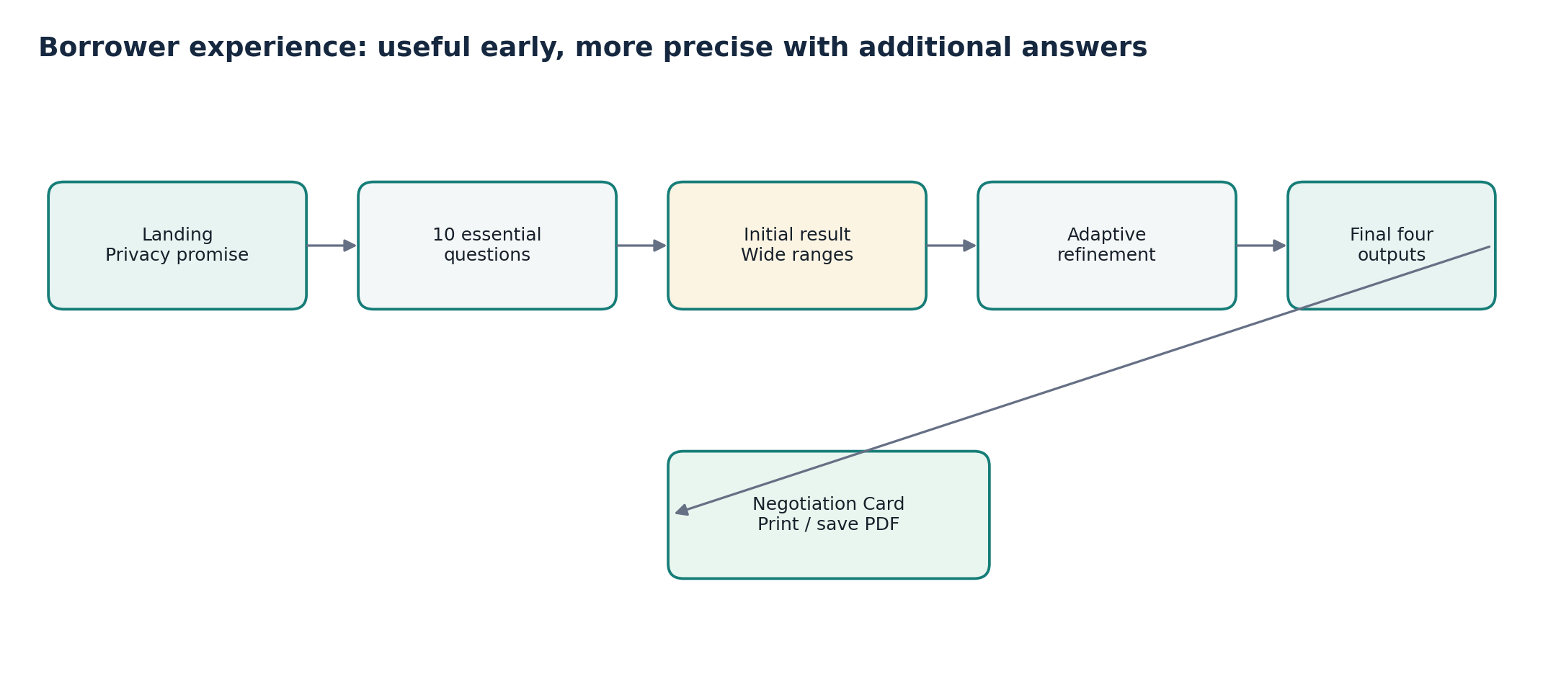
Figure 1. Borrower journey from privacy promise to a usable lender conversation.
- Landing: explain the four decisions, expected time, privacy behavior and non-advisory limitation.
- Essential assessment: ask one focused question at a time and collect the minimum data required for all outputs.
- Initial result: immediately provide wide ranges and a confidence explanation; do not block usefulness behind optional questions.
- Adaptive refinement: show only questions relevant to the income type, loan purpose and earlier answers.
- Final result: lead with the verdict and recommended cap, then show evidence, pricing, repayment and stress.
- Negotiation Card: compress the decision into one actionable screen with lender questions and print styling.

4.1 Navigation rules
- Back preserves previous answers and recomputes the applicable path if a branching answer changes.
- Continue stays disabled only when a required question has neither a valid answer nor an allowed Unknown value.
- Reset clears in-memory state after confirmation and returns to the landing page.
- Refresh starts a new assessment because personal answers are not persisted.

5. System architecture
The application is a static single-page frontend. The browser hosts the UI, state, rules and deterministic assessment pipeline. There are no application servers or storage services in the challenge scope.
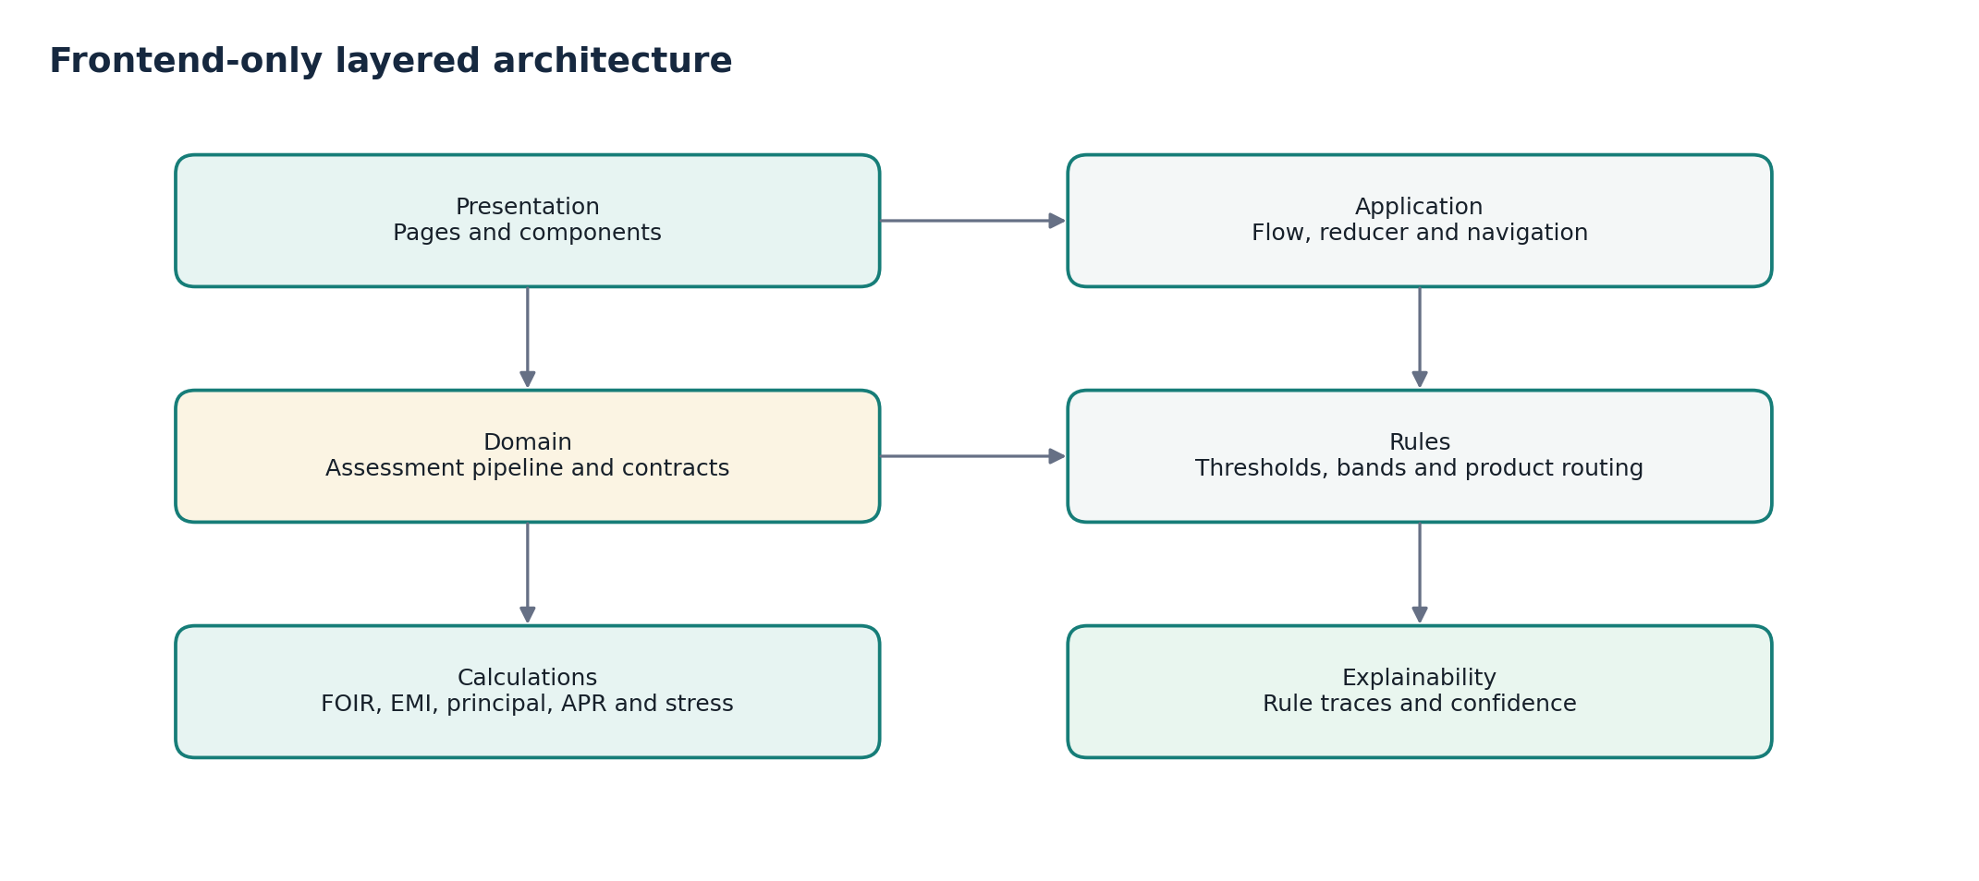
Figure 2. Layer boundaries prevent UI changes from altering lending rules accidentally.
Layer | Responsibility | May depend on
Presentation | Render pages, collect input, format INR values and expose reasons | Application contracts only
Application | Navigate phases, hold answers, choose applicable questions and trigger assessment | Domain contracts and question schema
Domain | Orchestrate the deterministic assessment and return complete output contracts | Rules and calculation utilities
Rules | Store thresholds, bands, modifiers, product routes and rule metadata | Domain types only
Calculations | Pure FOIR, EMI, principal, APR, range and stress functions | No UI or browser APIs
Explainability | Create rule traces, confidence effects and borrower-facing reasons | Domain results and rule metadata
DEPENDENCY RULE Dependencies point inward. Domain code must never import React components, browser storage or CSS.

6. Domain contracts and state

6.1 Core borrower profile
type IncomeType = 'salaried' | 'self_employed' | 'informal';
type Verdict = 'borrow' | 'borrow_less' | 'do_not_borrow';
type ConfidenceLevel = 'low' | 'medium' | 'high';
interface MoneyRange { minimum: number; maximum: number; }
interface BorrowerProfile {
age: number;
incomeType: IncomeType;
monthlyIncome: MoneyRange;
documentedMonthlyIncome?: number;
essentialExpenses: number;
existingEmis: number;
creditScore?: number; // undefined means unknown, never zero
requestedAmount: number;
requestedLoanType: LoanType;
purpose: LoanPurpose;
preferredTenureMonths: number;
}

6.2 Assessment result
interface BorrowerAssessment {
verdict: VerdictResult;
eligibility: {
likelyLenderAmount: MoneyRange;
safeBorrowingAmount: MoneyRange;
recommendedAmount: number;
explanation: string;
};
pricing: { interestRate: RateRange; estimatedApr: RateRange; };
repayment: { recommendedEmiCeiling: number; options: TenureOption[]; };
recommendedProduct: LoanType;
stressTest: StressTestResult;
confidence: ConfidenceResult;
ruleTraces: RuleTrace[];
}

6.3 Application state
Use React Context plus useReducer. This makes transitions explicit without introducing a global-state dependency for a small, linear application.
State field | Purpose
phase | landing | essential | initial_result | refinement | results | card
answers | Current borrower-provided values, held in memory only
currentQuestionId | Stable navigation key, not an array index
completedQuestionIds | Progress calculation and back navigation
assessment | Most recently calculated immutable assessment output

7. Adaptive questionnaire engine
QUESTION ADMISSION RULE Every additional question must identify the output it changes. If it does not change a range, product route, verdict, stress result or confidence, remove it.

7.1 Question schema
interface QuestionDefinition {
id: string;
tier: 'essential' | 'additional';
label: string;
helpText: string;
type: 'currency' | 'number' | 'choice' | 'range' | 'boolean';
required: boolean;
unknownAllowed?: boolean;
appliesWhen?: (answers: BorrowerAnswers) => boolean;
impactAreas: ('verdict' | 'eligibility' | 'rate' | 'emi' | 'confidence')[];
}

7.2 Essential set
ID | Question | Primary output impact
loan_purpose | What will the loan be used for? | Verdict and product route
loan_type | Which product is being considered? | Pricing and eligibility
requested_amount | How much is requested? | Verdict, amount and EMI
age | What is the borrower's age? | Tenure and eligibility
income_type | How is income earned? | Branching, income basis and confidence
monthly_income | What is net monthly income or its range? | Amount and EMI
existing_emis | What is already paid monthly toward debt? | FOIR and safe capacity
essential_expenses | What are essential monthly household costs? | Safe capacity
credit_score | What score or approximate band is known? | Pricing and confidence
preferred_tenure | What tenure is being considered? | EMI and total cost

7.3 Branching strategy
Income path | Relevant additional evidence
Salaried | Current-job tenure, total experience, fixed/variable salary, employer stability, savings
Self-employed | Business vintage, income range, ITR income, bank visibility, collateral, productive return
Informal | Lower income range, multiple sources, banked share, dependents, app loans, recent bounces

8. Assessment pipeline
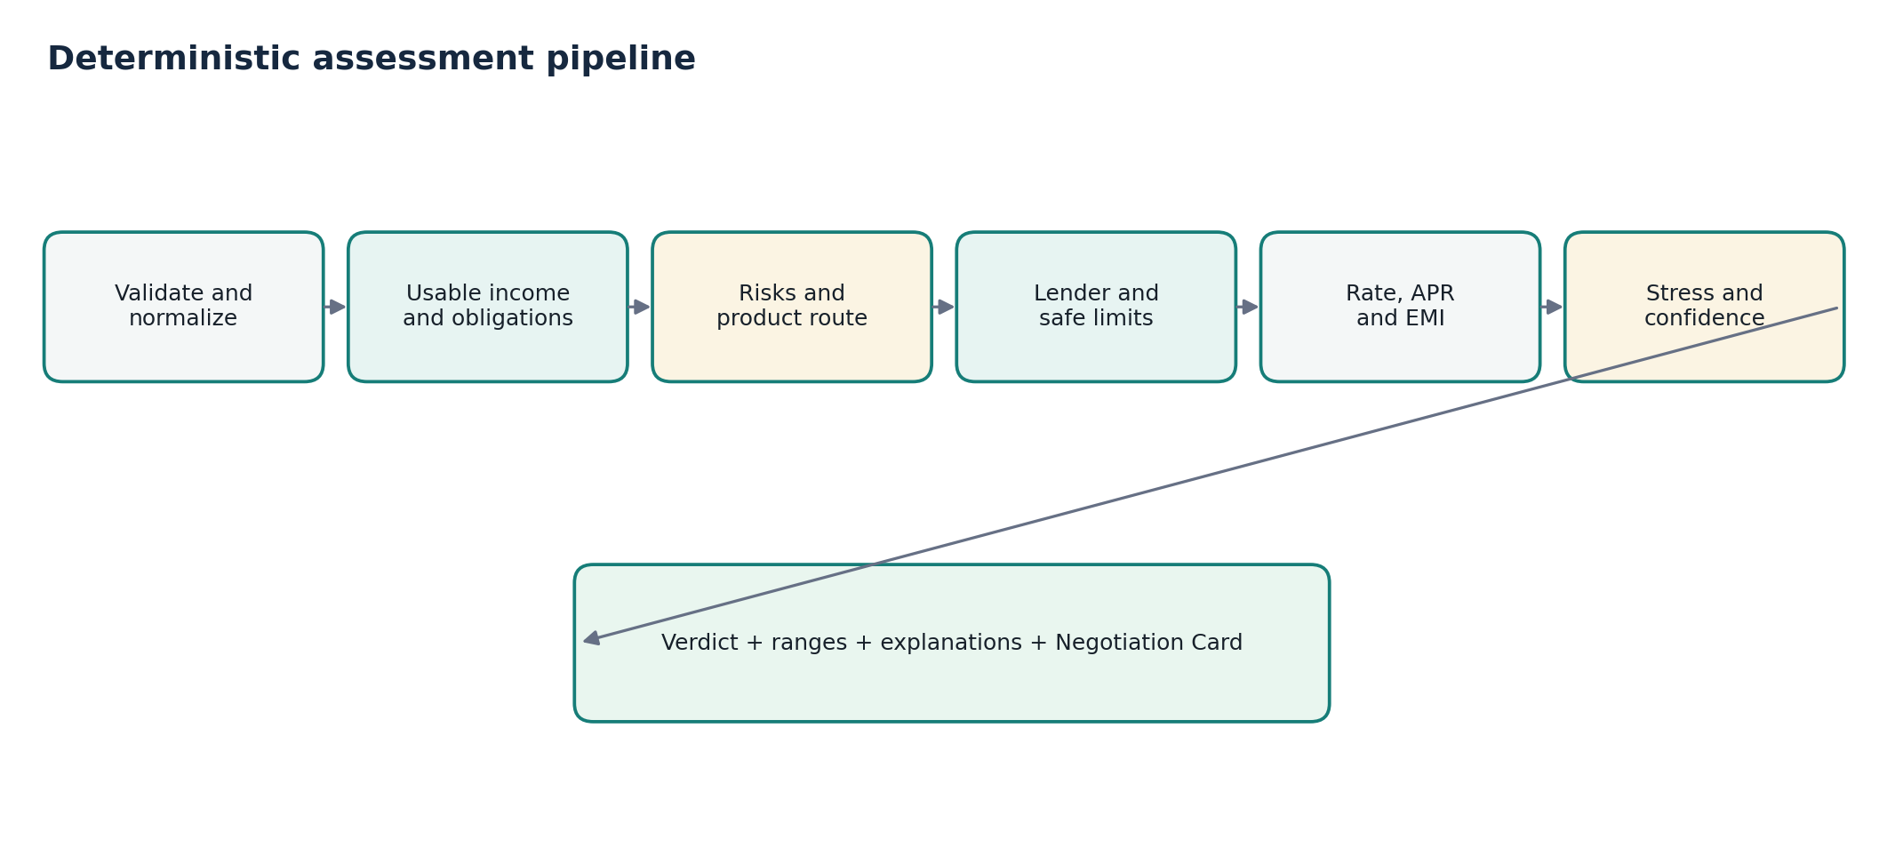
Figure 3. One deterministic pipeline produces every screen and document output.
Stage | Input | Output
1. Normalize | Raw form answers | Validated BorrowerProfile plus explicit unknowns
2. Income basis | Income range, type and documentation | Conservative usable-income range and reason
3. Risk and product | Debts, repayment events, purpose and collateral | Risk flags and candidate product
4. Limits | Income, obligations, expenses and FOIR rules | Lender capacity and borrower-safe capacity
5. Pricing and repayment | Product, profile, amount, rate rules and fees | Rate/APR ranges, EMI and tenure options
6. Stress and confidence | Missing evidence and relevant downside scenario | Stressed affordability and confidence effects
7. Verdict | All prior derived values | Ordered verdict, next step, explanations and traces

8.1 Orchestration contract
export function assessBorrower(profile: BorrowerProfile): BorrowerAssessment {
const normalized = normalizeProfile(profile);
const income = deriveUsableIncome(normalized);
const risks = detectRiskFlags(normalized, income);
const product = recommendProduct(normalized, risks);
const capacity = calculateCapacity(normalized, income, product);
const pricing = calculatePricing(normalized, product, risks);
const repayment = calculateRepayment(capacity, pricing, normalized);
const stress = runRelevantStress(normalized, repayment, product);
const confidence = calculateConfidence(normalized, pricing, capacity);
return composeAssessment({ normalized, income, risks, product,
capacity, pricing, repayment, stress, confidence });
}

9. Calculation specification

9.1 Affordability and FOIR
Lender-style capacity and borrower-safe capacity are separate calculations. Threshold values remain configuration, not immutable financial truth.
LENDER EMI CAPACITY (Eligible monthly income x configured lender FOIR limit) - existing monthly EMIs
BORROWER-SAFE EMI Minimum of the configured safe debt-service limit and the post-expense surplus after retaining a safety buffer.

9.2 EMI and maximum principal
For principal P, monthly rate r and tenure n, EMI = P x r x (1+r)^n / ((1+r)^n - 1). The inverse annuity formula converts an EMI ceiling into a maximum principal. Unit tests must cover zero-rate handling and rounding.

9.3 Fair-rate range
Start from a documented product-level band and apply named adjustments for score, income evidence, stability, security, repayment stress and business vintage. Each adjustment emits a trace. The final result remains a band and is labelled indicative.

9.4 All-in APR
APR is solved from borrower cash flows: the initial net amount received after compulsory upfront charges, followed by the scheduled monthly payments. Use a bounded monthly internal-rate-of-return solver and annualize the result. If a mandatory fee is unknown, show an APR range or a clear fee assumption rather than silently equating APR with the headline rate.

9.5 Stress selection
Profile/product | Default stress
Salaried or informal income | Income decreases by a configured percentage
Variable self-employed income | Use the lower end of the stated/documented income range
Floating-rate secured loan | Interest rate increases by a configured number of basis points
PRECISION RULE Round borrower-facing amounts sensibly. Preserve full precision internally, but avoid presenting a recommendation such as INR 6,43,217 when the underlying inputs are estimates.

10. Rules, explainability and confidence

10.1 Rule definition
interface RuleDefinition {
id: string;
category: 'income' | 'risk' | 'product' | 'amount' | 'pricing' | 'verdict';
value: number | MoneyRange | RateRange | string;
rationale: string;
source: SourceReference | 'my_judgement';
effectiveDate: string;
}

10.2 Rule trace
interface RuleTrace {
ruleId: string;
category: string;
inputSummary: string;
effect: string;
borrowerExplanation: string;
}
Example: PRICING-CREDIT-780 records that a reported 780 score narrows or improves the indicative rate range. The UI uses the same trace for Why this rate? and the Negotiation Card, preventing explanation drift.

10.3 Confidence model
Evidence condition | Effect
Credit score known | Improves pricing confidence and can narrow the rate band
Stable documented income | Improves lender-amount confidence
Essential expenses known | Improves safe-EMI confidence
Mandatory fees known | Improves APR confidence
Variable or undocumented income | Widens amount range and reduces confidence
Recent payment bounce | Creates a risk flag; it is not merely missing information

10.4 Ordered verdict evaluation
- Evaluate hard-stop or acute-distress rules first; return Do not borrow with constructive next actions.
- If requested amount or EMI exceeds the safe capacity, return Borrow less and recommend a cap.
- Only after higher-severity checks pass may the engine return Borrow.
UNKNOWN IS NOT ADVERSE EVIDENCE Unknown credit score lowers confidence and widens pricing. It must not be converted into a very poor score or treated as a repayment failure.

11. UI and UX specification

11.1 Design direction
The visual system should feel calm, trustworthy and borrower-aligned rather than promotional. Use warm neutral backgrounds, navy hierarchy, teal actions and restrained gold for warnings. Avoid instant-approval language, celebratory confetti, aggressive gradients and color-only verdicts.
Token | Value | Use
Background | #F7F7F2 | Page canvas
Surface | #FFFFFF | Cards and question panels
Navy | #16283F | Primary hierarchy and data
Teal | #167D78 | Actions, progress and supportive emphasis
Gold | #D5A94E | Caution and important trade-offs
Danger | #B42318 | Debt distress or unsafe outcomes

11.2 Questionnaire interaction
- One question per screen with a visible Essential or Refinement progress label.
- Show why the question matters directly under the label; do not hide it in a tooltip.
- Provide Indian currency formatting while preserving a stable typing cursor.
- Use explicit Unknown options and keep validation beside the field.
- Keep Back and Continue in a sticky mobile action bar with 44px minimum targets.
- Move keyboard focus to the new question heading and announce validation/results with appropriate ARIA regions.

11.3 Results hierarchy
- Verdict hero: decision, one-sentence reason and recommended next step.
- Amount comparison: lender view versus safer borrower view.
- EMI and tenure: ceiling, alternatives, total repayment and stress.
- Pricing: fair rate, estimated APR, fee assumptions and confidence.
- Evidence: expandable Why? traces and missing-information effects.
- Negotiation Card: phone and print presentation using the same assessment contract.

12. Negotiation Card contract
The card is not a sanction letter. It is a borrower-side comparison aid. It should fit on one printed page and remain readable at a mobile viewport without horizontal scrolling.
Section | Required fields
Assessment | Date, confidence level and indicative-not-approval label
Request | Product, purpose, requested amount and preferred tenure
Recommendation | Verdict, recommended amount and EMI ceiling
Price check | Fair interest band, APR band and fee assumptions
Why | Three strongest borrower-specific reasons drawn from traces
Stress | One relevant downside result
Ask the lender | KFS, all compulsory charges, insurance, fixed/floating terms and prepayment terms
Limitations | Self-reported data; not credit approval or personalized regulated advice

12.1 Example negotiation language
BORROWER SCRIPT Based on my reported profile, the indicative fair range is X%-Y% and my EMI ceiling is INR Z. Please show me the Key Facts Statement and the APR after all compulsory charges so I can compare the offer fairly.

12.2 Print behavior
- Use a dedicated print stylesheet; hide navigation, progress controls and refinement actions.
- Preserve high contrast without depending on background colors being printed.
- Avoid automatic file upload. Browser print-to-PDF is sufficient for the challenge.
- Do not put borrower answers in a shareable URL.

13. Privacy, safety and accessibility

13.1 Data handling
Control | Implementation
Collection | Collect only answers needed by an output or confidence calculation.
Storage | Keep answers in React memory; no localStorage, sessionStorage or database.
Transmission | No backend submission and no analytics events containing answer values.
Reset | Clear state after explicit confirmation and return to the landing page.
Samples | Use separate hardcoded fixtures for Priya, Ravi and Anita.
Disclosure | Explain that refreshing or closing the page clears the assessment.

13.2 Safety language
- Use indicative, estimate, likely and based on your answers; avoid approved, guaranteed or best available.
- For distress outcomes, give constructive steps without shame or alarmist copy.
- Document all judgement-based thresholds as such; do not attribute invented FOIR values to RBI.

13.3 Accessibility acceptance criteria
- All controls are keyboard reachable with a visible focus indicator.
- Inputs have programmatic labels, instructions and associated error messages.
- Verdicts use text and icons in addition to color.
- Heading order is logical and result updates are announced without stealing focus unexpectedly.
- Touch targets are at least 44 by 44 pixels and body text remains readable at 200% zoom.
FAILURE BEHAVIOR Because the engine is local and synchronous, do not show fake network loading. If an unexpected calculation error occurs, preserve answers, show a recoverable message and allow the borrower to go back.

14. Repository architecture
borrower-copilot/
|-- README.md
|-- RULES.md
|-- RUN_THROUGHS.md
|-- WALKTHROUGH.md
|-- src/
| |-- app/ # App shell, context, reducer and phase routing
| |-- pages/ # Landing, assessment, results and card pages
| |-- components/ # Common, questionnaire, results and card UI
| |-- domain/ # Assessment pipeline and output contracts
| |-- rules/ # Thresholds, bands, modifiers and metadata
| |-- questions/ # Essential and income-specific definitions
| |-- fixtures/ # Priya, Ravi and Anita
| |-- utils/ # INR formatting and print helpers
| `-- tests/ # Unit, component and integration tests
`-- e2e/ # Playwright persona and mobile journeys

14.1 Module ownership
Module | Must contain | Must not contain
components | Presentation, event callbacks and accessibility semantics | FOIR, pricing or verdict thresholds
questions | Schemas, conditions, impact metadata and validation | Assessment arithmetic
rules | Values, rationales, sources and effective dates | React imports
domain | Pure orchestration, derived values and result composition | CSS and browser storage
fixtures | Stable persona answers for tests and demos | Production branching logic

14.2 Build commands
npm install
npm run dev
npm run lint
npm run typecheck
npm run test
npm run test:e2e
npm run build

15. Test and verification architecture

15.1 Unit coverage
Area | Required cases
EMI/principal | Known examples, zero rate, short tenure, rounding and inverse consistency
APR | Zero fee, upfront fee, fee range, invalid cash flow and solver bounds
Affordability | No obligations, high obligations, negative surplus and variable income
Pricing | Strong score, unknown score, adverse repayment, collateral and modifier ordering
Confidence | Essential only, fully refined, unknown evidence and range widening by output
Verdict | Hard-stop precedence, borrow-less threshold and safe borrow route
Product route | Ravi-style collateral route and Anita-style safer vehicle/debt-repair route

15.2 Component and integration coverage
- Branching changes after income type is edited.
- Back navigation preserves answers and recalculates progress.
- Unknown credit score lowers pricing confidence without becoming zero.
- Essential-only answers produce all four outputs.
- Additional answers visibly narrow a relevant range or improve confidence.
- Reset removes answers and print view hides interactive controls.

15.3 End-to-end persona journeys
Journey | Assertions
Priya | Salaried path; strong-credit trace; distinct lender/safe ranges; controlled EMI
Ravi | Self-employed path; documented-income caution; secured-product recommendation
Anita | Informal path; payment-stress flag; Do not borrow now is reachable
Mobile | No horizontal overflow; sticky actions; usable card and print trigger
Keyboard | Complete essential flow without a pointer; visible focus and announced errors
REGRESSION INVARIANT For every persona, recommended amount must not exceed the top of the safe range, and a displayed EMI must be mathematically consistent with amount, rate and tenure.

16. Documentation, deployment and operations

16.1 Root deliverables
File | Purpose
README.md | Setup, architecture summary, commands, screenshots, privacy and deployment link
RULES.md | Every threshold, band and assumption: what, value, why, source and effective date
RUN_THROUGHS.md | Questions, answers, outputs, traces and Negotiation Cards for all three personas
WALKTHROUGH.md | Five-minute demo sequence, trade-offs, next steps and deliberate cuts

16.2 Deployment
- Deploy the static production build to Vercel with a single public URL.
- Verify a clean clone, npm install and npm run dev before submission.
- Run lint, typecheck, unit tests, Playwright and production build in CI or before every final deployment.
- Avoid remote fonts if they cause offline startup issues; bundle or use resilient fallbacks.

16.3 Minimal observability
No borrower-answer analytics are needed. Build-time and test feedback are sufficient. If anonymous analytics are added later, record only non-sensitive aggregate flow events after consent and never input values.

16.4 Regulatory-source handling
Use official sources to justify disclosure behavior, while clearly separating regulatory requirements from judgement-based affordability rules. RBI's April 2024 KFS circular requires applicable retail and MSME term-loan KFS documents to include APR computation and an amortisation schedule. Current digital-lending directions retain KFS/APR disclosure requirements. Product rate bands should be dated and sourced from current official lender pages when the rules are finalized.

17. Four-day implementation roadmap
Phase | Time | Work | Exit criteria
Day 1 - Domain | 4h | Types, questions, rules, EMI/principal/APR, confidence, traces and RULES draft | Pure functions tested; sample assessments return valid contracts
Day 2 - Flow | 4h | Landing, reducer, essential questions, adaptive refinement, validation and mobile navigation | Essential-only path works; branches and Back are stable
Day 3 - Results | 4h | Verdict, amount comparison, pricing, repayment, stress, explanations and print card | All required outputs readable on desktop and phone
Day 4 - Proof | 3-4h | Persona E2E tests, docs, accessibility pass, build, deploy and walkthrough | Clean clone works; tests/build pass; all deliverables complete

17.1 Recommended commit sequence
- chore: initialize React TypeScript application and quality scripts
- feat: add domain contracts, questionnaire definitions and rules
- feat: implement affordability, EMI, pricing, APR and confidence engines
- feat: build adaptive questionnaire and in-memory application flow
- feat: add results experience, stress case and Negotiation Card
- test: add persona unit, integration and Playwright coverage
- docs: complete rules, run-throughs, walkthrough and final README
- fix: accessibility, responsive layout and final QA
BUILD-ORDER GUARDRAIL Do not spend the first day polishing cards. Establish the rule schema, calculation contracts and persona tests before final visual styling.

18. Follow-up readiness and delivery risks

18.1 Live rule-change scenario
The evaluator may change a safe FOIR threshold, income haircut or pricing adjustment. The intended live workflow is:
- Open the relevant named rule in src/rules.
- Change one documented value and rationale if requested.
- Run the targeted unit and persona tests.
- Refresh the assessment and show the updated amount, explanation and Negotiation Card.
- Update RULES.md if the change is retained.

18.2 Key risks and mitigations
Risk | Mitigation
False precision | Use ranges, sensible rounding and visible confidence/assumption text.
Rules drift from docs | Give each rule a stable ID and verify RULES.md coverage in review.
UI contains hidden logic | Ban financial conditions in components; test the domain independently.
Extra questions add no value | Require impactAreas and an observable output/confidence effect.
APR misleads when fees are unknown | Show an assumption or widened range; never silently copy nominal rate.
Distress result feels punitive | Pair the warning with a practical next action and respectful language.
Overengineering | Keep a static frontend, one reducer and pure modules; no backend or AI API.

18.3 Definition of done
- All four outputs and the Negotiation Card work from essential answers.
- Optional answers narrow the correct ranges or improve confidence.
- Priya, Ravi and Anita each follow a relevant adaptive path and receive actionable guidance.
- Unknown values remain unknown; Do not borrow is reachable; Ravi can receive a secured route.
- Rules are centralized, sourced or labelled My judgement, and traceable in displayed explanations.
- The application is responsive, keyboard usable, printable and contains no persistent personal-data storage.
- Lint, typecheck, unit tests, persona E2E tests and production build pass.
- README, RULES, RUN_THROUGHS and WALKTHROUGH match the implemented behavior.

Appendix A - Source and assumption policy
This architecture defines how to encode and disclose rules; it does not freeze unsourced lender-specific thresholds. Final product bands and modifiers must carry an as-of date and source. If a threshold reflects product judgement rather than an official requirement, label it My judgement.

Primary references
1. Lokta. Borrower Copilot Build Challenge v2, issued 2 September 2026.
2. Reserve Bank of India. Key Facts Statement (KFS) for Loans & Advances, 15 April 2024
3. Reserve Bank of India. Reserve Bank of India (Digital Lending) Directions, 2025

Appendix B - Codex implementation contract
Codex should execute this document phase by phase. Before each phase, inspect current code and state the acceptance checks. After each phase, run the narrowest relevant tests plus typecheck. Do not silently introduce new thresholds or move rules into UI components.
Always | Never
Use pure functions for calculations | Store personal answers or send them to an API
Return rule traces and confidence effects | Replace unknown with zero or a worst-case score
Keep lender and safe capacity separate | Use one unexplained maximum-loan number
Date and source rule bands | Claim judgement thresholds are RBI rules
Verify three persona journeys | Optimize only the happy salaried path
Run tests after rule changes | Polish UI while calculations remain unverified
FINAL ARCHITECTURE PRINCIPLE A borrower should be able to challenge every number, and a developer should be able to change every rule without hunting through the UI.

