Multi-Modal Deepfake Detection: Techniques And Integration For Enhanced Multimedia Security

**A White Paper by:**

**Akshay Redekar, Mansi Alhat, Prachi Nikalje, Pradnya Vavale**

Department of Computer Engineering

Bharati Vidyapeeth’s College of Engineering, Pune Savitribai Phule Pune University

Academic Year: 2024–25

**Guides**: Prof. Yogesh Kadam (Internal)

# Executive Summary

The **Multimodal Deepfake Detection System** is a cutting-edge security application that utilizes artificial intelligence to detect manipulated multimedia content. With the rise of synthetic media generated by GANs and AI-based models, identifying fake audio and video is increasingly vital in digital forensics, media integrity, and cybersecurity.

This system leverages two state-of-the-art models—**EfficientNetV2** for image/frame classification and **Wav2Vec2** for audio/speech analysis—combined via a **Fusion Module** that intelligently integrates both outputs to determine the authenticity of multimedia content.

Designed with modularity and security in mind, the system includes robust **FastAPI-based backend services**, efficient **preprocessing pipelines**, and a clean **frontend interface** for users to upload content. Its architecture supports offline deployment for secure environments, enabling critical use cases in journalism, law enforcement, and governmental agencies.

# Problem Statement & Objectives

**Problem Statement**

The widespread dissemination of deepfakes poses significant risks in domains ranging from politics to personal privacy. Traditional single-modal detectors (image-only or audio-only) often fail against sophisticated manipulations. There is a pressing need for a **multimodal detection framework** that simultaneously processes both visual and auditory cues for robust decision-making.

**Objectives**

* Develop an AI-based detection pipeline using both audio and visual modalities.
* Integrate **EfficientNetV2** and **Wav2Vec2** models to analyze media content.
* Design a **Fusion Module** for aggregating model outputs for final classification.
* Create a secure, responsive web interface for user interaction and uploads.
* Ensure scalability and offline support for secure environments.

# System Overview & Architecture

The architecture is composed of modular layers ensuring scalability and flexibility:

1. **Data Ingestion Layer** – Accepts user-uploaded audio/video/image files.
2. **Preprocessing Layer** – Extracts frames and audio, normalizes inputs.
3. **Model Processing Layer** – Sends inputs to respective models (EfficientNetV2 for images; Wav2Vec2 for audio).
4. **Backend Layer** – Orchestrates communication using FastAPI.
5. **Frontend Layer** – Streamlit-based user interface for uploads and results.

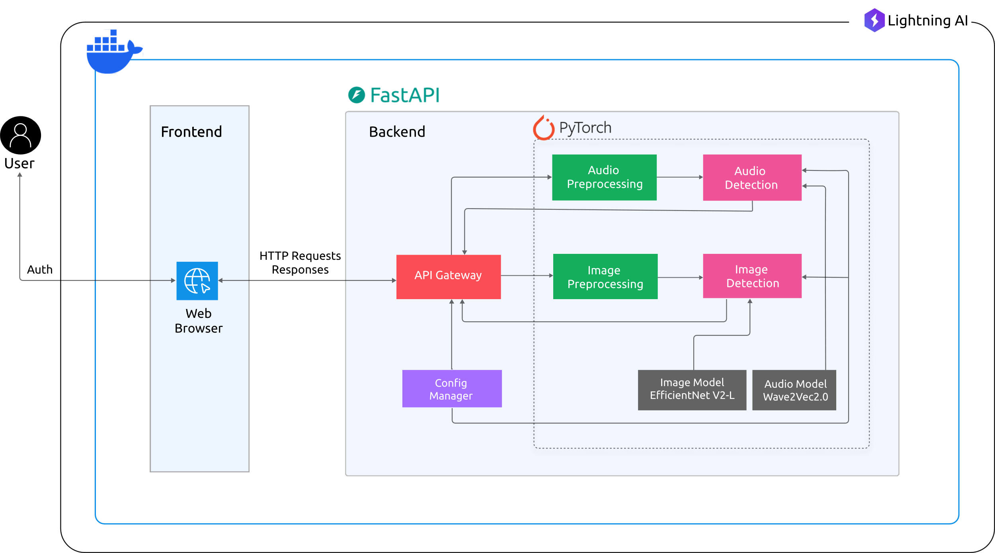

*System Architecture*

# Methodology

* 1. **Data Processing**
     + **Sources:** DFDC dataset, FakeAVCeleb, and custom-curated deepfake videos.
     + **Types:** MP4, AVI (video); JPG, PNG (image); WAV, MP3 (audio).
     + **Preprocessing Techniques:**
     1. Frame sampling and resizing
     2. Audio waveform conversion and normalization
     3. Spectrogram extraction for visualization (optional)
     4. Temporal alignment of audio and video streams
  2. **Model Development**

The following models were explored during development:

|  |  |  |  |
| --- | --- | --- | --- |
| **Model** | **Accuracy** | **Pros** | **Cons** |
| EfficientNetV2 | 89.2% | Fast, lightweight, high image accuracy | Lacks audio context |
| Wav2Vec2 | 87.5% | Contextual speech understanding | Sensitive to noise |
| Fusion Module | 93.1% | Multimodal insight, higher robustness | Increased complexity |

* 1. **Fusion Strategy**
* **Late Fusion**: Combine model probabilities via weighted average.
* **Threshold-Based Binary Classification**
* **Fallback logic**: If one modality fails, rely on the other with lower confidence.

# Results & Evaluation

* 1. **Evaluation Metrics**

|  |  |  |  |
| --- | --- | --- | --- |
| **Metric** | **Image Model** | **Audio Model** | **Fused Output** |
| Accuracy | 89.2% | 87.5% | 93.1% |
| Precision | 88.7% | 86.4% | 92.5% |
| Recall | 90.1% | 88.2% | 94.0% |
| F1 Score | 89.4% | 87.3% | 93.2% |

The Fusion approach outperforms both standalone models on standard test datasets.

# Applications.

* Digital Forensics and Law Enforcement
* Media Verification (News and Fact-checking)
* Cybersecurity in Government & Military
* AI Content Moderation in Social Platforms
* Educational Tools on AI Literacy

# Limitations

* High GPU resource requirement for real-time inference.
* Performance degradation in poor-quality inputs (e.g., low audio clarity).
* Lack of multilingual support for audio streams.
* Limited real-world dataset diversity.

# Future Enhancements

* **Cross-modal Transformers** for better fusion.
* **Real-time detection engine** with edge device support.
* **Explainable AI (XAI)** layer to visualize which segments were fake.
* **Multilingual Audio Model Integration**.
* **Live-stream Monitoring** for deepfake detection in social media or broadcasting.

# Embedded Diagram

*Data Flow Diagram*

*Use Case Diagram*

*Use Case Diagram*

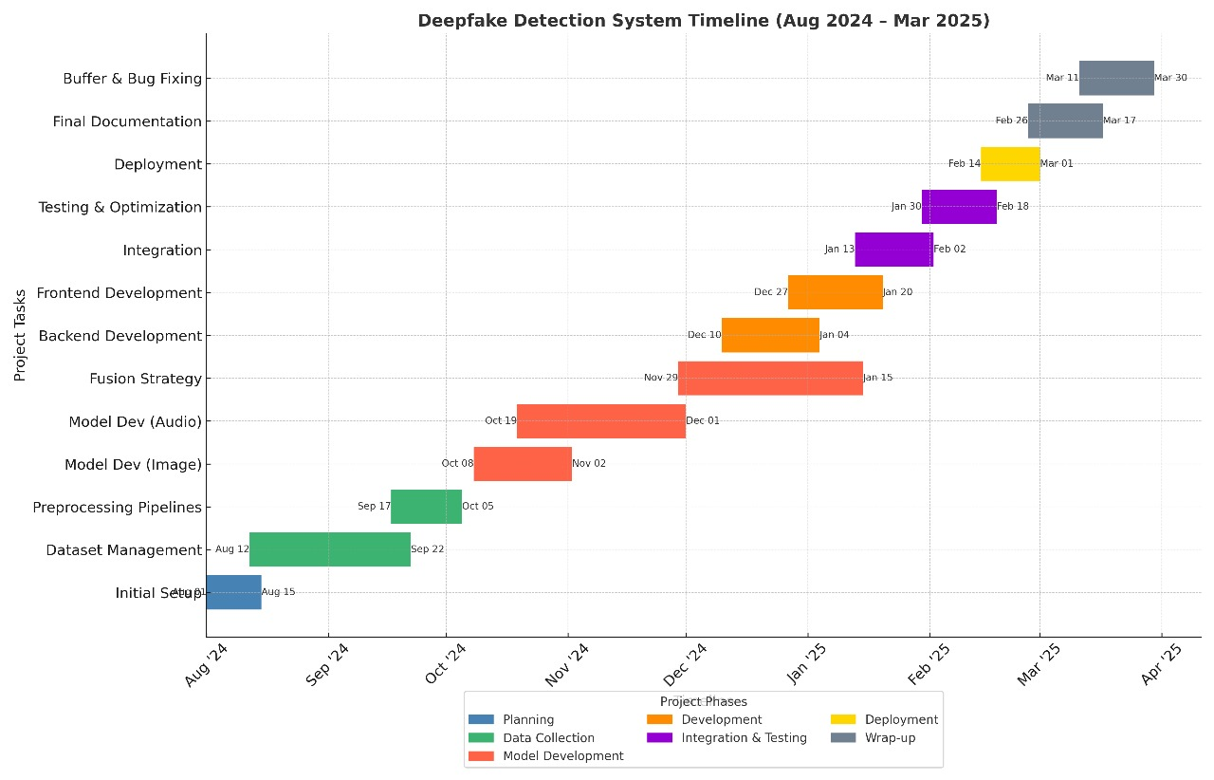

*Timeline Diagram*

# References

[1] E. Haller and T. Rebedea, "Designing a Chat-bot that Simulates an Historical Figure," IEEE Conference Publications, Jul. 2013.

[2] M. Wodzicki, P. Hołobut, and M. Romaszewski, "A Robust Approach to Multimodal Deepfake Detection," Journal of Imaging, vol. 9, no. 6, p. 122, Jun. 2023. [Online]. Available: <https://www.mdpi.com/2313-433X/9/6/122>

[3] A. Tolosana, R. Vera-Rodriguez, and R. Guest, "Multimodal Approach for DeepFake Detection," ResearchGate, May 2021. [Online]. Available: <https://www.researchgate.net/publication/351489509_Multimodal_Approach_for_DeepFake_Detection>

[4] A. Bhattacharya, B. Saha, A. Chatterjee, and A. Chakraborty, "Deepfake Detection: A Multi-Algorithmic and Multi-Modal Approach for Robust Detection and Analysis," ResearchGate, Dec. 2023. [Online]. Available: <https://www.researchgate.net/publication/377131236_Deepfake_Detection_A_Multi-Algorithmic_and_Multi-Modal_Approach_for_Robust_Detection_and_Analysis>

[5] R. Doshi, T. D. Nguyen, and A. Das, "DF-TransFusion: Multimodal Deepfake Detection," arXiv preprint arXiv:2309.06511, Sep. 2023. [Online]. Available: <https://arxiv.org/abs/2309.06511>

[6] A. Kumar and V. Sharma, "A Multimodal Framework for Deepfake Detection," ResearchGate, May 2024. [Online]. Available: <https://www.researchgate.net/publication/384680324_A_Multimodal_Framework_for_Deepfake_Detection>