
KiyaAI Credit Assessment System
BRD_V.1.0
Submitted to –
Date -
Table of Contents
1. INTRODUCTION 4
2. PURPOSE 4
3. SCOPE OF THE BRD 5
3.1 In-Scope Functional Areas 5
3.2 Out-of-Scope Areas 6
3.3 Stakeholders 6
3.4 Assumptions 7
3.5 Dependencies 7
4. Features & Functionalities 8
4.1. Login 8
4.2. Dashboard 9
4.3. Rating Templates 11
4.4. Parameters Management 15
4.5. Credit Assessment 18
4.6. Reports 31
4.7. Administration 34
4.7.1. Role Management 34
4.7.2. User Management 36
4.7.3. RBAC (Role-Based Access Control) 39
4.8. Masters 41
4.8.1. Lookup Management 41
4.9. System Configuration 43
5. Data Ingestion 48
6. API Catalogue 50
7. Deployment Mechanism 52
8. Software Pre-requisites 53
8.1. ENVIRONMENT SETUP 53
9. Project Documentation 54

SIGN-OFF
Business Requirements Document (BRD) – KiyaAI Credit Assessment System
This document has been reviewed and approved by the stakeholders listed below.
Their signatures confirm that:
- All requirements stated in the BRD are understood and accepted
- Scope, modules, workflows, and features are agreed upon
- Any changes after sign-off will follow the formal change-management process
Stakeholders – KiyaAI (Solution Provider) & CBK (Client Team)
Organization | Name | Designation | Department / Role | Signature | Date
KiyaAI
KiyaAI
KiyaAI
KiyaAI
CBK
CBK
CBK
CBK
CBK

✔️ Approval Statement
By signing this document, all parties acknowledge that the requirements described herein are complete to the best of their knowledge and accurately represent the expected functionality of the KiyaAI Credit Assessment System.
Any modifications post–sign-off must go through the agreed change-control process.

1. INTRODUCTION
The KiyaAI Credit Assessment System is a comprehensive digital platform designed to automate and enhance the credit evaluation process for financial institutions. The system provides a structured workflow for assessing borrowers by leveraging configurable rating templates, parameter-based scoring, financial analysis, automated ratio calculations, OCR-based data ingestion, and AI-driven insights.
The platform supports end-to-end credit assessment activities, including data collection, template management, parameter configuration, risk scoring, report generation, user management, system configuration, and audit tracking. It ensures consistency, transparency, and regulatory compliance in the credit evaluation lifecycle.
This Business Requirements Document (BRD) defines the detailed functional, non-functional, operational, and user-interface requirements required to implement the system in alignment with business expectations.

2. PURPOSE
The purpose of this BRD is to:
- Document all functional and operational requirements for the KiyaAI Credit Assessment System.
- Provide a detailed understanding of screens, workflows, user roles, system processes, data flows, APIs, and infrastructure needs.
- Establish a single source of truth for stakeholders including:
  - Product Owners
  - Business Analysts
  - Technical Architects
  - Developers
  - QA Teams
  - End Users
  - Implementation & Deployment Teams
- Define expected behaviors of each module to ensure:
  - Consistency in development
  - Clarity for UI/UX teams
  - Precision for backend/API development
  - Alignment with regulatory and business objectives
- Bridge the gap between business expectations and technical implementation by clearly articulating:
  - Use cases
  - Flows
  - Acceptance criteria
  - Dependencies
The BRD ensures that all teams have a unified understanding of what the system must deliver and how it should function.

3. SCOPE OF THE BRD
The scope of this BRD includes documenting the full set of business and system requirements for the design, development, deployment, and operation of the KiyaAI Credit Assessment System.

3.1 In-Scope Functional Areas
This BRD covers detailed requirements for the following modules:
A. Core User Modules
- Login & Authentication
- Dashboard & Analytics
- Credit Assessment Module
  - Entity details
  - Financial data capture (manual + OCR + file upload)
  - Ratio calculations
  - Business and qualitative scoring
  - Final rating computation
  - Maker-checker approvals (if applicable)
- Rating Templates Management
- Parameters Management
- Reports & Document Generation
B. Administrative Modules
- Role Management
- User Management
- RBAC (Role-Based Access Control)
- Master Data Management
  - Country, State, City
  - Lookup management
- System Configurations
  - Email settings
  - Email templates
  - Module management
C. Data Management Modules
- Data Ingestion
  - Financial data ingestion
  - OCR processing
  - Excel/CSV file processing
  - Data validation
  - Gaps identification
D. Technical & Deployment Scope
- API Catalog
  - Internal APIs
  - Expected third-party integrations
- Deployment & Infrastructure Requirements
  - Hosting
  - Database (Oracle)
  - Software prerequisites
- System Documents
  - FSD
  - User Manual
  - Deployment Guide

3.2 Out-of-Scope Areas
The following items are outside the scope of this BRD unless otherwise requested:
- Enterprise LOS integration (Loan Origination System)
- Credit Bureau API integrations (unless added as per customer requirement)
- Mobile application development
- Advanced ML risk modeling
- Automated underwriting engine
- Third-party compliance validation tools

3.3 Stakeholders
- Business Team – Defines assessment rules, workflows, templates
- IT Team – Infrastructure, security, deployment
- Development Team – UI, backend, APIs
- QA Team – Testing and validations
- Operations Users – Credit analysts, approvers
- Administrators – Role, user and system configuration

3.4 Assumptions
- The system will run on a secure network with HTTPS enabled.
- Oracle Database will be available as the primary data source.
- All users will be authenticated using username/password unless SSO is enabled in future.
- Master data will be provided prior to UAT.

3.5 Dependencies
- Availability of financial data input formats.
- Integration availability for OCR engine.
- Access control rules provided by business team.
- Email server configuration details.

4. Features & Functionalities

4.1. Login
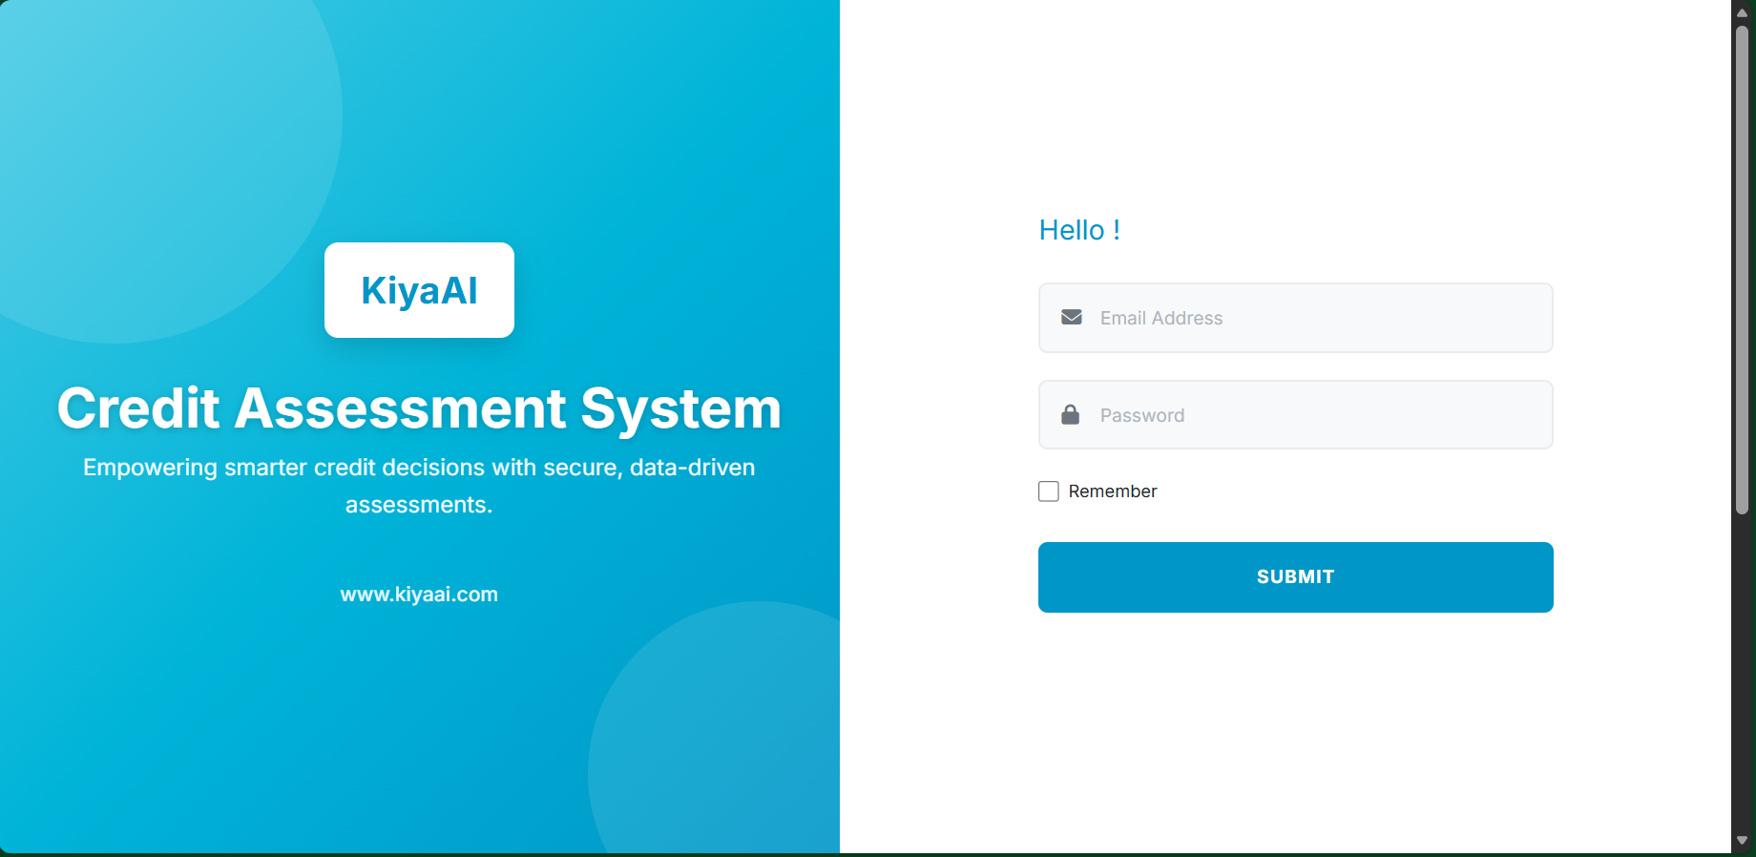
The Login module provides secure entry into the KiyaAI Credit Assessment System. Users can authenticate either through ADS (Active Directory Services) or through Manual Login using email and password. The objective is to ensure only authorized users gain access to the system.
The Login screen contains:
- Left Panel → Welcome branding, logo, product title
- Right Panel → Login form
- Fields:
  - Email
  - Password
  - Remember Me
- Buttons:
  - Login
  - ADS Login (if enabled)
- Error Display: Invalid credential banner
- Fully responsive layout
Manual Login
- User enters Email + Password.
- System validates format and required fields.
- Authentication request sent to backend.
- On success → dashboard loads.
- On failure → error message shown with shake animation.

ADS Login
- User clicks "Login with ADS".
- System redirects to configured ADS/SSO endpoint.
- ADS validates user credentials.
- On success → system receives user profile & roles.
- User is logged into the application without manual credential entry.

Security
- All credentials transmitted over HTTPS (If SSL Certificate implemented).
- Invalid attempts logged in audit trail.
- User session managed via token-based authentication.
- Logout clears token and session.

4.2. Dashboard
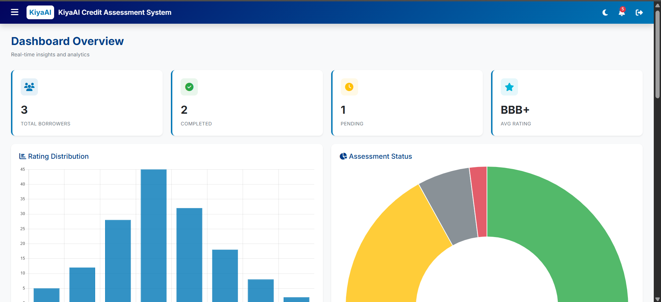

The Dashboard provides a real-time overview of credit assessment activities, borrower statistics, rating outcomes, and workflow status. It acts as the user’s landing page after login and presents high-level operational insights.
The Dashboard contains the following key UI elements:
A. Summary Cards
- Total Borrowers
- Completed Assessments
- Pending Assessments
- Average Rating
B. Charts & Analytics
- Rating Distribution (Bar Chart)
- Assessment Status Distribution (Pie Chart)
- Monthly Assessment Trend (Line Chart)
C. Recent Assessments Table
- ID
- Entity Name
- Template
- Date
- Status
- Rating
- Quick Actions: Edit, Tag CIF, 360° View
A “New Assessment” button is also available to directly start the assessment workflow.

FUNCTIONAL DETAILS
Summary Statistics
- Fetches aggregated data from backend services.
- Auto-refresh on page load.
- Reflects live assessment counts and performance indicators.
Charts
- Rating Distribution: Shows number of entities per rating grade.
- Assessment Status Chart: Displays Pending / Completed / Draft statuses.
- Trend Chart: Monthly count of assessments over the selected period.
Charts help users understand portfolio risk patterns and workloads.
Recent Assessments
- Displays latest assessment records.
- Sortable and supports quick navigation to Edit/View.
- “New Assessment” initiates Step-1 of the Assessment Module.
- 360° customer view button opens consolidated customer profile (if implemented).
- Records show status badges (Draft, Pending, Completed).
User Actions
- Navigate to Assessment Module
- Continue editing previous assessments
- Tag CIF to assessments lacking customer linkage
- Trigger analytics or 360° views
Client Additions –
- Dashboard/Landing Page must show each case with:
  - Current workflow stage
  - Status indicators
- Helps users track assessment stage quickly.

4.3. Rating Templates
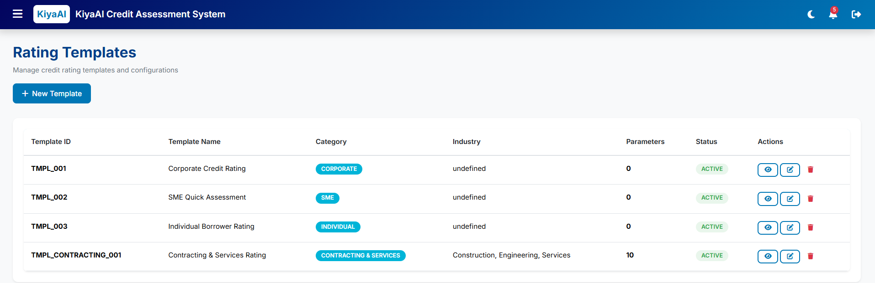

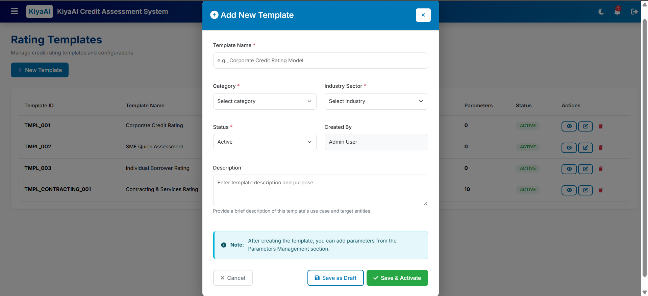

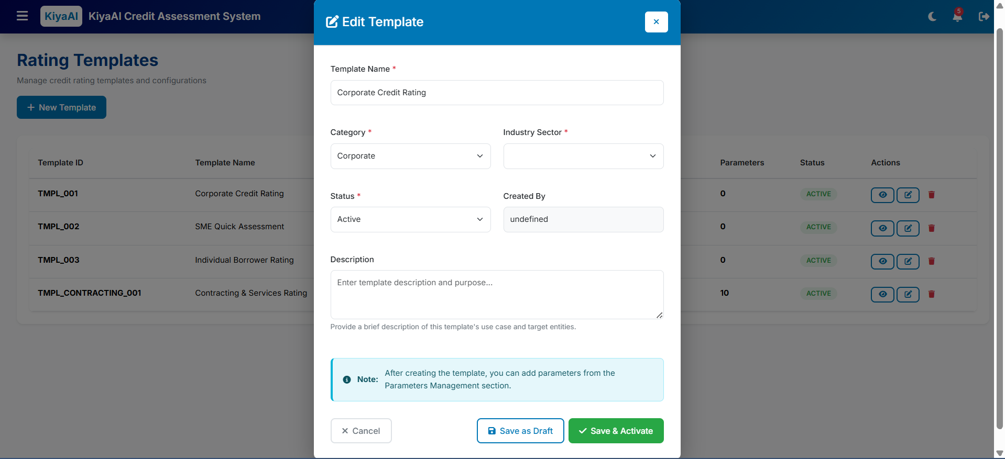

The Rating Templates module allows administrators and credit analysts to create, configure, and manage rating templates used during credit assessment.
Each template defines the structure of parameters, categories, weights, and industry applicability.
The Templates screen contains:
A. Template List Table
Columns include:
- Template ID
- Template Name
- Category (Corporate, SME, Real Estate, etc.)
- Industry
- Parameter Count
- Status (Active / Draft / Inactive)
- Actions (Edit, Activate/Deactivate)
B. Header Actions
- New Template button opens the Add/Edit Template Modal.
C. Add/Edit Template Modal
Includes fields:
- Template Name
- Category
- Industry
- Status
- Created By
- Description
- Save as Draft / Save & Activate buttons
The modal also displays a note that parameters can be added from the Parameters module after template creation.
FUNCTIONAL DETAILS
Create Template
- User clicks New Template.
- Modal opens to input mandatory fields.
- On save:
  - If “Save as Draft” → Template saved as Draft.
  - If “Save & Activate” → Template becomes Active.
- System records:
  - Creator
  - Creation timestamp
  - Status
Templates cannot be used in assessments unless status = Active.

Edit Template
- Selecting “Edit” from the table opens the modal pre-filled.
- Editable fields:
  - Name
  - Category
  - Industry
  - Description
  - Status
- Updating an Active template may require versioning (based on customer requirement).

Template Status Management
Statuses:
- Active → Available for assessments
- Draft → Editable, not usable
- Inactive → Archived, not selectable
Status changes will be logged in the audit trail.

Template-Parameter Linkage
- Templates define structure only.
- Parameters (weights, formulas, qualitative options) are configured in the Parameters Module.
- Each template may have multiple parameters grouped by categories.

Client Additions –
4.3.x Template Associations & Auto-Selection Enhancements
- Multi-Select Category & Sector Mapping
  - Rating Templates must support:
    - Multi-select Categories
    - Multi-select Industry Sectors
  - Admin can assign a single template to multiple sectors & categories.
- Auto-Selection of Rating Model
  - During assessment, the Rating Model/template must be automatically selected based on:
    - Entity Type
    - Industry Sector
  - If user chooses a different template, system must display a warning prompt stating recommended template and allowing override.

4.4. Parameters Management
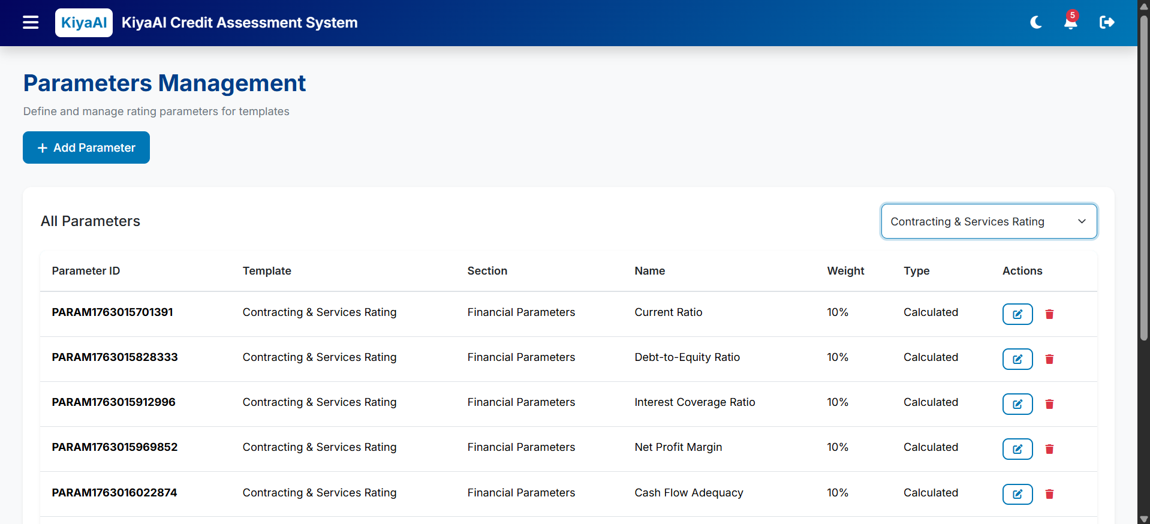

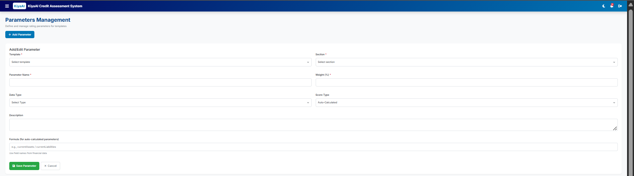

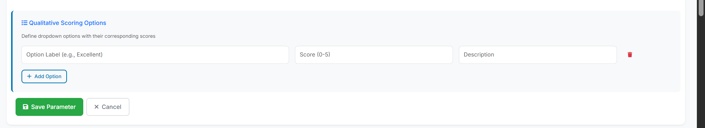

The Parameters Management module allows administrators to define, configure, and maintain scoring parameters used inside rating templates.
Each parameter contributes to the overall credit score through weights, formulas, scoring methods, or qualitative options.
This module ensures consistency and flexibility in rating model configuration.
The screen consists of:
A. Parameter List Table
Columns:
- Parameter ID
- Template Name
- Section (Financial / Business / Risk)
- Parameter Name
- Weight %
- Type (Ratio / Percentage / Number / Qualitative / Score)
- Actions (Edit/Delete)
B. Header Action
- Add Parameter button → opens Parameter Form
C. Parameter Form (Add/Edit)
Fields include:
- Template
- Section
- Parameter Name
- Weight (%)
- Data Type
- Score Type (Auto / Manual)
- Description
- Formula (for auto-calculated parameters)
- Qualitative Options Section (dynamic fields)
Visibility:
- Qualitative section appears only when Data Type = Qualitative.
FUNCTIONAL DETAILS
Add Parameter
- User selects template & section.
- Enters parameter details including:
  - Name
  - Weight
  - Type
  - Description
  - Formula (optional)
- If Data Type is Qualitative, user adds:
  - Options
  - Score for each option
- Save stores parameter under selected template.

Edit Parameter
- Opens the form with existing parameter data.
- Allows modification of:
  - Weight
  - Description
  - Formula
  - Options (if qualitative)
- Template link may be restricted for editing (based on configuration rules).

Parameter Types
- Ratio → Formula-based computation
- Percentage → Numeric input
- Number → Raw numeric values
- Score (1–5) → Manual or auto
- Qualitative → Dropdown with score mapping

Weight Validation
- Total weight across all parameters for a template must sum up to 100%.
- System must:
  - Warn user on exceeding
  - Block save if invalid

Parameter-Template Relationship
- One template → Multiple parameters
- Parameters grouped by:
  - Financial Parameters
  - Business Parameters
  - Risk Parameters
Displayed in assessment steps accordingly.

Data Binding
- Parameters influence:
  - Ratio calculations
  - Business scoring
  - Final rating outcome
Values captured during assessment populate these parameters.

4.5. Credit Assessment

The Credit Assessment module enables analysts to evaluate borrowers through a structured, step-by-step assessment workflow.
It covers entity verification, financial data capture, automated ratio computation, qualitative scoring, and generation of a final rating outcome.
This is the core functional module of the system.

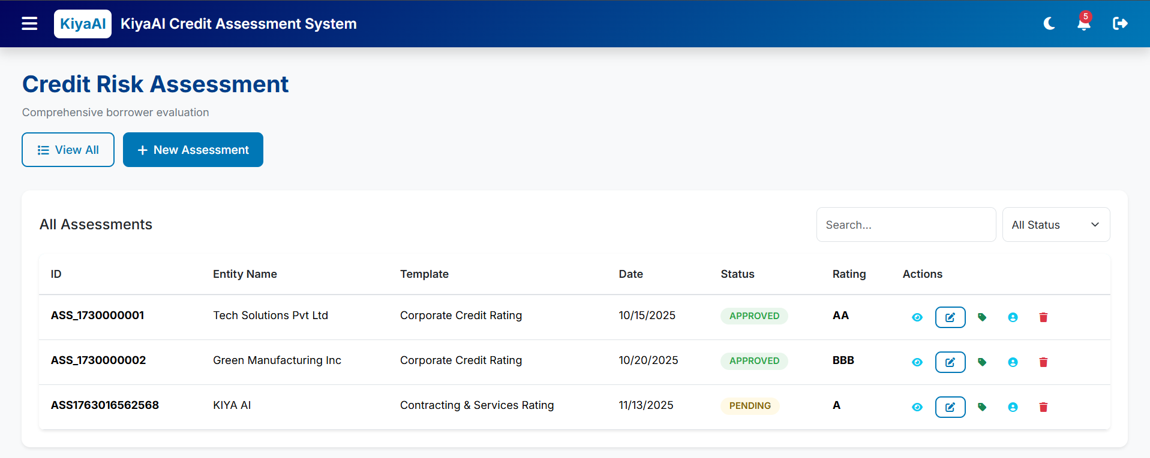

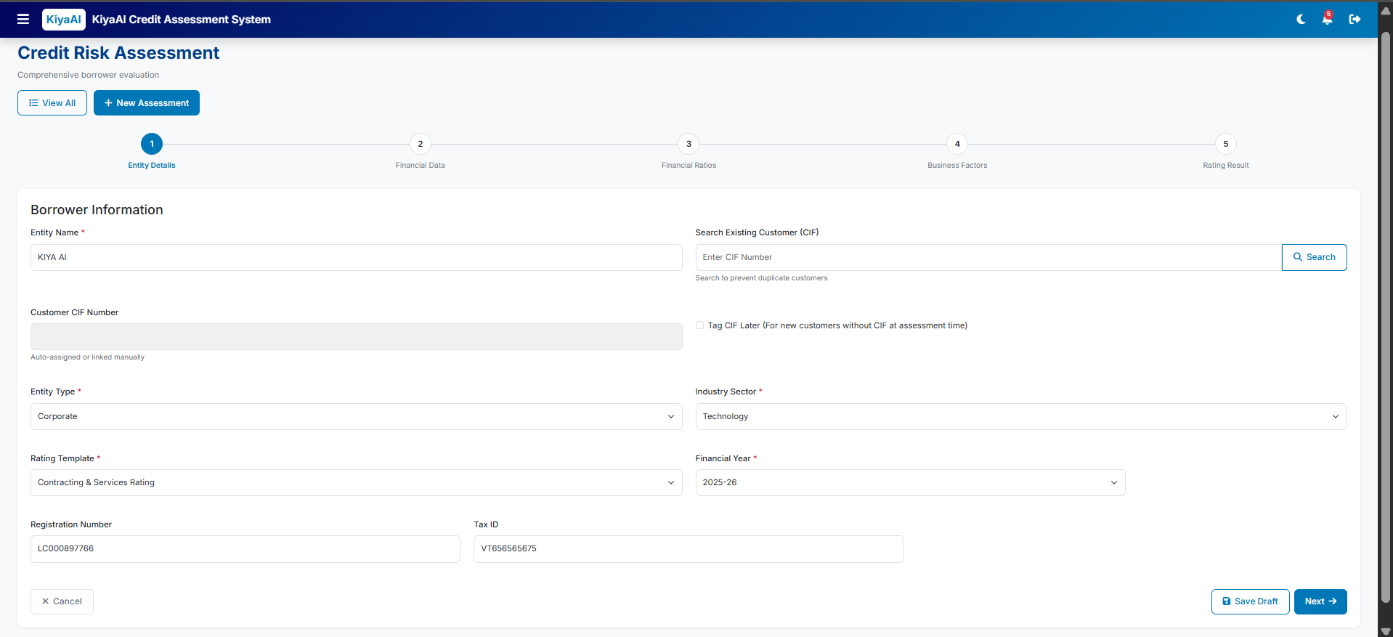
Step 1 – Entity Details
Fields:
- Entity Name
- CIF Search & Deduplication
- Entity Type
- Industry Sector
- Rating Template
- Financial Year
- Registration No., Tax ID
- CIF Linking Options (Auto / Manual / Tag Later)
User enters entity information.
Template selection determines parameters in future steps.
CIF Search:
- User enters CIF → system checks duplicates.
- If match found → display match details with options:
  - “Link to Customer”
  - “Continue as New Customer”
“Tag CIF Later” allowed for new customers.

Client Additions –
- Auto-Fetch Customer Information via CIF
  - When CIF is entered, system must auto-fetch:
    - Entity Type
    - Industry Sector
  - Loaded data must appear pre-filled and editable.
- Business Activity Field
  - Add a new field Business Activity to support customers without CIF.
- CINET / Ci-Net Number
  - Add input field: CINET Number
  - Used for:
    - Validation of assessment
    - Future EOD file ingestion for bureau data
- Historical Auto-Population of Existing Customer Data
  - For returning customers, system must auto-load all previously captured:
    - Entity information
    - Financial statements
    - Qualitative answers
    - Past rating results
  - Pre-filled values must remain editable.

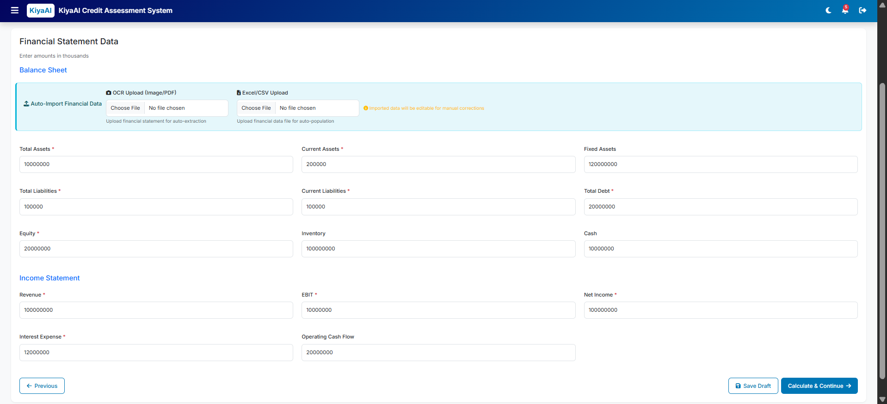
Step 2 – Financial Data
Sections:
- Balance Sheet
- Profit & Loss
- Cash Flow
Additional features:
- OCR Import (PDF/Image)
- Excel/CSV Upload
- Editable pre-filled fields after extraction
A. OCR Upload
- User uploads PDF/Image.
- OCR extracts values like:
  - Total Assets, Liabilities, Revenue, Expenses, etc.
- Populate fields for editing.
B. Excel/CSV Upload
- Predefined format.
- Auto maps financial data into fields.
C. Manual Entry
- All fields editable in thousands format.
- Mandatory fields validated before moving to next step.

Client Additions –
Support Full Financial Statement Structure
- UI must support complete statements:
  - Balance Sheet
  - Income Statement
  - Cash Flow
  - Financial Ratios
  - Projections Sheet
Alignment With Bank’s Excel Template
- All rows/columns must match the bank’s format exactly.
Excel Upload / OCR Extraction Enhancements
- Excel/OCR must:
  - Identify year columns
  - Identify financial line items
  - Auto-fill values year-wise
  - Allow manual correction
Dynamic Financial Years
- Replace fixed 5-year view with dynamic year selector (1–30 years).
- UI must expand/shrink columns accordingly.

NEW SUBSECTION: STEP 2B – PROJECTIONS MODULE
Insert after Step 2 or create a new Step 2B.
4.5.x Projections & Forecasting
- Projection Input Screen
  - Capture projection drivers:
    - Revenue growth %
    - Operating expense %
    - Other configurable drivers
- Auto-Generated Forecast Statements
  - System must auto-generate:
    - Projected Balance Sheet
    - Projected Income Statement
    - Projected Cash Flow (if required)
- Integration With Scoring
  - Projections must influence:
    - Credit Score
    - Derived ratios
    - Final rating
- Bank-Configurable Projection Rules
  - Growth rules & mapping must be fully configurable per bank.

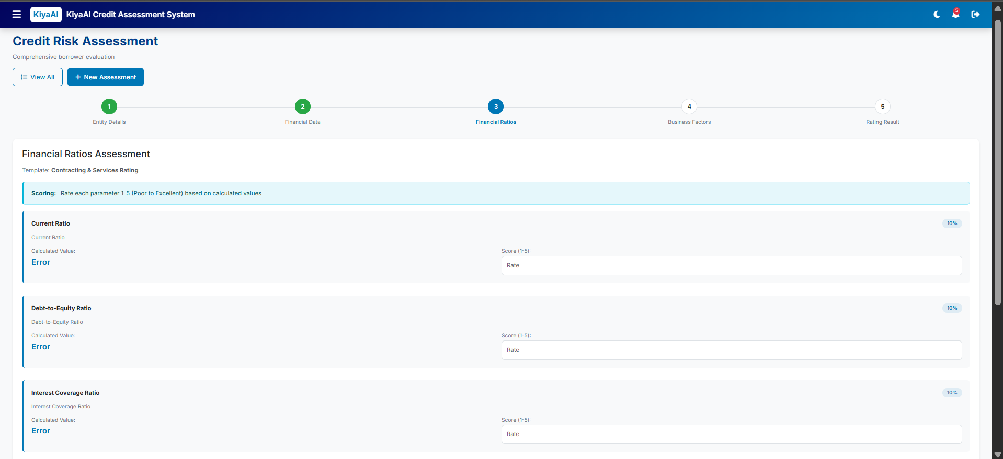
Step 3 – Financial Ratios
- Auto-calculated based on formulas defined in Parameters
- Editable if Score Type = Manual
- Shows formula and validation cues

Ratios pulled dynamically based on template parameters.
Types:
- Liquidity
- Leverage
- Profitability
- Efficiency
If formula exists:
- Auto calculate
- Display formula beneath field
Manual override allowed only if Parameter Score Type = Manual.
Client Additions –
Dynamic Ratio Calculation
- Ratios must auto-compute based on:
  - Imported data
  - Edited data
  - Projected financials
Real-Time Updates
- Editing any financial input must instantly update ratios.

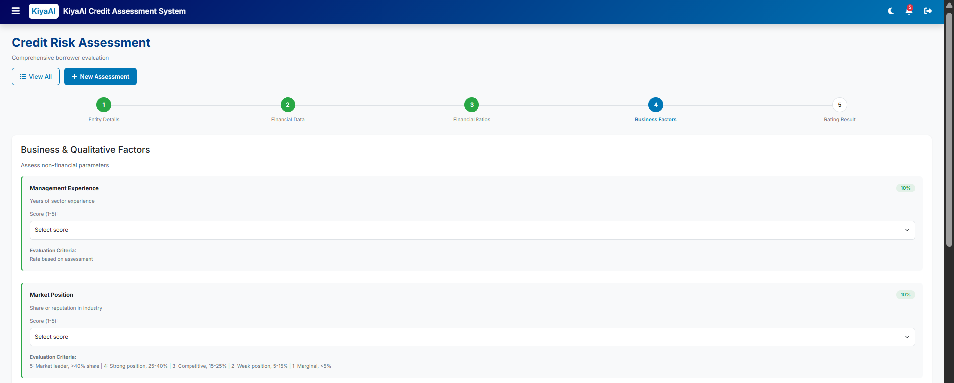

Step 4 – Business & Qualitative Factors
- Parameters from template (Qualitative / Score-based)
- Dropdowns, score fields
- Section-wise scoring summaries
Derived from parameters with Data Type = Qualitative/Score.
Dropdown selections map to configured scoring options.
Weighted section score auto-populated from parameter module configuration.
Analyst can input comments or justifications.
Evaluation Criteria Range 1 – 5, for qualitative parameter criteria-wise evaluation and option selection.
Client Additions –

Grouped Questions Support
- Questions must be organized in configurable groups.
Configurable Question Logic
- Admin must configure:
  - Questions
  - Groups
  - Scoring rules
  - Weightages
Miscellaneous Question Subsection
- Add a separate Miscellaneous Questions area before final score.
Historical Qualitative Data Retention
- System must retain qualitative answers across assessments and show history.

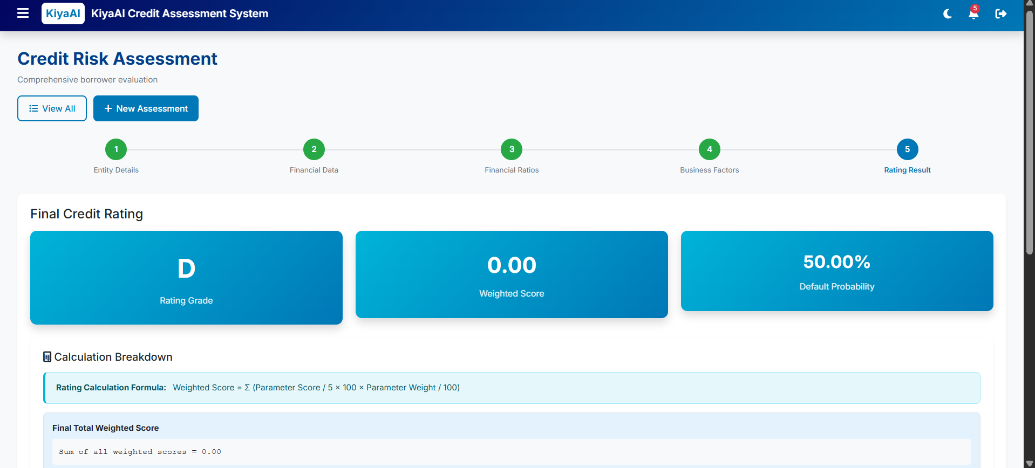

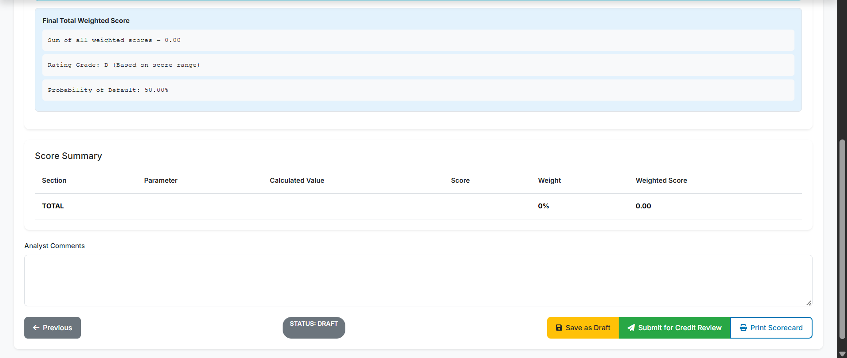

Rating Result (Step 5)
- System computes:
  - Final Weighted Score
  - Rating Grade (e.g., A+, BBB, C)
  - Probability of Default (PD)
- Displays:
  - Color-coded rating card
  - Section-wise contribution
  - Full scoring matrix
- Actions:
  - Save
  - Submit for Approval (if workflow enabled)
  - Generate Report (PDF)
Workflow Handling (Optional Maker–Checker) – Will be defined as per Banks requirements
- Maker creates assessment → submits.
- Checker reviews → approves/rejects.
- Audit trail stored for every action.

CIF Tagging
- If tagged later, user can add CIF in edit mode from Dashboard or Assessment List.
- CIF becomes part of customer profile.

Client Additions –
Historical Comparison
- User must be able to:
  - Open previous rating results in popup
  - Compare current vs previous ratings side-by-side
NEW SUBSECTION: MANUAL ADJUSTMENT LAYER
Insert after Rating Result or before Final Submission.
Manual Adjustment Layer
- Only accessible to authorized users (Senior Credit Officer, etc.).
- User can override computed score.
- System must capture:
  - Adjusted value
  - Reason for adjustment
  - User
  - Timestamp
- All overrides must be included in Audit Trail.

NEW SUBSECTION: DECISION SNAPSHOT
Insert after Manual Adjustment.
Decision Snapshot
At final submission, store a complete snapshot including:
- All financial inputs
- All ratios
- All projections
- All qualitative scores
- Scoring parameters used
- Adjustment logs
Used for:
- Audit
- Regulatory review
- Post-loan monitoring

HIGH-LEVEL INTER-DEPARTMENT WORKFLOW

A. CBD / IBD WORKFLOW (Business Unit)
This unit performs the pre-risk business checks, consisting of:
1. Business Maker (X123)
- Creates the case
- Enters all customer/entity details
- Uploads documents
- Saves drafts or submits to checker
Transition → Submits the case to Business Checker

2. Business Checker (X123)
- Reviews data entered by Maker
- Can approve or return for corrections
- Cannot modify actual data (remarks only)
Two possible paths:
- Return → Goes back to Business Maker for corrections
- Submit Forward → Sends case to Risk Verifier (RMD)
This transition to RMD triggers a system notification.

B. RISK MANAGEMENT DEPARTMENT (RMD) WORKFLOW
3. Risk Maker (X123)
- Reviews the case sent from CBD/IBD
- Fills Risk Parameters & qualitative risk details
- Uploads risk documents
- Can save draft
- Submits to Risk Checker
Transition → Risk Checker

4. Risk Checker (X123)
- Validates the risk assessment performed by the Risk Maker
- Adds remarks
- Approves or returns for risk-level rework
If approved:
Transition → Final Approver

5. Final Approver (X123)
- Performs final credit-level approval
- Confirms end-to-end completion from Business & Risk
- Once approved, the entire assessment becomes FROZEN
- No further edits allowed
End State → Assessment Frozen + Final Rating Report Enabled

(MESSAGE FLOWS)
1. Notification (CBD/IBD → RMD)
Triggered when Business Checker forwards the case to Risk Verifier:
- Risk team receives workflow notification
- Assessment enters Risk Draft state
2. Submission Flow (RMD → CBD/IBD for tracking)
Once Risk Approval completes, the submission progresses to Final Approver:
- Final approval notification
- System locks record post-approval

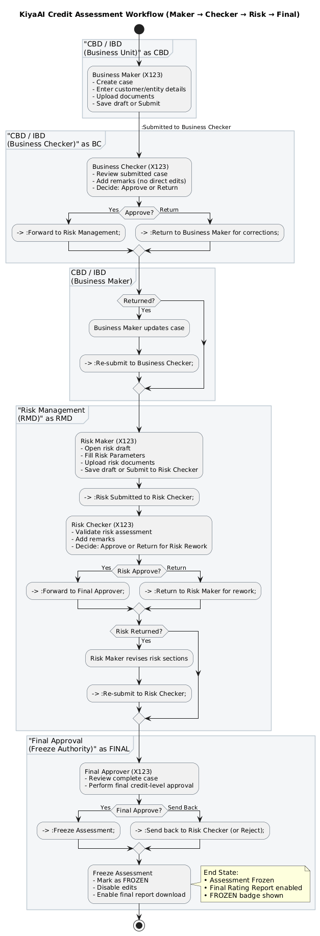

4.6. Reports
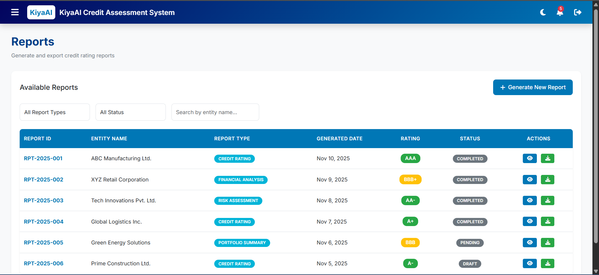

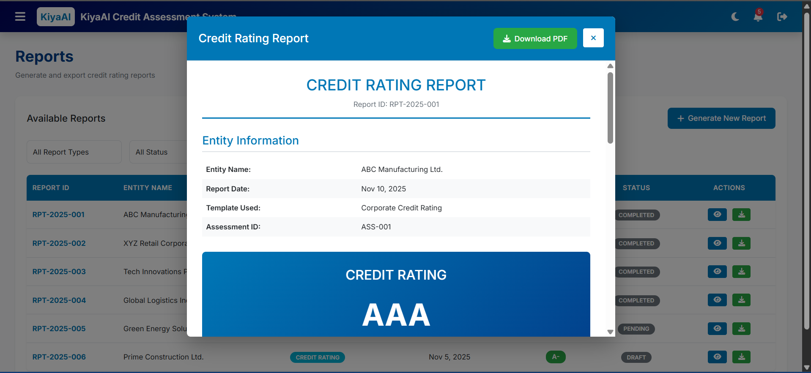
The Reports module allows users to generate, download, and review credit assessment reports.
It provides standardized document formats based on templates, offering transparency and auditability of rating results.
The Reports screen includes:
A. Report List Table
Columns:
- Report Name
- Description
- Report Type (PDF/Template-Based)
- Last Generated
- Actions (Generate, Download, View)
B. Report Generation Filters
For applicable reports:
- Date Range
- Status
- Template
- Entity Name
- Financial Year
These filters refine the dataset before generating output.
C. Output Format
Reports generated in:
- PDF
- Excel (if defined)
- System-defined Template Output
Types of Reports
Common reports include:
- Assessment Summary Report
- Parameter Score Report
- Final Rating Report
- Portfolio Overview Report
- Assessment Status Report

Report Generation Process
- User selects the report type.
- Applies filters based on available input parameters.
- System fetches relevant data set.
- Backend prepares the report using predefined template.
- User downloads or previews the output.

Report Template Management
- System supports configuration of:
  - Report Layout
  - Header/Footer
  - Branding
  - Section Arrangement
- Admin module controls available templates (future scope if not yet implemented).
Client Additions -
Include Decision Snapshot in reports.
Add Historical Rating Comparison Report.
Include projection-based statements in Assessment Report.

4.7. Administration

4.7.1. Role Management
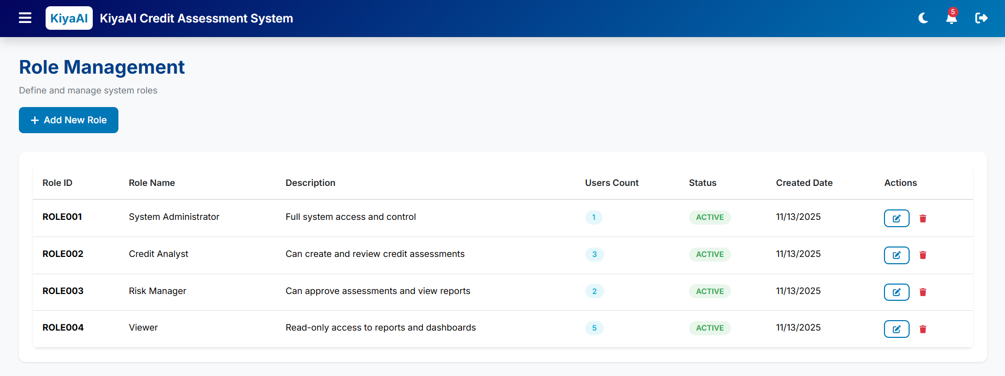
The Roles module enables administrators to create and manage user roles within the application.
Each role defines a set of permissions that control access to modules, screens, and actions across the system.
It forms the foundation of RBAC (Role-Based Access Control).
The Role Management screen displays:
A. Roles List Table
Includes:
- Role ID
- Role Name
- Role Type (System / Custom)
- Description
- Status (Active / Inactive)
- Actions (Edit, Activate/Deactivate)
B. Add/Edit Role Modal
Fields:
- Role Name
- Description
- Role Status
- Permissions Assignment (linked with RBAC module)
- Save / Cancel buttons

FUNCTIONAL DETAILS
Create Role
- Admin enters:
  - Role Name (e.g., Analyst, Reviewer, Admin)
  - Description
  - Status
- Saves role to system.
- Default roles may be predefined (e.g., System Admin).

Edit Role
- Admin can update:
  - Name
  - Description
  - Status
- Permissions edited via the RBAC module.

Role Status Management
- Active roles available for assignment.
- Inactive roles cannot be assigned.
- Audit logs maintained for status changes.

Permissions Integration
- Role definition alone does not grant access.
- Permissions must be linked in RBAC Module.
- Each role maps to modules, screens, or actions.

Validation Rules
- Role name must be unique.
- Cannot deactivate role if users are actively assigned (unless allowed by business).

4.7.2. User Management
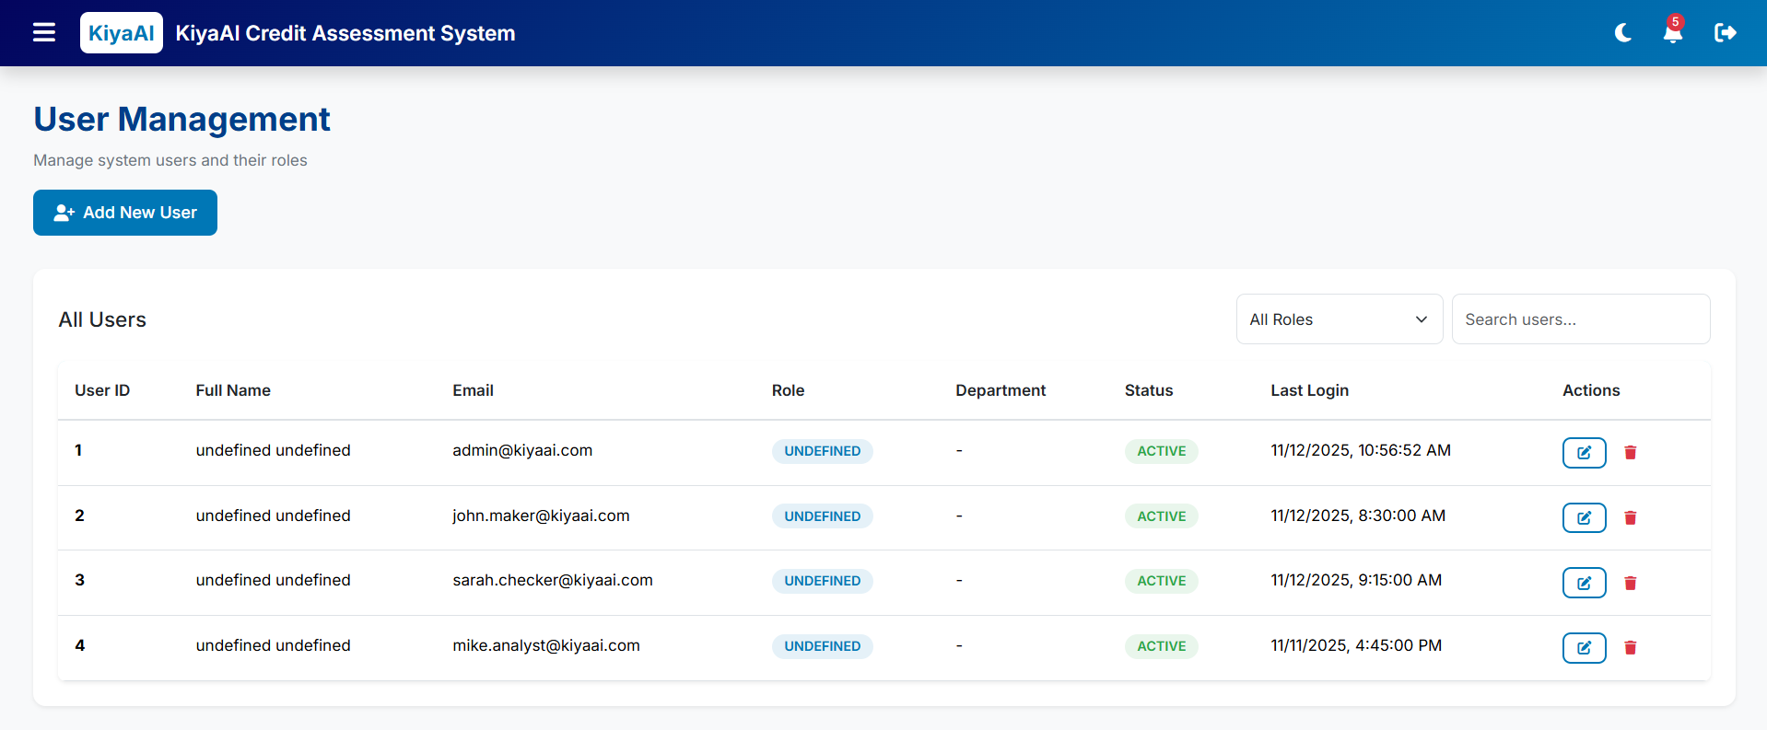

The User Management module enables administrators to create, update, and maintain user accounts for the KiyaAI Credit Assessment System.
It defines user identity, assigned roles, access levels, and operational status.
This module ensures secure and controlled access of users across the system.
The User Management screen includes:
A. User List Table
Columns:
- User ID
- Name
- Email
- Role
- Status (Active / Inactive / Locked)
- Last Login
- Actions (Edit, Activate/Deactivate, Reset Password)
B. Add/Edit User Form/Modal
Fields:
- Full Name
- Email Address
- Phone Number (optional)
- Role Assignment (dropdown)
- User Type (ADS / Manual Login)
- Status
- Optional: Department / Location
- Save / Cancel
C. Optional Actions
- Reset Password (Manual login users)
- Unlock User (after failed attempts lockout)
- Deactivate Account

FUNCTIONAL DETAILS
Create User
- Admin enters user details.
- Selects Role from Role Management module.
- Selects login type:
  - ADS User → Authenticated through Active Directory
  - Manual User → Password generated and sent via email
- Saves user into system.

Edit User
- Admin updates user details:
  - Name
  - Email
  - Role
  - Status
- Critical fields like email may be restricted depending on business rules.

User Status Management
Statuses include:
- Active → User can log in
- Inactive → User blocked from login
- Locked → System-locked due to failed attempts
Admin can:
- Unlock user
- Activate / Deactivate account

Password & Authentication Handling
For Manual Login Users:
- Admin can reset password
- User receives system-generated credentials
- User must change password on first login (optional requirement)
For ADS Users:
- Password managed in Active Directory
- No reset option inside system

Audit Trail Integration
System logs:
- User creation
- Updates
- Role changes
- Status changes
- Login attempts
- Failed login events

4.7.3. RBAC (Role-Based Access Control)
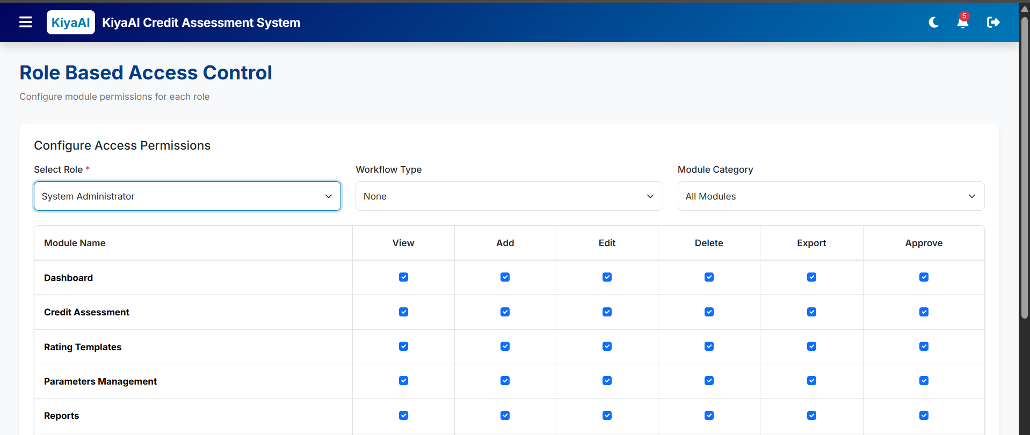
The RBAC (Role-Based Access Control) module defines permissions and access rights for each role in the system.
It determines what every role can view, edit, create, approve, or delete across modules.
RBAC ensures users only access features relevant to their responsibilities.
The RBAC screen includes:
A. Role Selection Panel
- Dropdown listing all active roles
- Selecting a role loads its current permissions
B. Permissions Matrix
Displayed in a table/grouped list:
- Modules (Dashboard, Assessment, Templates, Parameters, Reports, Admin, etc.)
- Submodules and screens
- Action-level controls, such as:
  - View
  - Create
  - Edit
  - Approve
  - Delete
  - Download Reports
  - Manage Workflow
Each permission uses toggle switches or checkboxes.
C. Save Permissions
- Button to persist changes for the selected role.

FUNCTIONAL DETAILS
Permission Assignment
For each role, admin can enable/disable access to:
- Entire modules
- Specific screens
- Field-level or action-level permissions (if configured)
Example:
- Analyst → View + Edit Assessments
- Reviewer → View + Approve Assessments
- Admin → Full Access

Permission Types
Common permission categories:
- Module Access (visibility in sidebar)
- Screen Access
- Create/Edit/Delete
- Approval Rights
- Report Generation
- Admin-Level Controls

Enforcement Mechanism
- Permissions are stored against each role.
- At login:
  - System loads user's role and permission set
  - Sidebar and screens dynamically adjust
- Actions blocked by API if unauthorized.

Integration with User Management
- Users inherit permissions from assigned roles.
- Role change automatically updates user access.

Audit Tracking
System logs:
- Permission modifications
- Modified by
- Timestamp

4.8. Masters

4.8.1. Lookup Management
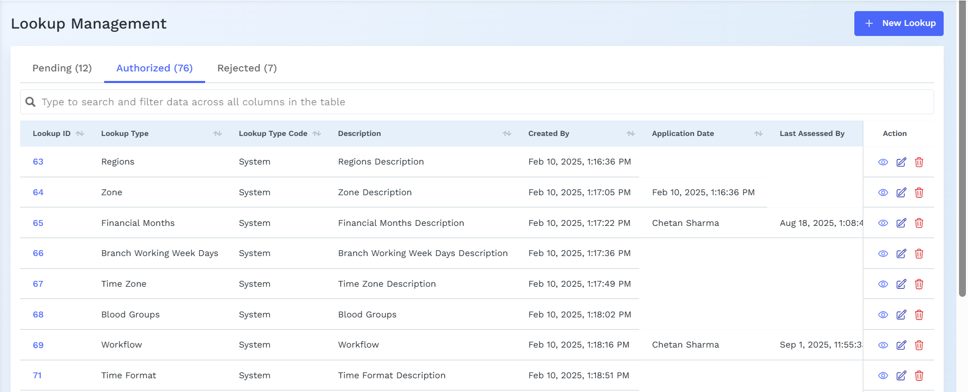

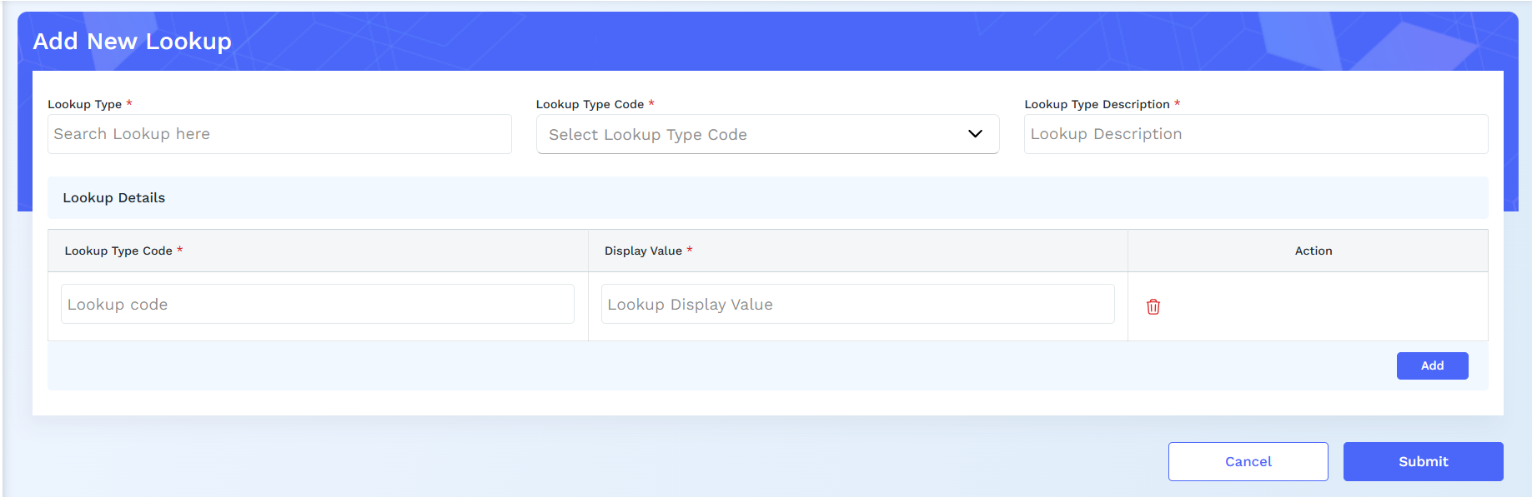

The Lookup Management module allows administrators to maintain all static and reusable dropdown values used across the system.
These lookups ensure consistency in data entry and support configurable options across multiple modules (Assessment, Templates, Parameters, Reports, etc.).
The Lookup Management screen includes:
A. Lookup Category List
Examples:
- Industry Category
- Entity Type
- Business Risk Options
- Qualitative Score Options
- Assessment Status
- Document Types
- Rating Grades
- Financial Ratio Types
B. Lookup Value Table
Columns:
- Lookup ID
- Lookup Name
- Display Value
- Status (Active/Inactive)
- Actions (Edit/Delete)
C. Add/Edit Lookup Modal
Fields:
- Category
- Lookup Name
- Display Value
- Description (optional)
- Status
- Save/Cancel buttons

FUNCTIONAL DETAILS
Create Lookup
- Admin selects a category or creates a new category.
- Adds lookup name and display value.
- Saves to system for immediate availability.

Edit Lookup
- Modify existing lookup:
  - Name
  - Display value
  - Status
- Deactivated lookups stop appearing in dropdowns.

Lookup Categories
Each category groups related values. Examples:
- Industry Sector for Entity Details
- Template Categories for Rating Templates
- Qualitative Options for Parameters
- Assessment Status Types for workflow

System Usage
Lookups populate:
- Dropdowns
- Filter lists
- Auto-complete inputs
- Validation reference data
Changes reflect across modules instantly.

Validation Rules
- Lookup name must be unique within its category.
- Category cannot be deleted if values exist.
- Inactive values cannot be assigned in new records.

4.9. System Configuration

The System Configuration module allows administrators to manage global system settings that impact communication, module visibility, and operational behavior.
It includes configuration of Email Server, Email Templates, and Module Management.

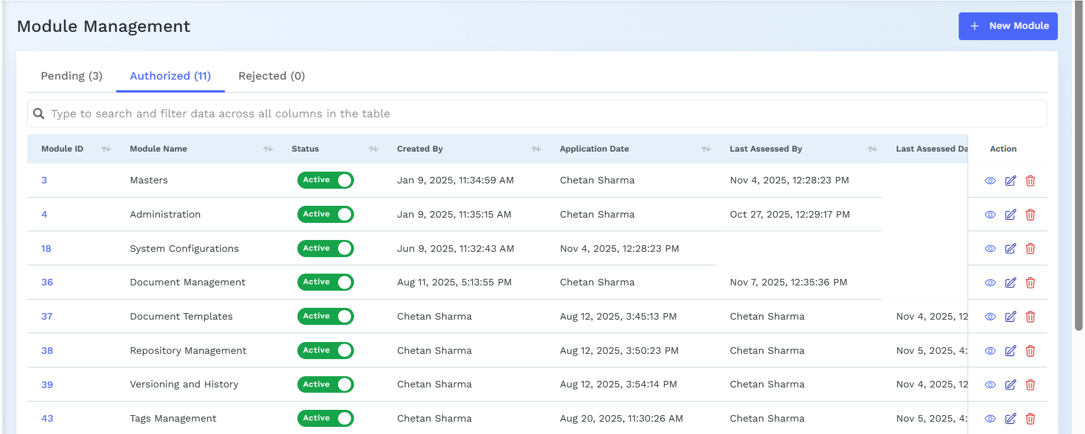

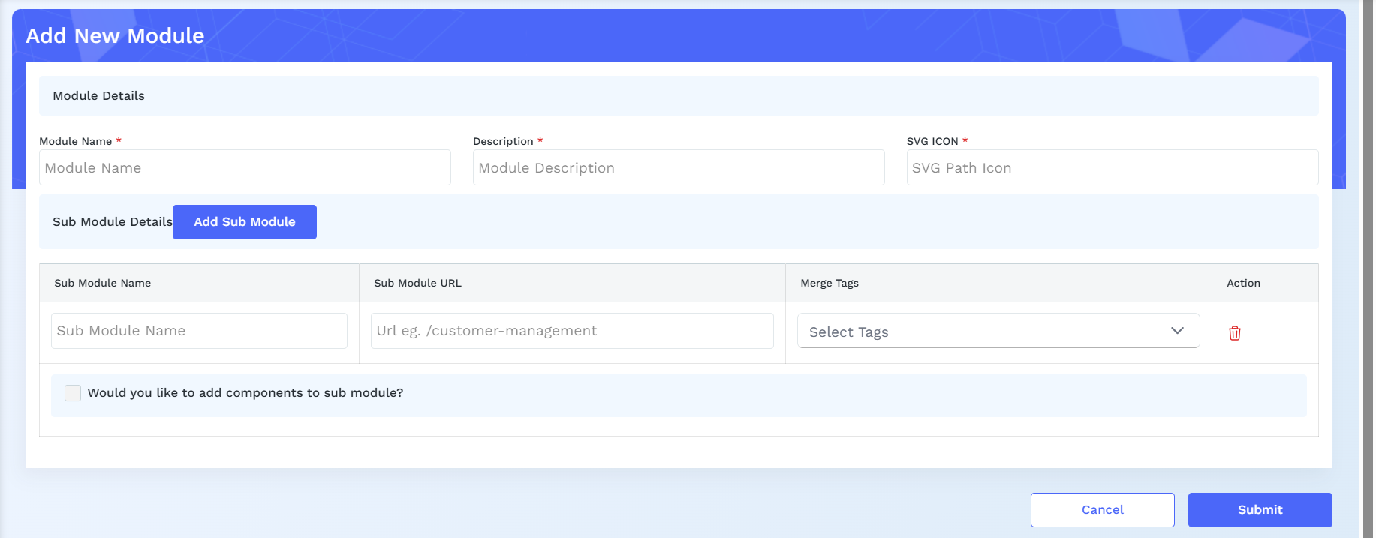

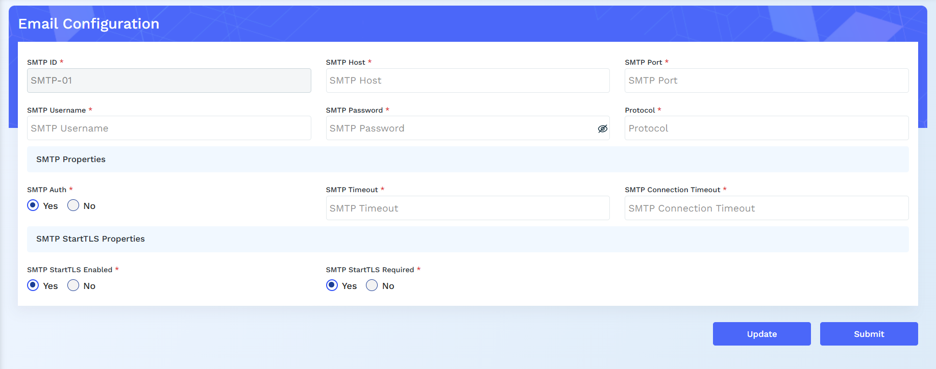

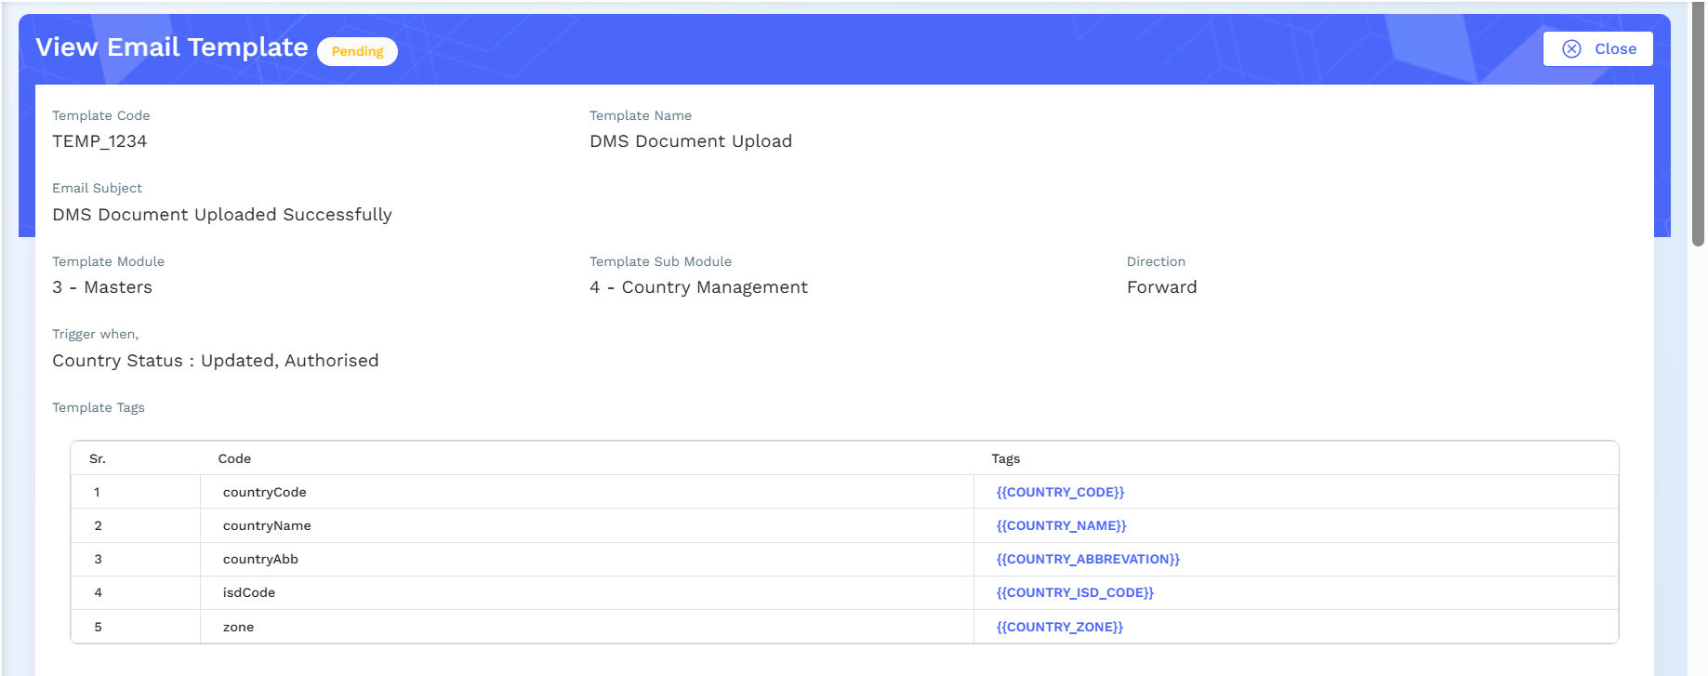
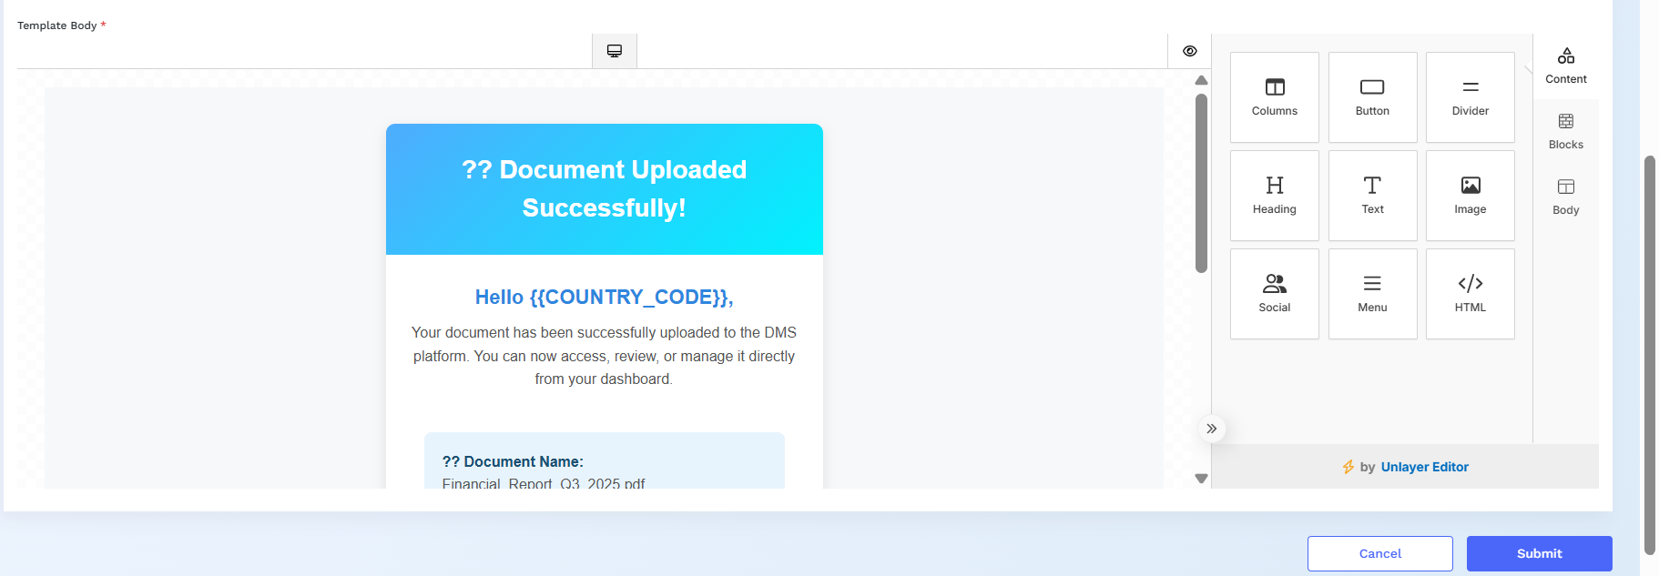

A. Email Configuration
Fields:
- SMTP Server
- Port
- Sender Email (From Address)
- Username
- Password / App Key
- SSL/TLS Enable Toggle
Email Configuration
- Admin enters SMTP details required for system notifications.
- “Test Email” validates configuration.
- Used for:
  - User creation emails
  - Password reset
  - Assessment alerts
  - Report delivery (if applicable)
Validation:
- Mandatory fields must be valid before save.

B. Email Templates
Columns:
- Template Name
- Subject
- Type (Password Reset, Notification, Assessment Report, Alerts)
- Actions (Edit/Preview)
Add/Edit Template Modal:
- Template Name
- Subject Line
- Body (Rich Text Editor)
- Dynamic Variables (e.g., {{UserName}}, {{AssessmentId}})
- Admin manages system-generated email formats.
- Templates support placeholders for dynamic data.
- Typical templates:
  - User Onboarding
  - Password Reset
  - Assessment Completed
  - Approval Notifications
Editing:
- Admin updates subject and body via rich text editor.
- Preview option before save.

C. Module Management
- Toggle-based list of modules:
  - Dashboard
  - Credit Assessment
  - Templates
  - Parameters
  - Reports
  - Audit
  - Admin Modules
- Admin can enable/disable modules for all users or selected roles (if extended).

Controls which modules appear in the sidebar.
Disabling a module hides it from all users (unless role-based override is configured).
Helps manage phased rollouts or features under development.

5. Data Ingestion

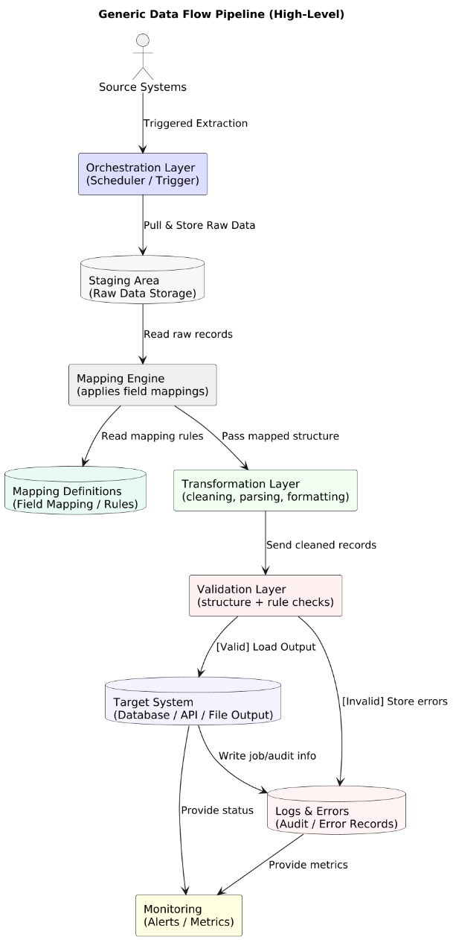

High-Level Stepwise Summary
1. Extract
Data is pulled from source systems (DB, API, files) based on a trigger or schedule.
2. Stage
Raw data is stored temporarily without changes, to keep an untouched copy.
3. Map
A mapping engine reads mapping definitions and aligns source fields to target fields.
4. Transform
Mapped data is cleaned, formatted, and converted into the required structure.
5. Validate
Data is checked for correctness, mandatory fields, formats, and business rules.
6. Load
Valid data is loaded into the target system (database, file, API, etc.).
7. Log & Error Handling
Invalid data and process errors are recorded for debugging or reprocessing.
8. Monitor
System monitors job status, performance, and alerts on failures or anomalies.

6. API Catalogue

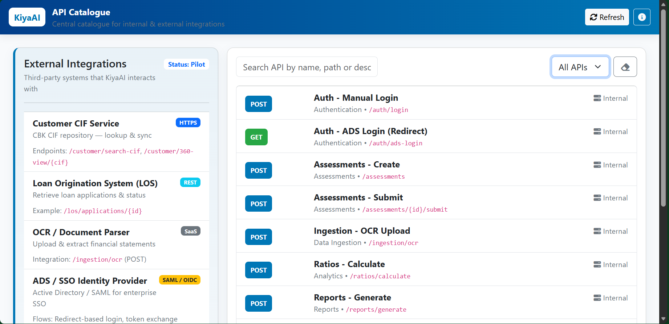

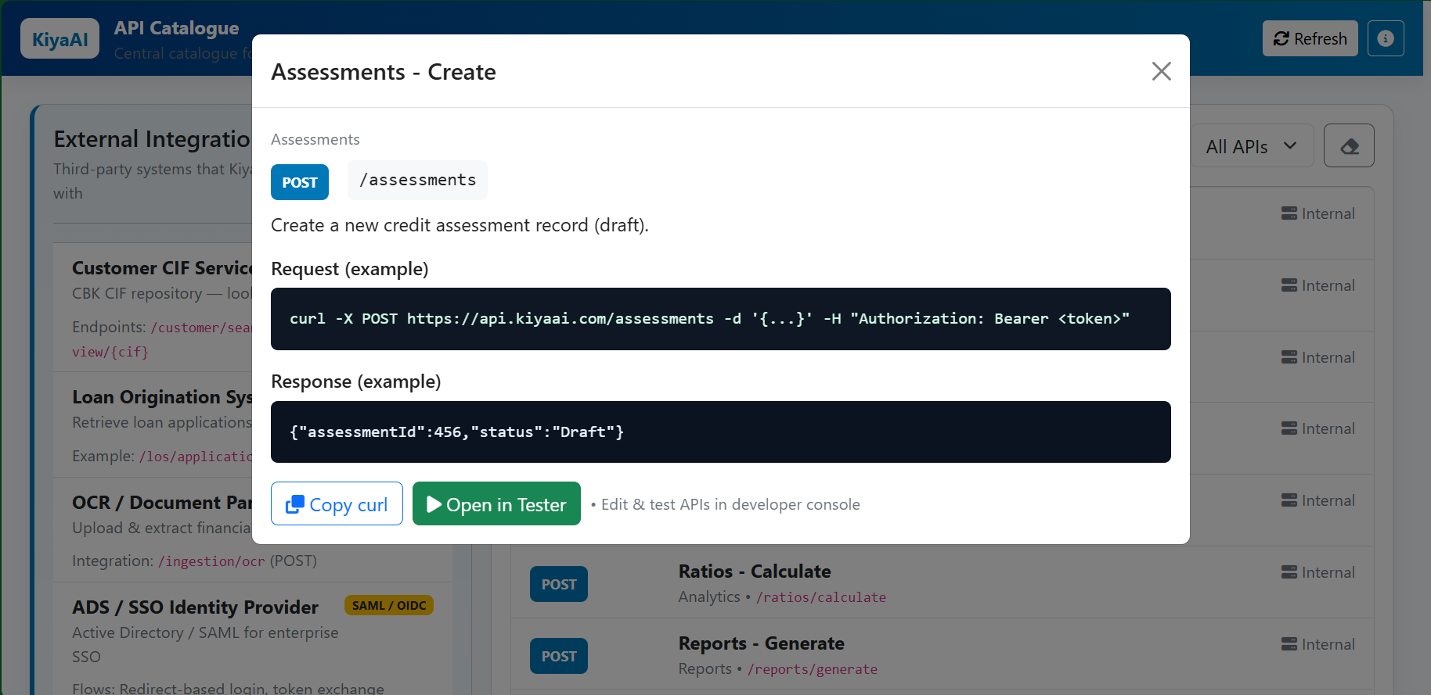

The API Catalog defines all backend services that the KiyaAI Credit Assessment System exposes or consumes.
These APIs are used by the frontend, admin modules, workflow engine, data ingestion components, and external systems where integration is required.
APIs ensure that all modules interact consistently and securely through REST-based communication.

The API Catalogue dashboard consists of the following sections:
A. External APIs Panel
This section lists all third-party or client-owned systems integrated with the solution.
Each external API displays:
- API/System Name
- Integration Type (REST, SOAP, SAML, OIDC, SMTP, etc.)
- Base URL / Endpoint Pattern
- Purpose (e.g., CIF Search, Document Parsing, SSO Authentication)
- Example Endpoints
The catalogue highlights:
- Endpoint Paths
- Supported HTTP Methods
- Functional Purpose
- Input Requirements
- Output Structure
- Authentication/Headers
- Dependencies
- External System Mapping

7. Deployment Mechanism

The system supports modern deployment methodologies that ensure reliable and repeatable releases.
A. Deployment Architecture
- 3-Tier Architecture
  - Frontend (Angular/React)
  - Backend (Spring Boot / .NET API)
  - Database (Oracle)
B. Deployment Models Supported
- On-Premises Deployment (Preferred by CBK)
- Cloud Deployment (Optional)
  - Private cloud / Containerized
  - Docker + Kubernetes-enabled (optional)
INFRASTRUCTURE REQUIREMENTS
A. Hardware Requirements
(Indicative, can be adjusted based on load)
Layer | Specification | Recommendation
Frontend Server
Backend Server
Database Server
File Storage

B. Operating Systems
- Windows Server – Optional for ADS integrations

C. Network & Connectivity
- HTTPS enabled
- SSL certificate (internal or public CA)
- Secure VPN/IP Whitelisting for external integrations
- Firewall rules for API communication

8. Software Pre-requisites

Will be shared by the KiyaAI Team during the Deployment Phase.

8.1. ENVIRONMENT SETUP
The solution will run across 3–4 environments:
Environment | Purpose
DEV | Developer testing
TEST / QA | Internal testing + automation
UAT | Client validation (CBK)
PRODUCTION | Live environment
Each environment mirrors production as closely as possible.

9. Project Documentation

The Project Documentation section lists all key documents that support the development, implementation, and ongoing use of the KiyaAI Credit Assessment System.
These documents ensure that stakeholders—from business users to technical teams—have the necessary clarity for system understanding, maintenance, and onboarding.

A. Functional Specification Document (FSD)
Purpose
The FSD provides a detailed functional description of every module, workflow, and business rule defined in the BRD.
It translates business requirements into actionable functional behaviors for development teams.
Contents
- Module-level functional descriptions
- Field-by-field specifications
- User interactions and system responses
- Workflow logic (including maker–checker, approvals, and validations)
- Error messages and exception handling
- Business rules, scoring logic, ratio formulas
- Integration specifications with CIF/LOS/OCR/ADS
- UI wireframes (if applicable)

B. User Manual
Purpose
The User Manual guides end-users in operating the system effectively. It includes navigation flows, screenshots, and instructions for daily activities.
Contents
- Login instructions (Manual + ADS)
- Using the Dashboard
- Creating and managing assessments
- Uploading financial statements (OCR/Excel)
- Ratio interpretation
- Viewing and generating reports
- Template and parameter management
- Admin activities (User, Roles, RBAC, Lookups)
- Troubleshooting and FAQs
Audience
- Analysts
- Reviewers
- Administrators
- Risk & Credit Teams
- Business Users

C. Deployment Guide
Purpose
The Deployment Guide provides step-by-step instructions for setting up and deploying the system in different environments.
Contents
- Prerequisites
- Required software and tools
- Server configuration steps
- Database setup (Oracle schemas, tables, seeds)
- Environment variable configuration
- Email and OCR configuration
- How to deploy frontend & backend builds
- Log configuration and monitoring setup
- Rollback strategies
- Post-deployment validation checklist
Audience
- IT Infrastructure Teams
- DevOps Teams
- System Administrators

-----------END OF THE DOCUMENT-----------

