# Content Negotiation

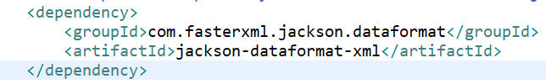

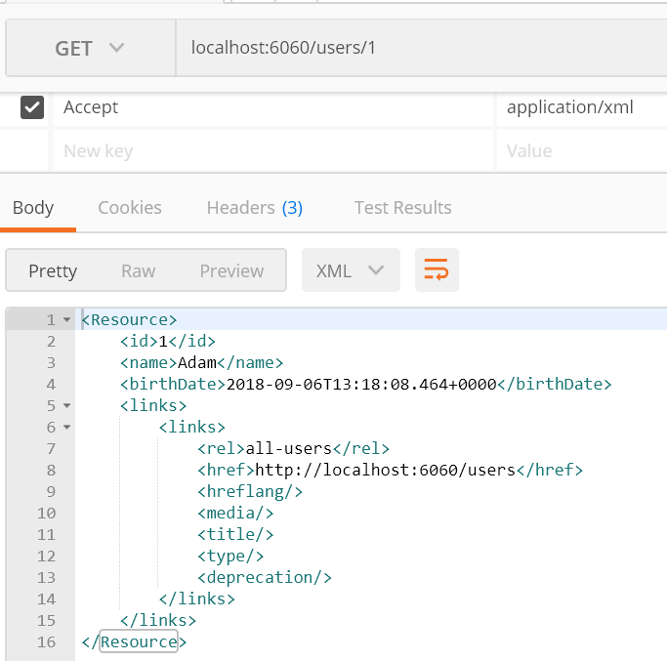

# Swagger

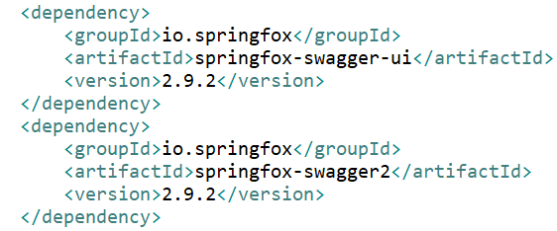

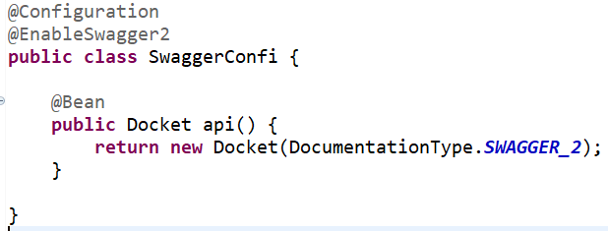

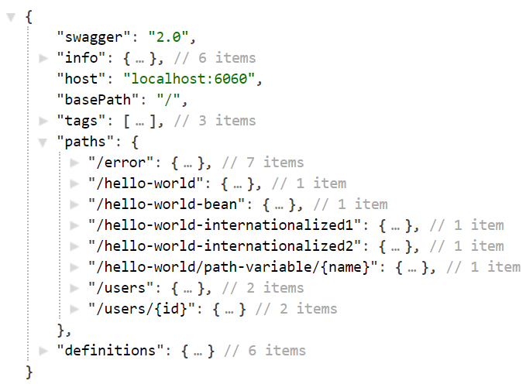

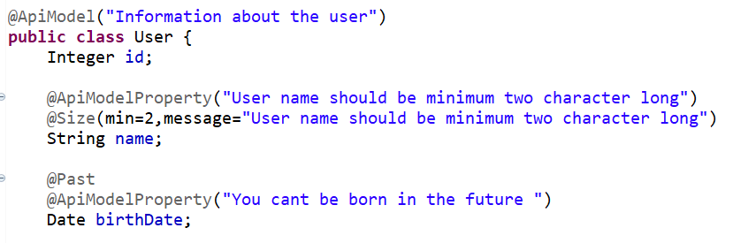

<http://localhost:6060/v2/api-docs>

http://localhost:6060/swagger-ui.html#/

# Filtering

## Method 1

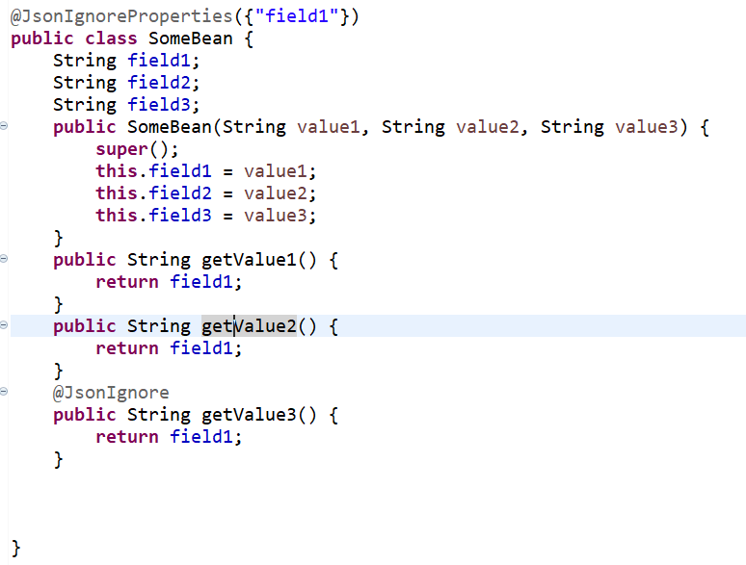

## Dynamic Filtering

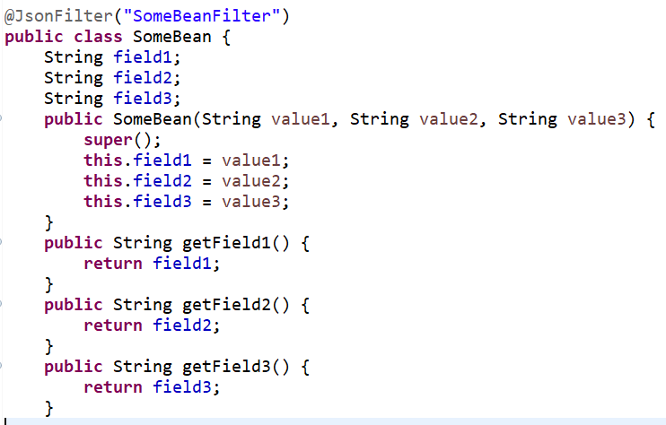

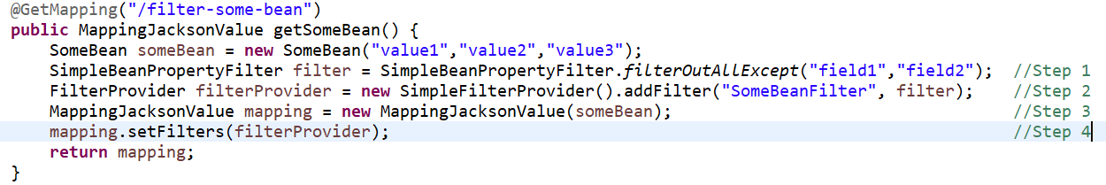

# Versioning

## Using Params(URI Versionig)

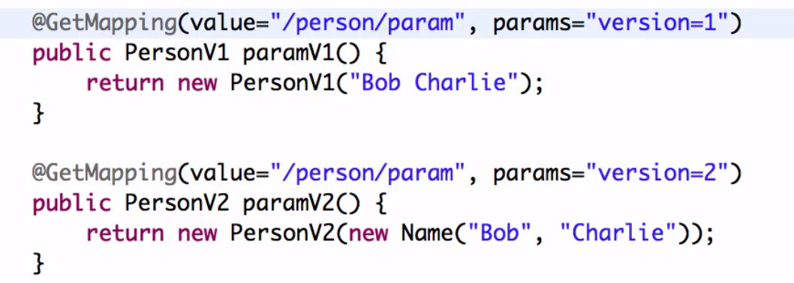

## Using Headers(Request Parameter versionig)

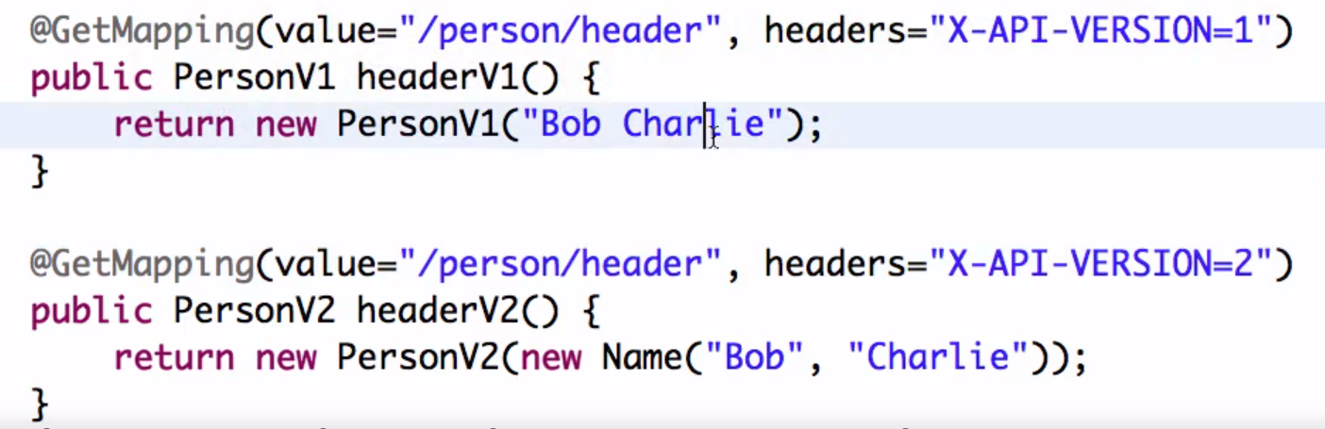

## Using Media Type

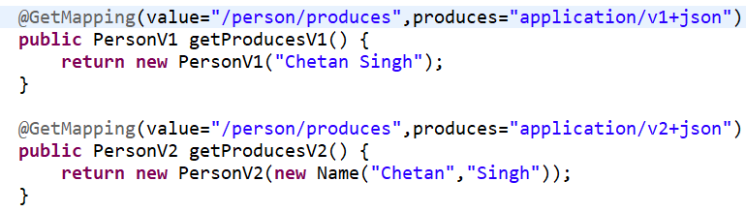

# Security

Step 1 : add security in pom

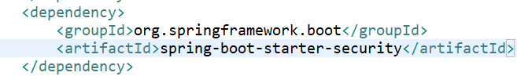

Step 2 : configure username and password in pom.xml

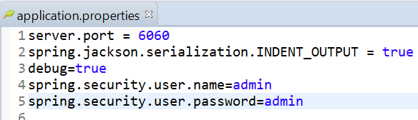

Step 3 : Send username/password in authorization

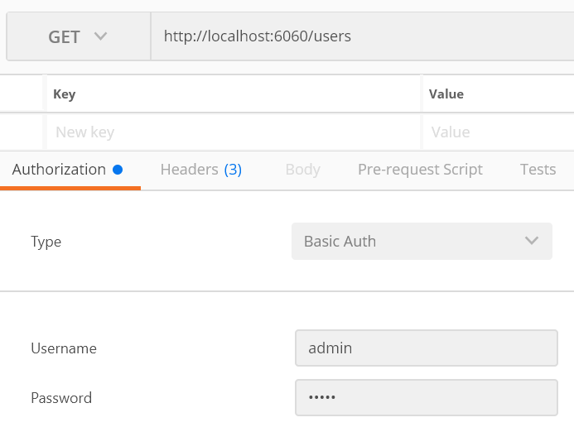

Spring Cloud

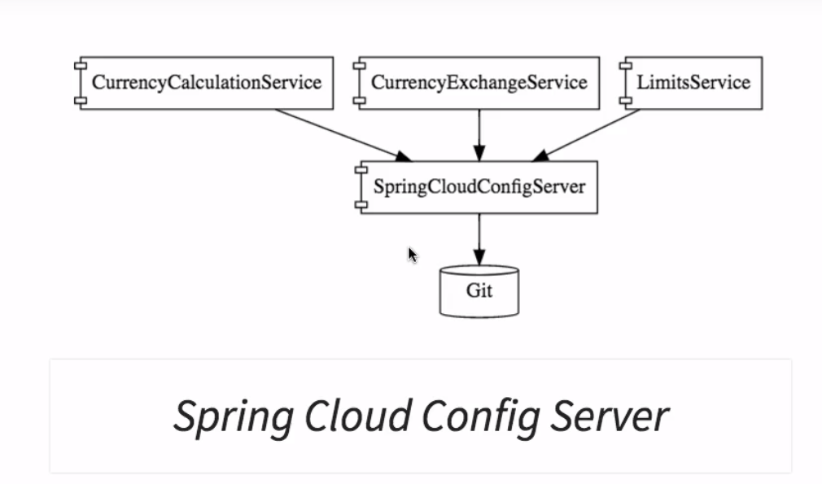

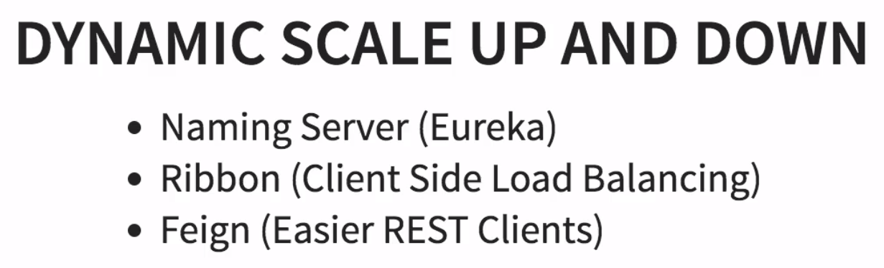

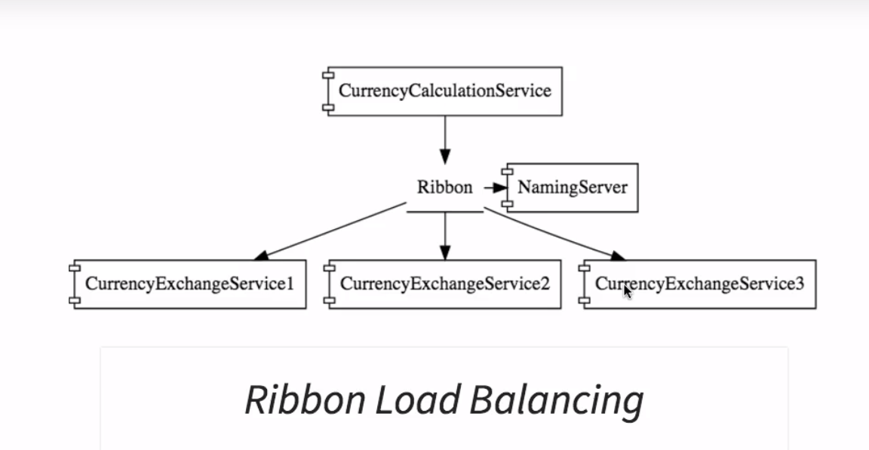

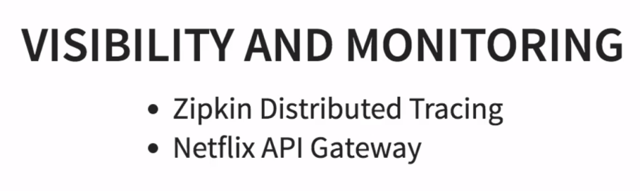

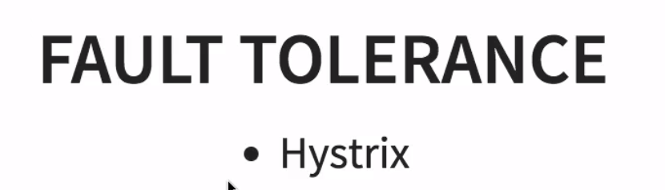

Advantages of Microservices

1. Adoption of new technology
2. Dynamic Scaling
3. Faster release cycles