# **Data Transafer using Sqoop:**

## Task 1 – MySQL 🡪 HDFS

Login to mysql and create a database Deepak and table employee.

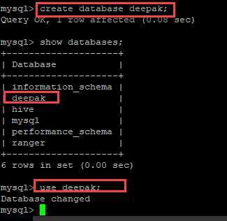

Insert data into the table.

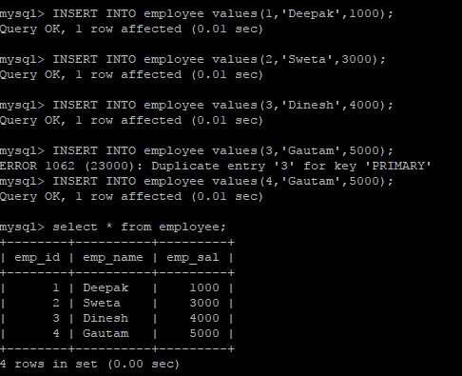

Now, exit mysql and type the following command.

Sqoopimport –connect jdbc:mysql://localhost/deepak--driver com.mysql.jdbc.Driver –username root –password Hadoop –table employee -m 1

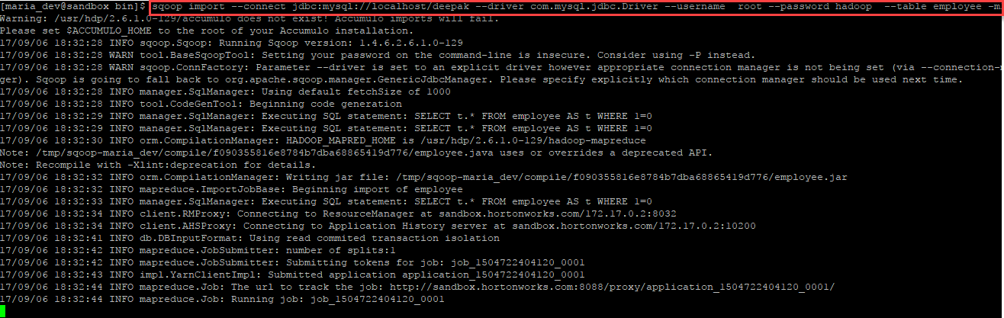

Wait for it to get finished.

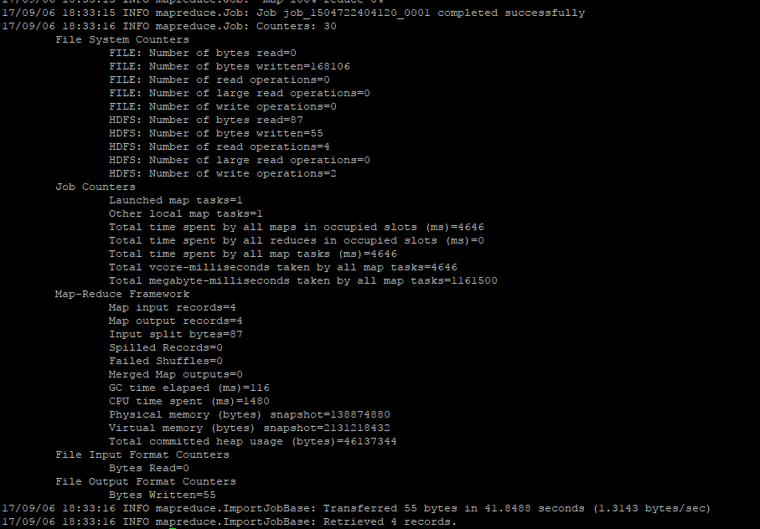

Check the output.

hadoop fs -ls /user/maria_dev/employee/part-m-00000

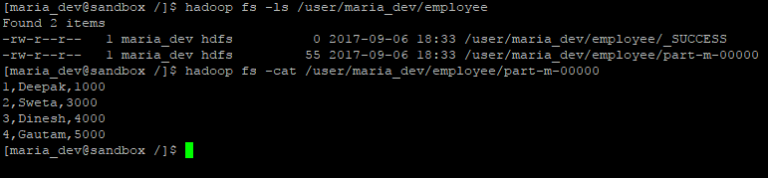`

## Task 2 – HDFS 🡪 MySQL

Sample data file in HDFS to be exported to MySQL

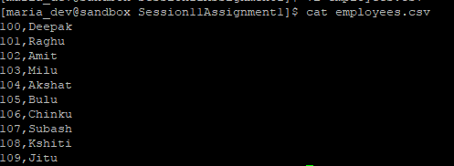

Create a table in hive to match the schema of the sample data file.

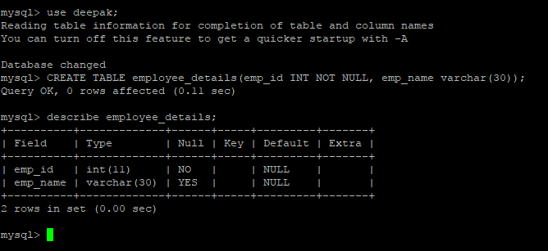

Put this file into hdfs.

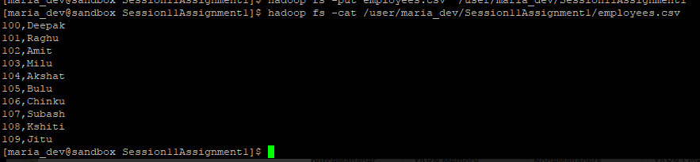

Now, export this data to mysql table employee_details.

sqoopexport--connect jdbc:mysql://localhost/deepak--table employee_details–username root –passwoordhadoop--export-dir/user/maria_dev/Session11Assignment1/employees.csv

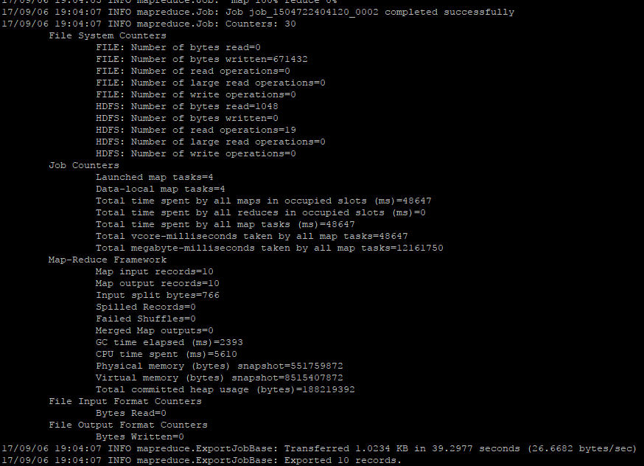

Now, check the table contents in mysql.

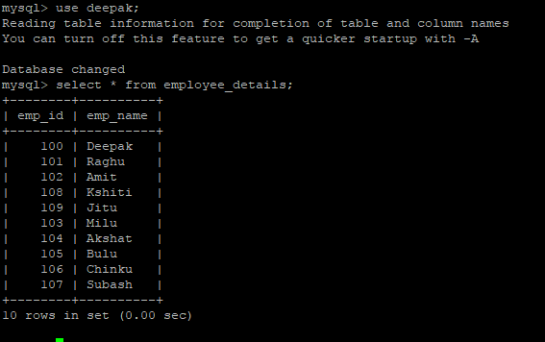

## Task 3 – MySQL 🡪 Hive

Create a table company1 in mysql.

Inser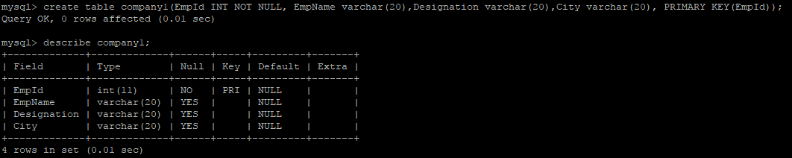

Insert sample data into this table.

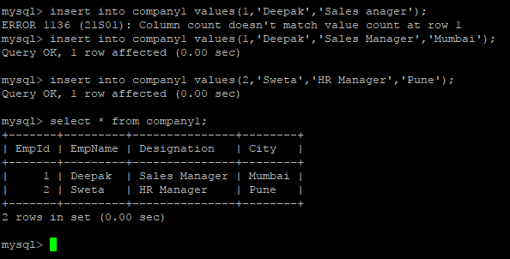

sqoop import --connect jdbc:mysql://localhost/deepak --driver com.mysql.jdbc.Driver --username root -P --split-by EmpId --columns EmpId,EmpName,City --table company1 --target-dir /user/maria_dev/myhive1 --fields-terminated-by "," --hive-import --create-hive-table --hive-table custom.company1hive

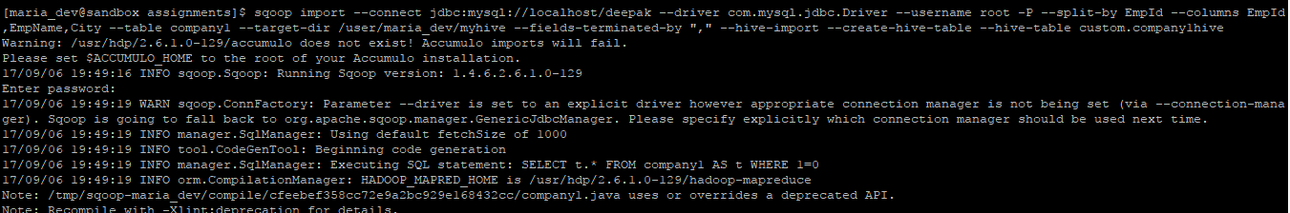

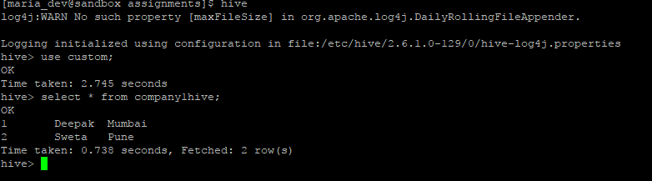

We can see that data has been transferred to hive table from mysql table.

## Task 3 – Hive 🡪 MySQL

From the above hive table compay1hive, we will fetch EmpId, EmpName and will transfer them to mysql.

Create a table in mysql having columns EmpId, EmpName

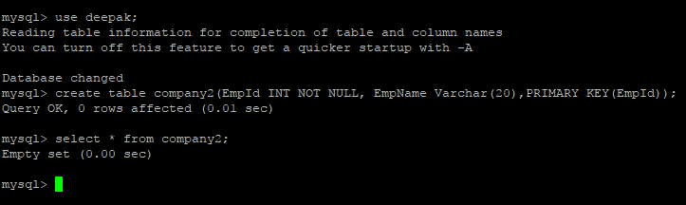

Now, export data from hive to mysql table.

sqoop export --connect jdbc:mysql://localhost/deepak --driver com.mysql.jdbc.Driver --username root -P --columns EmpId,EmpName --table company2 --export-dir /apps/hive/warehouse/custom.db/company1hive --input-fields-terminated-by ','

