Assignment 02

Prob 01 : Which route is generating the most revenue per year?

Create a Tupled RDD from the holiday’s data set (in text file format). Stored as holidaysRDD.

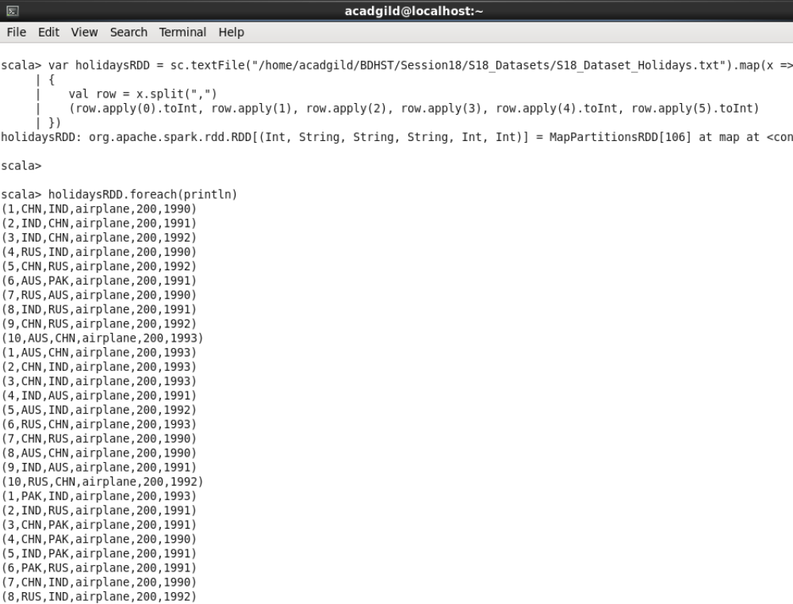

Create a Tupled RDD from the transport data set (in text file format). Stored as transportRDD.

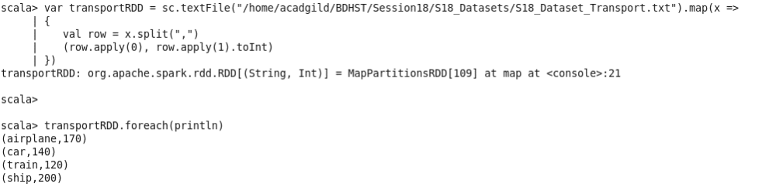

➢ Using the RDD’s created above,
➢ Map the holidaysRDD to only the 4th column with the 2nd and 3rd column (travel_mode, (src, dest)). This will be RDD modeRoute.
➢ Then, join modeRoute with transportRDD an map the result such that you have the 1st column (src, dest and travel_mode) from holidaysRDD and the cost_per_unit from transportRDD

➢ Then, group the data by the key. Here the key is the (src, dest and travel_mode) as the tuple is ((src, dest and travel_mode), cost_per_unit)

(
➢ Then, map the data such that we get the (src, dest and mode) and sum of the cost for every row that contains the key.
➢ Then you sort the data by cost descending and get the 1st record.

➢ Finally, display the result. . (mostRevenue)

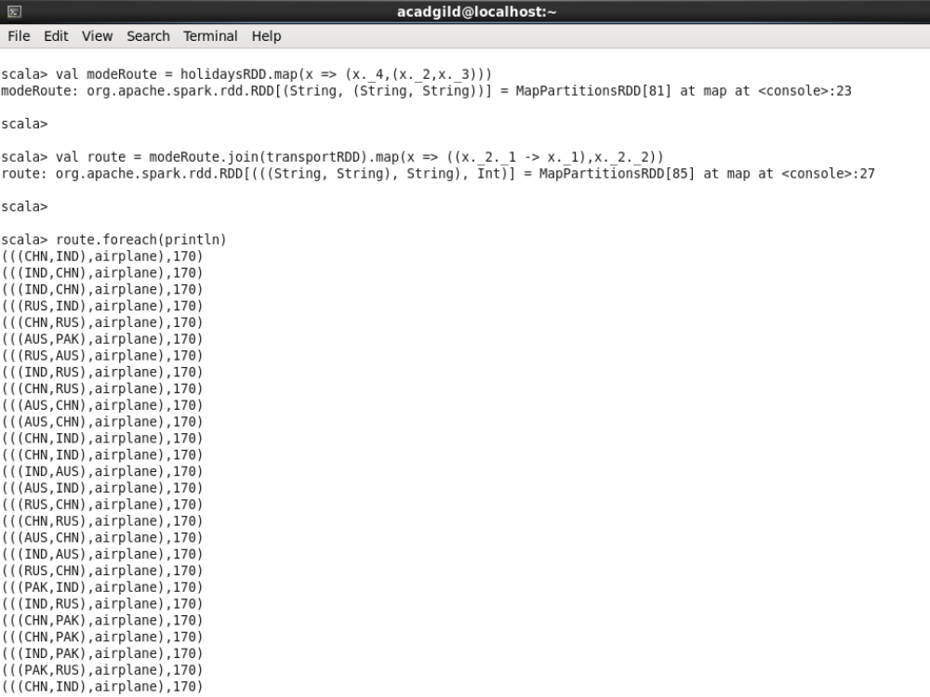
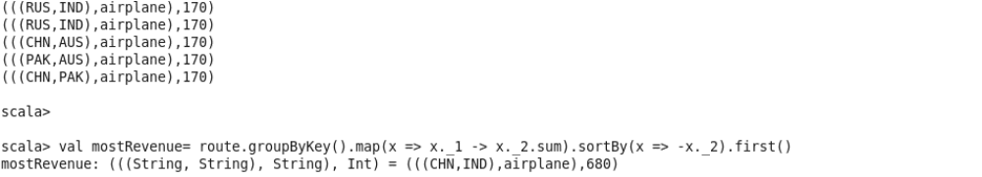
Prob02: What is the total amount spent by every user on air-travel per year?

➢ Using the holidaysRDD and transportRDD created above,

➢ Map the holidaysRDD by grouping the data according to the 4th, 1st and 6th column (travel_mode, (user_id and year)). This is userYear.

➢ Then, join userYear with transportRDD an map the result such that you have the 1st column (user_id and year) from holidaysRDD and the cost_per_unit from transportRDD. This is userYearExpense.

➢ Then, group the data in userYearExpense by the key. Here the key is the (user_id, year) as the tuple is (user_id, year, cost_per_unit)

➢ Then, map the data such that we get the sum of the cost for every row that contains the (user_id, year) (distinct).

➢ For better readability, I have used the sortByKey() that sorts the data according to the key (user_id, year)
➢ Finally, display the result. (userTotExpense)

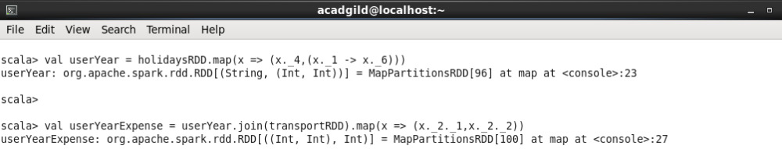
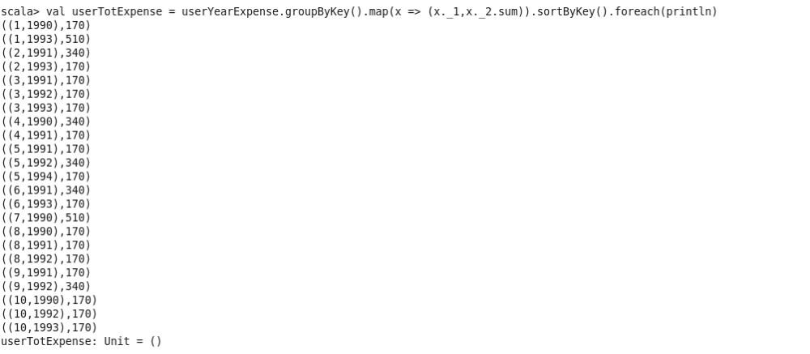
Prob03: Considering age groups of < 20, 20-35, 35 >, which age group is travelling the most every year?

To find which age group is travelling the most every year:

➢ Create a Tupled RDD from the user data set (in text file format). Stored as userDetailsRDD.

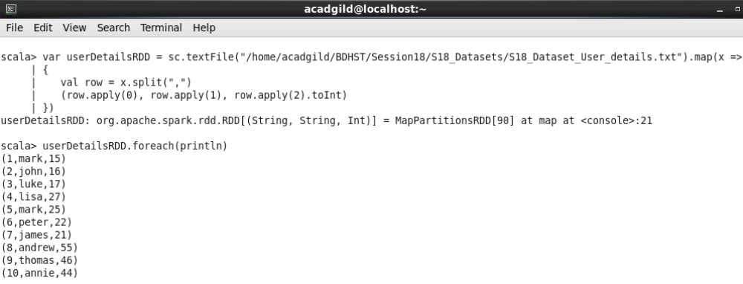

➢ Using the holidaysRDD and userDetailsRDD created before,

Here I have created an Object named AGTravellingMost that holds the implementation:
➢ Map the data in userDetailsRDD by grouping the data according to the 1st column(user_id) and 2nd column formed from checking the condition in the problem statement:

If user age < 20 column data is “<20”
Else if user age > 35 column data is “35>”
Else column data is “20-35”
Now, filter holidaysRDD so that we get the (year, 1) for every user_id and join this to the above
This is AgeGroup.
➢ Then, map the data in AgeGroup by new column to year and 1 for every row.
➢ This data is then grouped by key. Here the key is the (new column, year) as the tuple is (new column, year, 1)

➢ Then, map the data such that we get the sum of the 1’s for every row that contains the (new column, year).

➢ Now, for every year, create a RDD and filter it by the year and sort it descending by 3rd column (sum of 1’s) and get the 1st record.
➢ I have created a list for the results of each year named AGMostTraveledYear and display this as the result.

