Assignment 03:

Prob 01: Considering age groups of < 20, 20-35, 35 >, which age group spends the most amount of money travelling?
To find which age group spends the most amount of money travelling:

Create a Tupled RDD from the holiday data set (in text file format). Stored as holidaysRDD.

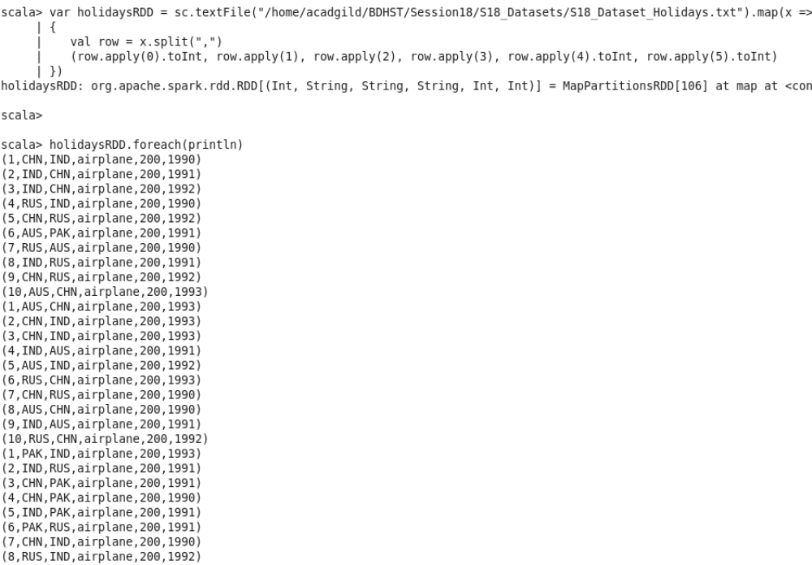

Create a Tupled RDD from the user data set (in text file format). Stored as userDetailsRDD.

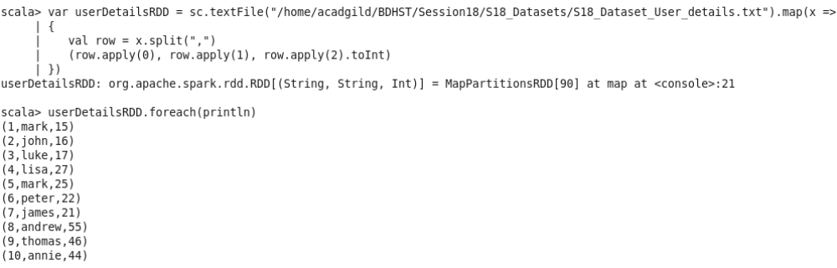

Create a Tupled RDD from the transport data set (in text file format). Stored as transportRDD.

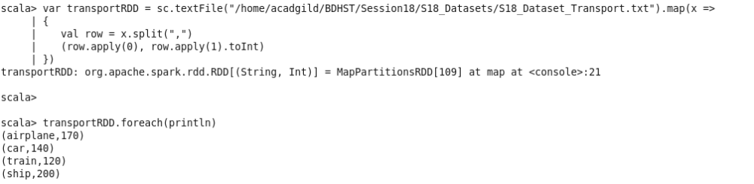

➢ Using the holidaysRDD, userDetailsRDD and transportRDD created above,

Here I have created an Object named AGSpendsMost that holds the implementation:
➢ Map the data in holidaysRDD to only columns 1(user_id) and 4(travel_mode). This is userTravel

➢ Map the data in userDetailsRDD to only columns 1(user_id) and 3(age). This is userAge

➢ Join userTravel and userAge and map the result to only the travel_mode and age and join transportRDD and map the result from this to age and cost_per_unit. This is userAgeDets.

➢ This data is then grouped by key. Here the key is the age as the tuple is (age, cost)

➢ Now, filter the data for every age group (find sum for each record in age group)and create a RDD respectively.

➢ This is the result of the problem; that is displayed.

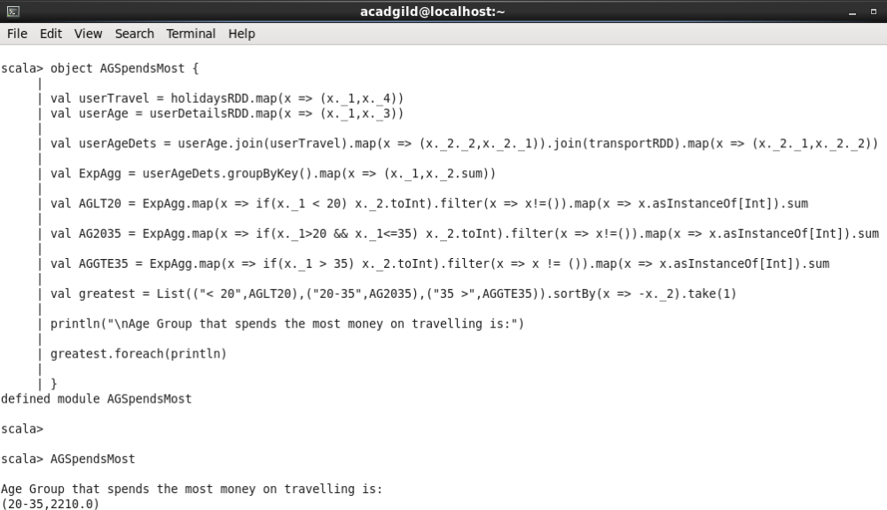
Prob 02: What is the amount spent by each age-group, every year in travelling?

➢ Using the holidaysRDD, userDetailsRDD and transportRDD created before,

Here I have created an Object named AGExpenseYear that holds the implementation:
➢ Map the data in holidaysRDD to only columns 1(user_id) and 4(travel_mode) & 6(year). This is userTravel

➢ Map the data in userDetailsRDD to only columns 1(user_id) and 3(age). This is userAge

➢ Join userTravel and userAge and map the result to only the travel_mode and (year, age) and join transportRDD and map the result from this to (year, age) and cost. This is finalList.

➢ This data is then grouped by key. Here the key is the (year, age) as the tuple is ((year, age), cost) and mapped to (year, sum) and the sum of cost for the key.

➢ Now, filter the data for every age group (group and find the sum for each record in age group) and create a RDD respectively.

This gives the amount spent by each group every year in travelling.
➢ The result is displayed for each group.

