# Session 12 Assignment 1

Objective – To download and install Acadgild Spark VM

First, down the vm image for Acadgild Spark

<https://drive.google.com/file/d/0ByJLBTmJojjzQ2hLc1RLX3pST0U/view>

Click on the following link and download the image and save it to your local system.

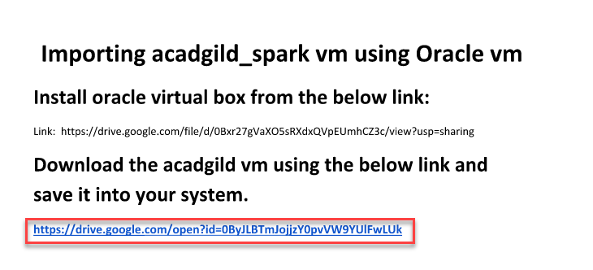

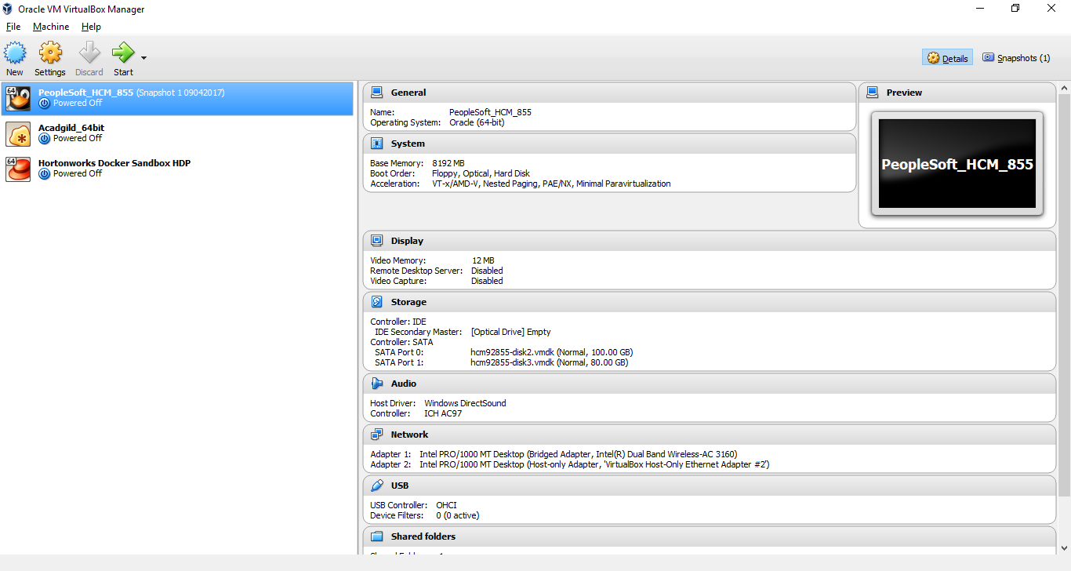

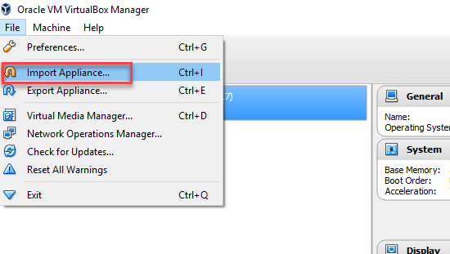

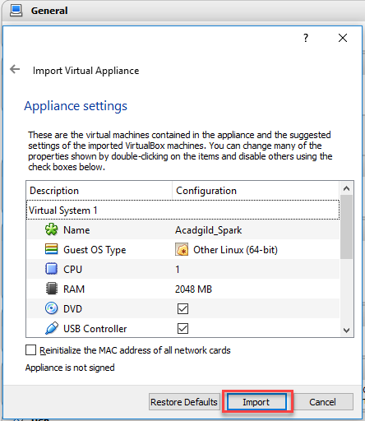

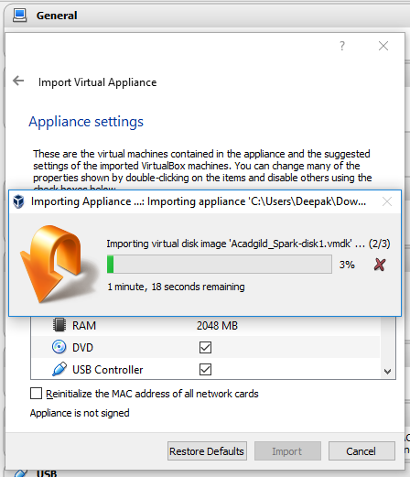

Once import is completed select the instance and click on the start button.

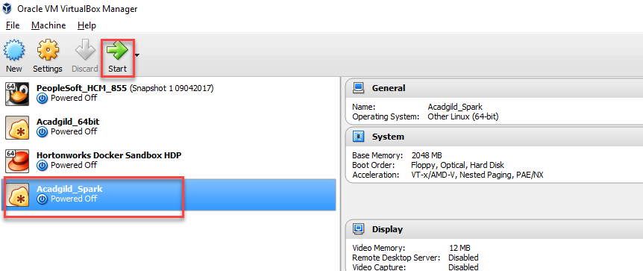

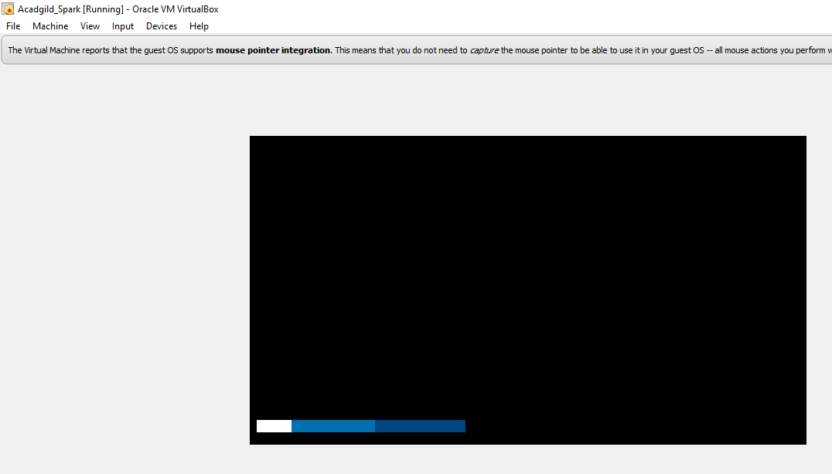

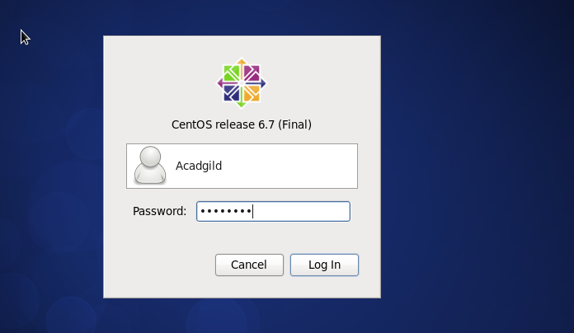

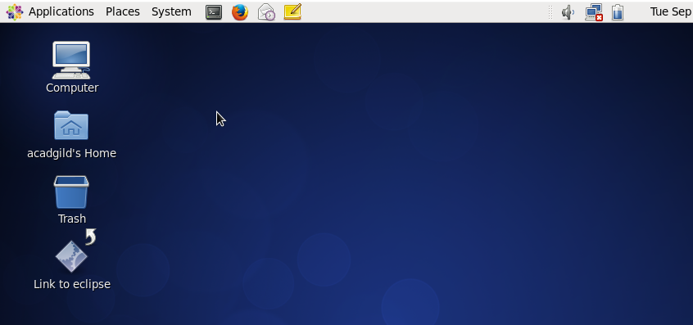

Now, check the services that are running in the VM

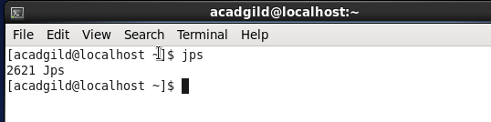

We can see that no services are running, so we will start all the required services.

Start Hadoop Daemons

Start namenode

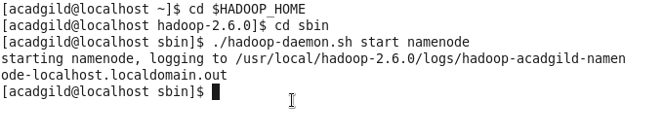

Start datanode



Start resourcemanager



Start nodemanager



Check the services that have started.

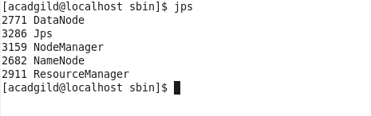

Start Spark Daemons Masters, Workers

Navigate to the following path

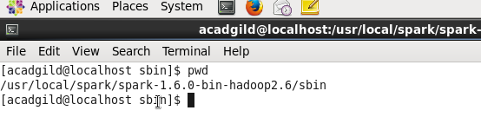

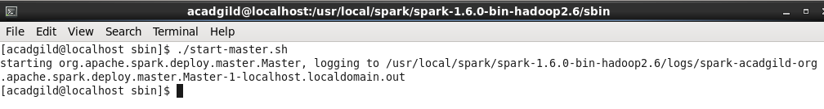

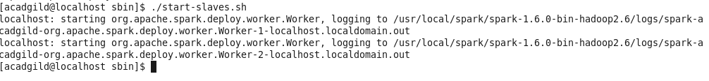

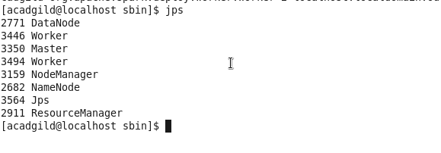

So, our environment is now ready for Spark.