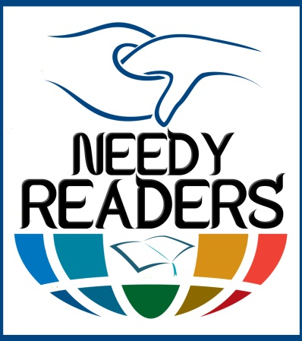

**Needy Readers 2013**

**Project Proposal**

# IMCD - Needy Readers Project



President’s Message…

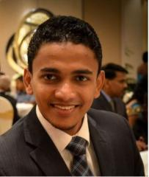

### Upul Chameera Senanayaka

Each and every individual should have a right and a desire to read. There can be many difficulties but non availability of the books shouldn’t be one of them.

Initially, we cannot cater our service to the entire community but at least if we could open the eyes of the children who are going to undertake our country’s future one day, it would be invaluable. Last but not least I would like to invite you all to contribute to The Needy Readers Project by donating at least a single book.

## Needy Readers

The Needy Readers’ project predominantly focuses on the schools and other communities without the library facility or which have limited number of books in their libraries. Reading is the first step to become a versatile intellect who could outstand from the rest. Knowledge, experience and changes in attitudes acquired from reading books bring an immense value to the readers/community.

Nevertheless, there are students who have the desire to read, willing to discover the world with the adventures in books, are deprived and underprivileged due to the shortage of good books. IMCD endeavors in facilitating them with the required material, for them to win the world.



**Who are we?**

International Movement for Community Development [IMCD] is an alliance of youth who pursuits to make the society a better place to live. Evolving around this phenomenon, IMCD has been established with the core principle of “From the society, to the society, with the society”. Being an exemplary social service organization, IMCD continuously seek new avenues of enriching the living standards of the community.

IMCD upholds an unwavering integrity, honesty, consequent to the collaboration of passionate, energetic, enthusiastic, selfless young team of graduates, as its’ founders. All members have voluntarily joined with IMCD by sharing the same vision of creating a better world to live. Further, IMCD has nurtured a conducive environment that is enjoyable to work with. ‘Needy Readers’ is one of the timely and valuable projects initiated under IMCDs belt which mainly focuses on schools which lacks library facilities.

**Vision**

To be the global role model in community centered social development.

**Mission**

International Movement for Community Development (IMCD) is a nongovernmental organization whose mission is to facilitate the underprivileged community to uplift their livelihoods. Social, economic, initiatives of IMCD are predominantly designed and implemented, to strengthen the hands of the people who are in need.

**Purposes & Objectives**

1. Advancing the well-being of the society at all levels (Individual, family, rural, urban etc.)

2. To assist the underprivileged people in enhancing their economic, social, and moral wellbeing

3. To empower the people in need to be self-dependent

4. To leverage the resource to the deprived micro level community

**What really is Needy Readers?**

The 'Needy Readers' is a community project which predominantly focuses on schools lacks library facility or schools which have limited number of books in their libraries.

Reading is the first step in become a versatile intellect that will outstand from the rest.   
Knowledge, experience and changes in attitudes acquired from reading books bring an immense value to us.   
Nevertheless, there are students who have the desire to read, willing to discover the world with the adventures in books, are underprivileged due to the shortage of good books. IMCD endeavor in facilitating them with the required material, for them to win the world.

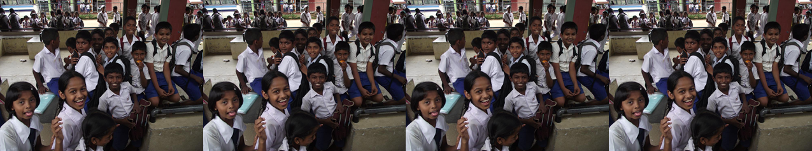

**What’s in store for Needy Readers in 2013?**

Needy Readers primary objective for 2013 is to collect and distribute 50, 000+ books among some selected 20 underprivileged schools from the 9 provinces. Also, collection camps will be driven to gather stationary, shoes and essential goods for the deprived children from around the country. As set forth in 2012, Needy Readers will also look in to distribution of books for the needy cultural centers and public libraries.

“Books are the quietest and most constant of friends; they are the most accessible and wisest of counselors, and the most patient of teachers.” ― Charles William Eliot

Needy Reader believes that books enable the future generation of the rural school children to have a better education that would bring change to our country as they are the future of our country. It is a social responsibility of all to bring ‘Change’ to this country by generously helping the underprivileged children to better their future.

Needy Readers strives to achieve its target of 50, 000+ which will be accomplished through valuable donors who have recognized the importance of catering to the needs of these underprivileged Needy Readers from around the country.

**How does Needy Readers plan to achieve this?**

This is where you as a donor can play a vital role in brightening the future of our underprivileged Needy Readers. Your valuable assistance and donations can make us reach 20 Schools, 50, 000+ books, 10, 000+ Happy Faces.

Needy Readers around the country…..

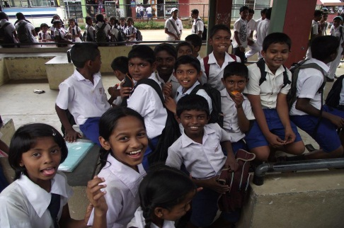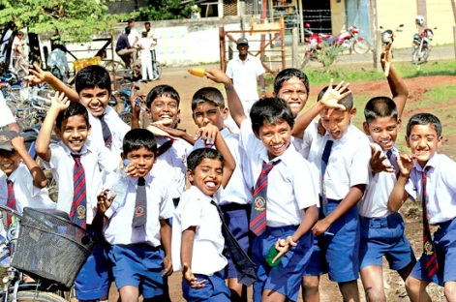

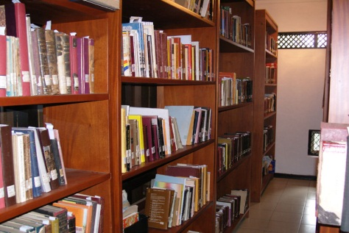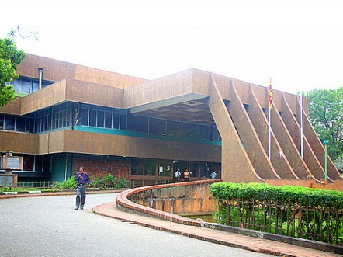

**Needy Readers Success in 2012**

Needy Readers were able to over achieve its target by collecting 12, 000+ books through its most valuable donors.

Beneficiaries included,

Schools-

* Siri Sumanajothi Maha Vidyalaya, Thunnana Hanwella
* Sirihanda Vidyalaya, Rajagiriya
* Dela Tamil Vidyalaya, Dela, Ratnapura
* Colombogama Tamil Vidyalaya, Colombogama, Nivithigala
* Sandalankawa Central Collage, Sandalankawa
* Pannala National School, Pannala
* Ingaradawula Maha Vidyalaya, Ingaradawula

Other-

* Nivithigala Cultural Center, Dela
* New Magazine Prison, Borella
* Pannala Ganapradeepa Public Library, Pannala

Stationary were donated to some of most vulnerable and needy children from Sri Sumanajothi and Colombogama Tamil Vidyalaya.

# Contact Details

# Needy Readers Project Management Committee 2013

Project Manager : Nimanthie Ariyasinghe  
 University of Moratuwa

0772386057

nimanthie.ariyasinghe@gmail.com

Manager Logistics : Madhawa Chandrasiri  
 University of Sri Jayawardanapura   
 0774982677  
 mcmadhawa@gmail.com

Manager Finance : Kanishka Rajawansha  
 University of Colombo

0714470473  
 kanishka.rajawansha@aiesec.net

Manager Events : Haritha Thilakarathne  
 University of Rajarata

07163123667

harithalht@gmail.com

Manager Com : Azeemullah Abdeen  
 National School of Business Management

0754636178

akmalazeee@gmail.com

Manager Doc : Ruwanthika Premalal  
 University of Peradeniya

0772737386

ruwanthikaroo@gmail.com

Manager ER : Hasara Thennakoon  
 University of Peradeniya

0775275080

kalpaniexp@gmail.com

Bhagya Kanakaratne  
 University of Moratuwa

0778861077

bhagya.kanakaratne@gmail.com