- Copy the TextProvider folder and run sh build.sh command to compile the files
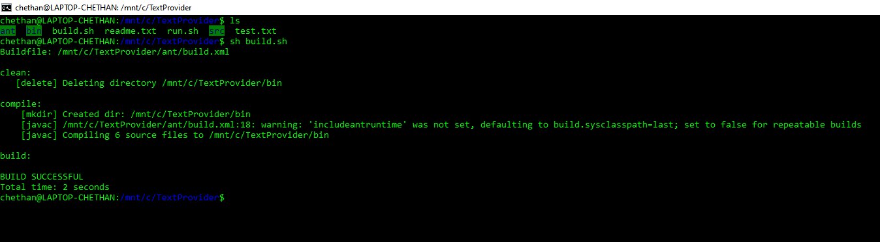

- Create sample test.txt file in unix/linux with some dummy data and run the system by providing test.txt file path as argument. System will create the cache of offset of the all lines and start running in the port 10322.
Sh run.sh <test.txt filepath>

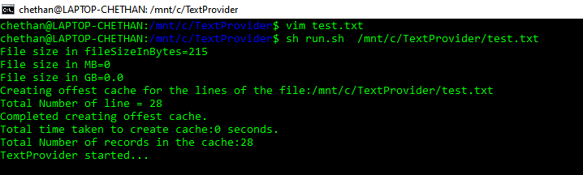

Note: Make sure that sample file is created in unix. For windows file content will not be displayed properly.
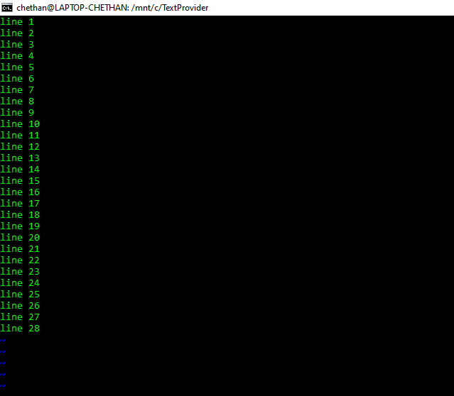

- Open the new window and try connecting using below telnet command.
telnet localhost 10322

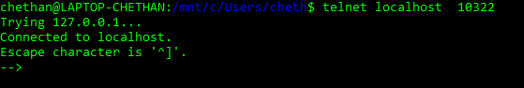

- Once connected, use GET 10(line number) command to display line number 10 content.

