**2.How to create new instances using amazon machine images:**

* **Creating image:**

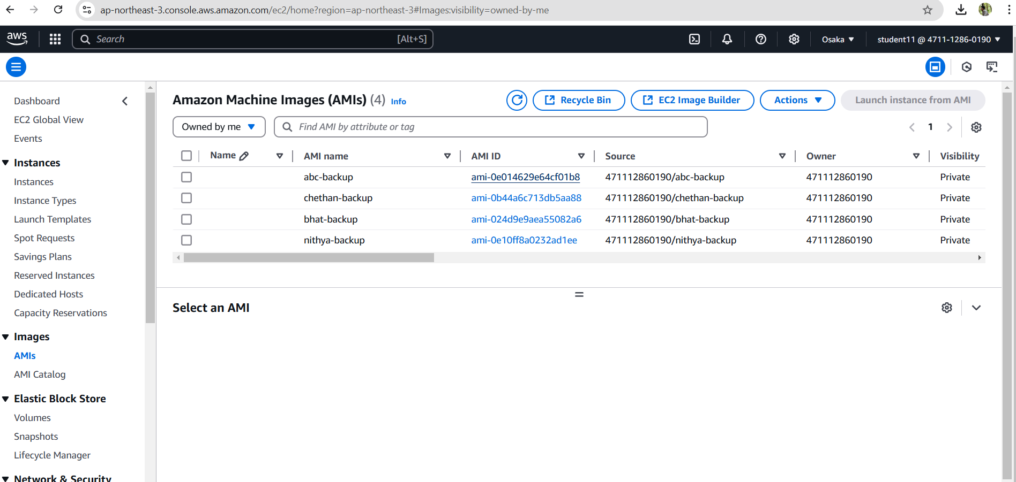

* **Created Instance as chethan-server**

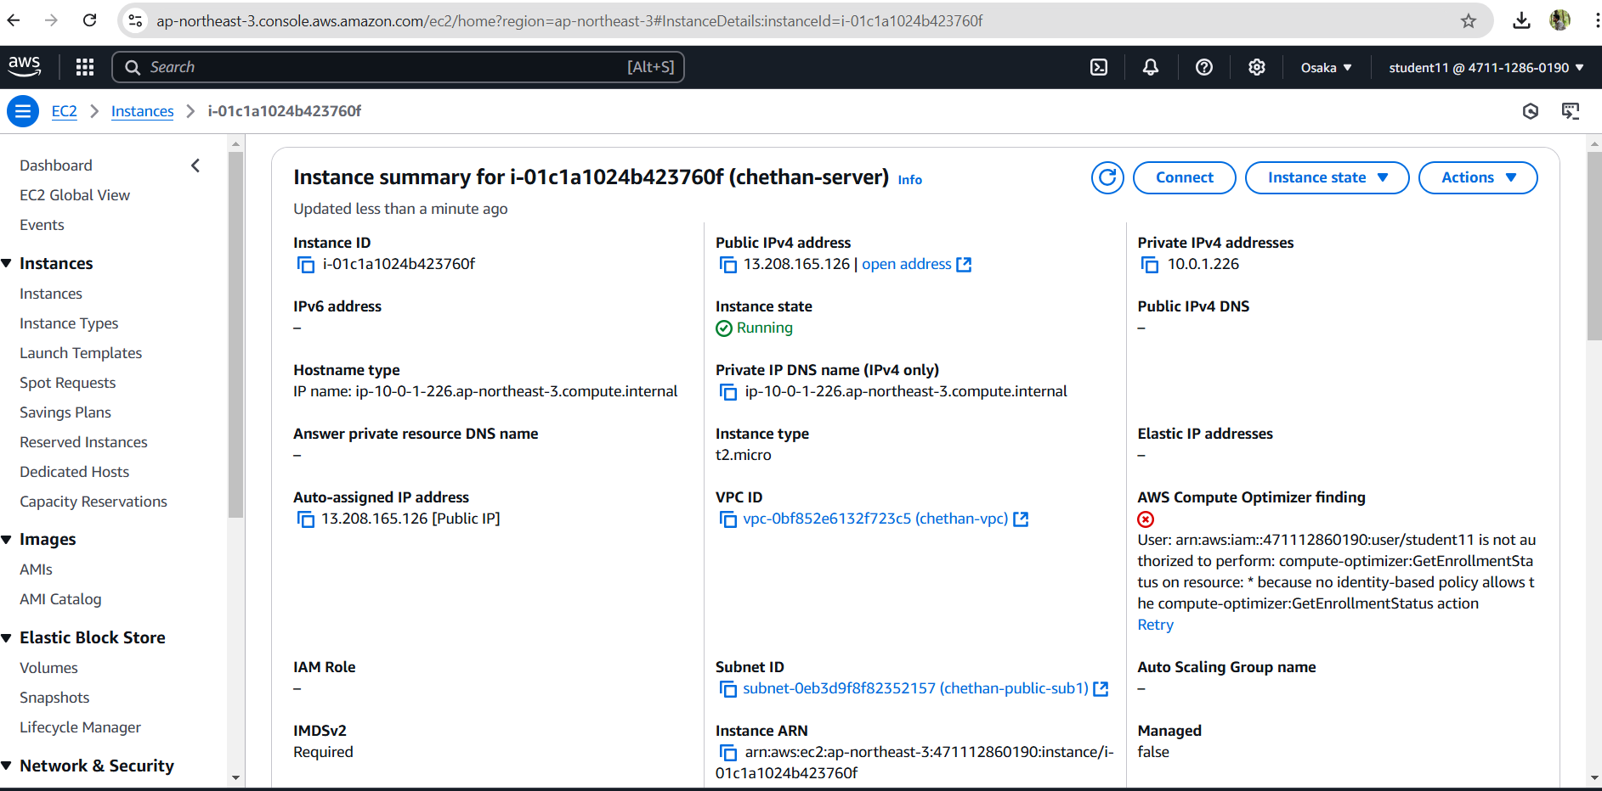

* **Final output**

