**3.How to connect private server to the internet using NAT gateway: (Jump server/Bastion host)**

* **VPC created as chethanvpc**

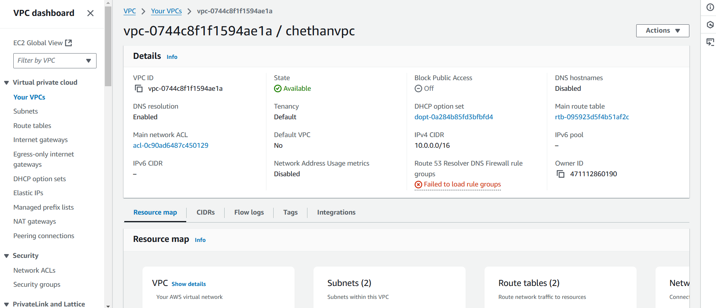

* **Subnet created as a chethansubnet1**

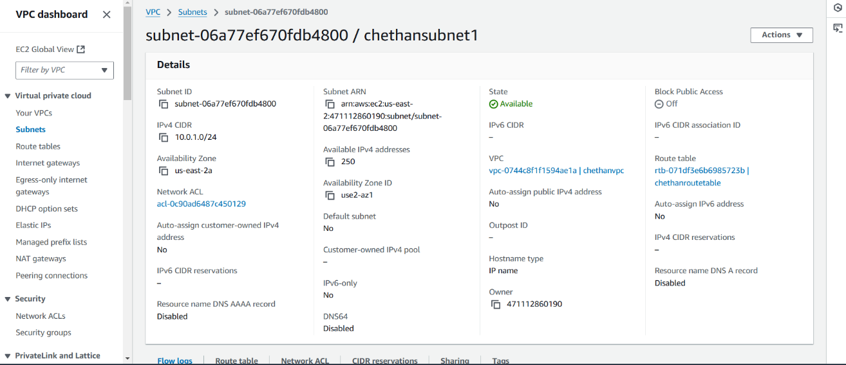

* **Subnet created as a chethansubnet2**

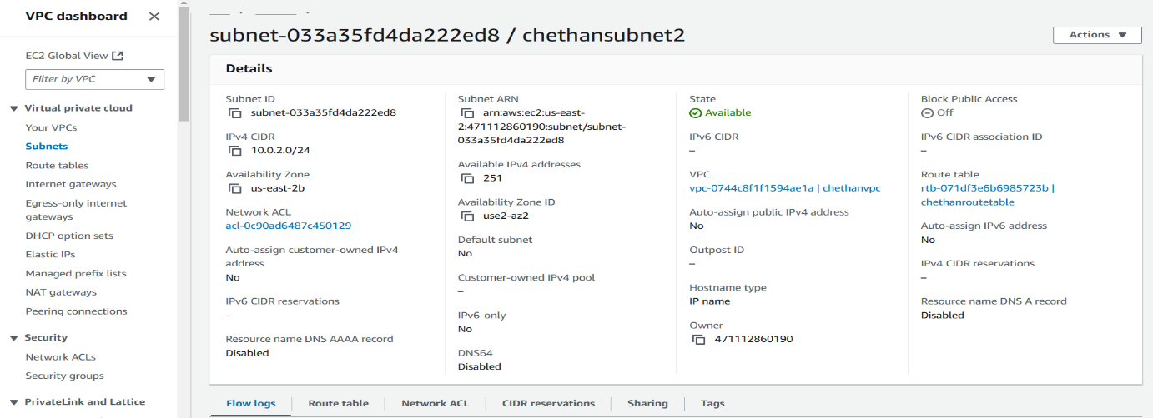

* **Routetable created as chethanroutetable**

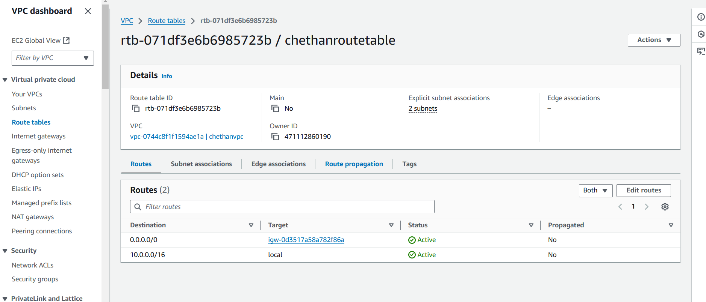

* **NAT gateway is created as Chethangateway**

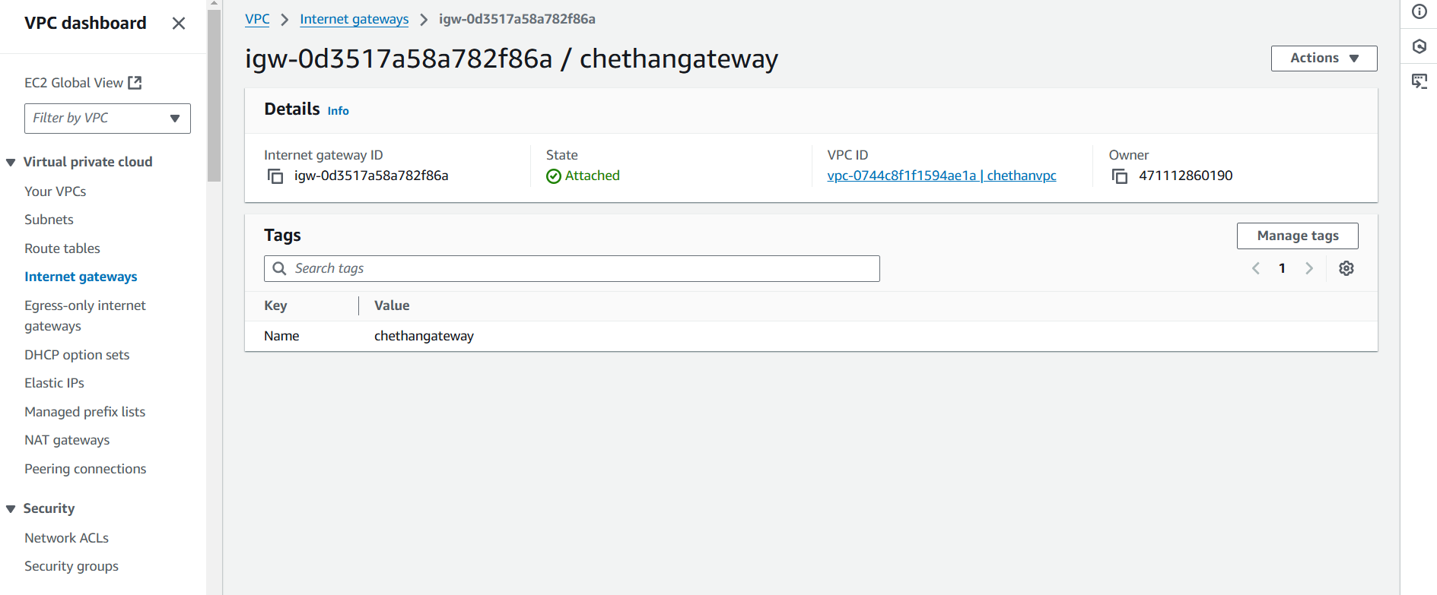

* **Creating private server in private subnet**

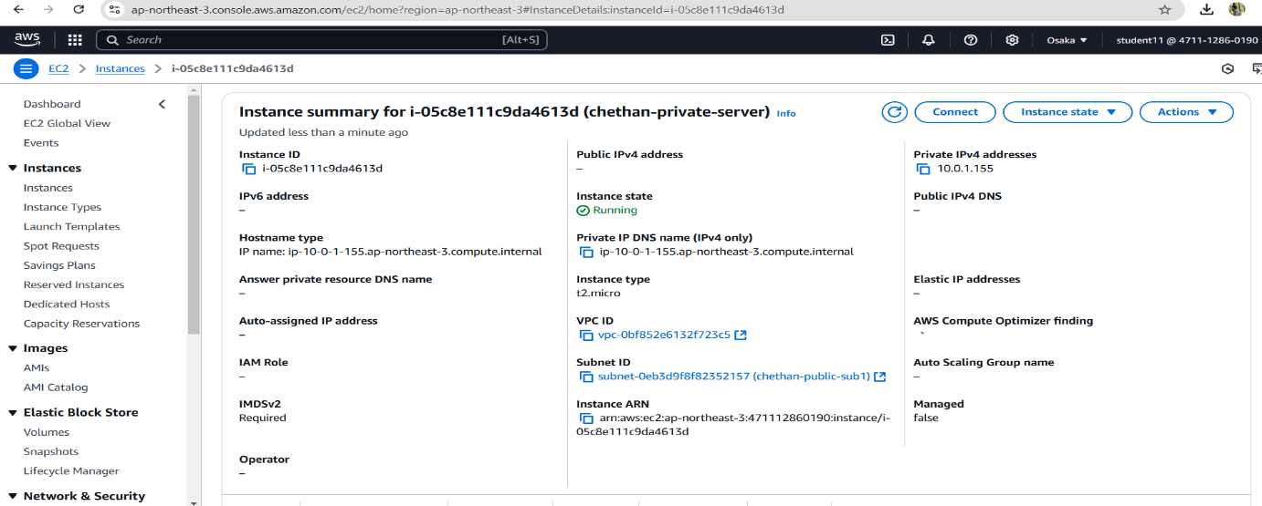

**Command prompt**

