|  |
| --- |
| **1. Create an XHTML page that provides information about your department. Your XHTML page must use the following tags:**  **a. Text Formatting tags**  **b. Horizontal rule**  **c. Meta element**  **d. Links**  **e. Images**  **f. Tables**  **(If needed use additional tags).** |

**Save file as: 1.html**

<html>

<body>

<h1> This is OXFORD COLLEGE OF ENGINEERING</h1>

<h2>MCA Department</h2>

<h3>1<sup>st</sup> semester<h3>

<h4> Web Programming lab</h4>

<hr/>

<p><h3> Text Formatting tags </></h3>

<p><b>hello this is bold</b><i> this is italic </i><strong> this is strong</strong></p>

<p><em>welcome emphasized</em></p>

<p>This is<sub> subscript</sub> and <sup>superscript</sup></p>

<hr/><h3> Links</></h3>

<a href="http://www.toce.com" target="_blank">Visit toce.com!</a>

<hr/>

<h3>Image</h3>

<img src="sunset.jpeg" alt="Sunset” width="100" height="100"/>

<hr/>

<h3>Tables</h3>

<table border="1">

<tr>

<td>100</td> <td>200</td> <td>300</td>

</tr>

<tr>

<td>400</td> <td>500</td> <td>600</td>

</tr>

</table>

</body>

</html>

**Output:**

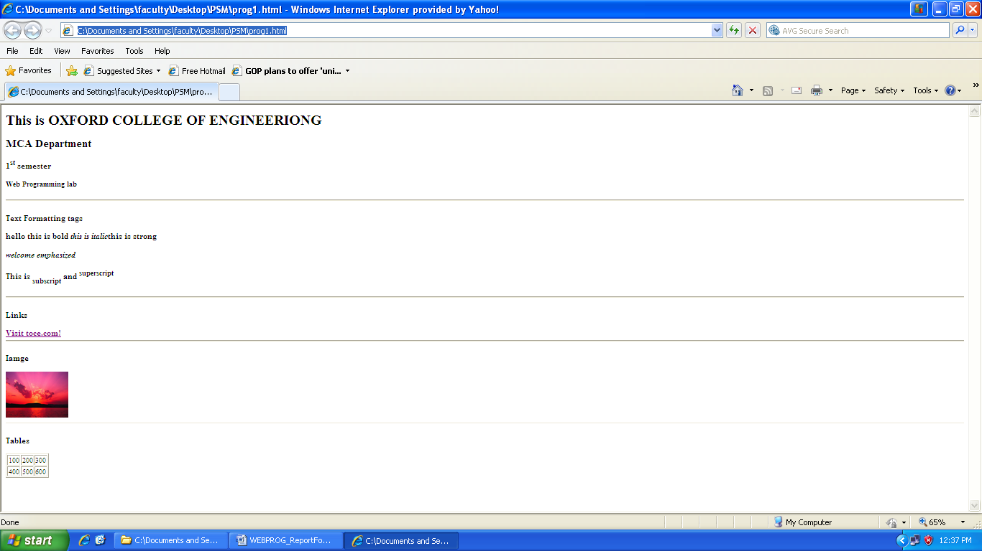

|  |
| --- |
| **2. Develop and demonstrate the usage of inline, external and internal style sheet using CSS. Use XHTML page that contains at least three paragraphs of text, listed elements and a table with four rows and four columns.**  **Save file as: 2.html**  <html>  <head>  <link href="special.css" rel="stylesheet" type="text/css">  </head>  <style type='text/css'>  ul.a {  list-style-type: circle;  }  ol.b {  list-style-type: upper-roman;  }  table, th, td {  border: 1px solid black;  text-align:left;  width:200;  height:50;  padding:10pt;  }  </style>  <body bgcolor=pink>  <h1 style="color:blue">Example of inline stylesheets</h1>  <p style="color:red"><font face="Verdana">Header1</font></p>  <p style="color:blue"><font face="Arial" size="12">Header2</font></p>  <p style="color:red"><font face="Times New Roman" size="11">header3</font></p>  <p class="special">this paragraph should have special green text.  Unordered List items<ul class="a">  <li>A</li>  <li>B</li>  <li>C</li>  </ul><br/>  Ordered List items<ol class="b">  <li>A</li>  <li>B</li>  <li>C</li>  </ol><br/>  <table >  <tr><th>SlNo</th><th>Name</th><th>Contact</th><th>Location</th></tr>  <tr><td>1</td><td>ABC</td><td>12213213</td><td>Bangalore</td></tr>  <tr><td>2</td><td>DEF</td><td>453545</td><td>Chennai</td></tr>  <tr><td>3</td><td>XYZ</td><td>46456546</td><td>Delhi</td></tr>  </table>  </body>  </html>  **Save file as: special.css**  P.special {  color: blue;  border: solid red;  }  **Output:** |

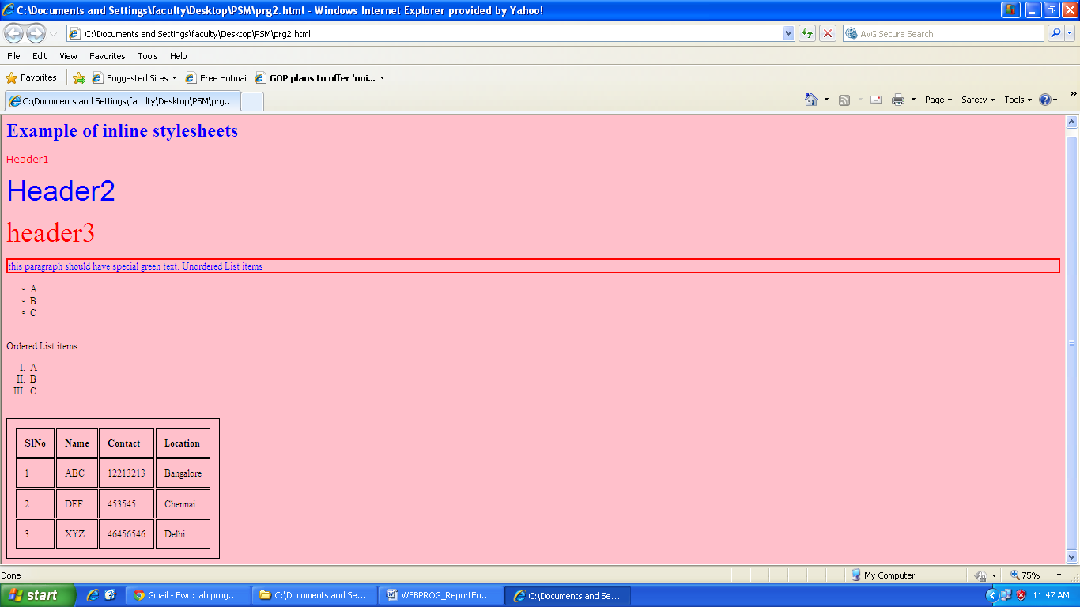

**3. Develop and demonstrate a XHTML file that includes Javascript script for the following problems:**

**a)Input : A number n obtained using prompt Output : The first n Fibonacci numbers**

**Save file as: 3a.html**

<?xml version="1.0" encoding="utf-8"?>

<!DOCTYPE html PUBLIC "-//W3C//DTD XHTML 1.1//EN"

"http://www.w3.org/TR/xhtm111/DTD/xhtm111.dtd">

<html xmlns ="http://www.w3.org/1999/xhtml">

<head><title> Lab1a</title></head>

<body>

<h1>Calculating The Fibonacci Number :</h1>

<hr/>

<script type="text/javascript">

var var1 = 0;

var var2 = 1;

var var3;

var num = prompt("Enter the limit to generate fibonacci no","");

if(num==0)

{

alert("INVALID NUMBER");

}

else

{

if(num==1)

{

document.write(var1+"<br />");

}

else

{

document.write(var1+"<br />");

document.write(var2+"<br />");

for(var i=2; i < num;i++)

{

var3 = var1 + var2;

var1 = var2;

var2 = var3;

document.write(var3+"<br />");

}

}

}

</script> </body> </html>

**Output:**

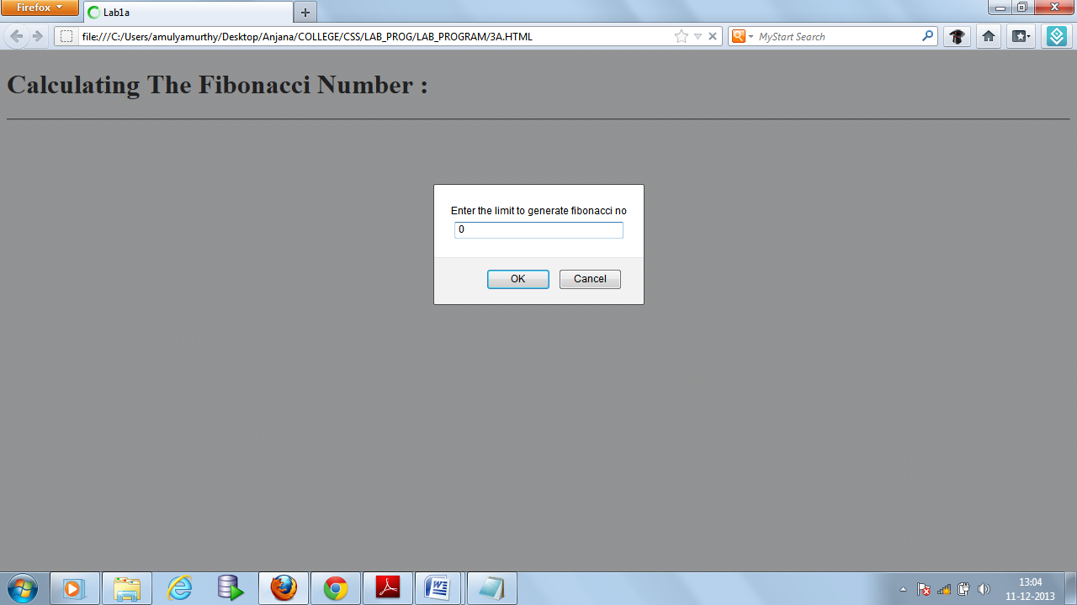 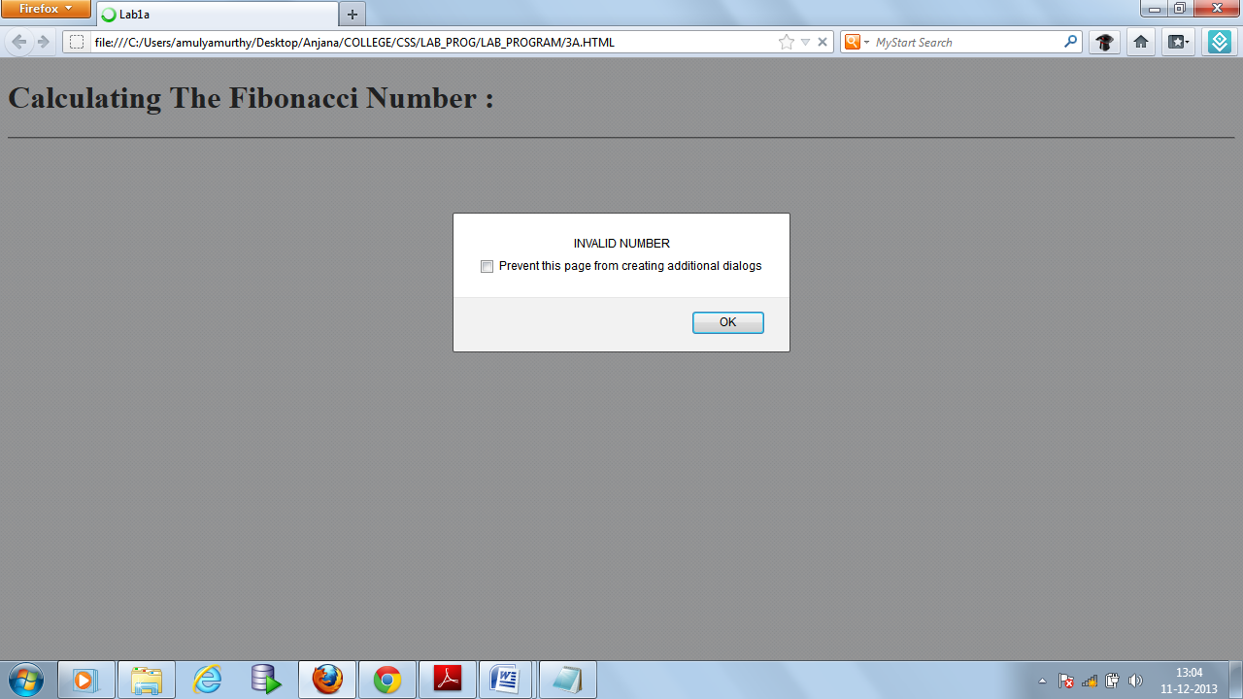

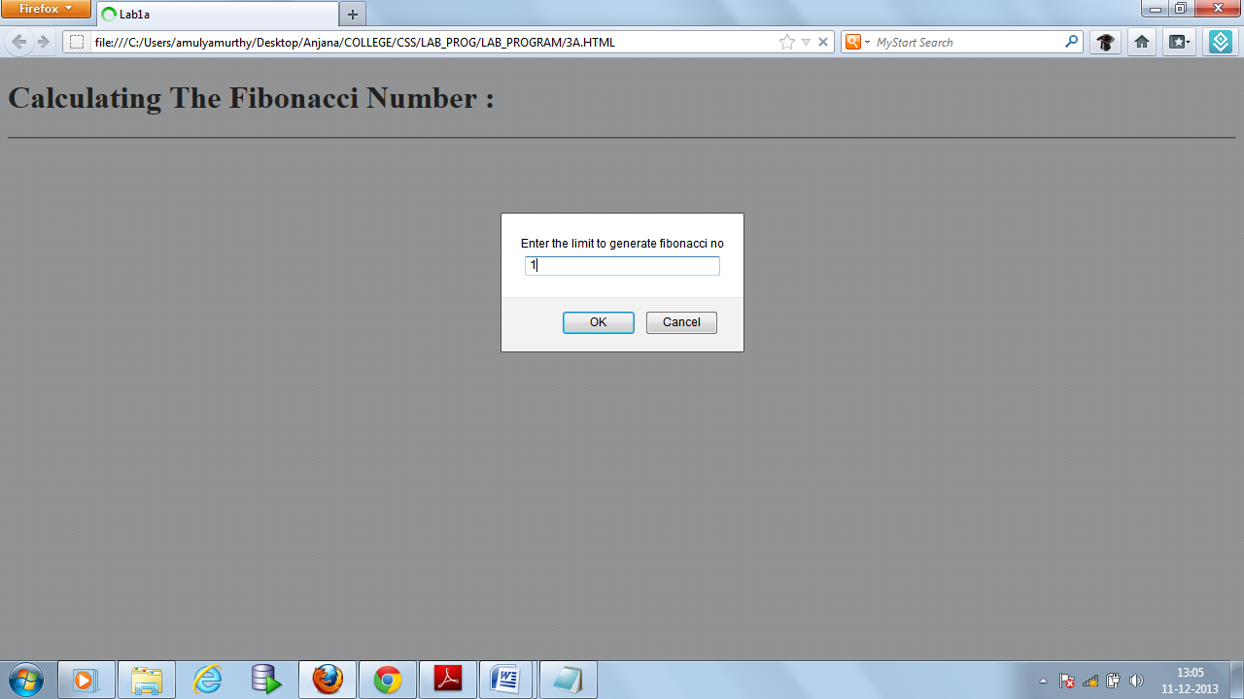 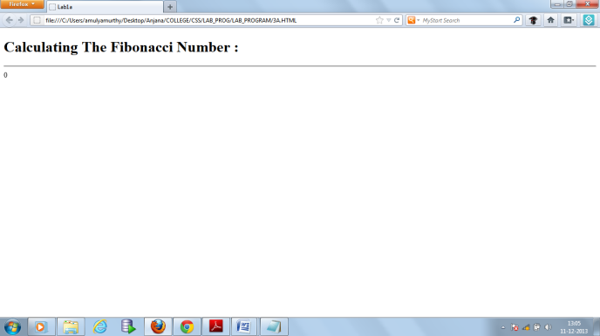

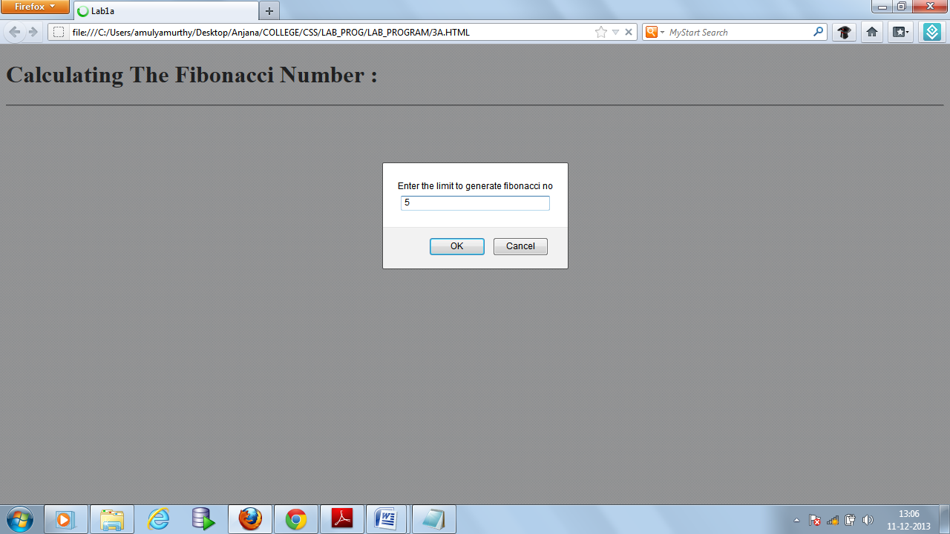 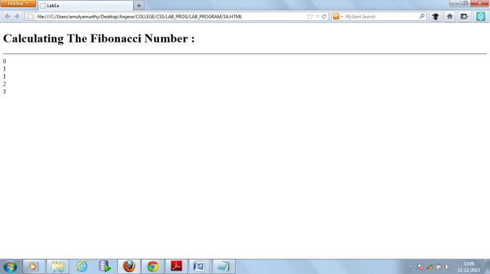

**b)** **Input : A number n obtained using prompt Output : A table of numbers from 1 to n and their squares using alert**

**Save file as: 3b.html**

<?xml version="1.0" encoding="utf-8"?>

<!DOCTYPE html PUBLIC "-//W3C//DTD XHTML 1.1//EN"

"http://www.w3.org/TR/xhtm111/DTD/xhtm111.dtd">

<html xmlns ="http://www.w3.org/1999/xhtml">

<head><title>lab1b</title></head>

<body>

<center>

<h1>CALCULATING SQUARE OF NUMBER</h1>

<hr/>

<table border="border">

<script type="text/javascript">

var num = prompt("ENTER THE LIMIT TO GENERATE SQUARE NUMBERS"," ");

var j = "";

if(num<=0)

{

alert("ENTER A VALID NUMBER");

}

for (var i = 1; i <= num; i++)

{

j += i + " " + i*i + " " + i*i*i + "\n";

}

alert(j);

</script>

</body>

</html>

**Output:**

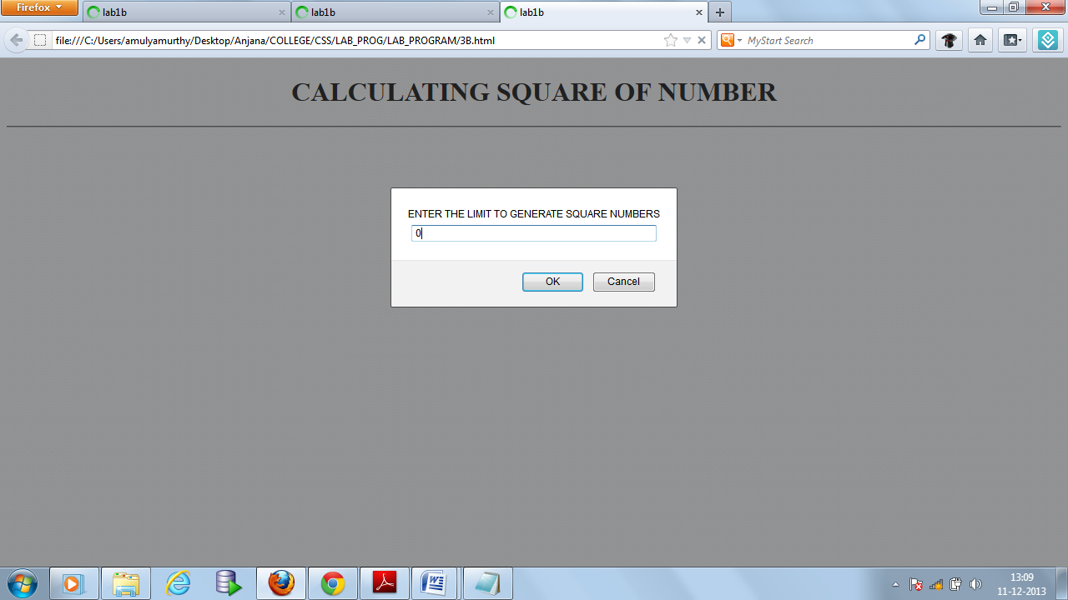 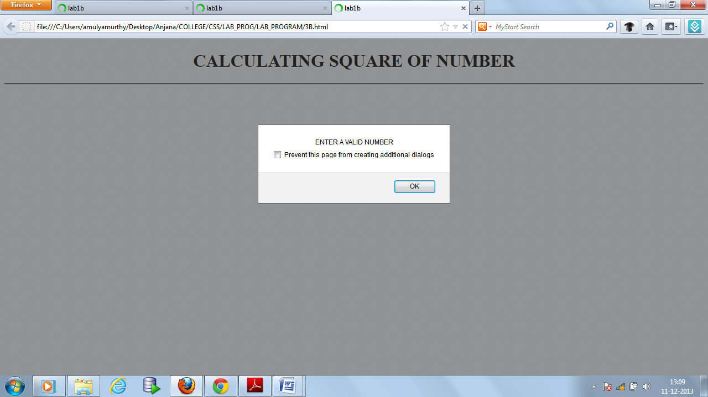

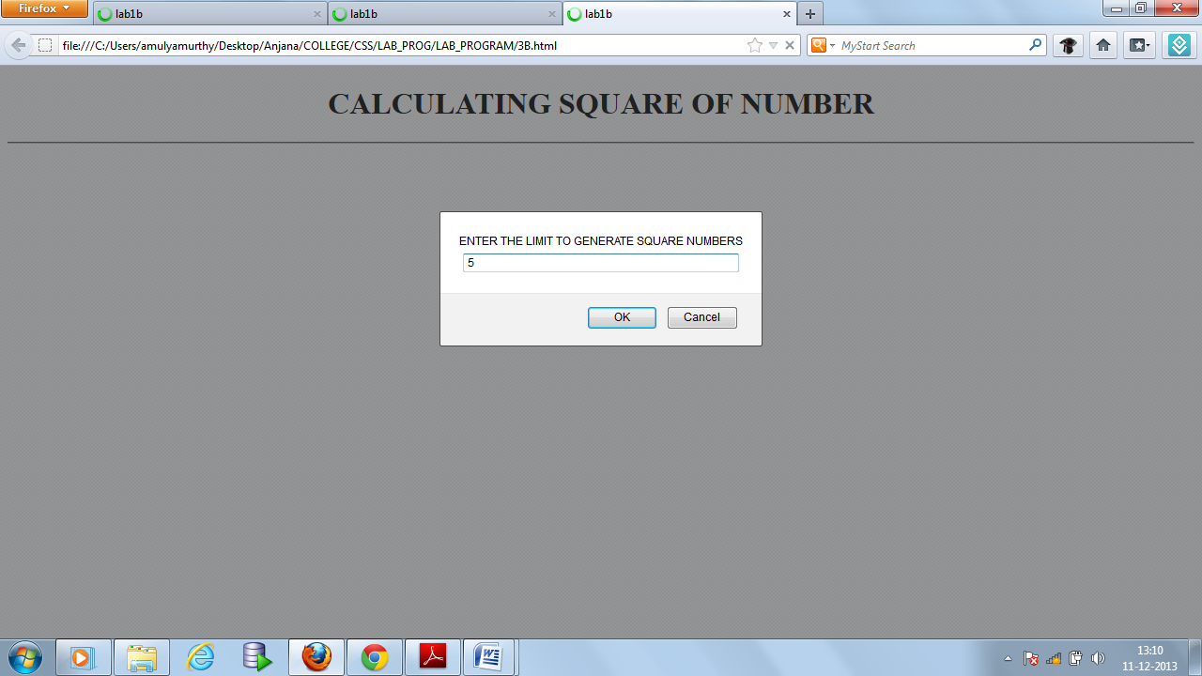

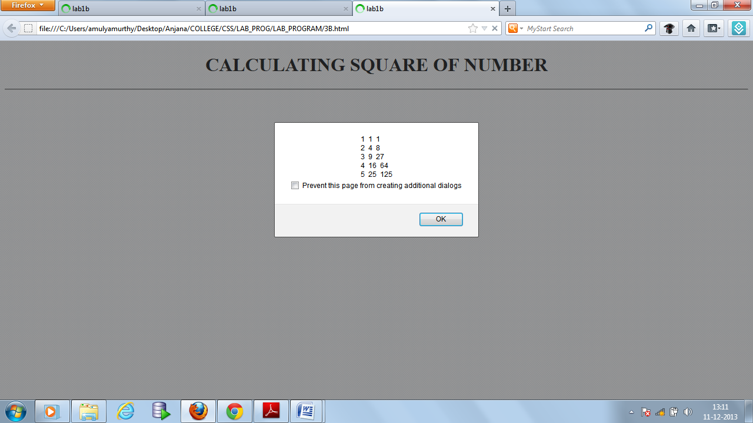

**4. Develop, test and validate an XHTML document that has checkboxes for apple (59 cents each), orange (49 cents each), and banana (39 cents each) along with submit button. Each checkboxes should have its own onclick event handler. These handlers must add the cost of their fruit to a total cost. An event handler for the submit button must produce an alert window with the message ‘your total cost is $xxx’, where xxx is the total cost of the chose fruit, including 5 percent sales tax. This handler must return ‘false’ (to avoid actual submission of the form data).**

**Save file as:4a.html**

<html>

<head>

<title> program 5 </title>

<script type="text/javascript">

function calculate()

{

var c1=document.getElementById("c1");

c2=document.getElementById("c2");

c3=document.getElementById("c3");

t1=document.getElementById("t1");

t2=document.getElementById("t2");

t3=document.getElementById("t3");

total = 0;

if(c1.checked)

{

total += +c1.value;

}

if(c2.checked)

{

total += +c2.value;

}

if(c3.checked)

{

total += +c3.value;

}

tax = total * 0.05;

tax = tax.toFixed(2);

t1 = +tax + +total;

alert('Total cost \t \t= ' + total +'\n sales tax(5%O) \t= '+ tax +'\n-------------------\n' + 'your total cost \t= ' + t1 );

}

</script>

</head>

<body>

<center>

<form method="">

<h1> <u>WELCOME TO FRUITS SHOP </u></h1> <br/> <br/>

<table>

<tr>

<td>

<input type="checkbox" name="c1" id="c1" value="59"/>

Apples(59/-)

</td>

</tr>

<tr>

<td>

<input type="checkbox" name="c2" id="c2" value="49"/>

Orange(49/-)

</td>

</tr>

<tr>

<td>

<input type="checkbox" name="c3" id="c3" value="39"/>

Banana(39/-)

</td>

</tr>

</table>

<br/>

<input type="submit" value="SUBMIT" onClick="calculate()"/>

</form>

</center>

</body>

</html>

**Output:**

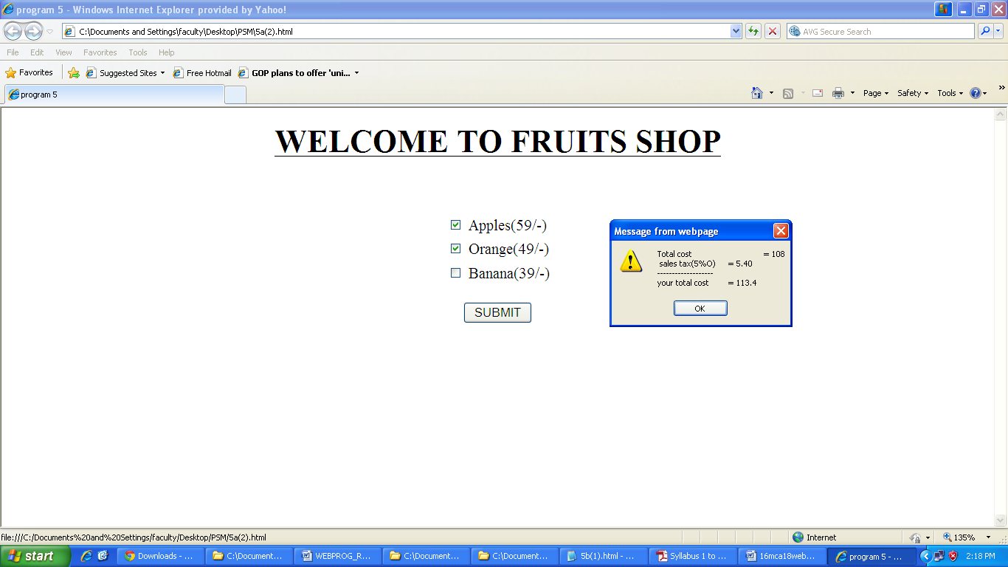

**4b. Modify the document to accept quantity for each item using textboxes**

**Save file as:6b.html**

<html>

<head>

<title> program 5 </title>

<script type="text/javascript">

function showhide1(c1)

{

var t1 = document.getElementById("t1");

t1.style.display = c1.checked ? "block" : "none";

}

function showhide2(c2)

{

var t2 = document.getElementById("t2");

t2.style.display = c2.checked ? "block" : "none";

}

function showhide3(c3)

{

var t3 = document.getElementById("t3");

t3.style.display = c3.checked ? "block" : "none";

}

function calculate()

{

var c1=document.getElementById("c1");

var c2=document.getElementById("c2");

var c3=document.getElementById("c3");

var t1=document.getElementById("t1");

var t2=document.getElementById("t2");

var t3=document.getElementById("t3");

total=0;

if(c1.checked)

{

total += +c1.value *t1.value;

}

if(c2.checked)

{

total += +c2.value*t2.value;

}

if(c3.checked)

{

total += +c3.value*t3.value;

}

tax = total * 0.05;

tax = tax.toFixed(2);

t1 = +tax + +total;

alert("Total cost \t \t= " + total +"\n sales tax(5%) \t= "+ tax +"\n-------------------\n" + "your total cost \t= " + t1 );

}

</script>

</head>

<body>

<center>

<form method="">

<h1> <U> WELCOME TO FRUITS SHOP</U> </h1><BR/><BR/>

<table>

<tr>

<td>

<input type="checkbox" name="c1" id="c1" value="59" onclick="showhide1(this)"/>

Apples(59/-)

</td>

<td>

<input type="text" id="t1" value="1" style="display:none;" size="2"/>

</td>

</tr>

<tr>

<td>

<input type="checkbox" name="c2" id="c2" value="49" onclick="showhide2(this)"/>

Orange(49/-)

</td>

<td>

<input type="text" id="t2" value="1" style="display:none;" size="2"/>

</td>

</tr>

<tr>

<td>

<input type="checkbox" name="c3" id="c3" value="39" onclick="showhide3(this)"/>

Banana(39/-)

</td>

<td>

<input type="text" id="t3" value="1" style="display:none;" size="2"/>

</td>

</tr>

</table>

<BR/> <BR/>

<input type="submit" value="SUBMIT" onclick="calculate()"/>

</form>

</CENTER>

</body>

</html>

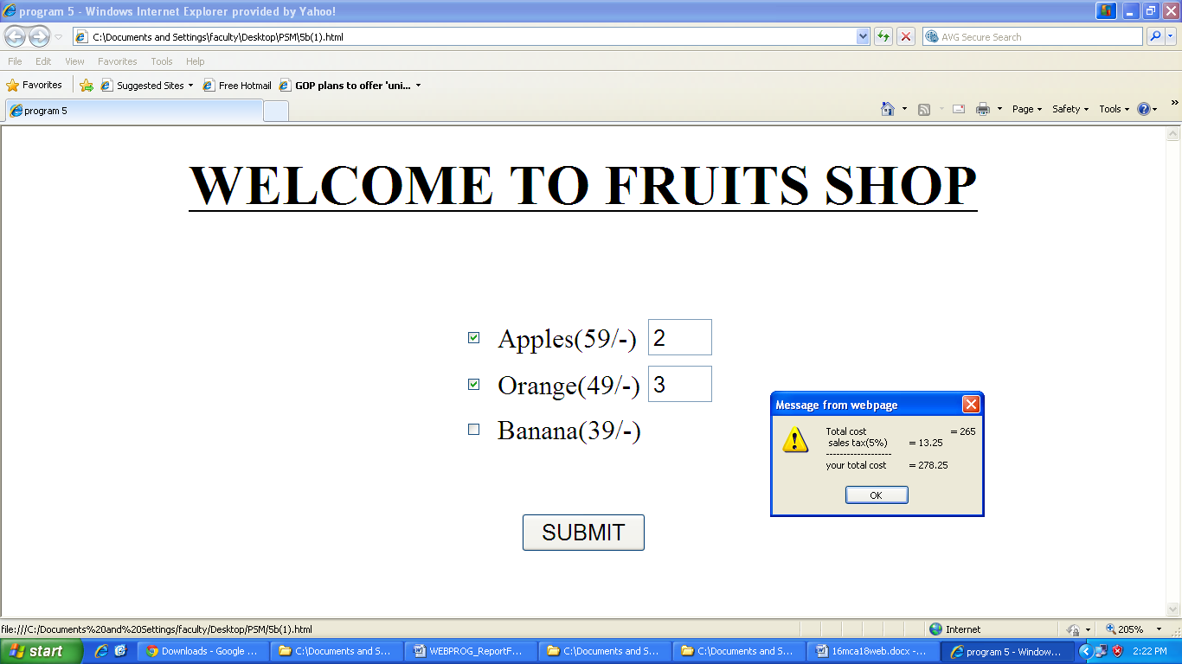

|  |
| --- |
| **5a. Develop and demonstrate, a XHTML document that collects the USN(the valid format is : A digit from 1 to 4 followed by two upper-case characters followed by two digits followed by three upper-case characters followed by two digits; (no embedded spaces are allowed) from the user. Use JavaScript that validate the content of the document. Suitable messages should be display in the alert if errors are detected in the input data. Use CSS and event handlers to make your document good-looking and effective.**  **Save file as: 5a.html**  <?xml version="1.0" encoding="utf-8"?>  <!DOCTYPE HTML PUBLIC "-//W3C//DTD XHTML 1.1//EN" "http://www.w3.org/TR/xhtml 1.1/xhtml//dtd">  <html>  <head><title>Program Lab5a</title>  <script type="text/javascript">  function validate(usn)  { var patt=/[1-4][A-Z][A-Z][0-9][0-9][A-Z][A-Z][A-Z][0-9][0-9]/;  if(!usn.value.match(patt)||usn.value.length>10)  { alert("Invalid, Enter valid USN");  usn.value="";  return false;  }  else  alert("Its valid USN");  }  </script>  </head>  <body>  <h1>Checking USN Format</h1>  <hr/>  <form>  Enter USN <input type="text" name="usn" size="30">  <input type="button" value="check" onclick="validate(usn)">  </form>  </body>  </html>  **Output:** |

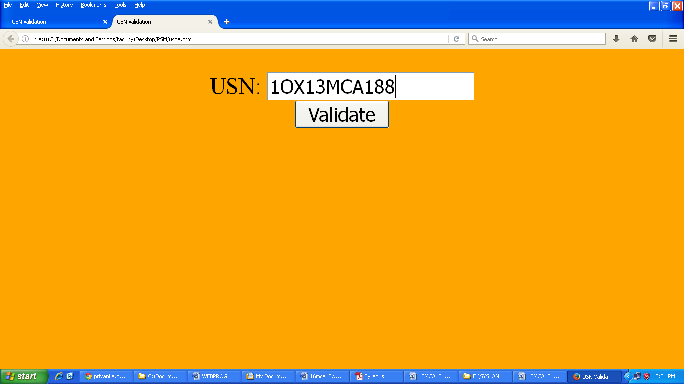

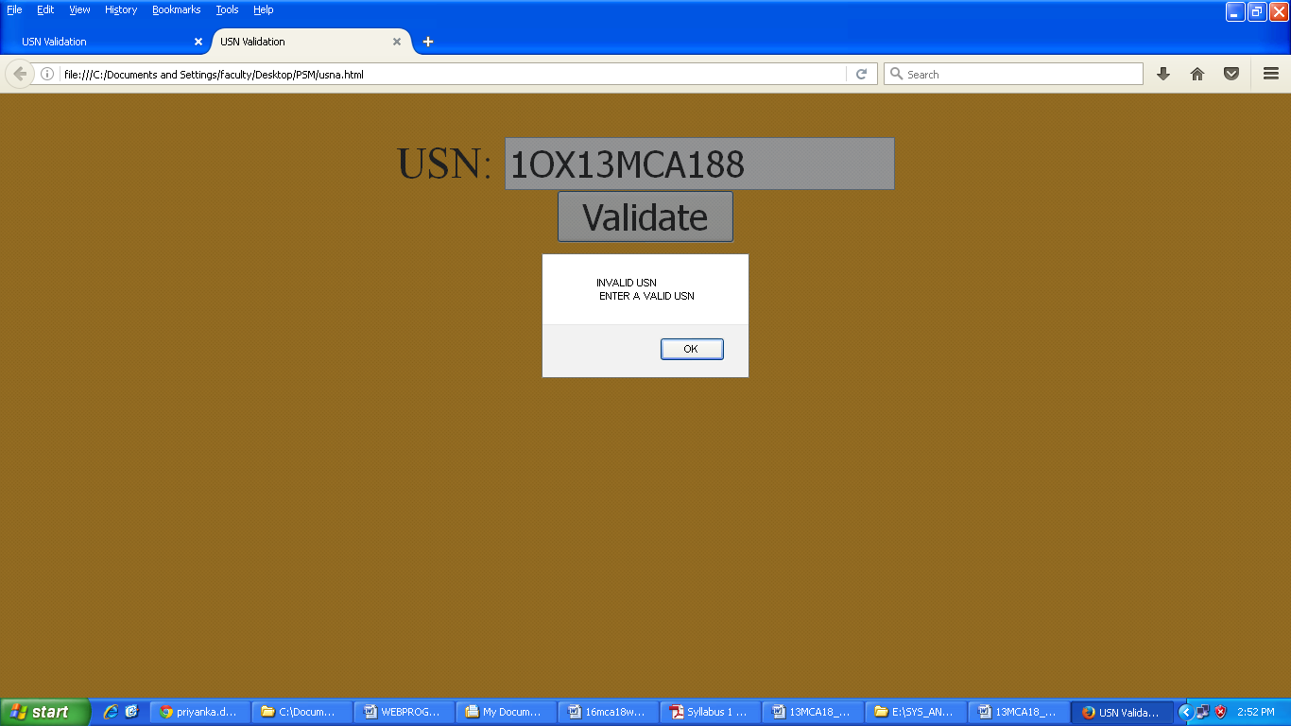

**5b. Modify the above program to get the current semester also (restricted to be a number from 1 to 6**

**Save file as: 5b.html**

<!DOCTYPE html PUBLIC "-//W3C//DTD XHTML 1.0 Transitional//EN" "http://www.w3.org/TR/xhtml1/DTD/xhtml1-transitional.dtd">

<html xmlns="http://www.w3.org/1999/xhtml">

<head>

<head>

<head><title>program 5b</title>

<script type="text/javascript">

function validate(usn)

{

var r=0;

var patt=/[1-4][A-Z][A-Z][0-9][0-9][A-Z][A-Z][A-Z][0-9][0-9]/;

if(!usn.value.match(patt)||usn.value.length>10)

{

alert("invalid, enter valid usn");

usn="";

return false;

}

else

{

var dt=new Date();

var y=parseInt(dt.getFullYear())-2000;

var m=dt.getMonth();

var sm=usn.value.substring(3,5);

var res=y-sm;

if(m<7)

r=res*2;

else

r=res*2+1;

if(r>0 && r<7)

{

alert("it is valid usn\n sem:"+r);

}

else

{

alert("invalid, enter valid usn");

usn="";

return false;

}

}

}

</script>

</head>

<body bgcolor="pink" style="font-family:castellar, calibri;">

<h1>checking usn format</h1>

<hr />

<form>

enterusn:<input type="text" name="usn" size="30">

<input type="button" value="check" onclick="validate(usn)">

</form>

</body>

</html>

**Output:**

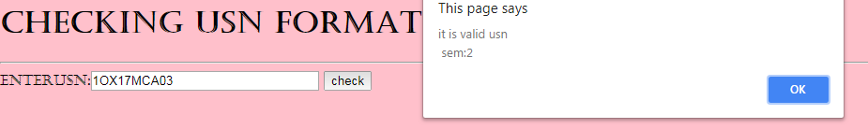

**6. Develop and demonstrate a HTML file which includes JavaScript that uses functions for the**

**following problems:**

1. **Parameter: A string**

**Output: The position in the string of the left-most vowel.**

**6a.html**

<html>

<head>

<title>Program 6a</title>

</head>

<script type="text/javascript">

function vovel()

{

var n = prompt("Enter a string: ","");

flag=0;

for(i=0;i<n.length && flag!=1 ;i++)

{

switch(n[i])

{

case 'a':

case 'e':

case 'i':

case 'o':

case 'u': alert("The left most vowel is present in the position: " +(i+1));

flag = 1;

break;

default : break;

}

}

if(!flag)

alert("No Vowels found.");

}

</script>

<body onload="vovel()">

</body>

</html>

**Output:**

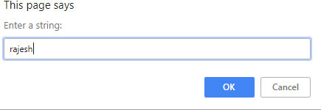

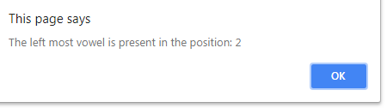

1. **Parameter: A number**

**Output: The number with its digits in the reverse order.**

**6b.html**

<html>

<head>

<title>Program 6b</title>

</head>

<script type="text/javascript">

<!--

function rev()

{

var n = prompt("Enter a number: ","");

var str=0;

for(i=n.length-1;i>=0;i--)

str = str*10 + Number(n[i]);

alert(str);

}

-->

</script>

<body onload="rev()">

**Output:**

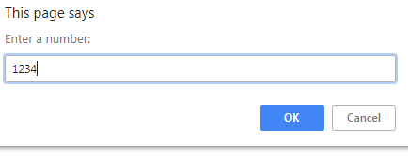

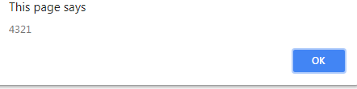

**7a. Develop and demonstrate a HTML5 page which contains**

1. **Dynamic Progressive bar.**

**7a.html**

<!DOCTYPE html>

<html>

<style>

#myProgress {

width: 100%;

background-color: yellow;

}

#myBar {

width: 1%;

height: 30px;

background-color: green;

}

</style>

<body>

<h1>JavaScript Progress Bar</h1>

<div id="myProgress">

<div id="myBar"></div>

</div>

<br>

<button onclick="move()">Click Me</button>

<script>

function move() {

var elem = document.getElementById("myBar");

var width = 1;

var id = setInterval(frame, 10);

function frame() {

if (width >= 100) {

clearInterval(id);

} else {

width++;

elem.style.width = width + '%';

}

}

}

</script>

</body>

</html>

o/p

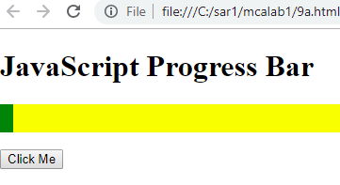

After clicking

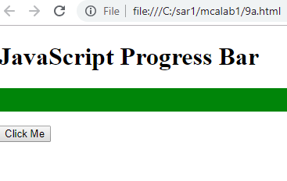

**7b. Display Video file using HTML5 video tag.**

**7b.html**

<!DOCTYPE html>

<html>

<body>

<video width="400" controls>

<source src="file:///C:/Users/mca/Videos/big_buck_bunny.ogv" type="video/mp4">

<source src="file:///C:/Users/mca/Videos/big_buck_bunny.ogv" type="video/ogg">

Your browser does not support HTML5 video.

</video>

<p>

Video courtesy of

<a href="file:///C:/Users/mca/Videos/big_buck_bunny.ogv">Big Buck Bunny</a>.

</p>

</body>

</html>

o/p



**8a. Develop and demonstrate, using JavaScript script, a XHTML document that contains three short paragraphs of text, stacked on top of each other, with only enough of each showing so that the mouse cursor can be placed over some part of them. When the cursor is placed over the exposed part of any paragraph, it should rise to the top to become completely visible.**

8a.**html**

<?xml version="1.0" encoding="utf-8"?>

<!DOCTYPE HTML PUBLIC "-//W3C//DTD XHTML 1.1//EN"

"http://www.w3.org/TR/xhtml 1.1/xhtml//dtd">

<head>

<title>The Stacking Order</title>

<style type="text/css">

.layer1

{

border:solid thick black;

padding:lcm;

width:350px;

height:100px;

background-color:rgb(0,255,0);

position:absolute;

top:100px;

left:200px;

z-index:0;

}

.layer2

{

border:dashed thick red;

padding:1cm;

width:300px;

background-color:rgb(100,100,255);

position:absolute;

top:120px;

left:50px;

z-index:0;

}

.layer3

{

border:dotted thick green;

padding:1cm;

width:300px;

background-color:purple;

position:absolute;

top:140px;

left:240px;

z-index:0;

}

</style>

<script type="text/javascript">

var topLayer="layer3";

function mover(toTop)

{

var oldTop=document.getElementById(topLayer).style;

var newTop=document.getElementById(toTop).style;

oldTop.zIndex="0";

newTop.zIndex="10";

topLayer=document.getElementById(toTop).id;

}

</script>

</head>

<body>

<h2>Program include Xhtml document to show the stacking of paragraphs</h2><hr/>

<div style="z-index:10" class="layer1" id="layer1" onmouseover="mover('layer1')">Hi Friends</div>

<div style="z-index:2"; class="layer2" id="layer2" onmouseover="mover('layer2')">Good morning</div>

<div style="z-index:0" class="layer3" id="layer3" onmouseover="mover('layer3')">Have a nice day</div>

</body>

</html>

7a.html o/p

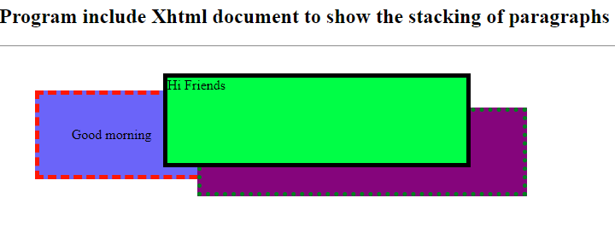

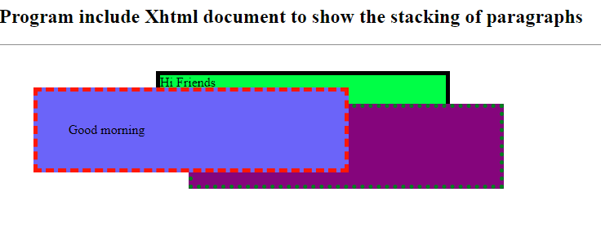

**8b. Modify the above document so that when a text is moved from the top stacking position, it returns to its original position rather than to the bottom.**

**10b.html**

<?xml version="1.0" encoding="utf-8"?>

<!DOCTYPE HTML PUBLIC "-//W3C//DTD XHTML 1.1//EN"

"http://www.w3.org/TR/xhtml 1.1/xhtml//dtd">

<head>

<title>The Stacking Order</title>

<style type="text/css">

.layer1style

{ border:solid thick black;

padding:lcm;

width:300px;

height:200px;

background-color:green;

position:absolute;

top:100px;

left:200px;

z-index:0;

}

.layer2style

{ border:solid thick red;

padding:1cm;

width:300px;

height:200px;

background-color:blue;

position:absolute;

top:120px;

left:220px;

z-index:0;

}

.layer3style

{ border:solid thick green;

padding:1cm;

width:300px;

height:200px;

background-color:purple;

position:absolute;

top:140px;

left:240px;

z-index:0;

}

</style>

<script type="text/javascript">

vartopLayer="layer3";

varorigpos;

function mover(toTop,pos)

{ varnewTop=document.getElementById(toTop).style;

newTop.zIndex="10";

topLayer=document.getElementById(toTop).id;

origpos=pos;

}

functionmoveback()

{ document.getElementById(topLayer).style.zIndex=origpos;

}

</script>

</head>

<body>

<h2>Program include Xhtml document to show the stacking of paragraphs.</h2>

<div style="z-index:10" class="layer1style" id="layer1" onmouseover="mover('layer1','1')" onmouseout="moveback()">Engg College</div>

<div style="z-index:2"; class="layer2style" id="layer2" onmouseover="mover('layer2','2')" onmouseout="moveback()">MCA Dept</div>

<div style="z-index:0" class="layer3style" id="layer3" onmouseover="mover('layer3','3')" onmouseout="moveback()">First Sem</div>

</body>

</html>

7b.html o/p

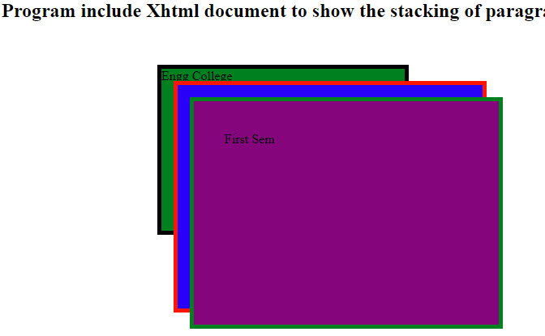

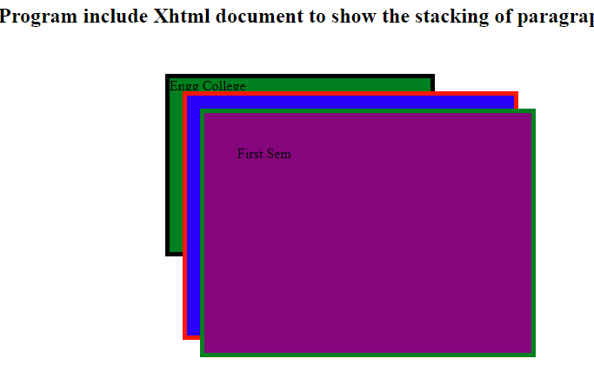

**9. Develop a simple calculator to perform arithmetic (addition, subtraction, multiplication and division) operations on given two numbers. Use an html tag that allows the user to input two numbers and to display the result of arithmetic operation. Write suitable HTML and JavaScript and CSS to your simple calculator. The following figure show sample document display.**



**9.html**

<html>

<head>

<title>lab 8</title>

<link rel="stylesheet" type="text/css" href="view.css"/>

<script type="text/javascript">

function add()

{

var a=parseInt(document.getElementById("t1").value);

var b=parseInt(document.getElementById("t2").value);

c=a+b;

document.getElementById("t3").value=c;

}

function sub()

{

var a=parseInt(document.getElementById("t1").value);

var b=parseInt(document.getElementById("t2").value);

c=a-b;

document.getElementById("t3").value=c;

}

function mul()

{

var a=parseInt(document.getElementById("t1").value);

var b=parseInt(document.getElementById("t2").value);

c=a*b;

document.getElementById("t3").value=c;

}

function div()

{

var a=parseInt(document.getElementById("t1").value);

var b=parseInt(document.getElementById("t2").value);

c=a/b;

document.getElementById("t3").value=c;

}

</script>

</head>

<body>

<center>

<h2><u>A Simple Calculator</u></h2><br />

<form>

<label>Number1=</label><input type="text" id="t1"/><br/><br/>

<label>Number2=</label><input type="text" id="t2"/><br/><br/>

<label>Result=</label><input type="text" id="t3" readonly="readonly"/><br/><br/>

<input type="button" value="ADD" onclick="add()"/>

<input type="button" value="SUB" onclick="sub()"/>

<input type="button" value="MUL" onclick="mul()"/>

<input type="button" value="DIV" onclick="div()"/>

<input type="reset" value="CLEAR"/>

</form>

</center>

</body>

</html>

**view.css**

body{

color:blue;

background-color:yellow;

}

**o/p**

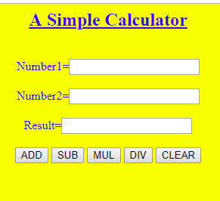

**10. Develop and demonstrate using jQuery to solve the following:**

**a. Limit character input in the text area including count.**

**10a.html**

<html>

<head>

<scripy src="jquery-3.3.1.min.js"</script>

<style>

textarea

{

display:block;

margin:1em 0:

}

</style>

</head>

<body>

<script>

$(document).ready(function()

{

var maxlength=15;

$('textarea').keyup(function()

{

var textlen=maxlength-$(this).val().length;

$('#rchars').text(textlen);

});

});

</script>

<form>

<label>maximum 15 charcters</label>

<textarea id="textarea" maxlength="15"></textarea>

<span id="rchars">15</span>characters remainaing

</form>

</body>

</html>

o/p

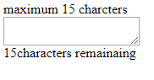

After writing text

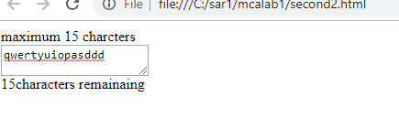

**10b. Based on check box, disable/enable the form submit button.**

**13b.html**

<html>

<head>

<script src="jquery-3.3.1.min.js"></script>

</head>

<body>

<script>

$(document).ready(function()

{

$('#ac').click(function() {

if ($('#sub').is(':disabled')) {

$('#sub').removeAttr('disabled');

} else {

$('#sub').attr('disabled', 'disabled');

}

});

});

</script>

<input id="ac" name="ac" type="checkbox" value="y"/>I accept<br>

<input id="sub" disabled="disabled" name="Submit" type="submit" value="Submit" />

</body>

</html>

o/p

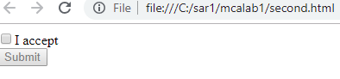

After clicking checkbox

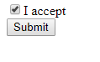

**11. Develop and demonstrate using jQuery to solve the following:**

**a. Fade in and fade out all division elements.**

**11a.html**

<head>

<title>Fade in and fade out all division elements</title>

<script src="jquery-3.3.1.min.js"></script>

<script>

$(document).ready(function(){

$("#btn1").click(function(){

$("div").fadeOut(3000);

});

$("#btn2").click(function(){

$("div").fadeIn(3000);

});

});

</script>

</head>

<body>

<div style="background:orange;width:100%;">My Effect is fadeOut Effect</div>

<button id="btn2">Fade In (3 Second)</button>

<button id="btn1">Fade Out (3 Second)</button>

</body>

</html>

o/p

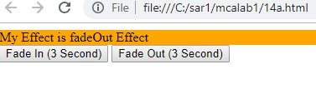

After clicking fade out button

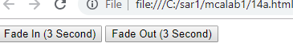

Noiw again clicking fade in button

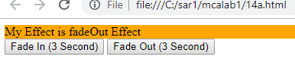

**11b. Animate an element, by changing its height and width.**

**14b.html**

<html>

<head>

<title>Animate an element, by changing its height and width</title>

<script src="jquery-3.3.1.min.js"></script>

<script>

$(document).ready(function(){

$( "#btn1" ).click(function() {

$( "#box" ).animate({

width: "300px",

height: "300px",

}, 3000 );

});

$( "#btn2" ).click(function() {

$( "#box" ).animate({

width: "100px",

height: "100px",

}, 1500 );

});

});

</script>

</head>

<body>

<button id="btn1">Animate height & width</button>

<button id="btn2">Reset</button>

<div id="box" style="background:brown;height:100px;width:100px;margin:6px;"></div>

</body>

</html>

o/p

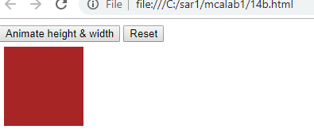

After clicking “Animate height and width” button

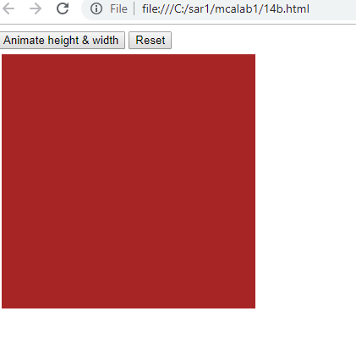

After clicking “Reset” button

