ASSIGNMENT-1

MACHINE LEARNING

NAME- CHETHAN Y

USN- 22BTRAD011

QUESTION 1:

1. Load a dataset with missing values (Boston Housing Dataset). # MUTTA DATTA SAI VISHNU MOHAN (22BTRAD026) import pandas as pd

# Load the Boston Housing dataset data = pd.read_csv('/content/HousingData.csv') 

1. Explore the description of the dataset.

print(data.describe())

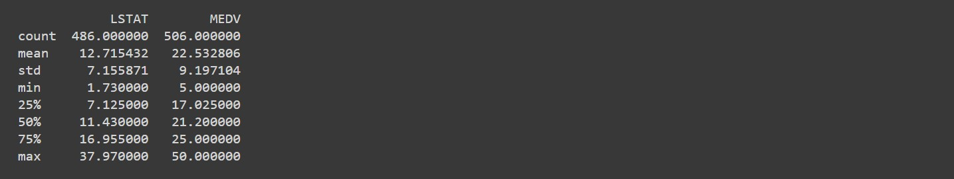

1. Identify the number of missing values corresponding to each feature.

# CHETHAN Y (22BTRAD011)

# Check for missing values print(data.isnull().sum())

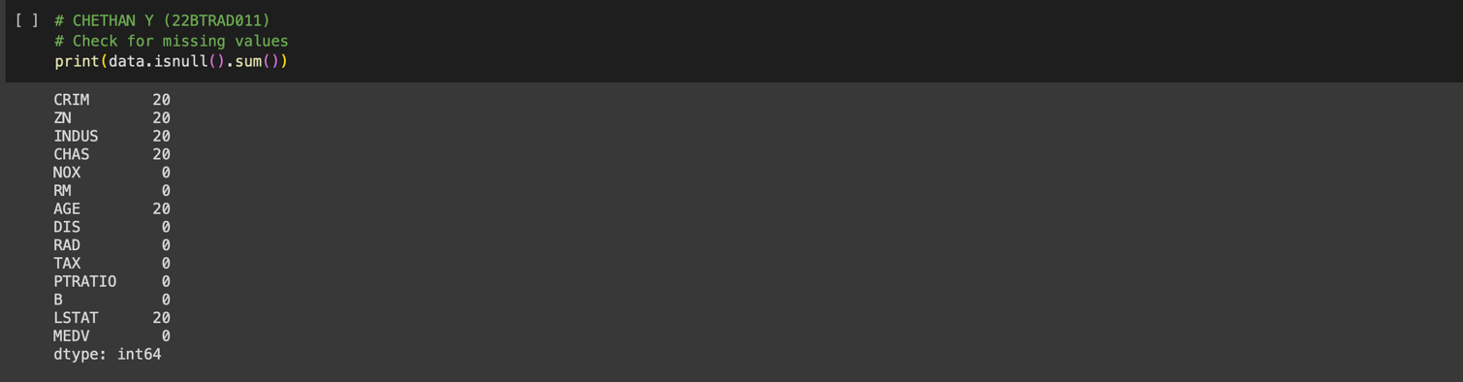

1. Explore and visualize the missing data patterns.

# CHETHAN Y (22BTRAD011)

import matplotlib.pyplot as plt

# Check for missing values and visualize them for col in data.columns: if data[col].isnull().sum() > 0:

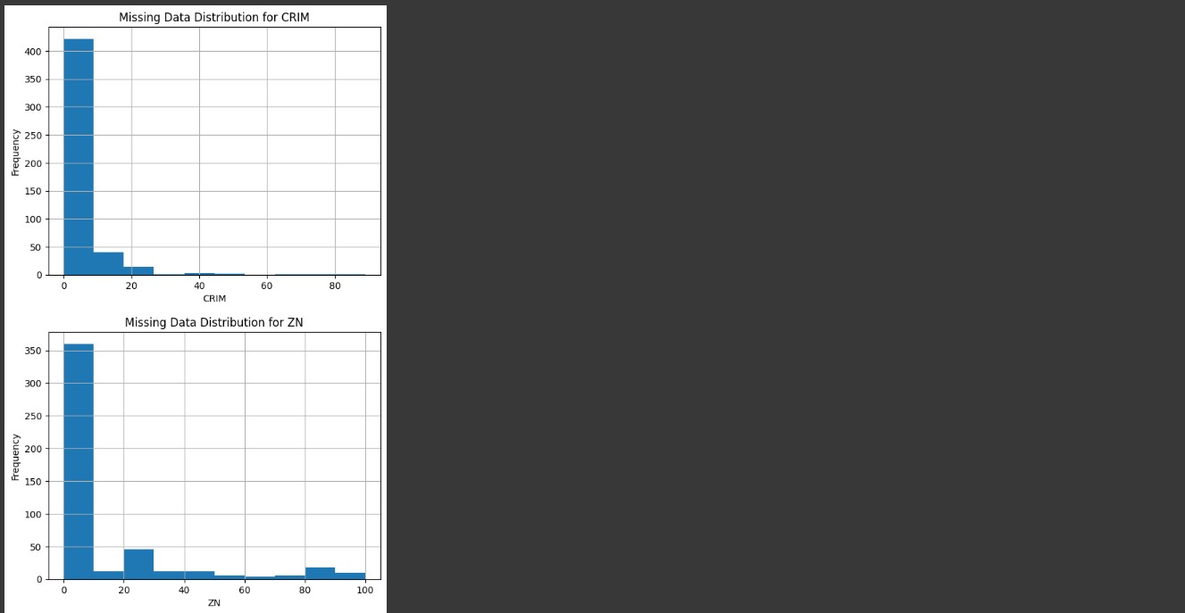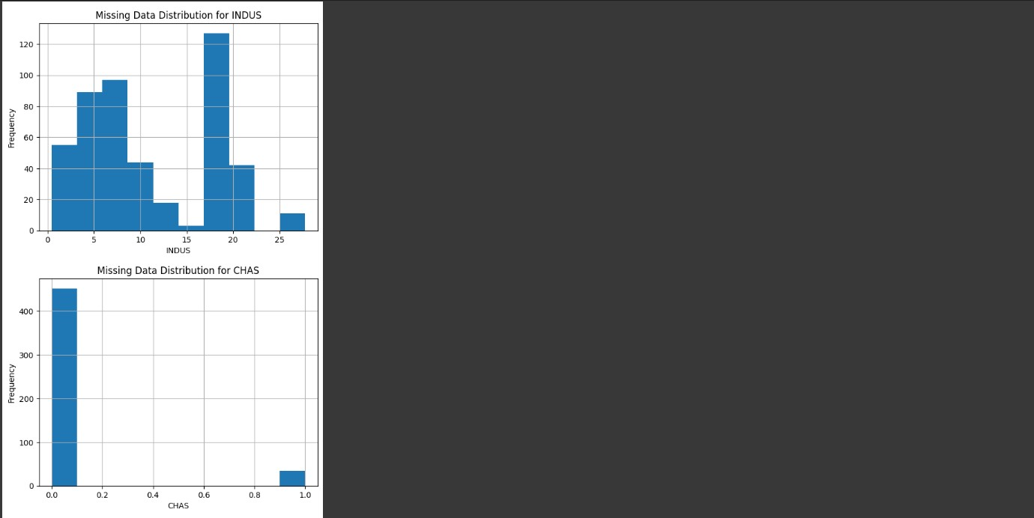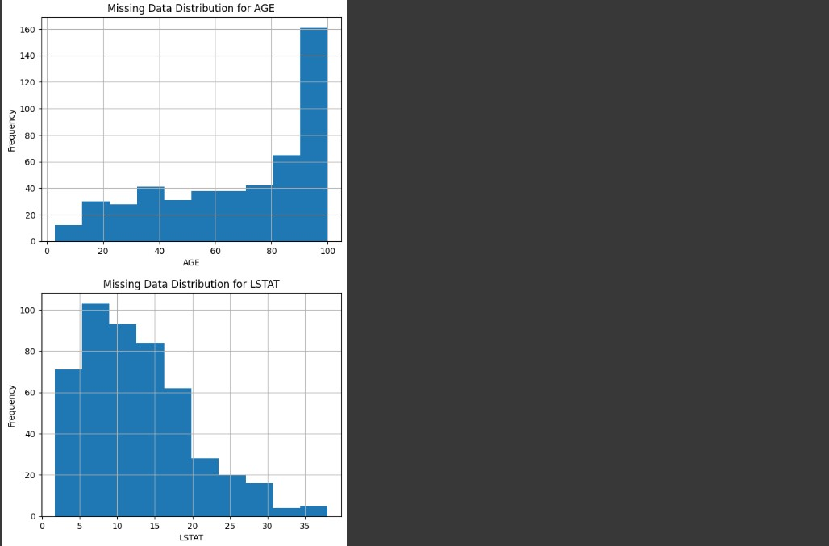

Handle missing values using imputation method for a specific feature. # CHETHAN Y (22BTRAD011)

1. from sklearn.impute import SimpleImputer

# Load the Boston Housing dataset data = pd.read_csv('HousingData.csv')

# Check for missing values print(data.isnull().sum())

# Impute missing values using mean imputation for 'CHAS' feature imputer = SimpleImputer(strategy='mean') imputer.fit(data[['CHAS']]) data['CHAS'] = imputer.transform(data[['CHAS']])

# Check for missing values after imputation print(data.isnull().sum())

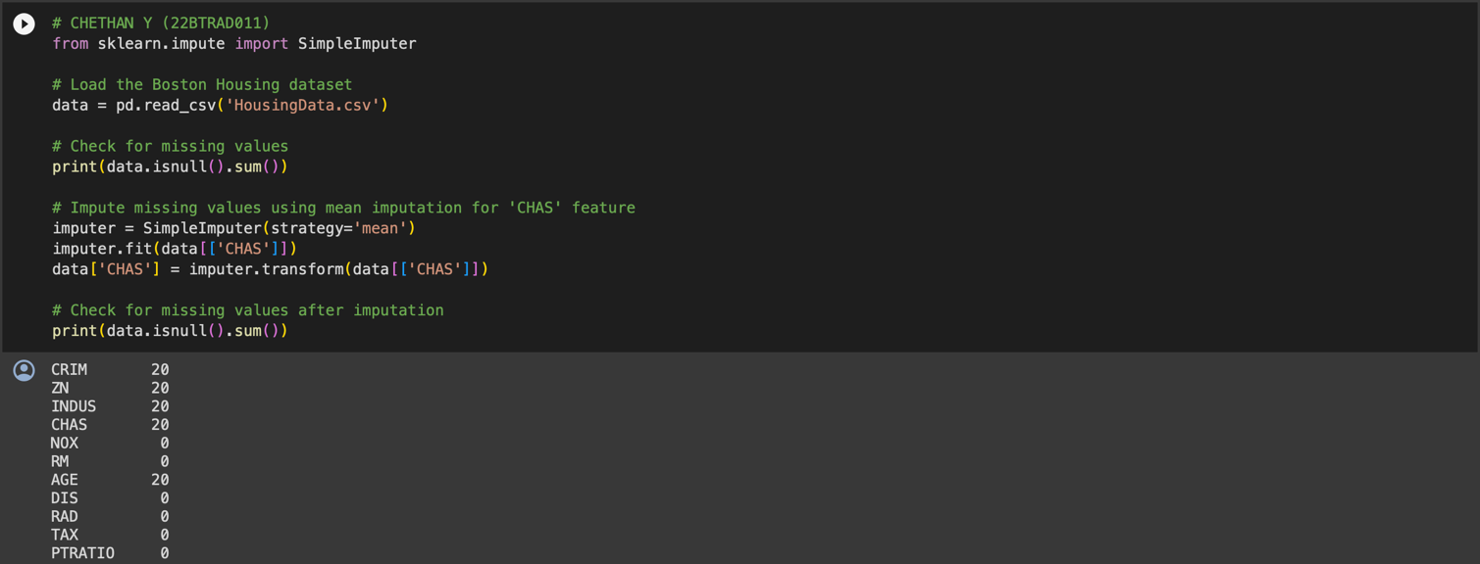

Handle missing values using tuple removal method.

# CHETHAN Y (22BTRAD011)

1. import pandas as pd

# Load the Boston Housing dataset

data = pd.read_csv('HousingData.csv')

# Drop rows with missing values

data_no_missing = data.dropna()

# Show the output print(data_no_missing)

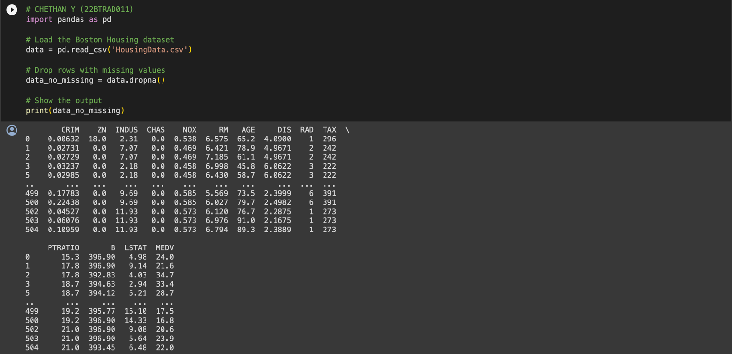

GITHUB:

https://github.com/CHETHAN/MACHINE-LEARNING