ASSIGNMENT-2

MACHINE LEARNING

NAME- CHETHAN Y

USN- 22BTRAD011

# QUESTION

1. Load a dataset with outliers values (Boston Housing Dataset).

CODE:

#CHETHAN Y (22BTRAD011)

import pandas as pd

# Load the Boston Housing dataset boston_housing = pd.read_csv('HousingData.csv') 

1. Use visualization or statistical methods to detect outliers.

CODE:

# CHETHAN Y (22BTRAD011)

import matplotlib.pyplot as plt

# Create box plots for each feature for col in boston_housing.columns:

boston_housing.boxplot(column=col) plt.title(col) plt.show() import matplotlib.pyplot as plt

# Create box plots for each feature for col in boston_housing.columns:

boston_housing.boxplot(column=col)

plt.title(col) plt.show()

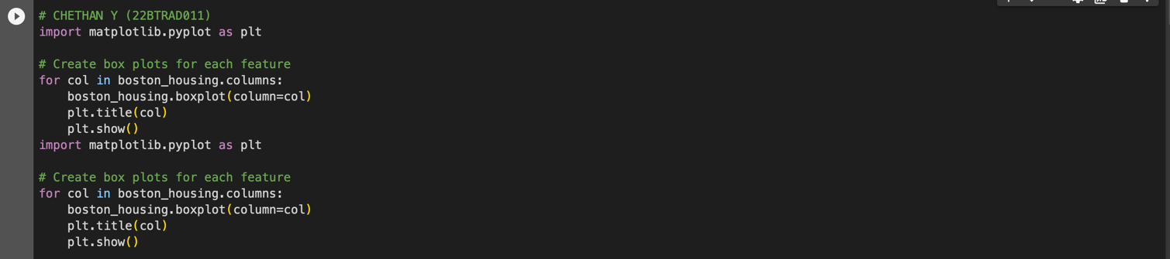

OUTPUT:

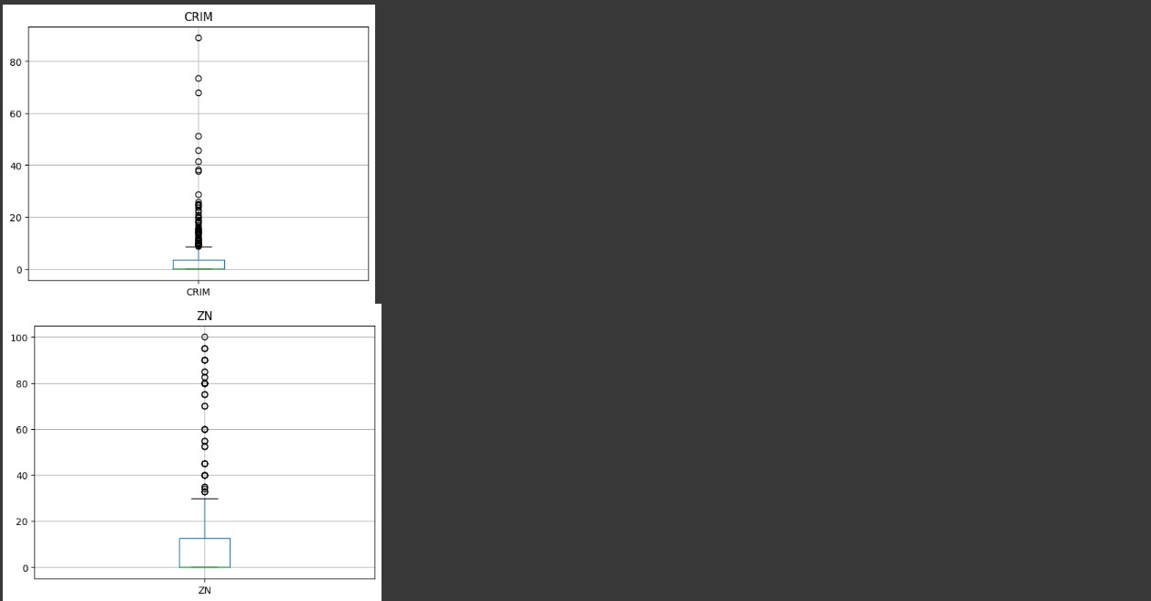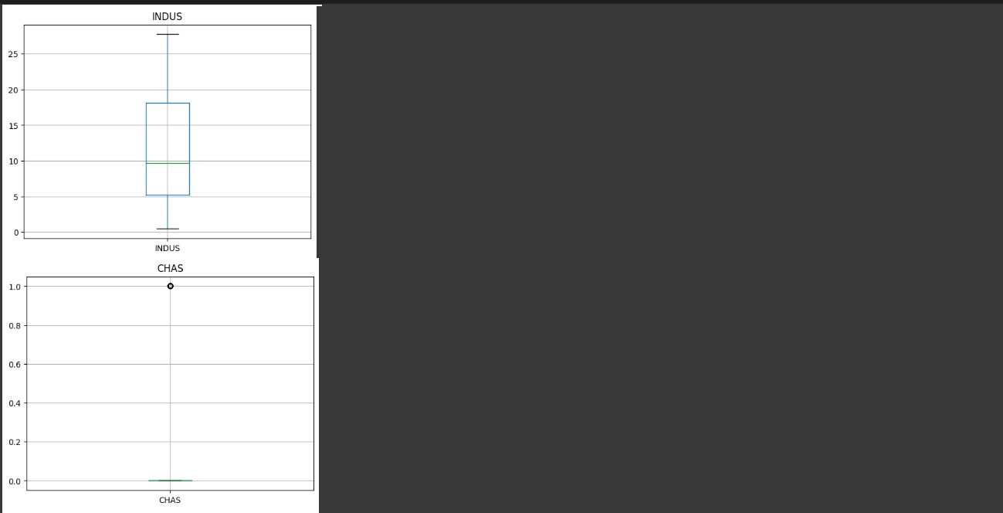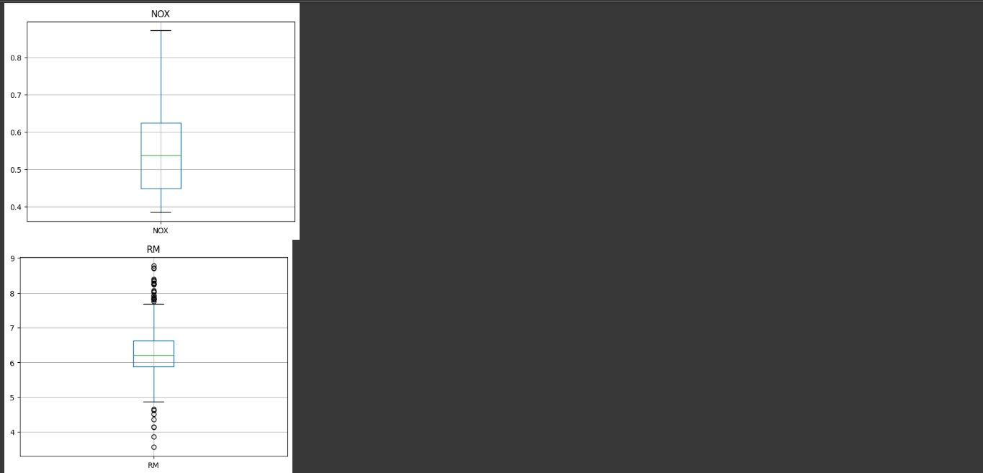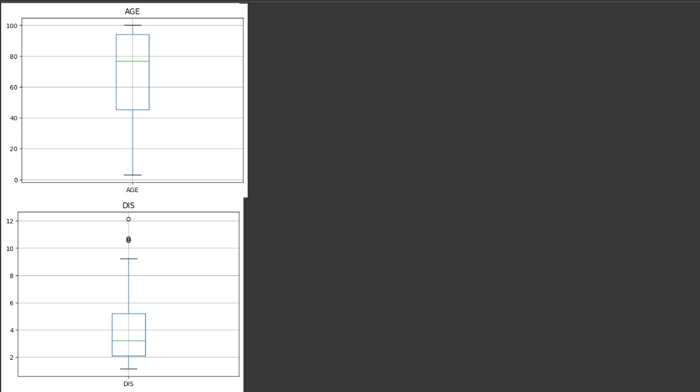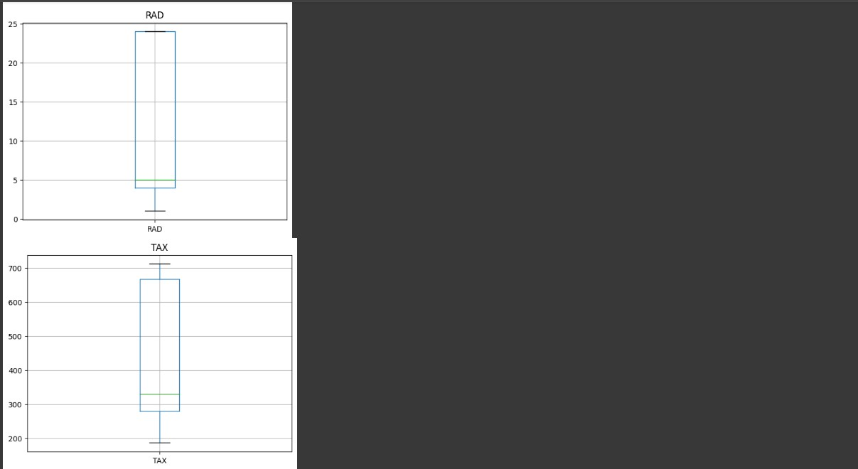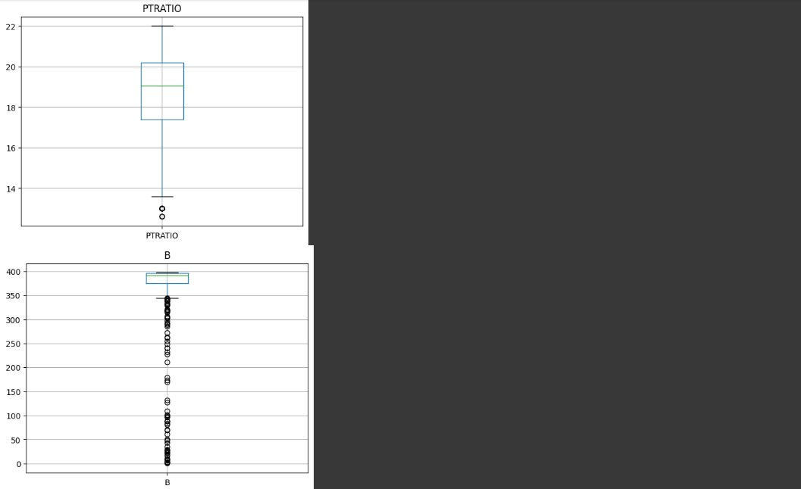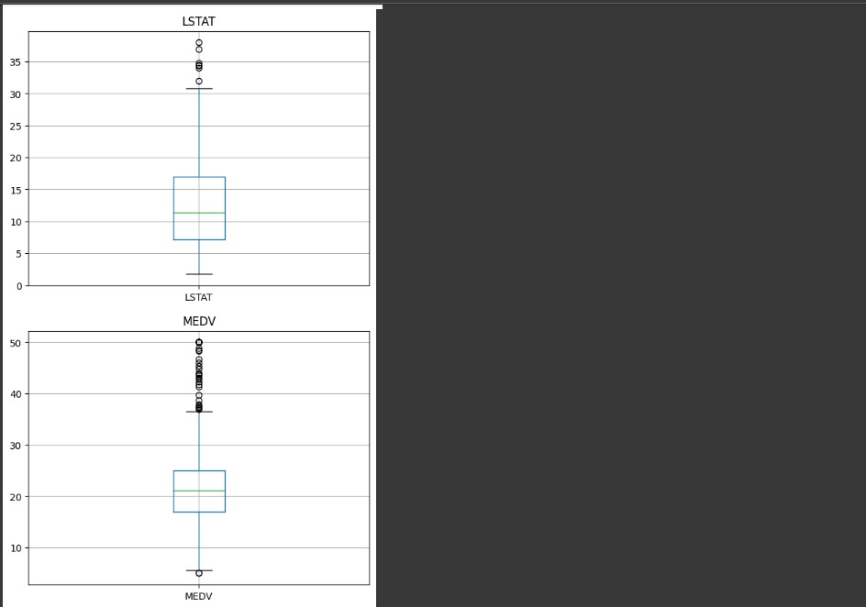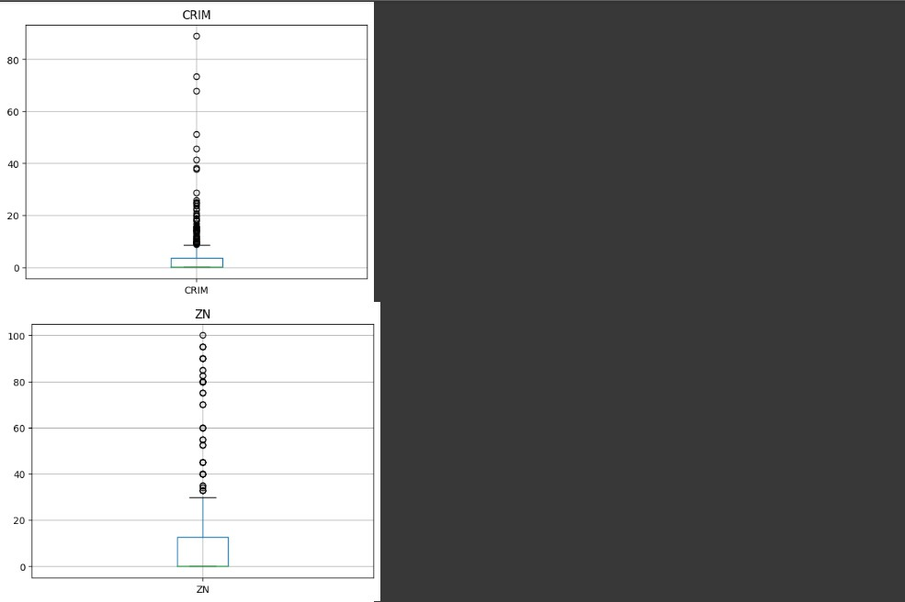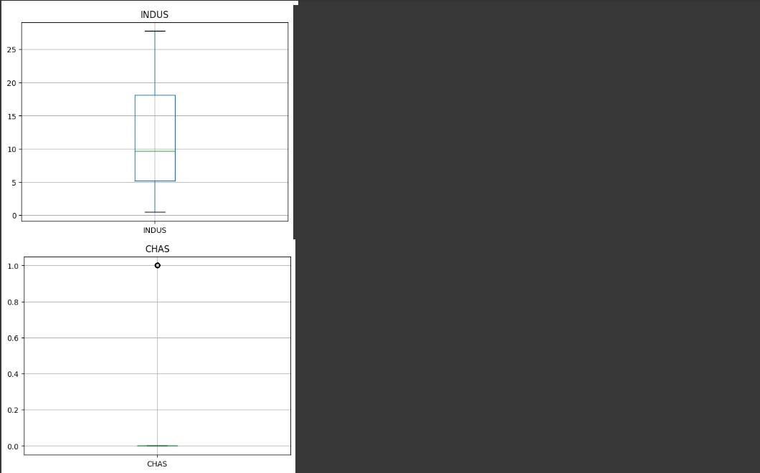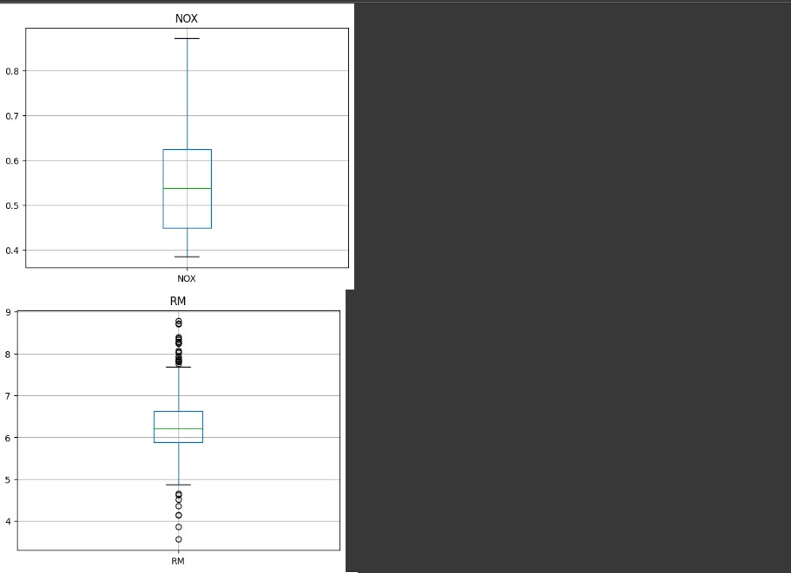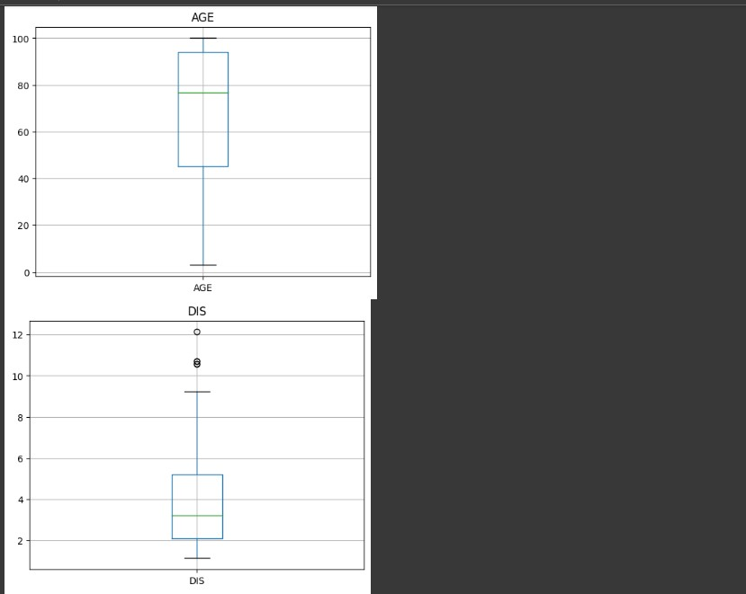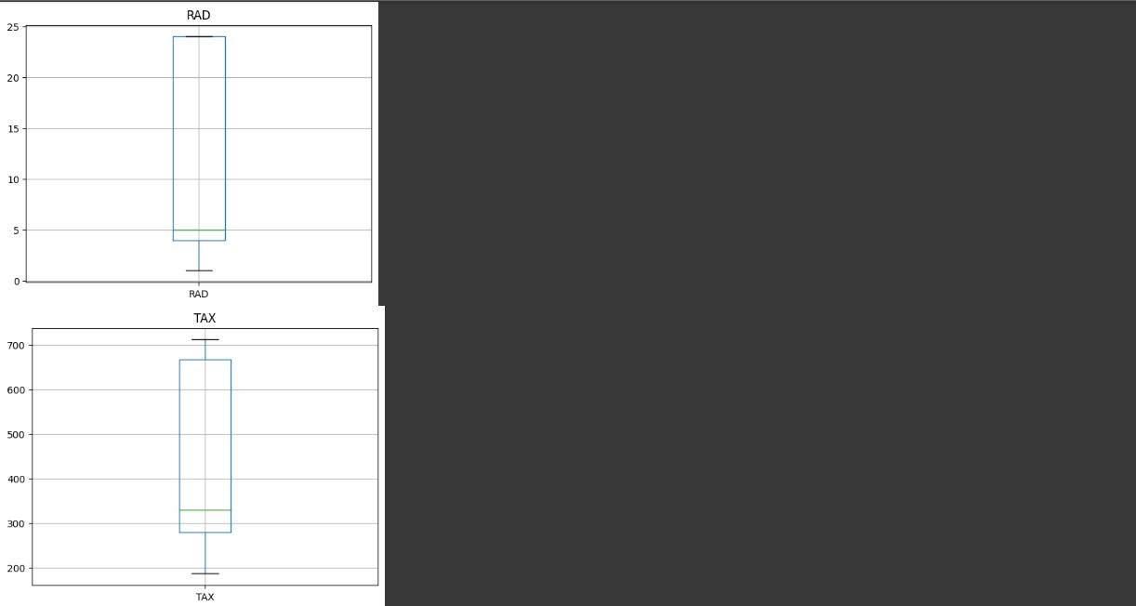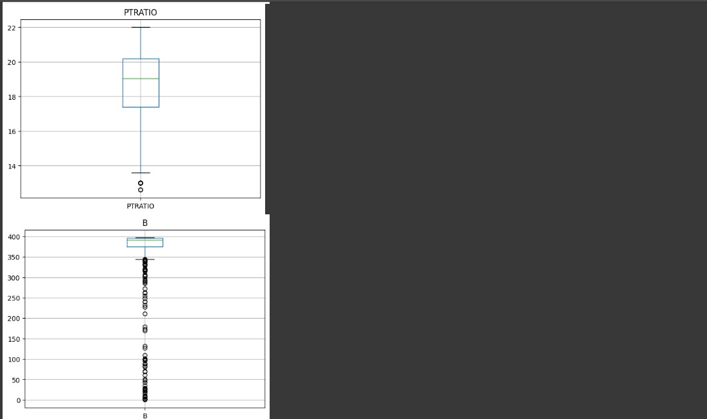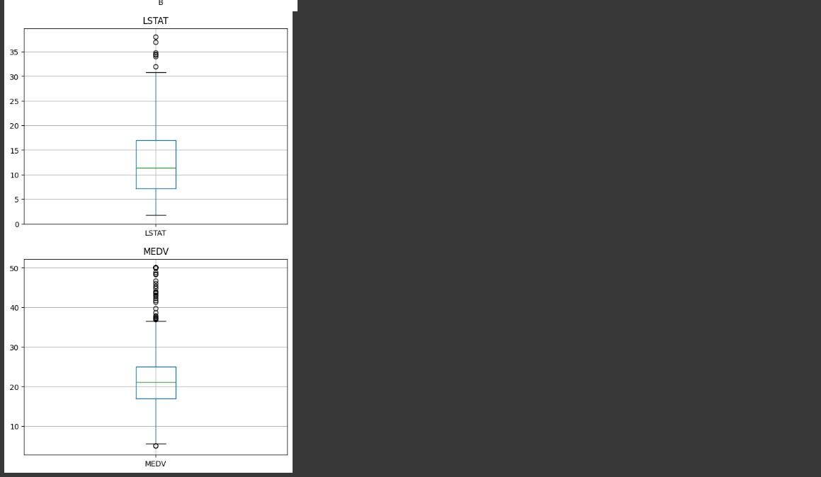

CODE:

# CHETHAN Y (22BTRAD011)

# Calculate the z-score for each feature for col in boston_housing.columns:

z = (boston_housing[col] - boston_housing[col].mean()) / boston_housing[col].std() outliers = boston_housing[abs(z) > 3] print(f"Number of outliers for {col}: {len(outliers)}")

OUTPUT: 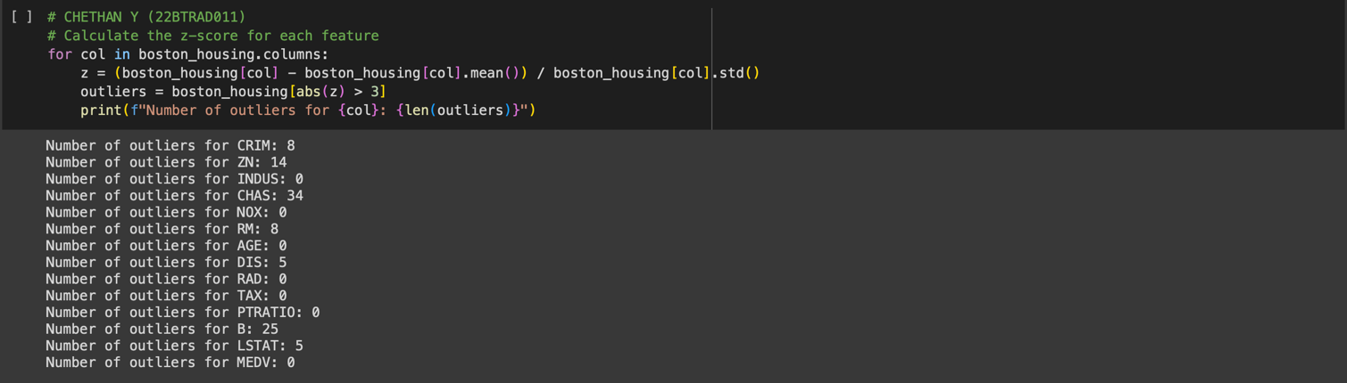

3. Implement a strategy to handle outliers (e.g., removal and transformation).

CODE:

# CHETHAN Y (22BTRAD011)

import pandas as pd

# Load the Boston Housing dataset

boston_housing = pd.read_csv('HousingData.csv')

# Calculate the IQR for each feature for col in boston_housing.columns:

q1 = boston_housing[col].quantile(0.25) q3 = boston_housing[col].quantile(0.75) iqr = q3 - q1

# Remove outliers

boston_housing = boston_housing[boston_housing[col] >= q1 - 1.5 * iqr]

boston_housing = boston_housing[boston_housing[col] <= q3 + 1.5 * iqr] print(boston_housing)

OUTPUT:

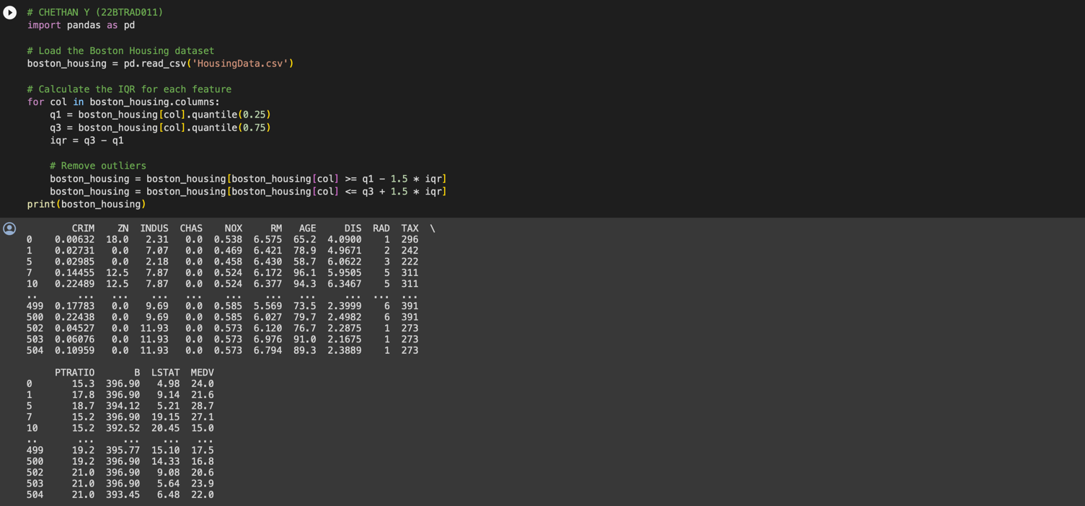

CODE:

# CHETHAN Y (22BTRAD011)

import pandas as pd import numpy as np

# Load the Boston Housing dataset

boston_housing = pd.read_csv('HousingData.csv') # Transform outliers using log transformation for col in boston_housing.columns: if not pd.api.types.is_categorical_dtype(boston_housing[col]):

boston_housing[col] = np.log(boston_housing[col])

**|** P a g e

print(boston_housing)

OUTPUT:

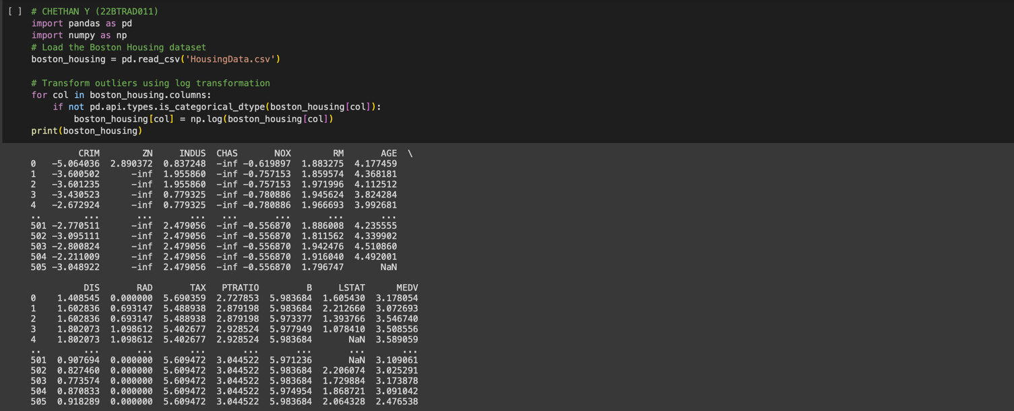

GITHUB:

https://github.com/CHETHAN /MACHINE-LEARNING

**|** P a g e