Exercise 1

Protecting your computing device:

Steps to turn on firewall in windows

Step1: Go to control panel search windows defender firewall.

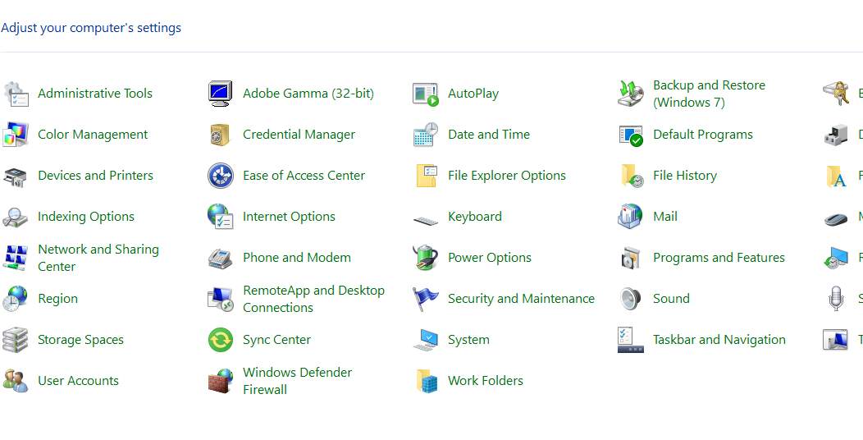

Step2: click the windows defender firewall

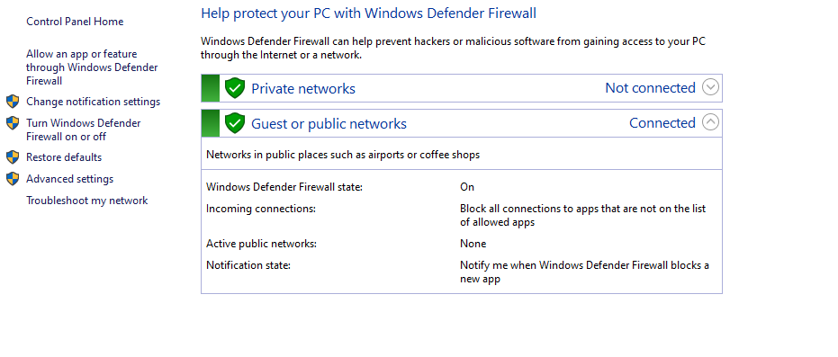

Turn windows defender firewall on or off

Steps to install avast antivirus :-

1. Click the button below to download the **Avast Free Antivirus** setup file, and save it in a familiar location on your PC (by default, downloaded files are saved to your **Downloads** folder).

Link to download [[Download Free Antivirus Software for Windows 10 PC | Avast](https://www.avast.com/windows-10-antivirus#pc)]

1. Right-click the downloaded setup file **avast_free_antivirus_setup_online.exe** and select **Run as administrator** from the context menu.

[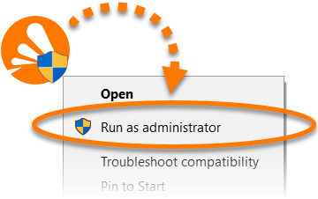](https://static.avast.com/support/kb/images/v2021/avkb42/en/v1_av_install_icon_admin.png)

**NOTE:**If you do not see the **Run as administrator** option, refer to the following article for instructions to manage administrative accounts on your PC:

* [Managing administrative accounts on your Windows PC](https://support.avast.com/en-in/article/311/)

1. If prompted for permission by the **User Account Control** dialog, click **Yes**.

[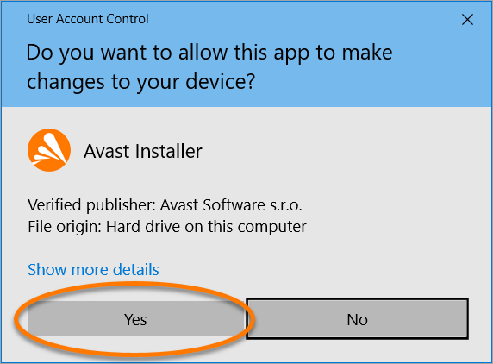](https://static.avast.com/support/kb/images/v2021/avkb42/en/v1_av_install_uac.png)

1. To change the default setup language, click the current language in the top-right corner of the screen. Then, click **Install** to proceed with default installation, or click **Customize** if you need to make changes to the default setup.

[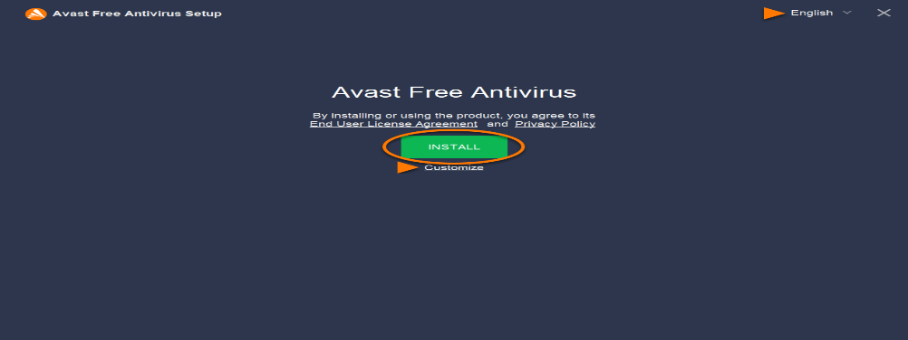](https://static.avast.com/support/kb/images/v2021/avkb42/en/v1_av_install_default_customize.png)

1. Wait while setup installs Avast Free Antivirus on your PC.

[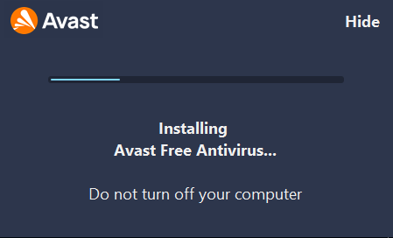](https://static.avast.com/support/kb/images/v2021/avkb42/en/v1_av_install_progress.png)

1. When the installation is complete, click **Continue**.

[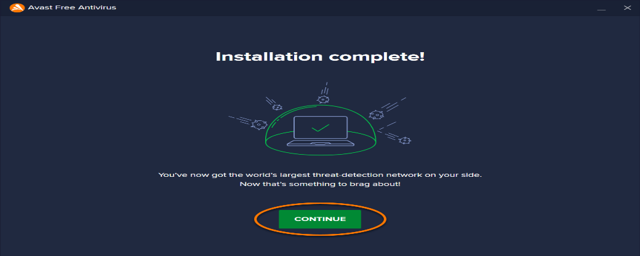](https://static.avast.com/support/kb/images/v2021/avkb42/en/v1_continue.png)

1. Click **Run first scan** to start a comprehensive [Smart Scan](https://support.avast.com/en-in/article/159/), which detects viruses, malware, bad browser add-ons, and other issues on your PC.

[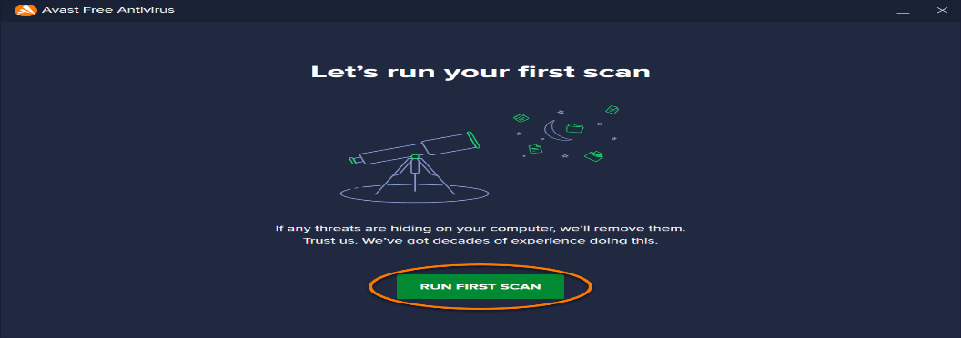](https://static.avast.com/support/kb/images/v2021/avkb42/en/v1_run_first_scan.png)

Managing operating system password :-

Step1: Click on start button search settings and click on sign-in options.

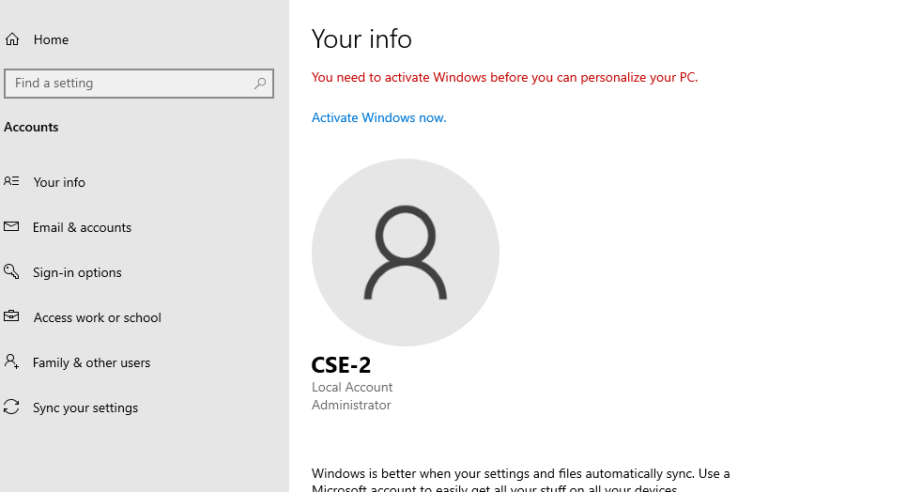

Step2: click on password

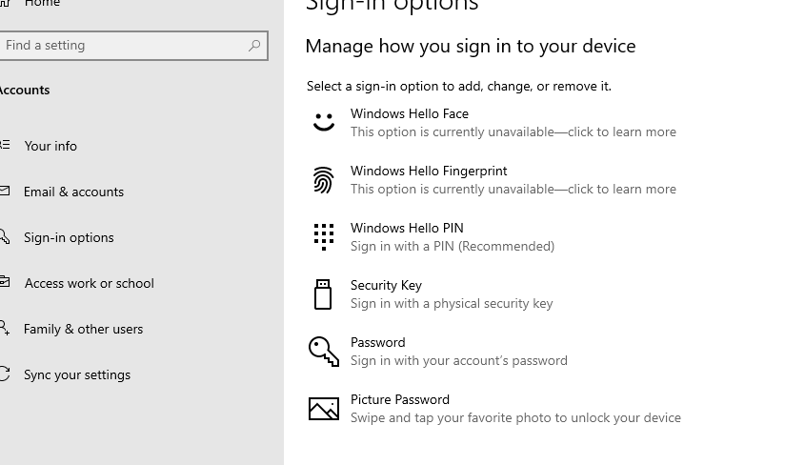

# Step3: change your password according to you .

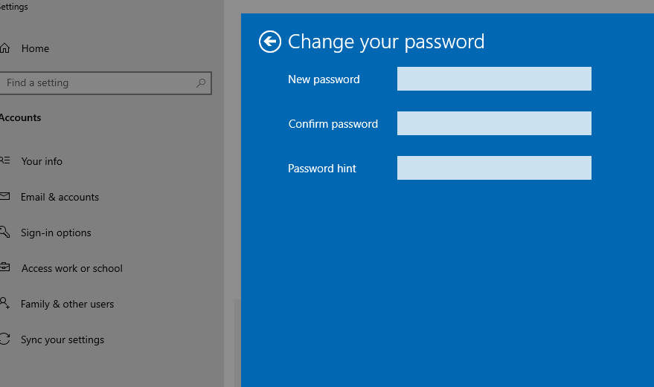

Set upping password protection in browser:-

Step1: Go to chrome web store and search set password for your browser

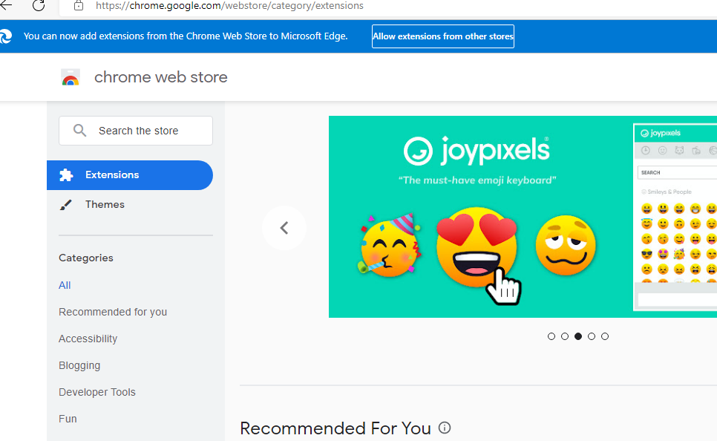

Step2: click on “ add to chrome”

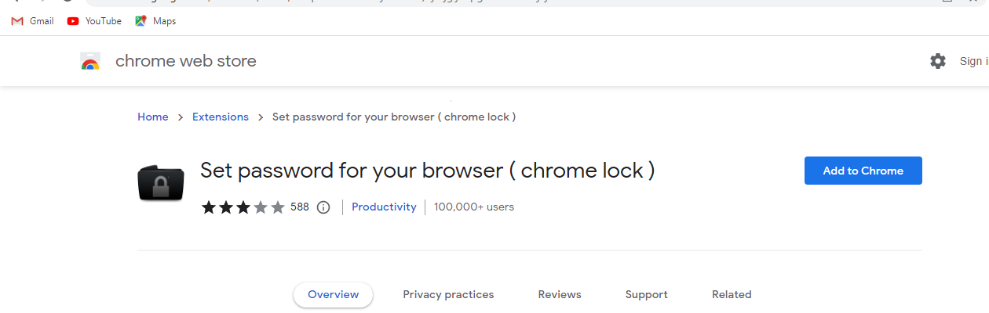

Step3: set your password

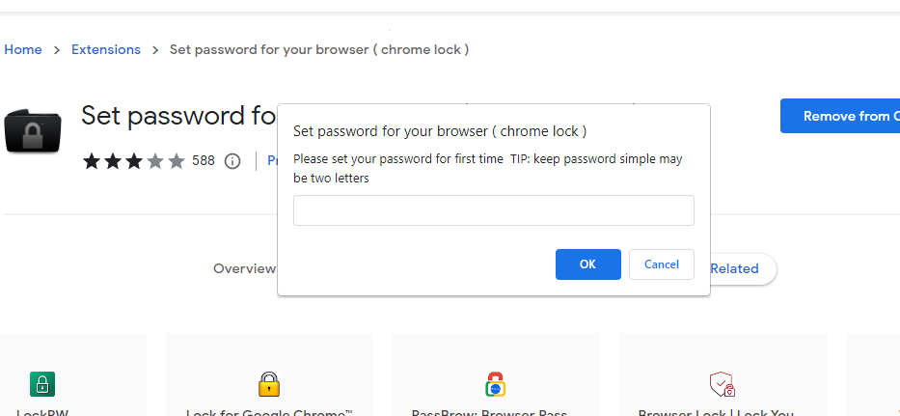

Exercise 2

* Steps to open digital certificates using web browser
* Step1: Go to any web browser and click on settings, click on privacy.

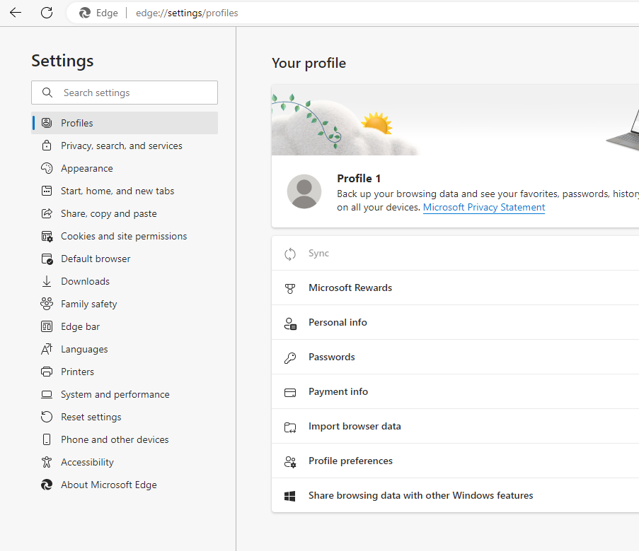

* Step2: Go to security and click manage certificates.

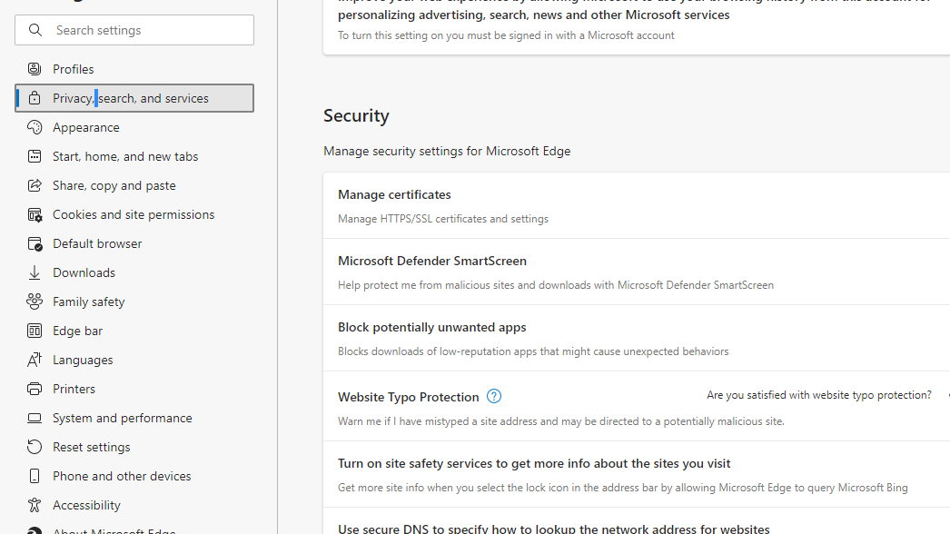

* Step3: Click on certification authorities to view list of certificates in web browser.

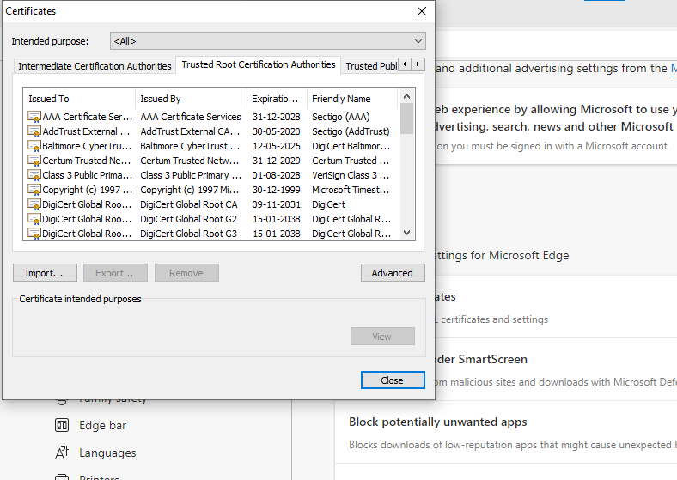

* Step4: click on any certificates to view valid or invalid.

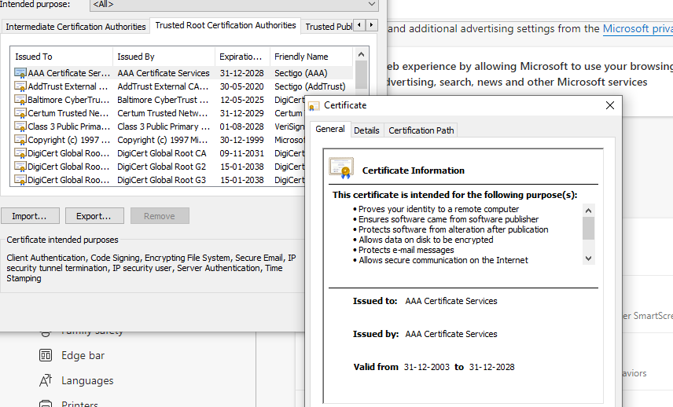

Exercise 03

* Steps to encrypt and decrypt in PGP tool:
* Step1: go web browser and search PGP online tool
* Step2: open the PGP tool, create PGP key and download public key and private key.

* Step3: Encrypt using receivers public key and signer’s private key and enter plain text.
* Step4: Decryption, enter receiver’s private key (for decryption) and enter the encrypted PGP message and click decrypt message.
* Step5: sign, enter your private key and plain text message click on sign message and verify
* Steps to Encrypt and Decrypt using J crypt tool:
* Step1: Go to web browser and search J crypt tool download and install
* Step2: open j crypt tool and create new file of plain text
* Step3: go to algorithm and select RSA encrypt.
* Step4: Create new key and enter password
* Step5: Decryption enter the key