**Project Plan**

**for**

**Video Streaming**

**Project ID: A17**

**Prepared by,**

Danish Mohammed Ebadulla(PES1201800096)

Rahul Raman(PES1201800146)

Joseph Dominic Cherukara(PES1201800328)

**Life cycle followed for execution of the project:**

Our project uses the Agile Software Development Lifecycle model. The Agile SDLC model is a combination of iterative and interactive process models focused on rapid delivery of working software products with high adaptability and customer interaction and satisfaction. Since our project has a short time frame, adopting the Agile model will allow for the product to be developed incrementally in multiple iterations consistently ensuring working deliverables with each iteration improving on the functionality of the software product.

Every iteration of the life cycle will stretch over 1-3 weeks and include teams working simultaneously on:

● Planning

● Design and requirements Analysis

● Building and implementation

● Unit and acceptance testing

● Review

Every iteration will produce a working product that can be demonstrated to customers or stakeholders, and the final iteration will produce the completed build holding all the features required by the customer or stakeholder.

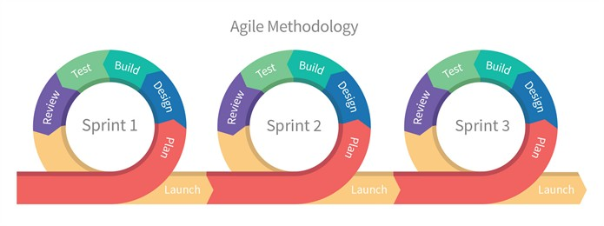

The above diagram depicts the iterations over a time frame of 1-2 months. Each iteration lasts around 2-3 weeks and each iterative product launch will ensure addition of new functionality to the product.

Advantages of using the Agile SDLC for this project:

1. Can incorporate versioning in the SRS and ensure the product is flexible and capable of adapting to stakeholders requirements by incorporating additional functionalities and changes during development
2. Face to face communication and continuous inputs from either customers or stakeholders will ensure the developers completely understand the users’ requirements and can modify their functionalities accordingly.
3. Gives flexibility to developers and requires little to no planning.
4. Delivers early partial working solutions and enables regular delivery with short time frames
5. Since the product does not involve any complex dependencies, the functionalities can be developed concurrently
6. Since all team members are developers, it overcomes the disadvantage of high individual dependency, as every member can regularly interact with other members and work on development even with minimum documentation

**References:**

<https://bikeshsrivastava.blogspot.com/2017/01/part-43what-is-agile-methodology.html>

<https://www.tutorialspoint.com/sdlc/sdlc_agile_model.htm>

<https://medium.com/@melsatar/software-development-life-cycle-models-and-methodologies-297cfe616a3a>

**Tools used:**

* **Planning Tools**

1. Google Docs
2. Google Sheets
3. ToDo Lists
4. Teamwork

* **Design Tools**

1. StarUML
2. Draw.io
3. Figma

* **Version Control**

1. Git Version Control with Github

* **Development Tools**
  + Front End: ReactJS, HTML, CSS, Bootstrap
  + Back End: Flask, Firebase, Heroku or SQL
  + Development tools: Github and Visual Studio Code
* **Bug Tracking**

1. Github Issues

* **Testing Tools**

1. Selenium Web Driver
2. Flask Security

**WORK BREAKDOWN STRUCTURE**

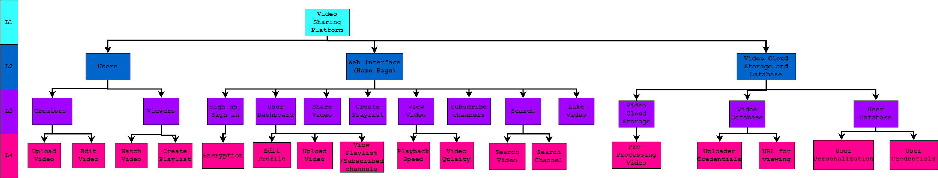

**Deliverables:**

During each iteration a component will either be created or further enhanced.After the first iteration, every iteration followed by that will have a **testing phase** for checking the working/security/improvement of the components. This is to ensure that the components till that iteration meet the expectation of the customers. Few of these iterations can be modified based on the customer feedback.

|  |  |  |  |
| --- | --- | --- | --- |
| **Sl no.** | **Deliverable** | **Description** | **Category** |
| **1** | **Software Requirement Specification** | The SRS document outlines the features provided by the software and a rough idea of implementation, provides functional and nonfunctional requirements and also describes the targeted audience, their user interface and minimum user requirements. | **Build :** This document is initially written to lay out the description of the software that is to be developed as well as the intention of the software under development.  **Reuse :** Later versions can bring changes based on customer feedback to the document due to our agile life cycle implementation. |
| **2** | **Project Plan** | This document provides the SDLC, outlines the execution procedures along with the specified period to achieve the intended software components. | **Build :** It is documented to guide the project execution and project control.  **Reuse :** Due to the agile SDLC, modifications can be made on the execution timeline. |
| **3** | **Database Initialization and Cloud Storage** | Initialize database for storing user credentials, user personalization options (playlist created and subscribed channels) and video ownership details (only uploaders)  Cloud Storage for storing the video uploaded by users. | **Build :** The database will be built to initiate the other functional components implementation. |
| **4** | **Video Playback, Video Pre-Processing and searching video** | A minimalistic frontend page consisting of an embedded video player with the ability to change the video playback speed and quality of the video.  Pre-Processing of the video to all the lower available qualities and storing in the cloud storage.  Simple video/channel searching via the title name. | **Build :** The main functionality of our software is video streaming service with features which ensure low network bandwidth consumption. |
| **5** | **User Details, User Dashboard and Database Integration** | To create a personal user account for viewing and uploading videos and keeping a record of all the users in our ecosystem with the database (Iteration 2). | **Build :** The frontend user interface and the backend for integration with the database.  **Reuse :** User Database. |
| **6** | **User Personalization** | Enables users to subscribe to channels and like videos.  The user homepage is personalized accordingly.  Users can create their own playlist. | **Build :** The frontend for the homepage and the backend for homepage suggestion video.  **Reuse :** Channel details and video database used by backend for personalization and for video/channel analytics (like and subscribe count) |
| **7** | **Advanced Web User Interface** | Further Development on the pre-existing user interface for more user friendliness, less network bandwidth consumption and viewed in any device(satisfying the minimal hardware and software requirements) | **Reuse :** All the existing functional components are used and only the interface is modified. |
| **8** | **Server Deployment on Web Service (Hosting)** | Now this software can be accessible from any device with internet connection. | **Reuse :** All the components used till this phase are reused with few changes as per the hosting services. |
| **9** | **Additional Security Features** | To ensure that all user details via communication and storage are safe and secure all details are encrypted using an asymmetric key encryption method along with TLS. | **Reuse :** The basic security features will be similar to localhost security features.  **Build :** To ensure that the software is not vulnerable to malicious attacks. |

**Rough Effort Estimate:**

This estimate assumes that there are 3 developers working for a total of 2 months, thus giving us 6 person months of time to execute this project.

The stages for the chosen life cycle are:

|  |  |
| --- | --- |
| **Tasks** | **Person Months** |
| Software Requirement Specification | 0.5 |
| Project Plan | 0.5 |
| Database Initialization and Cloud Storage | 1 |
| Video Playback, Video Pre-Processing and searching video | 1 |
| User Personalization | 1.5 |
| Advanced Web User Interface | 0.5 |
| Server Deployment on Web Service (Hosting) | 0.25 |
| Additional Security Features | 0.75 |
| **Total** | **6** |

**Gantt Chart:**

|  |  |  |  |  |  |  |  |  |  |  |  |
| --- | --- | --- | --- | --- | --- | --- | --- | --- | --- | --- | --- |
| **Tasks** | | | | | | | | | | | |
| Database Initialization and Cloud Storage |  |  |  |  |  |  |  |  |  |  |  |
| Video Playback, Video Pre-Processing and searching video |  |  | | |  |  |  |  |  |  |  |
| Server Deployment on Web Service (Hosting) |  |  |  |  |  | |  |  |  |  |  |
| Advanced Web User Interface |  |  |  |  |  |  | |  |  |  |  |
| User Details, User Dashboard and Database Integration |  |  |  |  |  |  |  | |  |  |  |
| User Personalization |  |  |  |  |  |  |  |  |  | |  |
| Additional Security Features |  |  |  |  |  |  |  |  |  |  |  |

|  |  |
| --- | --- |
| **Phase Leader** | |
| Member 1 |  |
| Member 2 |  |
| Member 3 |  |