**VISVESVARAYA TECHNOLOGICAL UNIVERSITY**

**“JnanaSangama”, Belgaum -590014, Karnataka.**



**LAB REPORT**

**on**

**Analysis and Design of Algorithms**

**(23CS4PCADA)**

***Submitted by:***

**Chethan N (1BM23CS075)**

***in partial fulfillment for the award of the degree of***

**BACHELOR OF ENGINEERING**

***in***

**COMPUTER SCIENCE AND ENGINEERING**



**B.M.S. COLLEGE OF ENGINEERING**

**(Autonomous Institution under VTU)**

**BENGALURU-560019**

**April 2025 - July 2025**

**B. M. S. College of Engineering,**

**Bull Temple Road, Bangalore 560019**

(Affiliated To Visvesvaraya Technological University, Belgaum)

**Department of Computer Science and Engineering**



**CERTIFICATE**

This is to certify that the Lab work entitled “**Analysis and Design of Algorithms**” carried out by **Chethan N (1BM23CS075),** who is bonafide student of **B. M. S. College of Engineering.** It is in partial fulfillment for the award of **Bachelor of Engineering in Computer Science and Engineering** of the Visvesvaraya Technological University, Belgaum during the year 2024-25. The Lab report has been approved as it satisfies the academic requirements in respect of **Analysis and Design of Algorithms - (23CS4PCADA)** work prescribed for the said degree.

**Sowmya T**              **Dr. Kavitha Sooda**

Associate Professor Professor and Head

Department of CSE Department of CSE

BMSCE, Bengaluru BMSCE, Bengaluru

**Table Of Contents**

|  |  |  |
| --- | --- | --- |
| **Lab Program No.** | **Program Details** | **Page No.** |
| 1 | Merge Sort | 2-4 |
| 2 | Quick Sort | 5-6 |
| 3 | Prim’s and Kruskal’s algorithm | 7-12 |
| 4 | Topological ordering of vertices | 13-14 |
| 5 | 0/1 Knapsack problem | 15-16 |
| 6 | Floyd’s algorithm. | 17-18 |
| 7 | Fractional Knapsack using Greedy technique | 19-20 |
| 8 | Dijkstra’s algorithm | 21-22 |
| 9 | N-Queens Problem | 23-25 |
| 10 | Johnson Trotter algorithm | 26-28 |
| 11 | Heap Sort technique | 29-31 |

**Github Link:** <https://github.com/chethannhub/ADA_Lab>

1. **Experiments**
   1. **Experiment - 1**
      1. **Question:**

**Sort a given set of N integer elements using Merge Sort technique**

**and compute its time taken. Run the program for different values**

**of N and record the time taken to sort.**

* + 1. **Code:**

#include <stdio.h>

#include <stdlib.h>

void merge(int arr[], int left, int mid, int right) {

int i, j, k;

int n1 = mid - left + 1;

int n2 = right - mid;

// Temporary arrays

int* L = (int*)malloc(n1 * sizeof(int));

int* R = (int*)malloc(n2 * sizeof(int));

// Copy data

for (i = 0; i < n1; i++)

L[i] = arr[left + i];

for (j = 0; j < n2; j++)

R[j] = arr[mid + 1 + j];

// Merge

i = 0;

j = 0;

k = left;

while (i < n1 && j < n2) {

if (L[i] <= R[j])

arr[k++] = L[i++];

else

arr[k++] = R[j++];

}

while (i < n1)

arr[k++] = L[i++];

while (j < n2)

arr[k++] = R[j++];

free(L);

free(R);

}

void mergeSort(int arr[], int left, int right) {

if (left < right) {

int mid = left + (right - left) / 2;

mergeSort(arr, left, mid);

mergeSort(arr, mid + 1, right);

merge(arr, left, mid, right);

}

}

void printArray(int arr[], int size) {

for (int i = 0; i < size; i++)

printf("%d ", arr[i]);

printf("\n");

}

int main() {

int arr[] = {38, 27, 43, 3, 9, 82, 10};

int size = sizeof(arr) / sizeof(arr[0]);

printf("Original array: ");

printArray(arr, size);

mergeSort(arr, 0, size - 1);

printf("Sorted array: ");

printArray(arr, size);

return 0;

}

* + 1. **Output:**

**a.**

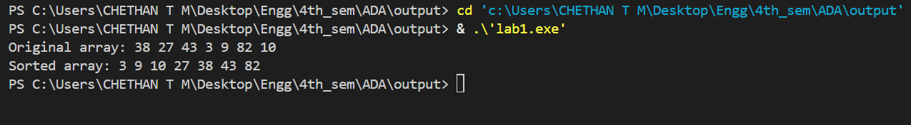

* 1. **Experiment - 2**
     1. **Question:**

**Sort a given set of N integer elements using Quick Sort technique**

**and compute its time taken.**

* + 1. **Code:**

#include <stdio.h>

void swap(int* a, int* b) {

    int temp = *a;

    *a = *b;

    *b = temp;

}

int partition(int arr[], int low, int high) {

    int pivot = arr[high];

    int i = (low - 1);

    for (int j = low; j <= high - 1; j++) {

        if (arr[j] <= pivot) {

            i++;

            swap(&arr[i], &arr[j]);

        }

    }

    swap(&arr[i + 1], &arr[high]);

    return (i + 1);

}

void quickSort(int arr[], int low, int high) {

    if (low < high) {

        int pi = partition(arr, low, high);

        quickSort(arr, low, pi - 1);

        quickSort(arr, pi + 1, high);

    }

}

void printArray(int arr[], int size) {

    for (int i = 0; i < size; i++)

        printf("%d ", arr[i]);

    printf("\n");

}

int main() {

    int arr[] = {10, 7, 8, 9, 1, 5};

    int n = sizeof(arr) / sizeof(arr[0]);

    printf("Original array: ");

    printArray(arr, n);

    quickSort(arr, 0, n - 1);

    printf("Sorted array: ");

    printArray(arr, n);

    return 0;

}

* + 1. **Output:**

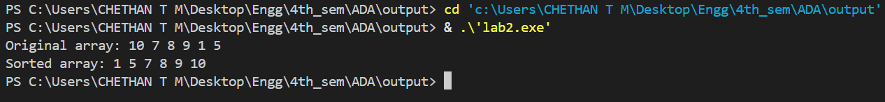

* 1. **Experiment - 3**

**1.3.1 Question:**

**a. Find Minimum Cost Spanning Tree of a given undirected graph**

**using Prim’s algorithm.**

**b. Find Minimum Cost Spanning Tree of a given undirected graph**

**using Kruskal’s algorithm.**

**1.3.2 Code:**

**a.**

#include <stdio.h>

#include <limits.h>

#define V 5

int minKey(int key[], int mstSet[]) {

    int min = INT_MAX, min_index;

    for (int v = 0; v < V; v++)

        if (!mstSet[v] && key[v] < min)

            min = key[v], min_index = v;

    return min_index;

}

void printMST(int parent[], int graph[V][V]) {

    printf("Edge \tWeight\n");

    for (int i = 1; i < V; i++)

        printf("%d - %d \t%d \n", parent[i], i, graph[i][parent[i]]);

}

void primMST(int graph[V][V]) {

    int parent[V];

    int key[V];

    int mstSet[V];

    for (int i = 0; i < V; i++)

        key[i] = INT_MAX, mstSet[i] = 0;

    key[0] = 0;

    parent[0] = -1;

    for (int count = 0; count < V - 1; count++) {

        int u = minKey(key, mstSet);

        mstSet[u] = 1;

        for (int v = 0; v < V; v++) {

            if (graph[u][v] && !mstSet[v] && graph[u][v] < key[v])

                parent[v] = u, key[v] = graph[u][v];

        }

    }

    printMST(parent, graph);

}

int main() {

    int graph[V][V] = {

        {0, 2, 0, 6, 0},

        {2, 0, 3, 8, 5},

        {0, 3, 0, 0, 7},

        {6, 8, 0, 0, 9},

        {0, 5, 7, 9, 0}

    };

    primMST(graph);

    return 0;

}

**b.**

#include <stdio.h>

#include <stdlib.h>

struct Edge {

    int src, dest, weight;

};

struct Graph {

    int V, E;

    struct Edge* edge;

};

struct Graph* createGraph(int V, int E) {

    struct Graph* graph = (struct Graph*)malloc(sizeof(struct Graph));

    graph->V = V;

    graph->E = E;

    graph->edge = (struct Edge*)malloc(E * sizeof(struct Edge));

    return graph;

}

struct Subset {

    int parent;

    int rank;

};

int find(struct Subset subsets[], int i) {

    if (subsets[i].parent != i)

        subsets[i].parent = find(subsets, subsets[i].parent);

    return subsets[i].parent;

}

void Union(struct Subset subsets[], int x, int y) {

    int xroot = find(subsets, x);

    int yroot = find(subsets, y);

    if (subsets[xroot].rank < subsets[yroot].rank)

        subsets[xroot].parent = yroot;

    else if (subsets[xroot].rank > subsets[yroot].rank)

        subsets[yroot].parent = xroot;

    else {

        subsets[yroot].parent = xroot;

        subsets[xroot].rank++;

    }

}

int compareEdges(const void* a, const void* b) {

    struct Edge* a1 = (struct Edge*)a;

    struct Edge* b1 = (struct Edge*)b;

    return a1->weight - b1->weight;

}

void KruskalMST(struct Graph* graph) {

    int V = graph->V;

    struct Edge result[V];

    int e = 0;

    int i = 0;

    qsort(graph->edge, graph->E, sizeof(graph->edge[0]), compareEdges);

    struct Subset* subsets = (struct Subset*)malloc(V * sizeof(struct Subset));

    for (int v = 0; v < V; ++v) {

        subsets[v].parent = v;

        subsets[v].rank = 0;

    }

    while (e < V - 1 && i < graph->E) {

        struct Edge next = graph->edge[i++];

        int x = find(subsets, next.src);

        int y = find(subsets, next.dest);

        if (x != y) {

            result[e++] = next;

            Union(subsets, x, y);

        }

    }

    printf("Edge \tWeight\n");

    for (i = 0; i < e; ++i)

        printf("%d - %d \t%d\n", result[i].src, result[i].dest, result[i].weight);

    free(subsets);

}

int main() {

    int V = 4;

    int E = 5;

    struct Graph* graph = createGraph(V, E);

    graph->edge[0] = (struct Edge){0, 1, 10};

    graph->edge[1] = (struct Edge){0, 2, 6};

    graph->edge[2] = (struct Edge){0, 3, 5};

    graph->edge[3] = (struct Edge){1, 3, 15};

    graph->edge[4] = (struct Edge){2, 3, 4};

    KruskalMST(graph);

    free(graph->edge);

    free(graph);

    return 0;

}

* + 1. **Output:**

**a.**

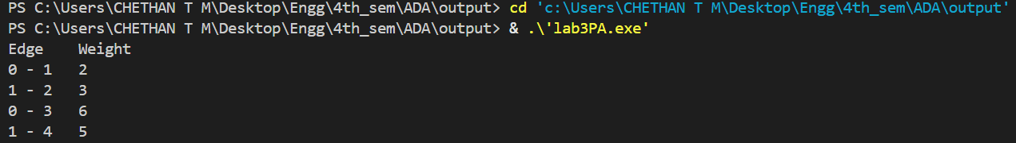

**b.**

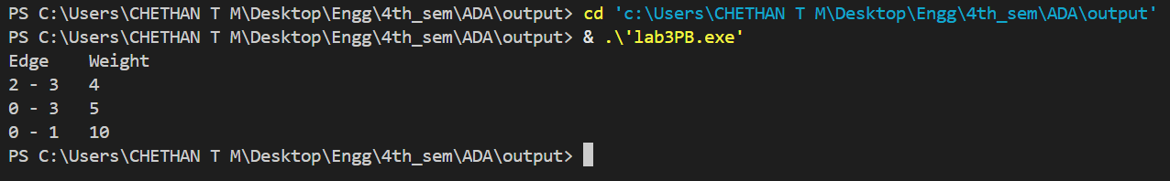

* 1. **Experiment - 4**
     1. **Question:**

**Write program to obtain the Topological ordering of vertices in a given**

**digraph.**

* + 1. **Code:**

#include <stdio.h>

#include <stdlib.h>

#define MAX 100

int graph[MAX][MAX];

int visited[MAX];

int stack[MAX];

int top = -1;

int n;

void addEdge(int u, int v) {

graph[u][v] = 1;

}

void dfs(int v) {

visited[v] = 1;

for (int i = 0; i < n; i++) {

if (graph[v][i] && !visited[i]) {

dfs(i);

}

}

stack[++top] = v;

}

void topologicalSort() {

for (int i = 0; i < n; i++) {

if (!visited[i]) {

dfs(i);

}

}

printf("Topological Order:\n");

while (top != -1) {

printf("%d ", stack[top--]);

}

printf("\n");

}

int main() {

int edges, u, v;

printf("Enter number of vertices: ");

scanf("%d", &n);

printf("Enter number of edges: ");

scanf("%d", &edges);

for (int i = 0; i < n; i++) {

visited[i] = 0;

for (int j = 0; j < n; j++) {

graph[i][j] = 0;

}

}

printf("Enter edges (u v) where u -> v:\n");

for (int i = 0; i < edges; i++) {

scanf("%d %d", &u, &v);

addEdge(u, v);

}

topologicalSort();

return 0;

}

* + 1. **Output:**

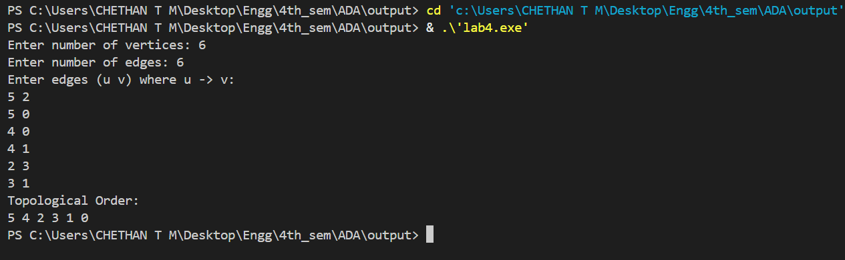

* 1. **Experiment - 5**
     1. **Question:**

**Implement 0/1 Knapsack problem using dynamic programming.**

* + 1. **Code:**

#include <stdio.h>

int max(int a, int b) {

return (a > b) ? a : b;

}

int knapsack(int W, int weights[], int values[], int n) {

int dp[n+1][W+1];

for (int i = 0; i <= n; i++) {

for (int w = 0; w <= W; w++) {

if (i == 0 || w == 0) {

dp[i][w] = 0;

}

else if (weights[i-1] <= w) {

dp[i][w] = max(dp[i-1][w], values[i-1] + dp[i-1][w-weights[i-1]]);

}

else {

dp[i][w] = dp[i-1][w];

}

}

}

return dp[n][W];

}

int main() {

int n, W;

printf("Enter number of items: ");

scanf("%d", &n);

printf("Enter the capacity of knapsack: ");

scanf("%d", &W);

int values[n], weights[n];

printf("Enter the values of the items:\n");

for (int i = 0; i < n; i++) {

scanf("%d", &values[i]);

}

printf("Enter the weights of the items:\n");

for (int i = 0; i < n; i++) {

scanf("%d", &weights[i]);

}

int result = knapsack(W, weights, values, n);

printf("Maximum value in Knapsack = %d\n", result);

return 0;

}

* + 1. **Output:**

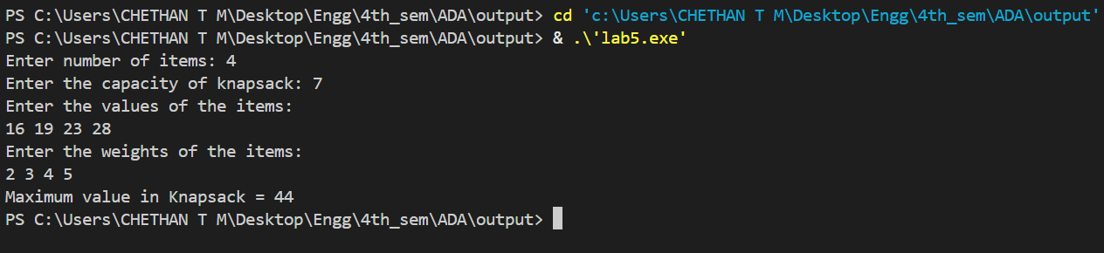

* 1. **Experiment - 6**
     1. **Question:**

**Implement All Pair Shortest paths problem using Floyd’s algorithm.**

* + 1. **Code:**

#include <stdio.h>

#include <limits.h>

#define INF INT_MAX

#define MAX_VERTICES 100

void floydWarshall(int graph[MAX_VERTICES][MAX_VERTICES], int n) {

int dist[MAX_VERTICES][MAX_VERTICES];

for (int i = 0; i < n; i++) {

for (int j = 0; j < n; j++) {

if (i == j)

dist[i][j] = 0;

else if (graph[i][j] == 0)

dist[i][j] = INF;

else

dist[i][j] = graph[i][j];

}

}

for (int k = 0; k < n; k++) {

for (int i = 0; i < n; i++) {

for (int j = 0; j < n; j++) {

if (dist[i][k] != INF && dist[k][j] != INF) {

dist[i][j] = (dist[i][j] < dist[i][k] + dist[k][j]) ? dist[i][j] : dist[i][k] + dist[k][j];

}

}

}

}

printf("Shortest distances between every pair of vertices:\n");

for (int i = 0; i < n; i++) {

for (int j = 0; j < n; j++) {

if (dist[i][j] == INF) {

printf("INF ");

} else {

printf("%d ", dist[i][j]);

}

}

printf("\n");

}

}

int main() {

int n, graph[MAX_VERTICES][MAX_VERTICES];

printf("Enter the number of vertices: ");

scanf("%d", &n);

printf("Enter the adjacency matrix (use 0 for no direct edge):\n");

for (int i = 0; i < n; i++) {

for (int j = 0; j < n; j++) {

scanf("%d", &graph[i][j]);

}

}

floydWarshall(graph, n);

return 0;

}

* + 1. **Output:**

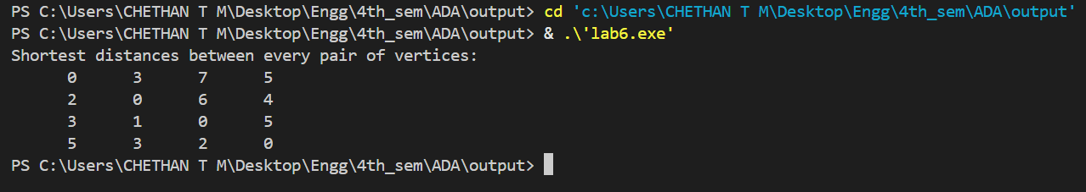

* 1. **Experiment - 7**
     1. **Question:**

**Implement Fractional Knapsack using Greedy technique.**

* + 1. **Code:**

#include <stdio.h>

typedef struct {

    int value;

    int weight;

} Item;

// Function to find the maximum of two floats

float max(float a, float b) {

    return (a > b) ? a : b;

}

// Function to sort items by value-to-weight ratio in descending order

void sortItemsByRatio(Item items[], int n) {

    for (int i = 0; i < n - 1; i++) {

        for (int j = 0; j < n - i - 1; j++) {

            float r1 = (float)items[j].value / items[j].weight;

            float r2 = (float)items[j + 1].value / items[j + 1].weight;

            if (r1 < r2) {

                Item temp = items[j];

                items[j] = items[j + 1];

                items[j + 1] = temp;

            }

        }

    }

}

// Fractional Knapsack function

float fractionalKnapsack(int capacity, Item items[], int n) {

    sortItemsByRatio(items, n);

    float totalValue = 0.0;

    int currWeight = 0;

    for (int i = 0; i < n; i++) {

        if (currWeight + items[i].weight <= capacity) {

            // Take the whole item

            currWeight += items[i].weight;

            totalValue += items[i].value;

        } else {

            // Take the fraction of the remaining capacity

            int remain = capacity - currWeight;

            totalValue += ((float)items[i].value / items[i].weight) * remain;

            break;

        }

    }

    return totalValue;

}

// Driver code

int main() {

    int n = 3;

    Item items[] = {{60, 10}, {100, 20}, {120, 30}};

    int capacity = 50;

    float maxValue = fractionalKnapsack(capacity, items, n);

    printf("Maximum value in Knapsack = %.2f\n", maxValue);

    return 0;

}

* + 1. **Output:**

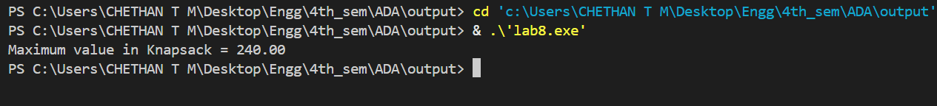

* 1. **Experiment - 8**
     1. **Question:**

**From a given vertex in a weighted connected graph, find shortest paths to**

**other vertices using Dijkstra’s algorithm.**

* + 1. **Code:**

#include <stdio.h>

#include <limits.h>

#define V 5

int minDistance(int dist[], int visited[]) {

int min = INT_MAX, min_index;

for (int v = 0; v < V; v++)

if (!visited[v] && dist[v] <= min) {

min = dist[v];

min_index = v;

}

return min_index;

}

void printSolution(int dist[], int src) {

printf("Vertex\tDistance from Source %d\n", src);

for (int i = 0; i < V; i++)

printf("%d\t\t%d\n", i, dist[i]);

}

void dijkstra(int graph[V][V], int src) {

int dist[V];

int visited[V];

for (int i = 0; i < V; i++) {

dist[i] = INT_MAX;

visited[i] = 0;

}

dist[src] = 0;

for (int count = 0; count < V - 1; count++) {

int u = minDistance(dist, visited);

visited[u] = 1;

for (int v = 0; v < V; v++) {

if (!visited[v] && graph[u][v] && dist[u] != INT_MAX

&& dist[u] + graph[u][v] < dist[v]) {

dist[v] = dist[u] + graph[u][v];

}

}

}

printSolution(dist, src);

}

int main() {

int graph[V][V] = {

{0, 10, 0, 0, 5},

{0, 0, 1, 0, 2},

{0, 0, 0, 4, 0},

{7, 0, 6, 0, 0},

{0, 3, 9, 2, 0}

};

int source = 0;

dijkstra(graph, source);

return 0;

}

* + 1. **Output:**

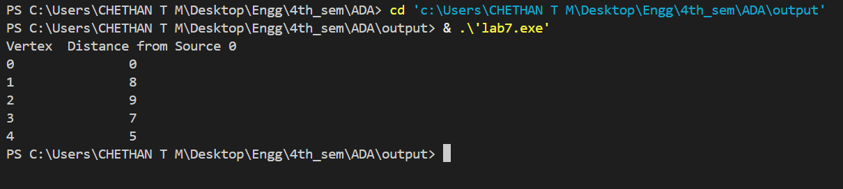

* 1. **Experiment - 9**
     1. **Question:**

**Implement “N-Queens Problem” using Backtracking.**

* + 1. **Code:**

#include <stdio.h>

#include <stdlib.h>

int is_safe(int** board, int row, int col, int n) {

int i, j;

for (i = 0; i < row; i++) {

if (board[i][col] == 1)

return 0;

}

for (i = row - 1, j = col - 1; i >= 0 && j >= 0; i--, j--) {

if (board[i][j] == 1)

return 0;

}

for (i = row - 1, j = col + 1; i >= 0 && j < n; i--, j++) {

if (board[i][j] == 1)

return 0;

}

return 1;

}

void print_board(int** board, int n) {

for (int i = 0; i < n; i++) {

for (int j = 0; j < n; j++) {

printf("%c ", board[i][j] ? 'Q' : '.');

}

printf("\n");

}

printf("\n");

}

int solve_n_queens_util(int** board, int row, int n) {

if (row == n) {

print_board(board, n);

return 1;

}

int res = 0;

for (int col = 0; col < n; col++) {

if (is_safe(board, row, col, n)) {

board[row][col] = 1;

res += solve_n_queens_util(board, row + 1, n);

board[row][col] = 0;

}

}

return res;

}

int main() {

int n;

printf("Enter the number of queens (N): ");

scanf("%d", &n);

int** board = (int**)malloc(n * sizeof(int*));

for (int i = 0; i < n; i++) {

board[i] = (int*)calloc(n, sizeof(int));

}

int solutions = solve_n_queens_util(board, 0, n);

printf("Total solutions: %d\n", solutions);

for (int i = 0; i < n; i++) {

free(board[i]);

}

free(board);

return 0;

}

* + 1. **Output:**

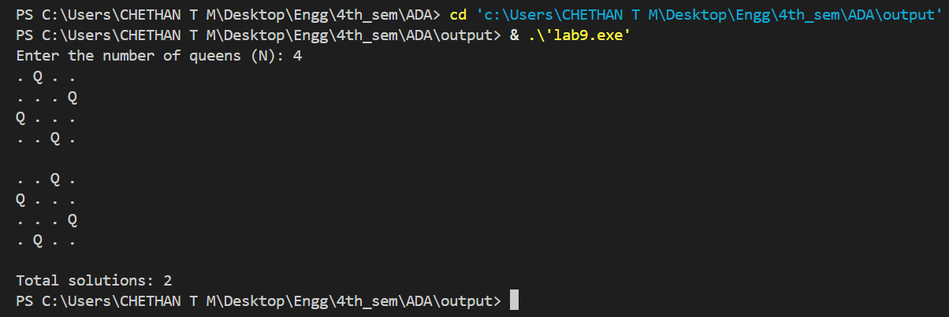

* 1. **Experiment - 10**
     1. **Question:**

**Implement Johnson Trotter algorithm to generate permutations.**

* + 1. **Code:**

#include <stdio.h>

#include <stdlib.h>

#define LEFT -1

#define RIGHT 1

void print_permutation(int *arr, int n) {

for (int i = 0; i < n; i++)

printf("%d ", arr[i]);

printf("\n");

}

int get_largest_mobile(int *arr, int *dir, int n) {

int largest_mobile_index = -1;

int largest_mobile = 0;

for (int i = 0; i < n; i++) {

int neighbor_index = i + dir[i];

if (neighbor_index >= 0 && neighbor_index < n) {

if (arr[i] > arr[neighbor_index] && arr[i] > largest_mobile) {

largest_mobile = arr[i];

largest_mobile_index = i;

}

}

}

return largest_mobile_index;

}

void johnson_trotter(int n) {

int *arr = malloc(n * sizeof(int));

int *dir = malloc(n * sizeof(int));

for (int i = 0; i < n; i++) {

arr[i] = i + 1;

dir[i] = LEFT;

}

print_permutation(arr, n);

while (1) {

int largest_mobile_index = get_largest_mobile(arr, dir, n);

if (largest_mobile_index == -1) break;

int swap_index = largest_mobile_index + dir[largest_mobile_index];

int temp = arr[largest_mobile_index];

arr[largest_mobile_index] = arr[swap_index];

arr[swap_index] = temp;

int temp_dir = dir[largest_mobile_index];

dir[largest_mobile_index] = dir[swap_index];

dir[swap_index] = temp_dir;

largest_mobile_index = swap_index;

for (int i = 0; i < n; i++) {

if (arr[i] > arr[largest_mobile_index]) {

dir[i] = -dir[i];

}

}

print_permutation(arr, n);

}

free(arr);

free(dir);

}

int main() {

int n;

printf("Enter number of elements: ");

scanf("%d", &n);

printf("All permutations generated by Johnson-Trotter algorithm:\n");

johnson_trotter(n);

return 0;

}

* + 1. **Output:**

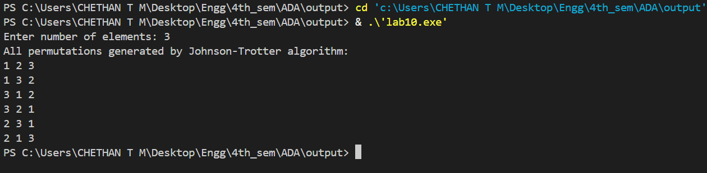

* 1. **Experiment - 11**
     1. **Question:**

**Sort a given set of N integer elements using Heap Sort technique and**

**compute its time taken..**

* + 1. **Code:**

#include <stdio.h>

#include <stdlib.h>

#include <time.h>

void heapify(int arr[], int n, int i) {

int largest = i;

int left = 2 * i + 1;

int right = 2 * i + 2;

if (left < n && arr[left] > arr[largest])

largest = left;

if (right < n && arr[right] > arr[largest])

largest = right;

if (largest != i) {

int temp = arr[i];

arr[i] = arr[largest];

arr[largest] = temp;

heapify(arr, n, largest);

}

}

void heapSort(int arr[], int n) {

for (int i = n / 2 - 1; i >= 0; i--)

heapify(arr, n, i);

for (int i = n - 1; i >= 0; i--) {

int temp = arr[0];

arr[0] = arr[i];

arr[i] = temp;

heapify(arr, i, 0);

}

}

int main() {

int n;

printf("Enter number of elements: ");

scanf("%d", &n);

int *arr = (int*)malloc(n * sizeof(int));

if (!arr) {

printf("Memory allocation failed!\n");

return 1;

}

printf("Enter %d elements:\n", n);

for (int i = 0; i < n; i++)

scanf("%d", &arr[i]);

clock_t start, end;

double cpu_time_used;

start = clock();

heapSort(arr, n);

end = clock();

cpu_time_used = ((double)(end - start)) / CLOCKS_PER_SEC;

printf("Sorted array:\n");

for (int i = 0; i < n; i++)

printf("%d ", arr[i]);

printf("\n");

printf("Time taken for heap sort: %f seconds\n", cpu_time_used);

free(arr);

return 0;

}

* + 1. **Output:**

