Azure DevOps CI/CD Pipeline
Deploying a React App to Azure Web App as a Container
Use Case Implementation Document

Chethan Paramkusham
Azure DevOps Organization: chethanparamkusham07 | Project: Usecase

1. Project Overview
This document covers the complete implementation of a CI/CD pipeline using Azure DevOps to build, containerize, and deploy a React.js currency converter application to Azure Web App as a Docker container.

Application : Currency Converter — React.js app built with Vite
Source Code : Azure Repos (Git) — Usecase project
Container : Docker — multi-stage build (Node.js 20 + Nginx)
Registry : Azure Container Registry — chethanacr.azurecr.io
Hosting : Azure Web App for Containers — currenyconverter
Pipeline : Azure DevOps YAML pipeline — 3 stages: Build + Test + Deploy

End-to-End Flow
Every time code is pushed to the main branch in Azure Repos, the pipeline automatically runs the following sequence:

- Developer pushes code to Azure Repos (main branch)
- Pipeline trigger fires automatically
- Stage 1 — Build: Docker image is built from Dockerfile and pushed to ACR
- Stage 2 — Test: Unit tests are run on the application code to verify nothing is broken
- Stage 3 — Deploy: Docker image is pulled from ACR and deployed to Azure Web App
- Azure Web App restarts with the new container — application is live

2. Azure DevOps Project Setup
Azure DevOps is the platform used to manage source code, run pipelines, and deploy the application. We created a dedicated project called "Usecase" under the organization chethanparamkusham07.

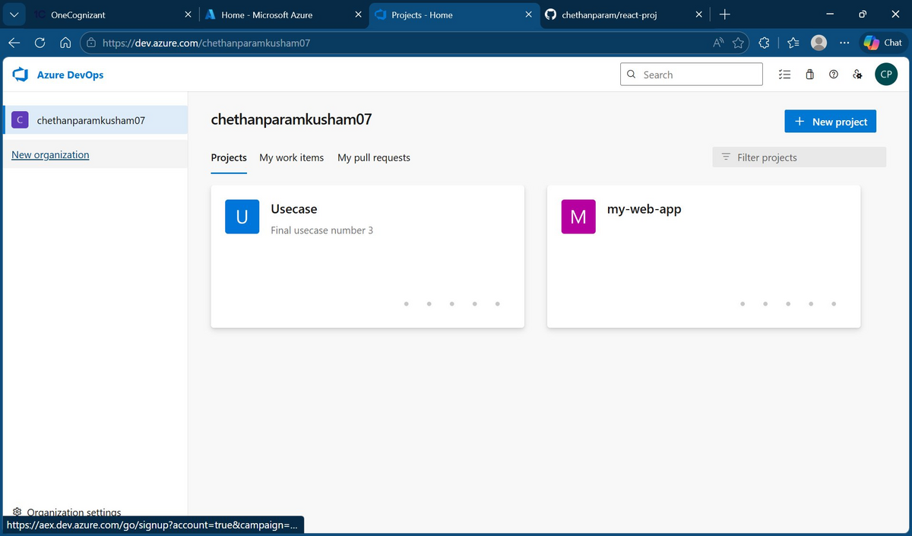
Azure DevOps home — showing both projects (Usecase and my-web-app)

The Usecase project contains all the components needed for this use case: Repos for source code, Pipelines for CI/CD, and Environments for deployment tracking.

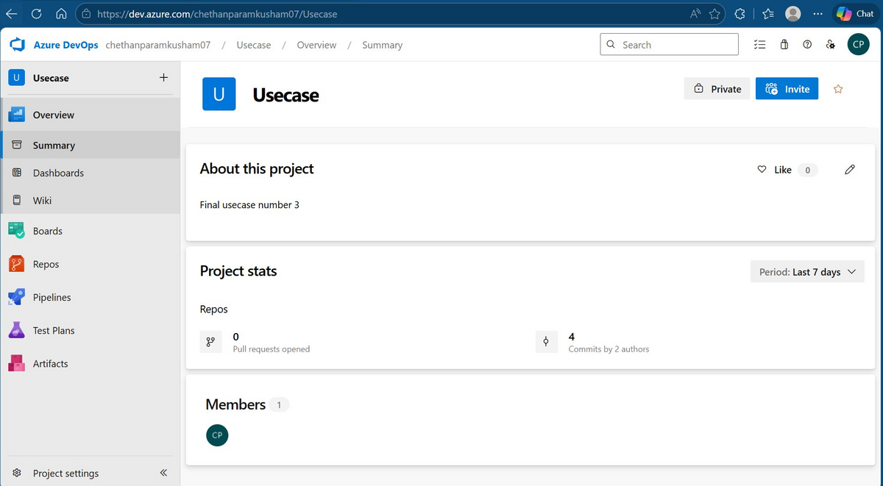
Usecase project overview — showing 4 commits and 1 member

3. Push Code to Azure Repos
The React app source code, Dockerfile, and pipeline YAML file are all stored in the Azure Repos Git repository. The repository was initialized locally in VS Code and pushed to Azure DevOps.

Steps performed in VS Code terminal
- git init — initialized a new local git repository
- git remote add origin <Azure Repos URL> — linked local repo to Azure DevOps
- git branch -m master main — renamed branch to main
- git add . && git commit -m "Initial commit"
- git push origin main --- pushed all files to Azure Repos

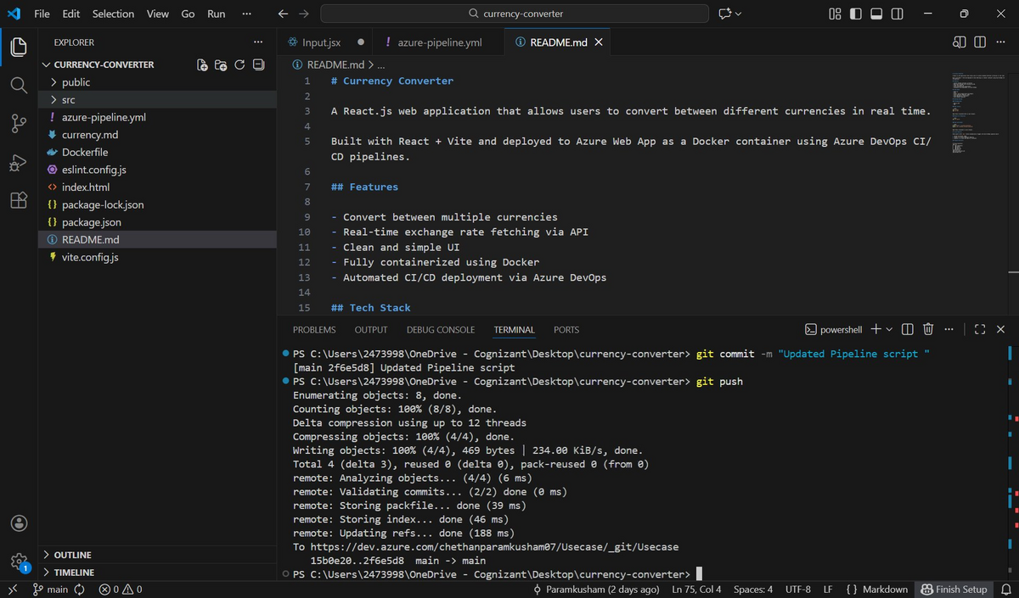
VS Code — git push to Azure Repos (Usecase), main branch

After the push, all project files are visible in Azure Repos including the Dockerfile and pipeline YAML.

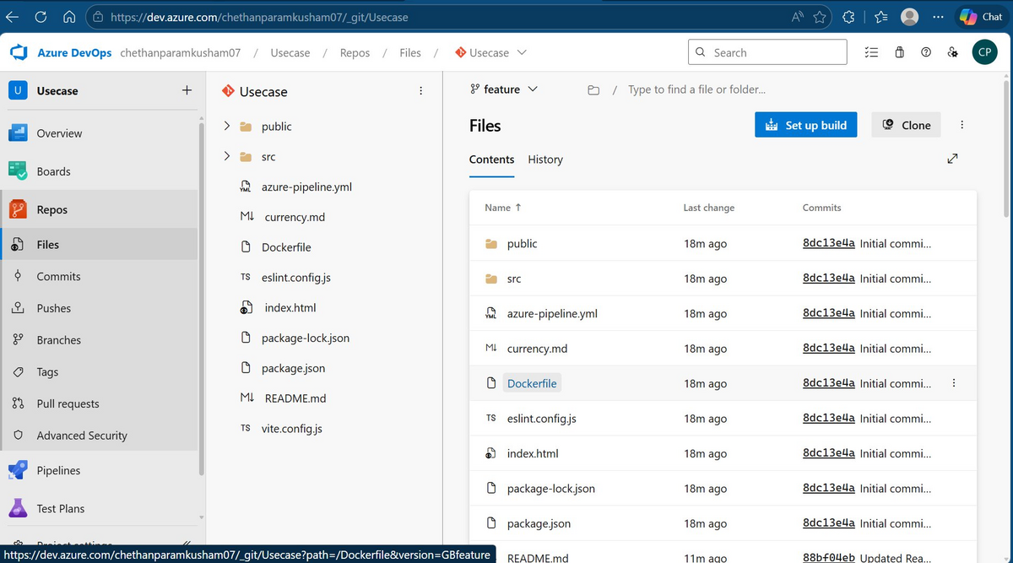
Azure Repos — all project files visible after push
Note: The repository contains: Dockerfile, azure-pipeline.yml, src/, public/, package.json, and README.md

4. Azure Container Registry (ACR)
Azure Container Registry (ACR) is a private Docker registry hosted on Azure. It stores the Docker images built by the CI pipeline. The pipeline pushes a new image to ACR on every successful build.

What ACR does in this setup
- Receives the Docker image pushed by the Build stage of the pipeline
- Tags each image with the pipeline Build ID so every build is traceable
- Also maintains a "latest" tag pointing to the most recent image
- The Deploy stage pulls the image from ACR and deploys it to the Web App

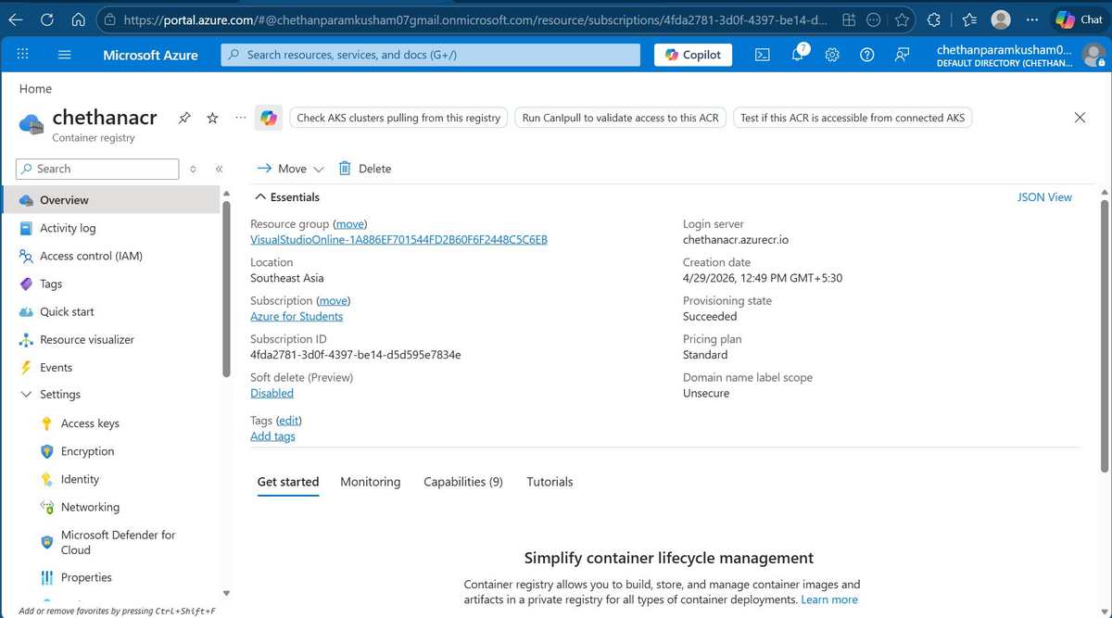
Azure Container Registry — chethanacr (Login server: chethanacr.azurecr.io)
Note: Resource group: VisualStudioOnline-1A886EF701544FD2B60F6F2448C5C6EB | Location: Southeast Asia | SKU: Standard

5. Azure Web App for Containers
Azure Web App for Containers is a managed hosting platform that runs Docker containers. It pulls the Docker image from ACR and serves the application over HTTPS automatically.

Key configuration
- Name: currenyconverter
- Publish mode: Docker Container
- Operating System: Linux
- Subscription: Azure for Students
- Resource Group: VisualStudioOnline-1A886EF701544FD2B60F6F2448C5C6EB
- Default domain: currenyconverter-avc2cffrg3hjh4dt.southeastasia-01.azurewebsites.net
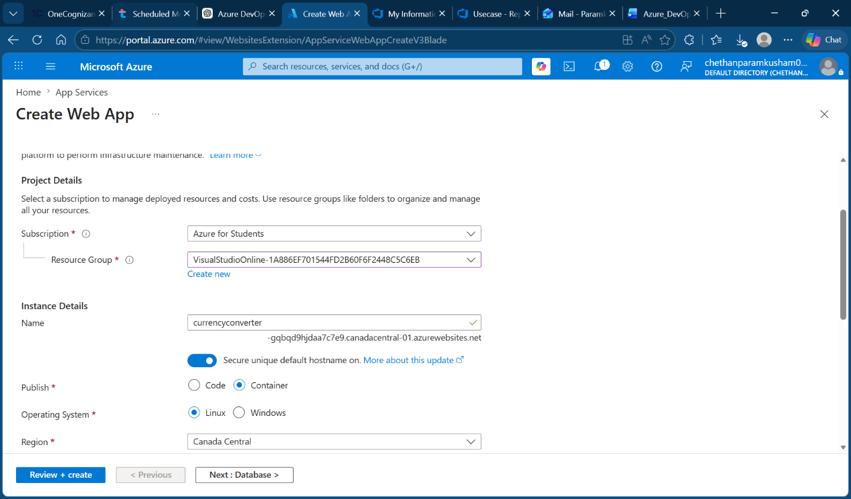
NOTE: When creating the Web App, Container mode must be selected instead of Code. When "Code" is selected, Azure expects raw source files and runs them using its own built-in runtime environment.
When "Container" is selected, Azure pulls and runs a Docker image directly from ACR. Since our pipeline builds a Docker image and pushes it to ACR, the Web App must be in Container mode — choosing "Code" would break the pipeline entirely, as it would receive a Docker image but expect source files.
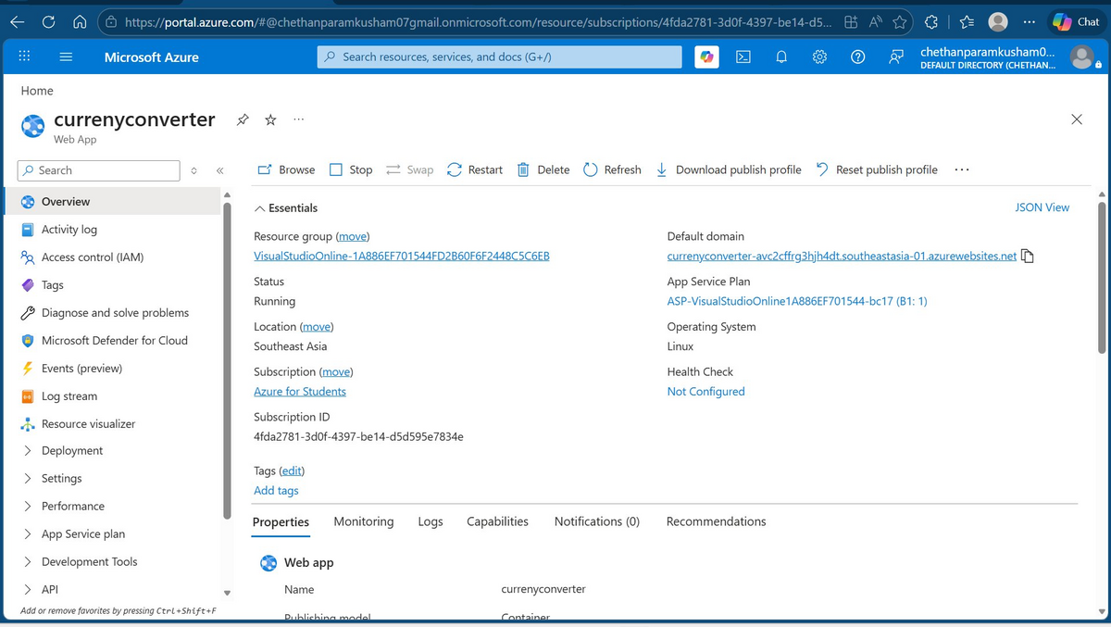
Azure Web App — currenyconverter overview (Status: Running, OS: Linux, Publish: Container)

6. Service Connections in Azure DevOps
Service connections allow Azure DevOps pipelines to securely authenticate with external Azure resources without storing credentials in the pipeline code. Two service connections are required for this use case.
When creating the Web App, Container mode must be selected instead of Code. When "Code" is selected, Azure expects raw source files and runs them using its own built-in runtime environment. When "Container" is selected, Azure pulls and runs a Docker image directly from ACR. Since our pipeline builds a Docker image and pushes it to ACR, the Web App must be in Container mode — choosing "Code" would break the pipeline entirely, as it would receive a Docker image but expect source files.

app-acr — Docker Registry Service Connection
This connection allows the pipeline to build and push Docker images to Azure Container Registry (chethanacr). It uses Service Principal authentication.

To create: Project Settings → Service Connections → New service connection → Docker Registry

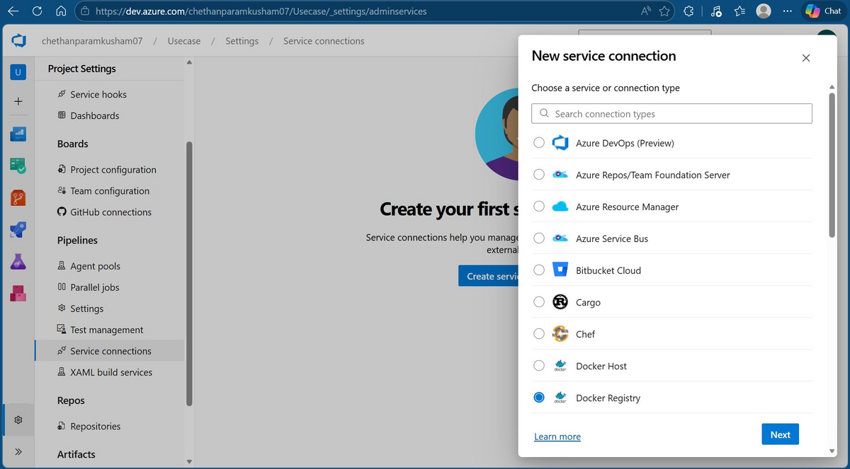
Creating new service connection — Docker Registry type selected

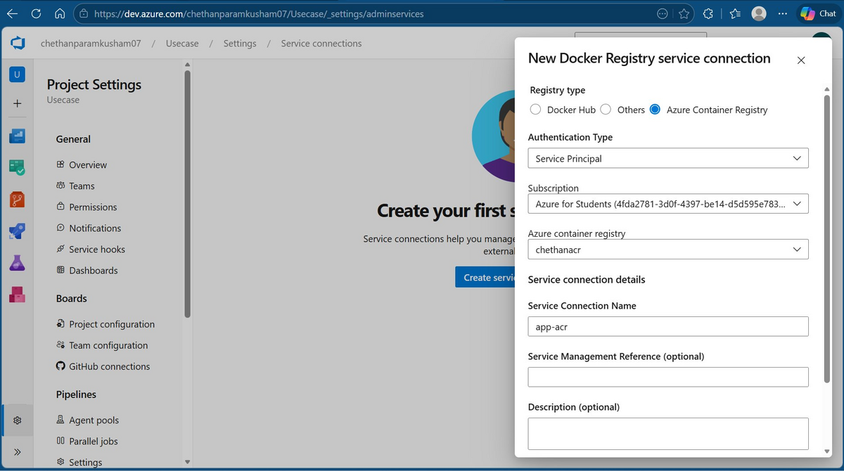
Docker Registry service connection setup — Registry type: Azure Container Registry, ACR: chethanacr, Name: app-acr

app-rm — Azure Resource Manager Service Connection
This connection allows the pipeline to deploy the container to the Azure Web App. It uses Workload Identity Federation (App registration, automatic) — the recommended approach as it does not require managing passwords or secrets.

To create: Project Settings → Service Connections → New service connection → Azure Resource Manager

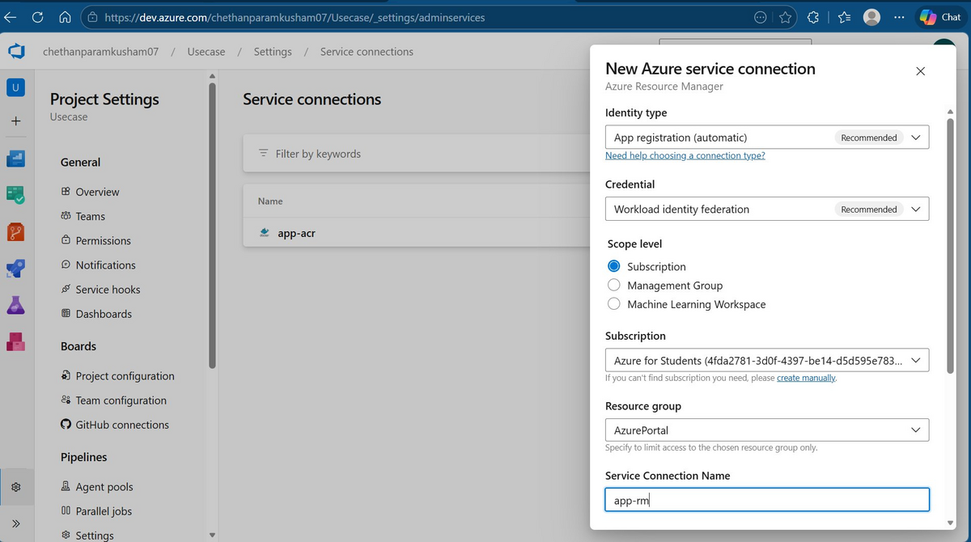
Azure Resource Manager service connection setup — Subscription: Azure for Students, Name: app-rm

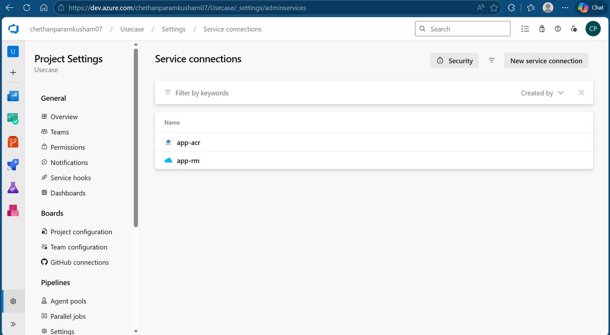
Both service connections created — app-acr and app-rm listed in Project Settings

7. Dockerfile
The Dockerfile is stored in the root of the repository. It uses a multi-stage build to keep the final container image size 7small and production-ready.

Stage 1 — Build
Uses Node.js 20 Alpine to install dependencies and build the React app. The output is the compiled static files in the /app/dist folder.

Stage 2 — Serve
Uses Nginx Alpine (lightweight web server) to serve the compiled static files. Node.js is not included in the final image — only Nginx and the built files. This makes the image small (about 26MB content size) and fast to pull.

# Stage 1: Build
FROM node:20-alpine AS build
WORKDIR /app
COPY package*.json ./
RUN npm install
COPY . .
RUN npm run build
# Stage 2: Serve with Nginx
FROM nginx:alpine
COPY --from=build /app/dist /usr/share/nginx/html
EXPOSE 80
CMD ["nginx", "-g", "daemon off;"]

8. CI/CD Pipeline (azure-pipeline.yml)
The pipeline is defined as a YAML file in the root of the repository. It runs automatically when code is pushed to the main branch and is divided into three stages.

Trigger
The pipeline triggers on any push to the main branch. This means every code change automatically kicks off the full build and deploy process.

Variables
Variables store configuration values used across the pipeline to avoid hardcoding. The tag variable is set to the pipeline Build ID, which ensures every image is uniquely tagged and traceable.

Stage 1 — Build and Push Docker Image
Runs on a Microsoft-hosted Ubuntu agent. Uses the Docker@2 task to build the image using the Dockerfile and push it to ACR with two tags: the Build ID and "latest".

Stage 2 — Run Tests
Only runs if Stage 1 succeeds. Installs Node.js 20 on the agent, runs npm install to restore dependencies, then runs npm test to execute unit tests. The --passWithNoTests flag ensures the stage passes even if no test files exist yet. If tests fail, the Deploy stage is blocked automatically.

Stage 3 — Deploy to Azure Web App
Only runs if Stage 2 (Test) succeeds. Uses the AzureWebAppContainer@1 task to deploy the image to the Azure Web App. The deployment targets the production environment.

trigger:
branches:
include:
- main

variables:
acrLoginServer: 'chethanacr.azurecr.io'
imageRepository: 'react-app'
webAppName: 'currenyconverter'
resourceGroup: 'VisualStudioOnline-1A886EF701544FD2B60F6F2448C5C6EB'
dockerfilePath: '$(Build.SourcesDirectory)/Dockerfile'
tag: '$(Build.BuildId)'

stages:

# ─── STAGE 1: BUILD & PUSH IMAGE TO ACR ───────────────────────────
- stage: Build
displayName: 'Build and Push Docker Image'
jobs:
- job: BuildJob
pool:
vmImage: 'ubuntu-latest'
steps:

- task: Docker@2
displayName: 'Build Docker Image'
inputs:
command: build
containerRegistry: 'app-acr'
repository: '$(imageRepository)'
dockerfile: '$(dockerfilePath)'
tags: |
$(tag)
latest

- task: Docker@2
displayName: 'Push Image to ACR'
inputs:
command: push
containerRegistry: 'app-acr'
repository: '$(imageRepository)'
tags: |
$(tag)
latest

# ─── STAGE 2: LINT ────────────────────────────────────────────────
- stage: Test
displayName: 'Code Quality Check'
dependsOn: Build
condition: succeeded()
jobs:
- job: LintJob
pool:
vmImage: 'ubuntu-latest'
steps:

- task: NodeTool@0
displayName: 'Install Node.js'
inputs:
versionSpec: '20.x'

- script: npm install
displayName: 'Install Dependencies'

- script: npm run lint
displayName: 'Run ESLint'

# ─── STAGE 3: DEPLOY TO AZURE WEB APP ─────────────────────────────
- stage: Deploy
displayName: 'Deploy to Azure Web App'
dependsOn: Test
condition: succeeded()
jobs:
- deployment: DeployJob
displayName: 'Deploy Container to Web App'
environment: 'production'
pool:
vmImage: 'ubuntu-latest'
strategy:
runOnce:
deploy:
steps:
- task: AzureWebAppContainer@1
displayName: 'Deploy to Azure Web App as Container'
inputs:
azureSubscription: 'app-rm'
appName: '$(webAppName)'
resourceGroupName: '$(resourceGroup)'
containers: '$(acrLoginServer)/$(imageRepository):$(tag)'

9. Pipeline Execution — Build Stage
After the pipeline was created and the YAML file was linked to the repository, the first run was triggered automatically by a push to the main branch.

What happens during the Build stage
- The pipeline agent (Ubuntu latest) is provisioned by Azure
- The repository code is checked out onto the agent
- Docker pulls the Nginx and Node.js base images from Docker Hub
- The multi-stage Docker build runs — first compiling the React app, then packaging with Nginx
- The completed image is pushed to ACR tagged with the Build ID and "latest"

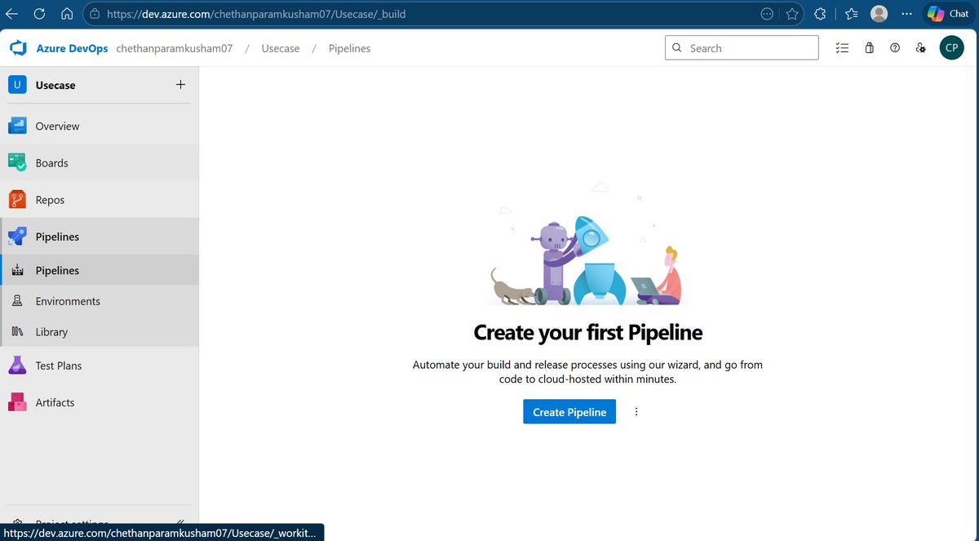
Azure DevOps Pipelines — Create your first Pipeline page

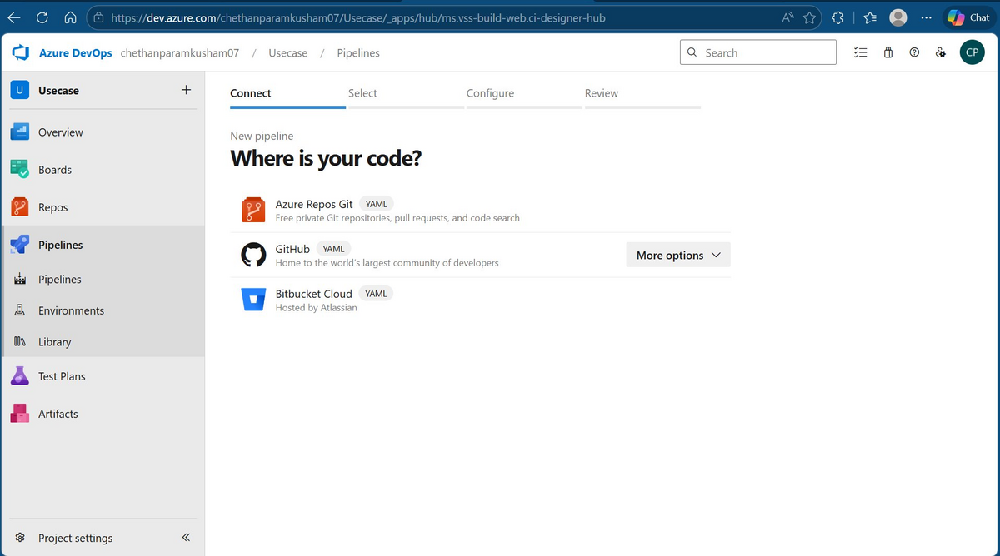
Pipeline creation wizard — selecting Azure Repos Git as source

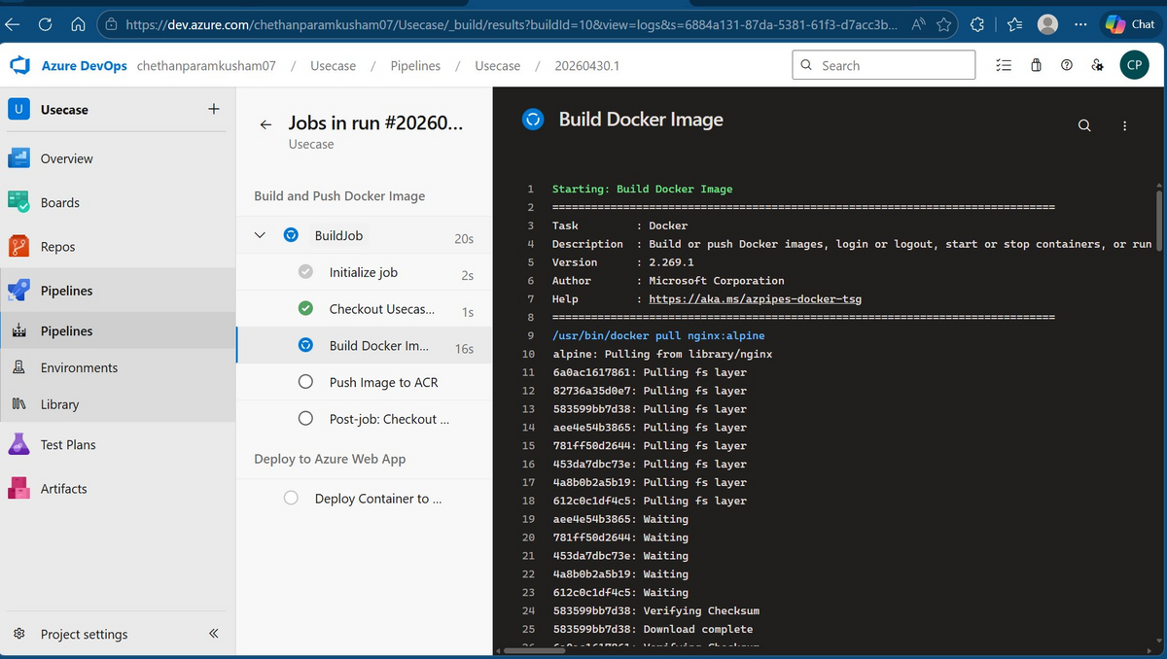
Build stage running — Docker task pulling Nginx Alpine base image layers

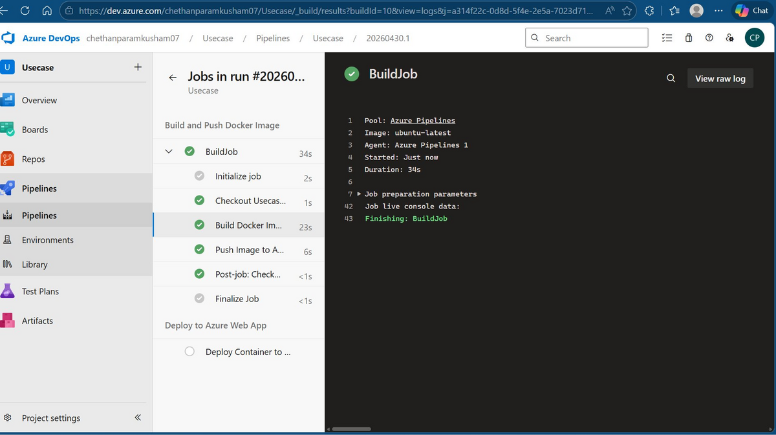
Build stage complete — all steps green (Checkout, Build Docker Image, Push Image to ACR, Post-job)

10. Pipeline Execution — Deploy Stage
After the Build stage completes successfully, the Deploy stage starts. Because the pipeline uses the "environment: production" block, Azure DevOps checks for any required permissions or approvals before proceeding.

Environment Permission — First Run Only
On the very first run, Azure DevOps asks for permission to use the "production" environment. This is a one-time approval. After clicking Permit, all future runs proceed automatically without needing approval.

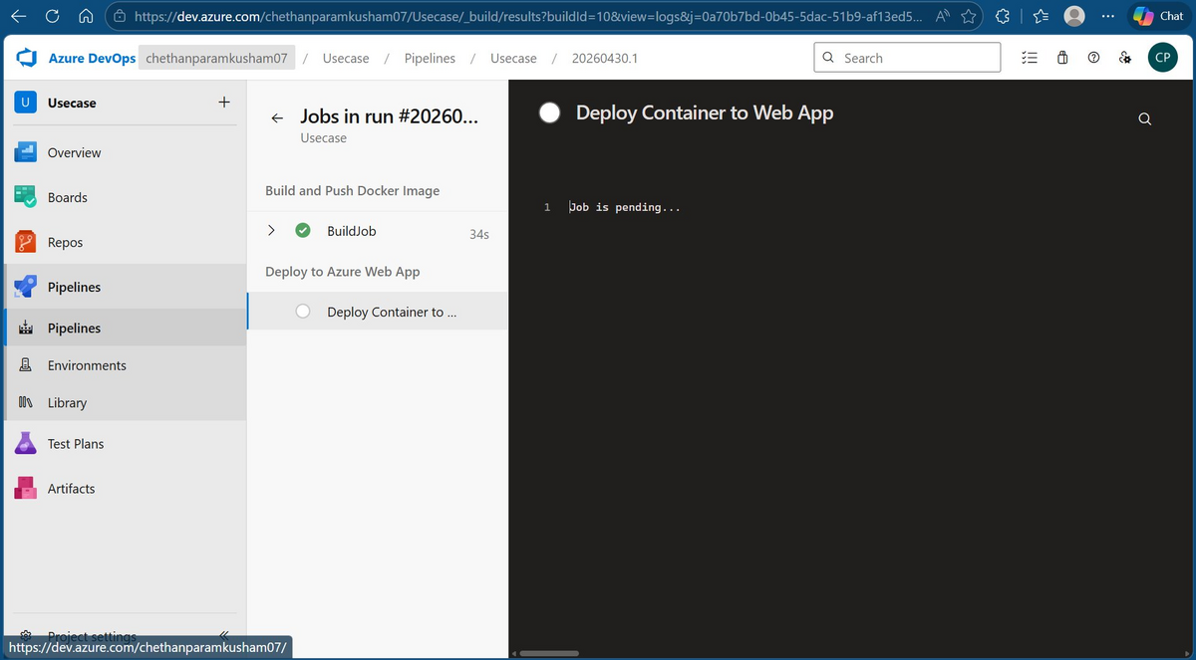
Deploy stage — Job is pending, waiting for permission

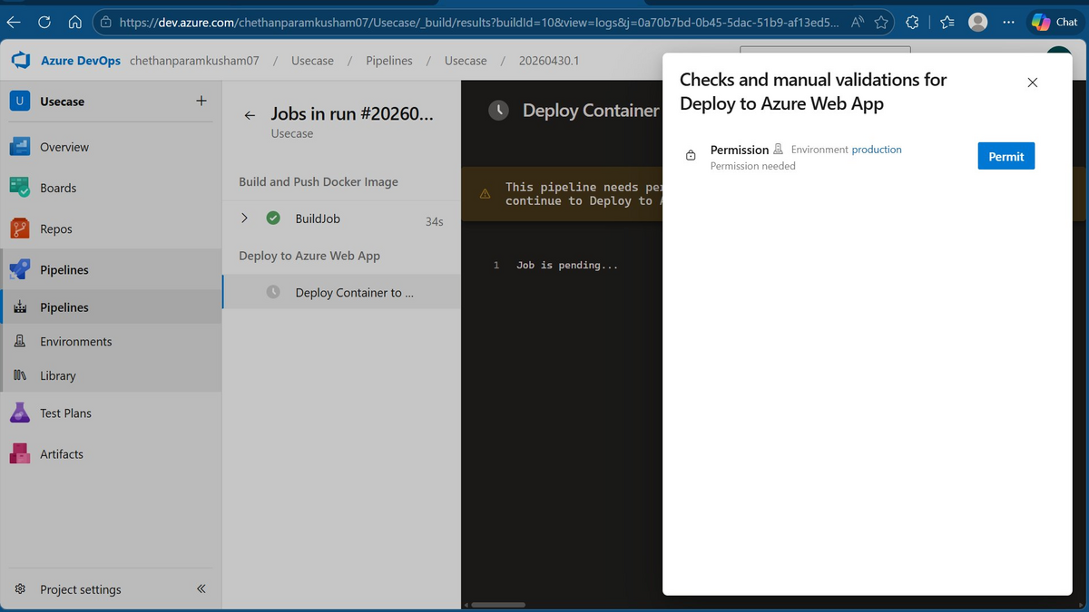
Permission popup — "Checks and manual validations for Deploy to Azure Web App" — clicking Permit grants access

11. Error & Troubleshooting
After the first pipeline run, the Build stage passed but the Deploy stage failed with an error. This section covers the error, its cause, and how it was resolved.

Error: Resource does not exist

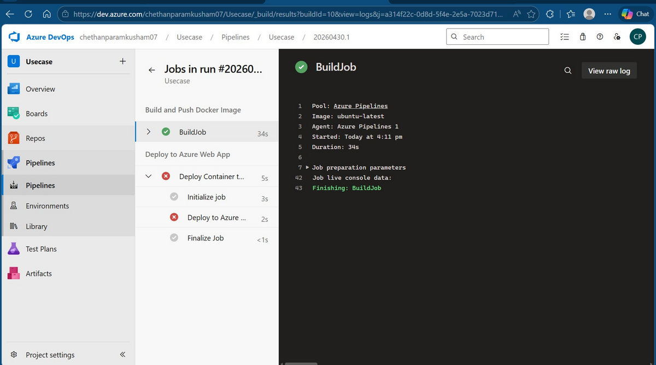
Deploy stage failed — red X on "Deploy Container to Web App"

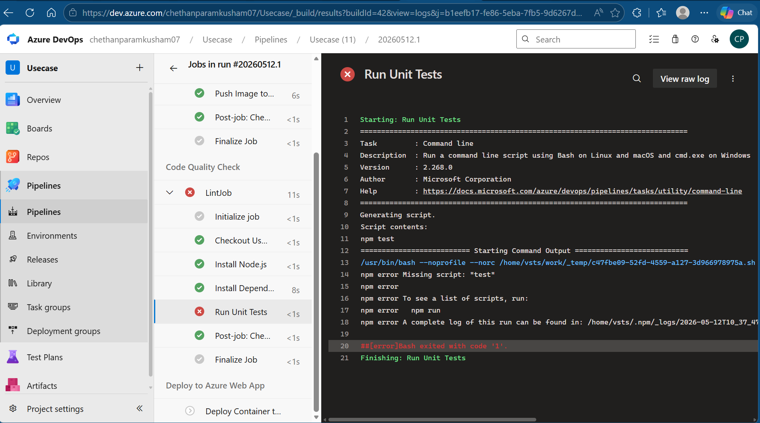
Error log: "Resource 'currenyconverter' doesn't exist. Resource should exist before deployment."

❌ ERROR DESCRIPTION
Error: npm error Missing script: "test"
Root Cause: Vite + React scaffolding does not include a "test" script in package.json by default. When the CI/CD pipeline attempted to execute "npm test" as part of the pipeline stages, npm could not find a test script, causing the pipeline to exit with a non-zero error code and fail the build.
Impact: The entire pipeline failed at the test stage, preventing Docker build and deployment from executing.

IMPACT: The Test stage failed, which automatically blocked the Deploy stage due to the dependsOn: Test, condition: succeeded() configuration. The Docker image was successfully built and pushed to ACR in Stage 1, but never reached the Web App.
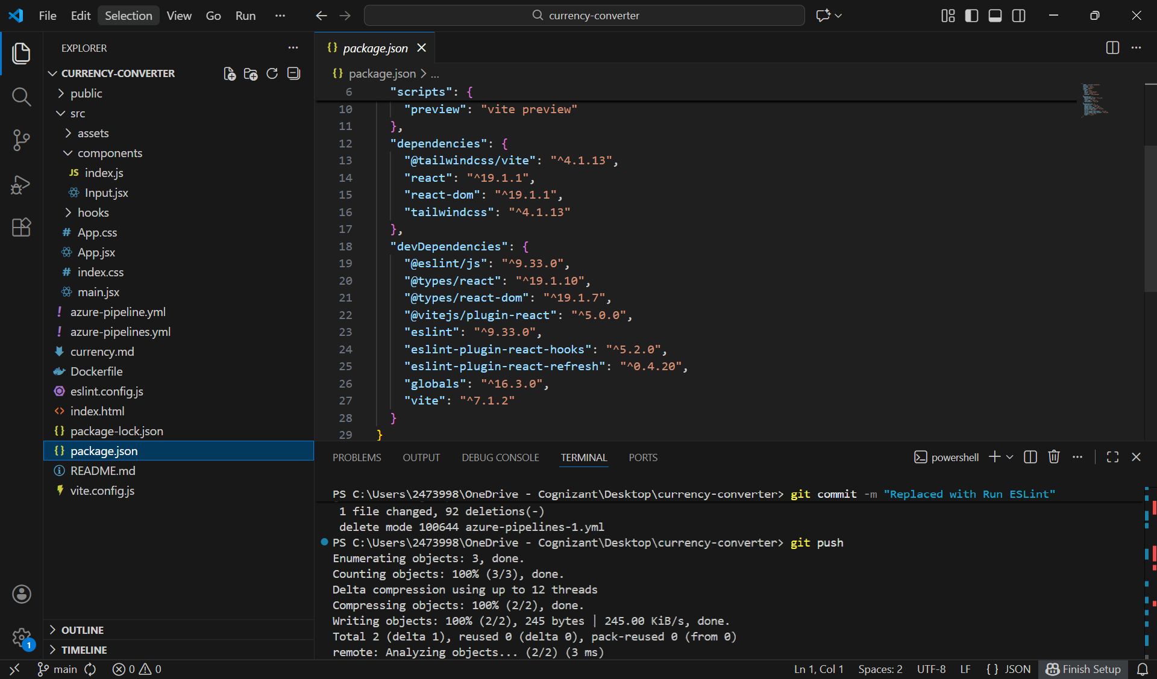
Fix:
Run a different quality gate that does exist — ESLint. This still acts as a safety check, catches syntax errors, unused variables, code style issues and runs in seconds.
For your Vite + React project, ESLint was already installed and configured when we ran npm create vite@latest — that's why an eslint.config.js file exists in your repo. The npm run lint script (defined in package.json) executes ESLint across your src/ folder using that config.

Error: Application Error — Solved by Environment Variables
After the pipeline ran successfully and the container was deployed, opening the Web App URL in the browser showed an Application Error page. The pipeline showed green — meaning the deployment itself worked — but the app was not reachable. The root cause was missing environment variables in the Azure Web App configuration.
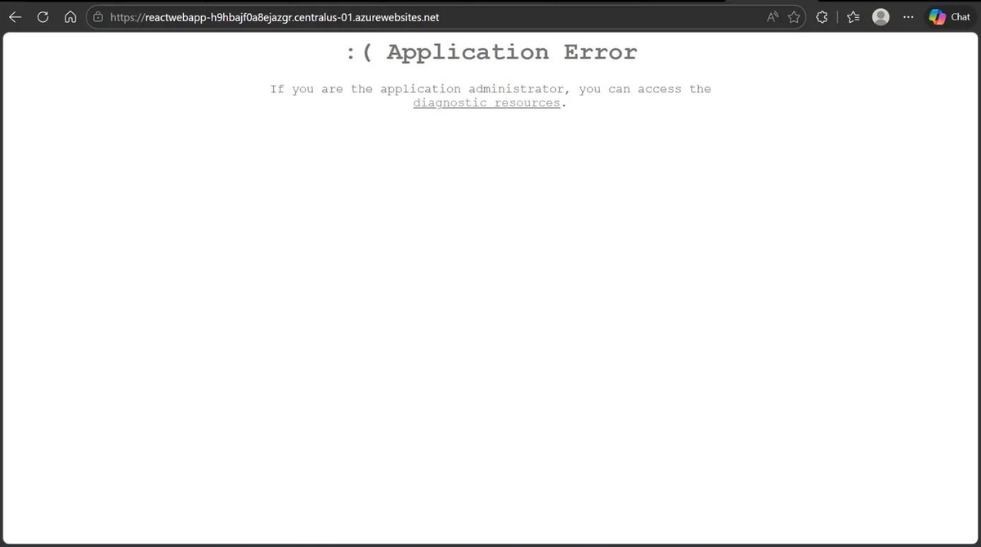

Environment variables are key-value configuration settings injected into the running container at startup. They tell Azure and the container runtime how to behave

Application Error Occurred
The Dockerfile exposes port 80 and Nginx listens on port 80 inside the container. However, Azure Web App by default expects the container to be reachable on port 8080. Because there was no WEBSITES_PORT variable set, Azure tried to connect to port 8080, got no response, and returned the Application Error page to the browser. The container was actually running correctly — Azure just did not know which port to use.

Fix — Setting Environment Variables in Azure Portal
To fix the error, the following environment variables were added in the Web App: Settings → Environment variables → App settings.

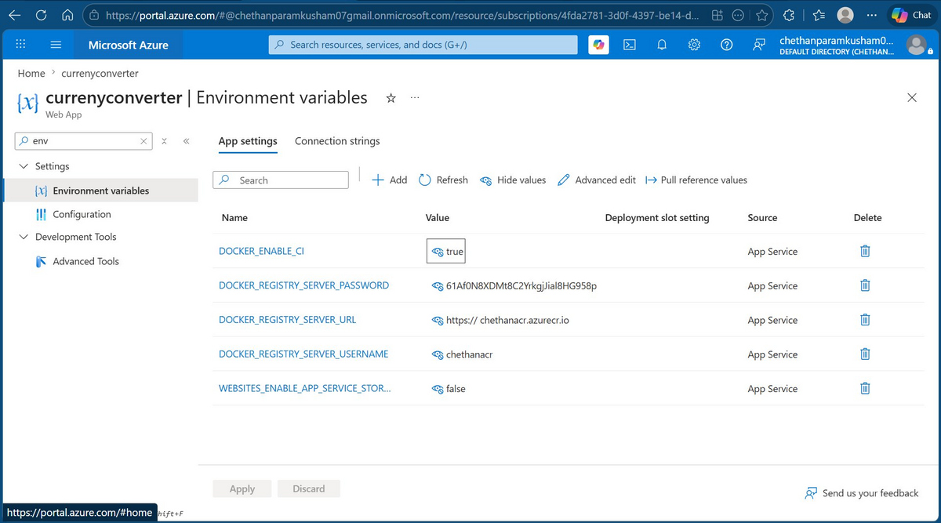

Variable Name | What It Does
WEBSITES_PORT | Tells Azure which port the container is listening on. Set to 80 to match the Nginx port exposed in the Dockerfile. Without this, Azure defaults to port 8080 and cannot reach the app.
DOCKER_REGISTRY_SERVER_URL | The login server URL of the Azure Container Registry. Set to https://chethanacr.azurecr.io. Tells Azure where to pull the Docker image from at runtime.
DOCKER_REGISTRY_SERVER_USERNAME | The admin username for the ACR. Set to chethanacr. Used by the Web App to authenticate and pull the image from the private registry.
DOCKER_REGISTRY_SERVER_PASSWORD | The admin password for the ACR. Retrieved from ACR → Access keys in the Azure Portal. Required alongside the username for the Web App to authenticate with the private registry.
DOCKER_ENABLE_CI | Set to true. Enables continuous deployment webhook — when a new image is pushed to ACR with the same tag, Azure automatically pulls and restarts the container without needing a pipeline redeploy.
WEBSITES_ENABLE_APP_SERVICE_STORAGE | Set to false. Disables persistent file storage mounting inside the container. Recommended for stateless containers like this React app — the container filesystem should come entirely from the Docker image.

12. Linux VM — Docker Verification
To verify the Dockerfile was correct and the React app built successfully inside Docker, a Linux Virtual Machine was created in Azure Portal and used to manually test the Docker build and run process before relying on the pipeline.

Why this was done
If there is a problem with the Dockerfile or the app build, it is faster to debug it manually on a VM than to wait for a full pipeline run each time. This also confirms the image runs correctly as a container on port 8080.

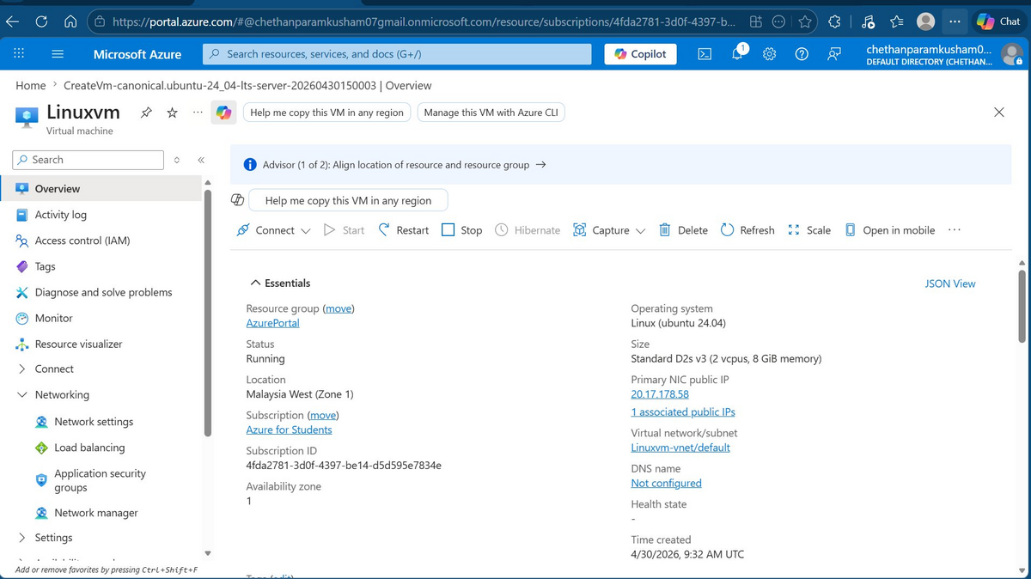
Azure Linux VM (Linuxvm) — Ubuntu 24.04 LTS, Southeast Asia, Standard D2s v3

Step 1 — Connect to VM and update packages
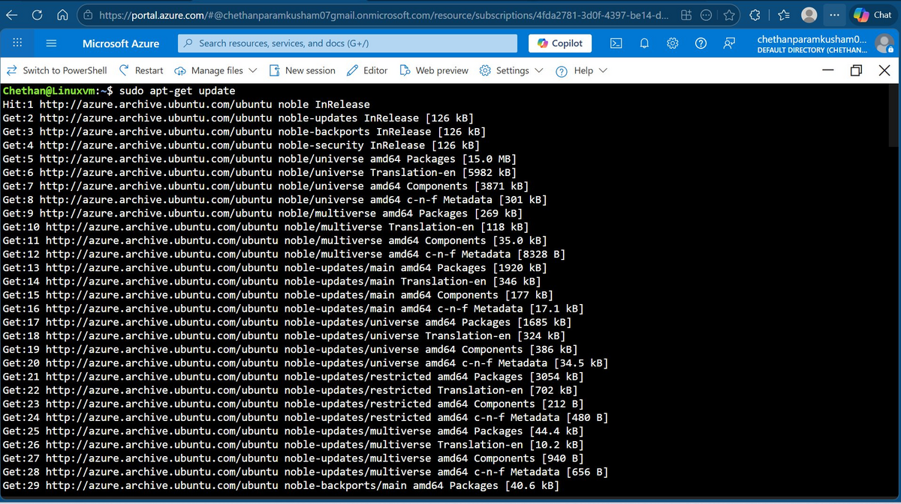
VM terminal — running sudo apt-get update to refresh package lists

Step 2 — Install Docker
Docker was installed on the VM using the official Docker repository. Dependencies were installed first, then Docker CE and its plugins.

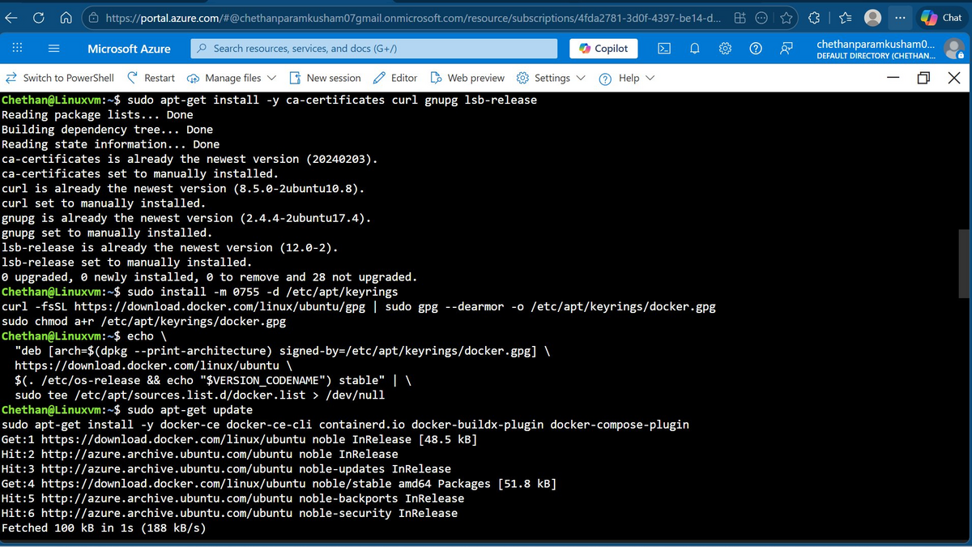
VM terminal — installing Docker dependencies (ca-certificates, curl, gnupg, lsb-release)

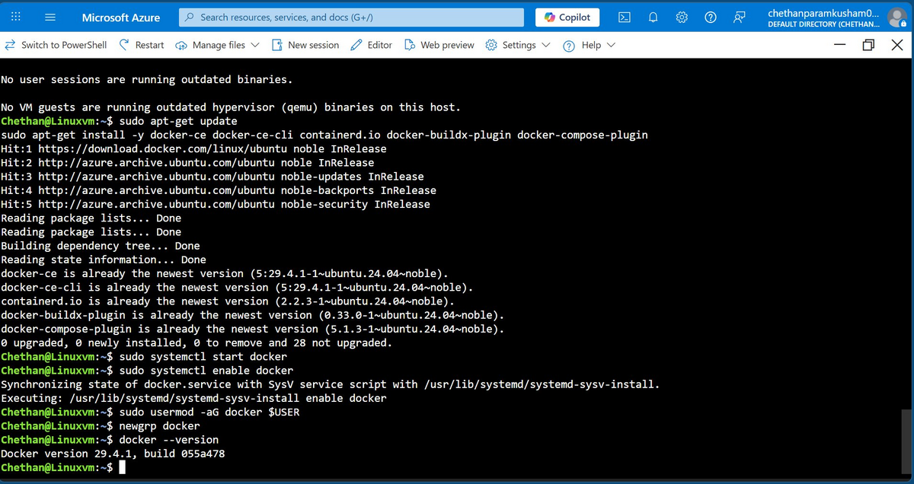
VM terminal — Docker installed and verified: Docker version 29.4.1

Step 3 — Clone the repository and build image
Git was configured and the project was cloned from GitHub. Then the Docker image was built using the Dockerfile.

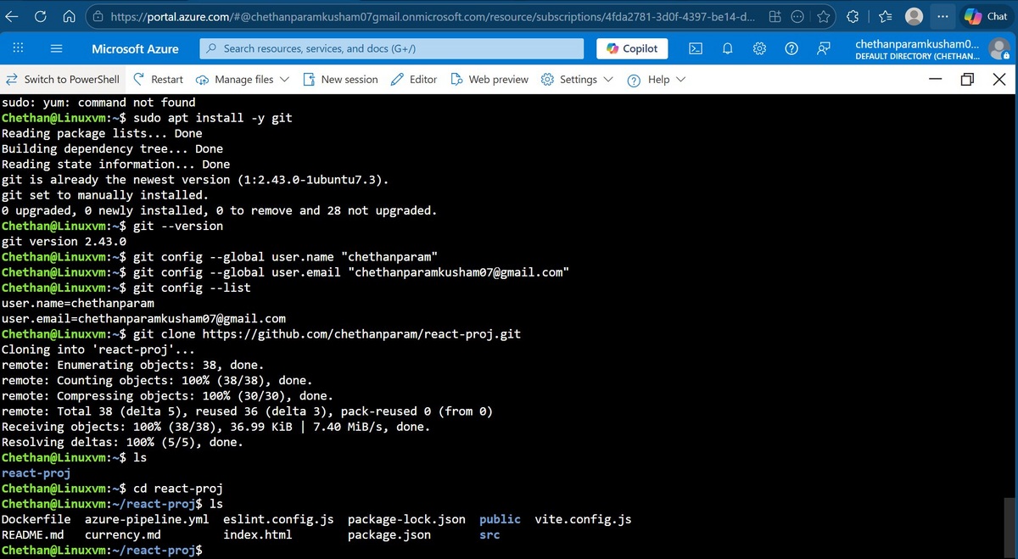
VM terminal — git clone from GitHub, files listed: Dockerfile, azure-pipeline.yml, src/, package.json

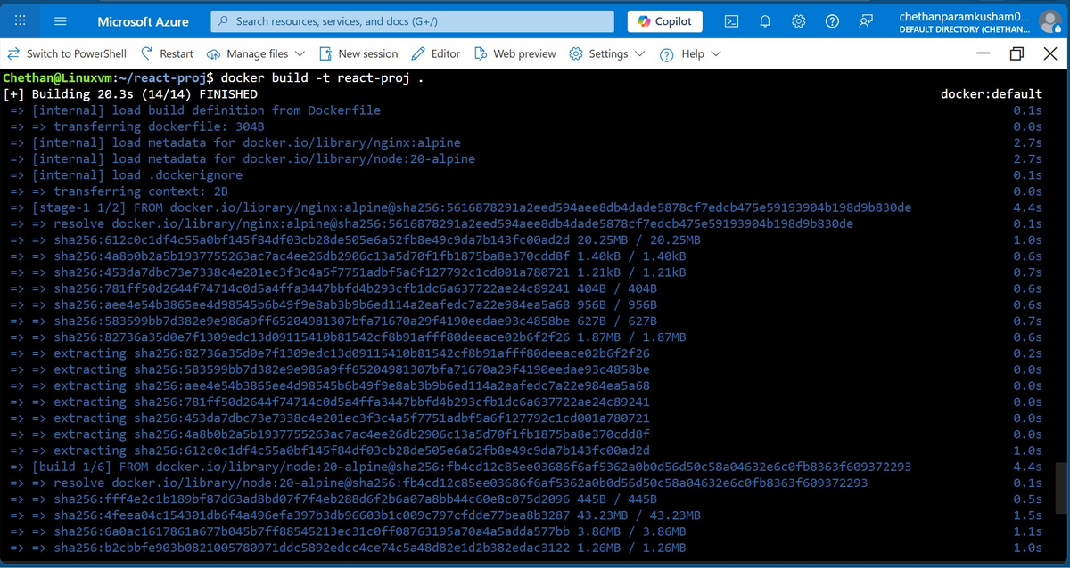
VM terminal — docker build running, pulling Node.js 20 Alpine and Nginx Alpine base images

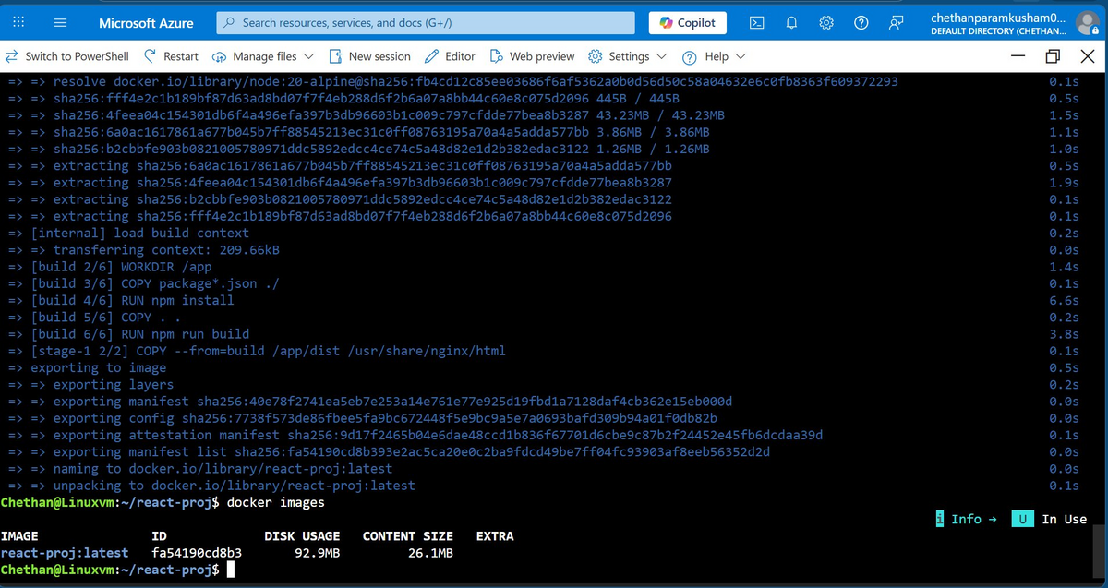
VM terminal — Docker build complete. docker images shows react-proj:latest (92.9MB disk, 26.1MB content)

Step 4 — Run container and verify
The built image was run as a container on port 8080. A port conflict error occurred on the second run attempt because the first container was still running on the same port. This was resolved by stopping the first container before re-running.

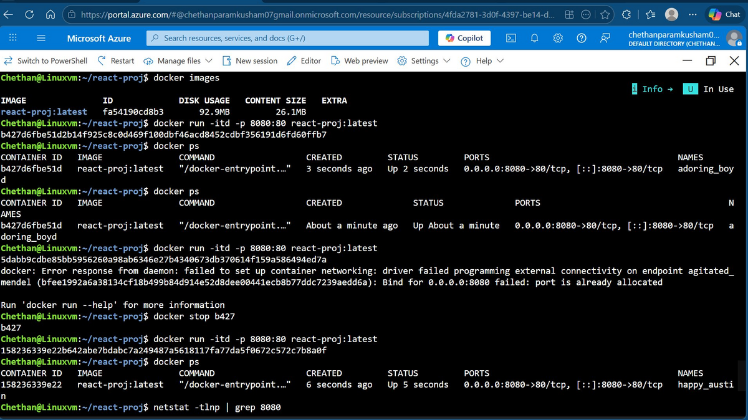
VM terminal — docker run on port 8080, docker ps confirming container is up, port conflict error and resolution

Error : Bind for 0.0.0.0:8080 failed: port is already allocated
Cause : Tried to run a second container on the same port while the first was still running.
Fix : Ran docker stop <container_id> to stop the first container, then re-ran on port 8080.

13. Successful Deployment
After creating the Azure Web App in the portal and re-running the pipeline, all three stages completed successfully. The React application was live and accessible from the public URL.

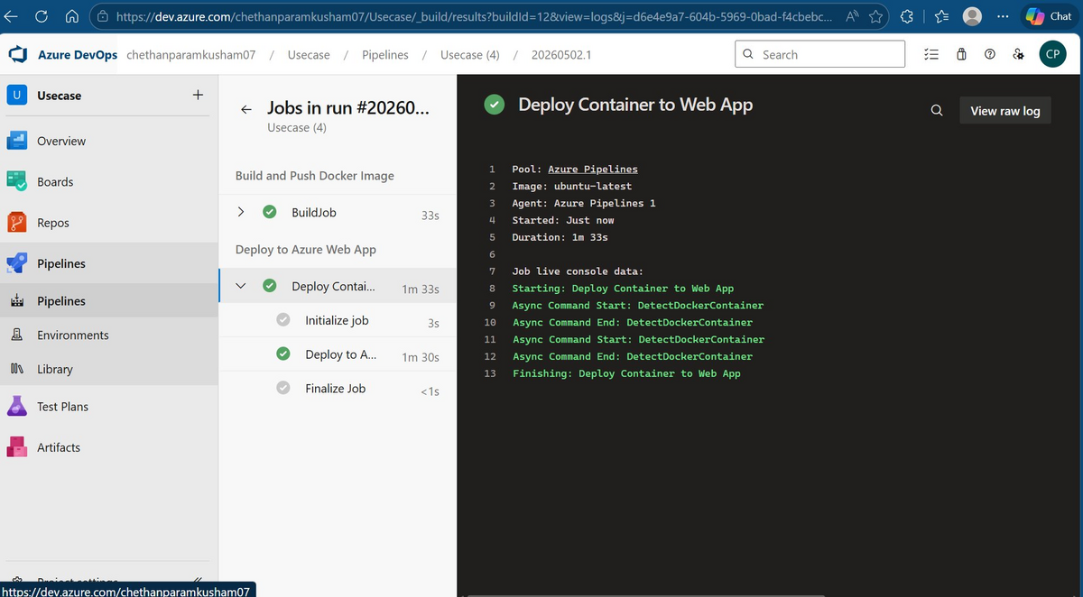
Pipeline run — all three stages green: Build and Push Docker Image ✅, Run Tests ✅, Deploy to Azure Web App ✅

Live Application
The application is accessible at:
https://currenyconverter-avc2cffrg3hjh4dt.southeastasia-01.azurewebsites.net

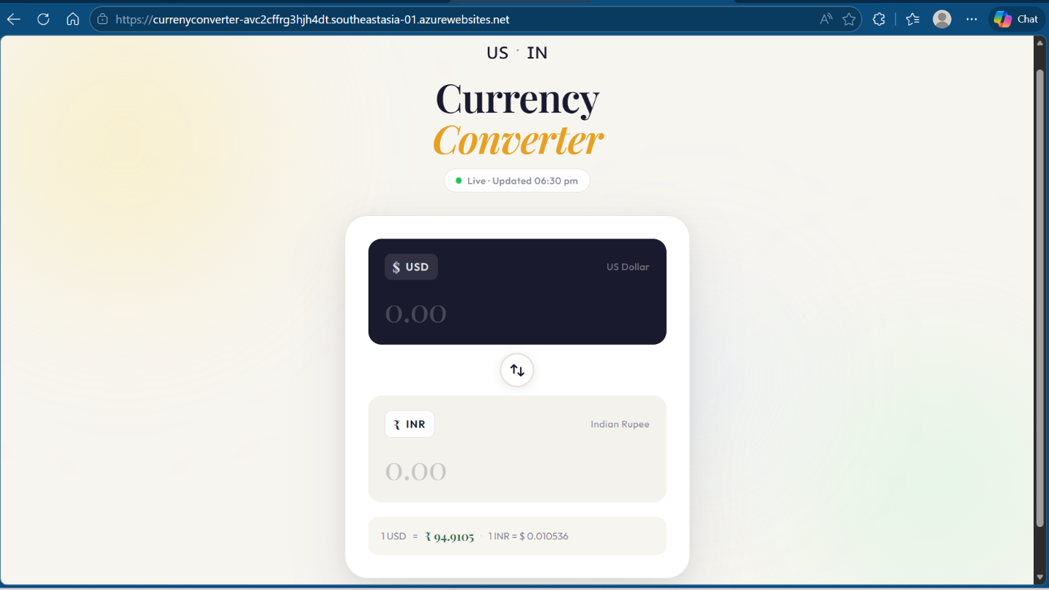
Live application — Currency Converter loaded in browser (default state: 0 USD to 0 INR)

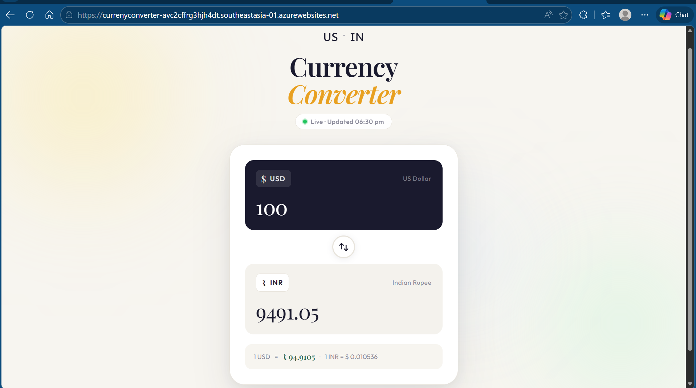
Application working — 1 USD = 94.94882758 INR (real-time exchange rate from API)

14. Key Learnings

Git & Version Control
- Local branch names and remote branch names must match — a branch named master cannot push to main without renaming first
- config.lock files left by interrupted git commands block future operations and must be manually deleted
- git push --force is needed when the remote has commits that are not in the local history
- git push --set-upstream links the local branch to the remote once so future pushes only need git push

Azure DevOps Pipelines
- Service connections must be created before running the pipeline — the pipeline looks them up by name
- The environment block (environment: production) creates an approval gate on the first run. Click Permit to allow the pipeline to proceed
- The AzureWebAppContainer@1 task deploys to an existing Web App — it cannot create a new one. The resource must exist first in Azure Portal
- Each pipeline run tags the Docker image with the Build ID — this makes every deployment traceable back to a specific pipeline run
- The Test stage acts as a safety gate — if tests fail, the Deploy stage is blocked automatically and broken code never reaches production

Docker
- Multi-stage builds keep the final image small — the build tools (Node.js) are not included in the production image
- Port conflicts occur when a container is already running on the same port — stop the old container first
- Testing the Dockerfile manually on a VM before running the pipeline saves time — failures are faster to debug

Azure Resources
- Service connections must point to the correct Azure subscription — if the Web App is in "Azure for Students", the service connection must also reference that subscription
- Web App for Containers requires the image reference to include the full ACR login server path: acrname.azurecr.io/repo:tag

