COALAB Assignment – 4 in verilog(30-08-23)

Problem No: 1
Group No : 14
Semester: AUTUMN 2023:
Group Members:
1)Pasupulety Chethan Krishna Venkat(21CS30036)
2)Gummadi Vikhyath (21CS10028)

Booth’s Algorithm :

Represent both the multiplier and the multiplicand in two's complement form.
Extend the length of the multiplier by one bit to the left, making it one bit longer than the original.
Initialize a product register (initialized to 0),and a "previous bit"(initialized to 0).
Perform a series of steps for each bit of the multiplier:
- Check the last two bits of the multiplier and the previous bit.
- If the pattern is 01, subtract the multiplicand from the product.
- If the pattern is 10, add the multiplicand to the product
- Shift the product register right by 1 bit.
After all steps are completed, the product register contains the result of the multiplication.

The flow chart for the above process is :

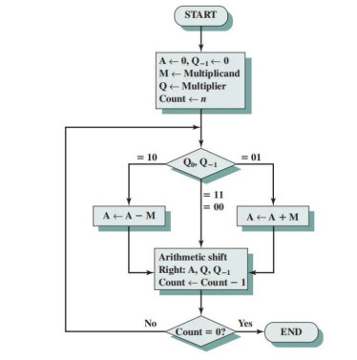

Test bench data:
- a = 62 and b = 37 the product is 2294
- a =34 and b = -9 the product is -306
- a = -18 and b= -10 the product is 180.
- a = 0 and b = 121 the product is 0.

