COALAB Assignment – 5 in verilog(6-09-23)

Problem No: 1
Group No : 14
Semester: AUTUMN 2023:
Group Members:
1)Pasupulety Chethan Krishna Venkat(21CS30036)
2)Gummadi Vikhyath (21CS10028)

Algorithm :

- We need to find the value of x/255 where x is 32 bit input . To find the required number we are using a simple logic .As we can see y = x/255; this can be written as y = 256*y -x .

- Now we can see that we dont know y but we know that last 8 digits of 256*y is 00000000 so we will solve the problem in parts . First we will subtract 00000000 and last 8 digits of x and the result of the above subtraction is the last 8 digits of y (i.e 1-8 digits of y) .

- Now we will subtract the above result and (9-16) digits of x and we will get the result which is equal to (9 -16) digits of y . Repeat the above process 2 more times as we have 32 bit input .

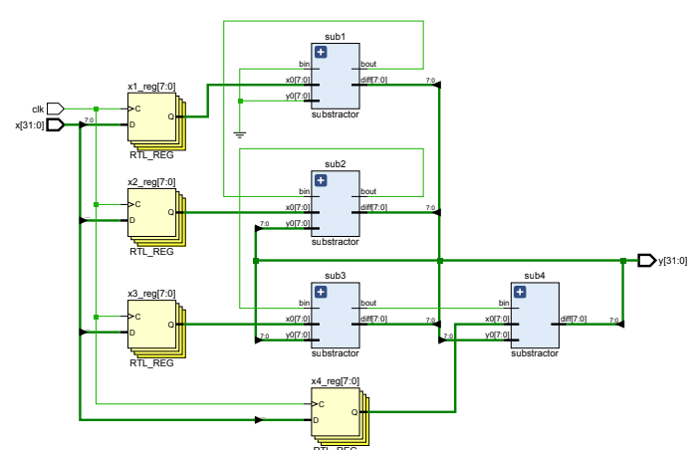
The flow chart for the above process is :

Test bench data:
- x = 2550 the divison ans is (x/255) Y=10.
- x =510 and the division ans (x/255) Y= 2.
- x = 255 and the division ans (x/255) Y=1.
- x = 0 the division ans (x/255) Y = 0.

