Generative AI and its Applications
Unit-4 Handson
Name: Chethan S | SRN: PES2UG23CS150
Section: 6 C | Date: 23-04-2026

1). Multimodal Models:
1. CLIP:
Image:

Image-text similarity:
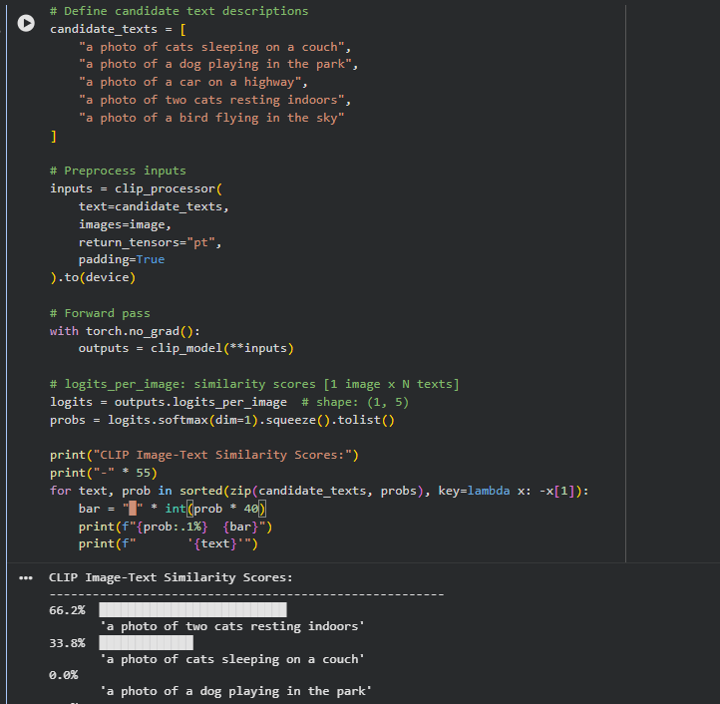
Image-text similarity is high for the cat captions

Zero-shot for dog is successful
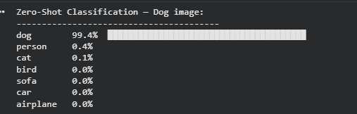
Shared Vector Space – image embeddings
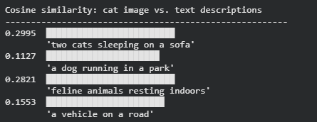
2. BLIP:
Image captioning:
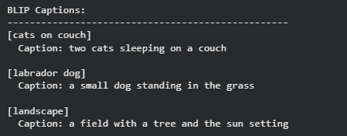
VQA on the same image:
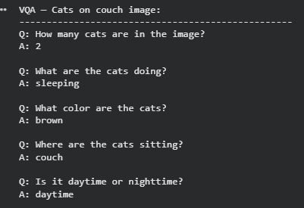

3. Whisper
Output:
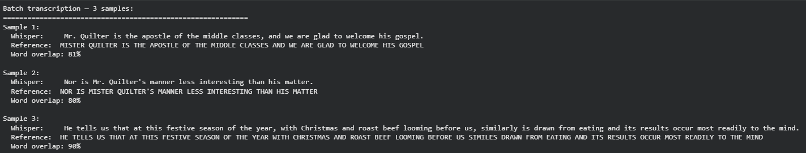
Complete Pipeline:
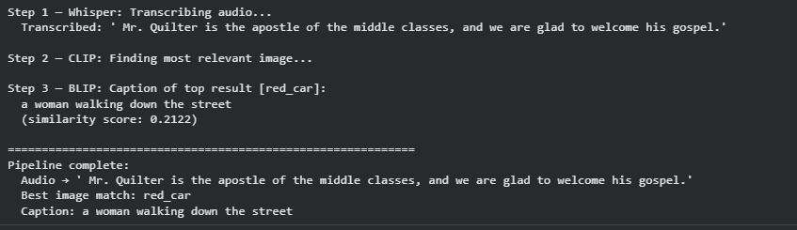

Key Takeaways
1. CLIP is discriminative — it scores similarity. It cannot generate text from scratch.
2. BLIP is generative — it can produce captions and answers, but it builds on CLIP-style alignment.
3. Whisper is specialized for audio — it converts the audio modality into text, making it the entry point for voice-driven pipelines.
4. Multimodal pipelines chain these models: each model handles its modality and passes outputs to the next

2). Agentic Workflow
Part 1: Agentic Design Patterns:
- Reflection: an agent critiques and improves its own output iteratively.
- Tool Use: an agent calls external functions (search, API calls, file ops) while reasoning.
- Planning: the agent decomposes a big goal into ordered sub-steps before execution.
- Multi-Agent Collaboration: specialized agents split responsibilities and coordinate outcomes.
- Core message: frameworks differ in API style, but these same patterns appear underneath.
Part 2: AutoGen:
Agents created:
- UserProxy: controls the flow, no LLM, watches for TERMINATE.
- Researcher: converts raw search results into structured findings.
- Writer: turns findings into a polished article.
- Translator: translates article to Spanish.
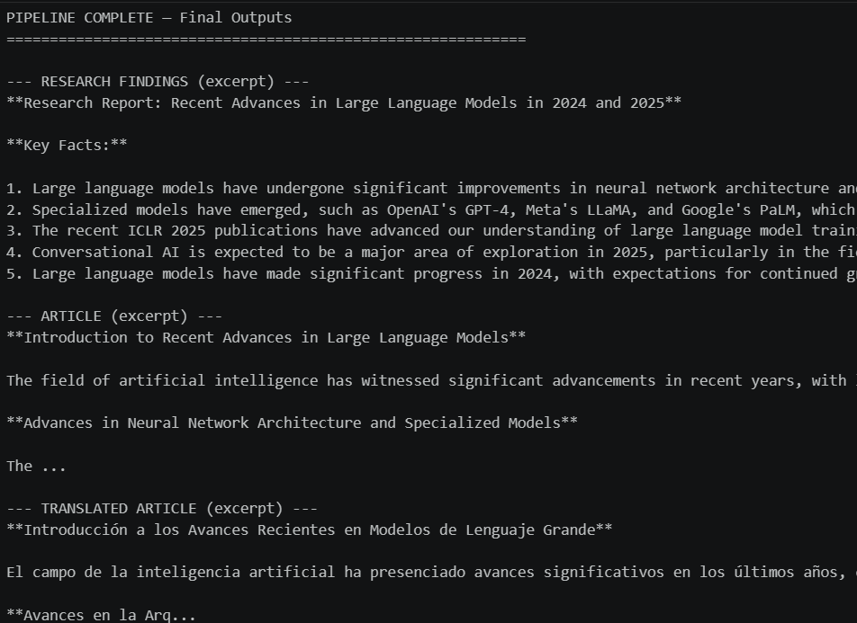

Part 3: CrewAI:
Agents: Research Analyst, Writer, Translator.
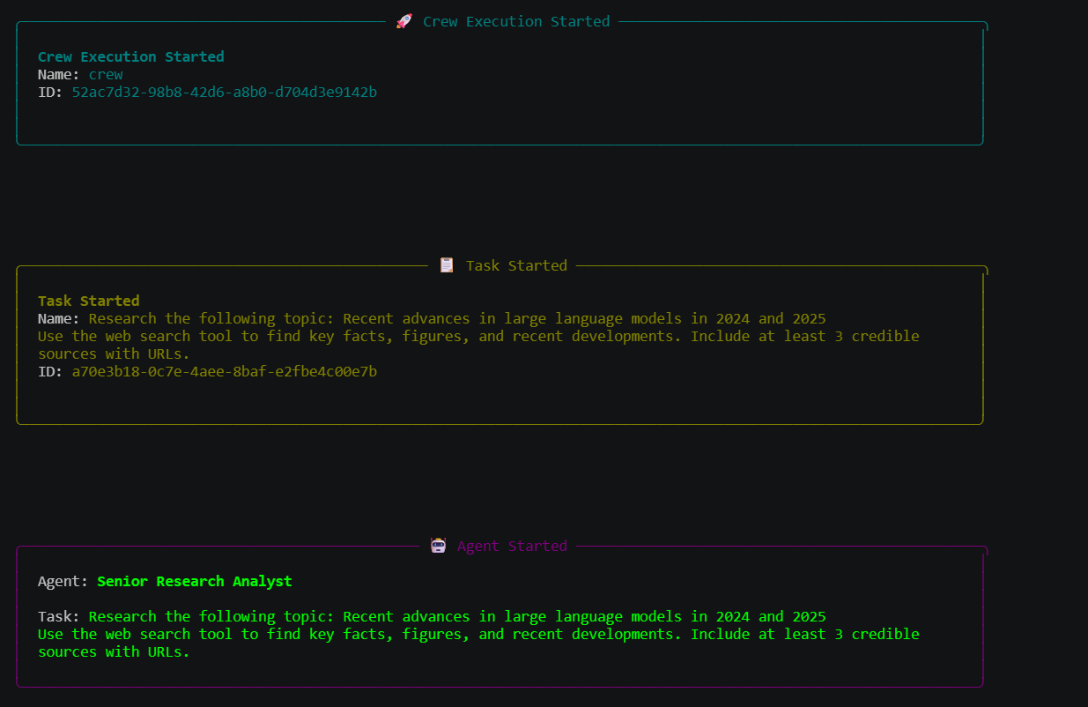
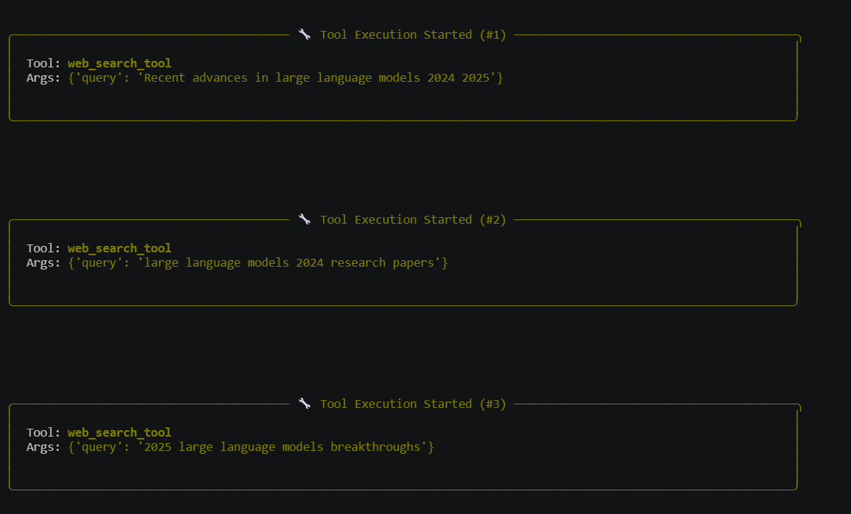

Part 4: Devyan 4-Agent Pipeline:
Agents:
- Architect defines signature, return shape, and edge cases.
- Programmer writes typed implementation code.
- Tester produces pytest tests.
- Reviewer gives concise quality feedback and usage instruction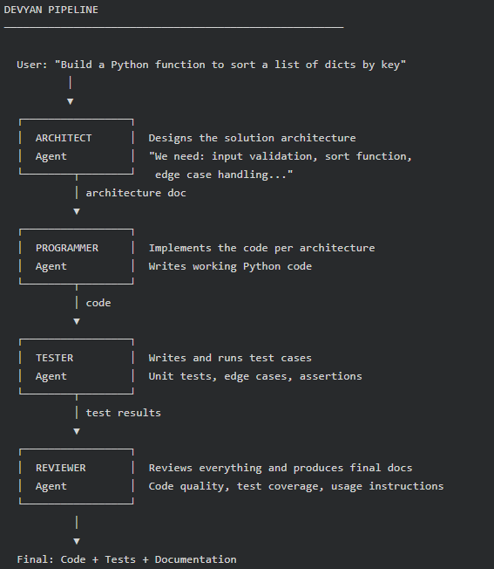

3). Evaluation Data Ethics:

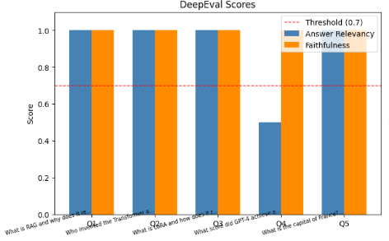

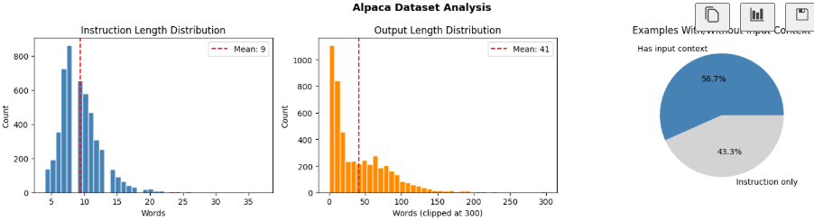

LLM evaluation is the process of measuring how well a language model performs beyond simple word overlap metrics, focusing on qualities like correctness, relevance, faithfulness to source context, safety, and robustness under tricky inputs. Because LLM outputs are open-ended, modern evaluation combines automated checks (for consistency, toxicity, latency, and cost) with LLM-as-judge methods and human review to capture nuance, especially in RAG systems where context relevance and groundedness matter. In practice, teams use test sets, scenario-based prompts, and thresholded metrics to track regressions over time, so evaluation becomes a continuous quality loop rather than a one-time benchmark.

Key insights:
