GENERATIVE-AI AND APPLICATIONS
Unit-01
Submission-02
Chethan S
PES2UG23CS150
6 C

Problem statement:
10. Smart Resume Parser
  - Goal: Upload a resume text and automatically extract specific fields: Name, University, Company.
  - Tech: pipeline('ner') to find PER (Person) and ORG (Organization) entities.
Abstract:
This project presents a Smart Resume Parser implemented using Huggin face transformer pipelines . The system processes unstructured resume text and extracts meaningful information using Named Entity Recognition (NER) . It also generates a concise professional summary through abstractive summarization and classifies the resume into relevant skill domains using zero shot classification . The project demonstrates the practical application of pre-trained NLP models without fine-tuning and serves as a foundational prototype that can be extended into a full resume analysis and job-matching system in the future .

Overview:
With respect to Unit-1, we learned that Natural Language Processing (NLP) models can be used to understand and process human language using pre-trained transformer models. Hugging Face provides an easy to use `pipeline` interface that allows us to apply complex NLP tasks such as Named Entity Recognition (NER), summarization, and classification without training models by ourselves.
From this project, we can also understood that most real-world text data (here it’s resumes) is unstructured, and NLP techniques are required to extract meaningful and structured information from it. Different transformer architectures are suited for different tasks:
- Encoder models (BERT) are useful for understanding text and extracting entities.
- Encoder–Decoder models (BART) are effective for summarization and reasoning-based classification.

Based on this understanding, I implemented a Smart Resume in a Jupyter Notebook. The project takes a hardcoded resume text as input and processes it through multiple NLP pipelines.
1. First, Named Entity Recognition (NER) is applied to identify important entities such as person names and organizations from the resume. Used pipeline(“ner”)
2. Next, a zero-shot classification model is used to categorize the resume into different skill domains such as Programming, Machine Learning, Web Development, and Cybersecurity. Used pipeline(“zero-shot-classifier”)
3. Finally, an abstractive summarization model generates a short professional summary of the resume content, using pipeline(“summarization)
The output of the system is a structured and readable representation of the resume information along with a concise summary. The project can be further scaled and improved with better fine-tuning.

Output:
Named Entity Recognition with confidence values -
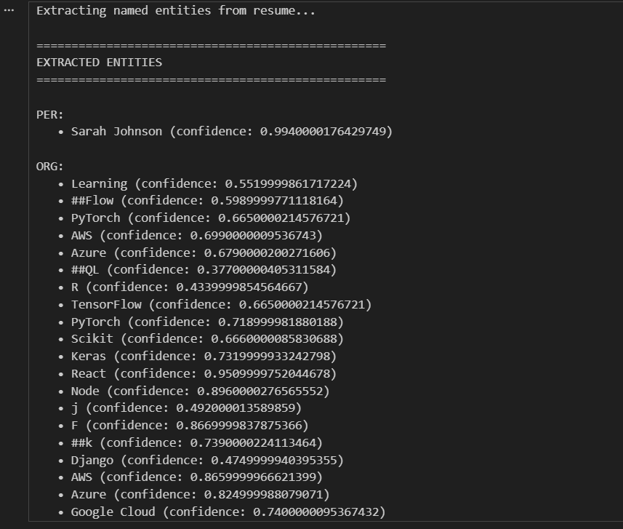
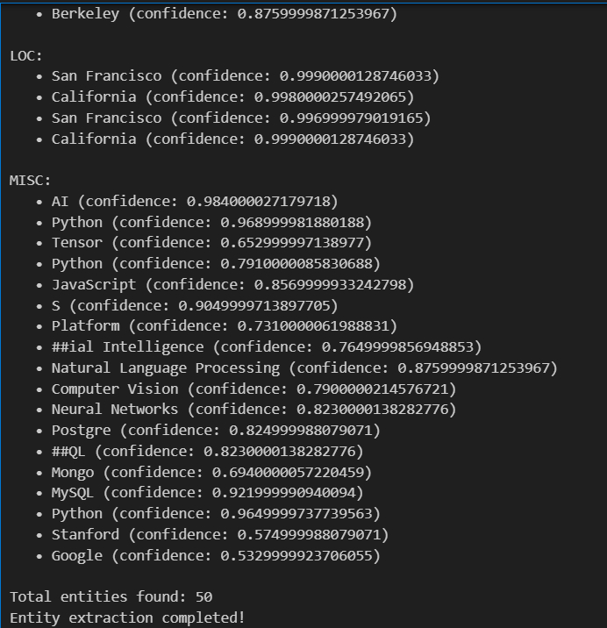
Summary generation using the DistilBART model:
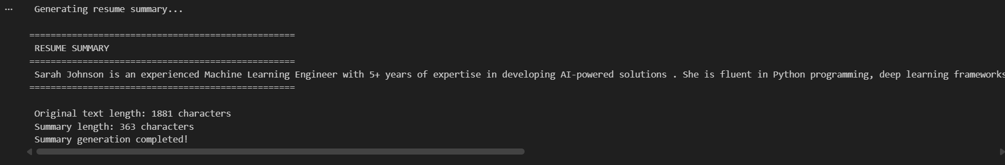

Zero-shot-classifier output:
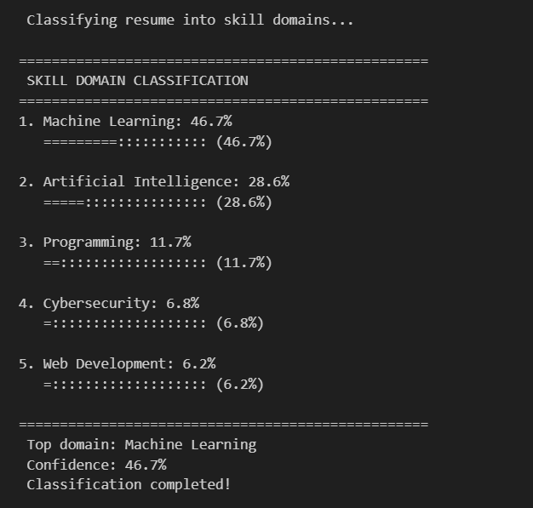
Overall summary:
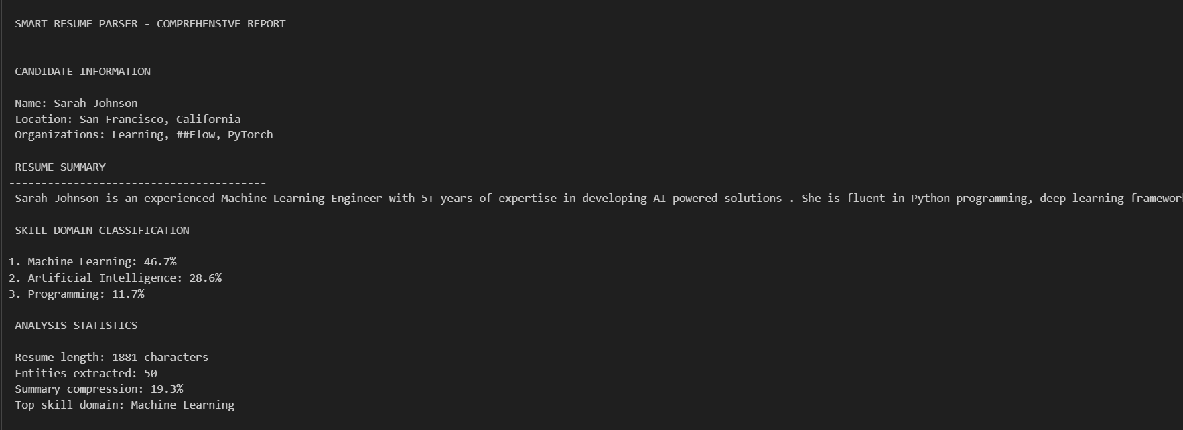
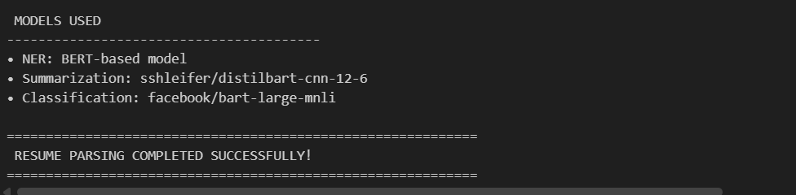

Successfully learnt and explored NLP models practical implementation.

