MACHINE OPERATION CALCULATIONS

- Turning

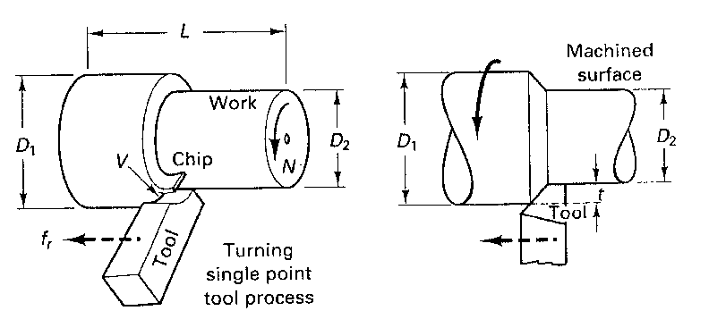

  - Machine Speed: To achieve a specific cutting speed:
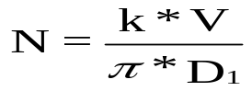
N = machine speed in revolutions/minute (RPM)
k is a constant to “correct” speed (V) and part diameter (D_{i} ) units
V is desired cutting speed, a Handbook Value
D₁ is largest part diameter (initial size)

V given in surface feet per minute (SFPM), D₁ in inches: k = 12
V given in meters per second (MPS), D₁ in mm: k = 60000
V given in meters per minute (MPM), D₁ in mm: k = 1000

If Cutting Speed for a given RPM rate is desired, solve above equation for V: V = πND/k

B. Cutting Time: minutes per operation
CT is cutting time per “pass”
L is length cut
A is “allowance” or starting offset
f_{r} is machine feed rate units/revolution, a Handbook Value

C. Material Removal Rate (MRR or Q): Volume Removed
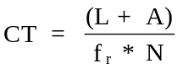
cutting time

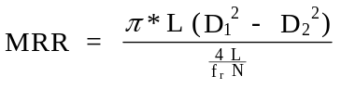

D₂ is Finished Diameter

Substituting for N from above:
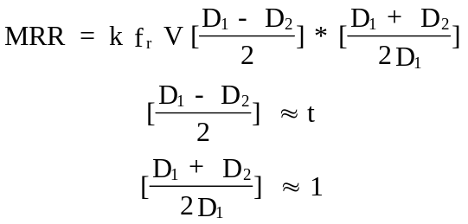

and:

t is Depth of cut (inch or mm)

Therefore:
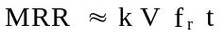

II. Boring

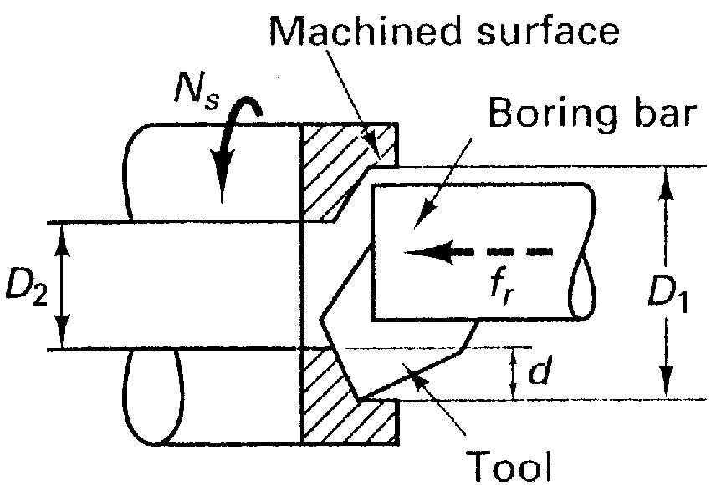
A. Machine Speed: as above except D₁ is the finished (larger) diameter

B. Cutting Time: same as above

C: Material Removal Rate: as above except D₁ is finished diameter while D₂ is Initial (smaller) diameter.

III. Facing, Slot Cutting or Cut Off

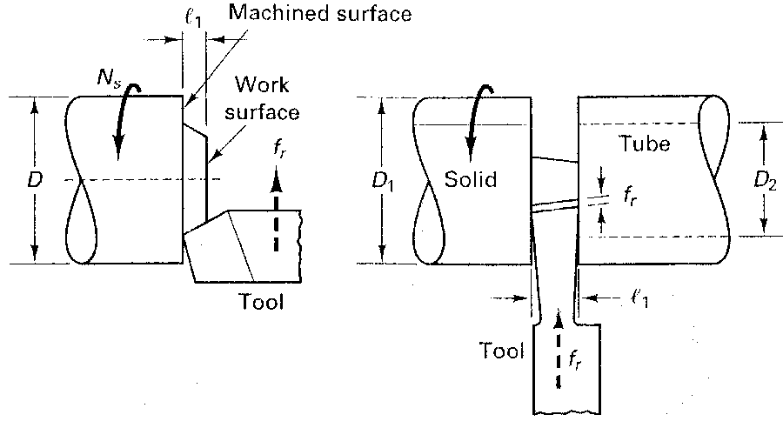

In facing, slot (plunge) cutting and cut off, the cutting speed for a given RPM decreases as the tool progresses toward the center of the piece being cut. This follows since most (manual) lathes cannot increase spindle speed (N) during cutting operations. Thus, the required N is calculated as above using the outside (largest) diameter of the part for a given V.

- Machine Speed
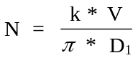

If Cutting Speed for a given RPM rate is desired, solve above equation for V: V = πND/k

- Cutting Time

C. Material Removal Rate (here D₁ is Outside Diameter)

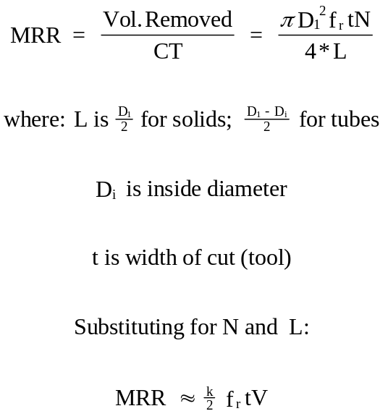

IV. Slab (Horizontal) Milling (be careful with units!!)

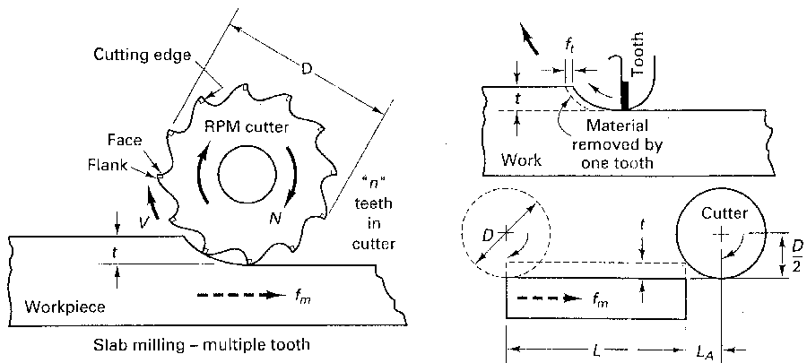
Terms Used:
N: RPM of Cutter
n: Number of Teeth on Cutter
W: Width of cut (may be full cutter or partial cutter)
t: depth of cut
V: cutting speed -- a Handbook value
L: Length of pass or cut
f_{m}: Table (machine) Feed
f_{t}: feed/tooth of cutter -- a Handbook value
D: Cutter Diameter

- Cutting Speed:

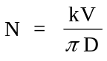

If Cutting Speed for a given RPM rate is desired, solve above equation for V: V = πND/k

B. Table Feed Rate:

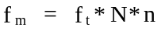

C. Cutting Time:
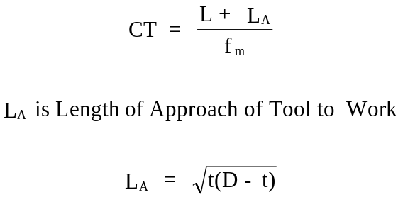

D. Material Removal Rate:

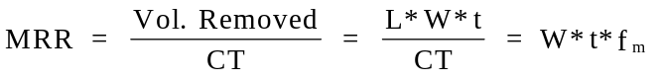

Remember that the length of approach calculated here puts the cutter against the work at the start, we will add a small additional air gap to spin the tool to speed and allow the table to achieve target feed rate before chip making begins. When determining cutting time and MRR, care must be exercised. Ask yourself if total cutting time or time to make one pass across the part is being requested, ie. is a single or multiple pass operation to be studied. Also, note that in the MRR equation the “cutting time” term does not include the time of partial engagement (L_{A}). Again, if a multi-pass operation is being employed, the appropriate width term should be used in the MRR equation.
V. Face (Vertical) Milling

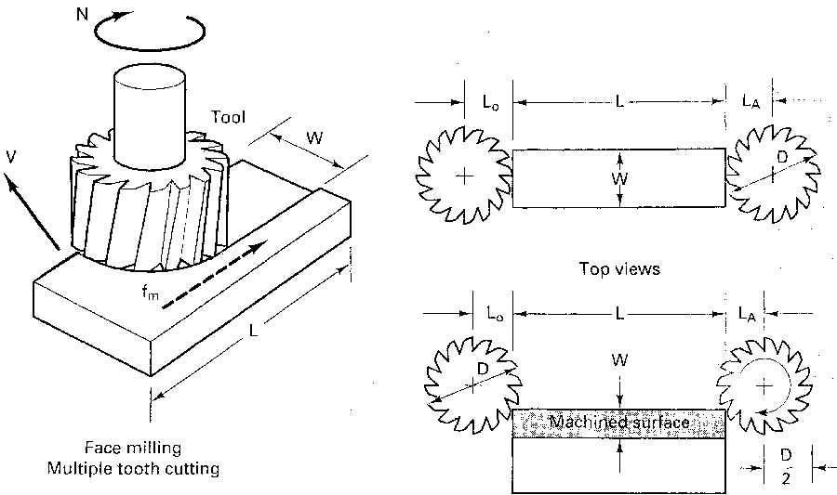

Terms Used:
N: RPM of Cutter
n: Number of Teeth on Cutter
W: Width of cut (may be full cutter or partial cutter)
t: depth of cutter engagement
V: cutting speed -- a Handbook value
L: Length of pass or cut
f_{m}: Table (machine) Feed
f_{t}: feed/tooth of cutter -- a Handbook value
D: Cutter Diameter
L_{A}: Approach Length
L_{O}: Length of “OverTravel”

- Cutting Speed:

If Cutting Speed for a given RPM rate is desired, solve above equation for V: V = πND/k

B. Table Feed:

C. Cutting Time. Here several situation must be considered, these include:
1. Tool Not Fully Engaged with W<D/2
2. Tool not Fully Engaged but W> D/2
3. Tool Fully Engaged, Roughing Pass -- Doesn’t require “Full Wipe”
4. Tool Fully Engaged, Finishing Pass -- requires “Full Wiping Action”
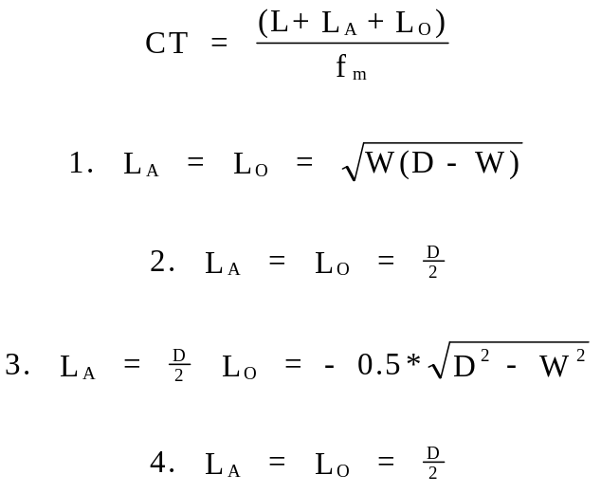

D: Metal Removal Rate:

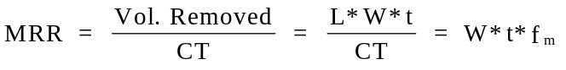

Again, the cautions on single vs. multiple pass CT and MRR apply as with Slab Milling. Remember too, that the length of approach here puts the cutter against the work at the start, we will add a small additional air gap to spin the tool to speed and allow the table to achieve target feed rate before chip making begins. Also, care should be exercised with regards to units.

VI. Drilling

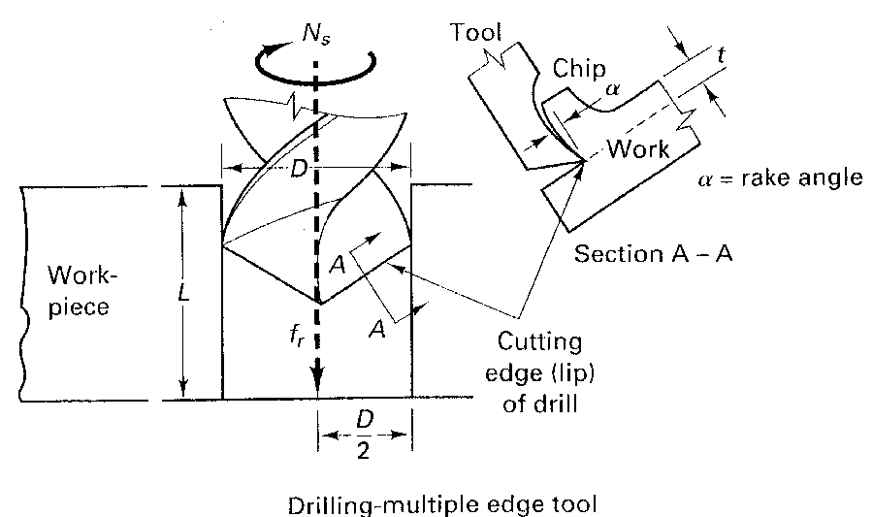

A. Drill Speed, RPM

k is a “Units Constant”
D is Drill Diameter
V is cutting speed, a Handbook Value, if Cutting Speed for a given RPM rate is desired, solve above equation for V: V = πND/k

- Cutting Time (min)

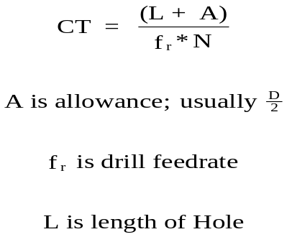

- MRR is (again) Material Removal Rate
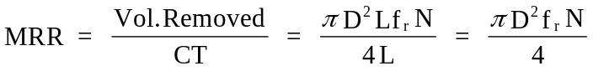

And note, no material is removed while the Drill travels through the “Allowance Zone”

Use caution with units!!

