**VISVESVARAYA TECHNOLOGICAL UNIVERSITY, BELGAUM 59014**



Website DevelopmentReport on

**“Project Proposal Submission System”**

By

Chethan.S.V (1BM16CS028) Harish.S (1BM16CS034)

Under the Guidance of

**Dr. Umadevi V**

Associate Professor, Department of CSE

BMS College of Engineering

Website Development carried out at



Department of Computer Science and Engineering

BMS College of Engineering

(Autonomous college under VTU)

P.O. Box No.: 1908, Bull Temple Road, Bangalore-560 019

2017-2018

**BMS College of EngineerinG**

**DEPARTMENT OF COMPUTER SCIENCE AND ENGINEERING**



***CERTIFICATE***

This is to certify that the website development titled “Project Proposal Submission System” has been carried out by Chethan.S.V (1BM16CS028), Harish.S (1BM16CS034), during the academic year 2017-2018.

Signature of the guide

**Dr. Umadevi V**

Associate Professor

Department of Computer Science and Engineering

BMS College of Engineering, Bangalore

**BMS College of EngineerinG**

**DEPARTMENT OF COMPUTER SCIENCE AND ENGINEERING**



***DECALARATION***

We, Chethan.S.V (1BM16CS028), Harish.S (1BM16CS034),students of 3rd Semester, B.E, Department of Computer Science and Engineering, BMS College of Engineering, Bangalore, hereby declare that, this website development work entitled "Project Proposal Submission System" has been carried out by us under the guidance of Dr. Umadevi V, Associate Professor, Department of CSE, BMS College of Engineering, Bangalore during the academic semester Aug-Dec 2017

We also declare that to the best of our knowledge and belief, the development reported here is not from part of any other report by any other students.

Signature

Chethan.S.V (1BM16CS028)

Harish.S (1BM16CS034)

**1 .INTRODUCTION**

Website development for “ Project Proposal Submission”

This Online submission supports following users

a. Student

b. Teacher

**Functionalities under Student login**

i .Can submit their project proposals.

ii. Can give all their project details and requirements.

**Functionalities under Teacher login**

i .Can accept or reject the project proposals.

ii. Can give suggestions to improve the project.

**2. Webpage Screen Shots**

2.1 Opening Page

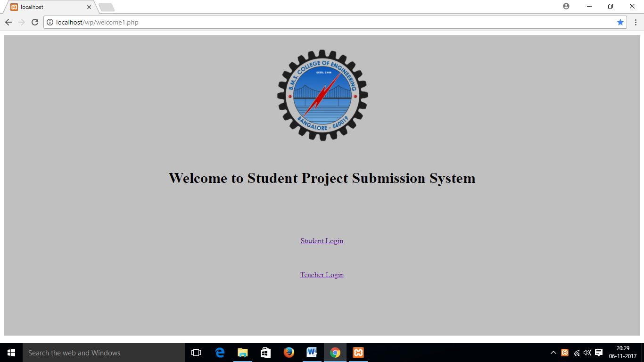

2.1.1 Student Login Page

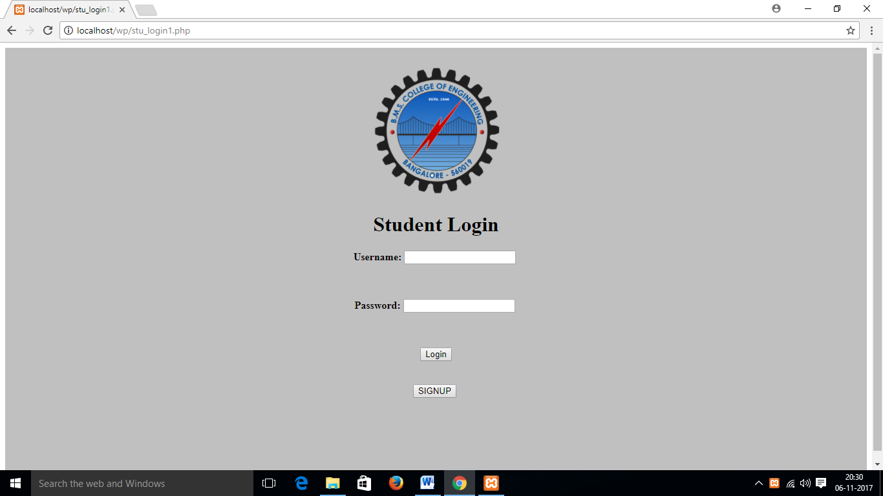

2.1.2 Student signup page

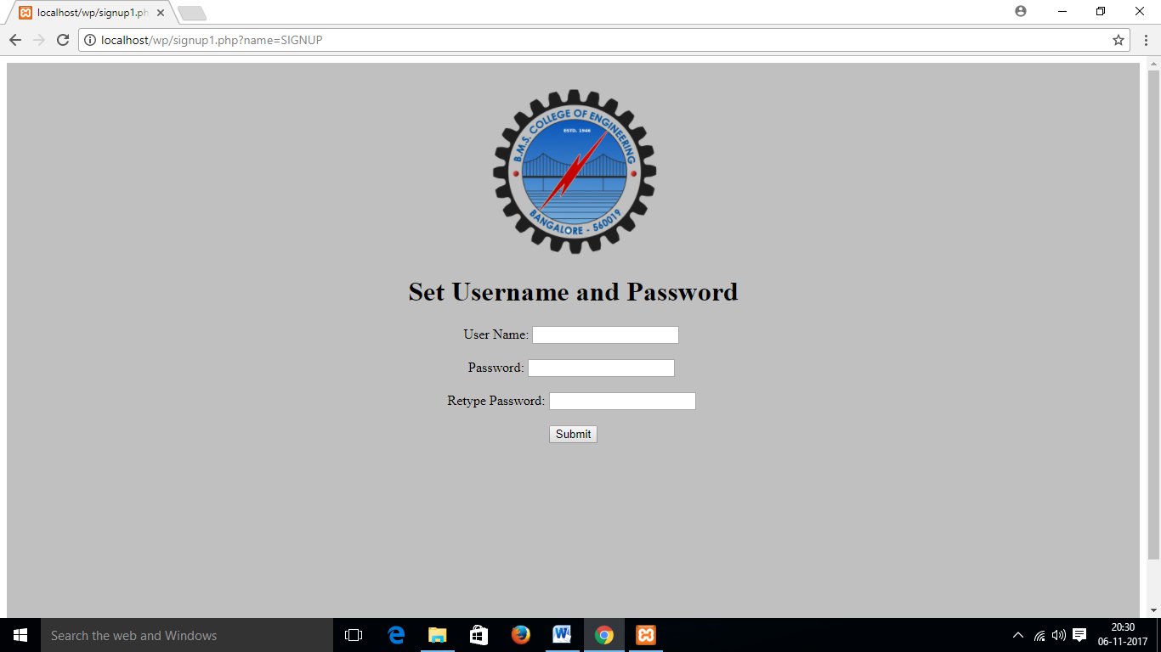

2.1.3 Student Home Page

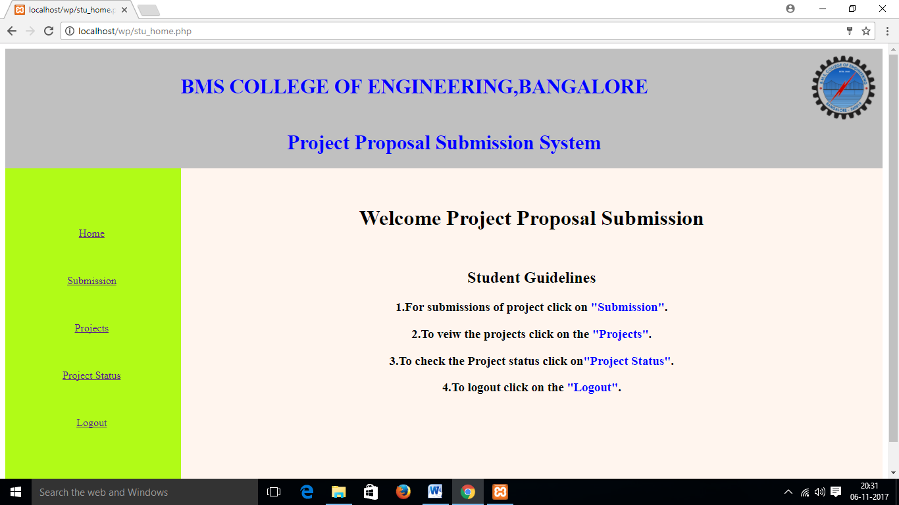

2.1.3 Student Submission Page

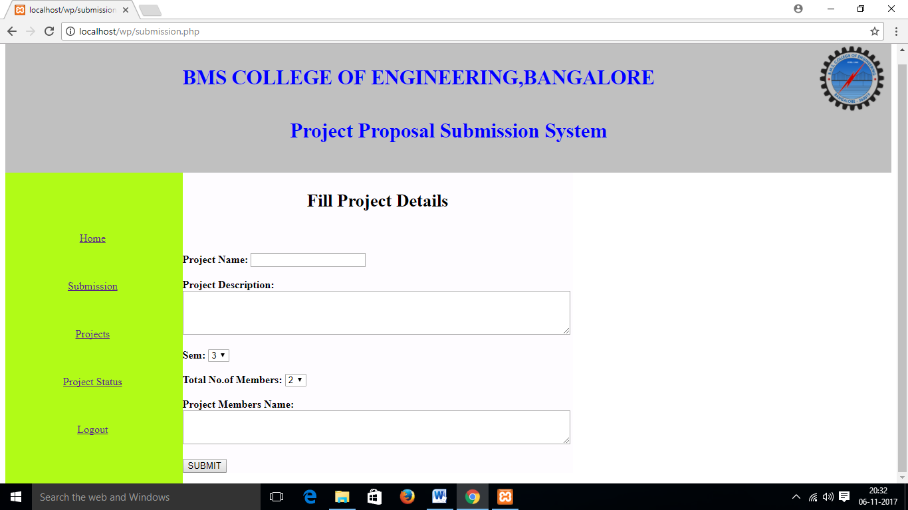

2.1.4 Student Project tab page

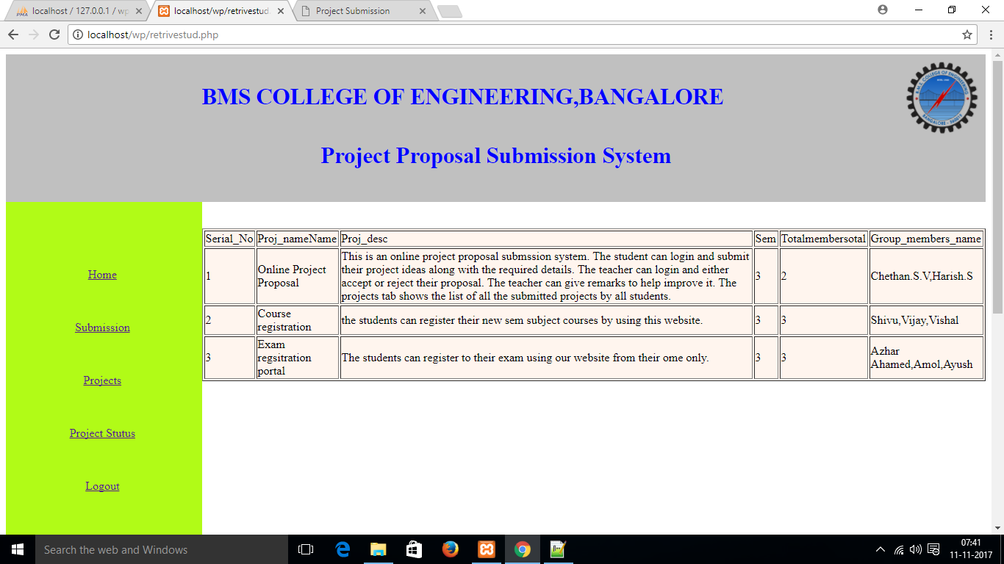

2.1.5 Student Project Status Page

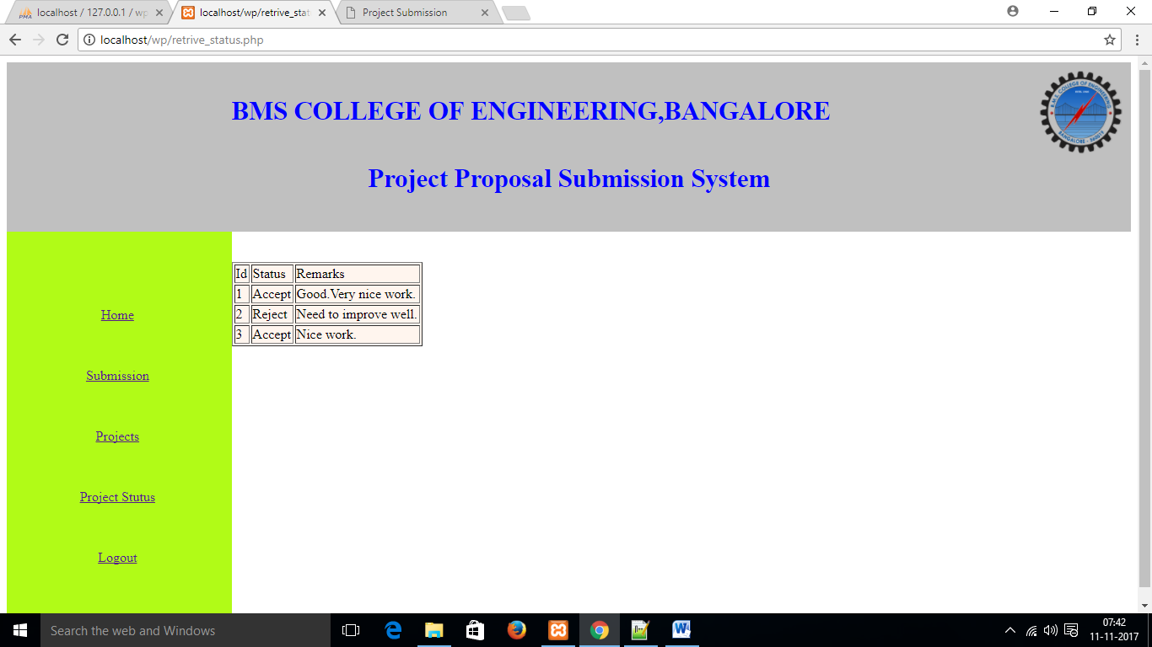

2.2 Teacher’s Login Page.

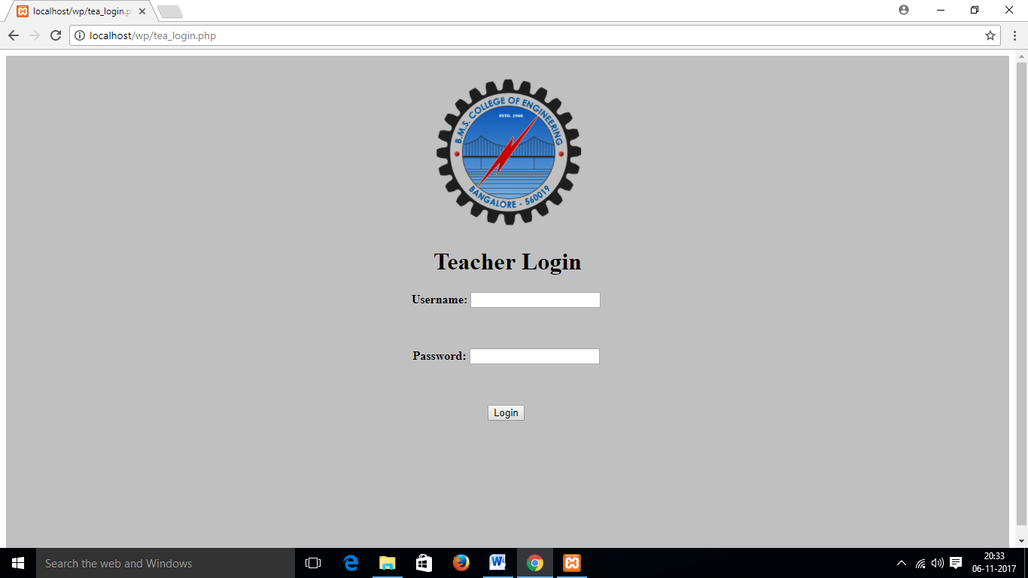

2.2.1 Teacher’s Home Page.

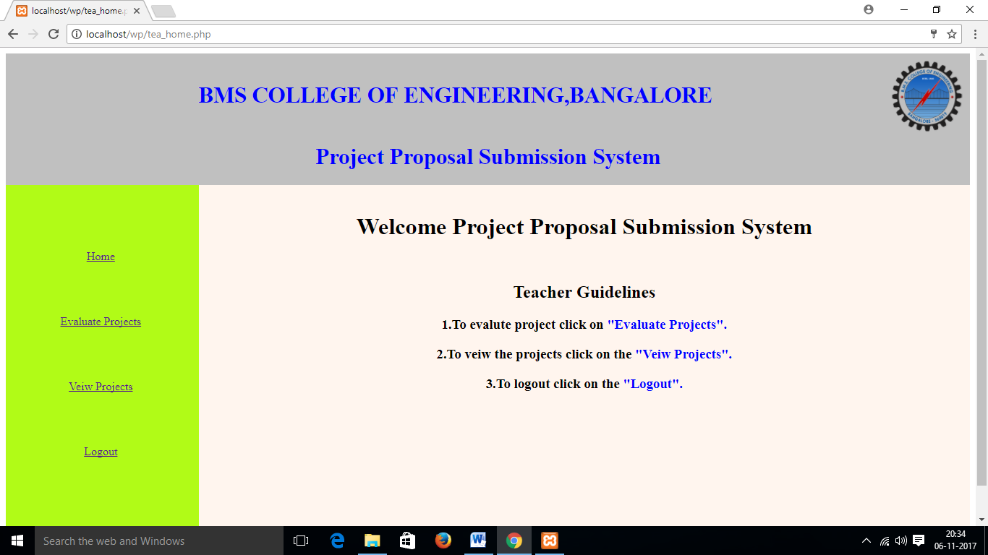

2.2.2 Teacher’s View Projects tab Page.

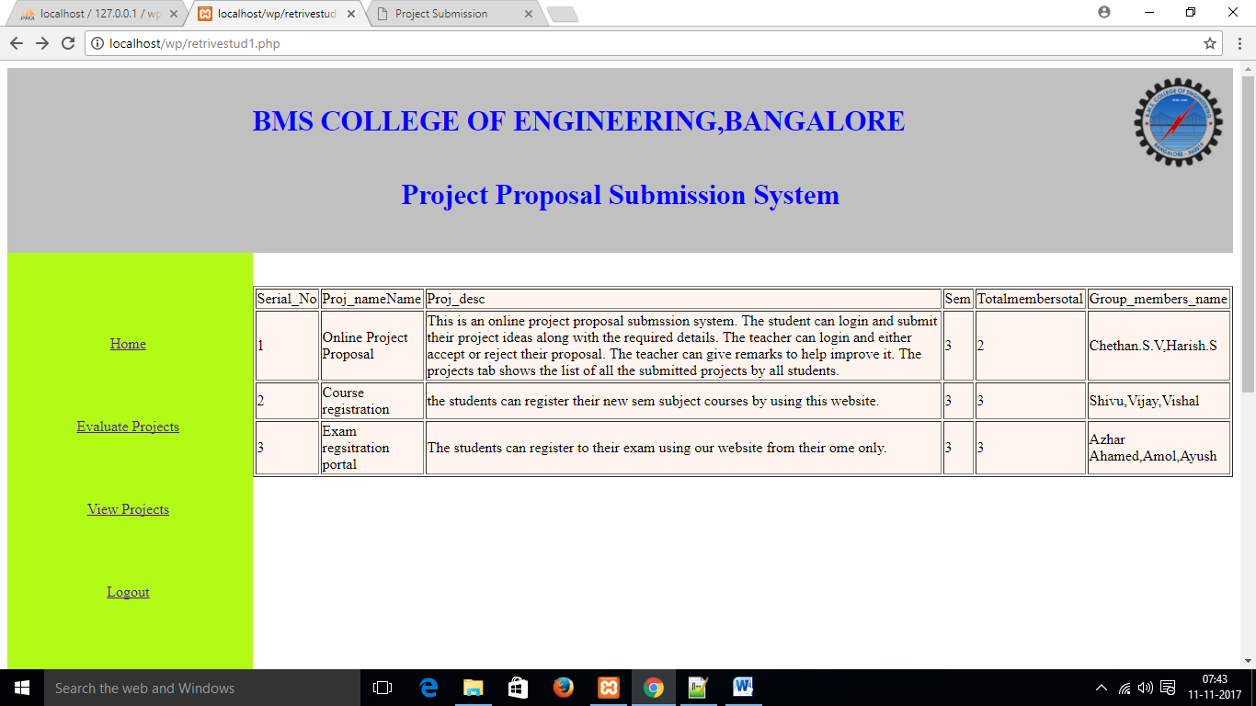

2.3.3 Teacher’s Evalution Pages.

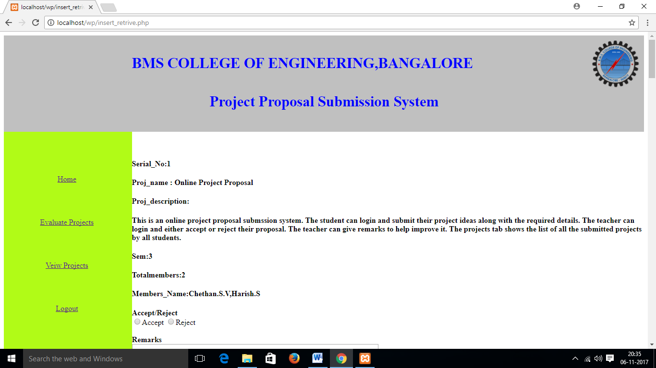

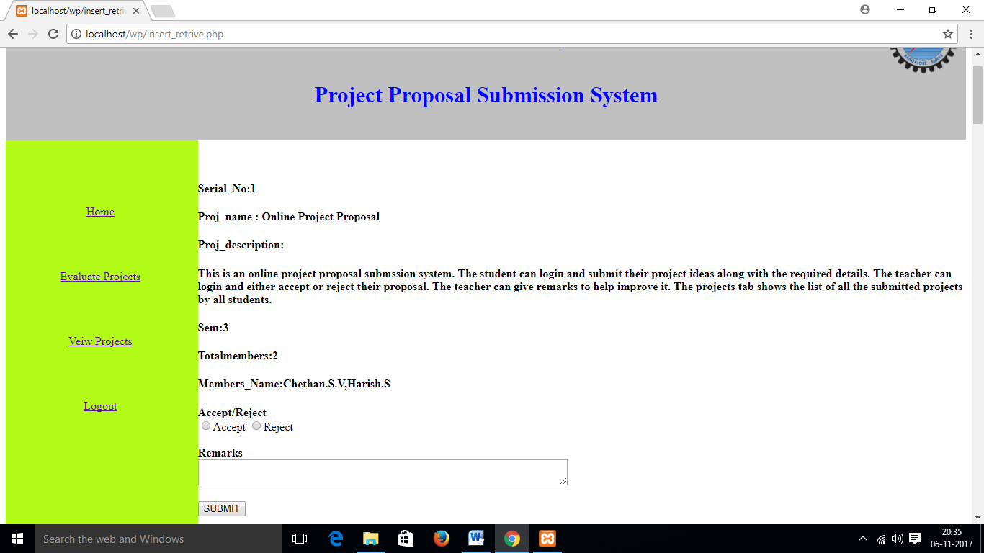

3. Database table Screen Shots

3.1 Student signup: Structure

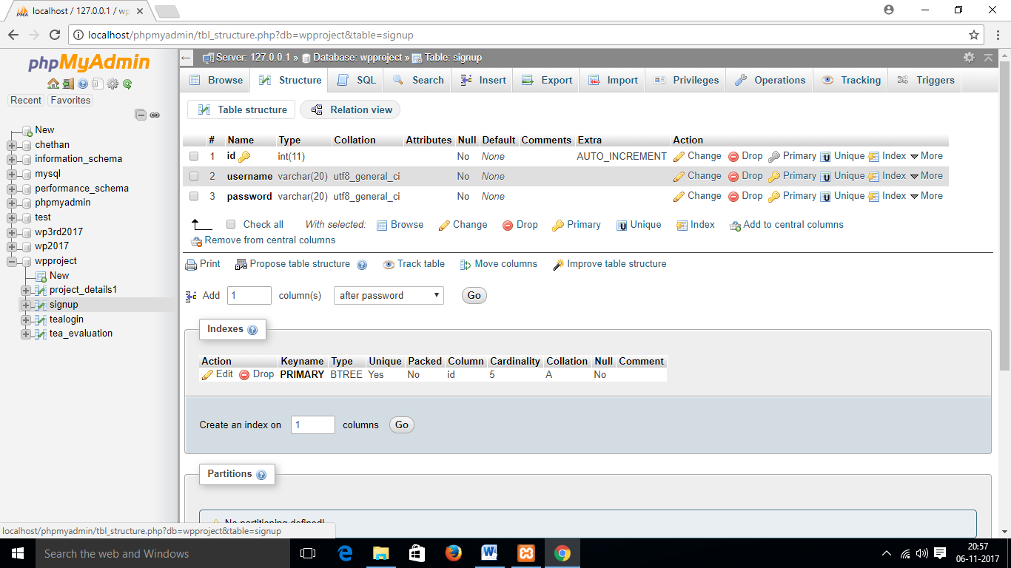

3.1.1 Student Signup :Data

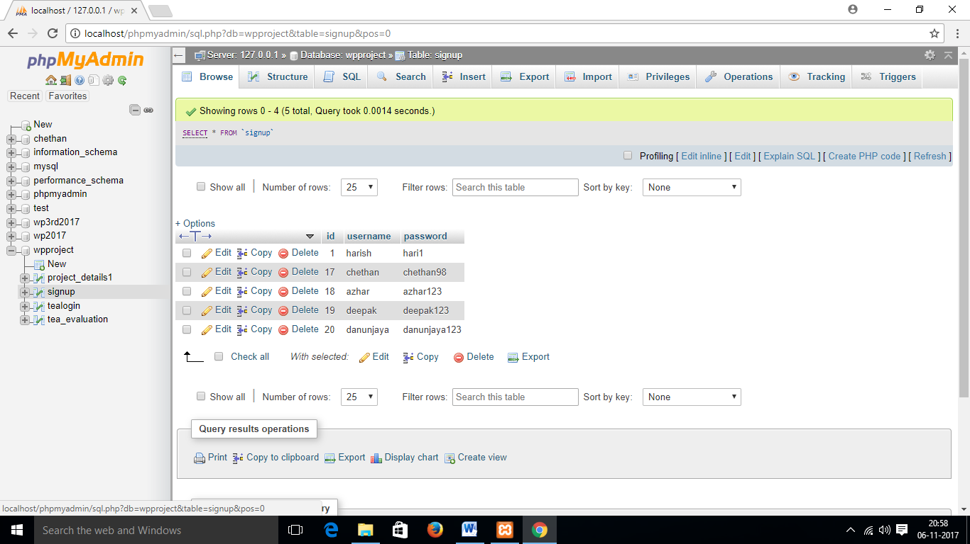

3.2 Project_details:Description

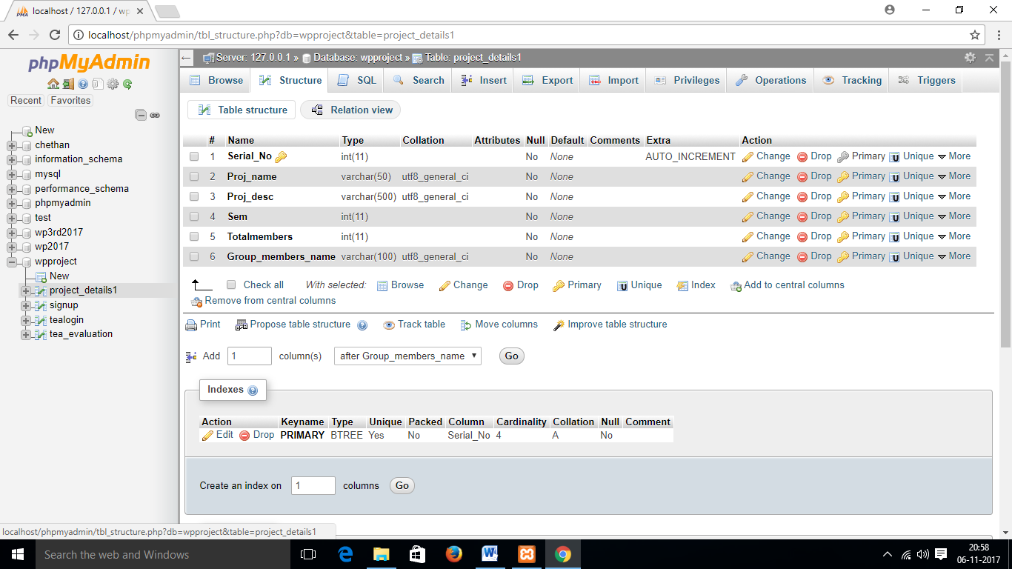

3.2.1 Project details : Data

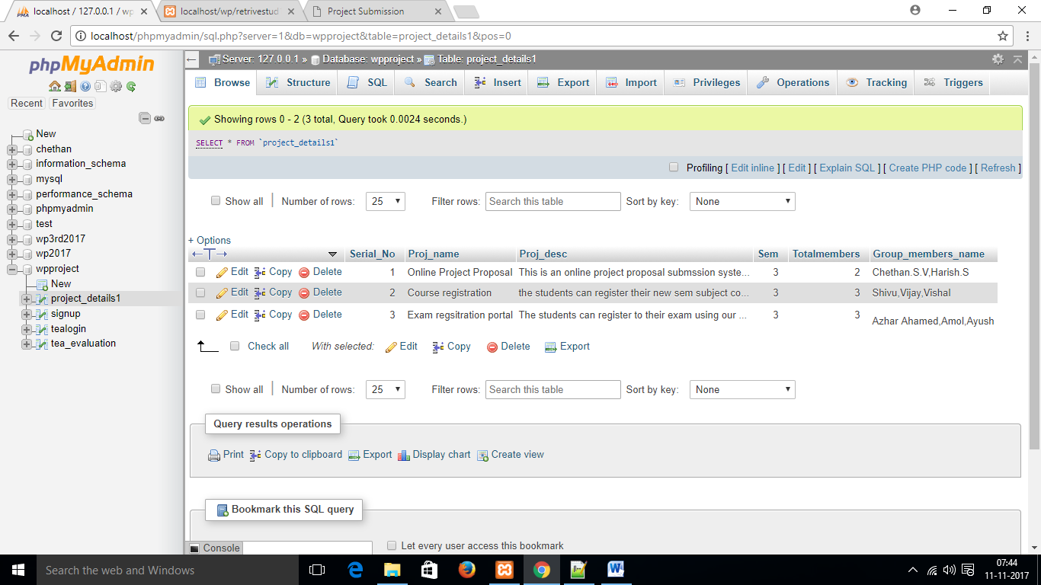

3.3 Teacher Login:Description

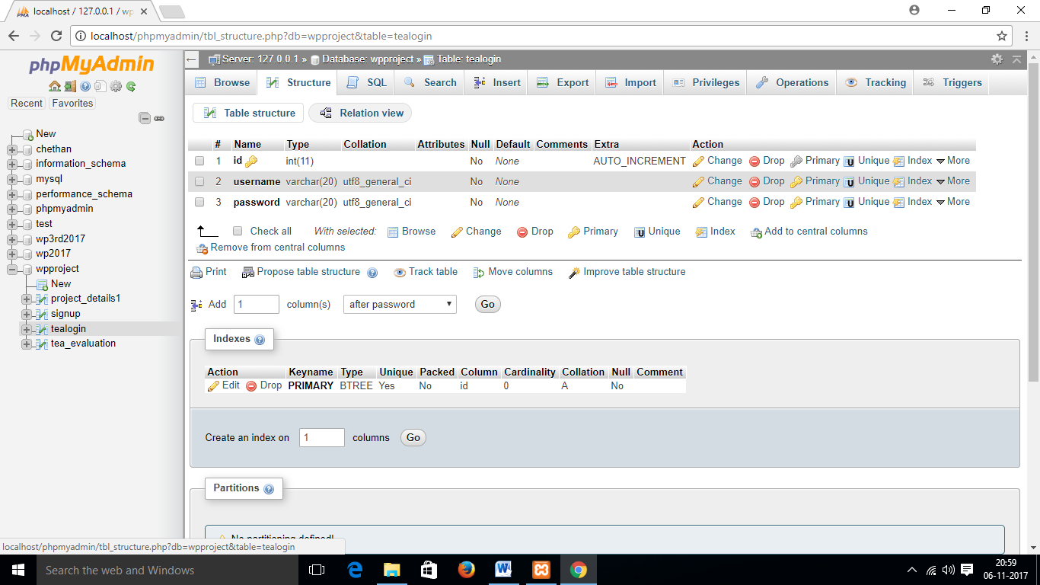

3.3.1 Teacher Login: data

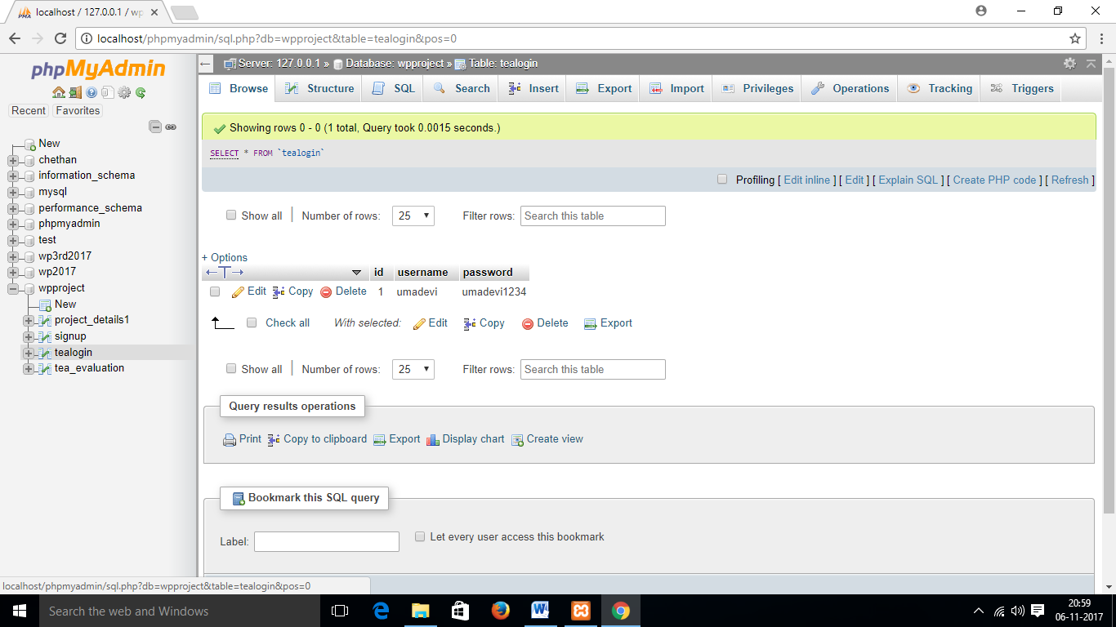

3.4 Teacher Evaluation: Description

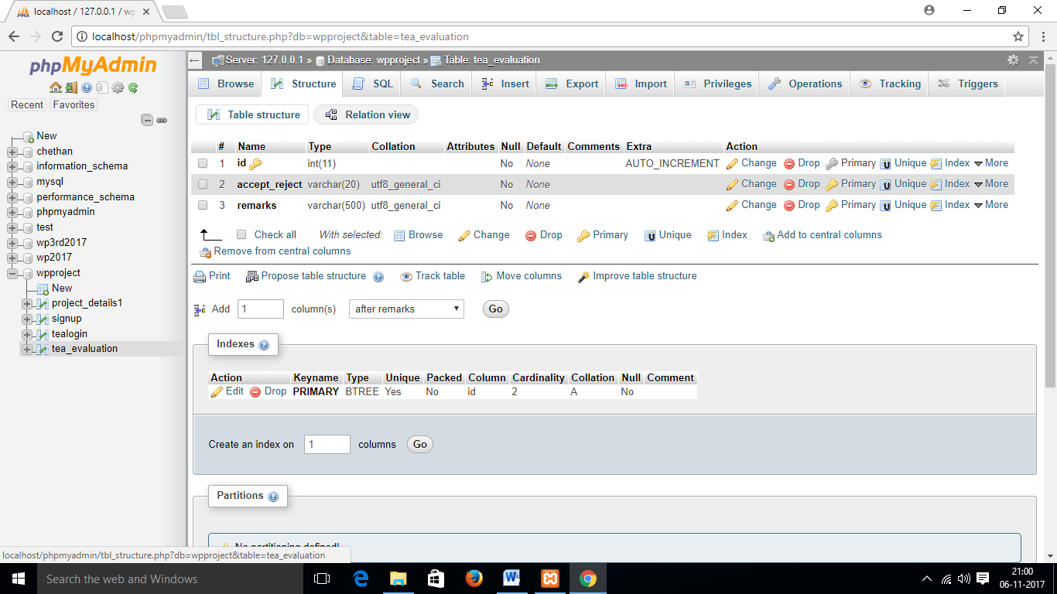

3.4.1 Teacher Evaluation: Data

