ROBOT STATUS (2017/11/17)

………..

Used Facebook User URL= https://www.facebook.com/milette.mamaril

Entity ID=11338487

Used Instagram User URL= https://www.instagram.com/serkancayoglu/

Entity ID= 13495954

FacebookUserDetails=No issues

FBFollowing=No issues

FBFriends=

Unappropriated test condition (I think so, please refer the robot, I have no IDEA)

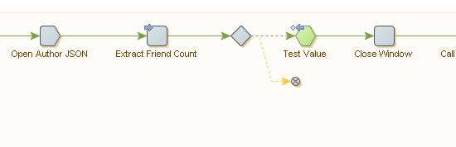

FBUserGroups

**ERROR**=

Error from the Call REST Web Service action. Error calling REST web service. 403 Bad Port loading from <http://checkmate.ukwest.cloudapp.azure.com:9100/managementModule/api/entity/avatarEffort>

**LOCATION=** Load Page - Extract Kapow Server - Extract Entityt Repository - Extract Document Repository - Extract Node Server - (Unnamed Try step) - Repeat[5] - (Unnamed Try step) - Call REST Web Service - Open Avatar - Extract Username - Extract Password - Extract Avatar Id - Extract IP - Extract Port - Extract User Name - Extract Password - (Unnamed Try step) - Test Value - Change Proxy - Load Page - (Unnamed Try step) - Enter Text - Enter Password - (Unnamed Try step) - Click Log In - Call REST Web Service

Solution= Changed the proxy

GetInstagramDetails

One issue about the extraction, I earlier mentioned you about it,

Can you please just add the ROBOT that sent?

Thank you